**Week 5 : Microservices**

**Hands On 1**

**Create Microservices for Account & Loan**

**Account Microservice**

**Code :**

**AccountController.java**

package com.cognizant.Account.controller;  
  
import org.springframework.web.bind.annotation.GetMapping;  
import org.springframework.web.bind.annotation.PathVariable;  
import org.springframework.web.bind.annotation.RequestMapping;  
import org.springframework.web.bind.annotation.RestController;  
  
@RestController  
@RequestMapping("/accounts")  
public class AccountController {  
 @GetMapping(value = "/{number}", produces = "application/json")  
 public Account getAccount(@PathVariable String number) {  
 return new Account(number, "savings", 234343);  
 }  
  
 static class Account {  
 private String number;  
 private String type;  
 private double balance;  
 public Account(String number, String type, double balance) {  
 this.number = number;  
 this.type = type;  
 this.balance = balance;  
 }  
 // Getters  
  
 public String getNumber() {  
 return number;  
 }  
  
 public String getType() {  
 return type;  
 }  
  
 public double getBalance() {  
 return balance;  
 }  
 }  
}

**Output :**

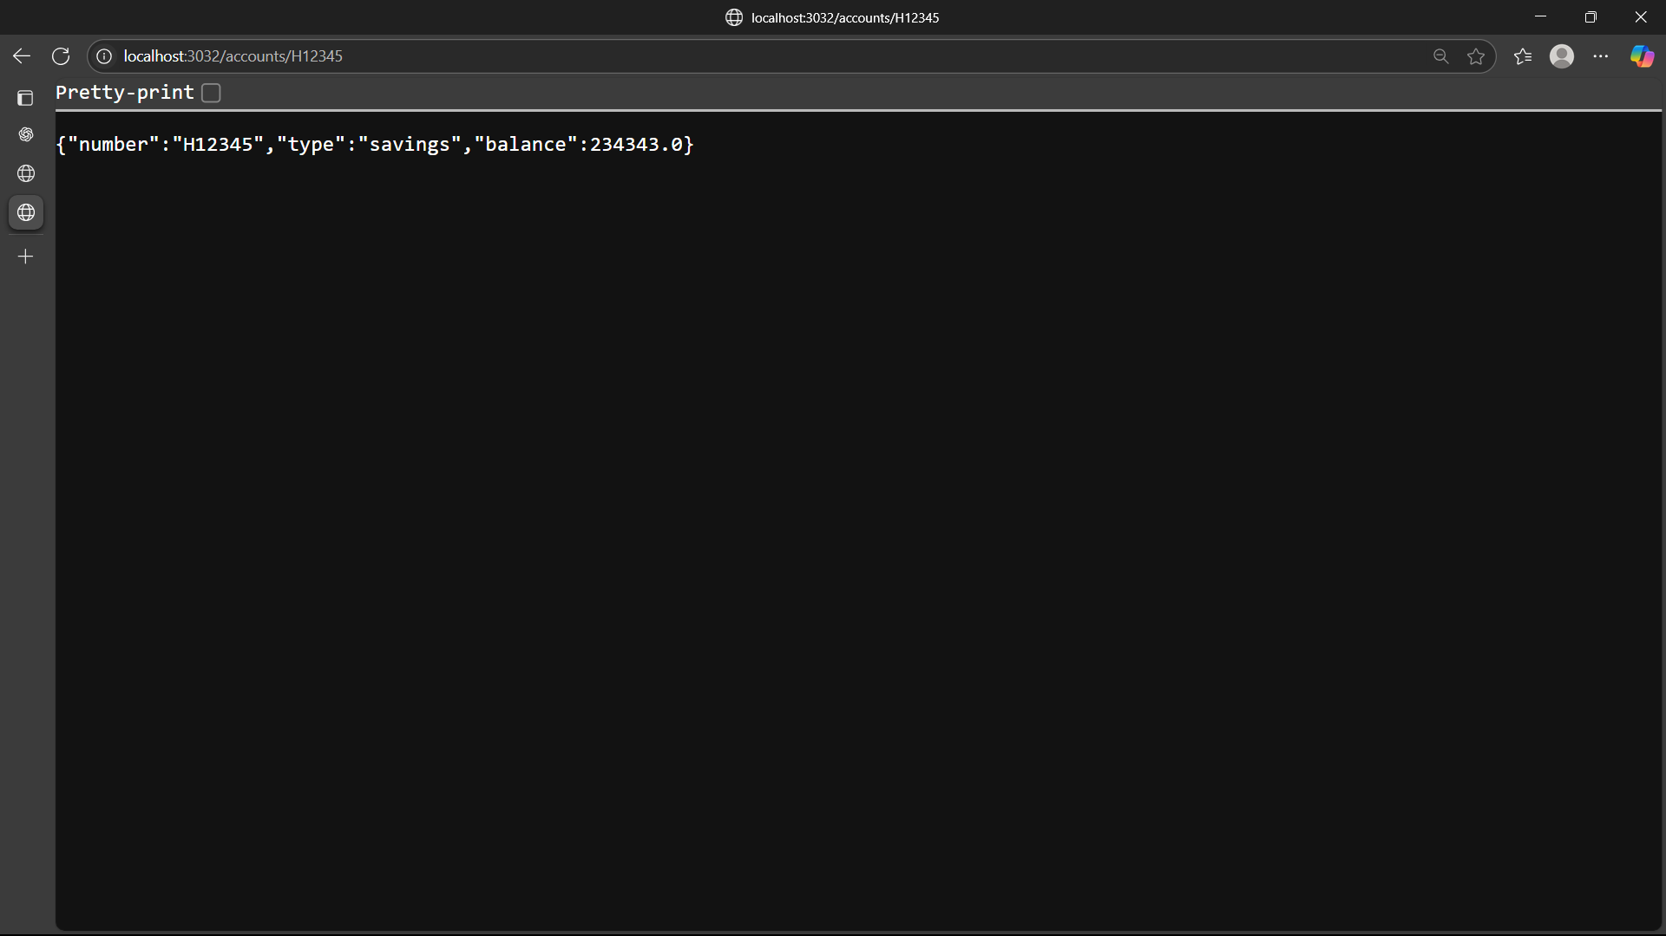

**Loan Microservice**

**Code :**

**LoanController.java**

package com.cognizant.Loan.controller;  
import org.springframework.web.bind.annotation.GetMapping;  
import org.springframework.web.bind.annotation.PathVariable;  
import org.springframework.web.bind.annotation.RequestMapping;  
import org.springframework.web.bind.annotation.RestController;  
  
@RestController  
@RequestMapping("/loans")  
public class LoanController {  
 @GetMapping("/{number}")  
 public Loan getLoan(@PathVariable String number) {  
 return new Loan(number, "car", 400000, 3258, 18);  
 }  
 static class Loan {  
 private String number;  
 private String type;  
 private double loan;  
 private double emi;  
 private int tenure;  
 public Loan(String number, String type, double loan, double emi, int tenure) {  
 this.number = number;  
 this.type = type;  
 this.loan = loan;  
 this.emi = emi;  
 this.tenure = tenure;  
 }  
 // Getters  
  
 public String getNumber() {  
 return number;  
 }  
  
 public String getType() {  
 return type;  
 }  
  
 public double getLoan() {  
 return loan;  
 }  
  
 public double getEmi() {  
 return emi;  
 }  
  
 public int getTenure() {  
 return tenure;  
 }  
 }  
}

**Output :**

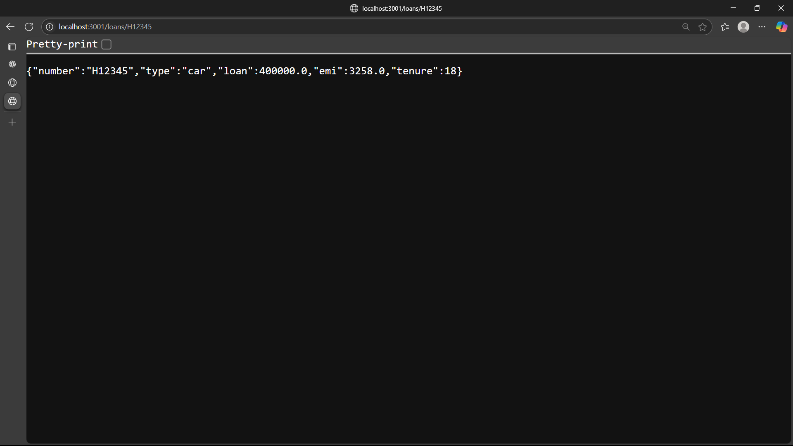

**Hands On 2**

**Setup Eureka Discovery Server**

**Code :**

**EurekaDiscoveryServer.java**

package com.cognizant.eureka_discovery_server;  
  
import org.springframework.boot.SpringApplication;  
import org.springframework.boot.autoconfigure.SpringBootApplication;  
import org.springframework.cloud.client.discovery.EnableDiscoveryClient;  
import org.springframework.cloud.netflix.eureka.server.EnableEurekaServer;  
  
@EnableDiscoveryClient  
@EnableEurekaServer  
@SpringBootApplication  
public class EurekaDiscoveryServerApplication {  
  
 public static void main(String[] args) {  
 SpringApplication.*run*(EurekaDiscoveryServerApplication.class, args);  
 }  
  
}

**application.properties**

spring.application.name=eureka-discovery-server  
server.port=8761  
  
eureka.client.register-with-eureka=false  
eureka.client.fetch-registry=false  
  
logging.level.com.netflix.eureka=OFF  
logging.level.com.netflix.discovery=OFF

**Output :**

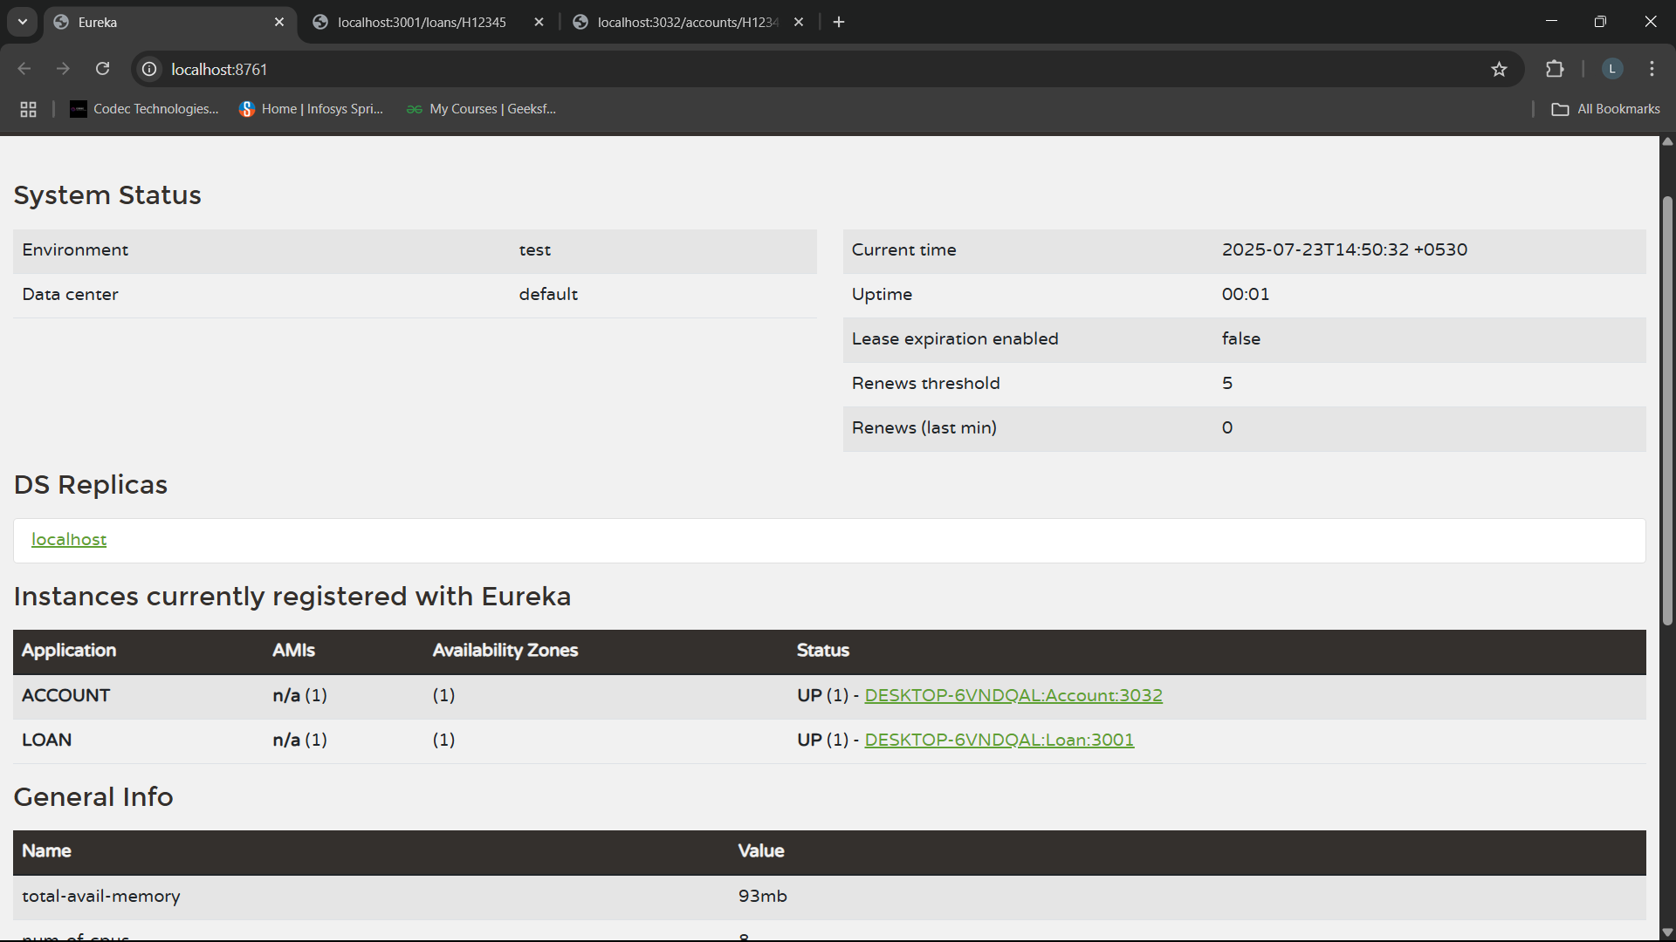

**Hands On 3**

**Create a Simple greet-service Microservice**

**Code :**

**GreetService.java**

package com.cognizant.greet_service;  
  
import org.springframework.boot.SpringApplication;  
import org.springframework.boot.autoconfigure.SpringBootApplication;  
  
@SpringBootApplication  
public class GreetServiceApplication {  
  
 public static void main(String[] args) {  
 SpringApplication.*run*(GreetServiceApplication.class, args);  
 }  
}

**GreetController.java**

package com.cognizant.greet_service.controller;  
  
  
import org.springframework.web.bind.annotation.GetMapping;  
import org.springframework.web.bind.annotation.PathVariable;  
import org.springframework.web.bind.annotation.RestController;  
  
@RestController  
public class GreetController {  
  
 @GetMapping("/greet/{name}")  
 public String greet(@PathVariable String name) {  
 return "Hello, " + name + "! Welcome to greet-service.";  
 }  
}

**Output :**

