Short Term Internship on
Developing Java Based Applications on Hospital Patient Management System and Online Exam Registration Portal
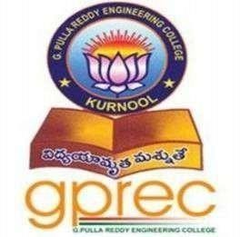

A Short Term Internship report submitted in partial fulfilment for the award of degree in
BACHELOR OF TECHNOLOGY IN
CSE(Artificial Intelligence & Machine Learning) By
S. Harini
Under the esteemed guidance of
Dr. A. Vishnuvardhan Reddy Assistant Professor
Department of CSM

Department of CSE (AI & ML)

G. PULLA REDDY ENGINEERING COLLEGE(Autonomous): KURNOOL
(Affiliated to JNTUA, ANANTAPURAMU) 2025-2026

Department of CSE (AI & ML)
G. PULLA REDDY ENGINEERING COLLEGE(Autonomous): KURNOOL

(Affiliated to JNTUA, ANANTAPURAMU)

CERTIFICATE
This is to certify that the Short Term Internship on ‘CropCare AI – Plant Disease Detection , Smart Farming Assistance using Machine Learning and Computer Vision’ is a Bonafide recordof work carried out by

S. Harini 239X1A3380
Under my guidance and supervision in partial fulfillment of the requirements for
the award of degree of

BACHELOR OF TECHNOLOGY IN
CSE (ARTIFICIAL INTELLIGENCE & MACHINE LEARNING)

Dr. A. Vishnuvardhan Reddy Dr. R. Praveen Sam
Assistant Professor, Professor & HOD,
Department of CSM, Department of CSM, GPREC, GPREC,
KURNOOL. KURNOOL.

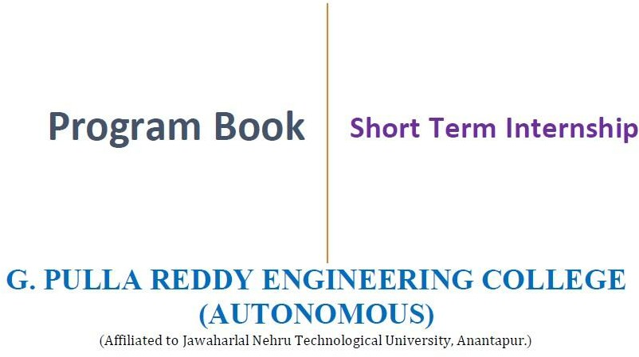

Program Book
for
Short-Term Internship

Name of the Student: Sandyapogu Harini
Name of the College: G. Pulla Reddy Engineering College
Registration Number: 239X1A3380

Period of Internship: From: 03/05/2026 To: 26/06/2026

Name & Address of the Intern Organization: Indian Servers Private Limited

An Internship Report
On
(CropCare AI – Plant Disease Detection , Smart Farming Assistance using Machine Learning and Computer Vision)

Submitted in accordance with the requirement for the degree of B.Tech

Name of the College: G Pulla Reddy Engineering College

Department: Computer Science and Engineering (AI & ML)

Name of the Faculty Guide: Dr. A. Vishnuvardhan Reddy

Duration of the Internship: From: 03/05/2026 To: 26/06/2026

Name of the Student: Sandyapogu Harini

Programme of Study: B. Tech – CSE(AI&ML)

Year of Study: 2025-2026

Register Number: 239X1A3380

Date of Submission: 18/07/2026

Student’s Declaration
I, Sandyapogu Harini, a student of Bachelor of Technology Program, Reg. No. 239X1A3380 of the Department of Computer Science and Engineering (AI & ML), G. Pulla Reddy Engineering College do hereby declare that I have completed the mandatory internship from 03-05-2026 to 26-06-2026 in Indian Servers Private Limited under the Faculty Guideship of Dr. A. Vishnuvardhan Reddy, Department of Computer Science and Engineering (AI & ML),
G. Pulla Reddy Engineering College (Autonomous), Kurnool.

(Signature and Date)

Endorsements

Faculty Guide

Head of the Department

Principal

Certificate from Intern Organization

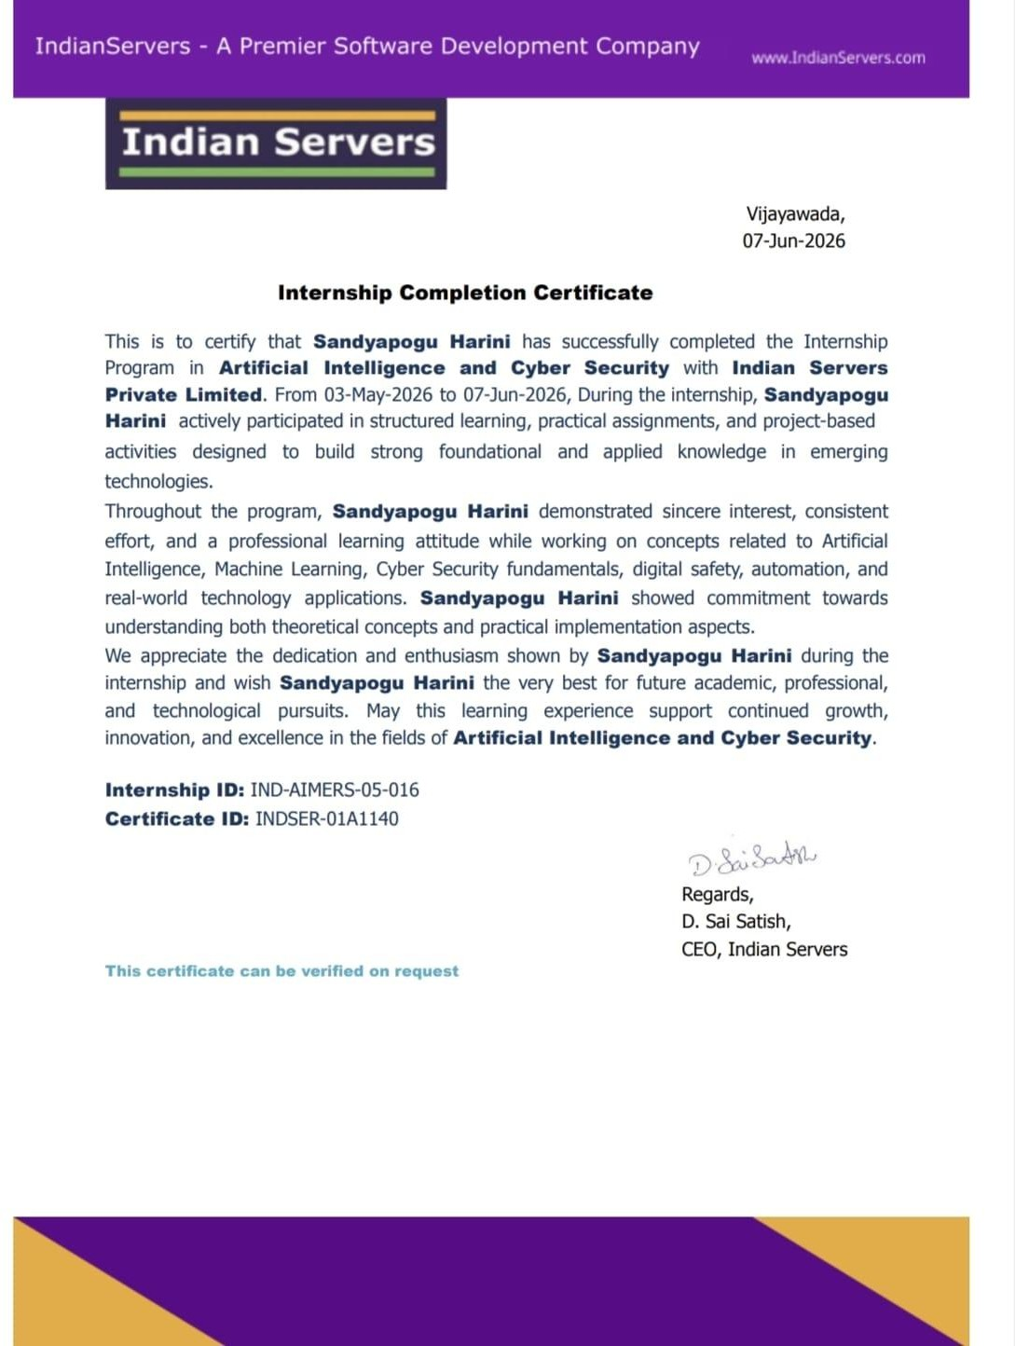

ACKNOWLEDGEMENT

I am extremely thankful to my guide Dr. A. Vishnuvardhan Reddy , Assiociate Professor, Department of CSE (AI & ML), for her valuable guidance, encouragement, and constant support throughout the internship. Her suggestions and mentorship helped me in the successful completion of my internship and project report.
I extend my heartfelt gratitude to Prof. Dr. R. Praveen Sam, Head of the Department of CSE (AI & ML), for his motivation and support, which inspired me to give my best during this internship.
I am grateful to Dr. B. Sreenivasa Reddy, Principal, G. Pulla Reddy Engineering College, for providing me with the necessary resources and an excellent environment to learn and grow.
I also sincerely thank all my faculty members and non-teaching staff of the Department of CSE (AI & ML) for their constant guidance and encouragement.

CHAPTER 1: EXECUTIVE SUMMARY

This report presents the outcomes of a short-term internship focused on developing CropCare AI – Plant Disease Detection, Smart Farming Assistance using Machine Learning and Computer Vision. The project applies Machine Learning, Computer Vision, and Generative AI to assist farmers in detecting plant diseases, receiving smart farming recommendations, and improving crop management. The application combines image analysis, weather information, and AI-powered advisory to provide accurate and user-friendly support for sustainable agriculture.

Learning Objectives & Outcomes

The internship enabled the achievement of the following learning objectives:
- Technical Skills: Developed practical knowledge of Python, YOLOv8, OpenCV, Streamlit, Generative AI APIs, and Weather APIs.
- AI & Problem Solving: Built an intelligent system for plant disease detection and AI-based farming recommendations.
- System Design: Integrated computer vision, AI chatbot, weather services, and multilingual support into a single application.
- Project Management: Improved planning, implementation, testing, and documentation skills throughout the project.
- Documentation: Gained experience in preparing technical reports and documenting system architecture and project outcomes.

Project Overview

The internship involved developing CropCare AI, an AI-powered agriculture application that detects plant diseases using YOLOv8 and OpenCV, provides farming guidance through Gemini/OpenAI, and delivers weather-aware recommendations using Weather APIs. The application also incorporates RAG (FAISS + LangChain) and multilingual support to offer clear, explainable recommendations. The project demonstrates the practical use of AI technologies to enhance crop health monitoring and support sustainable farming practices.

CHAPTER 2: OVERVIEW OF THE ORGANIZATION

Introduction of the Organization
Indian Servers Private Limited is a technology company that provides software development, Artificial Intelligence, Cyber Security, and web-based solutions. The organization offers industry-oriented internship programs that help students gain practical experience by working on real-world AI projects and modern technologies.

Vision, Mission and Values of the Organization
Vision: To promote innovation through technology and develop skilled professionals.
Mission: To provide quality training, practical exposure, and industry-relevant solutions using emerging technologies.
Values: Innovation, Integrity, Teamwork, Quality, and Continuous Learning.

Policy of the Organization in Relation to the Intern Role
The organization encourages interns to follow professional ethics, complete assigned tasks on time, learn new technologies, collaborate with mentors, and actively participate in project development.

Organizational Structure
The organization consists of Management, Project Mentors, Development Team, and Interns, who work together to develop AI-based software solutions and ensure successful project execution.

Roles and Responsibilities of the Intern
My responsibilities included developing the CropCare AI application, implementing plant disease detection using Machine Learning and Computer Vision, integrating AI chatbot and Weather API services, testing the application, and preparing project documentation.

Performance of the Organization
Indian Servers Private Limited has built a strong reputation in technology training and software development by offering industry-focused internships and AI-based solutions that help students gain practical skills.

Future Plans of the Organization
The organization aims to expand its AI and software development initiatives by adopting advanced technologies such as Machine Learning, Computer Vision, Generative AI, and Cloud Computing while providing more industry-oriented internship opportunities.

CHAPTER 3: INTERNSHIP PART

Introduction to the Internship
The internship was undertaken at Indian Servers Private Limited as part of the B.Tech curriculum requirements. The primary objective was to bridge the gap between academic knowledge and practical implementation by developing an AI-based agriculture solution. The project titled "CropCare AI – Plant Disease Detection, Smart Farming Assistance using Machine Learning and Computer Vision" focuses on helping farmers detect plant diseases, receive intelligent farming recommendations, and improve crop productivity using Artificial Intelligence.

Objectives of the Internship
- To gain practical experience in developing AI-based applications using Machine Learning and Computer Vision.
- To implement plant disease detection using YOLOv8 and OpenCV.
- To integrate Generative AI, Weather APIs, and RAG for intelligent farming assistance.
- To develop a user-friendly application that provides accurate and explainable recommendations.

Activities and Responsibilities
- Analyzed project requirements and designed the system architecture.
- Developed image-based plant disease detection using YOLOv8 and OpenCV.
- Integrated Gemini/OpenAI API, Weather API, and FAISS + LangChain (RAG) for smart farming recommendations.
- Tested the application, evaluated model performance, and prepared technical documentation.

Working Environment
- The internship was carried out under the guidance of mentors at Indian Servers Private Limited.
- Development was performed using Python, Streamlit, OpenCV, YOLOv8, Gemini/OpenAI API, FAISS, LangChain, and GitHub.
- Regular mentor reviews and testing sessions ensured continuous improvement and successful project completion.

Learning Outcomes
- Technical Competence: Gained practical knowledge of Machine Learning, Computer Vision, Generative AI, and API integration.
- Problem-Solving Skills: Improved the ability to develop AI solutions for real-world agricultural challenges.
- Professional Skills: Enhanced project planning, documentation, testing, and time management skills.
- Industry Exposure: Understood the practical application of AI technologies in smart agriculture and sustainable farming.

Reflection
This internship provided valuable hands-on experience in developing an AI-powered agriculture application using modern technologies. Working on CropCare AI enhanced my knowledge of Machine Learning, Computer Vision, and Generative AI while improving my software development and problem-solving skills. The experience strengthened my confidence in building intelligent applications and prepared me for future opportunities in Artificial Intelligence and software development.

ACTIVITY LOG FOR THE FIRST WEEK
DAY  & DATE | BRIEFDESCRIPTION OF THE DAILYACTIVITY | LEARNING OUTCOME | Person In-charge Signature
Day – 1  03/05/2026 | Orientation session, internship introduction, and discussion on the CropCare AI project requirements. | Understood the project objectives and internship workflow.
Day – 2 04/05/2026 | Installed Python, VS Code, required libraries, and configured the development environment. | Learned project setup and environment configuration.
Day – 3  05/05/2026 | Analyzed project requirements and studied plant disease detection using Machine Learning and Computer Vision. | Understood AI-based agriculture solutions and problem analysis.
Day – 4  06/05/2026 | Designed the system architecture and identified project modules. | Learned system design and modular application  development.
Day – 5 09/05/2025 | Collected and studied the PlantVillage dataset and planned data preprocessing. | Gained knowledge of dataset preparation and image  classification.
Day – 6 08/05/2026 | Explored YOLOv8, OpenCV, and image preprocessing techniques for plant disease detection. | Learned Computer Vision concepts and model  implementation basics.

WEEKLY REPORT

WEEK – 1 (From 03/05/2026 to 08/05/2026)

Objective of the Activity Done:
To set up the development environment, analyze project requirements, and design the architecture for the CropCare AI – Plant Disease Detection, Smart Farming Assistance using Machine Learning and Computer Vision application.

Detailed Report:
During the first week, the development environment was configured by installing Python, VS Code, and the required libraries for Machine Learning and Computer Vision. The project requirements were analyzed to understand the challenges in plant disease detection and smart farming. The overall system architecture was designed, including modules for disease detection, AI chatbot, weather-based recommendations, and multilingual support. The PlantVillage dataset was studied for training and testing, and YOLOv8 and OpenCV were explored for image-based disease detection. These activities established a strong foundation for the implementation of the CropCare AI application in the following weeks.

ACTIVITY LOG FOR THE SECOND WEEK
DAY  & DATE | BRIEF DESCRIPTION OF THE DAILY ACTIVITY | LEARNINGOUTCOME | Person In-charge Signature
Day – 1 11/05/2026 | Collected and preprocessed the PlantVillage dataset for training the disease detection model. | Learned image preprocessing and dataset preparation  techniques.
Day – 2 12/05/2026 | Configured and trained the YOLOv8 model for plant disease detection. | Gained knowledge of object detection and model training.
Day – 3 13/05/2026 | Evaluated model performance and optimized detection accuracy using validation images. | Understood model evaluation and performance improvement.
Day – 4 14/05/2026 | Integrated OpenCV with the trained  model for image processing and disease prediction. | Learned real-time image  processing and Computer Vision integration.
Day – 5  15/05/2026 | Tested disease detection using different crop images and recorded prediction  results. | Improved testing, validation, and debugging skills.
Day – 6 16/05/2026 | Documented model training results. | Improved technical documentation.

WEEKLY REPORT

WEEK – 2 (From 11/05/2026 to 16/05/2026)

Objective of the Activity Done:

To develop the plant disease detection module by preparing the dataset, training the YOLOv8
model, and integrating OpenCV for image processing.

Detailed Report:

During this week, the PlantVillage dataset was preprocessed and organized for model training. The YOLOv8 model was configured and trained to detect plant diseases from leaf images. OpenCV was integrated for image preprocessing and real-time disease detection. The trained model was evaluated using validation images, and its performance was optimized to improve prediction accuracy. Testing was conducted with different crop images to verify reliable disease detection, and the implementation process was documented for future development and maintenance.

ACTIVITY LOG FOR THE THIRD WEEK
DAY  & DATE | BRIEFDESCRIPTION OF THE DAILYACTIVITY | LEARNING OUTCOME | Person  In-charge Signature
Day – 1  18/05/2026 | Developed the Streamlit interface for image upload and disease detection. | Learned interactive web application development.
Day – 2 19/05/2026 | Integrated the trained YOLOv8 model with the application. | Understood AI model deployment.
Day – 3  20/05/2026 | Added disease prediction results with confidence scores and  recommendations. | Learned result visualization and explainable AI.
Day – 4  21/05/2026 | Integrated Gemini/OpenAI API to  provide farming assistance and crop care suggestions. | Learned Generative AI integration.
Day – 5 22/05/2026 | Tested the application using different crop images and verified prediction accuracy. | Improved testing and debugging skills.
Day – 6  23/05/2026 | Documented the application modules and system workflow. | Enhanced technical  documentation skills.

WEEKLY REPORT

Week - 3 (From 18/05/2026 to 23/05/2026)

Objective of the Activity Done:
To integrate the trained YOLOv8 model into the application, develop the user interface, and implement AI-powered disease prediction with farming recommendations.

Detailed Report:
During this week, the Streamlit user interface was developed to allow users to upload crop leaf images for disease detection. The trained YOLOv8 model was integrated with the
application to perform real-time disease prediction. Prediction results were displayed with confidence scores and appropriate disease information. An AI chatbot using the
Gemini/OpenAI API was integrated to provide crop care suggestions and farming
recommendations based on the detected disease. The application was tested using different crop images to verify prediction accuracy and system performance. Finally, the project
documentation was updated with the application workflow, module descriptions, and testing results.

ACTIVITY LOG FOR THE FOURTH WEEK
DAY  & DATE | BRIEFDESCRIPTION OF THE DAILYACTIVITY | LEARNING OUTCOME | Person In-charge Signature
Day – 1  25/05/2026 | Integrated Weather API for location-based farming guidance. | Learned API integration techniques.
Day – 2  26/05/2026 | Developed AI chatbot using Gemini/OpenAI API. | Gained knowledge of Generative AI integration.
Day – 3  27/05/2026 | Added menu-driven interface in HospitalApp | Learned multilingual application development.
Day – 4  28/05/2026 | Added disease treatment and prevention recommendations. | Improved recommendation system development.
Day – 5 29/05/2026 | Tested chatbot responses and weather-based recommendations. | Enhanced testing and debugging skills.
Day – 6  30/05/2026 | Updated project documentation and workflow diagrams. | Improved documentation skills.

WEEKLY REPORT

WEEK – 4 (From 25/05/2026 to 30/05/2026)

Objective of the Activity Done:
To integrate AI-powered farming assistance, weather-based guidance, and multilingual support into the CropCare AI application.

Detailed Report:
During this week, the Gemini/OpenAI API was integrated to provide intelligent farming advice and crop care recommendations. A Weather API was connected to deliver location-based guidance for farming activities. Multilingual support was added to improve
accessibility for users. The chatbot and recommendation modules were tested to ensure accurate responses, and the project documentation was updated with workflow diagrams and implementation details.

ACTIVITY LOG FOR THE FIFTH WEEK

DAY  & DATE | BRIEFDESCRIPTION OF THE DAILYACTIVITY | LEARNING OUTCOME | Person  In-charge Signature
Day – 1  01/06/2026 | Implemented FAISS and LangChain for RAG. | Learned Retrieval-Augmented Generation.
Day – 2  02/06/2026 | Connected the knowledge base with the AI chatbot. | Understood knowledge retrieval techniques.
Day – 3 03/06/2026 | Improved disease recommendations and response quality. | Learned response optimization.
Day – 4  04/06/2026 | Integrated all project modules into a single application. | Learned complete system integration.
Day – 5  05/06/2026 | Conducted integration testing of the application | Improved integration testing skills.
Day – 6  06/06/2026 | Fixed bugs and optimized application performance. | Enhanced debugging and optimization.

WEEK – 5 (From 01/06/2026 to 06/06/2026)

Objective of the Activity Done:

To integrate the knowledge base, improve AI recommendations, and perform complete system integration.

Detailed Report:

During this week, FAISS and LangChain were implemented to enable Retrieval-Augmented Generation (RAG) for accurate farming recommendations. The knowledge base was
integrated with the AI chatbot to provide context-aware responses. All project modules, including disease detection, AI chatbot, and weather services, were integrated and tested. Bugs were resolved, and system performance was optimized to ensure reliable application functionality.

ACTIVITY LOG FOR THE SIXTH WEEK
DAY  & DATE | BRIEFDESCRIPTION OF THE DAILYACTIVITY | LEARNING OUTCOME | Person In-charge Signature
Day – 1  08/06/2026 | Conducted complete system testing. | Learned end-to-end application testing.
Day – 2 09/06/2026 | Improved user interface and user experience. | Enhanced UI/UX development skills.
Day – 3 10/06/2026 | Evaluated prediction accuracy using different crop images. | Learned model performance evaluation.
Day – 4 11/06/2026 | Prepared architecture diagrams and technical documentation. | Improved technical  documentation skills.
Day – 5 12/06/2026 | Created project presentation and demo materials. | Improved presentation preparation skills.
Day – 6 13/06/2026 | Mentor review and implementation of feedback. | Learned project review and improvement process.

WEEK – 6 (From 08/06/2026 to 13/06/2026)

Objective of the Activity Done:
To validate the complete application, improve usability, and prepare the project for final review.

Detailed Report:
During this week, comprehensive testing was performed to verify the functionality of all modules, including disease detection, AI chatbot, weather-based recommendations, and multilingual support. The user interface was enhanced for better usability, and prediction accuracy was evaluated using various crop images. Technical documentation, system
architecture diagrams, and the project presentation were prepared. Mentor feedback was incorporated to improve the application's performance and overall quality.

ACTIVITY LOG FOR THE SEVENTH WEEK

DAY  & DATE | BRIEFDESCRIPTION OF THE DAILYACTIVITY | LEARNING OUTCOME | Person  In-charge Signature
Day – 1 15/06/2026 | Reviewed all project modules and verified functionality. | Learned quality assurance practices.
Day – 2 16/06/2026 | Learned quality assurance practices. | Improved optimization techniques.
Day – 3 17/06/2026 | Enhanced disease recommendation accuracy. | Learned model refinement techniques.
Day – 4 18/06/2026 | Updated documentation with testing results. | Improved report preparation skills.
Day – 5 19/06/2026 | Conducted final project demonstration. | Improved communication and demonstration skills.
Day – 6 20/06/2026 | Incorporated mentor suggestions. | Learned continuous  improvement practices.

WEEK – 7 (From 15/06/2026 to 20/06/2026)

Objective of the Activity Done:

To refine the application, improve recommendation accuracy, and prepare the project for final submission.

Detailed Report:

This week focused on reviewing all application modules, optimizing system performance, and improving the accuracy of disease detection and AI recommendations. Testing results were documented, and a project demonstration was conducted. Feedback from mentors was incorporated to enhance the application's functionality and user experience.

ACTIVITY LOG FOR THE EIGHTH WEEK

DAY  & DATE | BRIEFDESCRIPTION OF THE DAILYACTIVITY | LEARNING OUTCOME | Person In-charge Signature
Day – 1 22/06/2026 | Reviewed and finalized all project modules. | Learned project finalization process.
Day – 2 23/06/2026 | Completed technical documentation and updated the project report. | Improved technical writing skills.
Day – 3 24/06/2026 | Prepared PowerPoint presentation and project demonstration. | Enhanced presentation and communication skills.
Day – 4 25/06/2026 | Presented the project to the mentor and received feedback. | Learned project review and improvement process.
Day – 5 26/06/2026 | Incorporated mentor suggestions and completed final testing. | Improved application quality and reliability.
Day – 6 27/06/2026 | Submitted the final project report and completed internship formalities. | Successfully completed the internship project.

WEEK – 8 (From 23/06/2026 to 28/06/2026)

Objective of the Activity Done:
To finalize, review, and submit the CropCare AI – Plant Disease Detection, Smart Farming Assistance using Machine Learning and Computer Vision project.

Detailed Report:
During the final week, comprehensive integration testing was carried out across all modules, including plant disease detection, AI chatbot, weather-based farming recommendations, RAG knowledge retrieval, and multilingual support. Mentor feedback was incorporated to improve the application's performance, user interface, and recommendation accuracy. A
PowerPoint presentation and complete project documentation were prepared, including the
system architecture, workflow diagrams, and sample input/output screenshots. The project was successfully reviewed, finalized, and submitted, marking the successful
completion of the internship.

CHAPTER 5: OUTCOMES DESCRIPTION
During the course of my internship, I gained valuable technical knowledge and practical experience by developing the CropCare AI – Plant Disease Detection, Smart Farming Assistance using Machine Learning and Computer Vision application. The project provided hands-on experience in Machine Learning, Computer Vision, Generative AI, API integration, and web application development. The outcomes of this internship can be described across the following dimensions:

People Interactions

Regular interactions with mentors helped me understand project requirements, improve implementation strategies, and enhance coding standards. Discussions with peers and mentors during development and testing improved problem-solving skills and project quality.

Facilities Available and Maintenance

The organization provided a suitable development environment with reliable internet connectivity and the required software tools, including Python, VS Code, Streamlit, OpenCV, YOLOv8, GitHub, and AI APIs, which enabled smooth project development and testing.

Clarity of Job Roles

The project objectives and responsibilities were clearly defined from the beginning. My responsibilities included developing an AI-based plant disease detection system, integrating an AI chatbot, implementing weather-based farming recommendations, and testing the complete application.

Protocols, Procedures, and Processes

Standard software development practices were followed throughout the project. The application was designed using a modular architecture, with regular testing, debugging, documentation, and version control to ensure a reliable and maintainable system.

Discipline and Time Management

Maintaining daily activity logs and weekly progress reports helped track project milestones effectively. Each phase, including requirement analysis, model development, API integration, testing, and documentation, was completed within the planned schedule.

Harmonious Relationships and Socialization

The internship provided a collaborative and supportive work environment. Mentors encouraged continuous learning and offered valuable feedback, while discussions with peers promoted knowledge sharing and teamwork.

Mutual Support and Teamwork

Although the project was developed individually, continuous guidance from mentors and regular review sessions helped improve implementation, testing, and documentation, contributing to the successful completion of the project.

Motivation

The opportunity to develop a real-world AI solution for agriculture enhanced my confidence and technical skills. Successfully integrating Machine Learning, Computer Vision, Generative AI, and Weather APIs motivated me to explore advanced AI technologies further.

Space, Ventilation, and Physical Environment

The internship provided a comfortable and productive working environment with the necessary technical resources. The positive atmosphere supported focused learning, efficient development, and successful completion of the project.

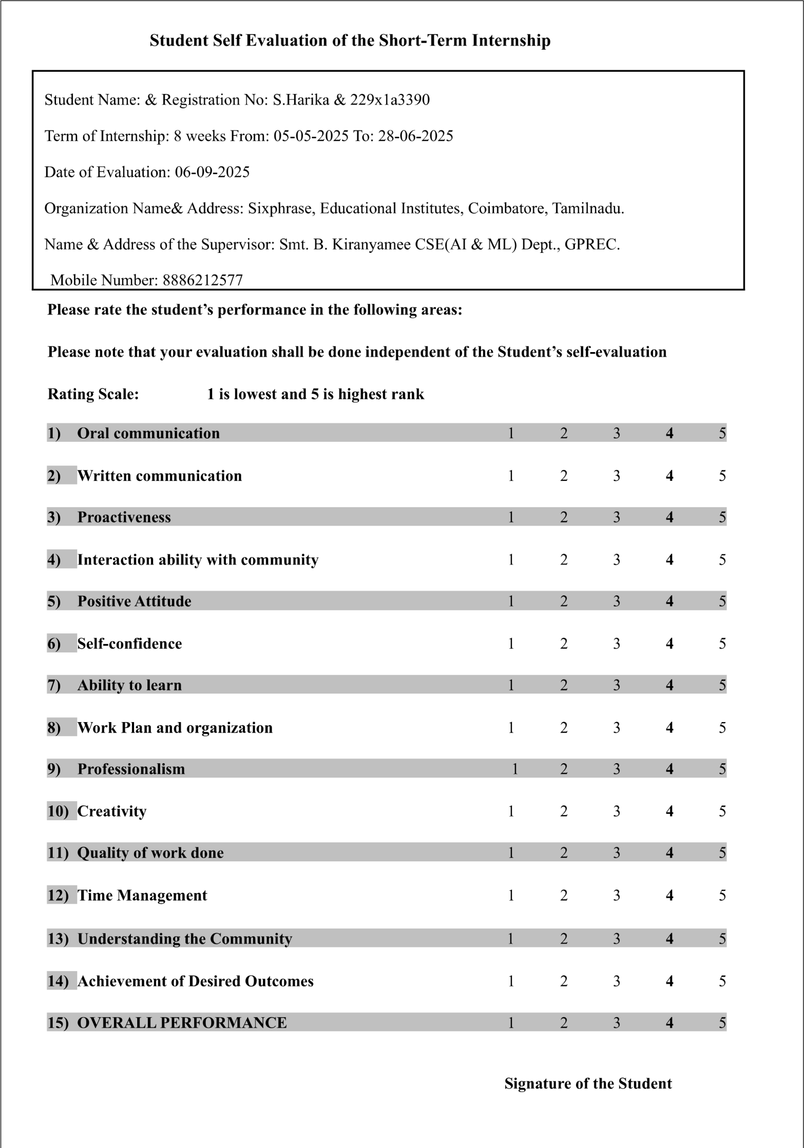

Evaluation by the Supervisor of the Intern Organisation

Student Name: & Registration No: S.Harini & 239X1A3380 Term of Internship: 8 weeks From: 03-05-2026 To: 26-06-2026 Date of Evaluation:
Organization Name& Address: Indian Servers Private Limited, Vijayawada, Andhra Pradesh.
Name & Address of the Supervisor: Dr. A. Vishnuvardhan Reddy CSE(AI & ML) Dept., GPREC. Mobile Number: 9100685858
Please rate the student’s performance in the following areas:
Please note that your evaluation shall be done independent of the Student’s self-evaluation

Rating Scale: 1 is lowest and 5 is highest rank
1) Oral communication 1 2 3 4 5
Written communication 1 2 3 4 5
2)
3) Proactiveness 1 2 3 4 5
Interaction ability with community 1 2 3 4 5
4)
5) Positive Attitude 1 2 3 4 5
Self-confidence 1 2 3 4 5
6)
W
7) Ability to learn | 1 | 2 | 3 | 4 | 5
ork8) Plan and organization 1 2 3 4 5
9) Professionalism | 1 | 2 | 3 | 4 | 5
10) Creativity | 1 | 2 | 3 | 4 | 5
11) Quality of work done | 1 | 2 | 3 | 4 | 5
12) Time Management | 1 | 2 | 3 | 4 | 5
13) Understanding the Community | 1 | 2 | 3 | 4 | 5
14) Achievement of Desired Outcomes | 1 | 2 | 3 | 4 | 5
15) OVERALL PERFORMANCE | 1 | 2 | 3 | 4 | 5

Signature of the Supervisor

