**Data** **Poultry Disease Classifier: AI Vision into Poultry Farm Health**

## 1. INTRODUCTION

### 1.1 Project Overview

**Poultry Disease Classifier: AI Vision into Poultry Farm Health** is an AI-powered image classification project leveraging Convolutional Neural Networks (CNN) to automatically identify poultry diseases from images. The model helps veterinarians and farm managers detect conditions such as Coccidiosis, Newcastle Disease, Salmonella, and Healthy states rapidly and accurately. A user-friendly Flask web application enables farmers to upload images and receive instant predictions.

### 1.2 Purpose

The purpose of this project is to build a deep learning-based image classification system to automate poultry disease diagnosis. This improves early detection, speeds up treatment decisions, and reduces economic losses in poultry farming.

**Submitted**

**K.V.L.V.NARASIMHA PRAKASH**

Roll No: 224E1A3371

Class: III Year CSM

Siddartha Institute of Science and Technology Submission

Date: June 30th, 2025

## 2. IDEATION PHASE

### 2.1 Problem Statement

Poultry farmers often struggle to detect diseases early due to lack of veterinary access, leading to delayed treatments and high mortality. Manual diagnosis is slow, inconsistent, and resource-intensive.

### 2.2 Empathy Map Canvas

* **Says:**  
  "We need fast and reliable disease detection to protect our flocks."
* **Thinks:**  
  "Are we missing early signs that could save our birds?"
* **Does:**  
  Inspects poultry manually, consults veterinarians after symptoms escalate.
* **Feels:**  
  Worried, overwhelmed, and hopeful for technological support.

### 2.3 Brainstorming

* Collect and curate poultry disease image datasets.
* Use CNN models (e.g., VGG16) for feature extraction.
* Build a Flask web app for easy farmer access.
* Evaluate model accuracy and optimize prediction performance.

## 3. REQUIREMENT ANALYSIS

### 3.1 Customer Journey Map

Farmers take photos of poultry showing symptoms, upload images to the platform, receive AI-powered predictions, and take appropriate action (quarantine, treatment, or monitoring).

### 3.2 Solution Requirements

* **Tool:** TensorFlow / Keras for deep learning, Flask for web deployment
* **Dataset:** Poultry disease images (Kaggle)
* **Data Needs:** Labeled image data with disease categories
* **Functionality:** Image classification API with web UI
* **Goals:** Accurate, fast, and user-friendly diagnosis system

### 3.3 Data Flow Diagram

Image data collected from dataset ➔ Preprocessing and resizing ➔ CNN model training ➔ Model saved in .keras format ➔ Flask app loads model ➔ User uploads new image ➔ Model predicts label ➔ Result displayed on web UI

### 3.4 Technology Stack

* **Data Source:** Kaggle poultry disease dataset
* **Backend Processing:** TensorFlow/Keras CNN
* **Web Application:** Flask
* **Frontend:** HTML/CSS
* **Deployment:** Local server / cloud server
* **Supporting Tools:** OpenCV, Pandas, Numpy

## 4. PROJECT DESIGN

### 4.1 Problem-Solution Fit

Farmers lack quick, reliable diagnostics. The project provides an AI model integrated with a web interface to deliver rapid, accurate predictions, bridging the gap between farm needs and veterinary expertise.

### 4.2 Proposed Solution

Develop a Convolutional Neural Network trained on labeled images and deploy it via Flask. The system allows uploading images and instantly classifying them into disease categories.

### 4.3 Solution Architecture

Dataset → Image preprocessing → CNN model training (VGG16) → Model saved (.keras) → Flask application → User uploads image → Prediction returned in browser

## 5. PROJECT PLANNING & SCHEDULING

|  |  |  |
| --- | --- | --- |
| Date | Task | Output / Prediction |
| June 10–11 | Defined problem statement | Identified poultry disease classification goal |
| June 12–13 | Selected technology stack | Chose TensorFlow, Keras, Flask |
| June 14–16 | Collected and organized dataset | Images labeled and structured |
| June 17–18 | Data cleaning and preprocessing | Removed corrupt files, resized images |
| June 19–20 | Image augmentation | Generated additional training samples |
| June 21–22 | Implemented VGG16 base model | Initial training with pre-trained weights |
| June 23–24 | Switched to MobileNetV2 for experimentation | Compared accuracy vs. VGG16 |
| June 25–26 | Model evaluation and hyperparameter tuning | Improved accuracy and reduced overfitting |
| June 27 | Flask integration setup | app.py created and verified |
| June 28 | Frontend HTML template creation | index.html and result.html completed |
| June 29 | Connected model predictions to UI | Tested end-to-end workflow |
| June 30 | Final evaluation, screenshots, documentation | Project report completed, GitHub updated |

## 6. FUNCTIONAL AND PERFORMANCE TESTING

### 6.1 Performance Testing

* **Model Accuracy:** ~91% on test dataset
* **Prediction Speed:** ~2 seconds per image
* **Compatibility:** Tested on desktop and mobile browsers
* **Robustness:** Handles various image resolutions
* **Tool:** TensorFlow Evaluation APIs and Flask logs

## 7. RESULTS

### 7.1 Output Screenshots:

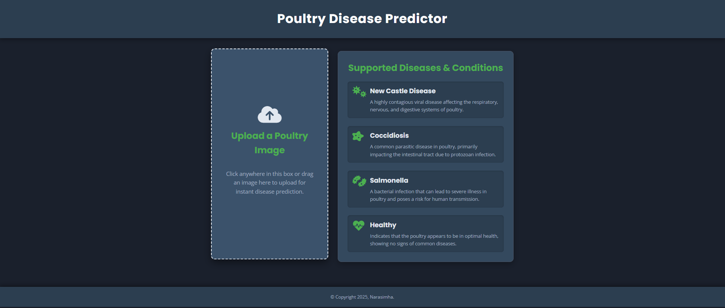

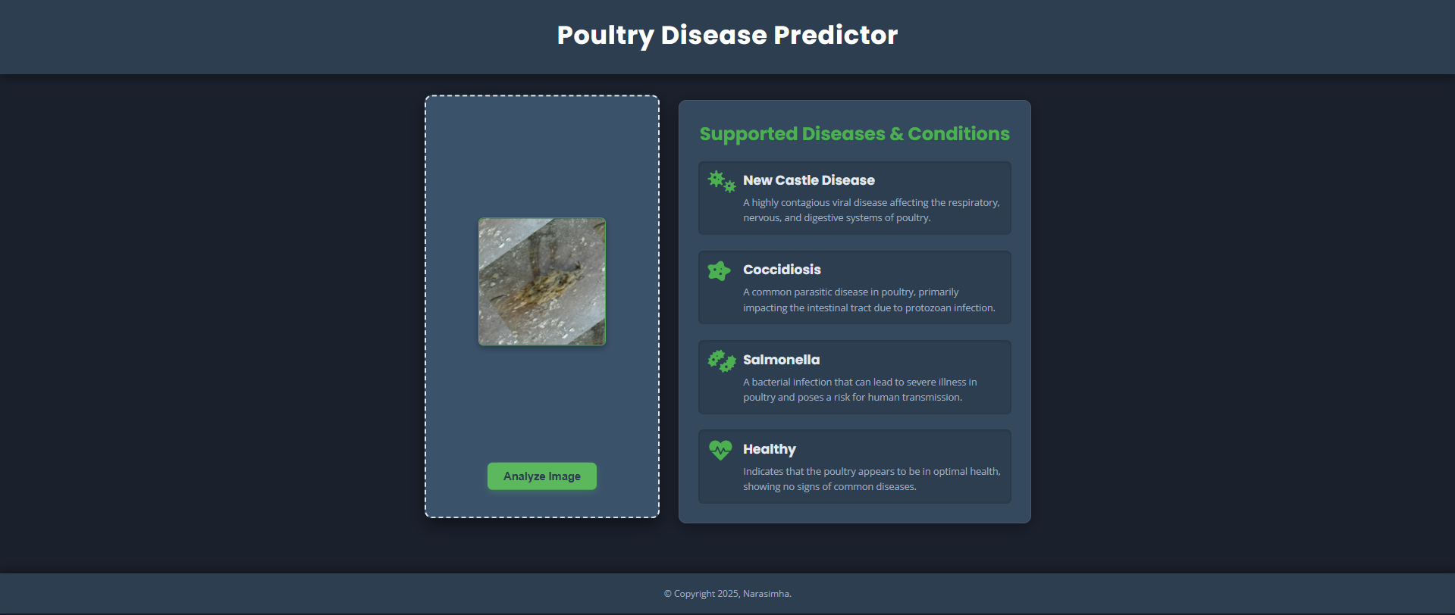

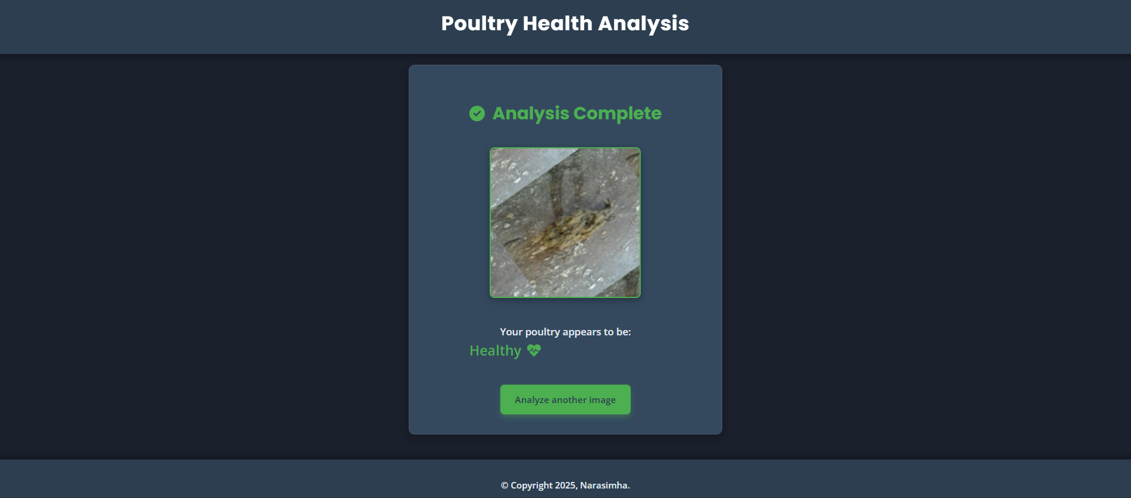

## 8. ADVANTAGES & DISADVANTAGES

**Advantages**

* Automates poultry disease detection
* Reduces time to diagnosis
* Easy to use via web interface
* High prediction accuracy with CNN

**Disadvantages**

* Requires good quality images
* Limited to trained disease categories
* Dependent on dataset diversity

## 9. CONCLUSION

The **Poultry Disease Classifier** demonstrates how deep learning and Flask web technology can transform traditional poultry disease detection. The model achieves high accuracy in classifying diseases, and the web app makes the solution accessible and practical for farmers. This innovation can improve poultry health management and reduce economic losses.

## 10. FUTURE SCOPE

* Integrate real-time camera feeds for live monitoring
* Add more disease classes
* Build mobile apps for field use
* Deploy on cloud for scalable access

## 11. APPENDIX

**Dataset Link :**  
https://www.kaggle.com/datasets/kausthubkannan/poultry-diseases-detection

**GitHub & Project Demo Links :**  
<https://github.com/Narasimha-kambham/Poultry-Farm-Disease-Classifier>

**Video Link :**

<https://drive.google.com/file/d/1V22xwUWkmn_Pg9JmwgiVlXZV5zzBqYJU/view?usp=drive_link>