1.JDK

1. The Java Development Kit (JDK) is a cross-platformed software development environment that offers a collection of tools and libraries necessary for developing Java-based software applications and applets.
2. It is a core package used in Java, along with the JVM (Java Virtual Machine) and the JRE (Java Runtime Environment).
Beginners often get confused with JRE and JDK, if you are only interested in running Java programs on your machine then you can easily do it using Java Runtime Environment. However, if you would like to develop a Java-based software application then along with JRE you may need some additional necessary tools, which is called JDK.
JDK=JRE+Development Tools

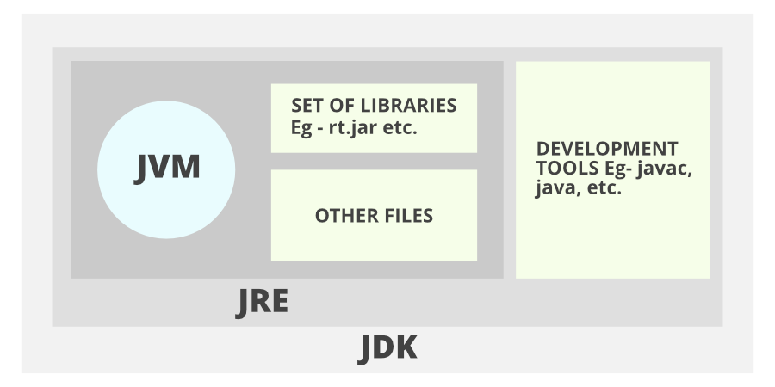

The Java Development Kit is an implementation of one of the Java Platform:
- Standard Edition (Java SE),
- Java Enterprise Edition (Java EE),
- Micro Edition (Java ME),

Contents of JDK
The JDK has a private Java Virtual Machine (JVM) and a few other resources necessary for the development of a Java Application.
JDK contains:
- Java Runtime Environment (JRE),
- An interpreter/loader (Java),
- A compiler (javac),
- An archiver (jar) and many more.
The Java Runtime Environment in JDK is usually called Private Runtime because it is separated from the regular JRE and has extra content. The Private Runtime in JDK contains a JVM and all the class libraries present in the production environment, as well as additional libraries useful to developers, e.g, internationalization libraries and the IDL libraries.

Most Popular JDKs:
- Oracle JDK: the most popular JDK and the main distributor of Java11,
- OpenJDK: Ready for use: JDK 15, JDK 14, and JMC,
- Azul Systems Zing: efficient and low latency JDK for Linux os,
- Azul Systems: based Zulu brand for Linux, Windows, Mac OS X,
- IBM J9 JDK: for AIX, Linux, Windows, and many other OS,
- Amazon Corretto: the newest option with the no-cost build of OpenJDK and long-term support.

Compile and Run Java Code using JDK:
You can use the JDK compiler to convert your Java text file into an executable program. Your Java text segment is converted into bytecode after compilation which carries the .class extension.
First, create a Java text file and save it using a name. Here we are saving the file as Hello.java.
class Hello{
public static void main (String[] args) {
System.out.println("Hello !");
}
}
After that just simply use the javac command, which is used for the compilation purpose in Java. Please don't forget to provide the full path of your java text file to the command line else you will get an error as "The system cannot find the path specified",
Your command should be similar to the given below example where Hello is the file name and the full path to the file is specified before the file name. The path and javac.exe should be inside the quotes.
"C:\Program Files\Java\jdk-11.0.9\bin\javac.exe" Hello.java
You can notice now that the Hello.class file is being created in the same directory as Hello.java. Now you can run your code by simply using the java Hello command, which will give you the desired result according to your code. Please remember that you don't have to include the .class to run your code.
C:\Users\Pinaki\Documents>java Hello
(Output:) Hello Geek!

The Jar component:
JDK contains many useful tools and among them, the most popular after javac is the jar tool. The jar file is nothing but a full pack of Java classes. After creating the .class files, you can put them together in a .jar, which compresses and structures them in a predictable fashion. Now, let's convert our Hello.class to a jar file.
Before proceeding, please note that you should be in the same directory where the Hello.java file was saved. Now type the command given below in the command line.
Creating a .jar file
C:\Users\Pinaki\Documents>"c:\Program Files\Java\jdk-11.0.9\bin\jar.exe" --create --file Hello.jar Hello.class
Now you can notice that Hello.jar file had been created in the same directory using Hello.class file and jar.exe. You can use the jar file by adding it to your classpath and executing the program inside it. Here the -cp stands for classpath which helps to add the jar to the same classpath.
Executing the .jar file
java -cp hello_world.jar hello_world

Important Components of JDK
Below there is a comprehensive list of mostly used components of Jdk which are very useful during the development of a java application.
Component | Use
javac | Java compiler converts source code into Java bytecode
java | The loader of the java apps.
javap | Class file disassembler,
javadoc | Documentation generator,
jar | Java Archiver helps manage JAR files.
appletviewer | Debugging of Java applets without a web browser,
xjc | Accepts an XML schema and generates Java classes,
apt | Annotation-processing tool,
jdb | Debugger,
jmc | Java Mission Control,
JConsole | Monitoring and Management Console,
pack200 | JAR compression tool,
extcheck | Utility tool to detects JAR file conflicts,
idlj | IDL-to-Java compiler,
keytool | The keystore manipulating tool,
jstatd | jstat daemon (experimental)
jstat | JVM statistics monitoring tool
jshell | jshell introduced in java 9.
jstack | Prints Java stack traces(experimental)
jrunscript | Java command-line script shell.
jhat | Java Heap Analysis Tool (experimental)
jpackage | Generate self-contained application bundles.
javaws | Web Start launcher for JNLP applications,
javah | C header and stub generator,
jarsigner | jar signing and verification tool
jinfo | configuration information(experimental)
javafxpackager | Package and sign JavaFX applications

2.JRE
Java Runtime Environment (JRE) is an open-access software distribution that has a Java class library, specific tools, and a separate JVM. In Java, JRE is one of the interrelated components in the Java Development Kit (JDK). It is the most common environment available on devices for running Java programs. Java source code is compiled and converted to Java bytecode. If you want to run this bytecode on any platform, you need JRE. The JRE loads classes check memory access and get system resources. JRE acts as a software layer on top of the operating system.

Components of Java JRE
The components of JRE are mentioned below:
- Integration libraries include Java Database Connectivity (JDBC)
- Java Naming, Interface Definition Language (IDL)
- Directory Interface (JNDI)
- Remote Method Invocation Over Internet Inter-Orb Protocol (RMI-IIOP)
- Remote Method Invocation (RMI)
- Scripting

Java Virtual Machine (JVM) consists of Java HotSpot Client and Server Virtual Machine.
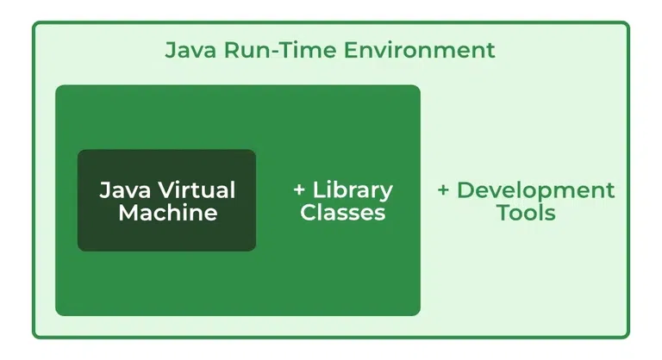
- User interface libraries include Swing, Java 2D, Abstract Window Toolkit (AWT), Accessibility, Image I/O, Print Service, Sound, drag, and Drop (DnD), and input methods.
- Lang and util base libraries, which include lang and util, zip, Collections, Concurrency Utilities, management, Java Archive (JAR), instrument, reflection, versioning, Preferences API, Ref Objects, Logging, and Regular Expressions.
- Other base libraries, including Java Management Extensions (JMX), Java Native Interface (JNI), Math, Networking, international support, input/output (I/O), Beans, Java Override Mechanism, Security, Serialization, extension mechanism, and Java for XML Processing (XML JAXP).
- Deployment technologies such as Java Web Start, deployment, and Java plug-in.

JRE Integration Libraries
1├── JDBC
└─ Connect and interact with databases
2├── JNDI
└─ Access naming and directory services
3├── IDL
└─ Enable CORBA-based communication
4├── RMI
└─ Remote method invocation between JVMs
5├── RMI-IIOP
└─ RMI over Internet Inter-Orb Protocol (CORBA)
6└── Scripting API
└─ Embed scripting languages (e.g., JavaScript) in Java
Java Runtime Environment (JRE)
├── Core Libraries
│ ├─ java.lang
│ ├─ java.util
│ ├─ java.io
│ ├─ java.net
│ ├─ java.security
│ ├─ Reflection & Instrumentation
│ ├─ Regular Expressions
│ └─ Concurrency Utilities

├── User Interface Libraries
│ ├─ AWT (Abstract Window Toolkit)
│ ├─ Swing
│ ├─ Java 2D
│ ├─ Sound & Print Services
│ └─ Drag & Drop, Input Methods
│
├── Integration Libraries
│ ├─ JDBC
│ ├─ JNDI
│ ├─ IDL
│ ├─ RMI
│ ├─ RMI-IIOP
│ └─ Scripting API
│

├── Other Base Libraries
│ ├─ JMX (Java Management Extensions)
│ ├─ JNI (Java Native Interface)
│ ├─ Math (BigInteger, BigDecimal)
│ ├─ Preferences API
│ ├─ JAR/ZIP utilities
│ ├─ XML Processing (JAXP)
│ └─ Beans
│
└── Deployment Technologies (deprecated in modern Java)
├─ Java Web Start
└─ Java Plug-in

3.JVM

What is JVM – Java Virtual Machine?
1. As we all know that we need to either compile or interpret any source code before executing it. But Java uses the combination of both, i.e, compiler as well as interpreter.

2. Java programs are first compiled into Java Byte Code(Binary form) and then a special Java interpreter interprets them for a specific platform.

3. Java ByteCode is the machine language for Java Virtual machine(JVM). The JVM converts the compiled binary byte code into a specific machine language.

4. Java Virtual machine acts as a subpart of Java Runtime Environment(JRE).
The JVM is an abstract machine that works on the top of existing processes. We can implement it in hardware or software.
JVM combined with Java APIs makes Java Platform. The essential use of the JVM is HotSpot.
We can define JVM in three ways:
1. A specification that specifies the working of Java Virtual Machine. The one who provides the implementation is independent to choose the algorithm.
2. An Implementation called the Java Runtime Environment (JRE).
3. A Runtime Instance that creates a JVM instance when you write a command on the command prompt to run the java class.
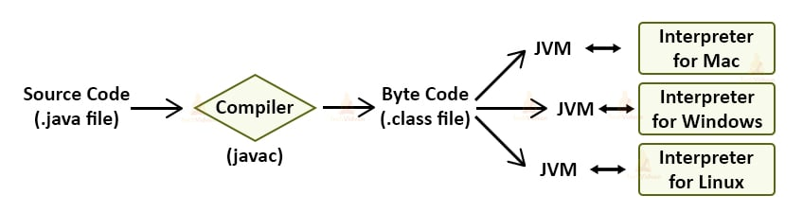

Working of JVM
JVM(Java Virtual Machine) behaves as a run-time engine to run Java applications. JVM calls the main method present in Java code.
Java Virtual machine(JVM) is a part of the JRE(Java Runtime Environment).
Java applications are WORA (Write Once Run Anywhere). This means that we need to write the Java programs just once, which we can run on different platforms without making changes in the Java program.
When we compile a .java file, the compiler generates the .class files(contains byte-code) with the same names as that of the class present in a .java file.
When we run a .class file, it goes through various steps.
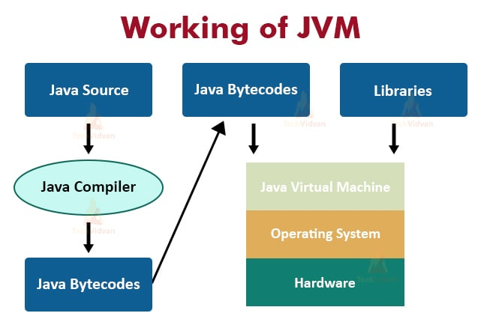

Need for Java Virtual Machine
The need for Java Virtual Machine is to handle the tasks that it performs which are necessary for the development of programs involving Java. Java virtual machine performs the following tasks:
- Loads the code.
- Verifies code.
- Executes the code.
- Provides a run-time environment for various applications.
- JVM provides a Memory area.
- Provides a Register set.
- JVM provides the garbage collection heap.
- Reports fatal errors.
- Provides a class file format
All these tasks make the Java virtual machine an integral part of Java development.

JVM Architecture in Java
There are three main subsystems in JVM Architecture:
1. ClassLoader
2. Memory Area
3. Execution Engine
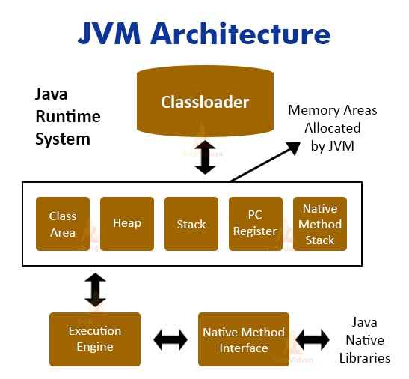
Now, we will understand each of them in detail.

Java ClassLoader
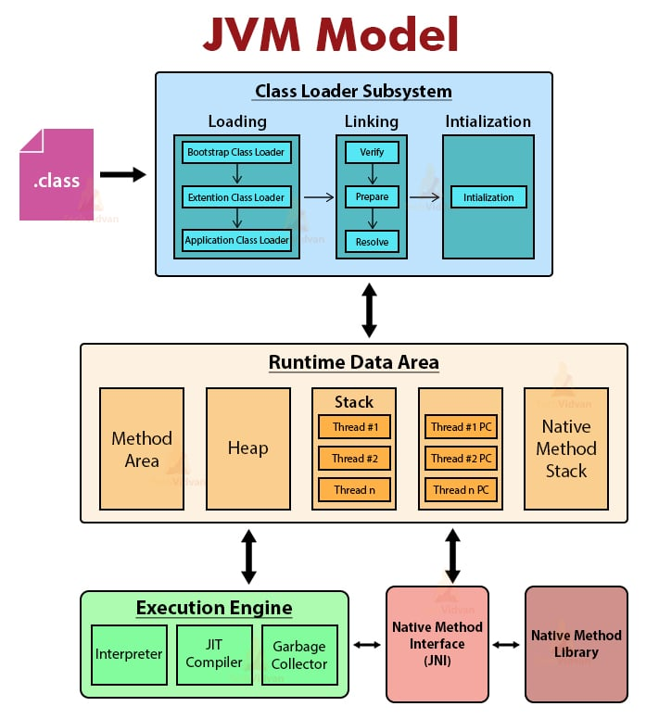

1.JDK
It is the component of JVM Architecture that loads classes in memory. Every JVM consists of a ClassLoader. Three built-in classloaders in Java are:

1. Bootstrap ClassLoader
This is the classloader which is the super class of Extension classloader. It loads the rt.jar file.

2. Extension ClassLoader
It is the ClassLoader which loads the jar files present in the directory. This is the child Bootstrap classLoader and parent of System classloader.

3. System/Application ClassLoader
It is the classLoader which loads the class files from the classpath. This is the child of the Extension classloader.
The Three important functions of ClassLoader are Initialization, Loading, Linking.

1. Initialization
This operation involves the assignment of all static variables with their specific values in the block of the program.
In this phase, there is an assignment of all static variables with their values defined in the code and static block.
The execution takes place from top to bottom in a class and from parent to child in the class hierarchy.

2. Loading
This operation loads files from secondary memory into the main memory (RAM) for execution. The Classloader reads the .class file, generates the corresponding binary data, and saves it in the method area.
JVM stores some information for each .class file in the method area. This information is:
- The fully qualified name of the loaded class and its immediate parent class.
- Whether .class file is related to interface or an enum or a class.
- Modifier, Variables and Method information, etc.
After loading the .class file, JVM creates an object of type Class to represent this file in the heap memory.
The programmers can use this Class object for getting class level information like the name of the class, parent name, methods, and variable information, etc.
To get this object reference we can use the getClass() method of Object class.

3. Linking
This operation combines different files in the main program together. It performs verification, preparation, and (optionally) resolution.
- Verification: The Verification phase checks the correctness of the .class file. It means that it checks that the file formation and generation is by a valid compiler or not. If the verification fails then we get a java.lang.Verify Exception.
- Preparation: JVM allocates memory for class variables and initializes the memory to default values.
- Resolution: Resolution is the process of replacing symbolic references with direct references. It uses searching into the method area to locate the referenced entity.
Code to demonstrate ClassLoader in Java:
Let us see an example to print the classloader name
package com.techvidvan.jvm;
public class Test1 {
public static void main(String[] args) {
// Let's print the classloader name of the current class.
//Application/System classloader will load this class
Class c = Test1.class;
System.out.println(c.getClassLoader());
//If we print the classloader name of String, it will print null because it is an
//in-built class which is present in rt.jar, Bootstrap classloader loads it.
System.out.println(String.class.getClassLoader());
Output:
sun.misc.Launcher$AppClassLoader@659e0bfd
null

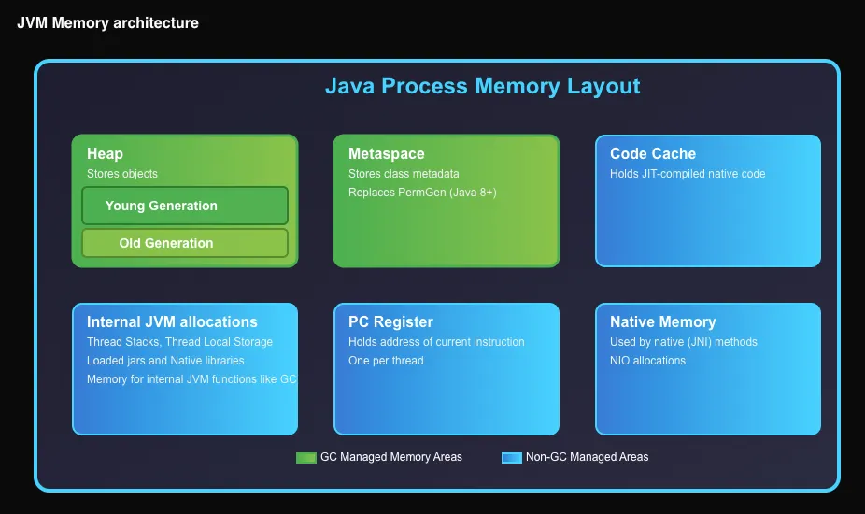
Method Area

JVM Memory area
1. Method Area– It stores the structure of each class like method data, field data, runtime pool, metadata.
2. Heap– Heap is the runtime area where object allocation takes place.
3. Stacks– Stacks store the partial results and local variables of a program. Whenever a thread is created, there is a simultaneous creation of JVM stack. When we invoke a method, a new frame creates and destroys at the same time when the invocation process completes.
4. PC Registers – It stores the address of the currently executing JVM instruction.
5. Native Method Stacks – It includes all the native methods required in any application. It is not written in java.

Execution Engine in Java
It is the component of JVM that reads data from memory locations and executes the instructions. It has three major components namely a virtual processor, an interpreter, and a JIT compiler.
1. Virtual Processor
2. Interpreter: Read the bytecode stream then execute the instructions.
3. Just-In-Time(JIT) compiler: It improves performance. JIT compiles parts of the byte code with similar functionality(repeated code of method or loop) at the same time and reduces the amount of time needed for compilation.

Native Method interface
It is a framework that helps in communication between different applications written in different languages such as c, c++, etc.
Native Method Interface allows Java code running in a JVM to call by libraries and native applications.

Method Libraries
Native Libraries is a collection of the Native Libraries(C, C++) which are essential for the Execution Engine.

Difference Between JDK, JRE, And JVM
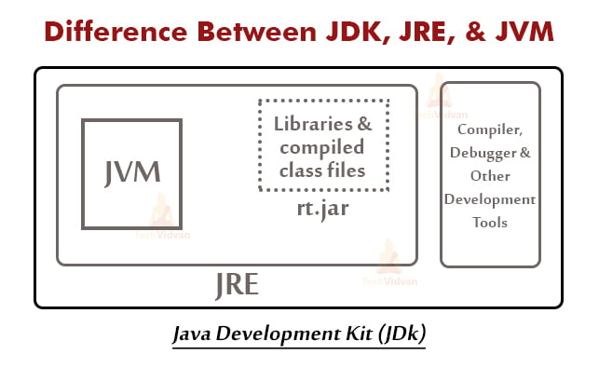
The following are a few important differences between JDK, JVM, and JRE.
1. JVM stands for Java Virtual machine, JDK stands for Java development kit, and JRE stands for Java runtime environment.
2. JDK is for the development environment whereas JRE is for the run time environment.
3. JVM runs inside the JRE environment. JRE contains class libraries, Java Virtual Machine and other files other than development tools like compiler and debugger.
4. JRE is a subset of JDK. JDK contains JRE along with development tools such as compiler, debugger, etc.

Important Points
- JVM stands for Java Virtual Machine that drives the Java Code. It converts Java bytecode into machine language.
- Here, Java code is compiled to bytecode. This bytecode gets interpreted on different machines
- JIT stands for a Just-in-time compiler. JIT is part of the Java Virtual Machine. It increases the execution time
- Java may be slow in execution compared to other compiler machines,

Conclusion
Here we come to the end of the JVM tutorial, where we learned about the Java Virtual machine in detail.
Moreover, we discussed the architecture and its subtypes. We also learned the differences between the important terms- JDK,JRE, and JVM.

