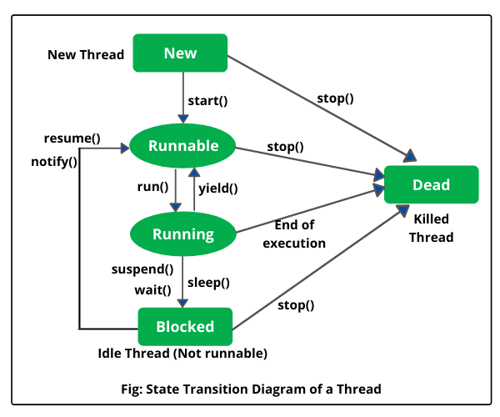
MULTITHREADING IN JAVA

🔹 1. NEW → RUNNABLE → RUNNING → TERMINATED
class MyThread extends Thread {
public void run() {
System.out.println("Thread is running...");
}
}

public class ThreadLifecycleDemo {
public static void main(String[] args) throws InterruptedException {
MyThread t = new MyThread();

// Thread is created but not started yet → NEW
System.out.println("State after creation: " + t.getState()); // NEW

t.start(); // now thread is RUNNABLE (scheduler decides when it runs)

Thread.sleep(100); // allow thread to finish
System.out.println("State after completion: " + t.getState()); // TERMINATED
}
}

🔹 What’s happening step by step in your code
- MyThread t = new MyThread();
  - Thread object created → NEW state.
- t.start();
  - JVM starts a new thread → moves to RUNNABLE.
  - Scheduler eventually makes it RUNNING and executes run().
- Inside run():
System.out.println("Thread is running...");
gets executed. After this, thread finishes → TERMINATED.
- Thread.sleep(100);
  - Main thread sleeps for 100 ms, allowing thread t to complete.
- After waking up, main checks:
System.out.println("State after completion: " + t.getState()); // TERMINATED

✅ So:
- run() is not called explicitly because start() handles it.
- Thread.sleep(100) pauses the main thread, not t. This ensures t has enough time to move to TERMINATED before checking its state.

🔹 1. What happens when you call run() directly?
class MyThread extends Thread {
public void run() {
System.out.println("Running in: " + Thread.currentThread().getName());
}
}

public class RunVsStartDemo {
public static void main(String[] args) {
MyThread t = new MyThread();

// Calling run() directly
t.run(); // No new thread created
System.out.println("Back in main thread: " + Thread.currentThread().getName());
}
}
Output (sample):
Running in: main
Back in main thread: main
👉 Explanation:
- run() is just a normal method call.
- It executes inside the main thread, so no new thread is spawned.
NOT:
run() = just a normal method call.
start() = creates a new thread and then internally calls run().

