MySQl installation in linex

Step 1: Update the system
sudo apt update
sudo apt upgrade -y

Step 2: Install MySQL Server

sudo apt install mysql-server -y Note: here -y means yes for all permisions

Step 3: Start and enable MySQL

sudo systemctl start mysql
sudo systemctl enable mysql

Step 4: Log in as root using sudo

sudo mysql

This opens the MySQL prompt as root without a password.

Step 5: Set a password and switch to password authentication

ALTER USER 'root'@'localhost' IDENTIFIED WITH mysql_native_password BY 'YourStrongPassword';
FLUSH PRIVILEGES;
EXIT;

note: 'root'@'localhost' ~ ‘root’

Replace YourStrongPassword with a secure password

This switches root from auth_socket to mysql_native_password and sets the password.

Step 6: Test root login

mysql -u root -p

Enter the password you just set.

You should now see the MySQL prompt (mysql>).

Step 7: Secure the installation (optional but recommended)
sudo mysql_secure_installation

Now that root has a password, this script will work without errors.

Recommended answers:

Remove anonymous users Y

Remove test database Y

Basics
MySQL Server
│
├── Databases
│ ├── testdb
│ │ ├── users Table
│ │ │ ├── id (PK)
│ │ │ ├── name
│ │ │ └── email
│ │ └── products Table
│ └── anotherdb
└── Users
├── root@localhost
└── newuser@localhost
1.DataTypes
Category | Type | Description / Example
Numeric | INT | Whole number, e.g., 123
 | BIGINT | Large integers
 | DECIMAL(M,D) | Fixed-point, e.g., DECIMAL(5,2) → 123.45
 | FLOAT, DOUBLE | Floating point numbers
String/Text | CHAR(N) | Fixed-length string, e.g., CHAR(10)
 | VARCHAR(N) | Variable-length string, e.g., VARCHAR(50)
 | TEXT, MEDIUMTEXT, LONGTEXT | Large text
Date/Time | DATE | YYYY-MM-DD
 | DATETIME | YYYY-MM-DD HH:MM:SS
 | TIMESTAMP | Automatic timestamp
 | TIME | HH:MM:SS
 | YEAR | YYYY

2.Constraints

1. NOT NULL
- Ensures a column cannot have NULL values.
- Example:
CREATE TABLE users (
id INT AUTO_INCREMENT PRIMARY KEY,
name VARCHAR(50) NOT NULL,
email VARCHAR(100)
);
- Here, name must always have a value; email can be empty (NULL).

2. UNIQUE
- Ensures all values in a column are unique.
- Example:
CREATE TABLE users (
id INT AUTO_INCREMENT PRIMARY KEY,
email VARCHAR(100) UNIQUE
);
- No two rows can have the same email.

3. PRIMARY KEY
- Uniquely identifies each row in a table.
- Combination of NOT NULL + UNIQUE.
- Example:
CREATE TABLE users (
id INT AUTO_INCREMENT PRIMARY KEY,
name VARCHAR(50)
);
- id automatically must be unique and cannot be NULL.

4. FOREIGN KEY
- Ensures referential integrity between two tables.
- Links a column in one table to the primary key of another table.
- Example:
CREATE TABLE orders (
order_id INT AUTO_INCREMENT PRIMARY KEY,
user_id INT,
order_date DATE,
FOREIGN KEY (user_id) REFERENCES users(id)
);
- user_id in orders must exist in users.id.

5. DEFAULT
- Sets a default value if no value is provided during insert.
- Example:
CREATE TABLE users (
id INT AUTO_INCREMENT PRIMARY KEY,
name VARCHAR(50) NOT NULL,
status VARCHAR(20) DEFAULT 'active'
);
- If status is not specified, it automatically becomes 'active'.

6. CHECK (MySQL 8.0+)
- Ensures a column meets a condition.
- Example:
CREATE TABLE users (
id INT AUTO_INCREMENT PRIMARY KEY,
age INT,
CHECK (age >= 18)
);
- Ensures age is always 18 or older.

7. AUTO_INCREMENT
- Automatically increases numeric values for each new row (commonly used with primary key).
- Example:
CREATE TABLE users (
id INT AUTO_INCREMENT PRIMARY KEY,
name VARCHAR(50)
);
- You don’t need to manually insert id; MySQL assigns it.

8. Summary Table of Constraints
Constraint | Purpose
NOT NULL | Column cannot be empty
UNIQUE | All values must be unique
PRIMARY KEY | Uniquely identifies a row (NOT NULL + UNIQUE)
FOREIGN KEY | Enforces relationship between tables
DEFAULT | Sets a default value if none provided
CHECK | Ensures values satisfy a condition
AUTO_INCREMENT | Automatically increments numeric values

Example – Combined Table
CREATE TABLE users (
id INT AUTO_INCREMENT PRIMARY KEY,
name VARCHAR(50) NOT NULL,
email VARCHAR(100) UNIQUE NOT NULL,
age INT DEFAULT 18 CHECK (age >= 18)
);
- id → primary key, auto-increments
- name → cannot be NULL
- email → must be unique and not NULL
- age → defaults to 18, cannot be less than 18

3.Clauses
Clauses are keywords in SQL statements that give conditions or instructions. They are not standalone commands, but part of bigger statements like SELECT, INSERT, UPDATE, etc.

1. WHERE Clause
- Filters records based on a condition.
SELECT * FROM users WHERE age >= 18;
👉 Returns only users with age 18 or above.

2. ORDER BY Clause
- Sorts results in ascending (ASC) or descending (DESC) order.
SELECT * FROM users ORDER BY age DESC;
👉 Users will be listed from oldest to youngest.

3. GROUP BY Clause
- Groups rows that have the same values in a column.
- Often used with aggregate functions (COUNT, SUM, AVG, etc.).
SELECT age, COUNT(*)
FROM users
GROUP BY age;
👉 Counts how many users share the same age.

4. HAVING Clause
- Works like WHERE, but for groups/aggregates (since WHERE can’t filter aggregate results).
SELECT age, COUNT(*)
FROM users
GROUP BY age
HAVING COUNT(*) > 1;
👉 Shows only ages that appear more than once.

5. LIMIT Clause
- Restricts the number of rows returned.
SELECT * FROM users LIMIT 5;
👉 Returns only the first 5 rows.
- Can also skip rows (offset):
SELECT * FROM users LIMIT 5 OFFSET 2;
👉 Skip first 2 rows, then show next 5.

6. DISTINCT Clause
- Removes duplicate rows from results.
SELECT DISTINCT age FROM users;
👉 Returns unique ages only.

7. JOIN Clauses (for multiple tables)
Type | Description
INNER JOIN | Returns rows with matching values in both tables
LEFT JOIN | Returns all rows from left table + matches from right
RIGHT JOIN | Returns all rows from right table + matches from left
FULL JOIN | (Not in MySQL directly, but can simulate with UNION)
Example:
SELECT u.name, o.order_date
FROM users u
INNER JOIN orders o ON u.id = o.user_id;
👉 Gets users with their orders.

8. LIKE Clause
- Used with WHERE for pattern matching.
SELECT * FROM users WHERE name LIKE 'A%';
👉 Names starting with "A".
SELECT * FROM users WHERE email LIKE '%gmail.com';
👉 Emails ending with gmail.com.

9. IN Clause
- Checks if a value matches any value in a list.
SELECT * FROM users WHERE age IN (18, 21, 25);
👉 Only users aged 18, 21, or 25.

10. BETWEEN Clause
- Checks if a value is within a range.
SELECT * FROM users WHERE age BETWEEN 18 AND 30;
👉 Users aged 18 to 30.

✅ Quick Summary – Common Clauses
Clause | Purpose
WHERE | Filter rows
ORDER BY | Sort rows
GROUP BY | Group rows
HAVING | Filter grouped results
LIMIT | Limit number of rows
DISTINCT | Remove duplicates
JOIN | Combine multiple tables
LIKE | Pattern matching
IN | Match from a list
BETWEEN | Match within a range

👉 Clauses = conditions inside SQL queries.
👉 Constraints = rules when designing tables.

Understanding the execution order of SQL queries is essential for grasping how the WHERE and HAVING clauses work fully. This order determines when each clause applies.

Understanding SQL query execution order
In SQL, queries execute in a specific order, which is crucial for effectively applying filters. This sequence determines how clauses interact and specifies where to apply each filter:
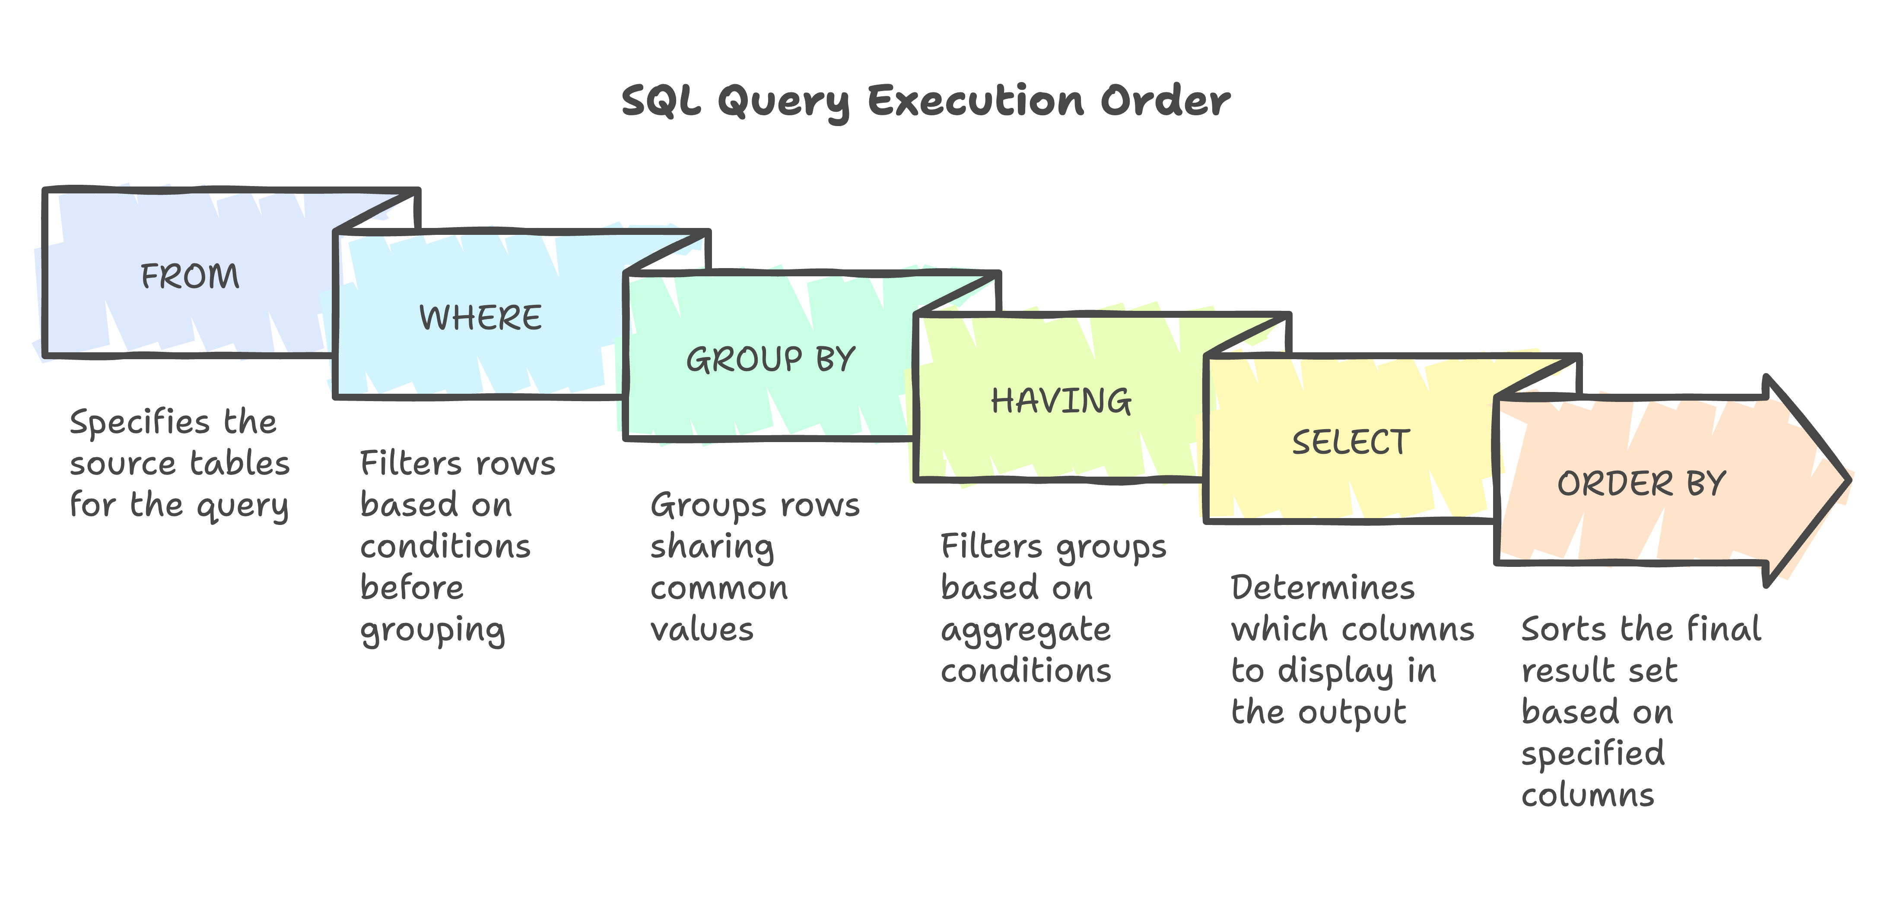
The typical SQL query execution order is as follows:
- FROM
- WHERE
- GROUP BY
- HAVING
- SELECT
- ORDER BY
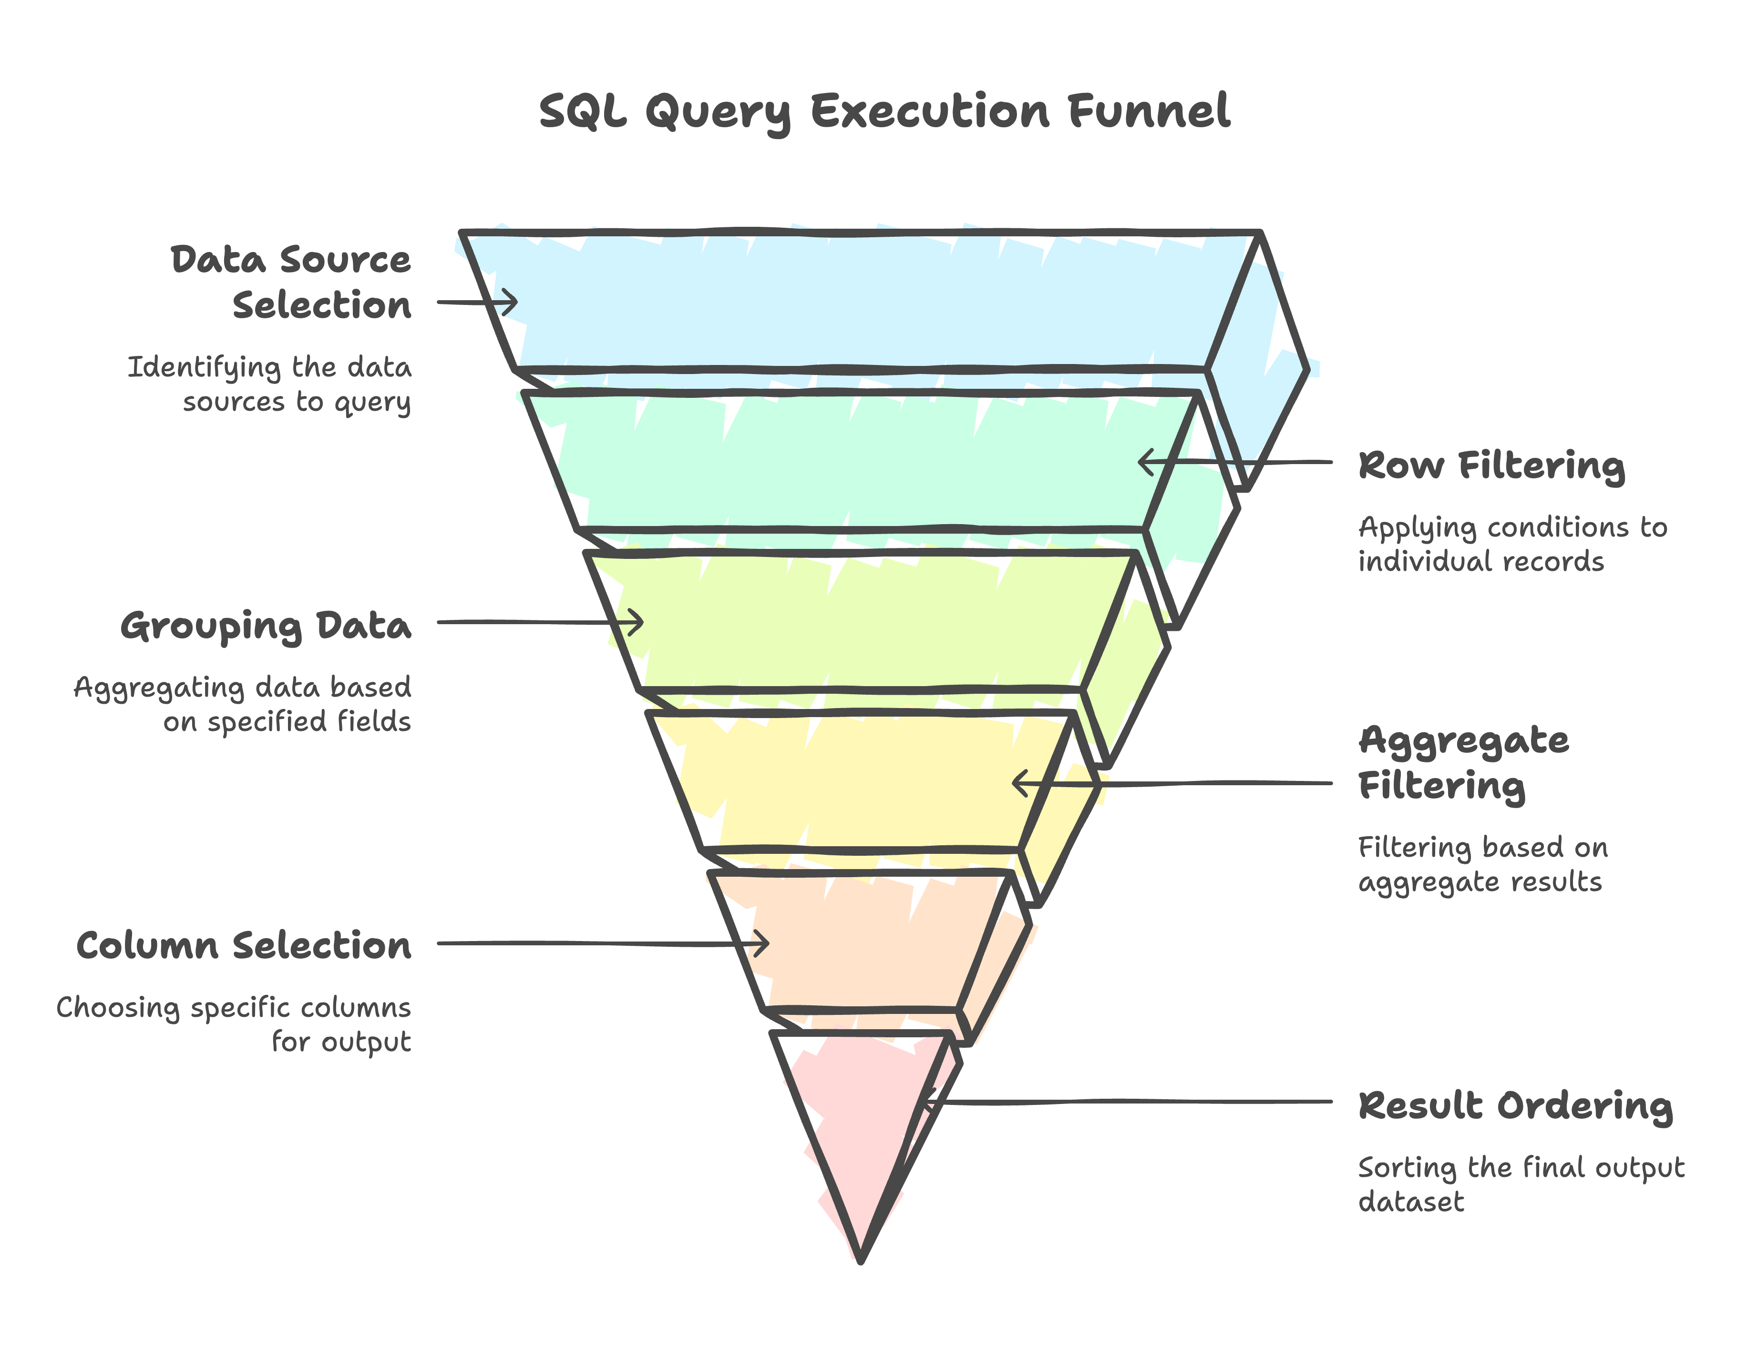
The WHERE clause filters rows before grouping occurs, so it works on individual records. In contrast, the HAVING clause applies after grouping, allowing it to filter based on aggregate results. This distinction explains why you use aggregate functions like SUM() or COUNT() with HAVING but not WHERE.
To better visualize this process, a query execution flowchart can help illustrate the sequence:
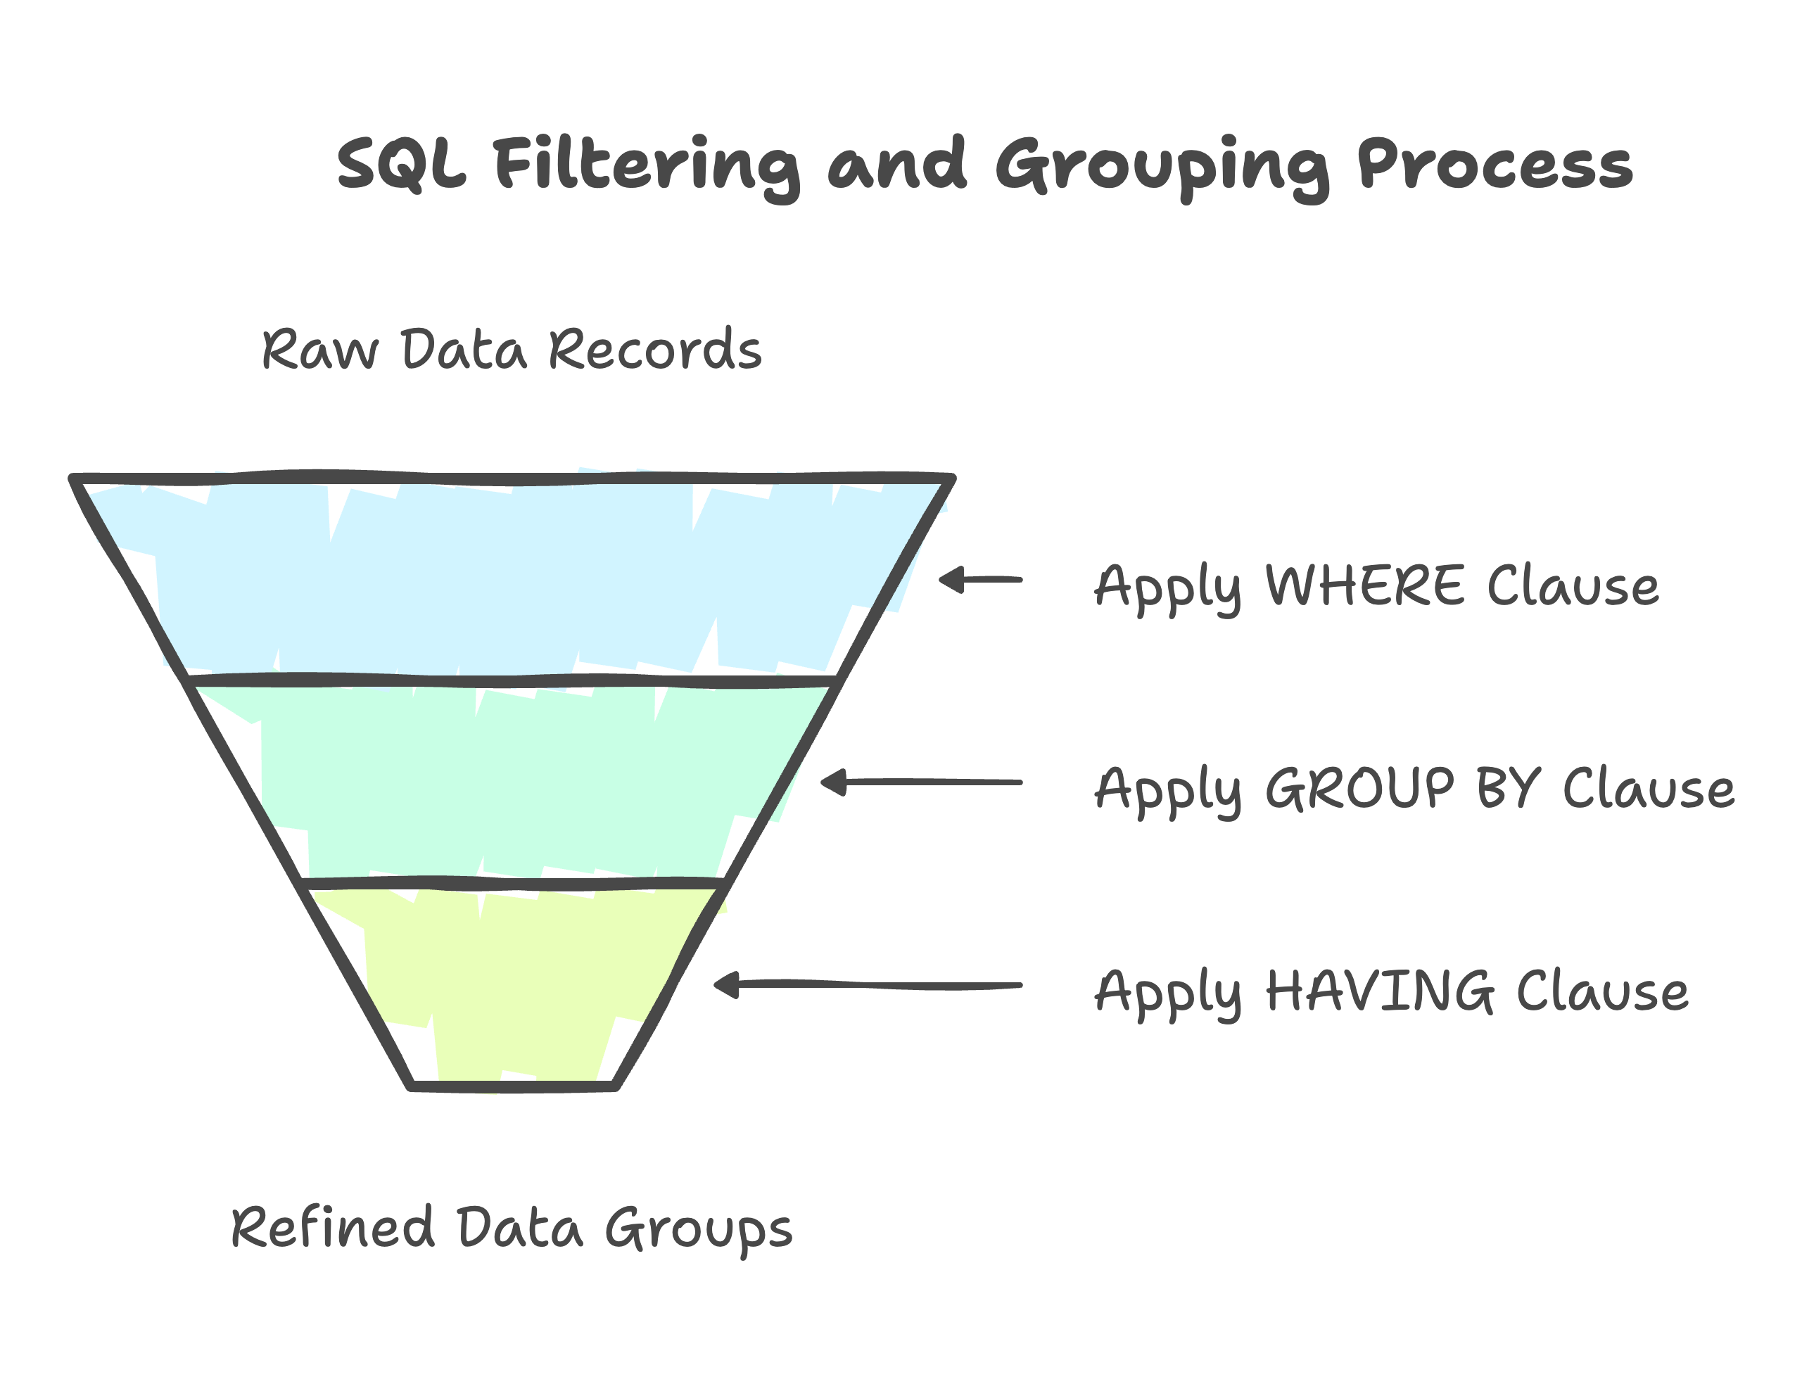
Now, let’s see an example where we might need to use both WHERE and HAVING and how the query is executed.
Consider a table Sales that tracks sales transactions with the columns -Product, Amount, and SaleDate:
Product | Amount | SaleDate
Apple | 500 | 2024-01-05
Banana | 200 | 2024-01-06
Apple | 600 | 2024-02-01
Orange | 300 | 2024-01-10
Banana | 300 | 2024-02-02
Apple | 700 | 2024-03-01
Suppose the task is to generate a report with the following criteria:
- Filter transactions that happened in 2024 only.
- Group the data by product to calculate the total sales amount for each product.
- Show only products where the total sales amount exceeds $1000.
The steps required to achieve this would be as follows:
- Filter by date: You need to consider only the transactions that occurred in 2024, which are done using the WHERE clause.
- Group by product: After filtering by date, you need to calculate the total sales for each product. This is done using GROUP BY.
- Filter by total sales: You want to include only products whose total sales exceed $1000. This is where the HAVING clause comes into play, filtering after the aggregation.
Hence, the SQL query would look like:
SELECT Product, SUM(Amount) AS TotalSales
FROM Sales
WHERE SaleDate >= '2024-01-01' -- Filters rows before grouping
GROUP BY Product
HAVING SUM(Amount) > 1000; -- Filters groups after aggregation

The output of the query is as follows:
Copy to clipboard
Product | TotalSales
Apple | 1800
This demonstrates how WHERE filters rows before grouping, while HAVING filters the result of the aggregation.
Now that we’ve seen how both the WHERE and HAVING clauses help filter data, it’s important to understand how they differ in their application.
In the next section, let’s examine the key differences between WHERE and HAVING.

WHERE vs HAVING in SQL
Both WHERE and HAVING in SQL serve similar purposes, but they operate at different stages of query execution and apply in different contexts.
Here’s a table that highlights the key differences between the WHERE and HAVING clauses:
Feature | WHERE | HAVING
Purpose | Filters rows before aggregation | Filters groups after aggregation
Usage | Applied to individual rows | Applied to aggregated results (groups)
Can use aggregate functions? | No | Yes
SQL position | Before the GROUP BY clause | After the GROUP BY clause
Example use case | Filtering customers from a specific city | Filtering products with total sales above a threshold

Conclusion
In conclusion, understanding the WHERE and HAVING clauses is essential for writing efficient SQL queries. While both filter data, the WHERE clause operates on individual rows before aggregation, whereas the HAVING clause filters aggregated results after grouping. Recognizing the SQL query execution order clarifies when and where to apply these clauses, ensuring precision in data retrieval.
Applying these concepts to real-world queries will enhance your ability to filter and aggregate data effectively, making your SQL queries powerful and efficient.
FROM → WHERE → GROUP BY → HAVING → SELECT → DISTINCT → ORDER BY → LIMIT

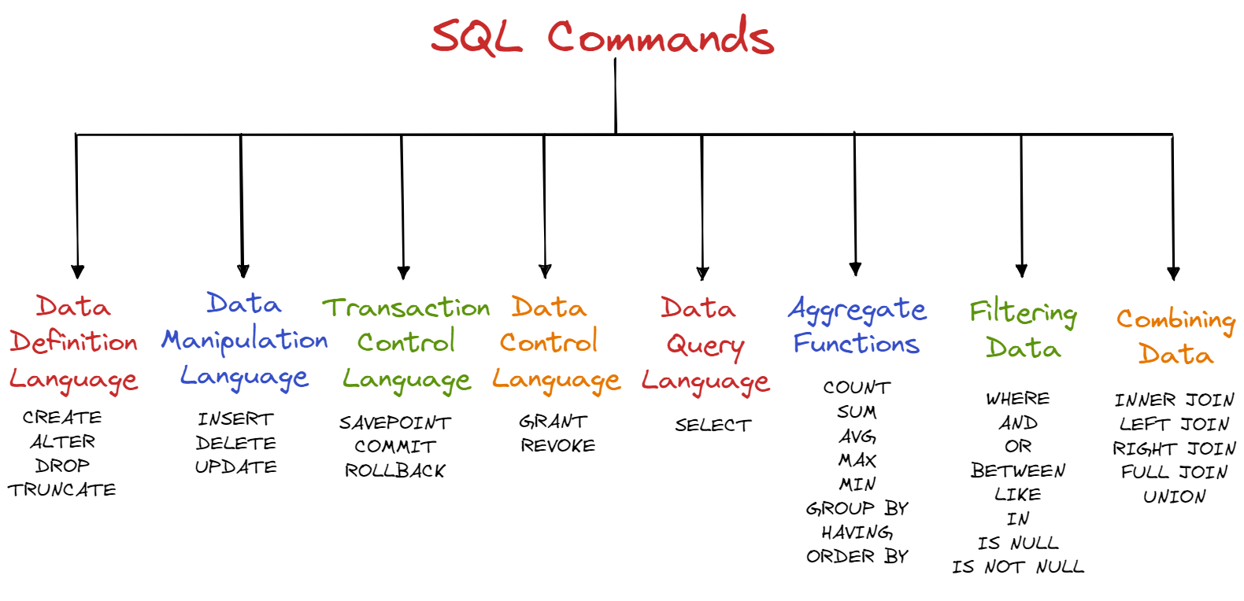

A. Data Definition Language (DDL)
By using DDL we can change the structure of our tables. Since all the command of DDL are auto committed it permanently saves all the changes in the database.

1. CREATE
Let's suppose you want to create a table with information about the type of rooms in the listings. The command below allows you to create a new database or table.
TEXT/X-SQL
CREATE TABLE room_details(
room_type TEXT,
room_size INTEGER
);

2. ALTER
Now let’s say you want to add a column to the airbnb_listings table which states if the property is reserved or not. The next command is used to modify (add, drop, rename, etc) the structure of the data in your database, it should be noted the data will remain unchanged.
TEXT/X-SQL
ALTER TABLE airbnb_listings
ADD listings_reserved BOOLEAN;

3. DROP
So you’ve decided that the table you created no longer serves a purpose and you want to delete it. The DROP command deletes a database or table. Before running this command you should be aware that it will delete your whole table, including all data, indexes, and more, so make sure you are certain before you run.
TEXT/X-SQL
DROP TABLE room_details;
To delete a specific column we can combine the ALTER TABLE command with the DROP command.
TEXT/X-SQL
ALTER TABLE airbnb_listings
DROP COLUMN listings_reserved;

4. TRUNCATE
This command is used to remove all data entries from a table in a database while keeping the table and structure in place.
TEXT/X-SQL
TRUNCATE TABLE airbnb_listings;

By using DML we can modify, retrieve, delete and update the data in our database.

1. INSERT
Suppose we have a new listing we would like to add to our database, to add this new record we use the INSERT INTO command. This command allows you to add one or more rows.
TEXT/X-SQL
INSERT INTO airbnb_listings(id, name, host_id, neighbourhood_group, price)
VALUES (1001, 'Luxury Villa', 2345, 'Brooklyn', 225);

2. DELETE
The new listings pulls out last minute so we need to remove the data from our table. To remove data we can simply use the DELETE command based on conditions specified with the WHERE command.
TEXT/X-SQL
DELETE FROM airbnb_listings
WHERE id = 1001;

3. UPDATE
Imagine you need to update data in your table because one listing increased their price. The UPDATE command allows you to do this based on conditions specified after the WHERE command.
TEXT/X-SQL
UPDATE airbnb_listings
set price = 200
WHERE id = 2539;

TCL commands are used to maintain consistency of our databases and for management of transaction made by DML commands. We can only use TCL commands with DML commands like INSERT, DELETE and UPDATE.

1. SAVEPOINT
The SAVEPOINT command allows us to pick a point in a transaction and save it so that we can roll back to it. This is similar to how you can backup your pictures to the cloud or you save a backup of an important project.
TEXT/X-SQL
SAVEPOINT SAVEPOINT_NAME;

2. COMMIT
By using the COMMIT statement we end the current transaction removing any existing savepoints that may be in use and make permanent all changes preformed in the transaction. Once the statement is run, we cannot roll back the transaction.
TEXT/X-SQL
DELETE FROM airbnb_listings
WHERE id = 1001;
COMMIT

3. ROLLBACK
To undo a transaction that are not saved to the database we use the ROLLBACK command. This can only be used to undo transactions that has came after the last COMMIT or ROLLBACK command that was ran. You can also rollback to a SAVEPOINT that has been created before.
TEXT/X-SQL
ROLLBACK TO SAVEPOINT_NAME;

By using DCL we can permit a user to access, modify or work on the different privileges in order to control the database.

1. GRANT
Suppose you hire a freelancer to update your airbnb_listings database with new information. By using the GRANT command you can give the user access to database objects such as tables, views or the database itself. The below example gives the user named ‘usr_maria’ SELECT and UPDATE access on the airbnb_listings table.
TEXT/X-SQL
GRANT SELECT, UPDATE ON airbnb_listings TO usr_maria;

2. REVOKE
After the freelancer has completed her work you now want to remove the users permission. You can do so by using the REVOKE command.
TEXT/X-SQL
REVOKE SELECT, UPDATE ON airbnb_listings FROM usr_maria;

1. SELECT
You use the SELECT command almost every time you query data with SQL. It allows you to define what data you want your query to return. By using the SELECT command with an asterisk () all of the columns in the table airbnb_listings* are returned.
TEXT/X-SQL
SELECT * FROM airbnb_listings;
Using the following command we can find out all the neighborhoods we have listings in.
TEXT/X-SQL
SELECT neighbourhood_group
FROM airbnb_listings;
However you will notice there are duplicate results. To overcome this we use the SELECT DISTINCT command which will eliminate duplicates and only return distinct data.
TEXT/X-SQL
SELECT DISTINCT neighbourhood_group
FROM airbnb_listings;
An aggregate function is used to combine a set of values and return a single result.

1. COUNT
We want to find out the number of Airbnb listings we have. To do so we use the COUNT() function which will add up the number of rows where the specified column is not NULL.
TEXT/X-SQL
SELECT COUNT()
FROM airbnb_listings;

2. SUM
Let’s say we want to find the total number_of_reviews left on our listings. Using the SUM function we can return the total sum of a numeric column.
TEXT/X-SQL
SELECT SUM(number_of_reviews)
FROM airbnb_listings;

3. AVERAGE
Let’s say you want to see what the average price is across your listings is. By using the AVG function the average value of the numeric column will be returned.
TEXT/X-SQL
SELECT AVG(price)
FROM airbnb_listings;

4. MAXIMUM & MINIMUM
To find what is the maximum and minimum price of our listings we use the MIN and MAX functions.
TEXT/X-SQL
-- Max
SELECT MAX(price)
FROM airbnb_listings;

-- Min
SELECT MIN(price)
FROM airbnb_listings;

5. GROUP BY
Let’s say we want to find the average price for each neighborhood. We can do this using the GROUP BY statement. It groups rows with the same values into summary rows and is commonly used with aggregate functions like AVG.
TEXT/X-SQL
SELECT neighbourhood, AVG(price)
FROM airbnb_listings
GROUP BY neighbourhood;

6. HAVING
HAVING acts in the same way as the WHERE clause with the difference being that HAVING is used for aggregate functions. Let’s suppose want to return the names of the clients who have more than 2 listings on Airbnb.
TEXT/X-SQL
SELECT COUNT(host_id), name
FROM airbnb_listings
GROUP BY host_name
HAVING COUNT(host_id) > 2;

7. ORDER BY
To order the results obtained from a query we use the ORDER BY command. By default the order will be ascending (A -> Z / 1 -> 100) however we can change this using DESC. Let’s say for example we want to order our listings by price.
TEXT/X-SQL
SELECT name, price
FROM airbnb_listings
ORDER BY price;

-- In descending order
SELECT name, price
FROM airbnb_listings
ORDER BY price DESC;

One of the most powerful feature of using SQL is the ability to rapidly filter data to match a certain criteria you are searching for.

1. WHERE
By using the WHERE filters with a query it allows us to only return results that match a set condition. We can use this together with conditional operators like =, >, <, >=, <=, etc.
TEXT/X-SQL
SELECT *
FROM airbnb_listings
WHERE price < 300;

2. AND
We can combine two or more conditions into a single query by using the AND command. All of the conditions must be met for the result to be returned. Let’s say we want results for listings over $300 in Brooklyn.
TEXT/X-SQL
SELECT name
FROM airbnb_listings
WHERE price < 300 AND neighbourhood_group = 'Brooklyn';

3. OR
We can combine two or more conditions into a single query by using the OR command. It differs from AND in the sense that only one of the conditions must be met for a result to be returned. Therefore from our example all listings priced over $300 will be returned as well as all listings located in Brooklyn.
TEXT/X-SQL
SELECT name
FROM airbnb_listings
WHERE price < 300 OR neighbourhood_group = 'Brooklyn';

4. BETWEEN
We can specify a range using the BETWEEN filter. For example creating a price range for listings as follows.
TEXT/X-SQL
SELECT name, price
FROM airbnb_listings
WHERE price BETWEEN 200 AND 400;

5. LIKE
We can search for patterns within our data using the LIKE command. Suppose you want to find listings with the word 'country' in the title, the code below will achieve this.
TEXT/X-SQL
SELECT name
FROM airbnb_listings
WHERE name LIKE ‘%country%’;
Other operators for LIKE:
- %x — will select all values that begin with x
- %x% — will select all values that include x
- x% — will select all values that end with x
- x%y — will select all values that begin with x and end with y
- _x% — will select all values have x as the second character
- x% — will select all values that begin with x and are at least two characters long. You can add additional characters to extend the length requirement, i.e. x___%

6. IN
By using the IN command we can specify multiple values we want to select from with the WHERE command.
TEXT/X-SQL
SELECT name, neighbourhood_group, price
FROM airbnb_listings
WHERE neighbourhood_group IN ('Brooklyn', 'Manhattan');

7. IS NULL & IS NOT NULL
IS NULL will return only rows with a NULL value, while IS NOT NULL does the opposite returning only rows without a NULL value. Let’s say we want to find listings which have received no reviews in the past month.
TEXT/X-SQL
-- IS NULL
SELECT name
FROM airbnb_listings
WHERE reviews_per_month IS NULL;

-- IS NOT NULL
SELECT name
FROM airbnb_listings
WHERE reviews_per_month IS NOT NULL;

So you want to combine your table with another. Let's first take a look at joins to accomplish this goal. A JOIN clause is used to combine rows from two or more tables allowing you to fetch combined results.
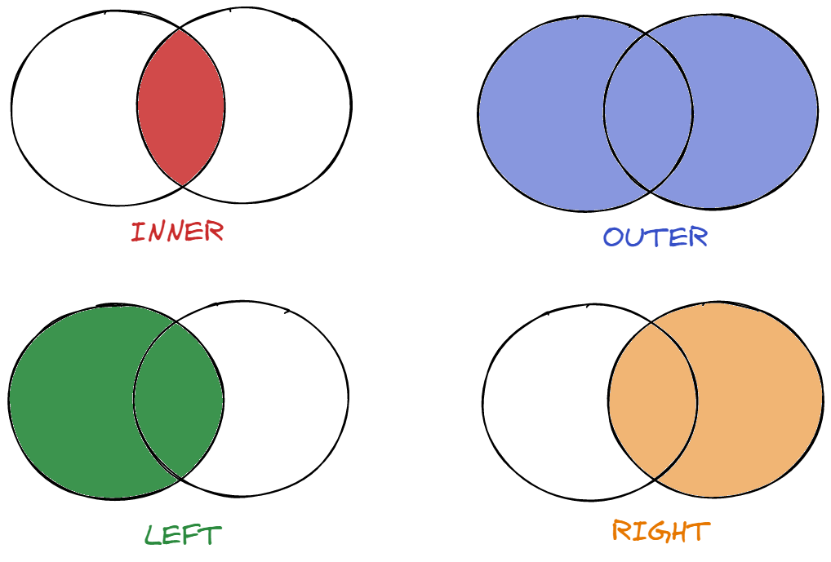
For this example let's imagine we're joining with another table called 'booking_listings' which contains listings from the website Booking.com.

1. INNER JOIN
INNER JOIN selects records that have matching values in both tables.
TEXT/X-SQL
SELECT name
FROM airbnb_listings
INNER JOIN booking_listings
ON airbnb_listings.host_id = booking_listings.host_id;

2. LEFT JOIN
LEFT JOIN selects records from the left table that match records in the right table. In the below example the left table is airbnb_listings.
TEXT/X-SQL
SELECT name
FROM airbnb_listings
LEFT JOIN booking_listings
ON airbnb_listings.host_id = booking_listings.host_id;

3. RIGHT JOIN
RIGHT JOIN selects records from the right table that match records in the left table. In the below example the right table is booking_listings.
TEXT/X-SQL
SELECT name
FROM airbnb_listings
RIGHT JOIN booking_listings
ON airbnb_listings.host_id = booking_listings.host_id;

4. FULL JOIN
FULL JOIN selects records that have a match in the left or right table. Think of it as the “OR” JOIN compared with the “AND” JOIN (INNER JOIN).
TEXT/X-SQL
SELECT name
FROM airbnb_listings
FULL OUTER JOIN booking_listings
ON airbnb_listings.host_id = booking_listings.host_id;

5. UNION
Union on the other hand allows you to append rows to each other. Unlike joins which append matching columns, union can append unrelated rows provided they have the same number and name of columns.
TEXT/X-SQL
SELECT price, name FROM airbnb_listings
UNION
SELECT price, name FROM booking_listings;
You can think of union as a way of combining the results of two queries. You can use the UNION ALL syntax to return all the data, regardless of duplicates.
TEXT/X-SQL
SELECT price, name FROM airbnb_listings
UNION ALL
SELECT price, name FROM booking_listings;

To master the SQL language having knowledge of SQL commands is necessary. With the previously discussed commands you should be well on your way to becoming an SQL expert!

One Pager Cheat Sheet
- Learn the essentialSQLcommands including SELECT, FROM, WHERE, and more to effectively work withNew York City Airbnbdata.
- A Data Definition Language (DDL) can be used to create, alter, drop, and truncate tables in the database, permanently changing their structure.
- The ALTER command can be used to add new columns, such as size_square_metres, to a database table.
- Through the use of Data Manipulation Language (DML), we can modify, retrieve, delete or update the data in our database.
- The UPDATE command can be used to modify data in a database by specifying WHERE conditions, such as changing the name of a listing from 'Clean & quiet apt home by the park' to 'Luxurious Apt. facing Kensington's Most Famous Park'.
- TCL commands are used to manage DML operations and ensure consistency of the database using SAVEPOINT, COMMIT, and ROLLBACK statements.
- The ROLLBACK command is used to undo a transaction that has not been saved to the database and to return to a previously created SAVEPOINT.
- Using Data Control Language (DCL) commands like GRANT and REVOKE, we can control a user's access and privileges to our database objects.
- The REVOKE command is used to remove access previously given to a user from database objects, like tables and views.
- By using SELECT and SELECT DISTINCT, the DQL (Data Query Language) allows us to query data from the database and get distinct data as required.
- No, the command SELECT (*) does not remove duplicates, rather it returns all columns in the query; to remove duplicates, SELECT DISTINCT should be used.
- Aggregate functions such as COUNT, SUM, AVG, MAX, MIN, GROUP BY and HAVING are used to process data and generate results based on a given criteria, and can be ordered using ORDER BY.
- The COUNT() function is used to determine the total number of records in a given table, and is an important aggregate function for quickly gauging the size of a dataset.
- SQL provides powerful querying capabilities to filter data using WHERE, AND, OR, BETWEEN, LIKE, IN, IS NULL and IS NOT NULL filters.
- We can use the BETWEEN command to return data from our query that is within a certain range, in this case listings with a 'minimum_nights' requirement of between 7 and 14 days.
- With INNER JOIN, LEFT JOIN, RIGHT JOIN, FULL JOIN and UNION, you can combine rows from two or more tables, either appending matching columns or appending all rows with the same number and name of columns.
- The SQL command INNER JOIN selects records with matching values in two or more tables to combine rows and return matching records.
- With knowledge of the essential SQL commands, you can master the SQL language and become an SQL expert.

