Data Types in Java
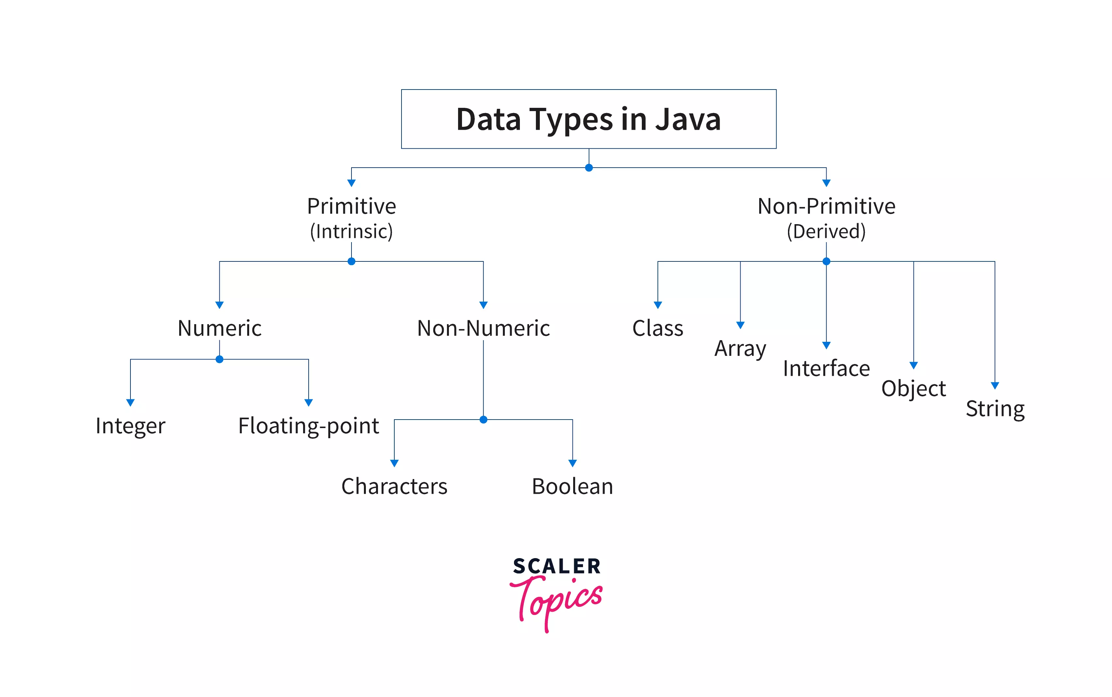

1.Primitive Data Types in Java

The data types represent type of data ,how much value it stores, the data types can be used in variable declaration and return type of a method. The byte, short, int, long, float, double, char, boolean are the basic primitive data types.
The valid Java data type hierarchy is given below.

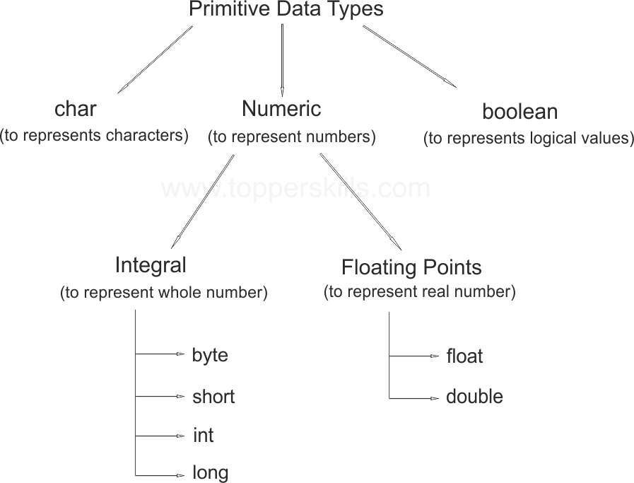

Data Type | Size(byte) | Range | Corresponding Wrapper class | Default Value
byte | 1 | -128 to 127 | Byte | 0
short | 2 | -32768 to 32767 | Short | 0
int | 4 | -2147483648 to 2147483647 | Integer | 0
long | 8 | -9,223,372,036,854,775,808 to 9,223,372,036,854,775,807 | Long | 0
float | 4 | -3.4e38 to 3.4e38 | Float | 0.0
double | 8 | -1.7e308 to 1.7e308 | Double | 0.0
char | 2 | 0 to 65535 | Char | 0 or \u0000
boolean | NA | NA(true/false) | Boolean | false

byte data type
Size: 1 byte or 8 –bits
Minimum value: -128
Maximum value: 127
The most significant bit is called “Sign bit”. 0 means positive value and 1 means negative value.
Positive numbers represented directly in the memory where as negative numbers represented in 2`s complement form.
Example:

byte b=100;// valid

byte b=127;// valid

byte b=130;// compile time exception; Possible loss of precision, found : int. Required : byte.

byte b=123.456;// compile time exception; Possible loss of precision. Found: double. Required : byte.

byte b=true;// compile time exception; incompatible types. Found :Boolean. Required : byte.

byte b="Topper Skills";// compile time exception; Incompatible types. Found:java.lang.String. Required : byte.

The byte data type is best suitable if you want to handle data in terms of streams either from the file or from the network.

short data type
Size: 2 bytes or 16 bits.
Minimum value: -32768
Maximum value: 32767
Example:

short s=32767;// valid

short s=-32768;// valid

short s=32768;// compile time exception; Possible Loss of Precision

short s=123.456;// compile time exception; Possible Loss of precision. Found: double. Required: short.

short s=true;// Compile time exception; Incompatible types. Found: Boolean. Required: short.

The short is the very rarely used data type in Java language.
The short data type is the best suitable if we are using 16 – bit processors like 8086 but these processors are outdated and hence corresponding short data type is not is much useful now.

int data type
The int is the most commonly used datatype in Java language.
Size: 4 bytes.
Minimum value: -2147483648
Maximum value: 2147483647
In C language the size of the int is varied from platform to platform, for 16 – bit processor it is 2 – byte but for 32 – bit processor it is 4 bytes.
The main advantage of this approach is, we can perform read and write options very efficiently and performance will be improved. But the main disadvantage of this approach is the chance of failing C program is very high if we are changing platform, hence C is not considered as robust.
But in Java the size of int is always 4 – bytes irrespective of any platform. The main advantage of this approach is the chance of failing java program is very less even if we are changing the underlying operating system.

long data type
Size: 8 bytes.
Minimum value: -9,223,372,036,854,775,808
Maximum value: 9,223,372,036,854,775,807
Whenever int is not enough to hold big values then we should use long data type.
Example:
1. To represent the amount of distance travelled by light in 1000 days, int is not enough then we should use long data type.
2. To count the number of characters present in a big file, int may not enough then we should use long data type.
Note: All the above data types(byte, short, int, long) are used to represent whole values. If we want to represent real numbers then we should go for floating point data types.

float data type
Size: 4 bytes.
Minimum value: -3.4e38
Maximum value: 3.4e38
If we want 5 to 6 decimal places of accuracy then we should go for float data type. The float allows single precision.
To use float data type we need to add f or F at the end of value because by default floating point data is considered of double type.

double data type
Size: 4 bytes.
Minimum value: -1.7e308
Maximum value: 1.7e308
If we want 14 to 15 decimal places of accuracy then we should use double data type. The double data type follows double precision.

boolean data type
Size: Not Applicable( The virtual machine dependent)
Range: Not Applicable ( but allowed values are true /false)
Example:

boolean b=true;// valid

boolean b=0;// //compile time exception: incompatible types. Found: int. Required: boolean.

boolean b=True;// compile time exception; Cannot find symbol.

boolean True=true;// valid.
boolean b= True;// valid.
System.out.println(b);// true

boolean b="false";// compile time exception; incompatible types.

Note: The only allowed values for the boolean data types are “true” or “false” where case is important.

char data type
Size: 2 bytes.
Range: 0 to 65535. (\u0000 to \uffff)
In languages like C and C++ you can use only ASCII characters and to represent all ASCII characters 8 bits are enough, therefore in C language char size is 1 byte.
In java we can use Unicode characters which covers worldwide all alphabets set. The number of Unicode characters are greater than 256 therefore 1 byte is not enough to represent all the characters hence the size of char in the Java is 2 bytes.
Unicode Character System in Java
Unicode is a computing industry standard designed to consistently and uniquely encode characters used in written languages throughout the world. The Unicode standard uses hexadecimal to express a character. For example the value 0x0041 represents the Latin character A.
The ASCII character set contained limited number of characters. It doesn't have Japanese characters, and a host of other possible characters from various different languages of the world.
The idea behind Unicode was to create a single character set that included every reasonable character in all writing systems in the world. In fact, Unicode has a different way of thinking about characters, and you have to understand the Unicode way of thinking of things or nothing will make sense.
The Unicode standard was initially designed using 16 bits to encode characters because the primary machines were 16-bit PCs. When the specification for the Java language was created, the Unicode standard was accepted and the char primitive was defined as a 16-bit data type, with characters in the hexadecimal range from 0x0000 to 0xFFFF.
The latest version of Unicode contains a repertoire of more than 128,000 characters covering 135 modern and historic scripts, as well as multiple symbol sets.

Why java uses Unicode
The evolution of Java was the time when the Unicode standards had been defined for very smaller character set. Java was designed for using Unicode Transformed Format (UTF)-16, when the UTF-16 was designed. The ‘char’ data type in Java originally used for representing 16-bit Unicode. Therefore the size of the char data type in Java is 2 byte, and same for the C language is 1 byte. Hence Java uses Unicode standard.
Java Example to Display Unicode Characters in Java Program

class UnicodeDemo
{
public static void main(String[] args)
{
String pi = "\u03C0";
System.out.println(pi); //pi sign
System.out.println("\u0021"); // !
System.out.println("\u002B"); // +
System.out.println("\u0030"); // \u0030 to \u0039 represents 0 to 9 digits
System.out.println("\u0041"); // \u0041 to \u005A represents A to Z
System.out.println("\u0061"); // \u0061 to \u007A represents a to z
System.out.println("\u007B"); // {
System.out.println("\u007E"); //~
System.out.println("\u0040"); // @
System.out.println("\u00A5"); //yen sign
System.out.println("\u00B5"); // micro sign
}
}

