Weather App

Weather App, which shows the current weather for the following cities by default, using Open weather API.
- London
- Paris

It displays
- Temperature
- Humidity
- Sunset and sunrise times of their respective tome zones.

Add functionality:
We can add new cities by tapping add button in the project, by entering name of the city we will get the following weather details
Ex. Hyderabad

You will receive Hyderabad’s temperature, humidity, sunrise and sunset weather details

What I have done:

- Created Open Weather API account and App ID.
- Project created on MVVM pattern for clean and extensibility purpose.
- Followed the folder structure and modularized the each file as per MVVM.
- As per the given designs developed the UI part.
- Handled errors appropriately, added network status observers to get the network status (online/offline) based on status handled the app data.
- Add functionality implemented, recently added city displaying on top of the list (Index 0).
- Developed App on iOS 13 and supported backward compatibility.

App Flow follows:

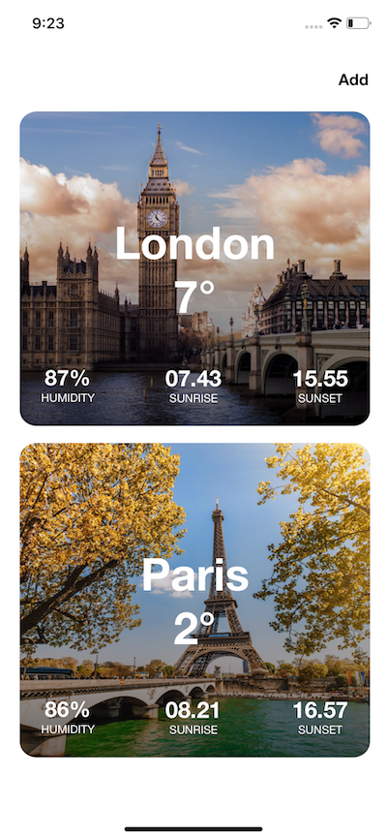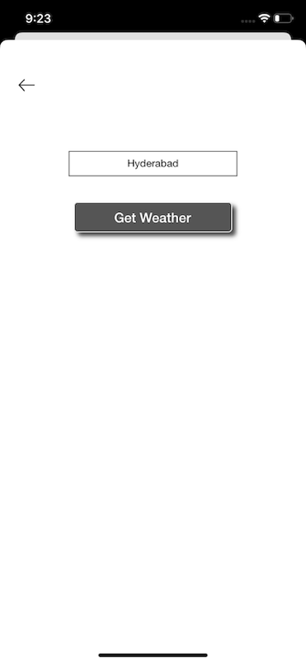

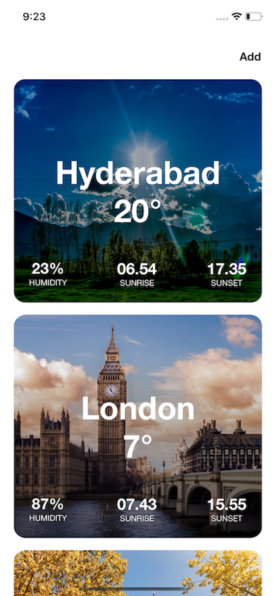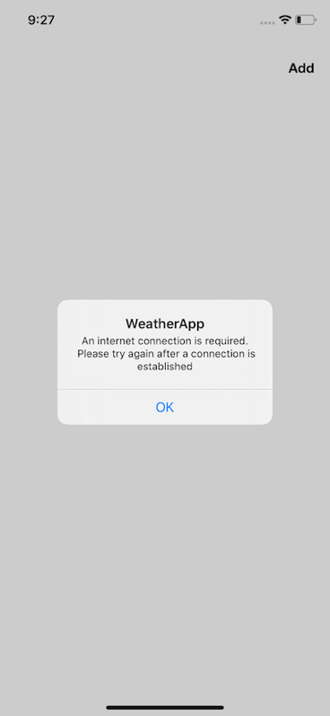

Approach I have followed

In Open weather API, to get the city weather details we have the following call

By city name:

We can call by city name or city Id, state code and county code

api.openweathermap.org/data/2.5/weather?q={city name}&appid={API key}

This API will fetch the single city weather details, If we have N number of cities we can’t use this API by call each city and adding the result data in a array / list.

In our case we need to get more than one city details, by default London and Paris city details we are fetching. In addition to that we have add functionality so we can’t use the above API.

To achieve our functionality, there is a possibility to get current weather data for several cities by making single API call

Call for several city IDs

Open weather API providing more than 200,000 locations to fetch the weather data. We can’t get the city Ids at runtime, so I used city.list JSON file provided by the Open Weather Maps.

api.openweathermap.org/data/2.5/group?id={id,..,id}&appid={API key}

Storing this JSON file in the bundle and fetching the city Id from city name, provided by the user (In add functionality).

This way we are getting the list of cities weather details and updating the details to list.

Assumptions

In the given UI design, I can see iPhone and iPad padding (leading, trailing pixels) is different but I have done the designs as per Auto Layout constraints. I have not designed iPhone and iPad designs separately.

Nice to have feature / Future modules:

Search functionality:

In the near future, we would have much more cities available in the list, to check for specific city weather details it is very hard to check each and every row, so search functionality will help us to get particular city weather details.

Delete functionality:

It is nice to have delete functionality, we can delete the particular city if we don’t require the weather details.

Save functionality:

We must and should have to Save the city name that user have added. It doesn’t mean that we will save city details, but it will only save the city name.

Whenever user opens the city weather list screen we will update the city details by calling the API.

To achieve save functionality, we can use Core Data / Realm / Firebase storage. But as of now, we are storing in User Defaults.

Pagination:

This feature will improves the app functionality and it will load only few rows, at first in the list, if user start scrolling down it will load more rows and continues.

Settings functionality:

Nice to have setting screen, for customize the weather details that user wants to see.

Getting weather for current location:

Based on the current location we can fetch the weather details and display on top of the list.

Weather details screen:

Nice to have weather details screen, if user tap on any city in the list, It should navigate to the list and displays additional details of the city, like
- Hour wise data
- Weekly data,
- Wind
- Chance of rain
- UV index and more

What happens if API structure changes in the future?

- Whatever happen to JSON structure, make sure that our app doesn’t crash, we need to handle the codable structure properly and use Optionals.
- Don’t strict to data type
- Better to have Generic types, In place of data types in the JSON structure

How unit testing could be used when building out the app with more features in future?

- The main benefits of unit testing is that it makes the coding process more Agile.
- In the future when building out the app with more features / feature to the existing code, sometimes we need to change old design and code. However, changing the already existing code is both risky and costly. If we have unit testing in place, then we can proceed for refactoring confidently.
- To catch bugs earlier, much earlier than test manually, to test small units of functionality before all the components are built.
- Reduce development cost
- Makes code debugging easy
- Unit tests reduces the defects in the newly developed features/ feature.

