**Title :**

Google Product External API call

**Description:**

We will be calling the Google External API and display the respective response received from External API.

**Sample Request URL :**









**Package Structure:**

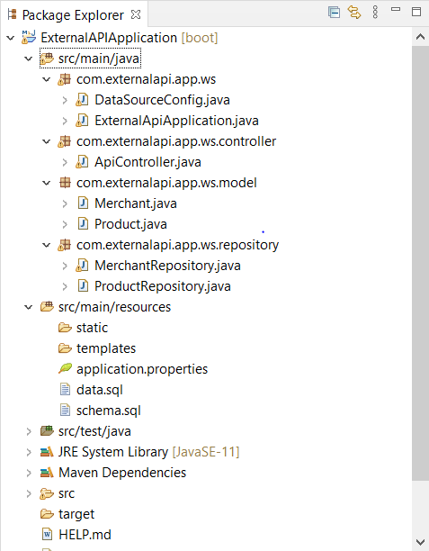

Copy the below git hub link:

<https://github.com/NarasimhanMohan/webpage-screen-capture.git>

Open the STS(Spring tool suite) STS can be downloaded from <https://spring.io/tools>

Click import Project -> Git -> Projects from GIT(smart import) -> Next -> Clone URI -> Paste the Above URI -> Next -> Main Branch will be selected -> Directory will be auto selected -> Next

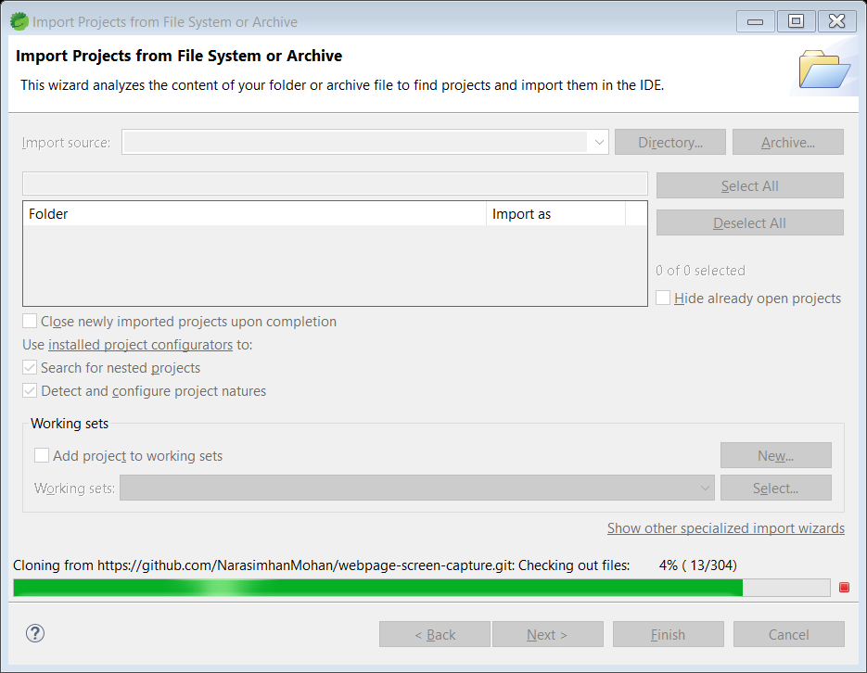

Project start to import as per above screenshot. Once imported click Finish.

Once Projects are imported then click on Run Drop-down-> Run configuration -> click Spring boot App -> click on the highlighted New launch -> search for maintype(com.externalapi.app.ws.ExternalApiApplication) - > Apply -> Run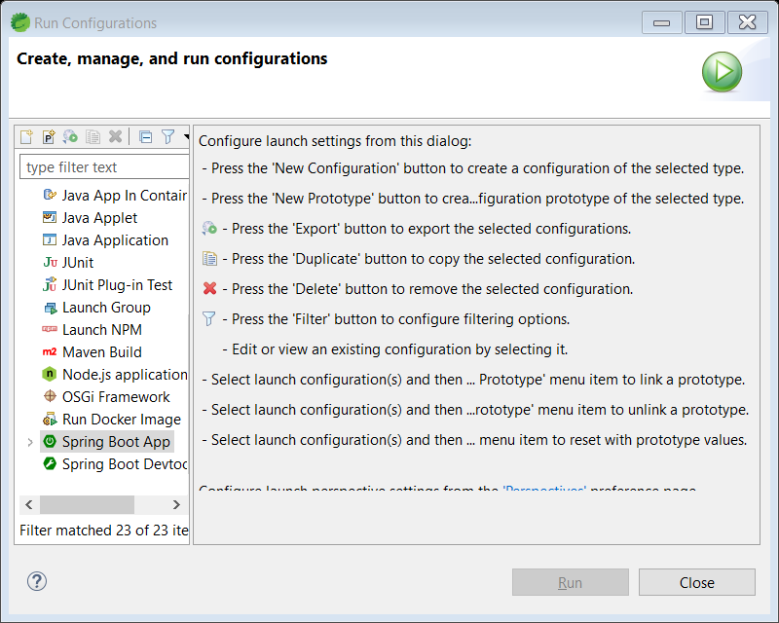

Now our Application has started.

**H2-Console:**

In our application we had used the H2 Embedded Database for maintaining the MERCHANT_ID and PRODUCT_ID.

Once application started, go to browser and type <http://localhost:8080/h2-console/>

In the below login screen, please provide the username and password as below.

Username : sa

Password : sam

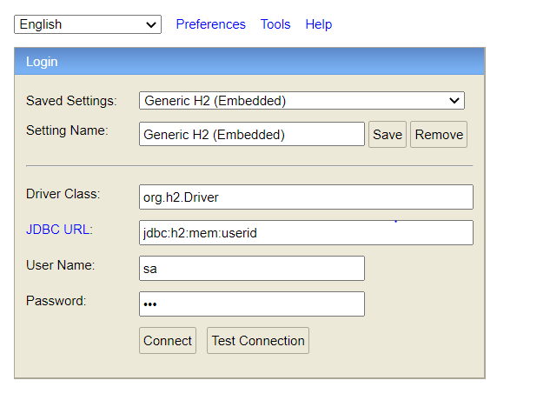

And click on Connect. Once connected you will see the two tables MERCHANT and PRODUCT.

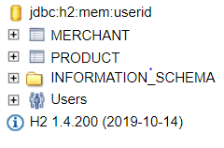

Now, Provide the insert query in the Given text box and run the query.

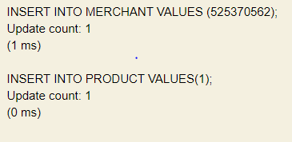

Now you can trigger the external API call.

Download post from <https://www.postman.com/downloads/> to test our API.

Once installed, open the postman and click create request.

Change the method to POST and give the below URL in bar.

<http://localhost:8080/createProduct>

<http://localhost:8080/getProduct>

<http://localhost:8080/updateProduct>

<http://localhost:8080/deleteProduct>