**Title :**

Webpage Screenshot API

**Description:**

API that will take a screenshot of a webpage. The screenshot will include the ENTIRE page of a website.

**Request :** A website URL that will be provided in the API request.

**Sample Request :**

{

    "url" : " https://en.wikipedia.org/wiki/Java_(programming_language)"

}

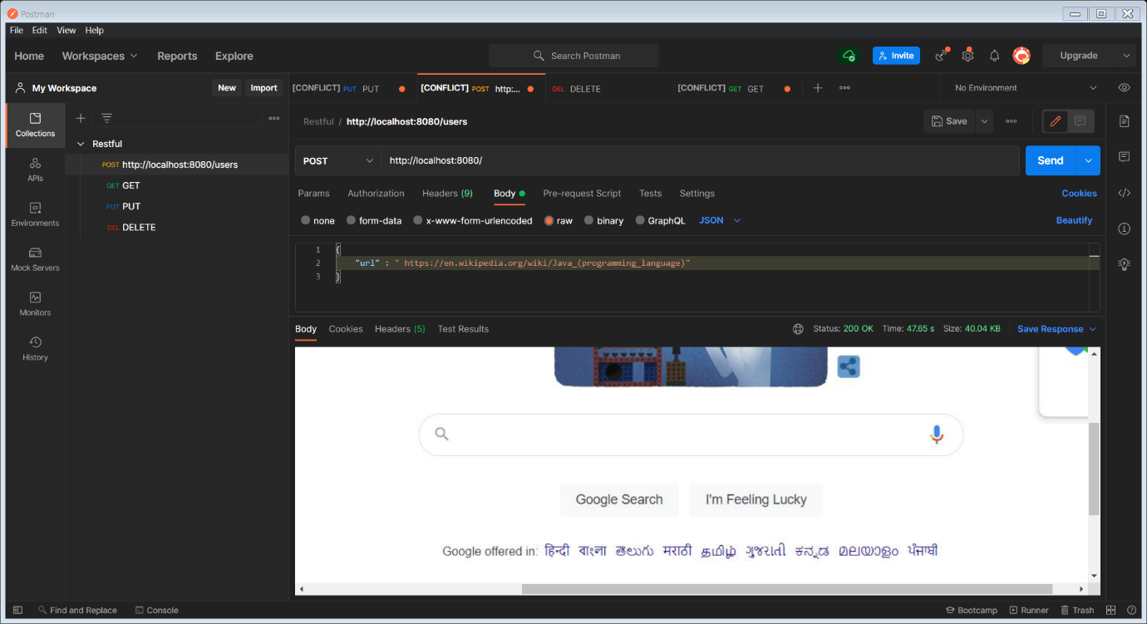

**Response :** A single screenshot file of the entire page

**Sample Response :**

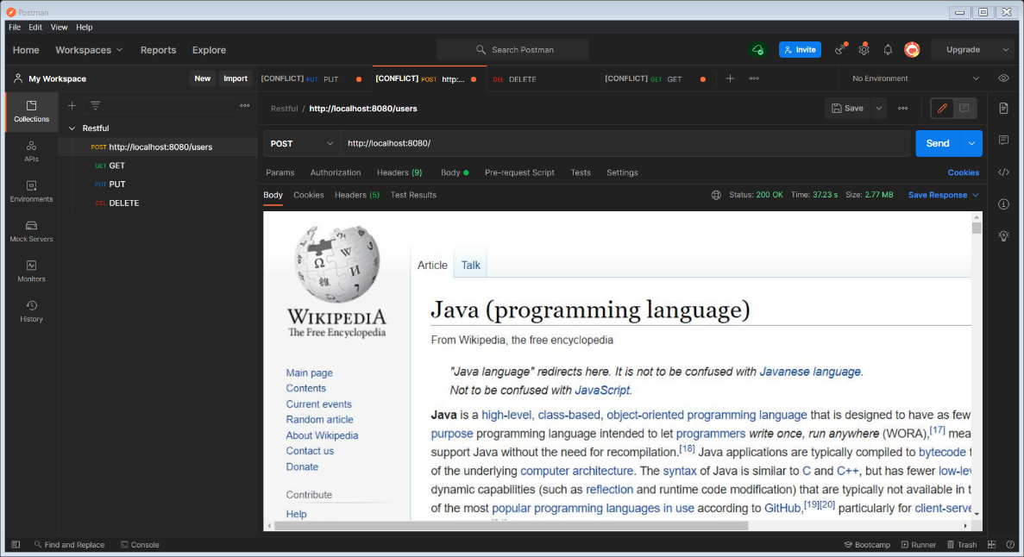

**Project Set-Up:**

Copy the below git hub link:

<https://github.com/NarasimhanMohan/webpage-screen-capture.git>

Open the STS(Spring tool suite) STS can be downloaded from <https://spring.io/tools>

Click import Project -> Git -> Projects from GIT(smart import) -> Next -> Clone URI -> Paste the Above URI -> Next -> Main Branch will be selected -> Directory will be auto selected -> Next

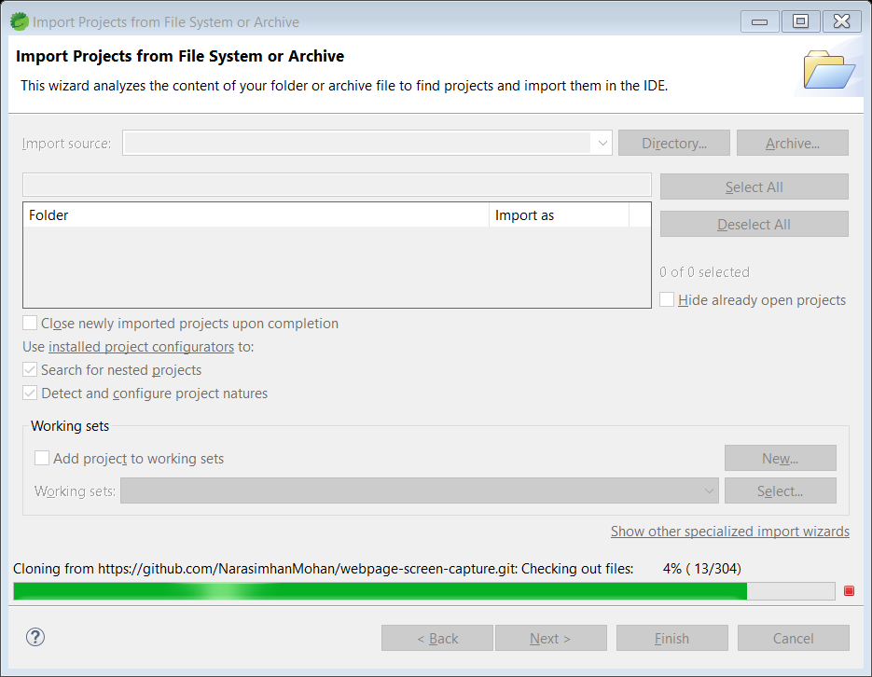

Project start to import as per above screenshot. Once imported click Finish.

Once Projects are imported then click on Run Drop-down-> Run configuration -> click Spring boot App -> click on the highlighted New launch -> search for maintype(com.webpagescreencapture.app.ws.WebpageScreenCaptureWsApplication) - > Apply -> Run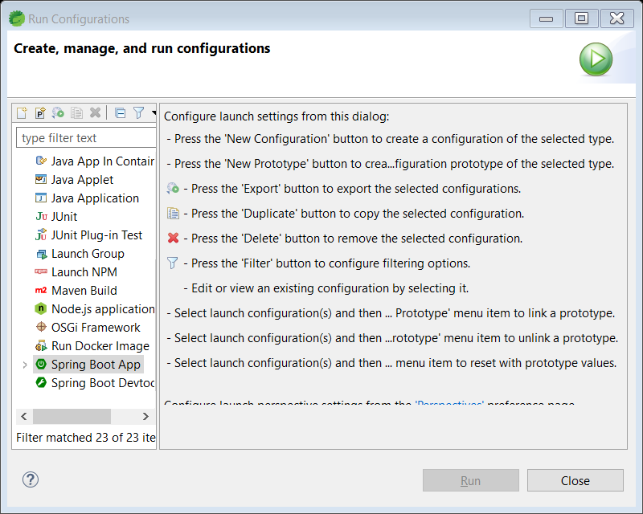

Now our Application has started.

Download post from <https://www.postman.com/downloads/> to test our API.

Once installed, open the postman and click create request.

Change the method to POST and give the below URL in bar.

<http://localhost:8080/>

Click on body -> Make it as raw(JSON) -> and the provide the request.

The request has the URL details.

{

    "url" : " https://en.wikipedia.org/wiki/Java_(programming_language)"

}

Once request provided click on the Send, we got the full webpage screenshot of the requested URL.