PROJECT TITLE IN CAPITAL LETTERS
A DBMS Capstone Project Report submitted in partial fulfillment of the requirements for the award of the degree of
BACHELOR OF TECHNOLOGY
in
ARTIFICIAL INTELLIGENCE AND MACHINE LEARNING

Submitted By
K.DEVI SRI CHARAN – 25B11AI570
K.VEERA CHANIKYA – 25B11AI528
D.L.NARASIMHA SAI – 25B11AI247
B.SRIRAM RATNA KUMAR – 25B11AI138

Under the esteemed guidance of
Mr. T.Srinivasulu M.Tech, (Ph.D.)
Assistant Professor



DEPARTMENT OF ARTIFICIAL INTELLIGENCE AND MACHINE LEARNING
ADITYA UNIVERSITY
(Formerly Aditya Engineering College (A))
Aditya Nagar, ADB Road, Surampalem, Andhra Pradesh, India
2026 – 2027

Aditya Nagar, ADB Road, Surampalem, Andhra Pradesh, India
DEPARTMENT OF ARTIFICIAL INTELLIGENCE AND MACHINE LEARNING
CERTIFICATE
This is to certify that the DBMS Capstone Project report entitled “HOSPITAL MANAGEMENT SYSTEM” is being submitted by K. Devi Sri Charan (Roll No. 25B11AI570), K. Veera Chanikya (Roll No. 25B11AI528), D. L. Narasimha Sai (Roll No. 25B11AI247) and B. Sriram Ratna Kumar (Roll No. 25B11AI138) in partial fulfillment of the requirements for the award of the B.Tech. degree in Artificial Intelligence and Machine Learning. The work documented in this report was carried out as part of the Capstone Project for the course Database Management Systems (2501IT05) during the academic year 2026–2027, and records the database design, implementation, and documentation undertaken by the team.

Project Guide Head of the Department
Mr. T. Srinivasulu, M. Tech, (Ph.D.) Dr. K. Naga Bhargavi, M. Tech, Ph.D. Associate professor Associate Professor & HOD

External Examiner

DECLARATION
We hereby declare that the DBMS Capstone Project entitled “HOSPITAL MANAGEMENT SYSTEM” is a genuine work carried out by us. The database design, SQL implementation, queries and documentation presented in this report are our own work, completed under the guidance of Mr.T.Srinivasulu M.Tech, (Ph.D.), Department of ARTIFICIAL INTELLIGENCE AND MACHINE LEARNING, Aditya University, Surampalem. We further declare that this work has not been submitted, in full or in part, for the award of any degree of this or any other educational institution.

Project Associates
K. Devi Sri Charan (25B11AI570)
K. Veera Chanikya (25B11AI528)
D. L. Narasimha Sai (25B11AI247)
B. Sriram Ratna Kumar (25B11AI138)

Date: 21-09-2026
Place: Surampalem

ACKNOWLEDGEMENT
It is with immense pleasure that we express our indebted gratitude to our project guide Mr.T.Srinivasulu M.Tech, (Ph.D.), Department of AIML, who guided us throughout the capstone project. We are thankful for the constant encouragement and valuable suggestions received at every review stage. We are grateful to , Dr. K. Naga Bhargavi, M. Tech, Ph.D. Head of the Department, for inspiring us and for arranging the facilities and resources needed for this project. We extend our sincere thanks to the Management, Dr. M. Sreenivasa Reddy, Deputy Pro-Chancellor, Dr. M. B. Srinivas, Vice-Chancellor, and Dr. A. Ramesh, Pro Vice-Chancellor (Engineering & Sciences), for providing an excellent academic environment. Not to forget, we thank the Teaching and Non-Teaching Staff, our parents and our friends, who have directly or indirectly supported us in completing this project on time.

Project Associates
Student Name : K. Devi Sri Charan Regd. No : 25B11AI570
Student Name : K. Veera Chanikya Regd. No : 25B11AI528
Student Name : D. L. Narasimha Sai Regd. No : 25B11AI247
Student Name : B. Sriram Ratna Kumar Regd. No : 25B11AI138

ABSTRACT
This Project belongs to the healthcare domain, where hospitals must manage volumes of patient staff, and financial data every day. In many hospitals, records are still kept on paper or in disconnected spreadsheets, which leads to duplicate entries, lost files, scheduling conflicts, and delays in billing and treatment. The Hospital Management System database solves these problems by storing all information in one structured, consistent, and secure repository. Its purpose is to streamline patient registration, doctor appointments, admissions, prescriptions, and billing, while its scope covers outpatient and inpatient operations within a single hospital. The design contains eight entities, with the major tables being Patient, Doctor, Department, Appointment, Admission, Room, Prescription, and Billing, linked through primary and foreign key constraints. The system is implemented in MySQL, using MySQL Workbench for schema design and ER modelling, and draw.io for diagrams. The main SQL operations include DDL Commands to create tables, DML Commands for inserting, updating, and deleting record, subqueries, aggregate functions, views, and indexes. The outcome is normalized database that reduces redundancy, enforces data integrity, and enables retrieval of patient histories, appointment schedules, and billing reports.

INDEX
Chapter | Title | Page No.
 | Certificate | i
 | Declaration | ii
 | Acknowledgement | iii
 | Abstract | iv
 | List of Figures | v
 | List of Tables | vi
1 | Introduction | 1
 | 1.1 Introduction to the Domain | 1-4
 | 1.2 Problem Statement | 1-2
 | 1.3 Motivation and Need for a Database | 2
 | 1.4 Objectives of the Project | 3
 | 1.5 Scope of the Project | 3
 | 1.6 Organization of the Report | 4
2 | System Study and Tools | 5-7
 | 2.1 Existing System and Its Limitations | 5
 | 2.2 Proposed Database System | 6
 | 2.3 Tools and Technologies Used | 7
 | 2.4 Software and Hardware Requirements | 7
3 | Database Design (Review – I) | 8-31
 | 3.1 Identified Entities | 8
 | 3.2 Entity Attributes and Attribute Types | 9-16
 | 3.3 ER Diagram | 17
 | 3.4 Relationships and Cardinality | 17-18
 | 3.5 Relational Database Schema | 18-30
 | 3.6 Primary Keys and Foreign Keys | 30-31
 | 3.7 Normalization up to 3NF | 31
4 | Database Implementation (Review – II) | 32-43
 | 4.1 Database and Table Creation – DDL | 32-39
 | 4.2 Sample Data Insertion – DML | 40-41
 | 4.3 Constraints and Data Integrity | 42
 | 4.4 Data Validation Rules | 43
5 | SQL Operations and Queries | 44-49
 | 5.1 DQL – Basic Retrieval Queries | 44
 | 5.2 Join Operations | 45
 | 5.3 Aggregate Functions, GROUP BY and HAVING | 46
 | 5.4 Nested and Correlated Subqueries | 47
 | 5.5 Views and Relational Set Operations | 48
 | 5.6 DCL and TCL Operations | 49
6 | Modules and Functionalities | 50-51
7 | Results – Sample Outputs and Screenshots | 52-54
8 | Testing and Data Validation | 55
9 | GitHub Repository and Team Contribution | 56
10 | Conclusion and Future Enhancements | 57-60
 | References | 59
 | Appendix A – Complete SQL Script | 60

LIST OF FIGURES
Figure No. | Title of the Figure | Page No.
Figure 1 | Entity Relationship (ER) Diagram of the Hospital Management System
Figure 2 | Relational Schema (EER) Diagram of hospital_db
Figure 3 | Database and Tables Created in MySQL Workbench
Figure 4 | Sample Records in the Patients Table
Figure 5 | Join Query: Appointments with Patient, Doctor and Department Details
Figure 6 | Aggregate Query: Appointments per Department using GROUP BY
Figure 7 | Subquery: Invoices Above the Average Total Amount
Figure 8 | View Creation: Unpaid and Partially Paid Invoices

LIST OF TABLES
Table No. | Title of the Table | Page No.
Table 1 | Summary of Database Tables and Their Purpose
Table 2 | Structure of the Patients Table
Table 3 | Structure of the Doctors Table
Table 4 | Structure of the Departments Table
Table 5 | Structure of the Appointments Table
Table 6 | Structure of the Admissions Table
Table 7 | Structure of the Rooms Table
Table 8 | Structure of the Prescriptions Table
Table 9 | Structure of the PrescriptionDetails Table
Table 10 | Structure of the Invoices Table
Table 11 | Structure of the LabTests Table
Table 12 | Structure of the Medicines Table
Table 13 | Structure of the Admins Table
Table 14 | Structure of the Inquiries Table
Table 15 | Foreign Key Relationships Between Tables
Table 16 | SQL Operations Implemented

CHAPTER 1: INTRODUCTION

Introduction to the Domain
Healthcare is the domain chosen for this project, and the organisation studied is a multi-specialty hospital. A hospital diagnoses, treats and cares for patients through outpatient consultations, inpatient admissions, laboratory diagnostics and pharmacy services. Its work is divided among specialised departments such as Cardiology, Neurology, Orthopedics, Pediatrics, Dermatology, ENT, General Medicine, Gynecology and Obstetrics, Oncology, and Psychiatry. Doctors, nurses, technicians and administrative staff work together across these departments, and each patient's care depends on information moving accurately between them.
Every day the hospital handles a large and varied amount of information. It records patient details such as personal and contact information, blood group, allergies, medical history and emergency contacts, along with professional details for each doctor, including specialisation, qualification, licence number and consultation fee. Appointments are scheduled with a date, time, department and reason for visit, and are later updated with symptoms, diagnosis and status. For inpatients, the hospital tracks the assigned room and bed, the admission and discharge dates, the diagnosis and the treatment summary. Room information, such as room type, bed capacity, occupancy and daily charge, must also be kept current.
The hospital also manages prescriptions, medicine stock, laboratory tests and billing. Prescriptions list the medicines given to a patient with their dosage, frequency and duration, while the pharmacy monitors stock levels, batch numbers and expiry dates. Laboratory tests are ordered, processed and reported with results and verification details. Each visit or stay ends in an invoice that combines consultation, room, lab and medicine charges with tax, discount and payment status. Administrative staff such as receptionists, accountants and managers also handle patient inquiries and complaints. Because this data is sensitive, interconnected and constantly changing, the hospital needs a structured database to keep it accurate, consistent and easy to retrieve.

1.2 Problem Statement
Hospitals handle a constant flow of interconnected information covering patients, doctors, appointments, admissions, rooms, prescriptions, medicines, laboratory tests and billing. In many hospitals this data is still kept in paper registers and separate departmental spreadsheets, with no single source of truth. As a result, the same patient details are entered repeatedly, records drift out of step when only one copy is corrected, and even simple questions become slow to answer. Examples are which patients have unpaid invoices, which rooms are free, or which medicines are running low. Nothing checks the data at entry either, so duplicate records, invalid values and entries that refer to non-existent patients or doctors can go unnoticed. These problems cause scheduling errors, delayed billing, wasted staff time and, more seriously, incomplete medical information at the point of care.
This project addresses the problem by designing and implementing a relational Hospital Management System database in MySQL. It must store all core hospital data in 13 related tables and remove redundancy through normalisation. It must enforce accuracy through primary keys, foreign keys, UNIQUE and CHECK constraints, and allow quick retrieval of patient histories, appointment schedules, room occupancy, medicine stock and billing summaries using SQL queries, joins, aggregate functions, subqueries and views. The aim is a consistent, reliable and easily searchable database that supports the daily work of both clinical and administrative staff.

1.3 Motivation and Need for a Database
A hospital's data is not a set of independent lists but a web of relationships. One patient can have many appointments, admissions, prescriptions, lab tests and invoices, and each admission links a patient to a doctor, a room and the staff member who created it. Files and spreadsheets store each list separately, so these links can only be kept by copying values by hand, and nothing stops them from breaking. A DBMS models the relationships directly through primary and foreign keys, so a bill cannot exist without a valid patient and a prescription cannot name a medicine that is not in stock records. Spreadsheets also cannot answer questions that cut across several lists. A question such as which departments earned the most from unpaid or partially paid invoices needs joins and grouping, which SQL performs in a single query but which would take a spreadsheet user repeated manual lookups.
A hospital is also a busy, multi-user environment where many staff work on the same data at once. Receptionists book appointments, wards update admissions, the laboratory uploads results and accountants generate invoices at the same time. With shared files, two people editing the same record can overwrite each other's changes or leave the file corrupted. A DBMS manages concurrent access, and its transaction support ensures that a multi-step operation, such as creating an invoice and recording its payment, is either fully completed or fully undone, never left half-finished. It also provides automatic backup and recovery, so a system failure does not mean the loss of medical and financial records.
Finally, hospital data is sensitive and legally important, so it needs controlled access and long-term reliability. Anyone who can open a spreadsheet can usually see and change everything in it, whereas a DBMS allows access to be restricted by user and role, for example letting a receptionist manage appointments but not view billing details, or an accountant manage invoices but not medical history. A DBMS also scales far better: as records grow from hundreds to hundreds of thousands, indexes keep searches fast, whereas spreadsheets slow down and become unreliable. It also separates the data structure from the applications using it, so new tables or fields can be added later without rewriting everything. For these reasons a DBMS such as MySQL is the appropriate foundation for a hospital, and files or spreadsheets are not.

1.4 Objectives of the Project
- To design a normalized relational database for the selected domain with at least six entities.
- To implement the database with appropriate primary keys, foreign keys and integrity constraints.
- To populate the database with realistic sample data of over 1,000 records across all 13 tables, including 100 patients, 30 doctors and 180 appointments, so that every query can be tested on meaningful data.
- To implement and execute at least 10 SQL queries covering DDL and DML commands, SELECT with WHERE, ORDER BY and GROUP BY, aggregate functions, multi-table joins, subqueries, views and indexes.
- To generate at least three operational reports (appointment schedules by department, room occupancy, and unpaid or partially paid invoices) and verify that the database rejects invalid entries, such as a duplicate doctor licence number or an appointment for a non-existent patient.

1.5 Scope of the Project
The database covers the core clinical and administrative operations of a single multi-specialty hospital. It stores patient registration data, doctors and departments, appointments from booking through diagnosis and final status, and inpatient admissions with room and bed allocation, dates and treatment summaries. It also holds room details, prescriptions with their medicine entries, medicine stock with batch and expiry information, laboratory tests with results, and invoices that combine consultation, room, lab and medicine charges with tax, discount and payment status. Administrative accounts, roles, and public inquiries are recorded as well. These 13 tables are linked by primary and foreign keys, protected by integrity constraints, and support queries, joins, aggregate functions, subqueries and views.
The database does not cover everything a hospital needs. It has no records for nurses or other clinical staff, and no shift scheduling, attendance, payroll, equipment, ambulance, blood bank or operating theatre management beyond room allocation. Insurance is stored only as a payment mode, without insurer, policy or claim details. Medicine suppliers and department heads are kept as plain ID numbers with no supplier table or enforced link, and lab reports are stored as file paths rather than as files. The project delivers only the database layer, with no user interface, access-control system or integration with external health systems, and it is limited to one hospital using sample data.

1.6 Organization of the Report
This report is organized into ten chapters. Chapter 2 presents the system study and the tools used. Chapter 3 covers the complete database design including the ER diagram, relational schema and normalization. Chapter 4 describes the database implementation with DDL and sample data. Chapter 5 presents the SQL operations and queries executed. Chapter 6 explains the modules and functionalities. Chapter 7 presents the results with sample outputs. Chapter 8 covers testing and data validation. Chapter 9 details the GitHub repository and the contribution of each team member. Chapter 10 concludes the report and outlines future enhancements.

CHAPTER 2: SYSTEM STUDY AND TOOLS

2.1 Existing System and Its Limitations
Existing system (without a database)
In a hospital without a proper database, information is kept in paper registers, patient files and separate spreadsheets maintained by each section. The reception desk writes registrations and appointments in a register. The wards keep admission notes in patient files, and the laboratory records test orders and results on its own sheets. The pharmacy tracks medicine stock in a stock book, and the accounts section prepares invoices by hand or in a standalone spreadsheet. Each section keeps its own copy of the details it needs and shares information with the others by passing papers, copying values or making phone calls. A patient's complete history therefore exists only by collecting pieces from several places, and staff have to search, cross-check and combine them manually for every task, from checking a bed's availability to preparing a bill.
Limitations of the existing system
- Data redundancy: The same patient details are written repeatedly in the appointment register, admission file, lab sheet and invoice, wasting time and storage.
- Data inconsistency: Copies are updated separately, so a corrected phone number, diagnosis or payment status may change in one place and stay outdated in another.
- Difficult retrieval: Simple questions, such as which patients have unpaid invoices, which rooms are free, or which medicines are low in stock, mean searching through files or combining spreadsheets by hand.
- No integrity checks: Nothing stops duplicate doctor licence numbers, invalid values, or an appointment for a patient who was never registered.
- Weak relationships between data: Links between patients, doctors, rooms, prescriptions and bills exist only in staff memory or handwritten references, so they easily break.
- No safe multi-user access: Two staff editing the same shared file can overwrite each other's changes, and paper records can be used by only one person at a time.
- Poor security and privacy: Paper files are easy to misplace or read without permission, and spreadsheets give anyone with access the ability to see and change everything.
- Risk of data loss: Files can be lost, damaged or corrupted, and there is no automatic backup or recovery for medical and financial records.
- Slow reporting and billing errors: Totals, taxes and discounts calculated by hand cause mistakes and delays in invoices and management reports.
- Poor scalability: As patients and records grow, searching and maintaining files becomes slower and less reliable.

2.2 Proposed Database System
Proposed system
The proposed system is a relational Hospital Management System database built in MySQL (hospital_db). It replaces scattered registers and spreadsheets with one central database of 13 related tables: Patients, Doctors, Departments, Appointments, Admissions, Rooms, Prescriptions, PrescriptionDetails, Medicines, LabTests, Invoices, Admins and Inquiries. Each fact is stored once and referenced through keys. For example, a patient's details live only in the Patients table, while appointments, admissions, prescriptions, lab tests and invoices link back to that record through the patient ID.
The database enforces its own rules through primary keys, foreign keys, and UNIQUE, CHECK, NOT NULL and DEFAULT constraints. Staff retrieve and analyse information with SQL, using queries, joins, aggregate functions, subqueries, views and indexes. Reception, wards, laboratory, pharmacy and accounts all work from the same data, so every section sees the same up-to-date record.
Advantages over the existing system
- Reduced redundancy: Details are entered once and referenced everywhere, instead of being rewritten in every register and sheet.
- Consistent data: One update is reflected in every related record, so the copies can no longer drift apart.
- Fast retrieval: Questions such as which patients have unpaid invoices, which rooms are free, or which medicines are low in stock are answered by a single SQL query instead of a manual search.
- Built-in integrity: Foreign keys stop records from referring to a patient, doctor or room that does not exist. UNIQUE and CHECK constraints reject duplicate licence numbers and invalid statuses.
- Connected data: Relationships between patients, doctors, rooms, prescriptions and bills are stored in the database, so they cannot be forgotten or broken by hand.
- Safe multi-user access: Many staff can work on the data at the same time without overwriting each other, and transactions keep multi-step operations complete or fully undone.
- Better security and recovery: MySQL can restrict access by user, and standard backup and recovery protect medical and financial records from loss.
- Accurate reporting and billing: Invoice totals, dues and payment status are stored and can be summarised by SQL, which reduces calculation mistakes and delays.
- Scalability and flexibility: Indexes keep searches fast as records grow, and new tables or fields can be added later without redesigning the whole system.

2.3 Tools and Technologies Used
Table 2.1: Tools and Technologies Used
Category | Tool / Technology Used | Version / Remarks
Database Server (DBMS) | MySQL with InnoDB engine | 8.0.x; database hospital_db, utf8mb4 character set
Query / Admin Tool | MySQL Workbench | Used to run the SQL script and view query output
ER Diagram Tool | draw.io (diagrams.net) | Used for the ER diagram and relational schema
Front-end | Not used | Database-only project; queries run directly in the SQL client
Version Control | Git and GitHub | Stores the SQL script and project documentation
Documentation | Microsoft Word | Used to prepare the final report

2.4 Software and Hardware Requirements
Table 2.2: Software and Hardware Requirements
Requirement Type | Specification
Operating System | Windows 11 (64-bit), 22H2 or later; Windows 10 (64-bit) also supported
Database Server | MySQL Community Server 8.0.16 or later; InnoDB storage engine; utf8mb4 character set; default port 3306
Query / Admin Tool | MySQL Workbench 8.0.x (requires Microsoft Visual C++ 2019 Redistributable)
ER Diagram Tool | draw.io (diagrams.net), web or desktop version
Version Control | Git 2.x and a GitHub account
Documentation | Microsoft Word 2019 or Microsoft 365
Web Browser | Google Chrome or Microsoft Edge (latest version)
Processor | Intel Core i3 (or AMD Ryzen 3), 2.0 GHz, dual-core
RAM | 4GB
Storage | 2 GB free disk space (HDD)
Display | 1366 x 768 resolution
Input Devices | Keyboard and mouse
Network | Internet connection for GitHub and draw.io

CHAPTER 3: DATABASE DESIGN
(Deliverables of Review – I)

3.1 Identified Entities
Minimum six entities are required. Give a one-line description of each.
Table 3.1: Entities Identified for the Selected Domain
S.No | Entity Name | Description
1. | Patients | Stores personal, contact, blood group, allergy and medical history details of registered patients.
2. | Doctors | Stores each doctor's specialization, qualification, license number and consultation fee, linked to a department.
3. | Departments | Stores the hospital's departments with their floor, phone extension and head doctor.
4. | Appointments | Records patient-doctor consultations with date, time, type, status and diagnosis.
5. | Admissions | Records inpatient stays with the assigned doctor, room, bed, dates, diagnosis and treatment summary.
6. | Rooms | Stores room type, floor, bed capacity, occupancy, daily charge and availability status.
7. | Prescriptions | Stores prescriptions issued by doctors to patients, linked to an appointment or an admission.
8. | PrescriptionDetails | Lists the individual medicines in a prescription with dosage, frequency, duration and instructions.
9. | Medicines | Stores the medicine inventory with batch number, stock quantity, unit price and expiry date.
10. | LabTests | Records tests ordered for patients with results, report status, cost and the technician handling them.
11. | Invoices | Stores bills combining consultation, room, lab and medicine charges with tax, discount and payment status.
12. | Admins | Stores administrative staff accounts with their roles, such as Receptionist, Accountant, HR and Manager.
13. | Inquiries | Records inquiries and complaints from the public with type, priority, assigned staff and resolution status.

3.2 Entity Attributes and Attribute Types
List every attribute of every entity. Mark the key column as PK, FK or —, and classify each attribute as Simple,
Table 3.2: Attributes of Each Entity
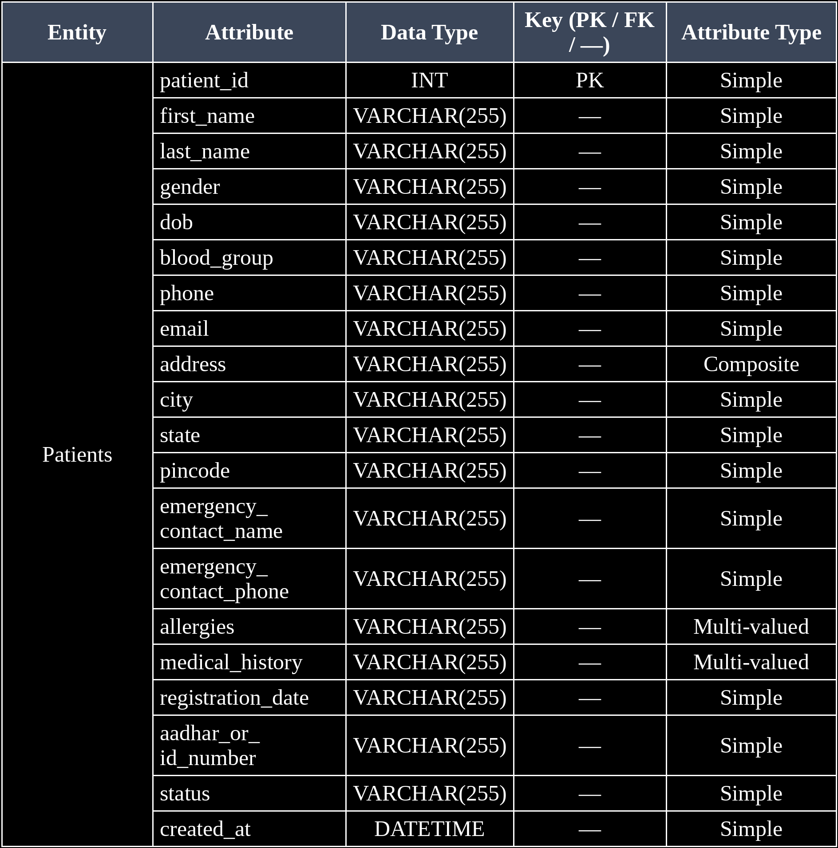

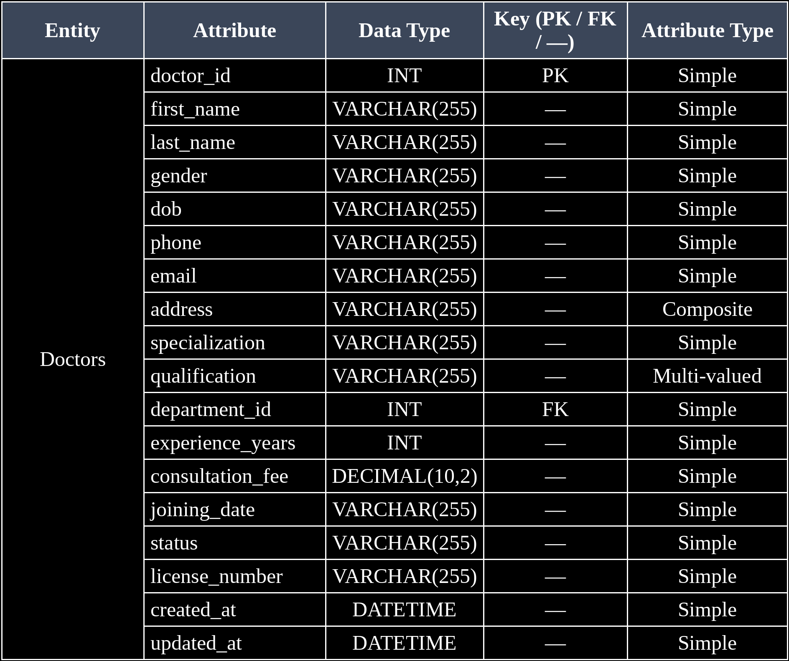

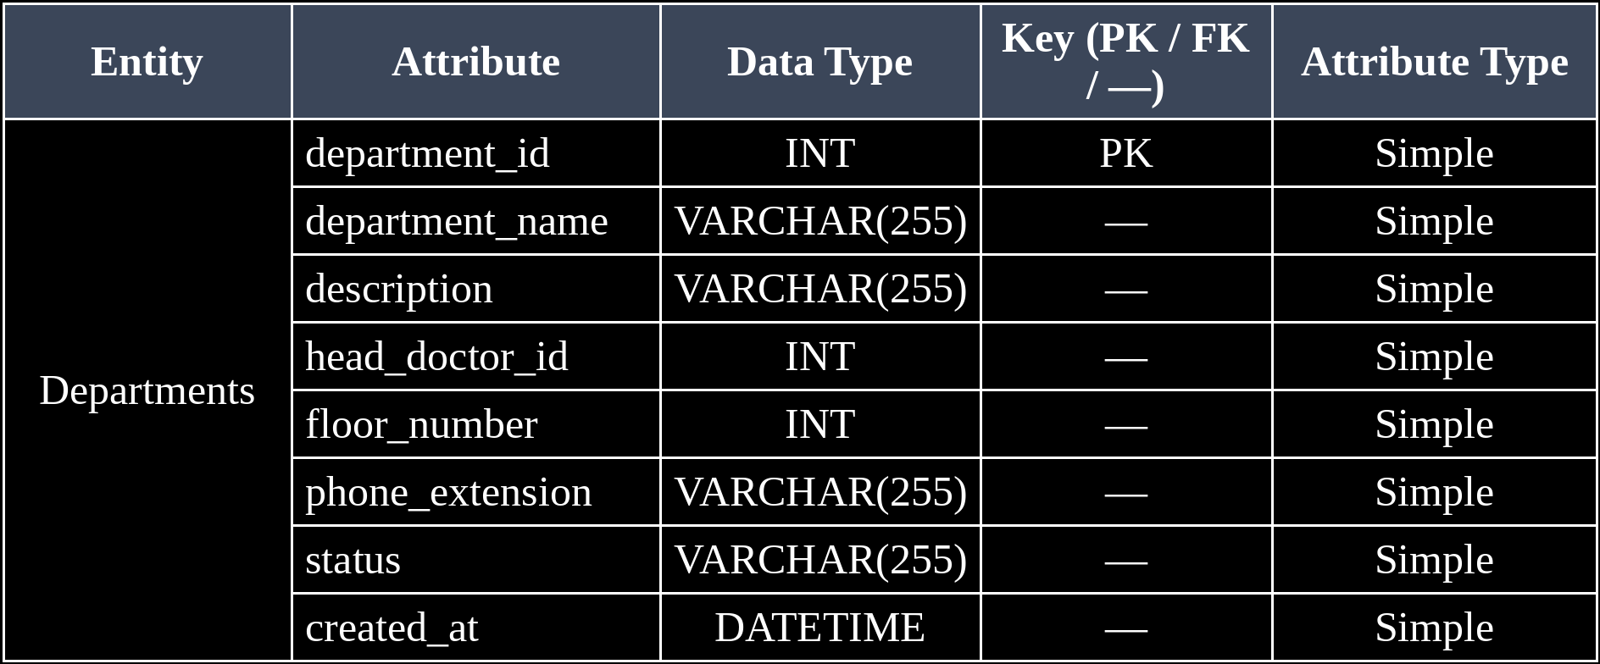

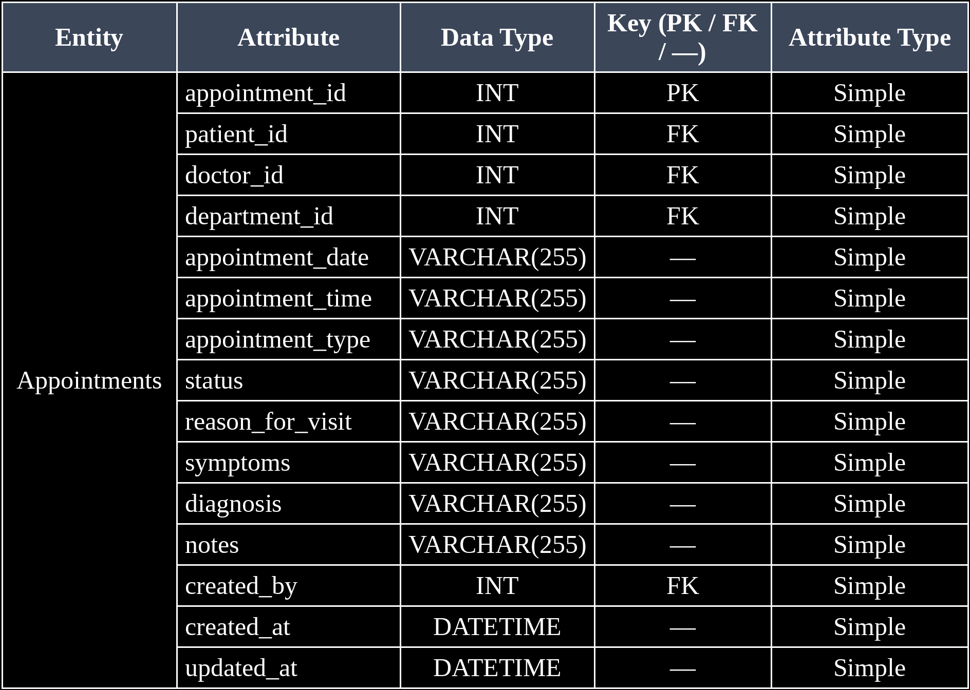

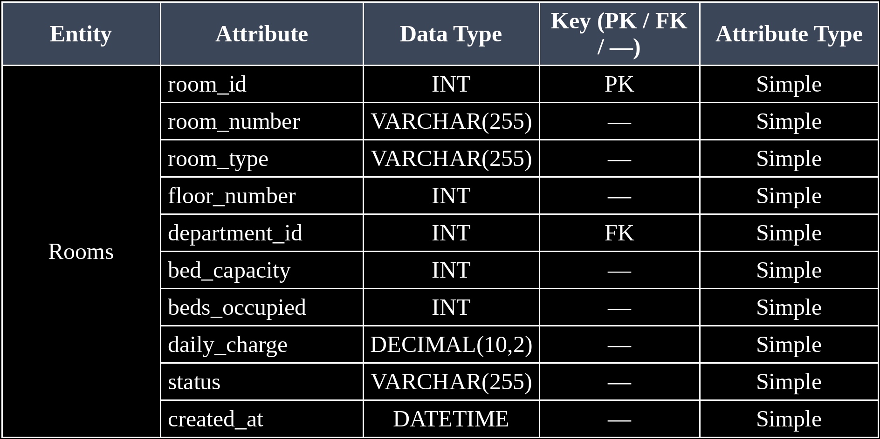
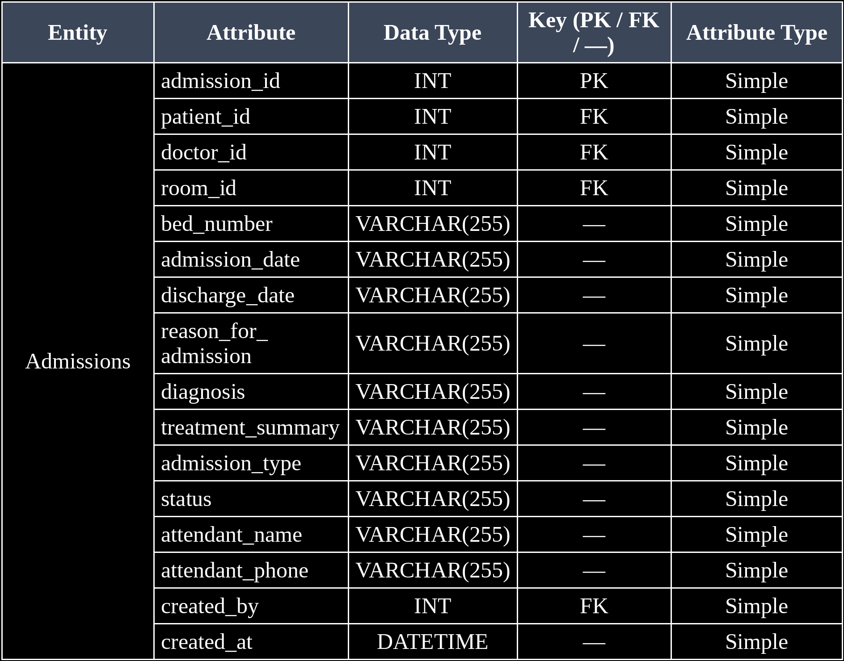

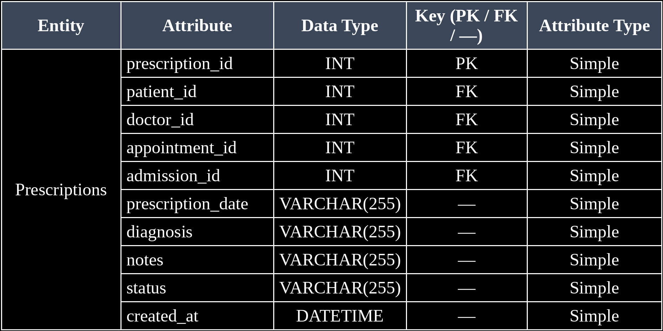

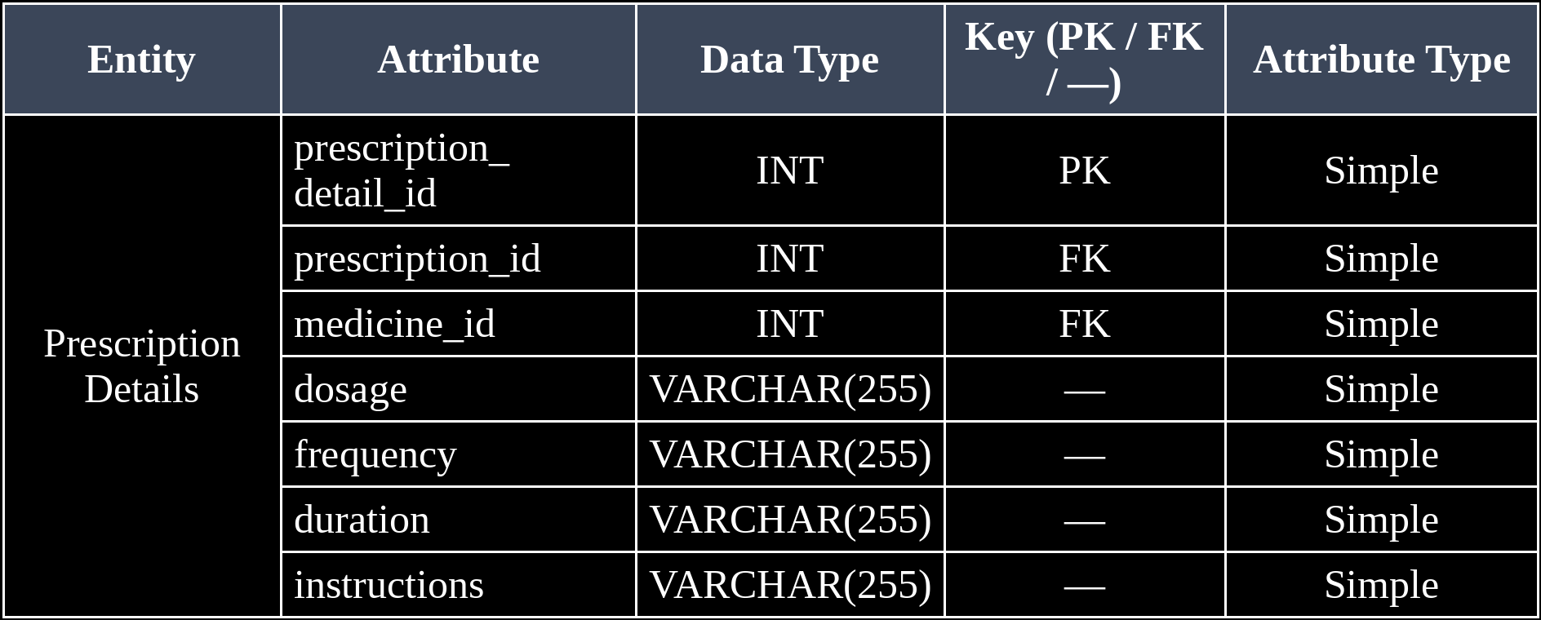

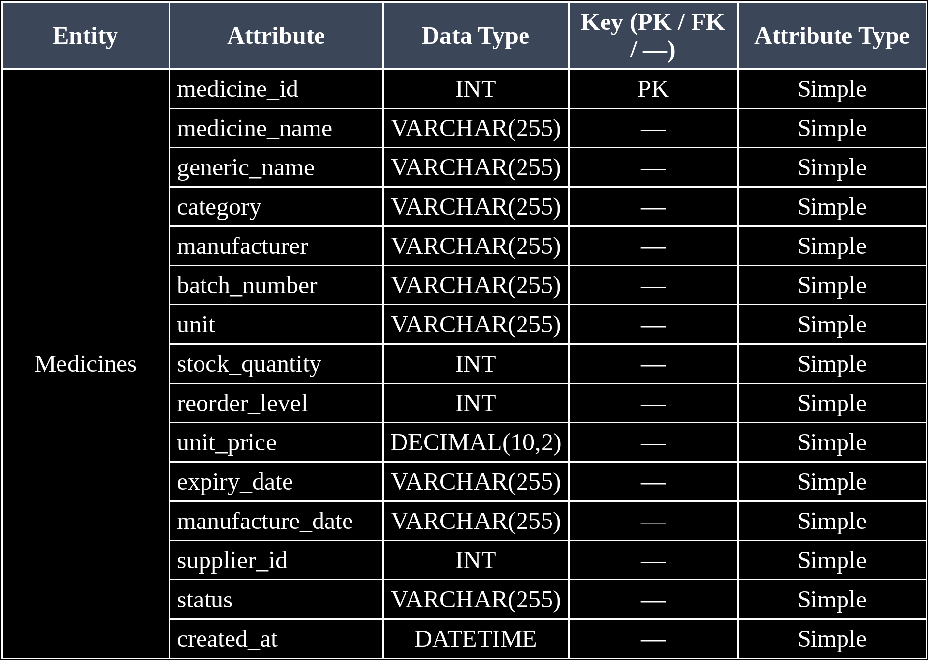

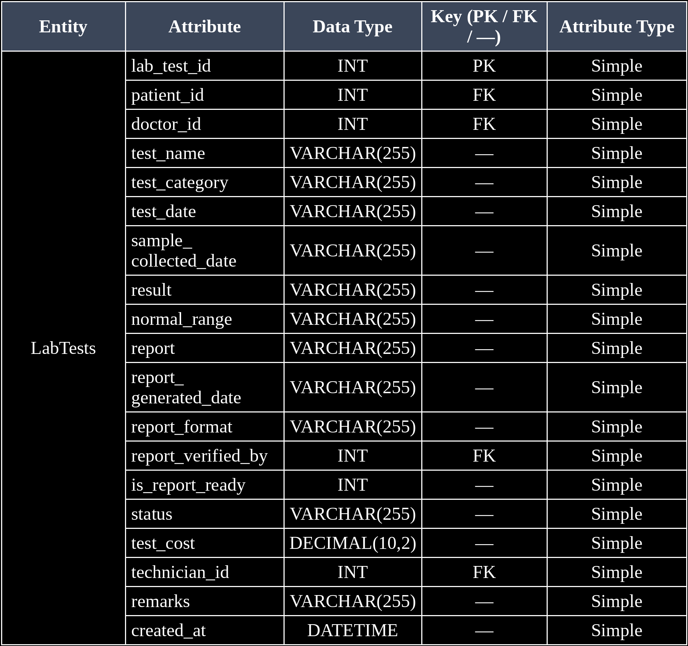

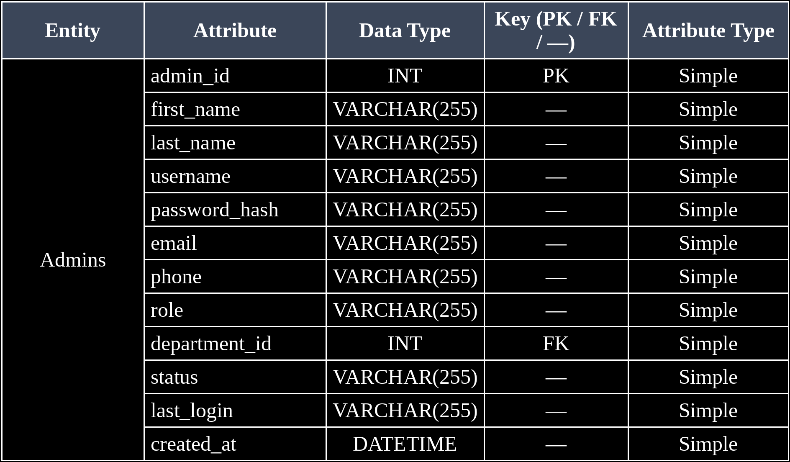

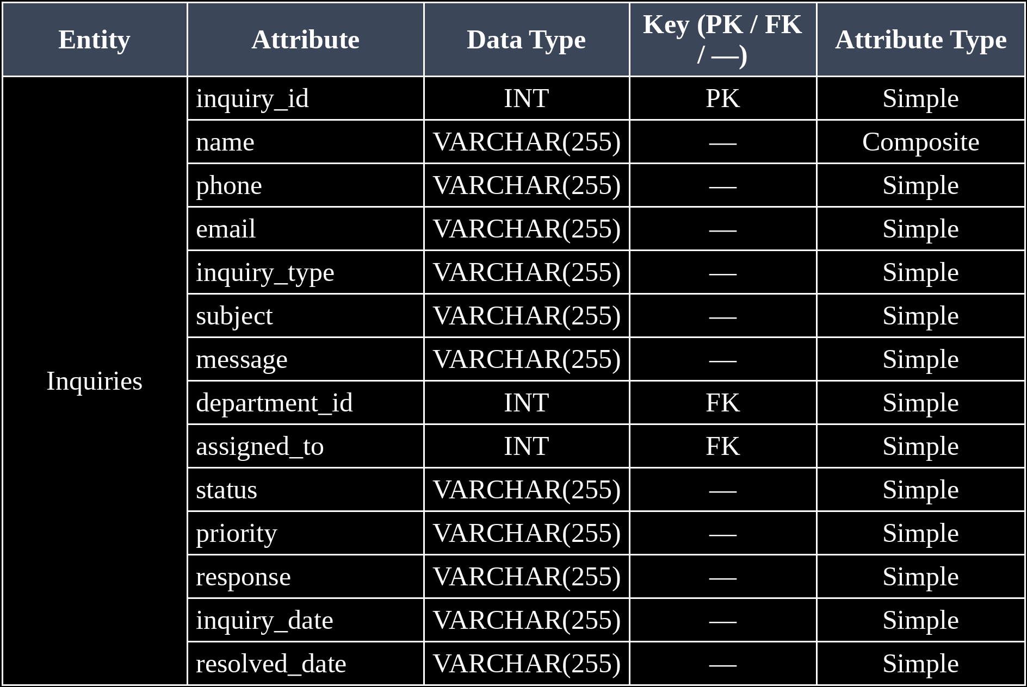
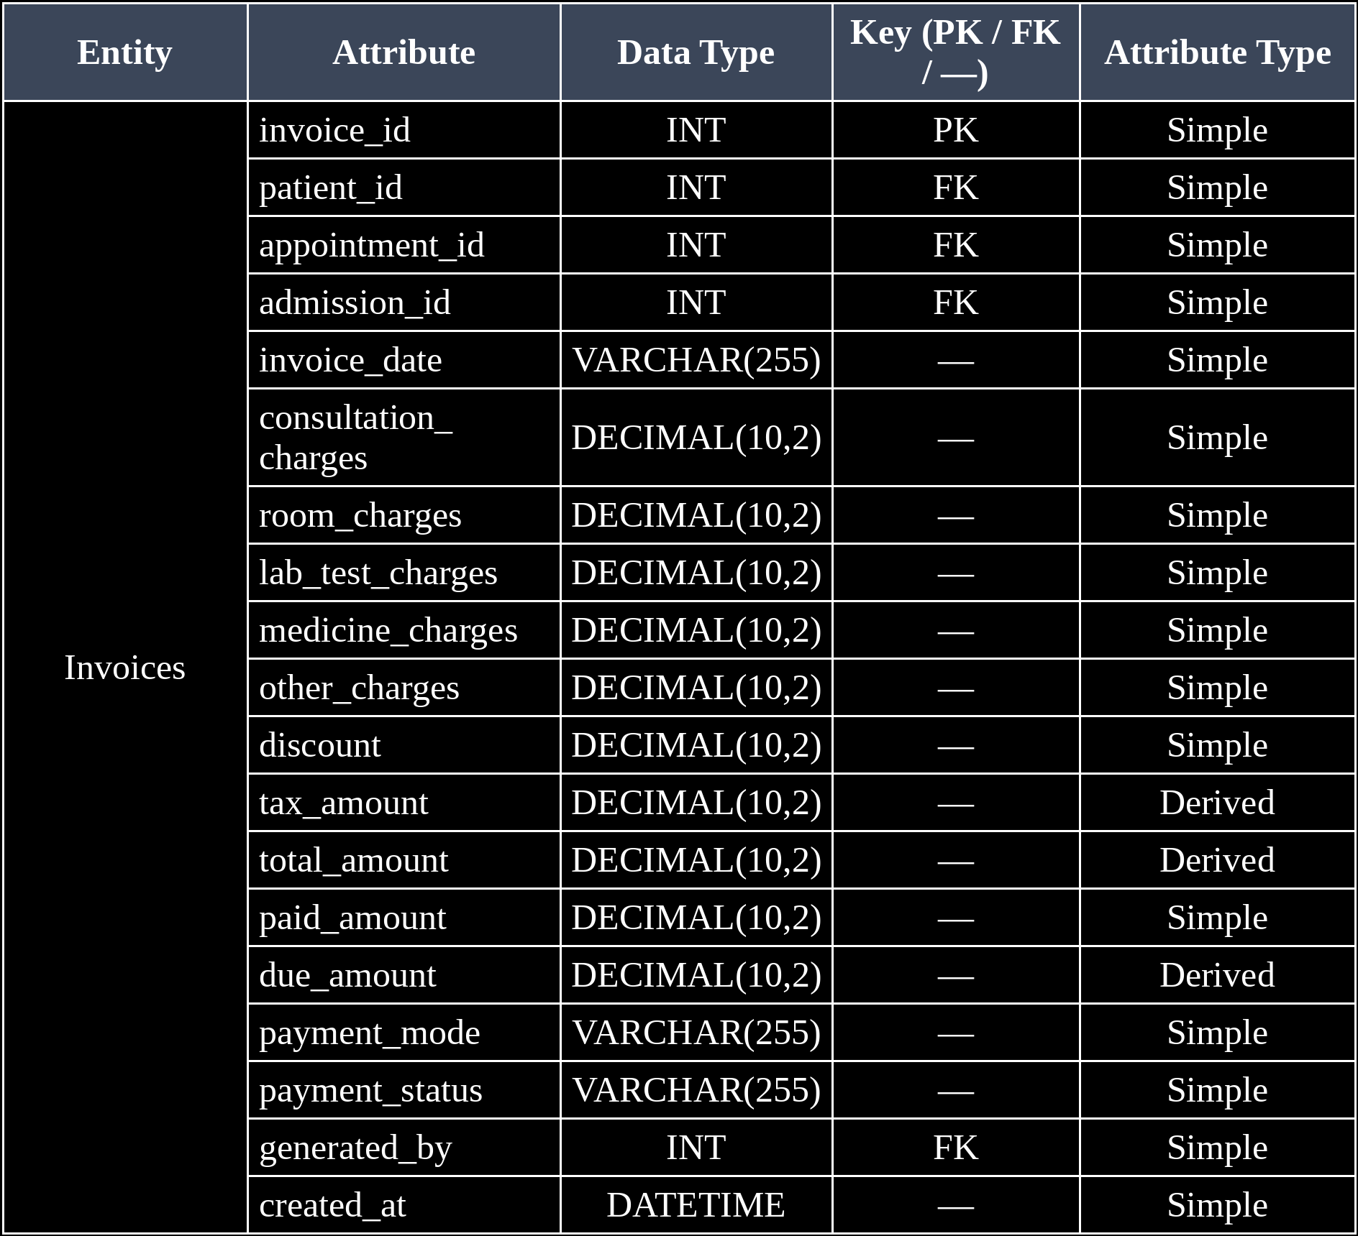

3.3 ER Diagram
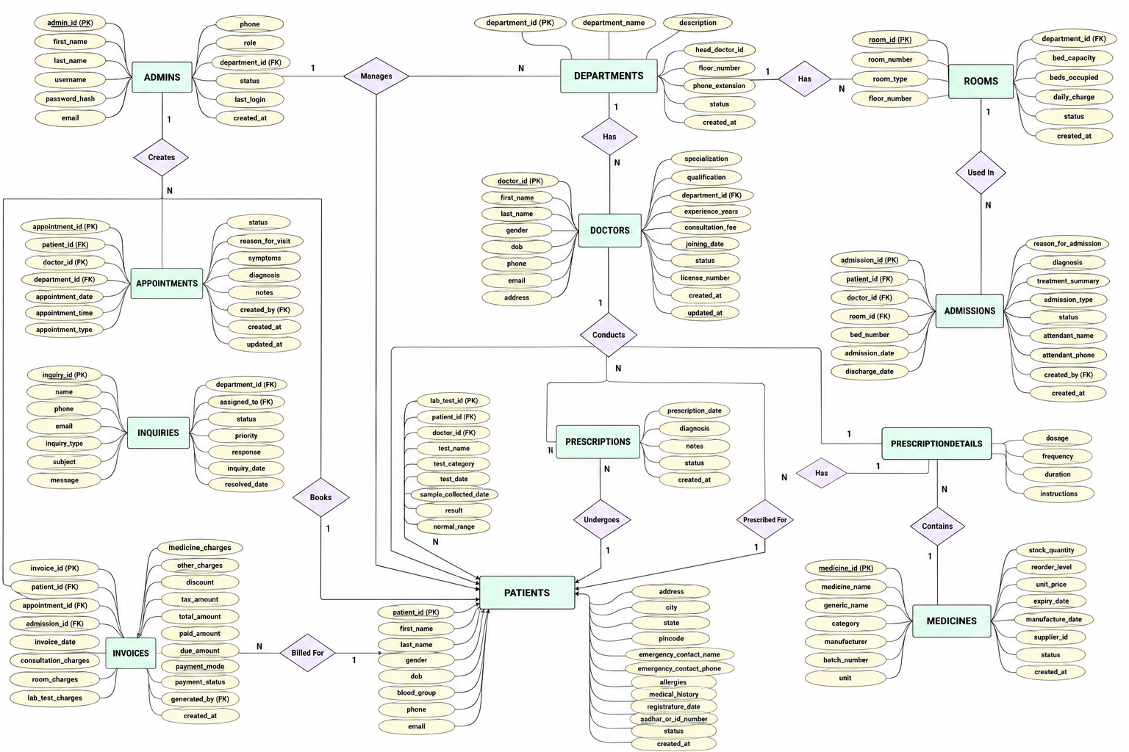

Fig. 3.1: ER Diagram of the System

3.4 Relationships and Cardinality
Table 3.3: Relationships and Cardinality
Entity 1 | Relationship | Entity 2 | Cardinality (1:1 / 1:N / M:N) | Participation
Department | Has | Doctor | 1:N | Partial – Partial
Doctor | Belongs to | Department | N:1 | Partial – Partial
Patient | Books | Appointment | 1:N | Partial – Partial
Appointment | Is Booked by | Patient | N:1 | Partial – Partial
Patient | Has | Admission | 1:N | Partial – Partial
Admission | Belongs to | Patient | N:1 | Partial – Partial
Patient | Undergoes | Lab Test | 1:N | Partial – Partial
Lab Test | Is performed for | Patient | N:1 | Partial – Partial
Prescription | Contains | Prescription Details | 1:N | Partial – Partial
Prescription Details | Refers to | Medicine | N:1 | Partial – Partial

3.5 Relational Database Schema

Table 3.4: Relational Database Schema
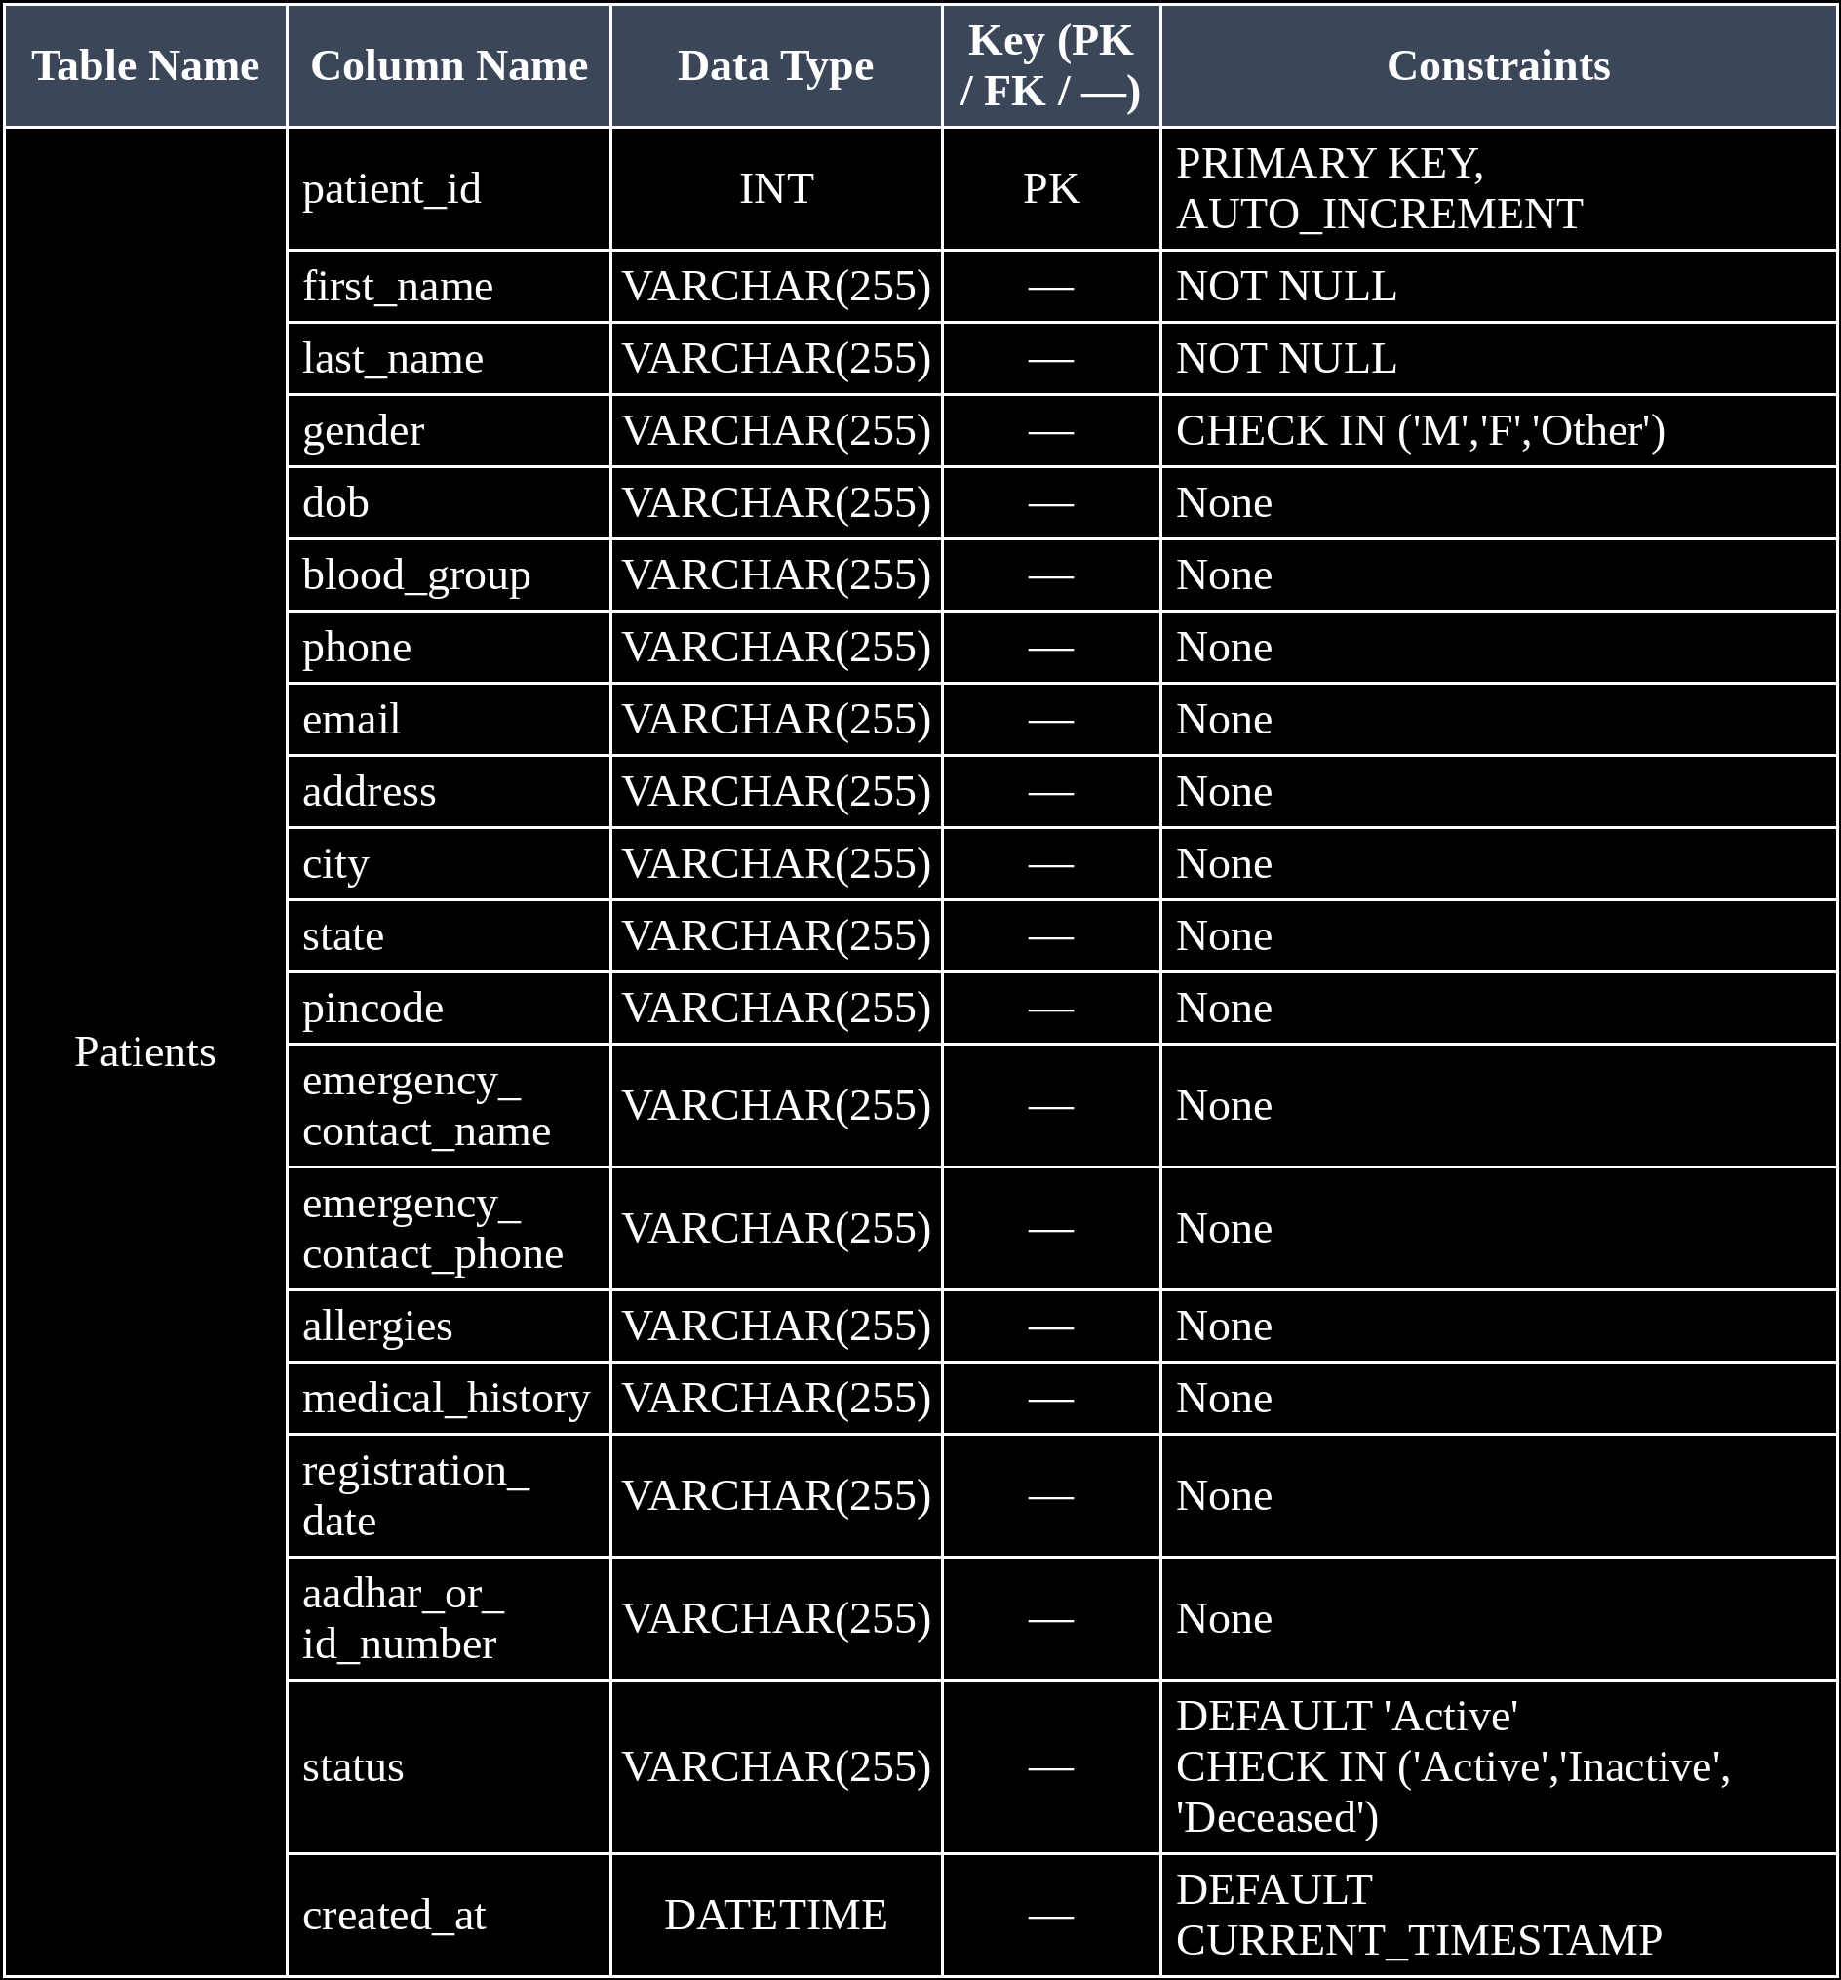
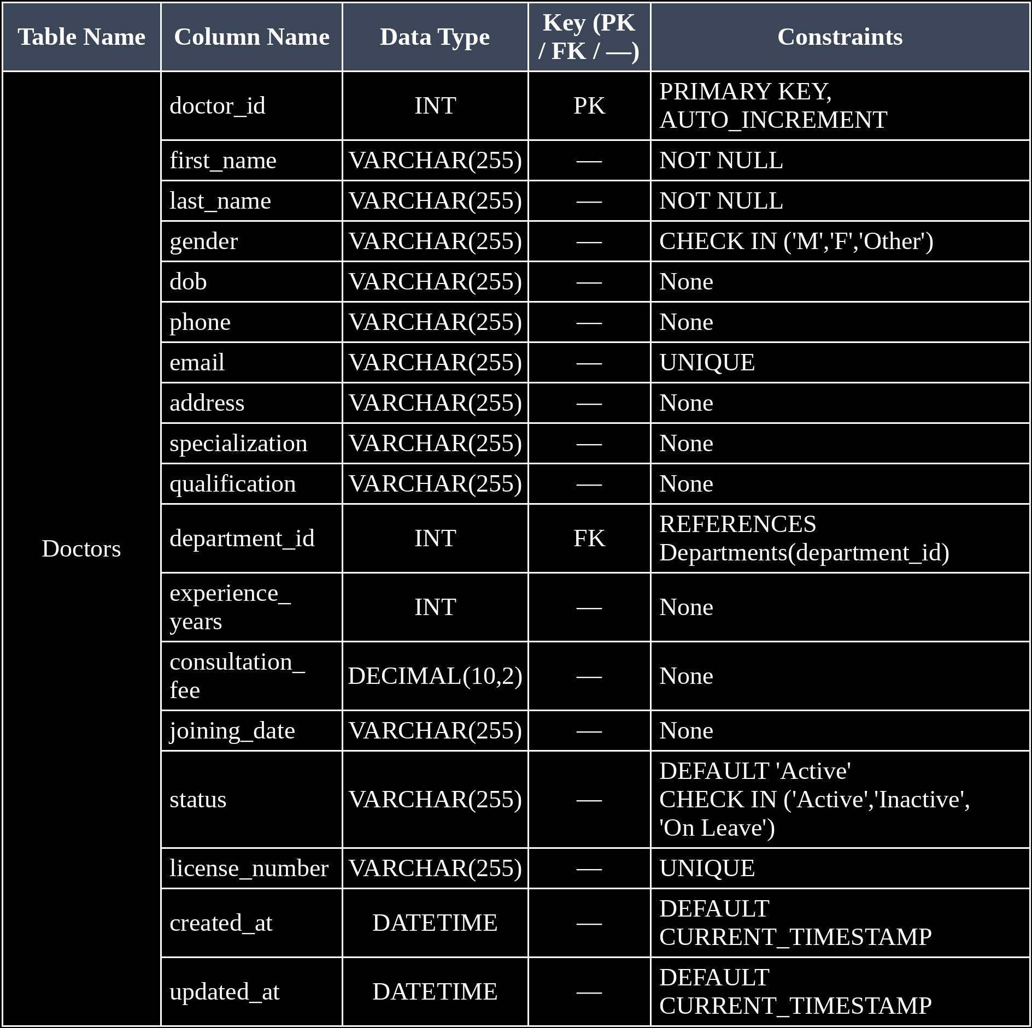

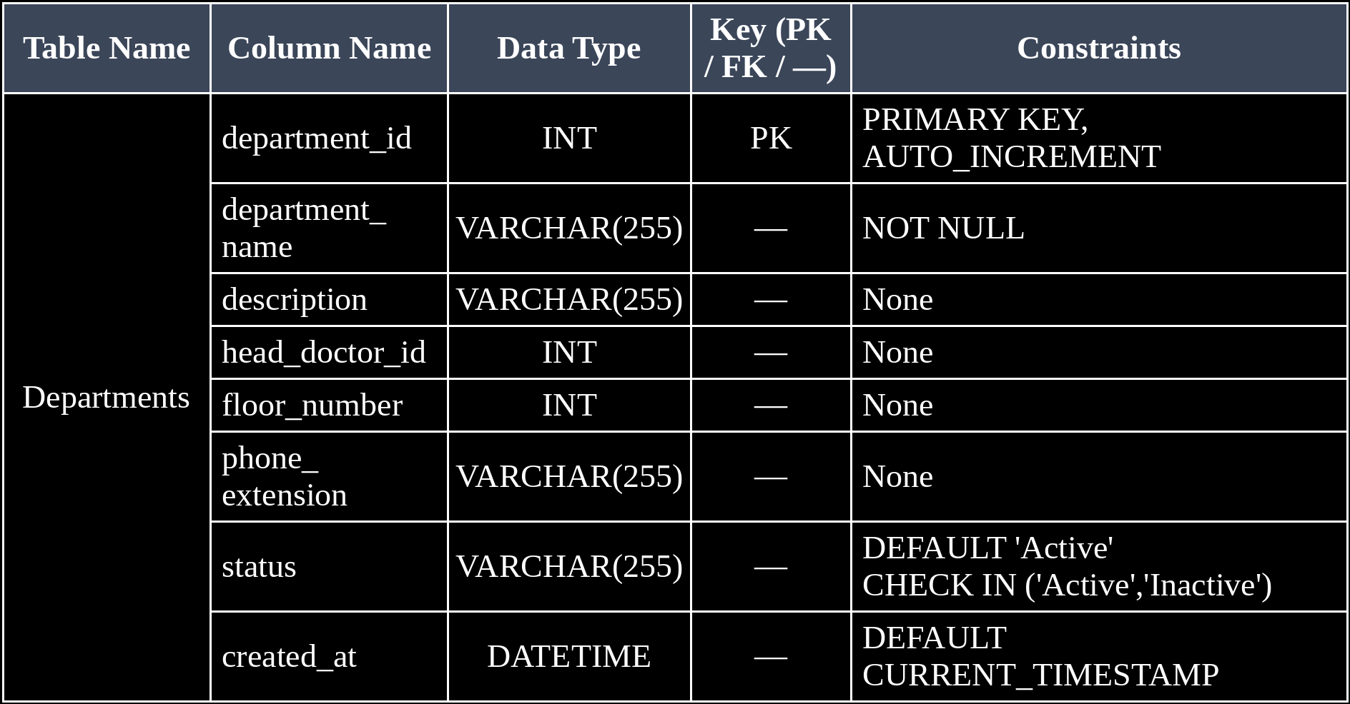
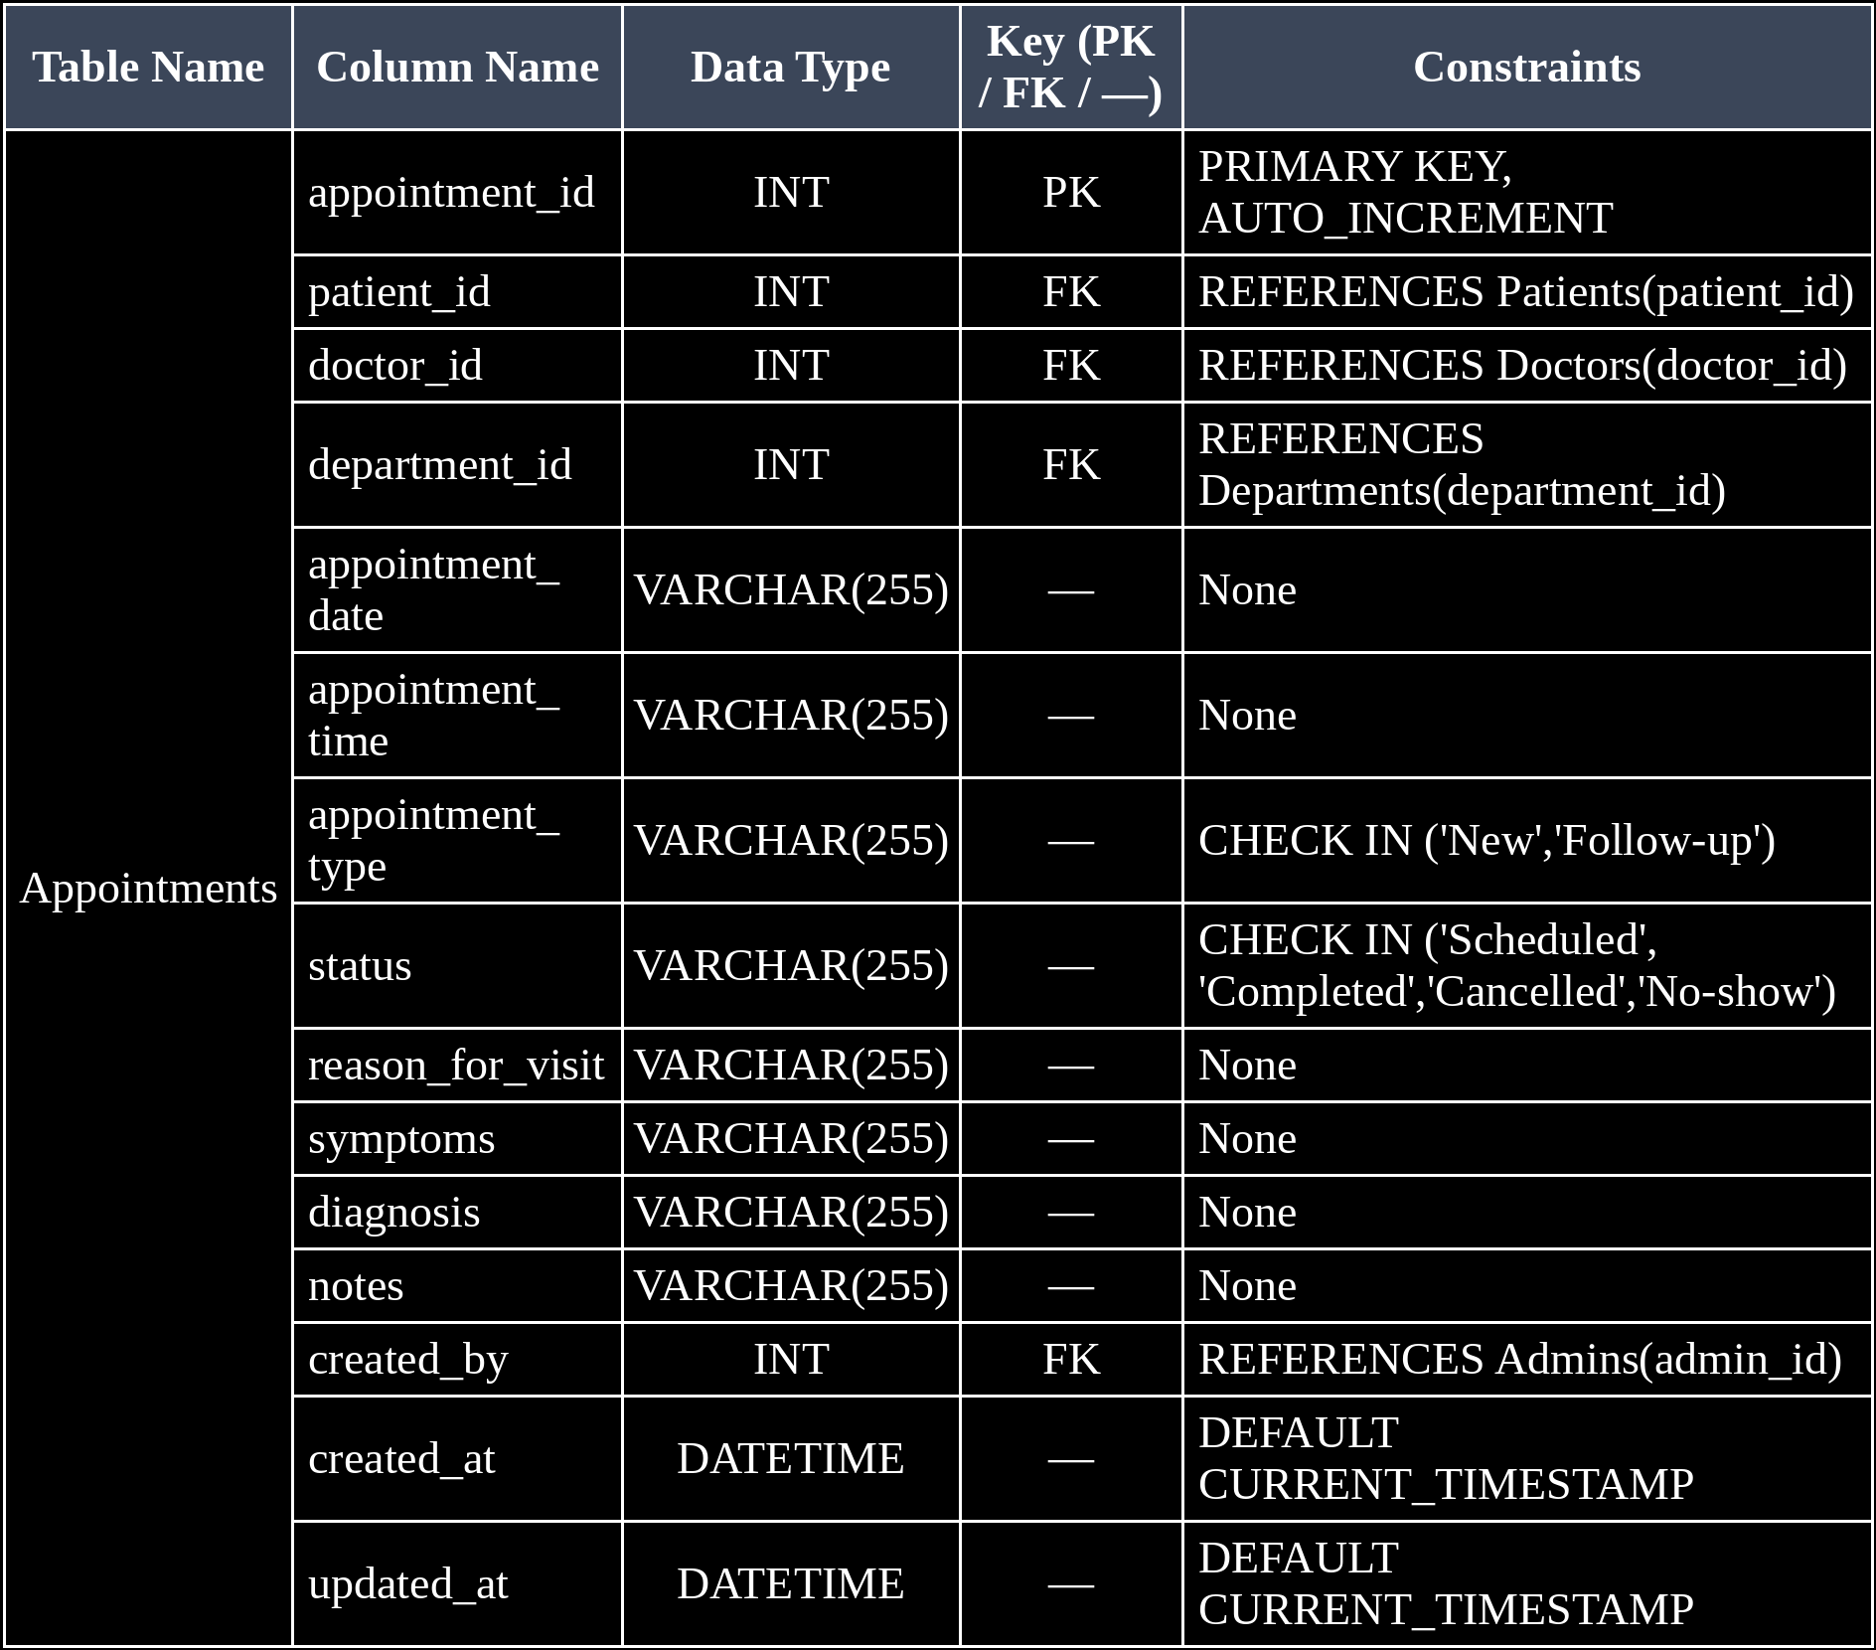
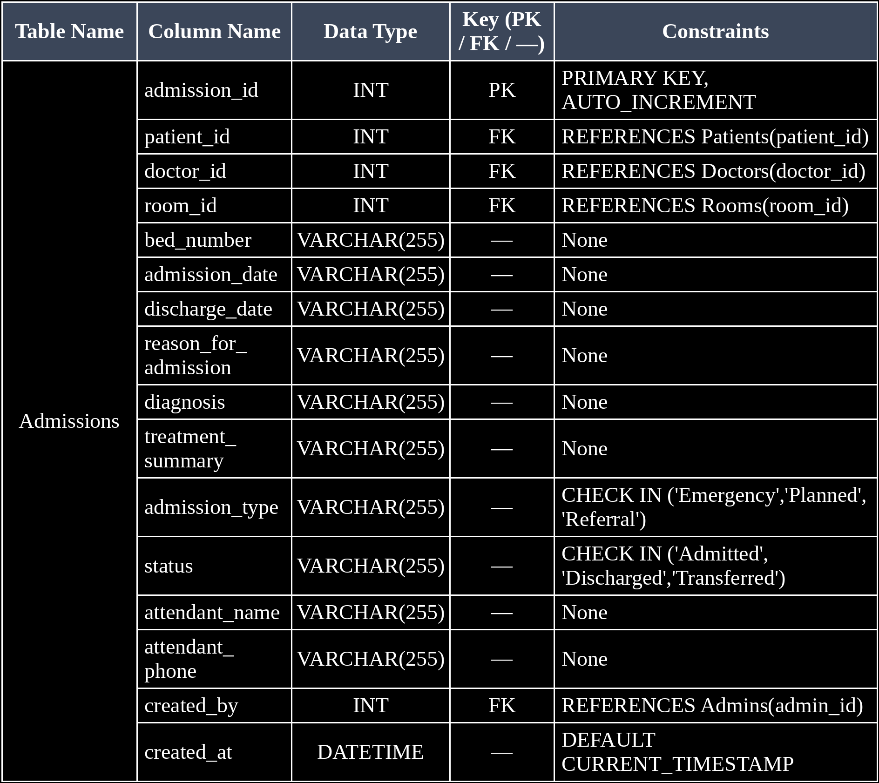

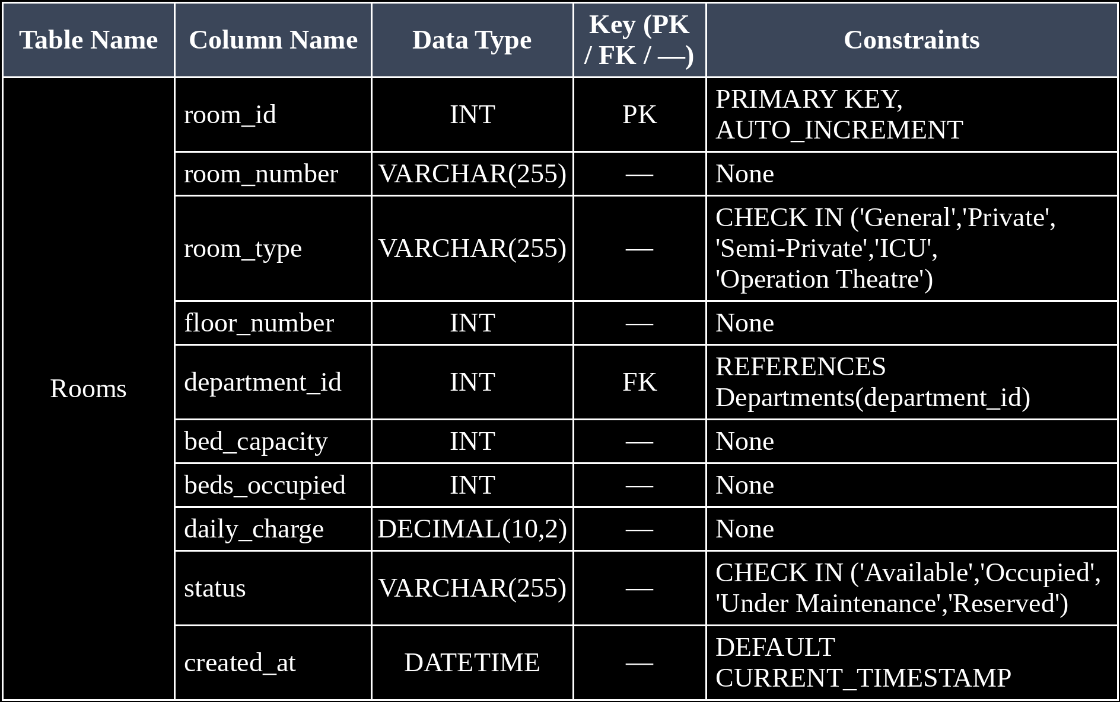

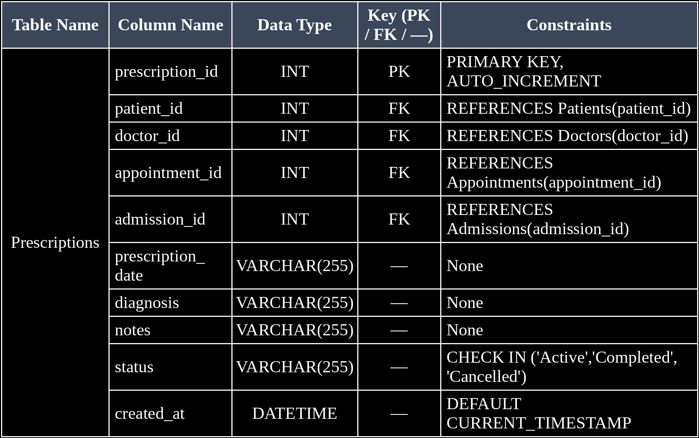

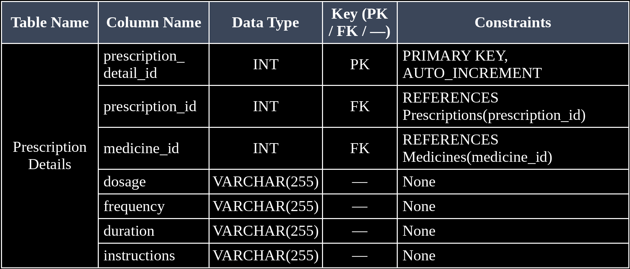

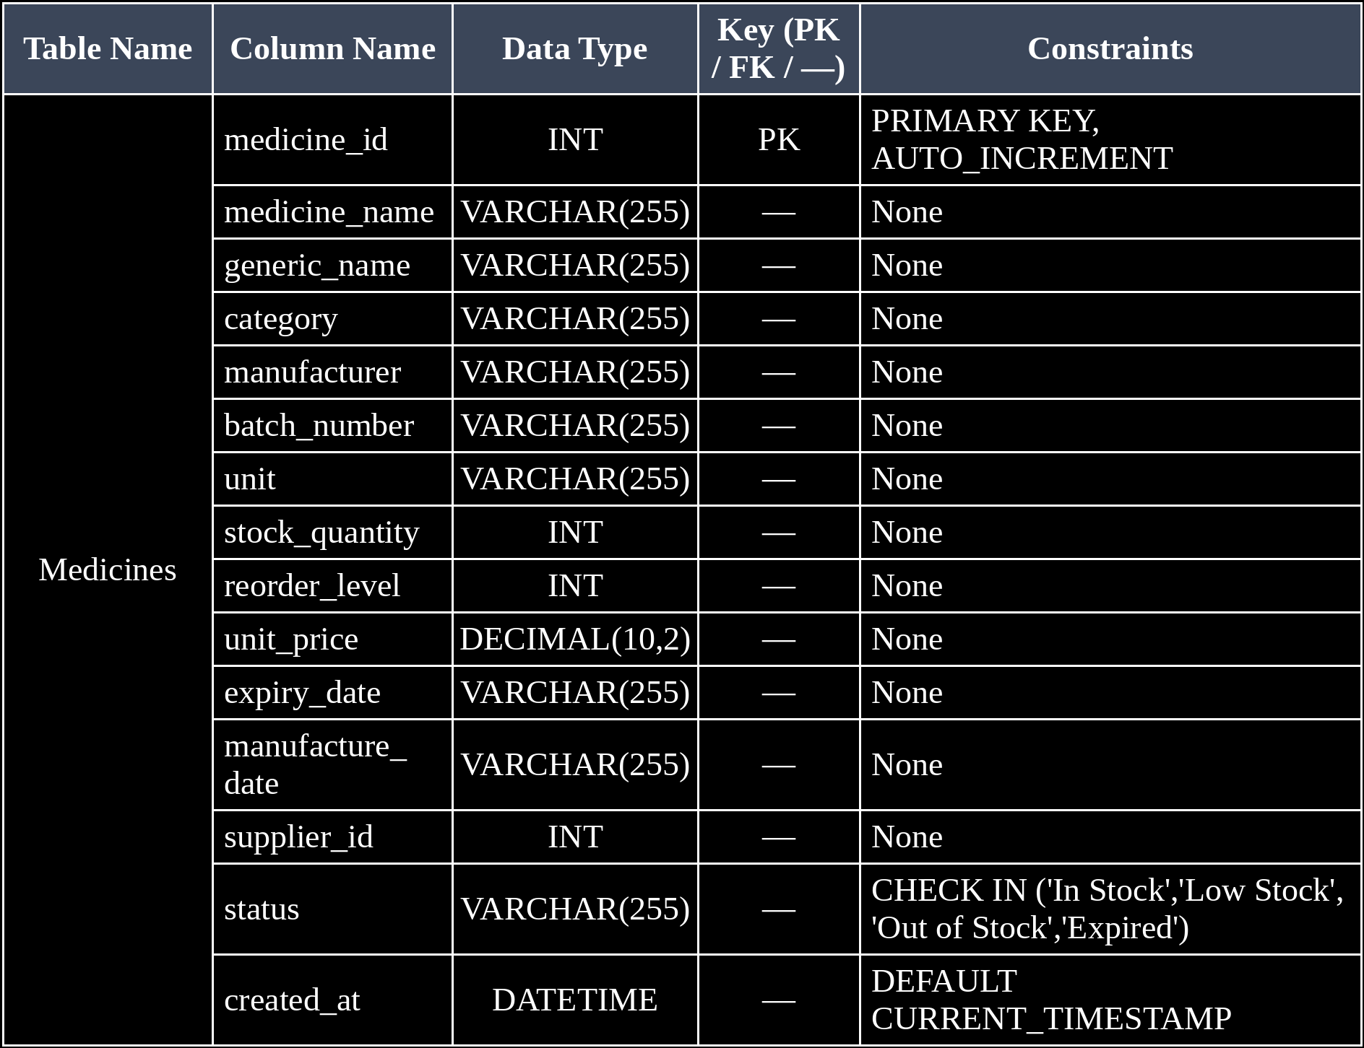

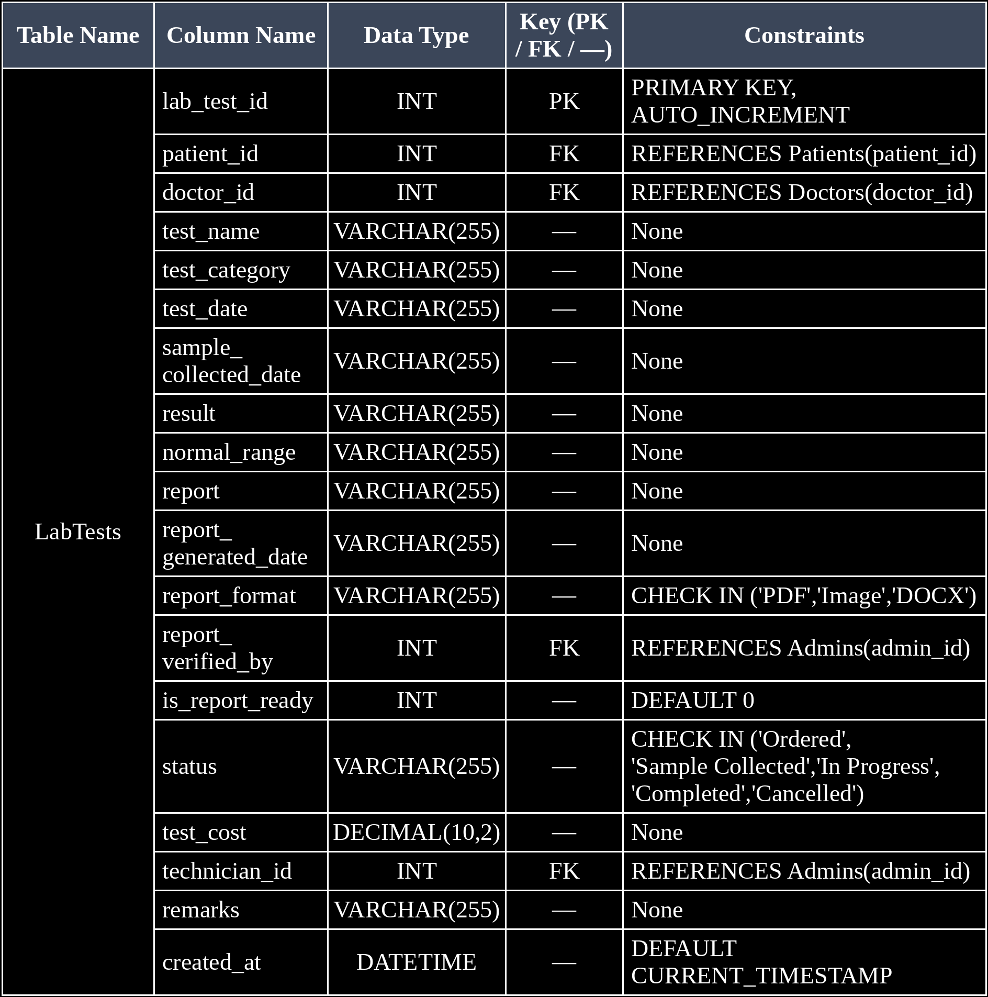
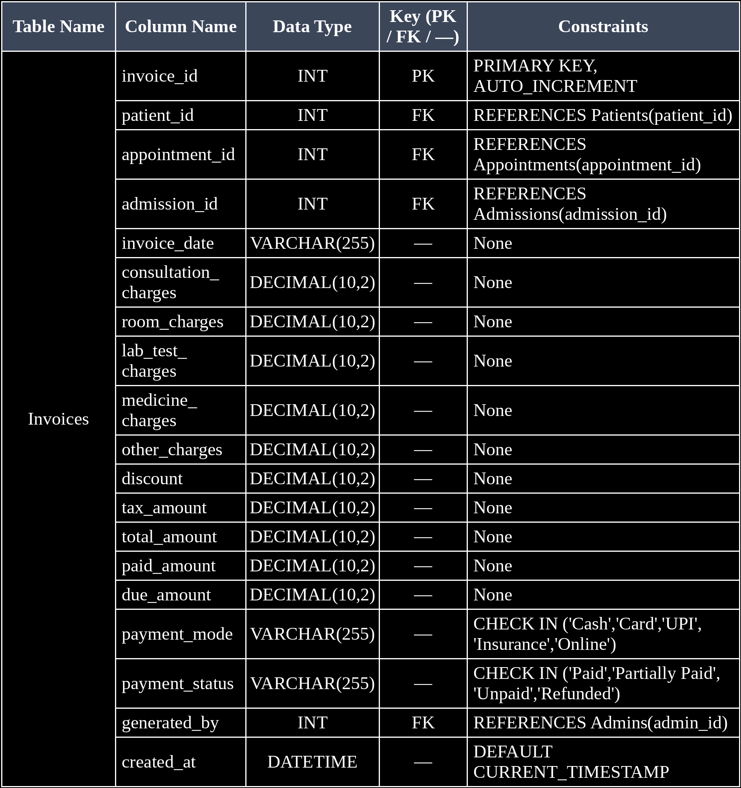

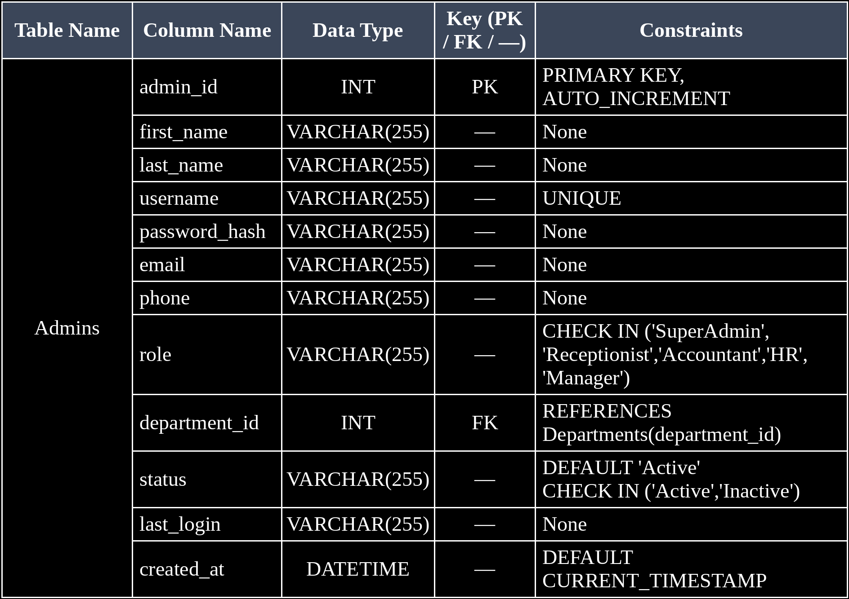

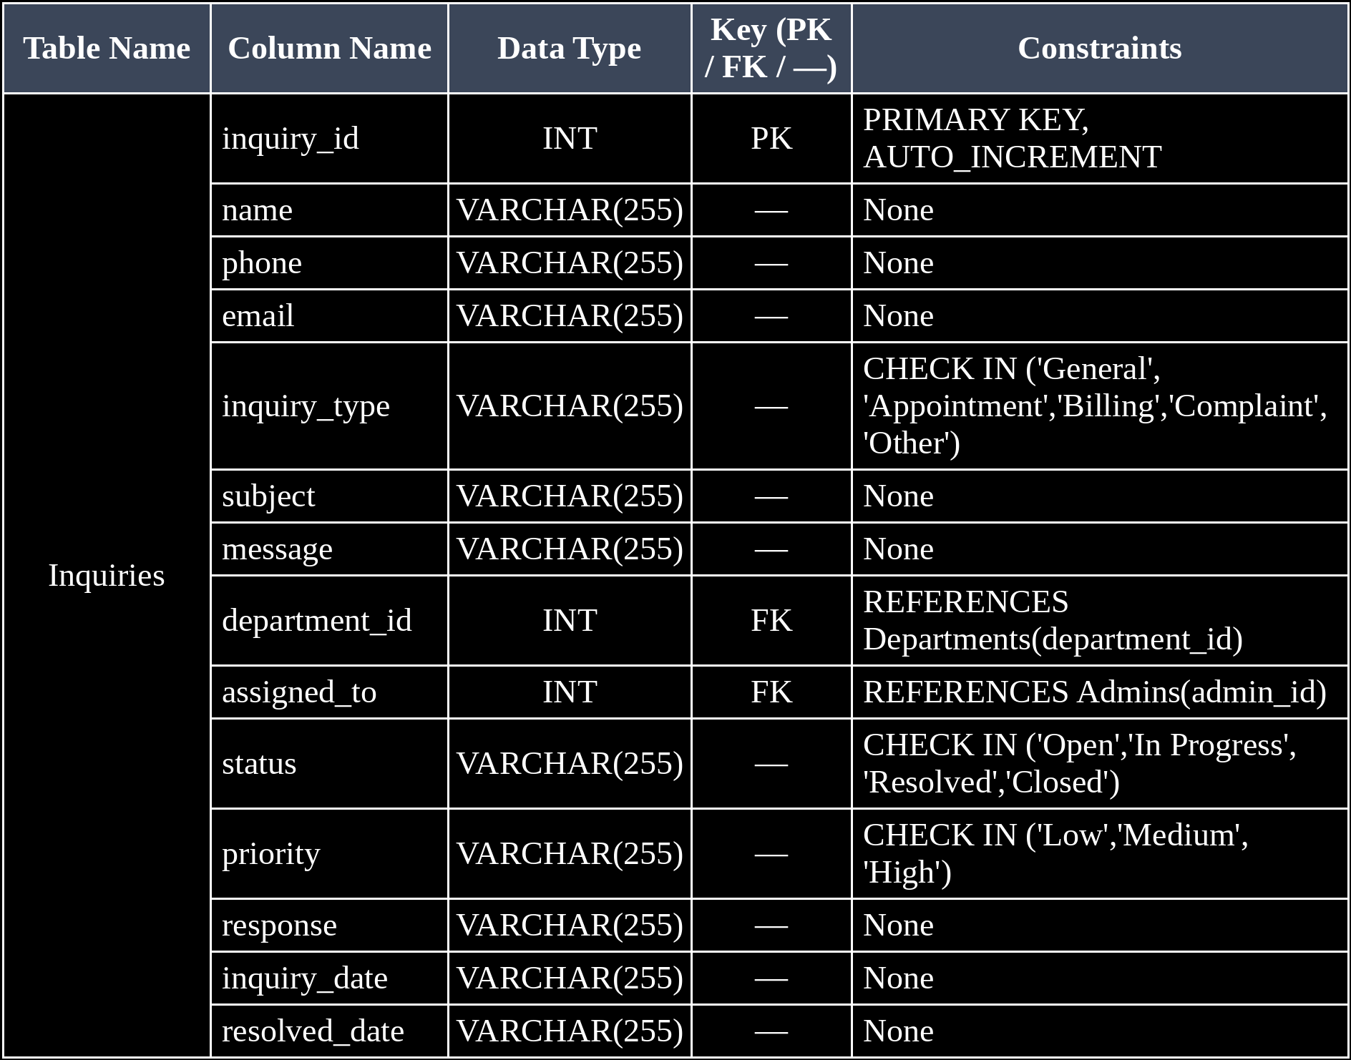

Schema Diagram
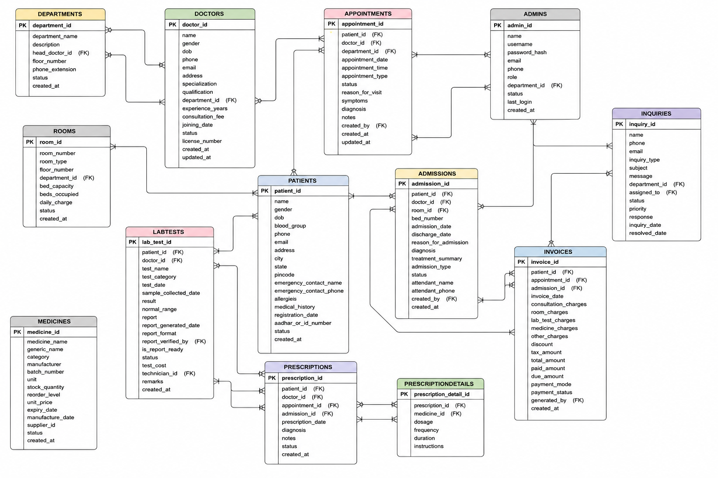

Fig. 3.2: Relational Schema Diagram

3.6 Primary Keys and Foreign Keys
Table 3.5: Primary Key and Foreign Key Definitions
Table | Primary Key | Foreign Key | References (Table.Column)
Admins | admin_id | department_id | Departments.department_id
Admissions | admission_id | patient_id | Patients.patient_id
Appointments | appointment_id | patient_id | Patients.patient_id
Departments | department_id | — | —
Doctors | doctor_id | department_id | Departments.department_id
Inquiries | inquiry_id | department_id | Departments.department_id
Invoices | invoice_id | patient_id | Patients.patient_id
Lab Tests | lab_test_id | patient_id | Patients.patient_id
Medicines | medicine_id | — | —
Patients | patient_id | — | —
Prescription Details | prescription_detail_id | prescription_id | Prescriptions.prescription_id
Prescription | prescription_id | patient_id | Patients.patient_id
Rooms | room_id | department_id | Departments.department_id

3.7 Normalization up to 3NF
UNF → 1NF → 2NF → 3NF
Table 3.6: Normalization Steps
Normal Form | Condition Satisfied | Anomaly Removed | Resulting Tables
UNF | Data may contain repeating groups and multiple values in a single record. |  | Hospital_Records
  —
1NF | All attributes contain atomic/single values and repeating groups are removed. | Repeating-group and insertion anomalies | Patients, Appointments, Admissions
2NF | 1NF satisfied and all non-key attributes depend completely on the primary key. | Partial dependency and update anomalies | Patients, Doctors, Departments, Appointments, Admissions, Rooms
3NF | 2NF satisfied and non-key attributes depend only on the primary key, with no transitive dependency. | Transitive dependency, update and deletion anomalies | Admins, Patients, Doctors, Departments, Appointments, Admissions, Inquiries, Invoices, LabTests, Medicines, PrescriptionDetails, Prescriptions, Rooms

CHAPTER 4: DATABASE IMPLEMENTATION
(Deliverables of Review – II)

4.1 Database and Table Creation – DDL

CREATE DATABASE IF NOT EXISTS hospital_db;

USE hospital_db;

SET NAMES utf8mb4;

SET FOREIGN_KEY_CHECKS = 0;

DROP TABLE IF EXISTS `Admins`;

CREATE TABLE `Admins` (
admin_id INT AUTO_INCREMENT PRIMARY KEY,
first_name VARCHAR(255),
last_name VARCHAR(255),
username VARCHAR(255) UNIQUE,
password_hash VARCHAR(255),
email VARCHAR(255),
phone VARCHAR(255),
role VARCHAR(255) CHECK(role IN ('SuperAdmin','Receptionist','Accountant','HR','Manager')),
department_id INT,
status VARCHAR(255) DEFAULT 'Active' CHECK(status IN ('Active','Inactive')),
last_login VARCHAR(255),
created_at DATETIME DEFAULT CURRENT_TIMESTAMP,
FOREIGN KEY (department_id) REFERENCES `Departments`(department_id)
) ENGINE=InnoDB DEFAULT CHARSET=utf8mb4;

DROP TABLE IF EXISTS `Admissions`;

CREATE TABLE `Admissions` (
admission_id INT AUTO_INCREMENT PRIMARY KEY,
patient_id INT,
doctor_id INT,
room_id INT,
bed_number VARCHAR(255),
admission_date VARCHAR(255),
discharge_date VARCHAR(255),
reason_for_admission VARCHAR(255),
diagnosis VARCHAR(255),
treatment_summary VARCHAR(255),
admission_type VARCHAR(255) CHECK(admission_type IN ('Emergency','Planned','Referral')),
status VARCHAR(255) CHECK(status IN ('Admitted','Discharged','Transferred')),
attendant_name VARCHAR(255),
attendant_phone VARCHAR(255),
created_by INT,
created_at DATETIME DEFAULT CURRENT_TIMESTAMP,
FOREIGN KEY (patient_id) REFERENCES `Patients`(patient_id),
FOREIGN KEY (doctor_id) REFERENCES `Doctors`(doctor_id),
FOREIGN KEY (room_id) REFERENCES `Rooms`(room_id),
FOREIGN KEY (created_by) REFERENCES `Admins`(admin_id)
) ENGINE=InnoDB DEFAULT CHARSET=utf8mb4;

DROP TABLE IF EXISTS `Appointments`;

CREATE TABLE `Appointments` (
appointment_id INT AUTO_INCREMENT PRIMARY KEY,
patient_id INT,
doctor_id INT,
department_id INT,
appointment_date VARCHAR(255),
appointment_time VARCHAR(255),
appointment_type VARCHAR(255) CHECK(appointment_type IN ('New','Follow-up')),
status VARCHAR(255) CHECK(status IN ('Scheduled','Completed','Cancelled','No-show')),
reason_for_visit VARCHAR(255),
symptoms VARCHAR(255),
diagnosis VARCHAR(255),
notes VARCHAR(255),
created_by INT,
created_at DATETIME DEFAULT CURRENT_TIMESTAMP,
updated_at DATETIME DEFAULT CURRENT_TIMESTAMP,
FOREIGN KEY (patient_id) REFERENCES `Patients`(patient_id),
FOREIGN KEY (doctor_id) REFERENCES `Doctors`(doctor_id),
FOREIGN KEY (department_id) REFERENCES `Departments`(department_id),
FOREIGN KEY (created_by) REFERENCES `Admins`(admin_id)
) ENGINE=InnoDB DEFAULT CHARSET=utf8mb4;

DROP TABLE IF EXISTS `Departments`;

CREATE TABLE `Departments` (
department_id INT AUTO_INCREMENT PRIMARY KEY,
department_name VARCHAR(255) NOT NULL,
description VARCHAR(255),
head_doctor_id INT,
floor_number INT,
phone_extension VARCHAR(255),
status VARCHAR(255) DEFAULT 'Active' CHECK(status IN ('Active','Inactive')),
created_at DATETIME DEFAULT CURRENT_TIMESTAMP
) ENGINE=InnoDB DEFAULT CHARSET=utf8mb4;

DROP TABLE IF EXISTS `Doctors`;

CREATE TABLE `Doctors` (
doctor_id INT AUTO_INCREMENT PRIMARY KEY,
first_name VARCHAR(255) NOT NULL,
last_name VARCHAR(255) NOT NULL,
gender VARCHAR(255) CHECK(gender IN ('M','F','Other')),
dob VARCHAR(255),
phone VARCHAR(255),
email VARCHAR(255) UNIQUE,
address VARCHAR(255),
specialization VARCHAR(255),
qualification VARCHAR(255),
department_id INT,
experience_years INT,
consultation_fee DECIMAL(10,2),
joining_date VARCHAR(255),
status VARCHAR(255) DEFAULT 'Active' CHECK(status IN ('Active','Inactive','On Leave')),
license_number VARCHAR(255) UNIQUE,
created_at DATETIME DEFAULT CURRENT_TIMESTAMP,
updated_at DATETIME DEFAULT CURRENT_TIMESTAMP,
FOREIGN KEY (department_id) REFERENCES `Departments`(department_id)
) ENGINE=InnoDB DEFAULT CHARSET=utf8mb4;

DROP TABLE IF EXISTS `Inquiries`;

CREATE TABLE `Inquiries` (
inquiry_id INT AUTO_INCREMENT PRIMARY KEY,
name VARCHAR(255),
phone VARCHAR(255),
email VARCHAR(255),
inquiry_type VARCHAR(255) CHECK(inquiry_type IN ('General','Appointment','Billing','Complaint','Other')),
subject VARCHAR(255),
message VARCHAR(255),
department_id INT,
assigned_to INT,
status VARCHAR(255) CHECK(status IN ('Open','In Progress','Resolved','Closed')),
priority VARCHAR(255) CHECK(priority IN ('Low','Medium','High')),
response VARCHAR(255),
inquiry_date VARCHAR(255),
resolved_date VARCHAR(255),
FOREIGN KEY (department_id) REFERENCES `Departments`(department_id),
FOREIGN KEY (assigned_to) REFERENCES `Admins`(admin_id)
) ENGINE=InnoDB DEFAULT CHARSET=utf8mb4;

DROP TABLE IF EXISTS `Invoices`;

CREATE TABLE `Invoices` (
invoice_id INT AUTO_INCREMENT PRIMARY KEY,
patient_id INT,
appointment_id INT,
admission_id INT,
invoice_date VARCHAR(255),
consultation_charges DECIMAL(10,2),
room_charges DECIMAL(10,2),
lab_test_charges DECIMAL(10,2),
medicine_charges DECIMAL(10,2),
other_charges DECIMAL(10,2),
discount DECIMAL(10,2),
tax_amount DECIMAL(10,2),
total_amount DECIMAL(10,2),
paid_amount DECIMAL(10,2),
due_amount DECIMAL(10,2),
payment_mode VARCHAR(255) CHECK(payment_mode IN ('Cash','Card','UPI','Insurance','Online')),
payment_status VARCHAR(255) CHECK(payment_status IN ('Paid','Partially Paid','Unpaid','Refunded')),
generated_by INT,
created_at DATETIME DEFAULT CURRENT_TIMESTAMP,
FOREIGN KEY (patient_id) REFERENCES `Patients`(patient_id),
FOREIGN KEY (appointment_id) REFERENCES `Appointments`(appointment_id),
FOREIGN KEY (admission_id) REFERENCES `Admissions`(admission_id),
FOREIGN KEY (generated_by) REFERENCES `Admins`(admin_id)
) ENGINE=InnoDB DEFAULT CHARSET=utf8mb4;

DROP TABLE IF EXISTS `LabTests`;

CREATE TABLE `LabTests` (
lab_test_id INT AUTO_INCREMENT PRIMARY KEY,
patient_id INT,
doctor_id INT,
test_name VARCHAR(255),
test_category VARCHAR(255),
test_date VARCHAR(255),
sample_collected_date VARCHAR(255),
result VARCHAR(255),
normal_range VARCHAR(255),
report VARCHAR(255),
report_generated_date VARCHAR(255),
report_format VARCHAR(255) CHECK(report_format IN ('PDF','Image','DOCX')),
report_verified_by INT,
is_report_ready INT DEFAULT 0,
status VARCHAR(255) CHECK(status IN ('Ordered','Sample Collected','In Progress','Completed','Cancelled')),
test_cost DECIMAL(10,2),
technician_id INT,
remarks VARCHAR(255),
created_at DATETIME DEFAULT CURRENT_TIMESTAMP,
FOREIGN KEY (patient_id) REFERENCES `Patients`(patient_id),
FOREIGN KEY (doctor_id) REFERENCES `Doctors`(doctor_id),
FOREIGN KEY (report_verified_by) REFERENCES `Admins`(admin_id),
FOREIGN KEY (technician_id) REFERENCES `Admins`(admin_id)
) ENGINE=InnoDB DEFAULT CHARSET=utf8mb4;

DROP TABLE IF EXISTS `Medicines`;

CREATE TABLE `Medicines` (
medicine_id INT AUTO_INCREMENT PRIMARY KEY,
medicine_name VARCHAR(255),
generic_name VARCHAR(255),
category VARCHAR(255),
manufacturer VARCHAR(255),
batch_number VARCHAR(255),
unit VARCHAR(255),
stock_quantity INT,
reorder_level INT,
unit_price DECIMAL(10,2),
expiry_date VARCHAR(255),
manufacture_date VARCHAR(255),
supplier_id INT,
status VARCHAR(255) CHECK(status IN ('In Stock','Low Stock','Out of Stock','Expired')),
created_at DATETIME DEFAULT CURRENT_TIMESTAMP
) ENGINE=InnoDB DEFAULT CHARSET=utf8mb4;

DROP TABLE IF EXISTS `Patients`;

CREATE TABLE `Patients` (
patient_id INT AUTO_INCREMENT PRIMARY KEY,
first_name VARCHAR(255) NOT NULL,
last_name VARCHAR(255) NOT NULL,
gender VARCHAR(255) CHECK(gender IN ('M','F','Other')),
dob VARCHAR(255),
blood_group VARCHAR(255),
phone VARCHAR(255),
email VARCHAR(255),
address VARCHAR(255),
city VARCHAR(255),
state VARCHAR(255),
pincode VARCHAR(255),
emergency_contact_name VARCHAR(255),
emergency_contact_phone VARCHAR(255),
allergies VARCHAR(255),
medical_history VARCHAR(255),
registration_date VARCHAR(255),
aadhar_or_id_number VARCHAR(255),
status VARCHAR(255) DEFAULT 'Active' CHECK(status IN ('Active','Inactive','Deceased')),
created_at DATETIME DEFAULT CURRENT_TIMESTAMP
) ENGINE=InnoDB DEFAULT CHARSET=utf8mb4;

DROP TABLE IF EXISTS `PrescriptionDetails`;

CREATE TABLE `PrescriptionDetails` (
prescription_detail_id INT AUTO_INCREMENT PRIMARY KEY,
prescription_id INT,
medicine_id INT,
dosage VARCHAR(255),
frequency VARCHAR(255),
duration VARCHAR(255),
instructions VARCHAR(255),
FOREIGN KEY (prescription_id) REFERENCES `Prescriptions`(prescription_id),
FOREIGN KEY (medicine_id) REFERENCES `Medicines`(medicine_id)
) ENGINE=InnoDB DEFAULT CHARSET=utf8mb4;

DROP TABLE IF EXISTS `Prescriptions`;

CREATE TABLE `Prescriptions` (
prescription_id INT AUTO_INCREMENT PRIMARY KEY,
patient_id INT,
doctor_id INT,
appointment_id INT,
admission_id INT,
prescription_date VARCHAR(255),
diagnosis VARCHAR(255),
notes VARCHAR(255),
status VARCHAR(255) CHECK(status IN ('Active','Completed','Cancelled')),
created_at DATETIME DEFAULT CURRENT_TIMESTAMP,
FOREIGN KEY (patient_id) REFERENCES `Patients`(patient_id),
FOREIGN KEY (doctor_id) REFERENCES `Doctors`(doctor_id),
FOREIGN KEY (appointment_id) REFERENCES `Appointments`(appointment_id),
FOREIGN KEY (admission_id) REFERENCES `Admissions`(admission_id)
) ENGINE=InnoDB DEFAULT CHARSET=utf8mb4;

DROP TABLE IF EXISTS `Rooms`;

CREATE TABLE `Rooms` (
room_id INT AUTO_INCREMENT PRIMARY KEY,
room_number VARCHAR(255),
room_type VARCHAR(255) CHECK(room_type IN ('General','Private','Semi-Private','ICU','Operation Theatre')),
floor_number INT,
department_id INT,
bed_capacity INT,
beds_occupied INT,
daily_charge DECIMAL(10,2),
status VARCHAR(255) CHECK(status IN ('Available','Occupied','Under Maintenance','Reserved')),
created_at DATETIME DEFAULT CURRENT_TIMESTAMP,
FOREIGN KEY (department_id) REFERENCES `Departments`(department_id)
) ENGINE=InnoDB DEFAULT CHARSET=utf8mb4;

SET FOREIGN_KEY_CHECKS = 1;

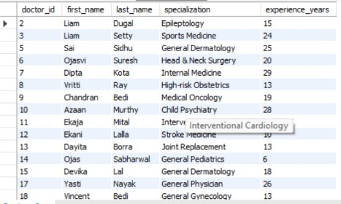

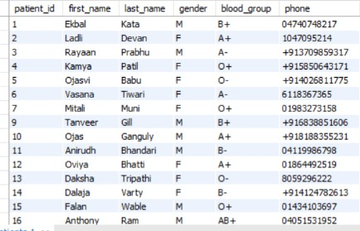

Fig. 4.1: Successful Creation of Tables

4.2 Sample Data Insertion – DML
Table 4.1: Sample Data Summary
S.No | Table Name | No. of Records Inserted | Screenshot Reference
1 | Departments | 10 | Figure 4.1
2 | Admins | 10 | Figure 4.1
3 | Doctors | 30 | Figure 4.1
4 | Patients | 100 | Figure 4.1
5 | Rooms | 50 | Figure 4.1
6 | Medicines | 40 | Figure 4.1
7 | Appointments | 180 | Figure 4.1
8 | Admissions | 30 | Figure 4.1
9 | Prescriptions | 90 | Figure 4.1
10 | Prescription Details | 226 | Figure 4.1
11 | Lab Tests | 110 | Figure 4.1
12 | Invoices | 130 | Figure 4.1
13 | Inquiries | 40 | Figure 4.1

INSERT INTO `Admins` VALUES(1,'Radhika','Tara','radhikatara0','f375a538896767e752c75e0bc1028cbb59b1459bd7b2d9b5c220f00ef1a07057','radhika.tara0@cityhospital.com','+913482477109','SuperAdmin',NULL,'Active','2026-04-10 09:39:20','2026-08-12 08:44:07');

INSERT INTO `Admins` VALUES(2,'Kashvi','Dutt','kashvidutt1','fd48ded432917e368ab7bfc10dd7bce1816b955f8dc0e821fd4969a039d37f43','kashvi.dutt1@cityhospital.com','+918613171274','HR',9,'Active','2026-06-19 17:43:08','2026-08-12 08:44:07');

INSERT INTO `Admins` VALUES(3,'Laban','Sagar','labansagar2','7d9a2b8f9316a8ef1f50168684d861d8095e040bda2fc505e21188f02e3aa760','laban.sagar2@cityhospital.com','03782639821','Accountant',NULL,'Active','2026-01-15 21:05:14','2026-08-12 08:44:07');

INSERT INTO `Admins` VALUES(4,'Lakshit','Sachdeva','lakshitsachdeva3','8f582f7927625174fec5e79f3764c1ae6b98546d0f20d9f300cf25a79d2942db','lakshit.sachdeva3@cityhospital.com','4044997278','HR',NULL,'Active','2026-05-30 17:21:33','2026-08-12 08:44:07');

INSERT INTO `Admins` VALUES(5,'Wyatt','Pai','wyattpai4','994179063a51364c111145ecf9946dfdcd11042701305b72db3a431a1550c5b9','wyatt.pai4@cityhospital.com','6753396360','Receptionist',2,'Active','2026-08-06 06:45:56','2026-08-12 08:44:07');

INSERT INTO `Admins` VALUES(6,'Nathan','Solanki','nathansolanki5','f152051026c302ee6f8f3af3284d8d046e04cbd88e624d57fcbe87d7968d2766','nathan.solanki5@cityhospital.com','06270289517','Receptionist',4,'Active','2026-04-14 04:21:53','2026-08-12 08:44:07');

INSERT INTO `Admins` VALUES(7,'Chandresh','Vora','chandreshvora6','03f5003e1967ac582cbf5a35125116191106c601f5d93389ed9603c9cfb568e3','chandresh.vora6@cityhospital.com','+912621745961','Receptionist',7,'Active','2026-06-18 21:15:03','2026-08-12 08:44:07');

INSERT INTO `Admins` VALUES(8,'Omya','Walla','omyawalla7','c45641253680ce050ab6a48cb7d990af651e6beb9aaeca7d05feaba61e8e3086','omya.walla7@cityhospital.com','07809134316','HR',NULL,'Active','2026-07-03 11:26:20','2026-08-12 08:44:07');

INSERT INTO `Admins` VALUES(9,'Chandran','Chaudhry','chandranchaudhry8','e343e521c4f1b214cb0ca41b1ce810108d2763103607d4394a255d1d21c54912','chandran.chaudhry8@cityhospital.com','4005045562','HR',5,'Active','2026-04-28 11:30:41','2026-08-12 08:44:07');

INSERT INTO `Admins` VALUES(10,'Jason','Wali','jasonwali9','3aeba03c25b583f2f78931583766bcbf699a2156c5d198090ca261ae2632ac63','jason.wali9@cityhospital.com','2221969379','Receptionist',10,'Active','2026-01-26 02:40:02','2026-08-12 08:44:07');

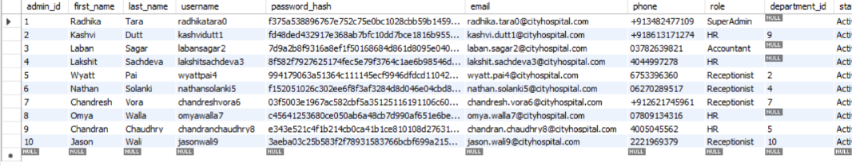

Fig. 4.2: Sample Data Inserted into the Tables

4.3 Constraints and Data Integrity

Table 4.2: Constraints and Data Integrity Rules
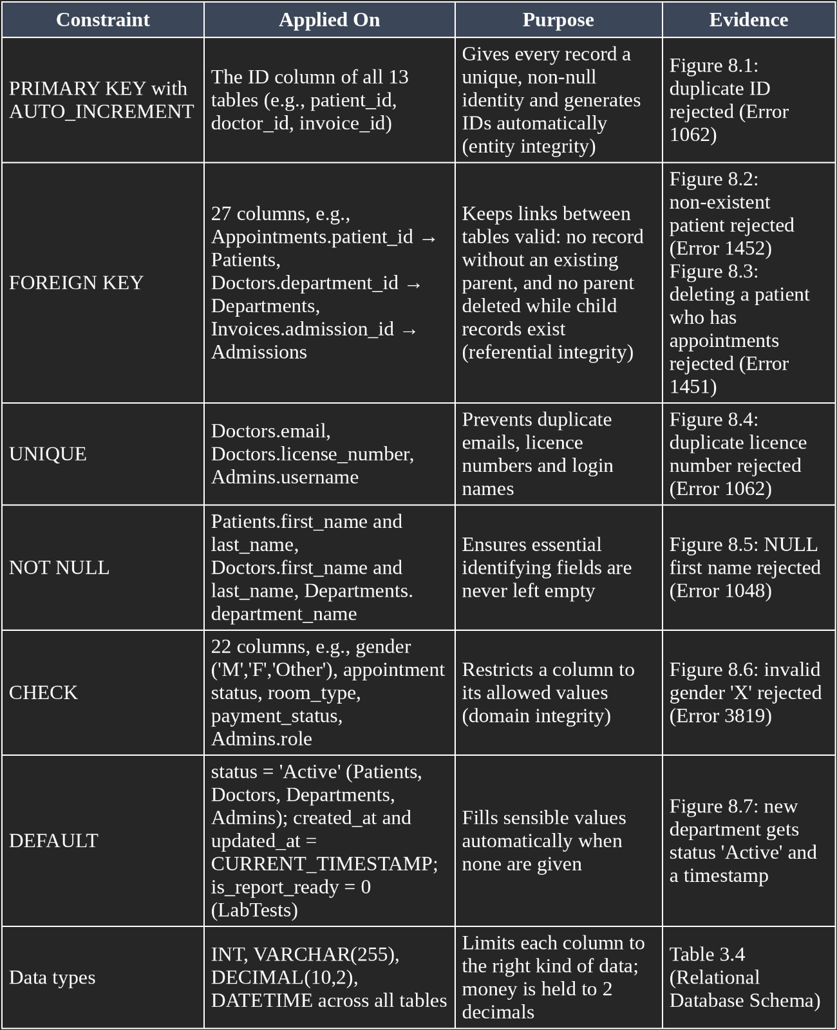

4.4 Data Validation Rules
Explain how duplicate IDs, invalid values and orphan records are prevented. Demonstrate one referential integrity violation and the error the database returns.
Data validation is implemented using database constraints. Primary keys and AUTO_INCREMENT prevent duplicate IDs in each table. UNIQUE constraints prevent duplicate values such as usernames, email addresses and license numbers. CHECK constraints restrict fields to valid predefined values, such as admission type, status, gender and payment mode. Foreign key constraints maintain referential integrity by ensuring that referenced records exist in the parent tables. Therefore, invalid values, duplicate identifiers and orphan records are prevented by the database.

Fig. 4.3: Referential Integrity Enforced by the Database

CHAPTER 5: SQL OPERATIONS AND QUERIES
For every query, give the purpose, the SQL statement and the output. Number them continuously (Q1, Q2, …). A minimum of fifteen queries covering all the sub-sections below is expected.

5.1 DQL – Basic Retrieval Queries
Table 5.1: Basic Retrieval Queries
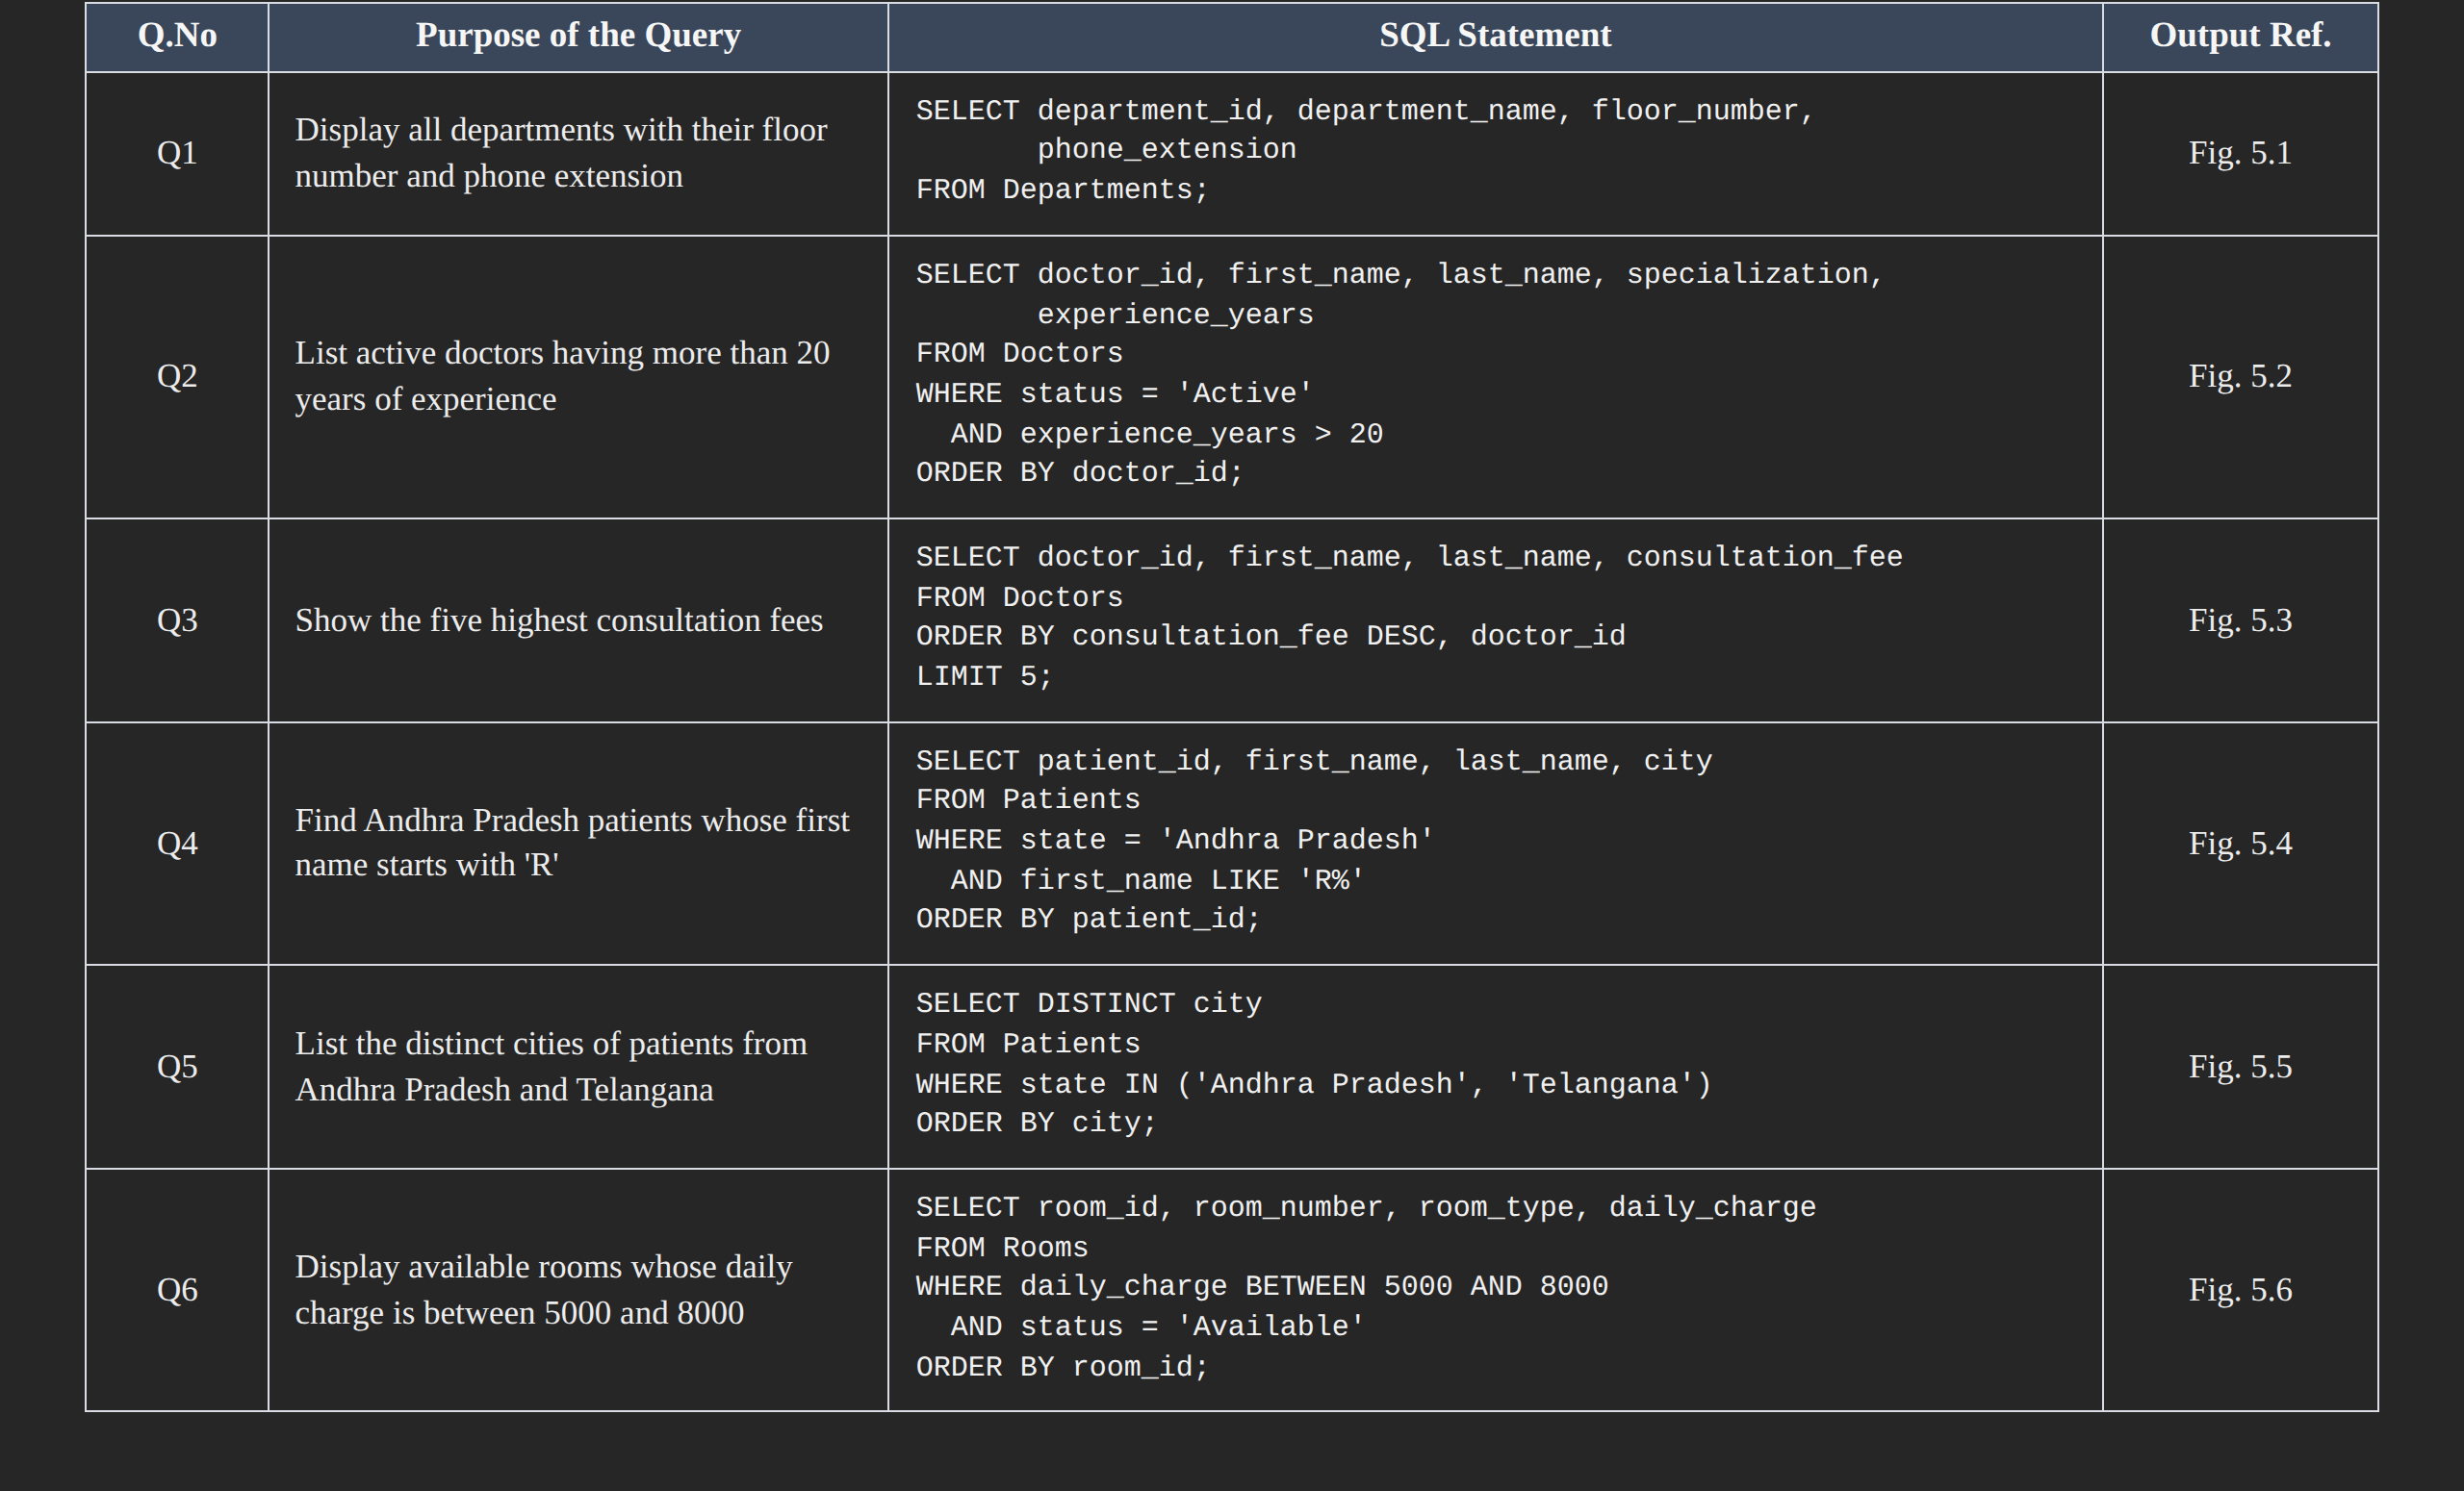

5.2 Join Operations
Table 5.2: Join Operations
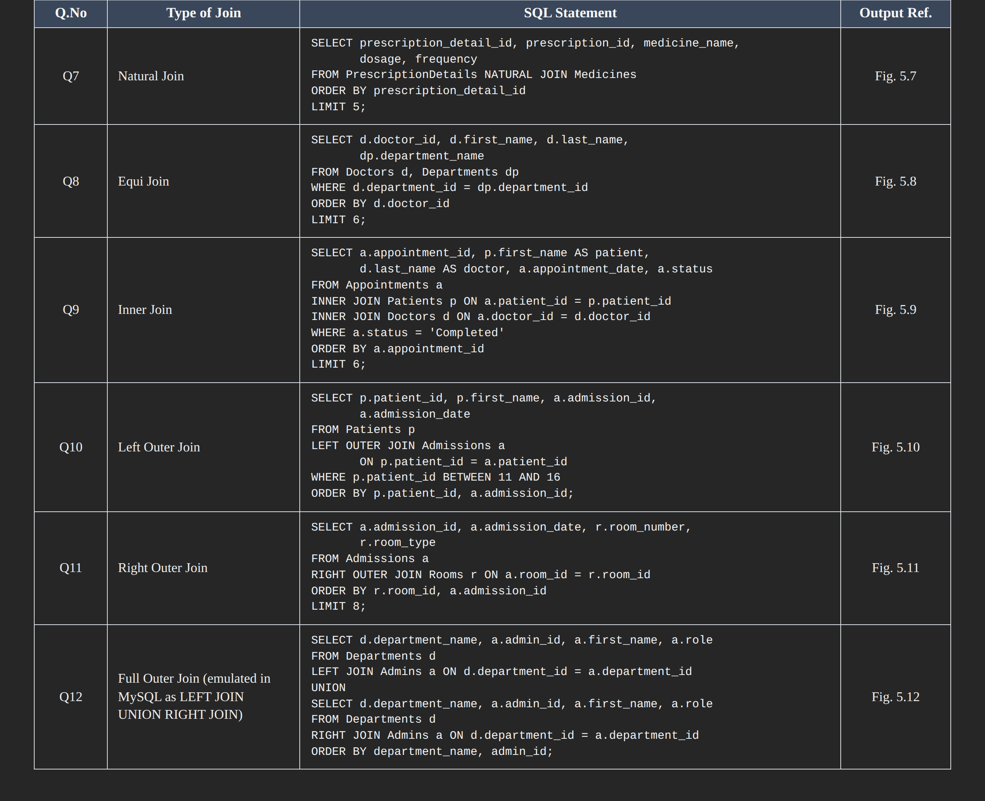

5.3 Aggregate Functions, GROUP BY and HAVING
Table 5.3: Aggregate, GROUP BY and HAVING Queries
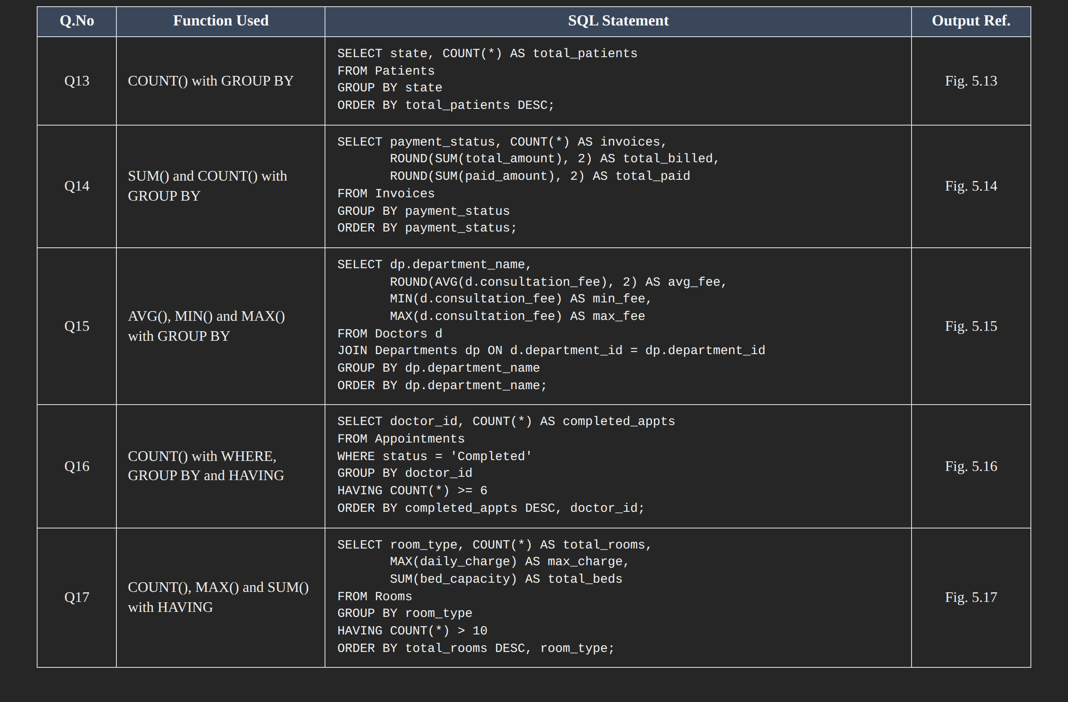

5.4 Nested and Correlated Subqueries
Table 5.4: Subqueries
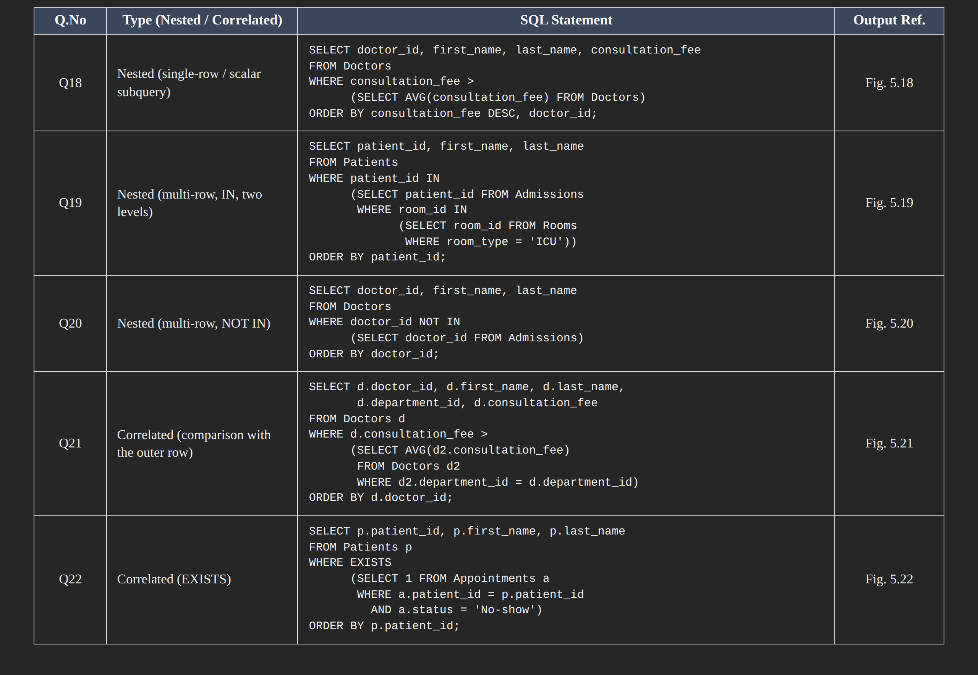

5.5 Views and Relational Set Operations
Include at least one updatable view and one non-updatable view, and the set operations UNION, INTERSECT and MINUS / EXCEPT.
Table 5.5: Views and Set Operations
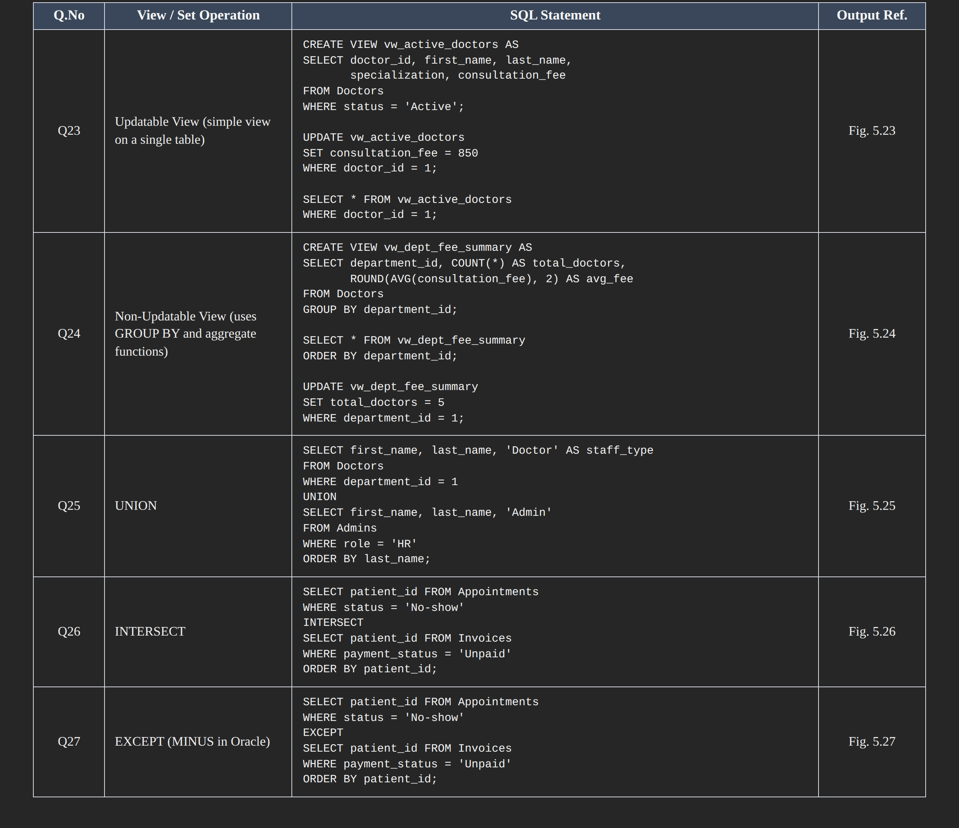

5.6 DCL and TCL Operations
Demonstrate GRANT and REVOKE (DCL), and COMMIT, SAVEPOINT and ROLLBACK (TCL).
Table 5.6: DCL and TCL Operations
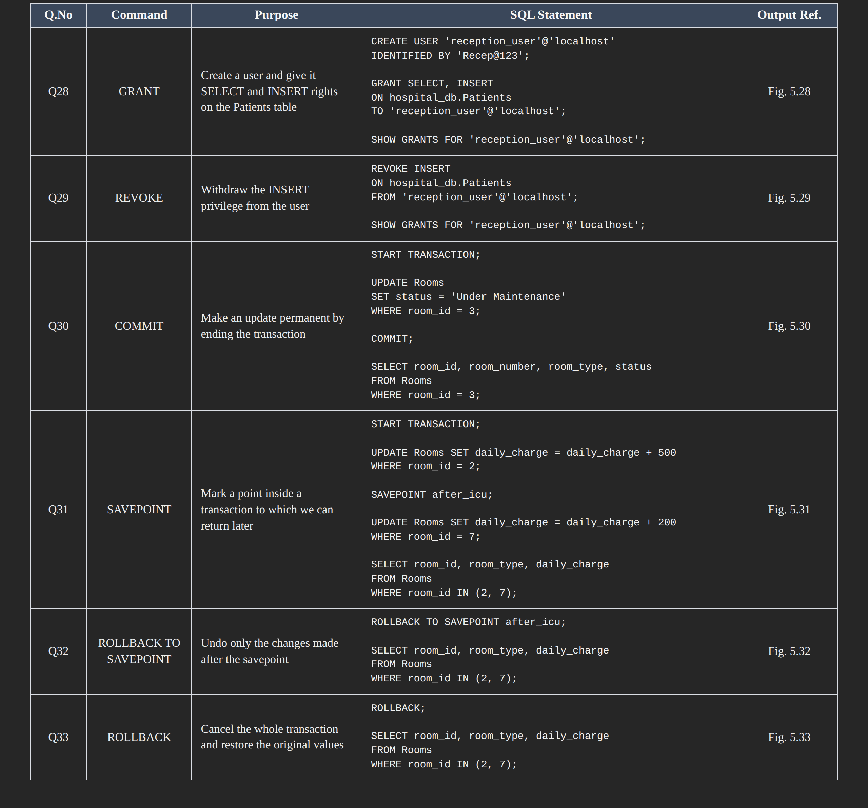

CHAPTER 6: MODULES AND FUNCTIONALITIES
Explain the major modules of the system, what each one does and which tables it operates on.
Table 6.1: Modules and Their Functionalities
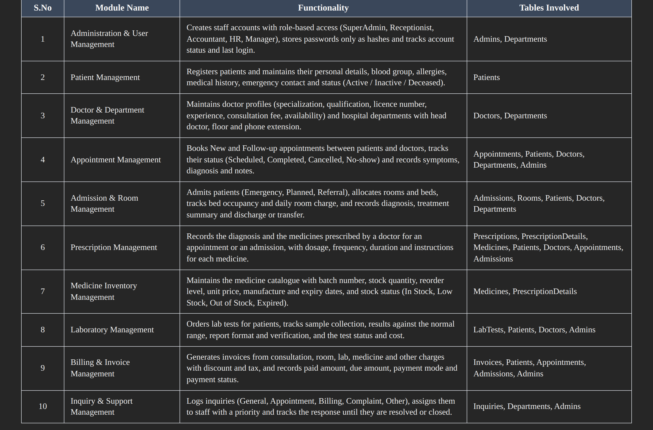

1. Administration & User Management. This module controls who can use the system. Every administrator has a unique username, a role and an Active/Inactive status, and passwords are kept only as hashes. The role decides which of the other modules a staff member works in, and the administrator's ID is stored as the creator of appointments, admissions and invoices so that every action can be traced.
2. Patient Management. This module is the starting point for all clinical work. A patient is registered once with demographic and contact details, blood group, allergies and past medical history, and every later appointment, admission, prescription, lab test and invoice refers back to that single patient record.
3. Doctor & Department Management. This module stores who treats patients and where they work. Each doctor belongs to a department, has a unique licence number and e-mail, and carries a consultation fee and a status of Active, Inactive or On Leave. Departments record their head doctor, floor number and phone extension.
4. Appointment Management. This module handles outpatient visits. Staff book an appointment for a patient with a doctor of a department on a given date and time, and the status is updated as the visit progresses. After the consultation, the symptoms, diagnosis and notes are stored against the same appointment.
5. Admission & Room Management. This module manages inpatient care. Rooms are classified as General, Private, Semi-Private, ICU or Operation Theatre, with bed capacity, occupied beds and a daily charge. When a patient is admitted, a room and bed are assigned, and the admission stays open until the patient is discharged or transferred.
6. Prescription Management. This module records what the doctor prescribes. A prescription is linked to a patient, a doctor and either an appointment or an admission, and each medicine on it is stored as a separate line in PrescriptionDetails with its dosage, frequency and duration. The status shows whether it is Active, Completed or Cancelled.
7. Medicine Inventory Management. This module keeps the pharmacy stock under control. Every medicine has a batch number, quantity in stock, a reorder level and an expiry date, so low or expired stock can be identified quickly. The link with PrescriptionDetails shows which medicines are actually being prescribed.
8. Laboratory Management. This module covers diagnostic testing. A doctor orders a test for a patient, a technician collects the sample and enters the result along with its normal range, and the report is verified by an administrator. The status moves from Ordered through Sample Collected and In Progress to Completed, or to Cancelled.
9. Billing & Invoice Management. This module produces the bill for a patient. An invoice is tied to an appointment or an admission and adds up the consultation, room, laboratory, medicine and other charges, subtracts any discount and adds tax. It also stores the amount paid, the amount still due, the payment mode and the payment status.
10. Inquiry & Support Management. This module handles questions and complaints from the public. Each inquiry is recorded with its type, subject, message and priority, optionally linked to a department and assigned to an administrator. It stays Open or In Progress until a response is given and it is marked Resolved or Closed.

CHAPTER 7: RESULTS – SAMPLE OUTPUTS AND SCREENSHOTS
Paste the important execution screenshots. Each screenshot must clearly show both the query and its output, and must carry a numbered caption.
SELECT patient_id, first_name, last_name, gender, blood_group, phone
FROM Patients
WHERE status = 'Active';

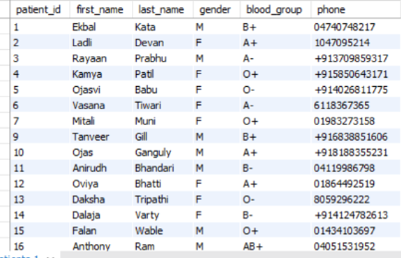

Fig. 7.1: Display all active patients
SELECT doctor_id, first_name, last_name, specialization, experience_years
FROM Doctors
WHERE experience_years > 5;

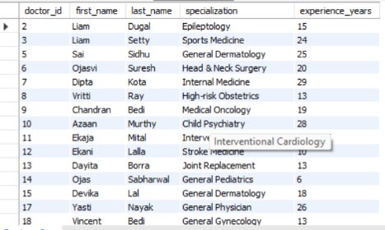

Fig. 7.2: Display doctors with more than 5 years of experience
SELECT
d.doctor_id,
CONCAT(d.first_name, ' ', d.last_name) AS doctor_name,
d.specialization,
dept.department_name
FROM Doctors d
JOIN Departments dept
ON d.department_id = dept.department_id;

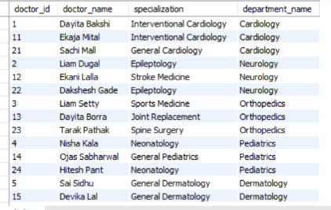

Fig. 7.3: Display doctors along with their department names

SELECT
a.appointment_id,
CONCAT(p.first_name, ' ', p.last_name) AS patient_name,
CONCAT(d.first_name, ' ', d.last_name) AS doctor_name,
a.appointment_date,
a.status
FROM Appointments a
JOIN Patients p
ON a.patient_id = p.patient_id
JOIN Doctors d
ON a.doctor_id = d.doctor_id;
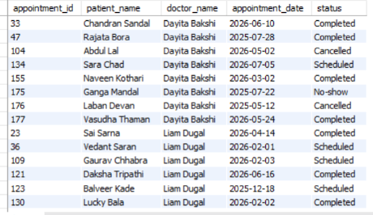

Fig. 7.4: Display appointments with patient and doctor names

CHAPTER 8: TESTING AND DATA VALIDATION
Record the test cases used to verify the database. Include constraint tests, referential integrity tests and query-correctness tests.
Table 8.1: Test Cases and Results

CHAPTER 9: GITHUB REPOSITORY AND TEAM CONTRIBUTION

9.1 Repository Details
GitHub Repository Link: https://github.com/Narasimhasai10/hospital-management-system.dbms

9.2 Team Responsibilities and Contribution
Table 9.1: Team Responsibilities
S.No | Student Name | Roll Number | Role / Responsibility | Modules Contributed
1. | KOPPALA DEVI SRI CHARAN | 25B11AI570 | ER Diagram & Relational Schema | diagrams/er-diagram.png
2. | DANDE LENANDAN NARASIMHA SAI | 25B11AI247 | DDL, Tables, Keys & Constraints | sql/ddl.sql
3. | BODDU SRIRAM RATNA KUMAR | 25B11AI138 | DML, CRUD, JOIN & Aggregate Queries | sql/dml.sql, sql/queries.sql
4. | KETHAMALLA VEERA CHANIKYA | 25B11AI528 | Documentation & Screenshots | docs/, screenshots/

9.3 Review-wise Progress
Table 9.2: Review-wise Progress Record
Review | Date | Deliverables Presented | Remarks of the Guide

CHAPTER 10: CONCLUSION AND FUTURE ENHANCEMENTS

10.1 Conclusion

The Hospital Management System database was successfully designed and implemented to manage important hospital activities in a centralized and structured manner. The database includes 14 entities/tables covering patients, doctors, departments, appointments, admissions, rooms, prescriptions, medicines, laboratory tests, invoices, inquiries and administrators.
The database design uses Primary Keys, Foreign Keys, UNIQUE constraints and CHECK constraints to maintain data accuracy and referential integrity. The database is normalized to reduce data duplication and improve consistency between related tables.
Various SQL operations were implemented, including DDL operations for creating tables and constraints, DML operations for inserting, updating, deleting and retrieving data, and SQL queries using JOINs, aggregate functions and subqueries for obtaining useful information from the database.
The objectives stated in Section 1.4 were achieved by creating a centralized database that manages hospital records efficiently, maintains relationships between different entities, reduces data redundancy, supports data validation, and allows information to be retrieved using SQL queries. Thus, the project provides a structured database foundation for managing hospital operations and can be further extended into a complete hospital management application.

10.2 Limitations of the Present Work
The current work mainly focuses on the database design and SQL implementation of the Hospital Management System. It does not currently include a complete web or mobile application interface for hospital staff and patients. Real-time notifications such as appointment reminders and alerts are not implemented. Online payment processing and integration with external hospital systems are also not included in the current version. In addition, automated database backup, recovery, advanced analytics and reporting dashboards are not implemented. These features can be added in the future to make the system more complete and suitable for real-world hospital use.

10.3 Future Enhancements

The Hospital Management System can be enhanced in the future by developing a complete front-end application connected to the existing database. Additional modules can be added for managing pharmacy, billing, laboratory reports and patient services. Stored procedures and triggers can be implemented to automate frequently performed database operations and maintain data consistency. Proper indexing can also be added to improve query performance as the amount of data increases. Security can be improved through user authentication, role-based access control and better protection of sensitive patient information. Automated database backup and recovery mechanisms can be introduced to prevent data loss. Reporting and analytics features can also be added to generate useful reports and help hospital staff analyze patient, appointment, billing and other hospital data.

REFERENCES
List textbooks, reference books, documentation and websites referred to. Follow the format shown below.
- Abraham Silberschatz, Henry F. Korth and S. Sudarshan, “Database System Concepts”, 8th Edition, McGraw-Hill, ISBN: 978-1260230508.
- Raghurama Krishnan and Johannes Gehrke, “Database Management Systems”, 4th Edition, McGraw-Hill, ISBN: 978-1260091195.
- Ramez Elmasri and Shamkant B. Navathe, “Fundamentals of Database Systems”, 7th Edition, Pearson, ISBN: 978-0137504277.
- MySQL Documentation, “MySQL 8.0 Reference Manual”, Oracle Corporation. MySQL 8.0 Reference Manual
- W3Schools, “MySQL Tutorial”, W3Schools. MySQL Tutorial

APPENDIX A – COMPLETE SQL SCRIPT
Paste the complete, final SQL script (CREATE, INSERT and all queries) in order, or give the exact path to the script file in the GitHub repository.
https://github.com/Narasimhasai10/hospital-management-system.dbms/blob/main/sql/ddl.sql

