1. 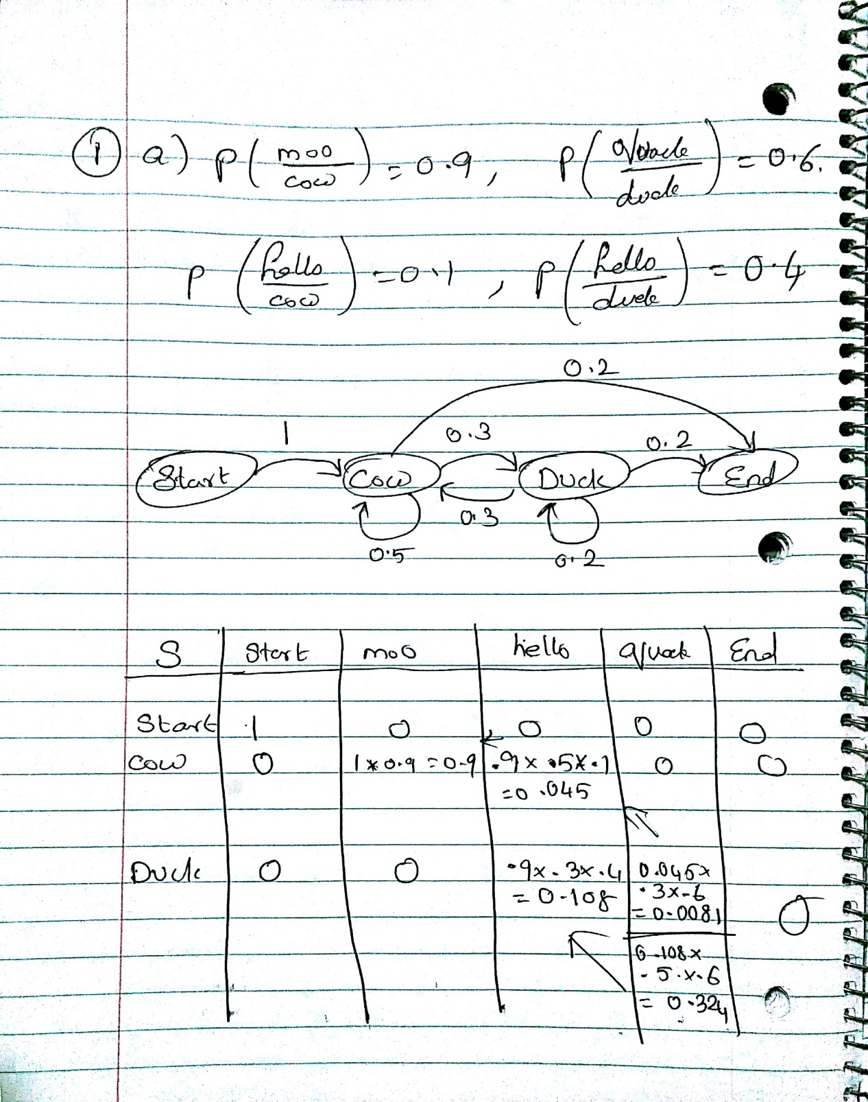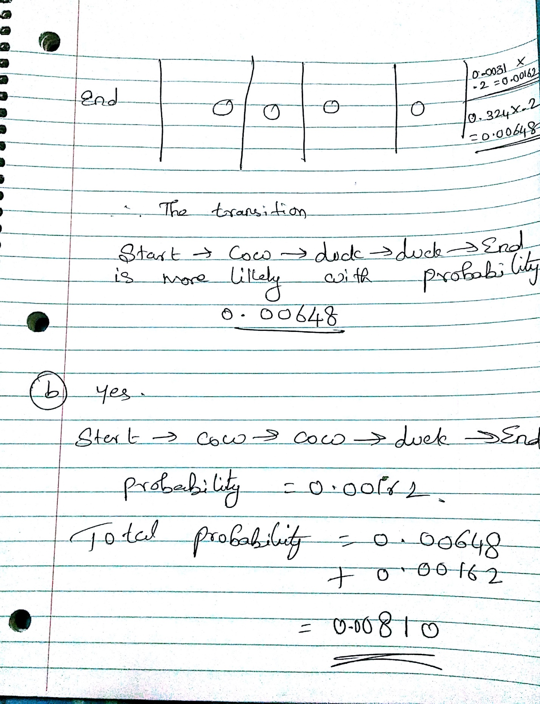

2. a.

Sentence: He is sleeping on the bed.

Annotate He == <constit cat="PRP">

Annotate is == <constit cat="VBZ">

Annotate sleeping == <constit cat="VBG">

Annotate on == <constit cat="IN">

Annotate the == <constit cat="DT">

Annotate bed == <constit cat="NN">

Annotate . == <constit cat=".">

b.

Sentence: I will sleep and wake up early.

Annotate I == <constit cat="PRP">

Annotate will == <constit cat="MD">

Annotate sleep == <constit cat="VB">

Annotate and == <constit cat="CC">

Annotate wake == <constit cat="NN">

Annotate up == <constit cat="IN">

Annotate early == <constit cat="JJ">

Annotate . == <constit cat=".">

In this sentence, wake is tagged as NN. It should be VBP (verb present tense)

STATE VBP = 14955

EMIT WAKE = 2

So, Emission probability of WAKE as VBP = 2/14955 = 0.0001337

STATE NN = 159394

EMIT WAKE = 55

So, Emission probability of WAKE as NN = 55/159395 = 0.000345

Now, looking at the sequence, wake comes after “and” (which is a CC)

STATE CC 28585

ARC TO VBP 344

ARC TO NN 3399

Transition probability of VBP = 0.0120

Transition probability of NN = 3399/28585 = 0.1189

So, the probability of wake being NN and VBP are

P(VBP) = 0.0001337 \* 0.0120 = 0.0000016

P(NN) = 0.000345 \* 0.1189 = 0.000051

So, the probability of wake being NN is more than the probability of it being NN. Hence, it was tagged as NN and not VBP.