# Griffith College HTML Worksheets: HTML Structural elements.

Create a folder called lab3 into which you will save all work on this lab.

## Part One:

Recreate the layout below.

Consider what elements are needed for each part. You should use all relevant structural elements to organize the content.

The entire page should be contained in a <div> with an id of 'container'. Then use a combination of <header>,<nav>,<section>,<article> and <footer> elements to structure the rest of the content.

**Hints:**

The top of the page should feature a <header>.

The logo is available in the this week’s file.

The main navigation should be in a <nav> element.

Consider using a <section> element with a suitable ID for the main 'content' section.

Consider where each 'article' might begin and end.

Use <aside> for the related stories section.

You also need to work out what other elements to use. (Paragraphs, lists, images, captions, headings, links etc.)

The first story features the following table:

|  |  |  |  |  |  |  |
| --- | --- | --- | --- | --- | --- | --- |
| Usage share of desktop browsers for June 2013 | | | | |  |  |
| Source | Chrome | IE | Firefox | Safari | Opera | Other |
| StatCounter | 42.68% | 25.44% | 20.01% | 8.39% | 1.03% | 2.44% |
| Clicky | 38.92% | 29.08% | 21.22% | 9.28% | 1.17% | 0.32% |

Recreate it, including the caption, table headers (<th>). Make the first column text link to the following pages:

StatCounter: http://gs.statcounter.com

Clicky: http://clicky.com/marketshare/global/web-browsers/

(You do not have to style the table – we will look at this later in the course)

The main navigation links can be dummy links, just put in # as the href.

The main article headline should link to article.html (as should the "Read more..." link)

The related story links should go to:

* TechCrunch: http://techcrunch.com/
* Hacker News: https://news.ycombinator.com/
* CNET: http://www.cnet.com/
* The Register: http://www.theregister.co.uk/

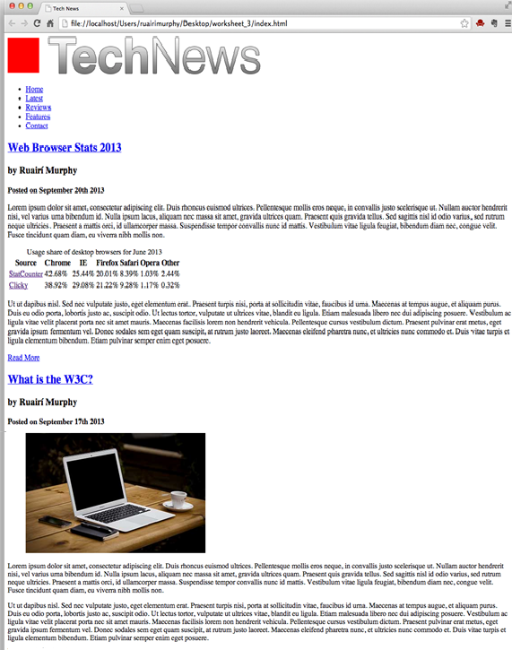

## Part Two:

Modify your personal profile page from last week and add structural elements. as per the spec for assignment 1

## Part Three:

Create article.html, a page to house a single blog post. Add more text (from lipsum.com) and more images (sourced online). [so when one were to click the headline of the first article it would take them to an article detail page]