

#### **Assignment Cover Sheet**

|  |  |  |  |  |  |  |
| --- | --- | --- | --- | --- | --- | --- |
| **Student name:** | **Sarah Narayamy Tavares Silva** | | | | | |
| **Student number:** | **2960992** | | |  | | |
| **Faculty:** | **Griffith Limerick** | | |  | | |
| **Course:** | **Computing Science** | | | **STAGE** | **Year 1** | |
| **Subject:** | **Client Side Web Development** | | | | | |
| **Study Mode:** | Full time | **x** |  | Part-time |  |  |
| **Lecturer Name:** | **Tina Lenihan** | | | | | |
| **Assignment Title:** | **Assignment 03 - Hero** | | | | | |
| **No. of pages:** |  | | |  | | |
| **Disk included?** | Yes |  |  | No | **x** |  |
| **Additional Information:** | (ie. number of pieces submitted, size of assignment, A2, A3 etc) | | | | | |
|  | | | | | |
|  | | | | | |
| Date due: | **17/02/2018** | | |  | | |
| Date submitted: | **17/02/2018** | | |  | | |
|  | | | | | | |
| **Plagiarism disclaimer:**  *I understand that plagiarism is a serious offence and have read and understood the college policy on plagiarism. I also understand that I may receive a mark of zero if I have not identified and properly attributed sources which have been used, referred to, or have in any way influenced the preparation of this assignment, or if I have knowingly allowed others to plagiarise my work in this way.*  *I hereby certify that this assignment is my own work; based on my personal study and/or research, and that I have acknowledged all material and sources used in its preparation. I also certify that the assignment has not previously been submitted for assessment and that I have not copied in part or whole or otherwise plagiarised the work of anyone else, including other students.*  **Signed & dated: Sarah Narayamy Tavares Silva 17/02/2018** | | | | | | |

## **Please note:** Students **MUST** retain a hard / soft copy of **ALL** assignments as well as a receipt issued and signed by a member of Faculty as proof of submission.

Description of site design

After deciding the subject of the website and look for pictures, it was easy to decide which colours I should use for the page, which was a light yellow, combined with the pictures.

The “home” page was designed to show the importance of the subject and why I choose it. I decided to start the page (and all the 7 pages) with a carrousel of images, which would slide automatically, but unfortunately it did not work. I found some tutorials online but none of them applied to my website so I finally found one which worked but I had to use width and height on the html files also, the slide would not change the pictures automatically so I added 3 small buttons, so the user can click on each button and change from 3 pictures. It is not the right thing to do, but it was the only way to make it work (I could not use the attribute on the css file).

Right underneath the slideshow and the <h1>, which were together on the header, I decided to put the navigation bar, inline to facilitate the navigation. I wanted to have one page for habitats and habits, and one page for diet and bite, but I wanted to separate the titles thus I decided to create a dropdown menu for habits underneath habitats and bite underneath diet.

The navigation is followed by the sections with a <h2> referent to each page’s title and the content.

The footer is in the same format as the assignment 2. The reason why is because I like to keep a pattern of some items, unless asked to change.

The background image was chosen online and it represents the Rattlesnake’ scales.

At the bottom of every content and before the footer I decided to put an arrow, sending back to the top of each page, because I believe it is easier than always have to scroll all the way back to the top to find the navigation.

The gallery page was really hard, because the plan was create a grid of images, but I could not understand the codes I found online; all of them included javaScript, which we did not learn yet. Thus I decided to add a video which is also very attractive in a website and people tend to get interested in seeing videos, especially with animals.

Ever since the assignment was given to us I had an idea of what to do, so I did not look up online for options of what to use on the website, I just had to deal with the difficulties I found during the construction of the website. Thus I do not have many screen shots or even links that had inspired me.

Site map

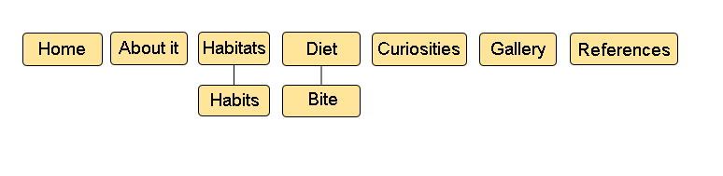

Wireframe

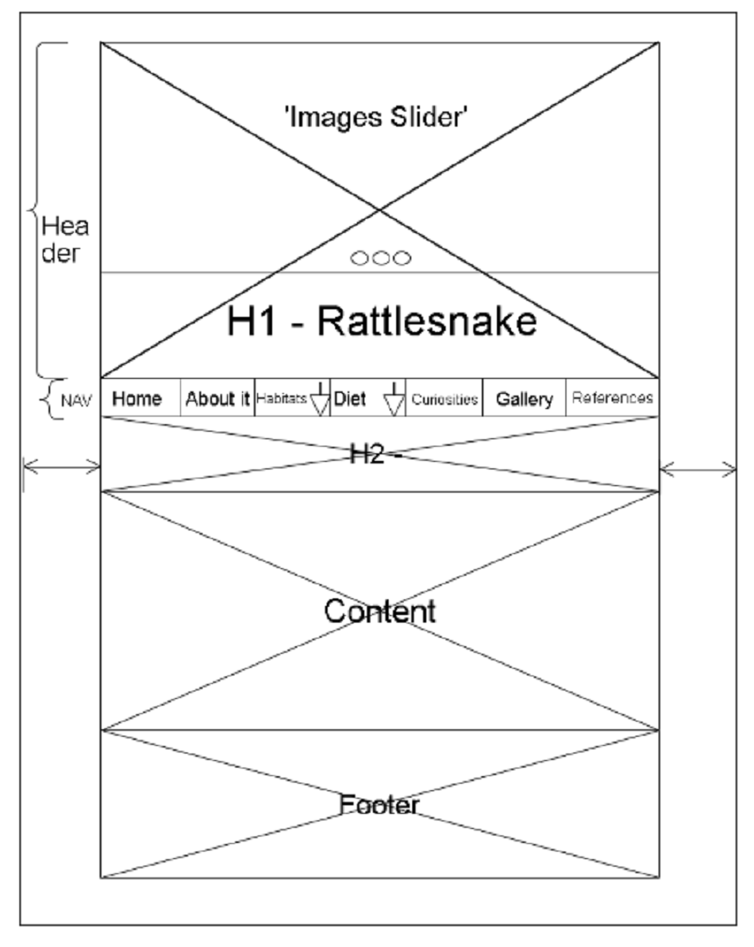

Research

