

#### **Assignment Cover Sheet**

|  |  |  |  |  |  |  |
| --- | --- | --- | --- | --- | --- | --- |
| **Student name:** | **Sarah Narayamy Tavares Silva** | | | | | |
| **Student number:** | **2960992** | | |  | | |
| **Faculty:** | **Computing Science** | | |  | | |
| **Course:** | **BSCO – Computing Science** | | | **Stage/year:** | **2** | |
| **Subject:** | **Data Structure and Algorithms** | | | | | |
| **Study Mode:** | Full time | **X** |  | Part-time |  |  |
| **Lecturer Name:** | **Elaine Tynan** | | | | | |
| **Assignment Title:** | **Assignment 10** | | | | | |
| **No. of pages:** |  | | |  | | |
| **Disk included?** | Yes |  |  | No | **X** |  |
| **Additional Information:** | (ie. number of pieces submitted, size of assignment, A2, A3 etc) | | | | | |
|  | | | | | |
|  | | | | | |
| Date due: | **30/04/2019** | | |  | | |
| Date submitted: | **30/04/2019** | | |  | | |
|  | | | | | | |
| **Plagiarism disclaimer:**  *I understand that plagiarism is a serious offence and have read and understood the college policy on plagiarism. I also understand that I may receive a mark of zero if I have not identified and properly attributed sources which have been used, referred to, or have in any way influenced the preparation of this assignment, or if I have knowingly allowed others to plagiarise my work in this way.*  *I hereby certify that this assignment is my own work, based on my personal study and/or research, and that I have acknowledged all material and sources used in its preparation. I also certify that the assignment has not previously been submitted for assessment and that I have not copied in part or whole or otherwise plagiarised the work of anyone else, including other students.*  **Signed: Sarah Narayamy Tavares Silva Date: 30/04/2019** | | | | | | |

## **Please note:** Students **MUST** retain a hard / soft copy of **ALL** assignments as well as a receipt issued and signed by a member of Faculty as proof of submission.

Question 1

Given below is a graph G.

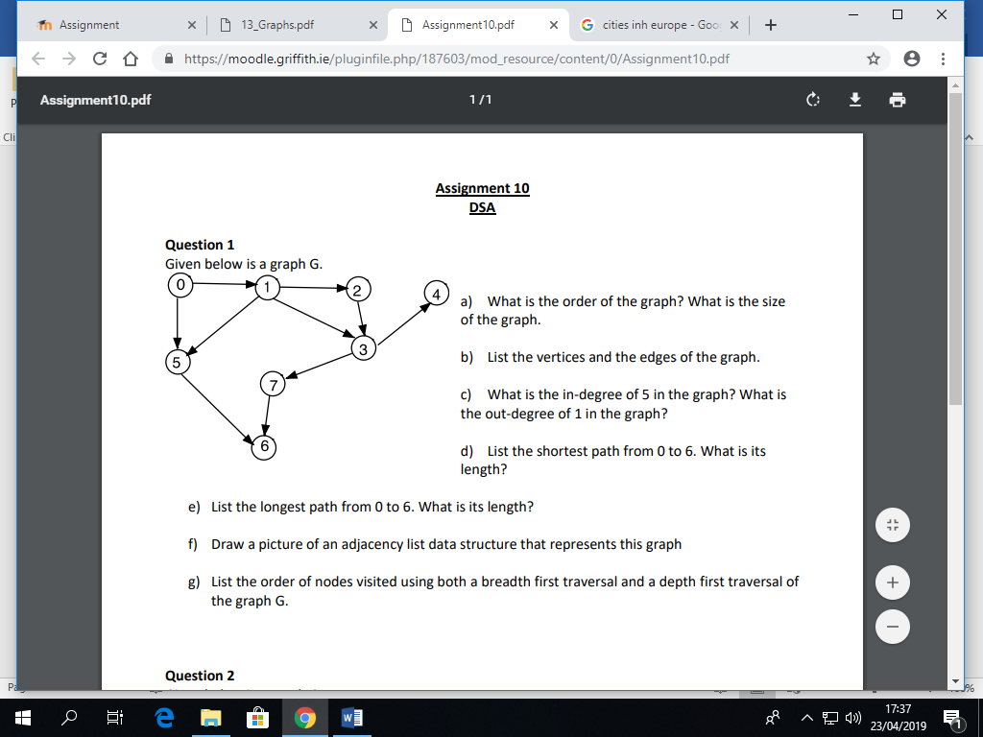

1. What is the order of the graph? What is the size of the graph?

Order: 8 /Size: 10

1. List the vertices and the edges of the graph.

Vertices: (0, 1, 2, 3, 4, 5, 6, 7)

Edges: {(0,1),(0,5),(1,2),(1,3),(1,5),(2,3),(3,4),(3,7),(5,6),(7,6)}

1. What is the in-degree of 5 in the graph? What is the out-degree of 1 in the graph?

In-degree of 5: 2 / Out-degree of 1: 3

1. List the shortest path from 0 to 6. What is its length?

Shortest path from 0 to 6: (0,5,6) = length: 3;

1. List the longest path from 0 to 6. What is its length?

Longest path from 0 to 6: (0,1,2,3,7,6) = length: 6;

1. Draw a picture of an adjacency list data structure that represents this graph.

|  |  |  |  |  |  |  |  |  |  |
| --- | --- | --- | --- | --- | --- | --- | --- | --- | --- |
| 0 |  | |  |  | | --- | --- | | 1 |  | | |  |  | | --- | --- | | 5 | / | |  |  |
| 1 |  | |  |  | | --- | --- | | 2 |  | | |  |  | | --- | --- | | 3 |  | | |  |  | | --- | --- | | 5 | / | |  |
| 2 |  | |  |  | | --- | --- | | 3 | / | |  |  |  |
| 3 |  | |  |  | | --- | --- | | 4 |  | | |  |  | | --- | --- | | 7 | / | |  |  |
| 4 | / |  |  |  |  |
| 5 |  | |  |  | | --- | --- | | 6 | / | |  |  |  |
| 6 | / |  |  |  |  |
| 7 |  | |  |  | | --- | --- | | 6 | / | |  |  |  |

1. List the order of nodes visited using both a breadth first traversal and a depth first traversal of the graph G.

Depth: (0,1,2,3,4,7,6,5)

Breadth: (0,1,5,2,3,6,4,7)

Question 2

Given below is a graph G.

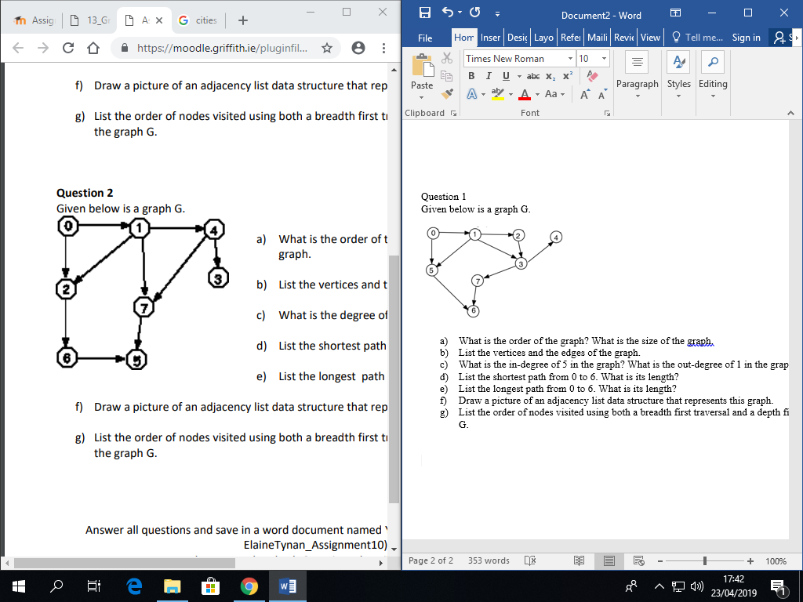

1. What is the order of the graph? What is the size of the graph?

Order: 8 / Size: 10

1. List the vertices and the edges of the graph.

Vertices: (0,1,2,3,4,5,6,7)

Edges: {(0,1),(0,2),(1,2),(1,4),(1,7),(2,6),(4,3),(4,7),(6,5),(7,5)}

1. What is the degree of 7 in the graph?

Degree of 7: 3

1. List the shortest path from 0 to 5. What is its length?

Shortest path from 0 to 5: (0,2,6,5) or (0,1,7,5) = length for both: 4

1. List the longest path from 0 to 5. What is its length?

Longest path from 0 to 5: (0,1,4,7,5) or (0,1,2,6,5) = length for both: 5

1. Draw a picture of an adjacency list data structure that represents this graph.

|  |  |  |  |  |  |  |  |  |  |
| --- | --- | --- | --- | --- | --- | --- | --- | --- | --- |
| 0 |  | |  |  | | --- | --- | | 1 |  | | |  |  | | --- | --- | | 2 | / | |  |  |
| 1 |  | |  |  | | --- | --- | | 2 |  | | |  |  | | --- | --- | | 4 |  | | |  |  | | --- | --- | | 7 | / | |  |
| 2 |  | |  |  | | --- | --- | | 6 | / | |  |  |  |
| 3 | / |  |  |  |  |
| 4 |  | |  |  | | --- | --- | | 3 |  | | |  |  | | --- | --- | | 7 | / | |  |  |
| 5 | / |  |  |  |  |
| 6 |  | |  |  | | --- | --- | | 5 | / | |  |  |  |
| 7 |  | |  |  | | --- | --- | | 5 | / | |  |  |  |

1. List the order of nodes visited using both a breadth first traversal and a depth first traversal of the graph G.

Depth: (0,1,4,3,7,5,2,6)

Breadth: (0,1,2,4,7,6,3,5)