

**Assignment Cover Sheet**

|  |  |  |  |  |  |  |
| --- | --- | --- | --- | --- | --- | --- |
| **Student name:** | **Sarah Narayamy Tavares Silva** | | | | | |
| **Student number:** | **2960992** | | |  | | |
| **Faculty:** | **Computing Science** | | |  | | |
| **Course:** | **BSCO** | | | **Stage/year:** | **3** | |
| **Subject:** | **HCI & GUI Programming** | | | | | |
| **Study Mode:** | Full time | **X** |  | Part-time |  |  |
| **Lecturer Name:** | **Brendan Fogarty** | | | | | |
| **Assignment Title:** | **Assignment 01** | | | | | |
| **No. of pages:** | **4** | | |  | | |
| **Disk included?** | Yes |  |  | No | **X** |  |
| **Additional Information:** | (ie. number of pieces submitted, size of assignment, A2, A3 etc) | | | | | |
|  | | | | | |
|  | | | | | |
| **Date due:** | **02/11/2019** | | |  | | |
| **Date submitted:** | **02/11/2019** | | |  | | |
|  | | | | | | |
| **Plagiarism disclaimer:**  *I understand that plagiarism is a serious offence and have read and understood the college policy on plagiarism. I also understand that I may receive a mark of zero if I have not identified and properly attributed sources which have been used, referred to, or have in any way influenced the preparation of this assignment, or if I have knowingly allowed others to plagiarise my work in this way.*  *I hereby certify that this assignment is my own work, based on my personal study and/or research, and that I have acknowledged all material and sources used in its preparation. I also certify that the assignment has not previously been submitted for assessment and that I have not copied in part or whole or otherwise plagiarised the work of anyone else, including other students.*  **Signed: Sarah Narayamy Tavares Silva Date: 02/11/2019** | | | | | | |

## **Please note:** Students **MUST** retain a hard / soft copy of **ALL** assignments as well as a receipt issued and signed by a member of Faculty as proof of submission.

BSC – HGP - Assignment 01

Stock Trade Profit Calculator

UI Design Document

# Instructions

**Submission:** Edit this template and submit it as part of your submission.

**Length**: Should be 4 pages approx. Word count is flexible, but all decisions should be clarified.

To achieve good marks in this item ensure that this document is well structured and addresses each of the following headings and subheading. The explanation of each UI Design Choice should be clear, precise and show substantial consideration has been made, references are welcome. All decision should be explained regardless of how basic they are. Do not cut and paste justification from the internet (plagiarism) or notes but include references and explanations in your own words where appropriate.

**Student Name:** Sarah Narayamy Tavares Silva

* Include multiple screen shots of the application each focusing on a different component clearly labelled
* Clearly indicate what is working and not work.
* Discuss each component under the following headings
* Location: e.g. The button was placed in the bottom right to as it si the default location to confirm and action
* Colour: The colour scheme was chosen to avoid the main form of colour blindness and produce high contrast for the visually impaired.
* Size:
* Style:
* Etc.
* This image shows the overall presentation of the application. Each label which needs input from the user were chosen to be set side by side with the “heading”, which self explains what the user should do. The size of the window was chosen due to accommodate all the features, most importantly the calendars because they are the biggest on the window.
* The application did not make necessary to have a button once it is meant to do only one job, thus I have established that showing all the results automatically would be more efficient and simple for the user to have full results from the application.

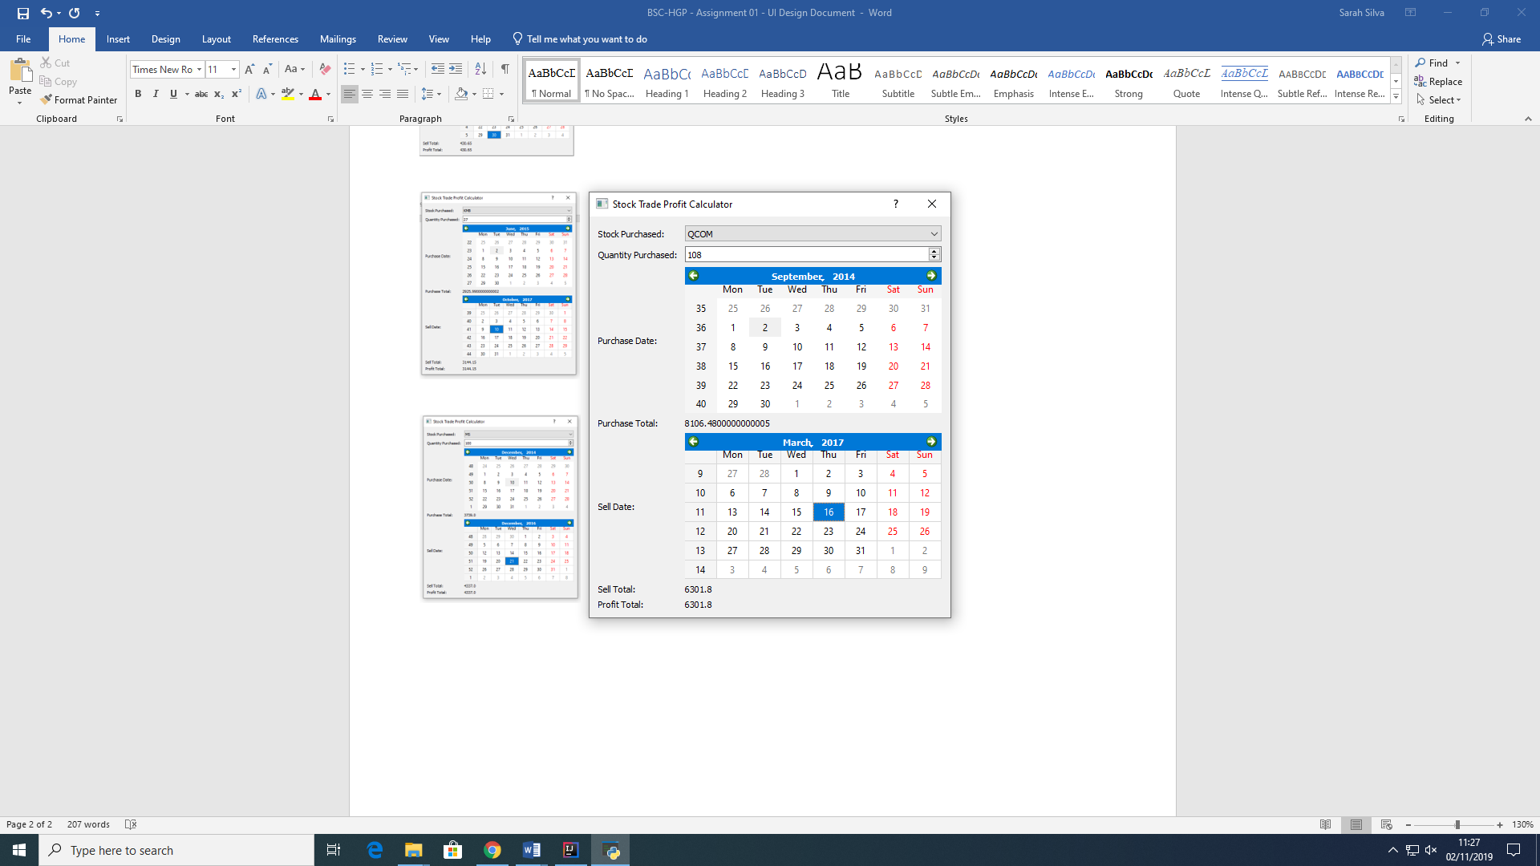

* The window title was chosen according to its functionality, which calculates the profit or the loss when buying stock trade.

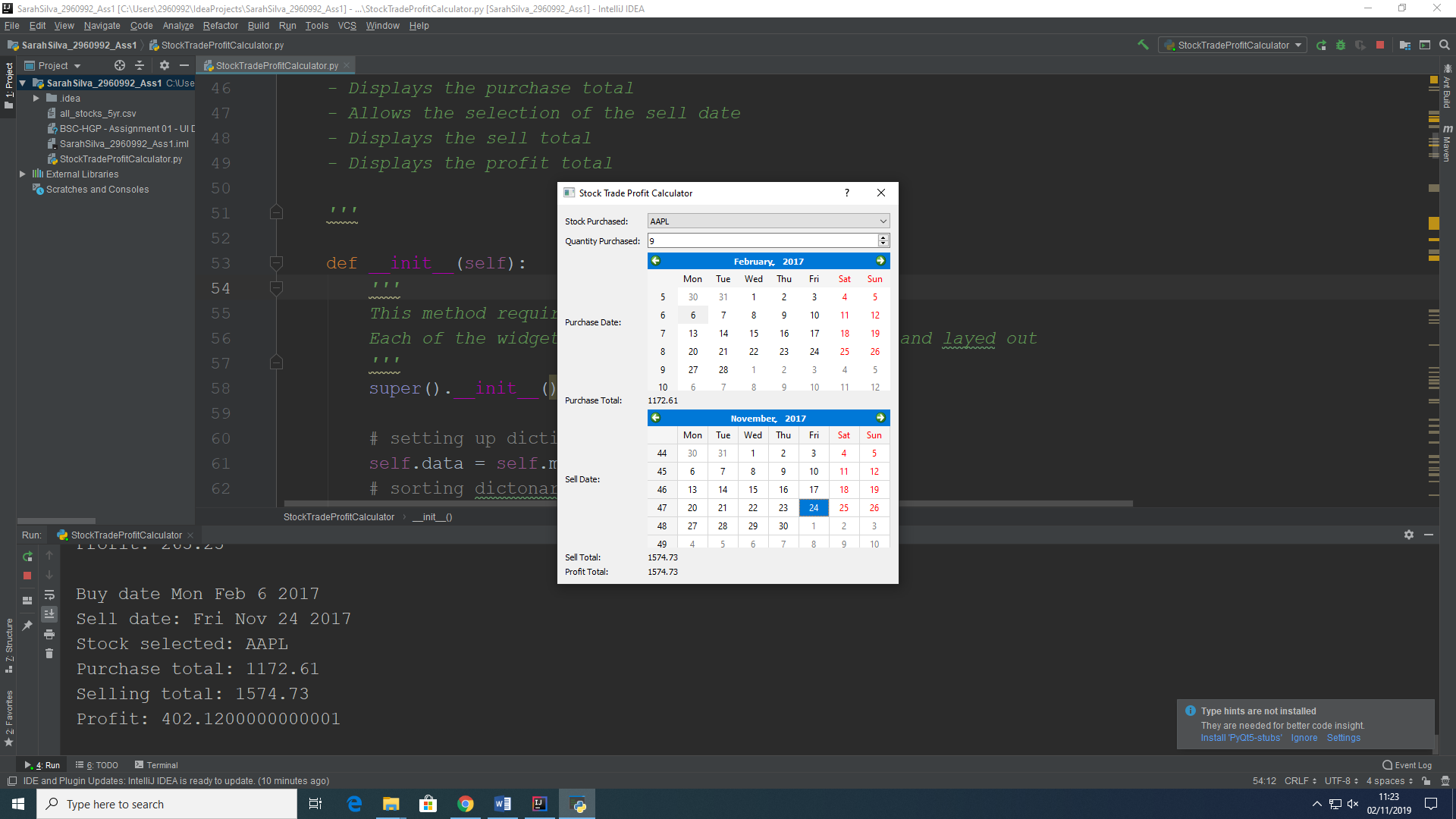

* Label Stock Purchased indicates what stock was purchased by the user followed by the combo box which stores all different stocks available to be purchased. They were put side by side in order to be clear on what is being selected on the label.

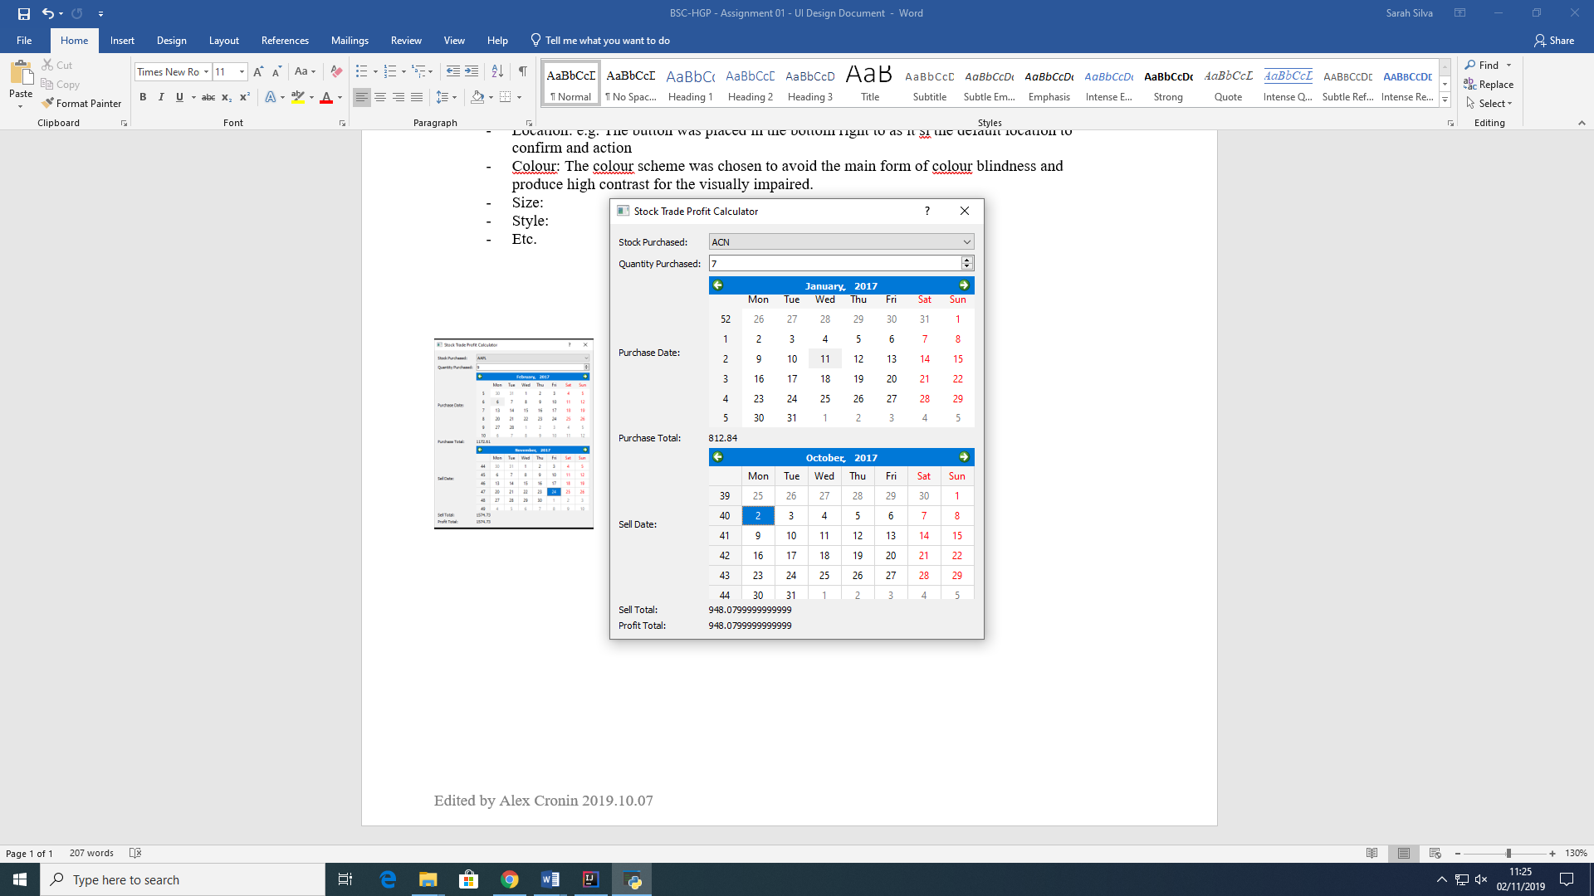

* Label Quantity Purchased as the name says indicates how many units of the stock were purchased by the user, followed by a spinbox with integers. A spinbox is more reasonable because the user does not need to type in how many units were bought; it is a simpler way for the user. It was used integer numbers because it is not possible to buy half a stock or any fraction of it.

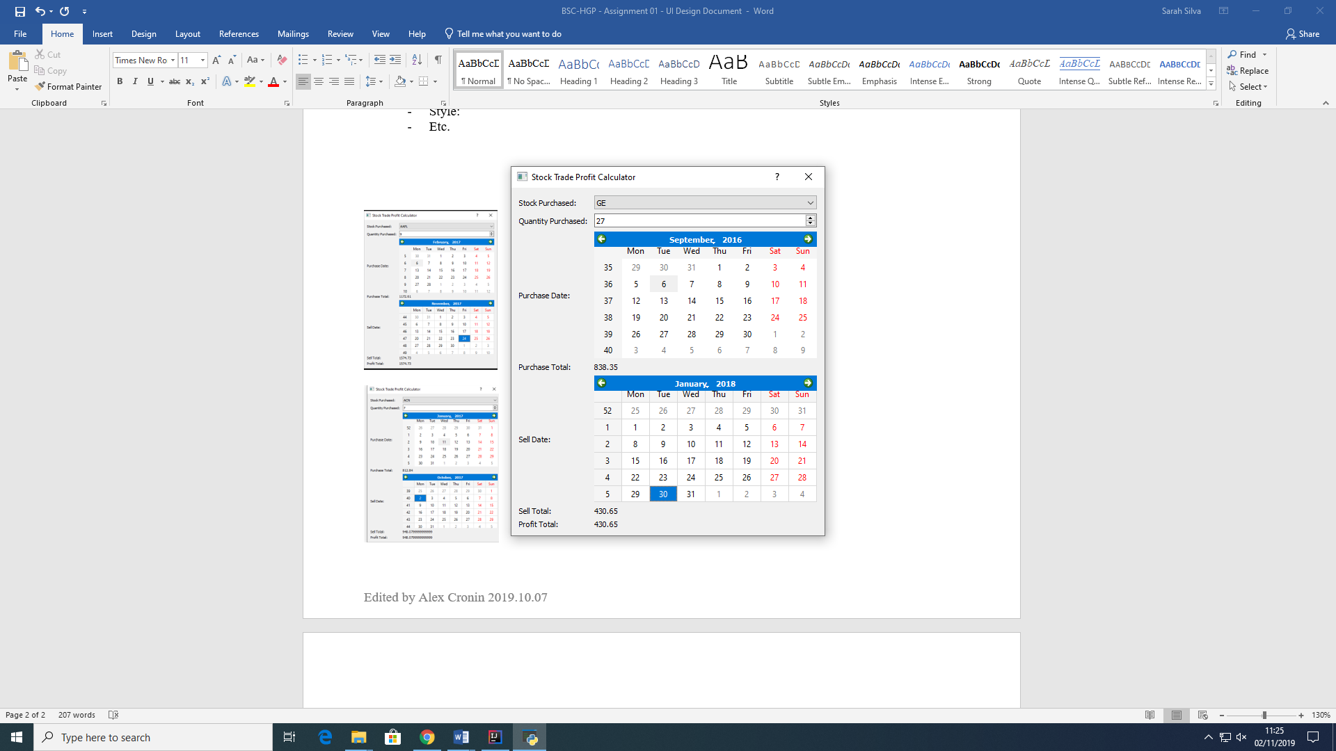

* The label Purchase Date is followed by a Calendar in which the user can select the date the stock was purchased. The dates on the calendar were limited according to the database provided, which show the oldest date of purchasing a stock to be 8th of February 2013, up to the latest date of purchasing a stock to be the 7th of February 2018.

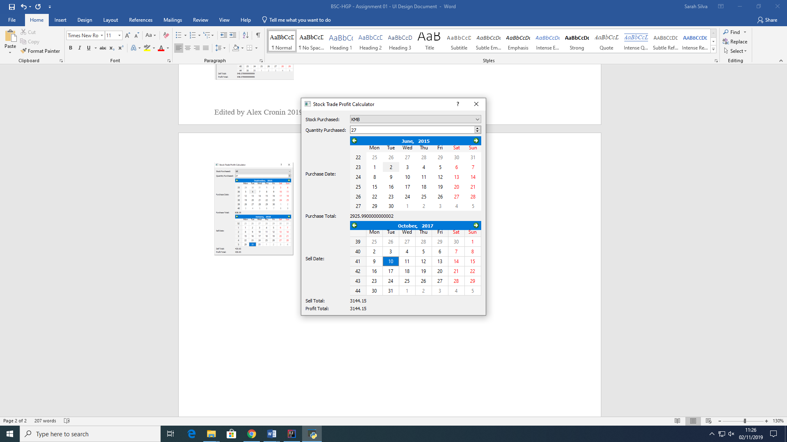

* The Label Purchase Total followed by a second label indicates the amount paid for the selected stock on the selected date. The amount can be a double number because prices can be bought in fraction. Thus this label shows how much was paid by the user for a specific stock on a specific date.

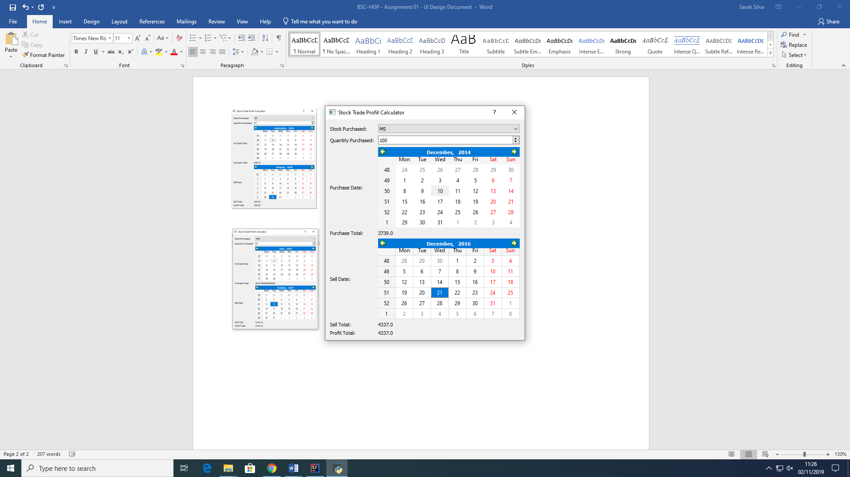

* The Sell Date label is also followed by a calendar in which the user can select the date in which it was decided to sell the stock once purchased. Like previously, the dates on the calendar were limited according to the database provided, which show the oldest date of purchasing a stock to be 8th of February 2013, up to the latest date of purchasing a stock to be the 7th of February 2018.



* The Sell Total label followed by a second label with double values indicates the value earned by the user when the particular stock previously selected on a particular date was sold. Once again, the value was chosen to be double because currency can be fractioned.



* The final and very important label Profit Total also followed by a second label with double values shows the result of a comparison between the buy price and the sell price and it shows whether the user made profit or he lost while investing on a particular stock, on a specified date for buying and selling.

