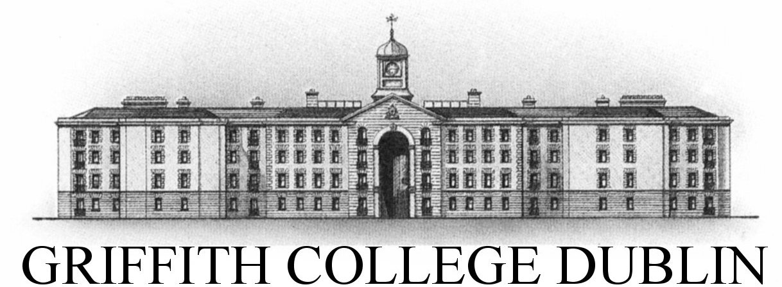

**Assignment Cover Sheet**

|  |  |  |  |  |  |  |
| --- | --- | --- | --- | --- | --- | --- |
| **Student name:** | **Sarah Narayamy Tavares Silva** | | | | | |
| **Student number:** | **2960992** | | |  | | |
| **Faculty:** | **Computing Science** | | |  | | |
| **Course:** | **BSCO** | | | **Stage/year:** | **3** | |
| **Subject:** | **HCI & GUI Programming** | | | | | |
| **Study Mode:** | Full time | **X** |  | Part-time |  |  |
| **Lecturer Name:** | **Brendan Fogarty** | | | | | |
| **Assignment Title:** | **Assignment 02** | | | | | |
| **No. of pages:** | **6** | | |  | | |
| **Disk included?** | Yes |  |  | No | **X** |  |
| **Additional Information:** | (ie. number of pieces submitted, size of assignment, A2, A3 etc) | | | | | |
|  | | | | | |
|  | | | | | |
| **Date due:** | **21/11/2019** | | |  | | |
| **Date submitted:** | **21/11/2019** | | |  | | |
|  | | | | | | |
| **Plagiarism disclaimer:**  *I understand that plagiarism is a serious offence and have read and understood the college policy on plagiarism. I also understand that I may receive a mark of zero if I have not identified and properly attributed sources which have been used, referred to, or have in any way influenced the preparation of this assignment, or if I have knowingly allowed others to plagiarise my work in this way.*  *I hereby certify that this assignment is my own work, based on my personal study and/or research, and that I have acknowledged all material and sources used in its preparation. I also certify that the assignment has not previously been submitted for assessment and that I have not copied in part or whole or otherwise plagiarised the work of anyone else, including other students.*  **Signed: Sarah Narayamy Tavares Silva Date: 21/11/2019** | | | | | | |

## **Please note:** Students **MUST** retain a hard / soft copy of **ALL** assignments as well as a receipt issued and signed by a member of Faculty as proof of submission.

BSC – HGP - Assignment 02

Paint Application

UI Design Document

# Instructions

**Submission:** Edit this template and submit it as part of your submission.

**Length**: Should be 4 pages approx. Word count is flexible, but all decisions should be clarified.

To achieve good marks in this item ensure that this document is well structured and addresses each of the following headings and subheading. The explanation of each UI Design Choice should be clear, precise and show substantial consideration has been made, references are welcome. All decision should be explained regardless of how basic they are. Do not cut and paste justification from the internet (plagiarism) or notes but include references and explanations in your own words where appropriate.

**Student Name:** Sarah Silva

* Include multiple screen shots of the application each focusing on a different component clearly labelled
* Clearly indicate what is working and not work.
* Discuss each component under the following headings
* Location: e.g. The button was placed in the bottom right to as it is the default location to confirm and action
* Color: The color scheme was chosen to avoid the main form of color blindness and produce high contrast for the visually impaired.
* Size:
* Style:
* Etc.

**N.B.** Clearly mention any additional features here either visual or functional so that apropriate marks are awarded

# **1. Title**

The first introduction end users have to an application is the title. That is why it is important to have a title that grabs the attention and describes the functionality of the program. In this case “Paint Application” was selected which show the main feature of this application which is painting.

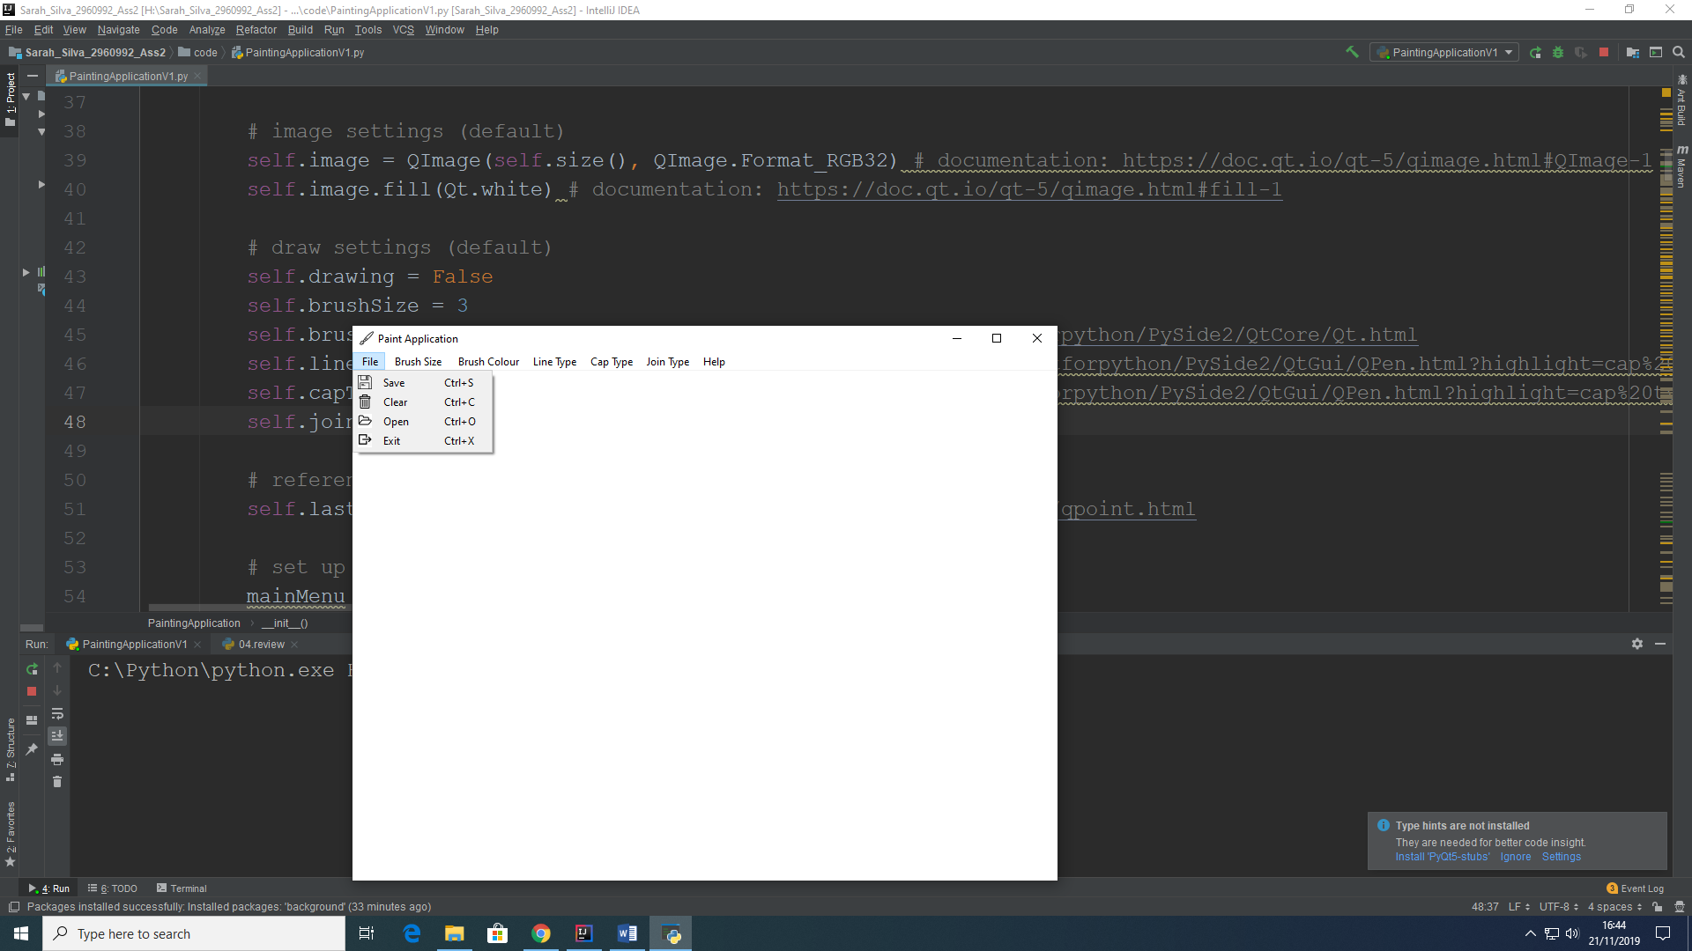

# **2. Menu**

Menus are important to allow the end user to know what the application features are. In this application, there is a main menu with seven features and each one of these features is composed by a dropdown menu with more specific features.

## **2.1 Main Menu**

The main menu is composed with seven options in which the end user can select features such as the size of the brush, the line type, the cap type, the join type and also other features included in File and Help. All these menus will be discussed in deeper below. Each feature shown in a dropdown menu within the main menu has its own Shortcut in which the end user simple has to press Ctrl + the indicated letter or number.



**2.2 File Menu**

The File Menu, offers a dropdown menu with four options to end user in relation to Files such as Saving a work, Clear the window in case the user wants to draw a different project, open a saved project or exit the application.



**2.2.1 Save**

As mentioned on topic 2.2, the Save option on the File menu allows the user to save a work in progress. This work in progress can be saved either in “png” or “jpg” format, depending on the user’s need.

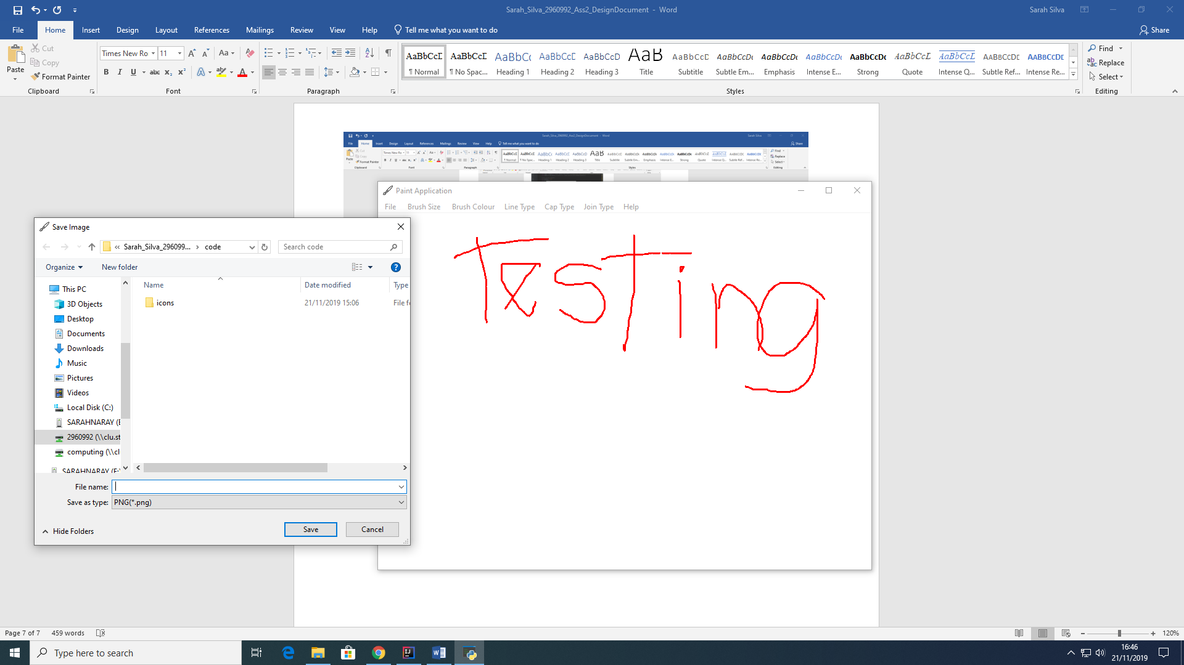

**2.2.2 Clear**

As mentioned on topic 2.2, the Clear option allows the end user to clear the current window in order to get a new blank window and start a new work.

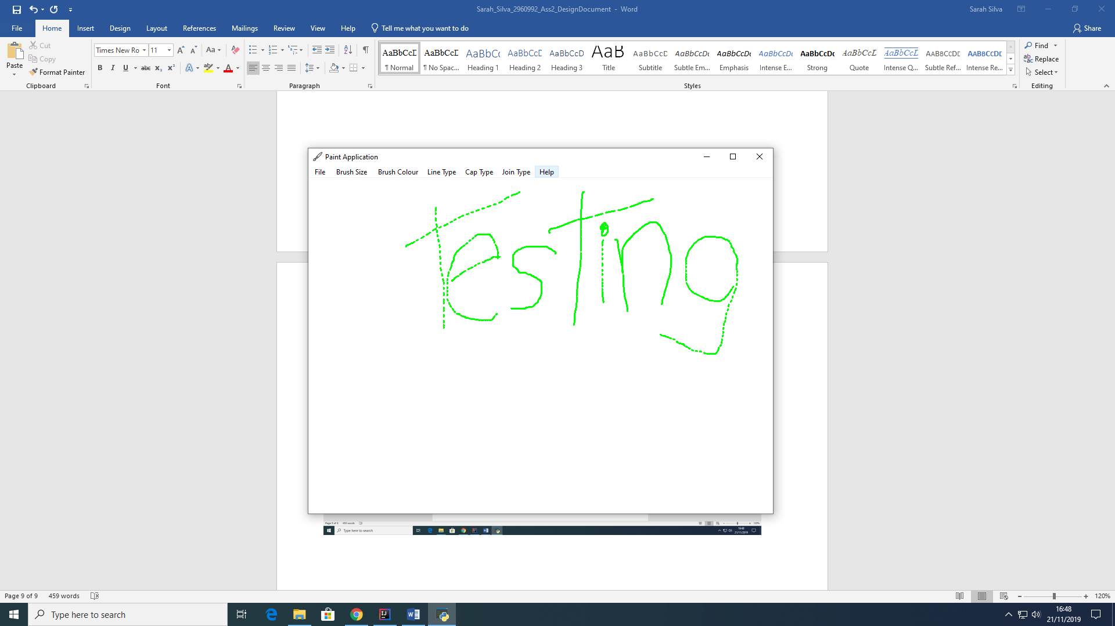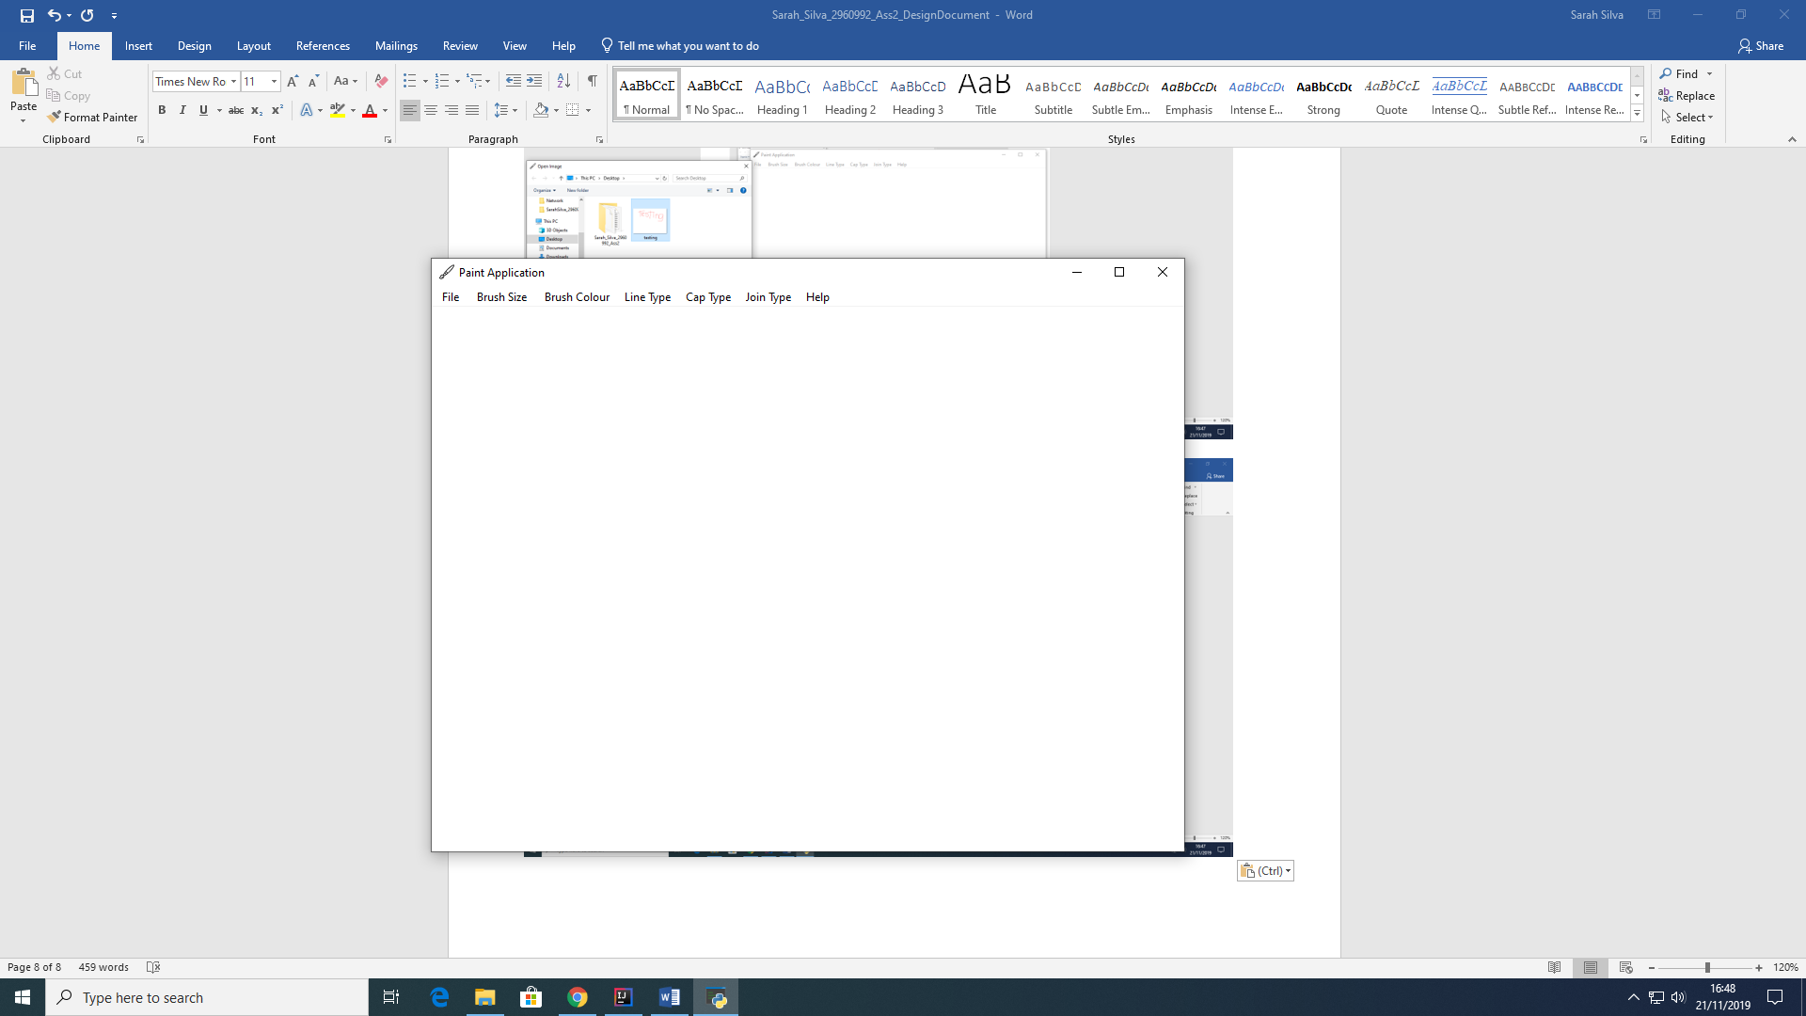

After

Before

**2.2.3 Open**

The Open option, allows the user to open an already saved project, by searching through the directories to find the file path.

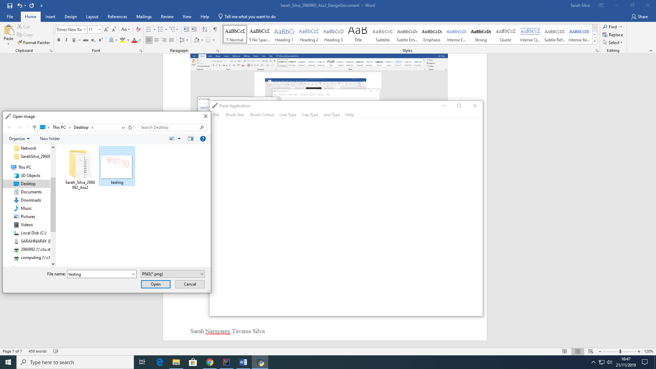

**2.3 Brush Size Menu**

The Brush Size Menu allows the user to select from four different sizes of Brush to draw. These sizes are specified as 3 pixels, 5 pixels, 7 pixels and 9 pixels.

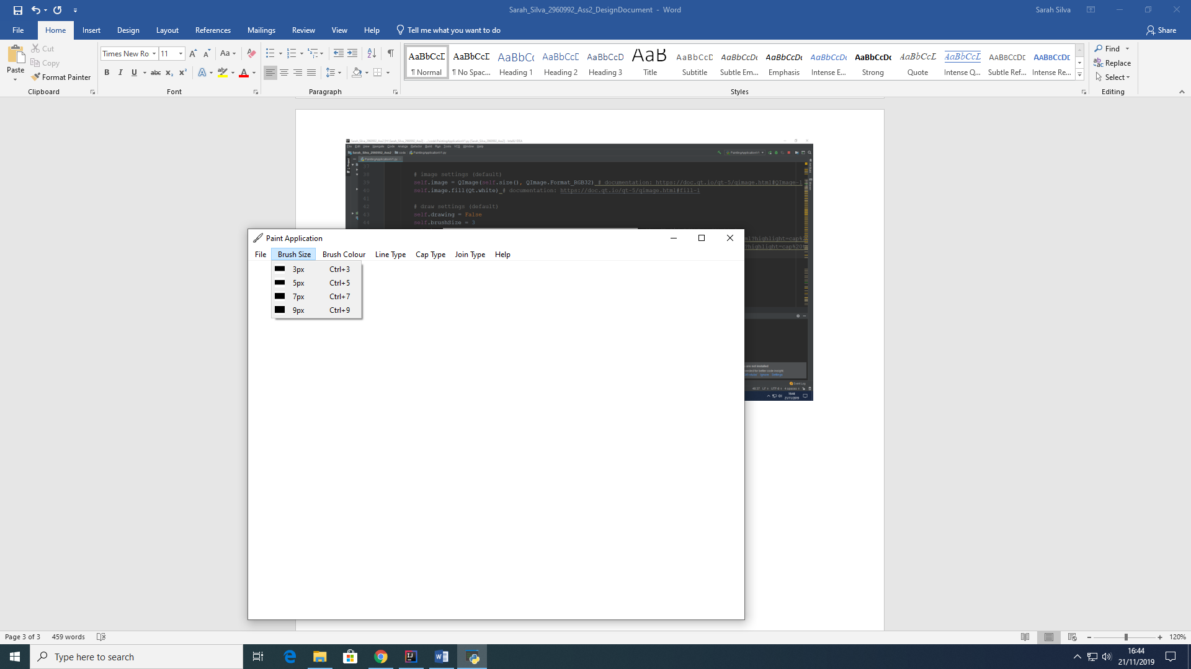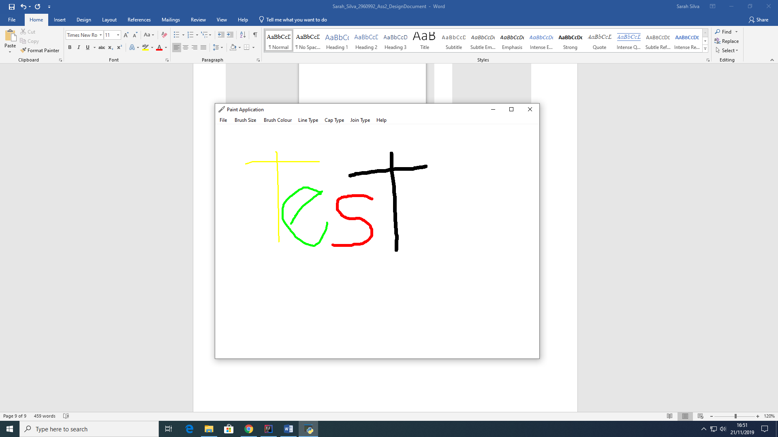

**2.4 Brush Color Menu**

The brush Color Menu is designed to allow the end user to select from different colors. My purpose was to create a new menu allowing the user to change also the background color of the window, but unfortunately there were several errors within the application so I decided to keep it simple and use only the primary colors. Even though I was able to find the method “QColorDialog.getColor()” that creates the palette of colors, I could not make it apply to the background color.

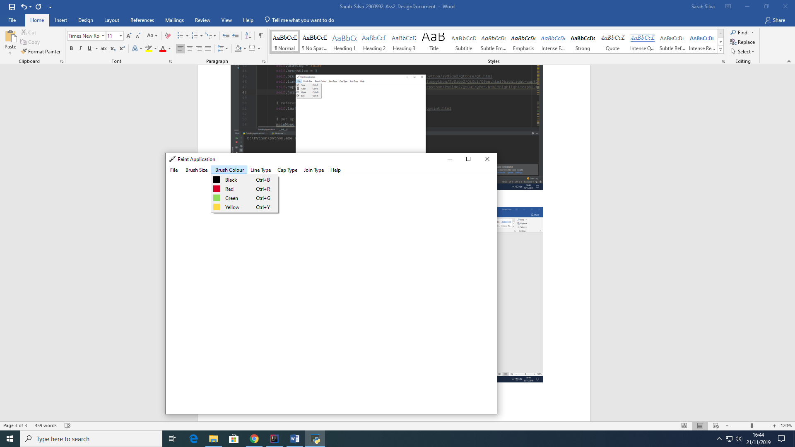

**2.5 Line Type Menu**

The Line type menu allows the user to select from 5 line types such as Dash Line, Dash Dot Dot, Dot, Dash Dot and Solid. The only issue with this feature is that the only way of recognizing the difference between the types is if the end user draws a fast line, otherwise the line would look exactly like a normal (solid) line.

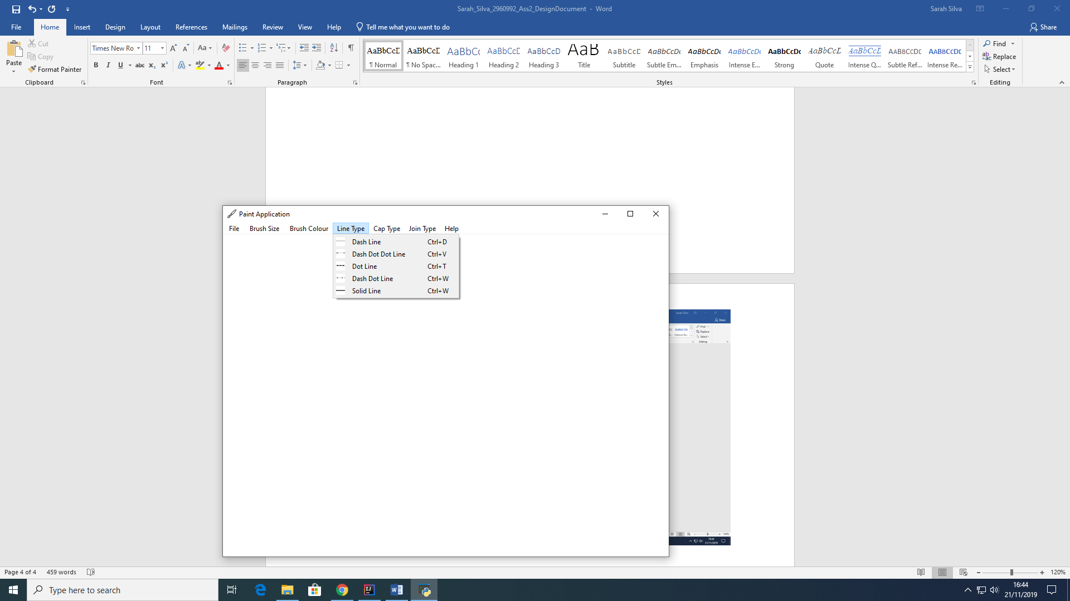

**2.6 Cap Type Menu**

The Cap Type Menu, allows the end user to select from three different types of Cap for the brush. The caps can be either square, flat or round Cap. The issue mentioned before on topic 2.5, also applies in this feature, except, that for this aspect, it hard to find the differences between them in a simple free hand drawing.

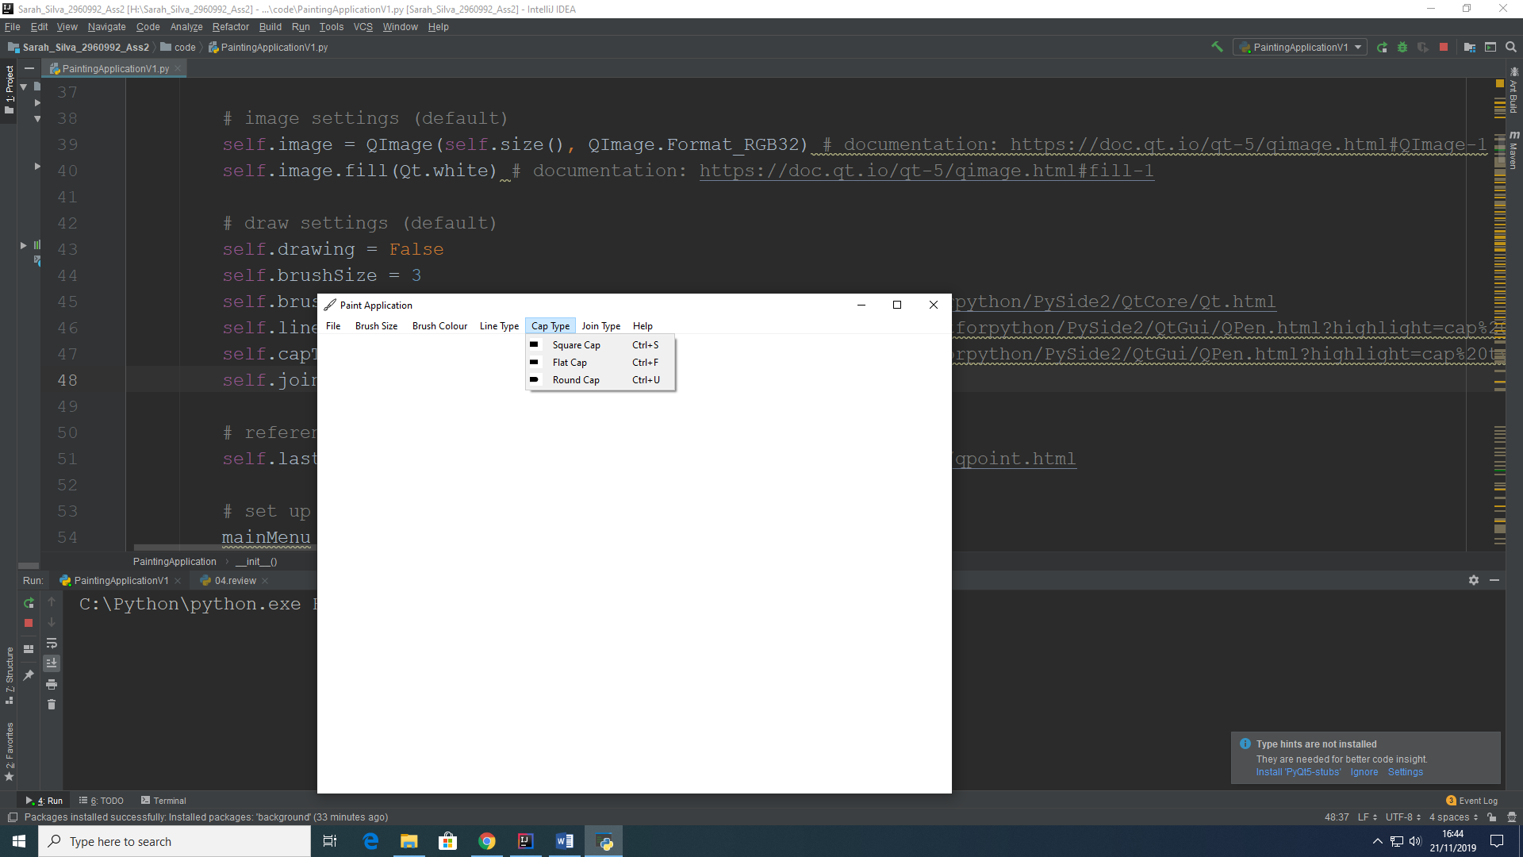

**2.7 Join Type Menu**

The Join Type Menu allows the User to select from three different types of Join, such as Bevel, Miter and Round Join. The issue persists on this feature, making it hard to recognize differences between the three join types by free hand drawing.

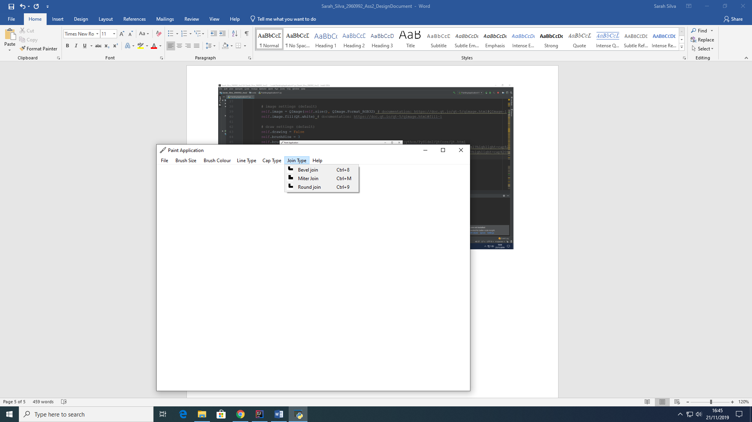

**2.8 Help Menu**

The last menu has a dropdown menu with two options which are About and Help.

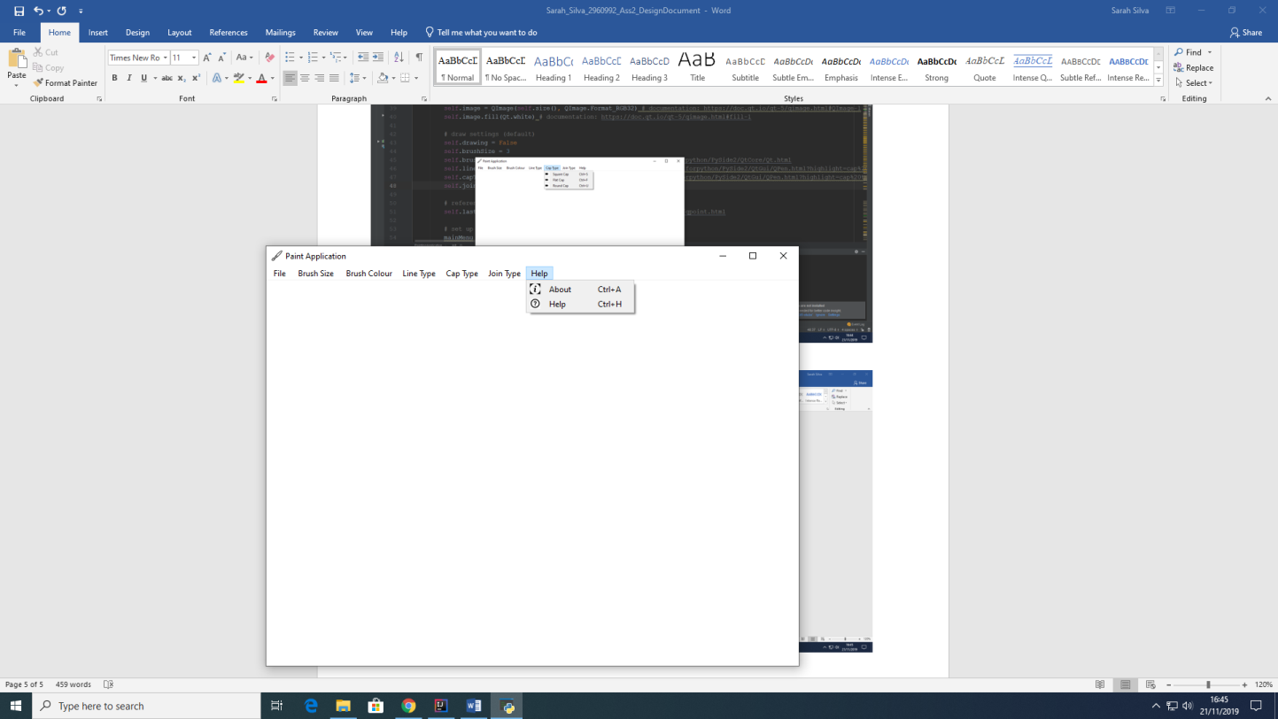

**2.8.1 About**

When clicked on the about option, a pop up message window with an “About Painting Application” title shows up to the user with information about the program. These information include the copyrights to who built the application and the purpose of it.

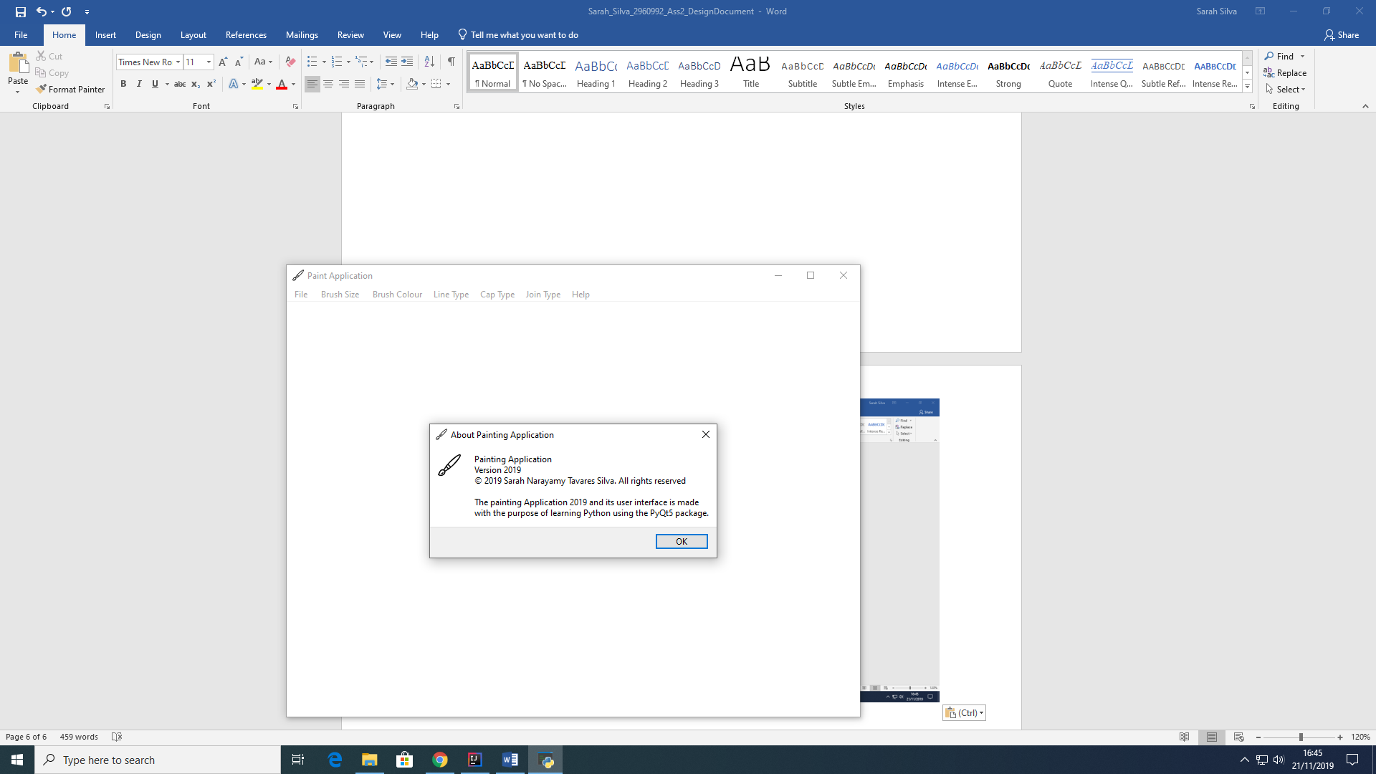

**2.8.2 Help**

When the user clicks on the help option within the Help main menu, a pop up message with the title “Let’s get started” shows up describing the features of the application.

