

**Assignment Cover Sheet**

|  |  |  |  |  |  |  |
| --- | --- | --- | --- | --- | --- | --- |
| **Student name:** | **Sarah Narayamy Tavares Silva** | | | | | |
| **Student number:** | **2960992** | | |  | | |
| **Faculty:** | **Computing Science** | | |  | | |
| **Course:** | **Computing Science** | | | **Stage/year:** | **3** | |
| **Subject:** | **Networks and Data Communications** | | | | | |
| **Study Mode:** | Full time | **X** |  | Part-time |  |  |
| **Lecturer Name:** | **Brendan Fogarty** | | | | | |
| **Assignment Title:** | **Tutorial Sheet 2** | | | | | |
| **No. of pages:** |  | | |  | | |
| **Disk included?** | Yes |  |  | No | **X** |  |
| **Additional Information:** | (ie. number of pieces submitted, size of assignment, A2, A3 etc) | | | | | |
|  | | | | | |
|  | | | | | |
| **Date due:** | **08/10/2019** | | |  | | |
| **Date submitted:** |  | | |  | | |
|  | | | | | | |
| **Plagiarism disclaimer:**  *I understand that plagiarism is a serious offence and have read and understood the college policy on plagiarism. I also understand that I may receive a mark of zero if I have not identified and properly attributed sources which have been used, referred to, or have in any way influenced the preparation of this assignment, or if I have knowingly allowed others to plagiarise my work in this way.*  *I hereby certify that this assignment is my own work, based on my personal study and/or research, and that I have acknowledged all material and sources used in its preparation. I also certify that the assignment has not previously been submitted for assessment and that I have not copied in part or whole or otherwise plagiarised the work of anyone else, including other students.*  **Signed: Sarah Narayamy Tavares Silva Date:** | | | | | | |

## **Please note:** Students **MUST** retain a hard / soft copy of **ALL** assignments as well as a receipt issued and signed by a member of Faculty as proof of submission.

**Question 01: Error Control**

1. **Compare the Single Bit Parity and CRC error checking mechanisms under three appropriate headings.**

Please Note: *One of the headings must be the error detection capability.*

CRC error checking mechanism can detect burst errors while Single bit parity mechanism as the name says can only detect a single error.

Parity check is done by adding an extra bit to make a number either even or odd depending on which one you are using. The CRC involves binary division of the data by a divisor generated by using polynomials.

Parity check is a very simple mechanism while CRC is quite complex to apply because involves the divisor, polynomials and a long division.

**Question 2: Single Bit Parity**

1. **The following bit patterns are being prepared for transmission, state the bit pattern transmitted in each scenario**.

Please Note: You must clearly show all workings and state any assumptions in your solution.

Assuming a single bit parity is ODD

1. 01111000

* Count the numbers of 1’s = 4
* Since the count is an even number, we must append a 1 at the end to be the parity bit in order to get a correct ODD number.
* The message sent altogether is = 011110001

1. 00110101

* Count the numbers of 1’s = 4
* Since the count is an even number, we must append a 1 at the end to be the parity bit in order to get a correct ODD number.
* The message sent altogether is = 001101011

1. 1011000

* Count the numbers of 1’s = 3
* Since the count is an ODD number, we must append a 0 at the end to be the parity bit so the number of 1’s stays an ODD number.
* The message sent altogether is = 10110000

1. **Show with the aid of an example how a receiver can detect an error in a received bitstream if single bit parity is the error checking mechanism.**

The receiver must ensure that the total number of 1’s of the data plus the parity bit is ODD or EVEN, depending on which error checking mechanism is being used.

Assuming we are using the EVEN error checking mechanism, the receiver receives the following message:

110011001

In which the last 1 is the parity bit.

If we count the number of 1’s before the parity bit, we find 4. Thus when we sum the number of 1’s and the parity bit we end up with 5 which is an ODD number. Since we are using the EVEN error checking mechanism, the fact that this sum is an ODD number indicates that there is an error in the message.

**Question 3: CRC**

1. **A communications system is using CRC as the error checking mechanism, if the data to be transmitted is 0101111000 and the generator polynomial is** **X3 + X + 1, determine the bit pattern that will be transmitted.**

Please Note: You must clearly show all workings and state any assumptions in your solution.

1. Use the polynomial to generate the binary divisor

|  |  |  |  |  |
| --- | --- | --- | --- | --- |
| **Polynomial** | **X3** | **X2** | **X1** | **+1** |
| **Divisor** | 1 | 0 | 1 | 1 |

1. The number of dummy bits to append to the data is equal to the width of the divisor minus 1.

Dummy bits = 4 - 1 = 3

1. The dummy bits are appended to the data:

0101111000000

1. Do the long division using the XOR subtraction.

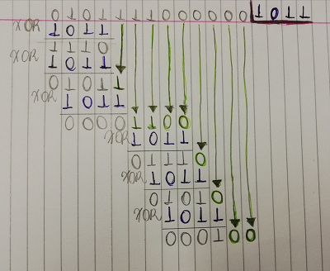

The last 3 digits of the remainder is used to append CRC to the data to be transmitted, which will be:

0101111000100

1. **A communications system is using CRC as the error checking mechanism, if the receiver receives the following bit pattern 010100110, determine if the received bit pattern has errors if the generator polynomial used to generate the CRC was X5 + X2 + 1**

Please Note: You must clearly show all workings and state any assumptions in your solution.

1. Use the polynomial to generate the binary divisor

|  |  |  |  |  |  |  |
| --- | --- | --- | --- | --- | --- | --- |
| **Polynomial** | **X5** | **X4** | **X3** | **X2** | **X1** | **+1** |
| **Divisor** | 1 | 0 | 0 | 1 | 0 | 1 |

1. Do the long division using the XOR subtraction.

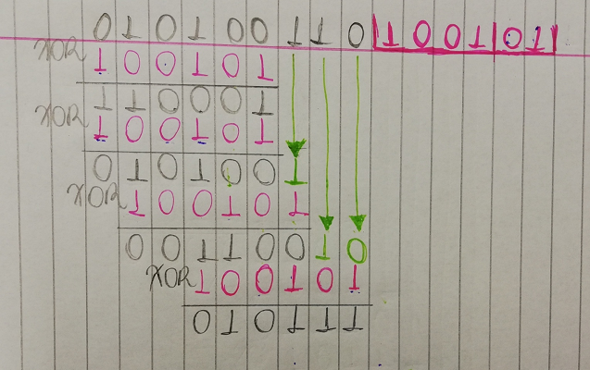

Compare the last 3 digits of the remainder of the division with the last 3 digits of the received pattern:

Remainder = 111

Received = 110

When there is no match in this comparison, it means that there is an error in the bit pattern

**Question 4: Block Parity**

**A communications system is using Block Parity as the error control mechanim. A TX is preparing the following bit pattern for transmission 0101111010100011110000011000 Determine the bit pattern to be transmitted stating any assumptions in your solution**.

Assuming the block parity is even

1. Build the table with parity column and parity row following the bit pattern transmission and adding the parity bit at the end of each column and each row according to the block parity chosen (in this case even).

|  |  |  |  |  |  |  |  |
| --- | --- | --- | --- | --- | --- | --- | --- |
| **0** | **1** | **0** | **1** | **1** | **1** | **1** | **1** |
| **0** | **1** | **0** | **1** | **0** | **0** | **0** | **0** |
| **1** | **1** | **1** | **1** | **0** | **0** | **0** | **0** |
| **0** | **0** | **1** | **1** | **0** | **0** | **0** | **0** |
| **1** | **1** | **0** | **0** | **1** | **1** | **1** | **1** |

1. The bit pattern to be transmitted is the whole sequence that was created in the table, row by row:

01011111 01010000 11110000 00110000 11001111

**Question 5: Framing 01**

1. **In the context of data communications, define what a frame is.**

A frame is a data transmission unit used at the layer 2 of the OSI model with a header which indicates the beginning and end of a block of data.

1. **With the aid of diagrams, explain any two approaches to framing.**

**Question 6: Framing 02**

1. **HDLC is a protocol used at the data link layer of the OSI model. A TX is preparing the following bit pattern for transmission: 01110100100000101000000. Show the bit pattern after the TX bit stuffs it.**
2. **HDLC is a protocol used at the data link layer of the OSI model. A RX receives the following bit pattern: 1000010001010000001000 Show the bit pattern after the TX bit strips it.**

**Question 7: Media Access Control**

1. **Explain what Media Access Control is and why it is necessary.**
2. **With the aid of diagrams, explain three different approaches to Media Access Control.**

**Question 8: IP Addressing**

Please Note: You must clearly show all workings and state any assumptions in your solution.

1. **In relation to IPv4 addressing, differentiate between a unicast, multicast and broadcast address.**
2. **Explain the purpose of a subnet Mask.**
3. **Determine if these two IP addresses are on the same network: 192.168.1.55/24 and 192.168.1.250**

**Question 9 and 10: Network Simulation**

**Use PacketTracer to simulate two networks which are separated by a router. Network 1 will contain 4 PCs and a printer. Network 2 will contain a server with Web, DHCP and DNS enabled. These services will be available to the devices on Network 1. The DNS Server table should contain a single entry YourNameYourStudentNumber.com (e.g. BrendanFogarty0123456789.com). The DHCP server should serve out IP addressing info to the PCs on Network1. The number of addresses served out should be equivalent to the last two digits of your student number + 5. (For example, if the last two digits of your student number are 37, your DHCP server should have a total of 42 addresses in its Pool).**

