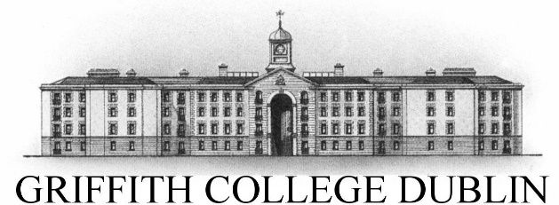

**Assignment Cover Sheet**

|  |  |  |  |  |  |  |
| --- | --- | --- | --- | --- | --- | --- |
| **Student name:** | **Sarah Narayamy Tavares Silva** | | | | | |
| **Student number:** | **2960992** | | |  | | |
| **Faculty:** | **Computing Science** | | |  | | |
| **Course:** | **Computing Science** | | | **Stage/year:** | **3** | |
| **Subject:** | **Networks and Data Communications** | | | | | |
| **Study Mode:** | Full time | **X** |  | Part-time |  |  |
| **Lecturer Name:** | **Brendan Fogarty** | | | | | |
| **Assignment Title:** | **Tutorial Sheet 3** | | | | | |
| **No. of pages:** |  | | |  | | |
| **Disk included?** | Yes |  |  | No | **X** |  |
| **Additional Information:** | (ie. number of pieces submitted, size of assignment, A2, A3 etc) | | | | | |
|  | | | | | |
|  | | | | | |
| **Date due:** | **24/11/2019** | | |  | | |
| **Date submitted:** | **24/11/2019** | | |  | | |
|  | | | | | | |
| **Plagiarism disclaimer:**  *I understand that plagiarism is a serious offence and have read and understood the college policy on plagiarism. I also understand that I may receive a mark of zero if I have not identified and properly attributed sources which have been used, referred to, or have in any way influenced the preparation of this assignment, or if I have knowingly allowed others to plagiarise my work in this way.*  *I hereby certify that this assignment is my own work, based on my personal study and/or research, and that I have acknowledged all material and sources used in its preparation. I also certify that the assignment has not previously been submitted for assessment and that I have not copied in part or whole or otherwise plagiarised the work of anyone else, including other students.*  **Signed: Sarah Narayamy Tavares Silva Date: 24/11/2019** | | | | | | |

## **Please note:** Students **MUST** retain a hard / soft copy of **ALL** assignments as well as a receipt issued and signed by a member of Faculty as proof of submission.

**Question 01: Analogue Signals - Basics**

**a. Using a diagram explain what an analogue signal is and define these three important properties:**

**i. Frequency**

**ii. Phase**

**iii. Amplitude**

Analogue signals are signals used to record measurements that vary with time such as temperatures. These signals can have any value in a predefined range which means that they have no upper/ lower limits and also a change is not immediate.

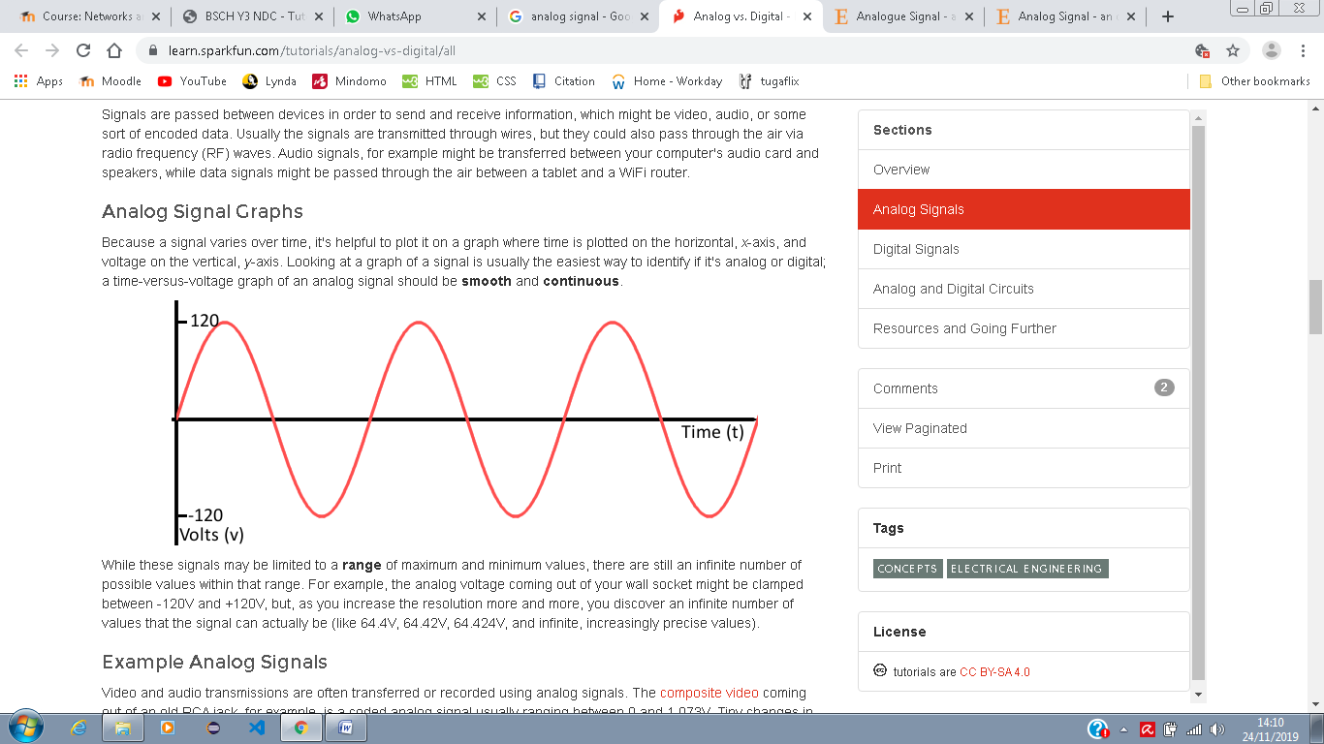

A signal with repeating waveform is called Sinusoidal. These type of waves has a few properties such as Frequency which means the total number of cycles within one second, it is measured in Hertz; Phase which defines the value of a position of a point in time of a waveform, it is measured in degrees, one cycle a waveform equals to 360° degrees; and Amplitude which is related to the strength of the signal, it is the difference (distance) between the midpoint and the Peak, it is measured in meters.

**b. List three examples of analogue signals.**

Examples of analogue signals are Sound, video and Temperature.

**Question 2: Analogue Signals - Calculations**

**a. The period of an analogue signal is 1.75nS, calculate its frequency.**

The formula for frequency is: , thus, = 1/1.75 * 10-9

= 571 * 106

**b. The radio station Radio 1, broadcasts on the frequency 89.2 MHz, what is the period of this waveform? Please Note: You must clearly show all workings and state any assumptions in your solution.**

The formula for frequency is: , thus,

**Question 3: Digital Signals – Basics**

**a. Using a diagram explain the following terms in relation to digital signals:**

**i. Bit Rate**

**ii. Bit Window**

**iii. Baud Rate**

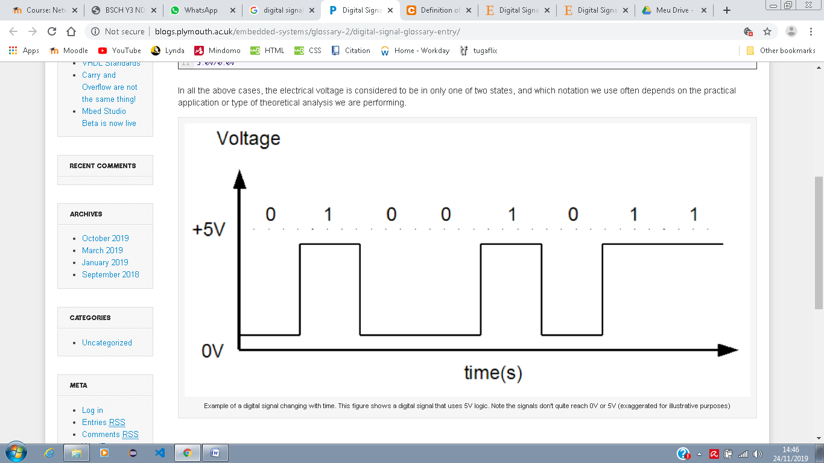

The Bit rate is the number of bits represented within 1 second or the number of bit windows in 1 sec. The Bit window is the time period in which a bit is represented, or the duration of a pulse. The Baud Rate is the number of bits represented in a single bit window. In each bit window, 1 bit is represented.

**b. List three examples of digital signals.**

Examples of digital signals are computers, digital phones, and digital pens.

**Question 4: Digital Signals - Calculations**

**a. A digital signal is used to encode digital data. In a single bit window of 250ρS a single bit is encoded. Calculate the number of bits encoded in 1 second.**

250ρS = 250 * 10-12

If 250 * 10-12 s = 1 bit window

1 s = X

Thus,

**4 Gbits**

**Question 5: Converting Analogue to Digital Signals**

**Outline the process used to convert an analogue signal to a digital signal. In your answer please include the following terms:**

* **Sampling rate**
* **Quantization**

The process to convert an analogue signal to a digital signal involves 4 different steps. The first step is to sample the analogue waveform, in which its taken measurements at regular intervals, this sampling should be done at twice highest the frequency of the analogue waveform.

The second step is the Quantization of the samples which involves mapping the samples values into a value in an 8 bit range of values (0 to 255 or -128 to +127). For example if you have a sample with 4 values such as 1000, 500, 200, 750. These values can be mapped as 1000 = 255, 500 = 127, 200 = 60, 750 = 180.

The third step is to convert the quantized values to binary. For example, from our previous sample, 255 would be converted to 11111111, 127 would be 1111111 60 would be 111100 and 180 would be 10110100.

The final and fourth step is to take the binary values and encode it. The simples encoding scheme is 0 = 0v and 1 = +5v.



**Question 6:** **Modulation**

**a. In your own words explain the term modulation and briefly describe three benefits associated with it.**

Modulation stands for a change in the information signal which results in a characteristic of the carrier waveform being changed or modified. It is the process of imposing an input signal onto a carrier wave. The advantages of implementing modulation are: reducing the size of Antennas, improving reception quality and allowing adjustments in the bandwidth.

**b. Give an overview of how Frequency Modulation operates.**

Frequency modulation is when the frequency of an input signal is changed. The term gave origin to the “FM” radio that we know now. Thus, users of a radio can use changes of frequency to carry speech information.

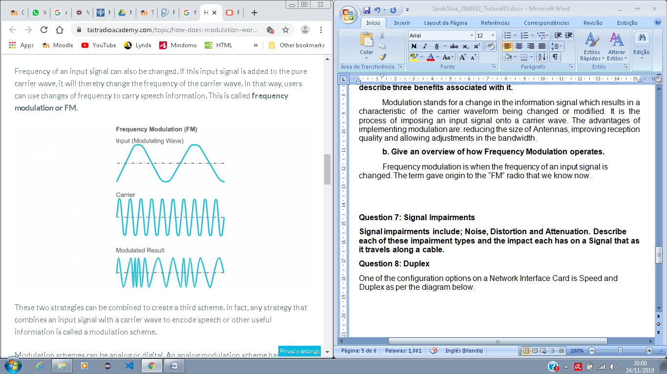

**Question 7: Signal Impairments**

**Signal impairments include; Noise, Distortion and Attenuation. Describe each of these impairment types and the impact each has on a Signal that as it travels along a cable.**

When analogue signals travel through a transmission media, the quality of the signal can deteriorate as the travel. Which means that the signal received may not be the same as the signal that was sent.

There are three types of impairments:

Noise is an unwanted signal that mixes up with the original signal. Noises can have three types such as White noise, which is emitted from high voltage electrical equipments such as microwaves; Thermal Noise is when a signal travels along a cable and the cable heats up by the motion of electrons. Impulse Noise is when there is high voltage like a lightning, this type of Noise happens infrequently.

Distortion is when the shape of the signal is changed. Delay distortion affects signals made up of multiple simple signals (composite signals) when each signal is sent out over the transmission medium at the same time. Thus, the signal may arrive out of sync at receiver, which means that the composite signal will not be reconstructed properly.

Attenuation stands for loss of energy, which means that the strength of signal decreases with distance. To solve this problem, an Amplifier is used to amplify the attenuated signal turning it back to its original characteristic.

**Question 8: Duplex**

**One of the configuration options on a Network Interface Card is Speed and Duplex as per the diagram below.**

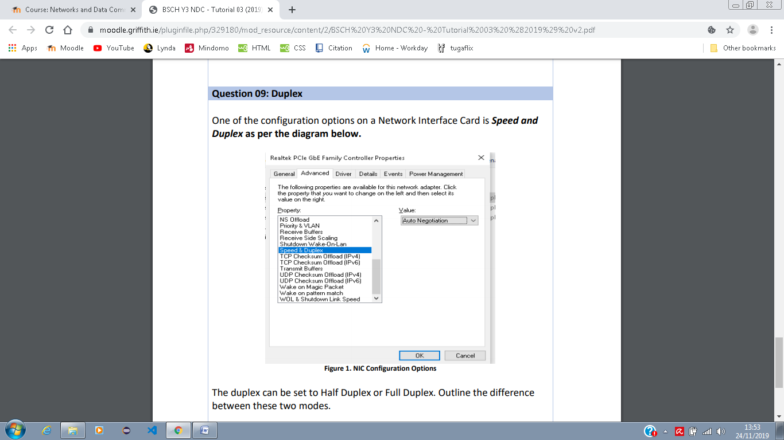

**The duplex can be set to Half Duplex or Full Duplex. Outline the difference between these two modes.**

Transmission mode or communication mode is when two devices transfer data between each other. This communication can be made in three different ways such as Simplex mode, which is when there is a unidirectional communications, meaning that only one device can transmit and the second one just receives, an example of this type is a keyboard, in which the keyboard can only input but not output.

In a Half Duplex mode both devices can transmit and receive, but not at the same time. Thus, whenever one device is sending information, the other device will only be able to receive. This type of communication is often used when communication in both directions at the same time is not needed, for example the use of a Walkie-talkie.

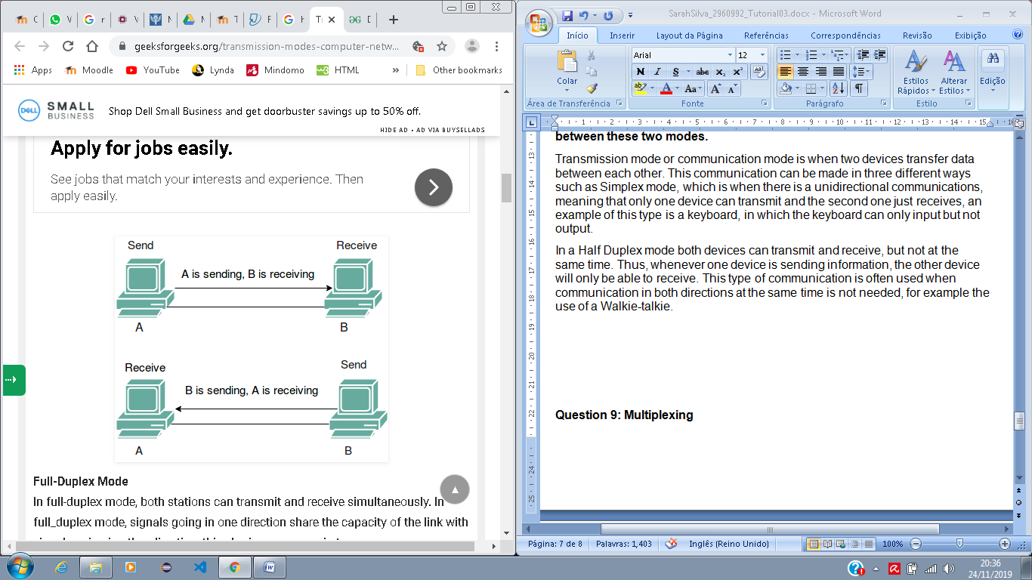

Unlike half duplex mode, in the Full Duplex mode, the devices can both transmit and receive information at the same time. This communication can be done by each device having two physically separate transmission paths for sending or receiving, or the capacity is divided between the signals travelling in both directions. An example of the use of a Full Duplex mode is a telephone in which two people must be able to talk and listen at the same time.

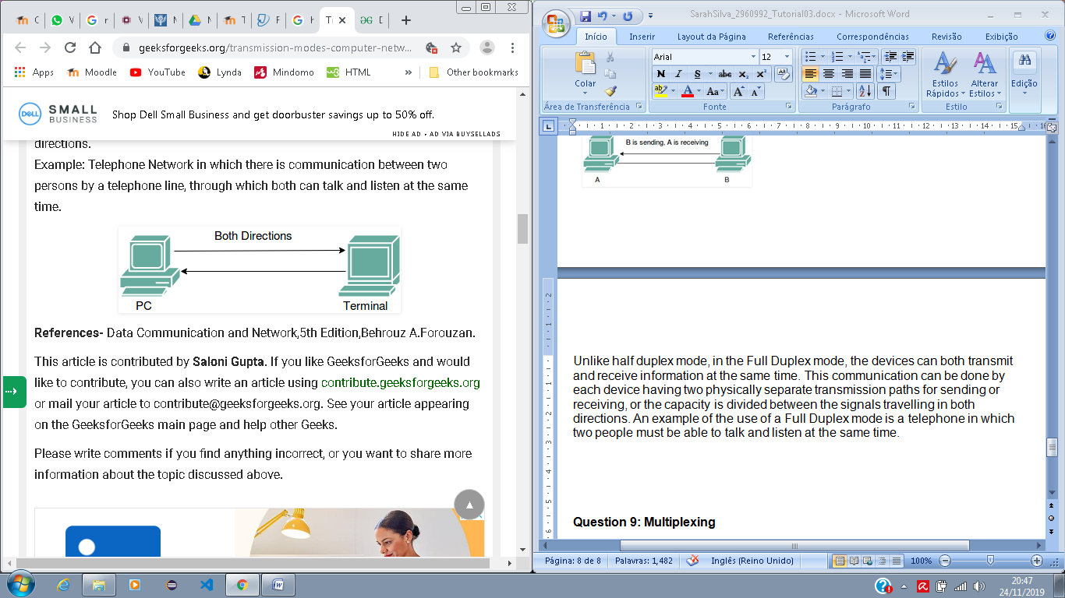

**Question 9: Multiplexing**

**Explain the term “Multiplexing”, the purpose it serves in data networks and two different types of Multiplexing.**

Multiplexing means that, in a network environment all devices are connected to a MUX and only one line to host all. In other words, it is the process of combining multiple signals into one single signal when devices share a medium. The MUX, which is the device that does the multiplexing, divides a communication channel into several numbers of logical channels, allotting each one of them to a different message signal. The DEMUX is the demultiplexing device that delivers the received segments at receiver side in the correct app layer process.

One type of Multiplexing is the Frequency Division Multiplexing (FDM), used in analogue system. This type of Multiplexing uses different frequencies to combine streams of data to send them on a communication medium as a single signal. An example of this type of multiplexing is the transmission of a television which sends a number of channels through a single cable.

A second type of Multiplexing is the Wavelength Division Multiplexing (WDM) which is an analogue technique that transmits several data streams of different wavelengths through the light spectrum. If there is an increasing of the wavelength, the frequency of the signal decreases. An example of this type of multiplexing is an optical fibre communication.

