

**Assignment Cover Sheet**

|  |  |  |  |  |  |  |
| --- | --- | --- | --- | --- | --- | --- |
| **Student name:** | **Sarah Narayamy Tavares Silva** | | | | | |
| **Student number:** | **2960992** | | |  | | |
| **Faculty:** | **Computing Science** | | |  | | |
| **Course:** | **Computing Science** | | | **Stage/year:** | **3** | |
| **Subject:** | **Networks and Data Communications** | | | | | |
| **Study Mode:** | Full time | **X** |  | Part-time |  |  |
| **Lecturer Name:** | **Brendan Fogarty** | | | | | |
| **Assignment Title:** | **Tutorial Sheet 5** | | | | | |
| **No. of pages:** | **5** | | |  | | |
| **Disk included?** | Yes |  |  | No | **X** |  |
| **Additional Information:** | (ie. number of pieces submitted, size of assignment, A2, A3 etc) | | | | | |
|  | | | | | |
|  | | | | | |
| **Date due:** | **30/12/2019** | | |  | | |
| **Date submitted:** | **28/12/2019** | | |  | | |
|  | | | | | | |
| **Plagiarism disclaimer:**  *I understand that plagiarism is a serious offence and have read and understood the college policy on plagiarism. I also understand that I may receive a mark of zero if I have not identified and properly attributed sources which have been used, referred to, or have in any way influenced the preparation of this assignment, or if I have knowingly allowed others to plagiarise my work in this way.*  *I hereby certify that this assignment is my own work, based on my personal study and/or research, and that I have acknowledged all material and sources used in its preparation. I also certify that the assignment has not previously been submitted for assessment and that I have not copied in part or whole or otherwise plagiarised the work of anyone else, including other students.*  **Signed: Sarah Narayamy Tavares Silva Date: 28/12/2019** | | | | | | |

## **Please note:** Students **MUST** retain a hard / soft copy of **ALL** assignments as well as a receipt issued and signed by a member of Faculty as proof of submission.

**Question 01: Topic: Switching**

1. **With the aid of a diagram explain what circuit switching is.**

Circuit switching is the simplest method of communication in which a dedicated connection path is established between sender and receiver. Once the connection is made between these two ends, the data transfer is forwarded continuously while there is connection between them, which means that the circuit is maintained for entire duration of the conversation which terminates only when one of the parties finalizes the connection (hang up), this termination can be made by the called party or the calling party. The quality of this circuit is very high and it is recommended for real time communication.

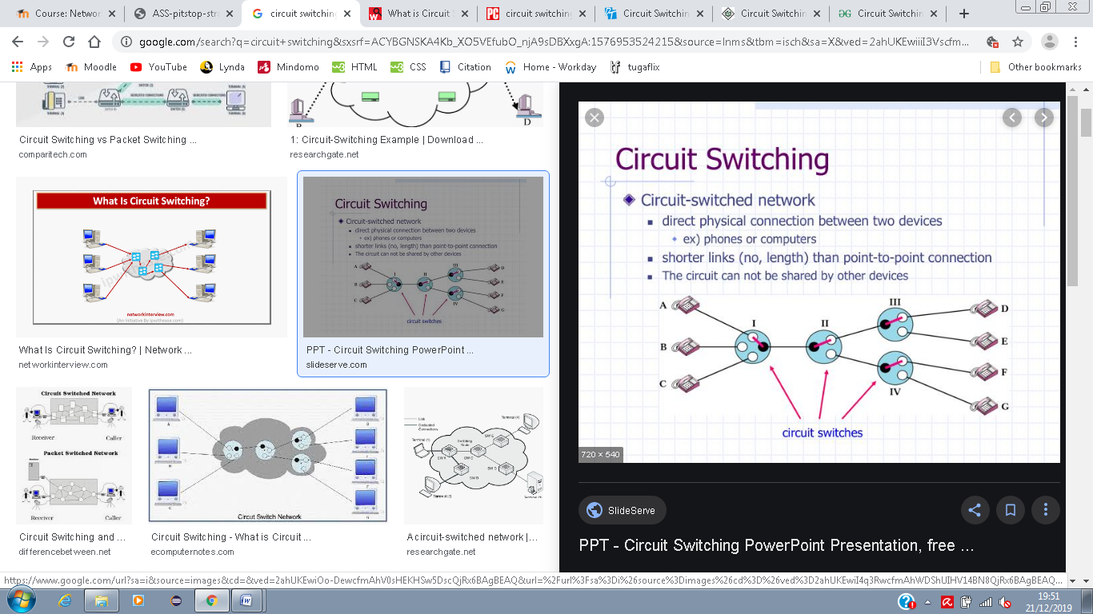

1. **Discuss any three properties of a circuit is established between two**

**End points over the PSTN network.**

In PSTN network, the connection is dedicated, exclusive and temporary, which means that connection involves only the calling and called party, and it keeps both parties connected only until one of them decides to terminate the circuit (hang up).

**Question 2: With the aid of diagrams explain the difference between Message Switching and Datagram* Switching.**

**\* Datagram refers to a unit of data such as a packet.**

Message switching relates to the transfer of data over a network in which a message or data to be transferred is treated as one complete unit. Each intermediary device between sender and receiver stores the message before forwarding it, which makes the data transfer rate slowly. Another aspect of message switching is that if the message arrives at its destine with errors, the entire message has to be retransmitted.

Datagram Switching or Packet Switching on the other hand, the message or data is divided into multiple smaller units (packets) and each packet contains routing information (SRC IP address and DST IP address) that allows it to be forwarded across the network. Packets may follow different paths and may arrive out of order to destination but the receiver reorders the packets if it is necessary. Also, if a packet arrives at destination with errors, only the packet containing error is to be resent.

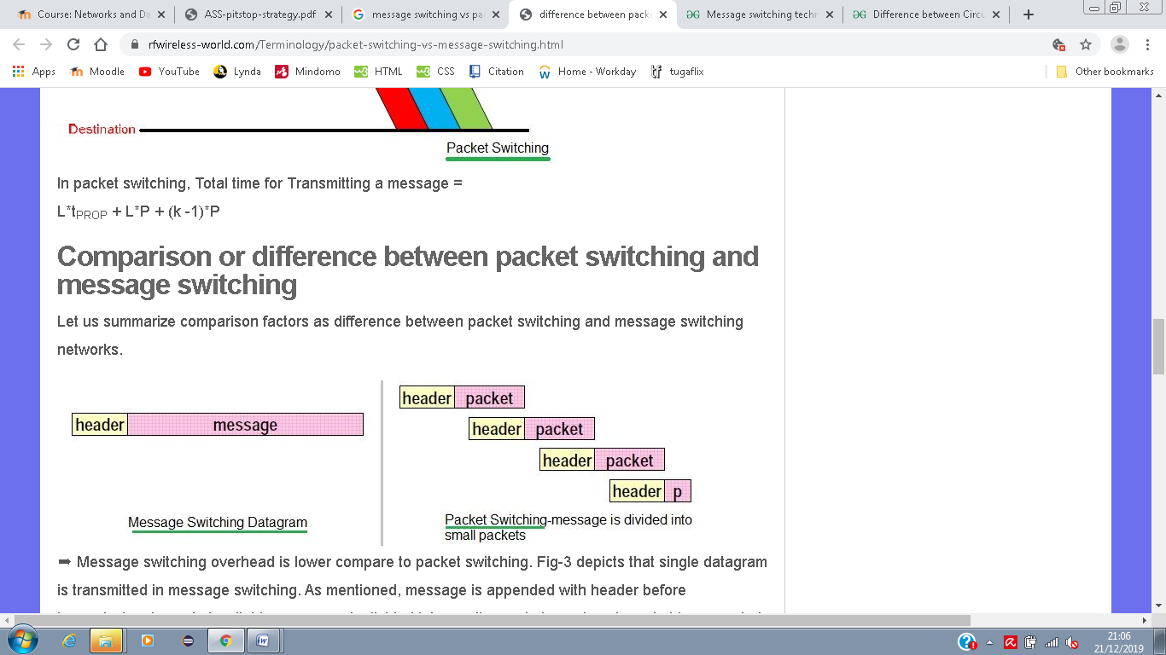

Question 3:

1. **Explain how it is possible to create a virtual circuit on a packet switched network.**

In order to create a virtual circuit on a packet switched network, routers must be configured so that all packets between sender and receiver follows the same route across the network. The packets will experience the same delay when transmitting network.

1. **Discuss any three properties of a virtual circuit on a packet switched**

**Network.**

In virtual circuit, the packets arrive in order at the receiver which means that no reordering is required to be done. It is a connection oriented service, which means that only the destination address, the source address and the information to be transmitted is required to establish the circuit. Another property is the price of the circuit, once new connection has to be made when reserving resources, this type of circuit is more costly than other circuits.

**Question 4:**

1. **Define the following terms (i) channel (ii) channel capacity (or bandwidth)**

Channel is the path in which the information passes through from the source to the receiver when there is a link between them two.

Bandwidth gives the measure of the capacity to carry signals containing data. It is given by the difference between the upper and lower frequencies of a communication system.

1. **A channel is using the frequencies between 4GHz and 9GHz, the channel is noiseless and only 2 signalling levels are used. Calculate the maximum theoretical capacity of this channel.**

If the Bandwidth is the difference between the upper and lower frequencies = 9GHz – 4GHz

Bandwidth (B) = 5GHz

**C = signalling level * B**

C = 2 *(5 * 103)

C = 10 * 103

C = 10 Kbps

1. **If the channel in (a) was using 8 signalling levels, how would the theoretical capacity change?**

**Capacity (C) = 2* B \***

C = 2 *(5 * 103)*3

C = 30000

C = 30 Kbps

**Question 5:**

1. **Express a Signal to Noise ratio of 10,000: 1 in decibels.**
$$Snr=10 \log_{10}{\frac{Signal power}{Noise power}}$$

$$Snr=10 \log_{10}{\frac{10000}{1}}$$

$$Snr=40 dB$$

2. **The noise power of a received signal is 150 microWatts, if the SNRdb is 20dB, calculate the signal power.**

$$Snr=10 \log_{10}{\frac{Signal power}{Noise power}}$$

$$20dB=10 \log_{10}{\frac{150* microWatts}{Noise power}}$$

$\frac{20}{10}$ = $\log_{10}{\frac{150* microWatts}{Noise power}}$

$${10}^{2}= \frac{150* microWatts}{Noise power}$$

Noise power * 10-6

Noise power =

Noise Power = 1.5 * 10-6

Noise Power = 1.5 µW

1. **A channel uses the bandwidth between 16MHz and 20Mhz. The signal to noise ratio is 35dB. Use Shannon’s Maximum Channel Capacity Formula to determine the theoretical data rate of the channel?**