

Assignment Cover Sheet

Student name: | Sarah Narayamy Tavares Silva
Student number: | 2960992
Faculty: | Computing Science
Course: | Computing Science |  |  | Stage/year: | 3
Subject: | Networks and Data Communications
Study Mode: | Full time | X |  | Part-time
Lecturer Name: | Brendan Fogarty
Assignment Title: | Research Assignment
No. of pages: | 11
Disk included? | Yes |  |  | No | X
Additional Information: | (ie. number of pieces submitted, size of assignment, A2, A3 etc)
Date due: | 16/11/2019
Date submitted: | 19/01/2020
Plagiarism disclaimer:
I understand that plagiarism is a serious offence and have read and understood the college policy on plagiarism. I also understand that I may receive a mark of zero if I have not identified and properly attributed sources which have been used, referred to, or have in any way influenced the preparation of this assignment, or if I have knowingly allowed others to plagiarise my work in this way.

I hereby certify that this assignment is my own work, based on my personal study and/or research, and that I have acknowledged all material and sources used in its preparation. I also certify that the assignment has not previously been submitted for assessment and that I have not copied in part or whole or otherwise plagiarised the work of anyone else, including other students.
Signed: Sarah Narayamy Tavares Silva Date: 19/01/2020

Please note: Students MUST retain a hard / soft copy of ALL assignments as well as a receipt issued and signed by a member of Faculty as proof of submission.

TABLE OF CONTENTS

1 INTRODUCTION 2
2 HISTORY OF WIRELESS NETWORK 2
3 BLUETOOTH 3
4 WI-FI 4
5 SATELITE 5
6 NFC 6
7 INFRARED 7
8 CONCLUSION 8
BIBLIOGRAPHY 9

1 INTRODUCTION
According to Collins dictionary, Network stands for a system of things which are connected and which operate together. In the computer world, a computer network is a number of computers that connect with each other in order to promote communication of data between users.
There are several ways to structure a network, such as Local Area Network (LAN), Metropolitan Area Network (MAN), Wide Area Network (WAN), Personal Area Network (PAN), Storage Area Network (SAN), Enterprise Private Network (EPN) and Virtual Private Network (VPN), each one of them with its particular aspects. Usually, these networks perform with the use of cables such as CAT5 and CAT5e, but it is possible to create a network without cables, thus Wireless like is the case of WANs among others.

2 HISTORY OF WIRELESS NETWORK
It all started with in the preindustrial age when the line-of-sight distances were used using smoke signals, torch signalling, flashing mirrors, signal flares, and semaphore flags.
In 1838 Samuel Morse invented the telegraph network that replaced the observation stations which were built in top of hills and along roads to spread the messages over large distances following by the telephone. Marconi demonstrated the first radio transmission through a 18 miles distance in 1895.
Radio transmissions evolved throughout the years improving the quality, the power, size, price, etc. Another aspect that improved within radio systems is the way information is transmitted. In early times, radio systems transmitted only Analog signals, but nowadays, radio systems transmit digital signals which are composed of binary bits.
Ethernet technology started in the 1970s steering away the attention on radio-based networking.
The greatest success of wireless networking was the creating of the cellular telephone system. Cellular systems in the current days provide not just voice communication like in early days, but it also provides emailing, voice mail and paging services. In addition to that, cellular system nowadays are digital (Walrand & Varaiya, 2000).

3 BLUETOOTH
The origin of the Bluetooth name is quite interesting. It came from the Denmark King (King Harald Gormsson, who lived more than 1000 years ago) and the reason why it is due to a dead tooth had that looked blue. The logo of Bluetooth is a combination of the two Scandinavian runes for the King’s initials. Image 1 shows the creation of the Bluetooth symbol (Mitchell, 2020).
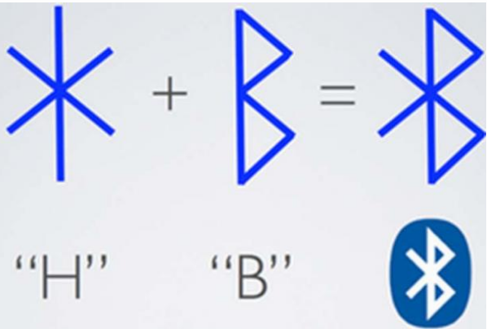
Image 1: Bluetooth origin (Mingren, 2017)

Still according to Mitchell, 2020, Bluetooth can be found in many different types of devices such as cell phones, Wireless headsets, wireless keyboards, printers, wireless speakers, computers, etc.
Paring is the name of the process used by these devices to connect with each other. The signal shared with these devices only cover short distances, usually up to 30 feet. This process of paring uses a called Piconet topology which contains a minimum of two and a maximum of eight Bluetooth peer devices (Mitchell, 2020). According to (Technopedia, 2020), in Piconet topology, when the network is established, one device assumes the master role and the other devices pared act as slaves. The word Piconet cames from the Italian word “pico” which means very small, the reason why is due to limit number of devices (7 plus the master) that can be connected in the same network. Data transfer rates in this network vary from 200 to 2100 kbps. Image 2 shows how Piconet topology works.

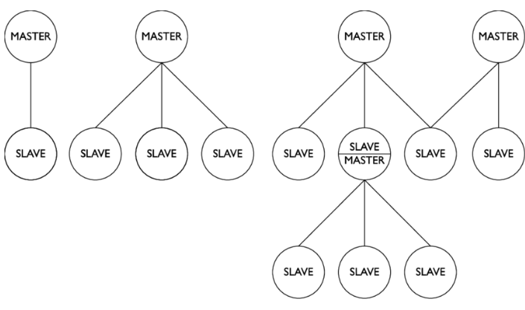
Image 2: Piconet Topology (Stirparo & Loeschner, 2013)

Bluetooth has similar connectivity standard to wi-fi connection, but it is not exactly as fast and it has not the same safety qualities.

4 WI-FI
Wi-Fi is a term that is a trademarked phrase meaning that it uses the IEEE 802.11x standard. This type of wireless connection uses radio waves to provide high-speed internet connection and network connection. The main aspect of Wi-Fi is the Access Point (AP) which has the job of broadcasting a wireless signal that devices can detect and “tune” into. Many devices nowadays are supported by Wi-Fi application, such as video game consoles, home networks, PDAs, mobile phones, computers, watches, etc (Beal, 2020). In terms of security, the WIFI password is what prevents hackers and others from accessing the network (Anon., 2020). Image 3 shows the WI-FI logo which indicates the Yin-Yang.

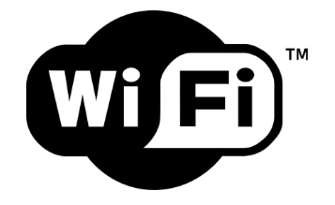
Image 3: WI-FI logo (Cablefree, 2017)

5 SATELITE
This technology has started in 1957 with Sputnik and developed into greatness sophisticated and powerful tool. It is also predicted to develop even more in the future providing more processing capabilities, more power, and more bandwidth.
Satellite provides for three different types of communication: telecommunications, which includes services for telephone calls and services provided to telephone companies, as well as wireless, mobile, and cellular network providers; broadcasting, which includes services for radio and television delivered to the consumer and mobile broadcasting services; and data communication which involves transferring data from one point to another. This technology is used in current days by the government, military, and other sectors other than just broadcasters and internet service providers consumers (Labrador, 2019).
Still according to Labrador, 2019, Satellite communications is highly important during natural disasters and emergencies when land-based communication services are down, especially because they can distribute signals from one point to many locations. The biggest issue with satellite though is the delay in transmission.
Image 4 illustrates the elements in a satellite communication system which is composed by the space segment and the ground segment (Lau, et al., 2011).
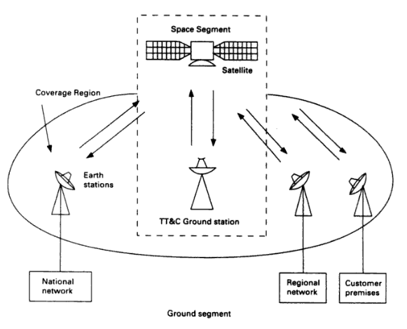
Image 4: Satellite network elements (Lau, et al., 2011)

6 NFC
NFC or Near Field Communication is the technology behind the tap-and-go behaviour available in services like Apple Pay, Android Pay and Amiibo. It is more common than we think. It can be found in simple activities such as security scan cards that allow you to get into the office or bypass that toolbooth on your morning commute (Hill, 2019). This method of wireless data transfer detects and consequently enables technology in close proximity to communicate without the need for an internet connection (Faulkner, 2017).
Still according to Falulker, 2017, NFC technology evolved from Radio Frequency Identification (RFID) tech, in which an NFC chip operates as one part of a wireless link, and once the link is activated by another chip a small amount of data can be transferred between the two devices when held a few centimetres from each other.
According to Hill, 2019, it is not necessary to pair or to discover a device to transfer data through NFC. The connection is established automatically when a NFC device enters a 4-inch range space from another NFC device and the communication is made instantly.
The main issue with NFC is that it happens over the air, which means that there is no protection against man-in-the-middle attacks, but these actions require a very close proximity of NFC to work (Montegriffo, 2019). Image 5 shows how the NFC system works.
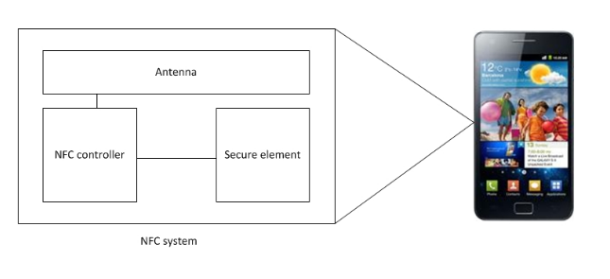
Image 5: NFC system (Diodati, 2012)

7 INFRARED
The most common use to Infrared wireless networking is the TV remote. In this technology, the input entered through the remote control travels over an infrared light wave to the TV. However, this system has developed throughout the years and it is now managed by the Infrared Data Association (IrDA). In order to transmit data between devices, Infrared Wireless Networking uses infrared beams offering high transmission rates reaching from 10Mbps to 16Mbps (Harwood, 2009).
Harwood, 2009 also said that Infrared can be either a directed (line-of-sight) or a diffuse technology. If dealing with directed technology, the signal can be disrupted if something blocks the light once it can not go through objects, hence, it does not work in two separate rooms if there is a wall that separates them. If dealing with diffuse technology however, the light can travel farther and is more difficult to block with a signal object, but it is still limited to room distances.
This type of communication is secure, the cost is low and it is a convenient cable replacement technology. Also, there are no radio frequency issues or signal conflicts when using infrared networking. Image 6 shows a connection between a remote control and its recipient.

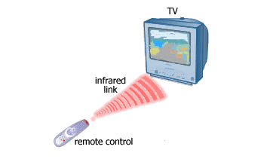
Image 6: Infrared communication (Connig, 2011)

8 CONCLUSION
The world of networking is vast and complex to implement, but the concepts are easy enough. When thinking of building a network, a few aspects must be taking into consideration. In this case, we are analyzing only the wireless option which means that there are no cables involved in the construction of the network.
The first aspect that must be considered when implementing a wireless connection between devices is the goal of the network, which means that it is important to evaluate what is it for that you are creating a network. The second is about the physical space that will be used by the network which evaluates if it is going to use one or more rooms or even if there is no need for an entire room, for example in the case of NFC which needs only 4-inches of proximity to establish a connection. The third aspect is the type of connection is necessary, which means analysing the speed needed for the connection, the amount of data that will be shared, etc. In this case, if you need to share a lot of information, NFC is not recommended once it can only share a very small amount of data, but on the other hand, the connection is instant.

BIBLIOGRAPHY
Anon., 2020. Actiontec. [Online]
Available at: https://www.actiontec.com/wifihelp/wifi-networking/what-is-wifi/
[Accessed 19 01 2020].
Beal, V., 2020. Webopedia. [Online]
Available at: https://www.webopedia.com/TERM/W/Wi_Fi.html
[Accessed 19 01 2020].
Cablefree, 2017. CableFree. [Online]
Available at: https://www.cablefree.net/wireless-technology/history-of-wifi-technology/
[Accessed 19 01 2020].
Connig, 2011. Conniq. [Online]
Available at: http://www.conniq.com/Networking_Media5.htm
[Accessed 19 01 2020].
Diodati, M., 2012. Gartner. [Online]
Available at: https://blogs.gartner.com/mark-diodati/2012/04/20/the-next-revolution-in-mobility-near-field-communication/
[Accessed 19 01 2020].
Faulkner, C., 2017. Techradar. [Online]
Available at: https://www.techradar.com/news/what-is-nfc
[Accessed 19 01 2020].
Harwood, M., 2009. Pearson It Certification. [Online]
Available at: http://www.pearsonitcertification.com/articles/article.aspx?p=1329709&seqNum=11
[Accessed 19 01 2020].
Hill, S., 2019. Digital Trends. [Online]
Available at: https://www.digitaltrends.com/mobile/what-is-nfc/
[Accessed 19 01 2020].
Labrador, V., 2019. Satellite Communication. Encyclopedia Britannica. [Online]
Available at: https://www.britannica.com/technology/satellite-communication/Satellite-applications
[Accessed 19 01 2020].
Lau, S. P., Tan, L. S. & Tan, C. E., 2011. IntechOpen. [Online]
Available at: https://www.intechopen.com/books/advances-in-satellite-communications/improving-quality-of-service-of-real-time-applications-over-bandwidth-limited-satellite-communicatio
[Accessed 19 01 2020].
Mingren, W., 2017. Ancient Origins. [Online]
Available at: https://www.ancient-origins.net/history-famous-people/bluetooth-why-modern-tech-named-after-powerful-king-denmark-and-norway-007398
[Accessed 19 01 2020].
Mitchell, B., 2020. Lifewire. [Online]
Available at: https://www.lifewire.com/definition-of-bluetooth-816260
[Accessed 19 01 2020].
Montegriffo, N., 2019. Androidpit. [Online]
Available at: https://www.androidpit.com/what-is-nfc
[Accessed 19 01 2020].
Stirparo, P. & Loeschner, J., 2013. Secure Bluetooth for Trusted m-Commerce. International Journal of Communications, Network and System Sciences, 14 06.
Technopedia, 2020. Technopedia. [Online]
Available at: https://www.techopedia.com/definition/5081/piconet
[Accessed 19 01 2020].
Walrand, J. & Varaiya, P., 2000. High-Performance Communication Networks. Second Edition ed. s.l.:Elsevier.

