Name : _________________________________ I.D. No. ___________

COMPUTING SCIENCE FACULTY

Higher Certificate in Computing
Relational Databases

Lab Workbook 4

Using SQL with MySql

On Moodle you will find a “Classic Models Database”.

Import this database into MySQL, using the following instructions:
- Download the database from Moodle and make a note of where you stored it.
- Log in to MySQL in the usual way.
- Import the database using the “SOURCE” command. The following is an example: replace the path given with the path to where you stored the file. Note that you should use forward-slashes even though Windows paths generally use backslashes:

mysql> SOURCE C:/Users/1034563/Desktop/sampledatabase.sql

This will create a database called classicmodels

Once you have done this, write SQL statements to find out the following information. You should also write the result that you achieve by running the SQL statement you suggest.

1. What tables are in the database?

Expression | Result
USE classicmodels;  SHOW TABLES; | 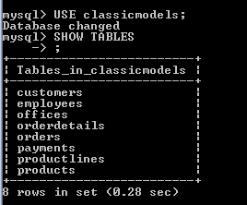

2. Describe the attributes and types of each table. (Use following blank page)

Expression | Result
DESCRIBE customers;  DESCRIBE employees;  DESCIBE offices;  DESCIBE orderdetails;  DESCRIBE orders;  DESCRIBE payments;  DESCRIBE productlines;  DESCRIBE product; | 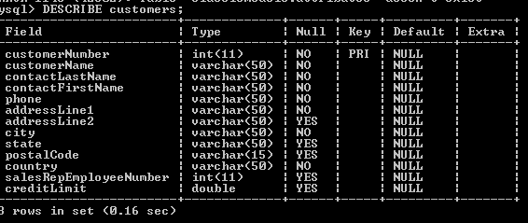  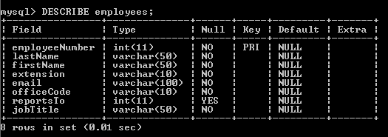  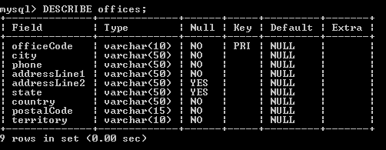  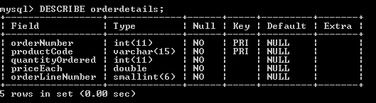  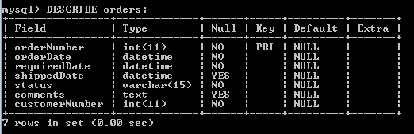  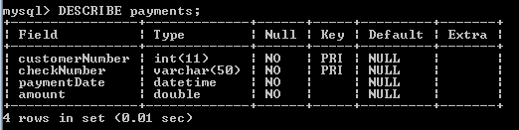  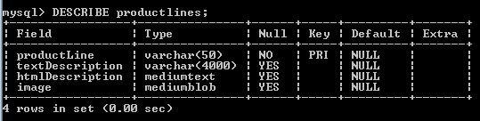  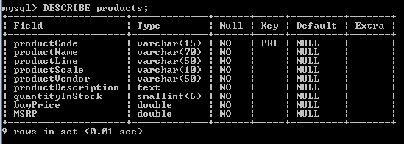

3. Write an SQL expression to select all customers.

Expression | Result
SELECT customerName FROM customers; | 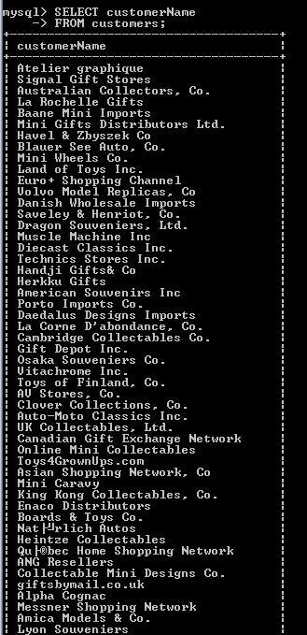  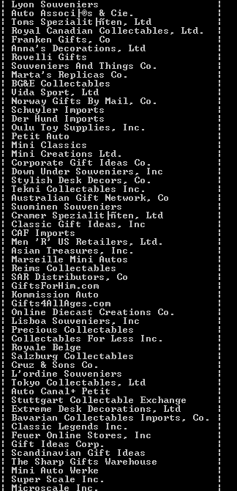  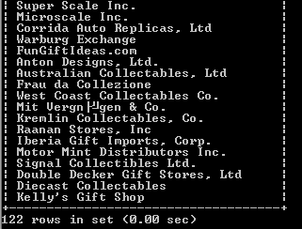

4. Write an SQL expression to give a list of customer names from Frankfurt.

Expression | Result
SELECT * FROM customers WHERE city = ‘Frankfurt’; | 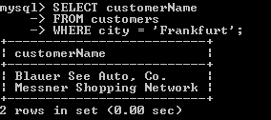

5. Write an SQL expression to give the customer name, city and phone number for all German customers.

Expression | Result
SELECT customerName, city, phone FROM customers WHERE country = ‘German’; | 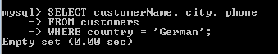

6. Write an SQL expression to find out how many product lines the company sells.

Expression | Result
SELECT COUNT(*)  FROM productlines; | 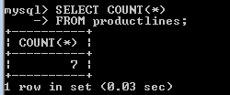

7. For each product line identified above, write an SQL statement to list the products in that line.

Expression | Result
SELECT productName  FROM products  WHERE productLine = ‘Classic Cars’;  ...  WHERE productLine = ‘Motorcycles’;  ...  WHERE productLine = ‘Planes’;  ...  WHERE productLine = ‘Ships’;  ...  WHERE productLine = ‘Trains’  ...  WHERE productLine = ‘Trucks and Buses’;  ...  WHERE productLine = ‘Vintage cars’; | 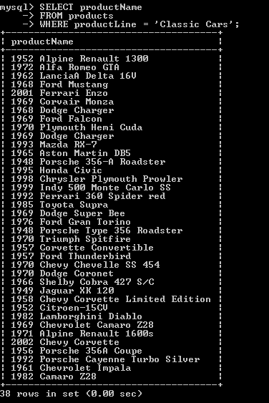  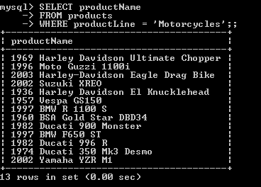  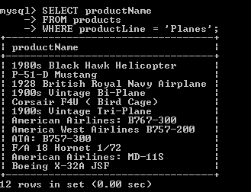  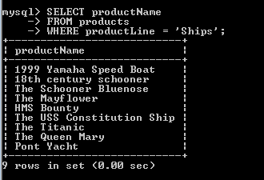  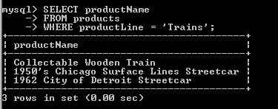  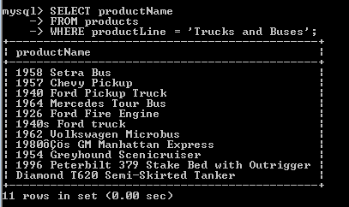  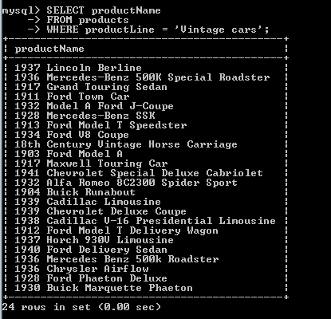

8. Write an SQL statement to identify which cities the company has offices in.

Expression | Result
SELECT city  FROM offices; | 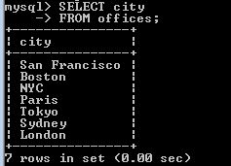

9. Write an SQL statement to list the number of employees in each office.

Expression | Result

10. Who is the company president and in what office is she based?

Expression | Result

END

