Name : Sarah Narayamy Tavares Silva I.D. No. 2960992

COMPUTING SCIENCE FACULTY

Bachelor of Science in Computing
Relational Databases

Lab Workbook 6

Using the SQL Aggregate Functions

As well as retrieving rows and columns from a database, we often want to perform some form of summation, or aggregation, of the data found in the columns. The ISO standard defines five aggregate functions.

- COUNT( ) – returns the number of values in a specific column
- SUM( ) – returns the sum of the values in a specific column
- AVG( ) – returns the mathematical average of the values in a specified column
- MIN( ) – returns the minimum value in a specified column
- MAX( ) – return the maximum value in a specified column
All of these are applied to columns (not rows) and return a single value.

Example 1 : With the classicmodels database, what is the number of products in the products table?

SELECT COUNT(*) FROM products;

Example 2 : What is the total amount of payments the company has received?

SELECT SUM(amount) FROM payments;

Example 3 : What is the average payment made?

SELECT AVG(amount) FROM payments;

Example 4 : What is the maximum payment made?

SELECT MAX(amount) FROM payments;

Example 5 : What is the minimum payment made:

SELECT MIN(amount) From payments:

Use of keyword DISTINCT. Take the following query: Find all the jobtitles held by employees of the company :

SELECT jobtitle FROM employees;

If you run this you will see that multiple outputs of Sales Rep appear on the screen. What’s wrong? Notice that there are 23 lines output. There are 23 employees. What is happening is that the jobtitle of every employee is being output. We don’t want that. We want a list of the jobtitles in the company. The following will give this :

SELECT DISTINCT jobtitle FROM employees;

Question 1

Write an SQL statement to output the number of products the company has in the ‘Classic Car’ product line?

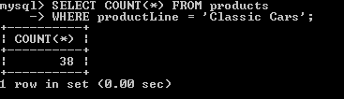

Question 2

Write an SQL statement to output the average price of a model plane.

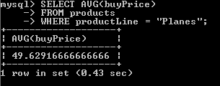

Question 3

If I was to buy the complete set of model vintage cars, how much would it cost?

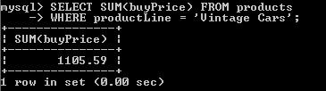

Question 5

What was the total revenue in 2004 for the sale of Classic Car models?

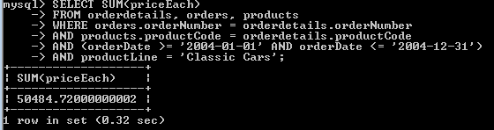

Question 6

Name the customer(s), product and quantity ordered which represents the largest quantity of any item ordered?

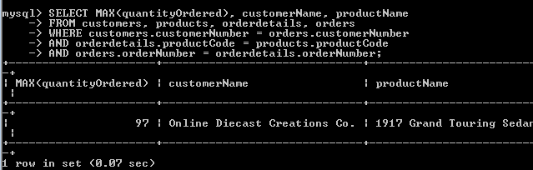

Question 7

Name the customer(s), product and quantity ordered which represents the smallest quantity greater than zero of any item ordered?

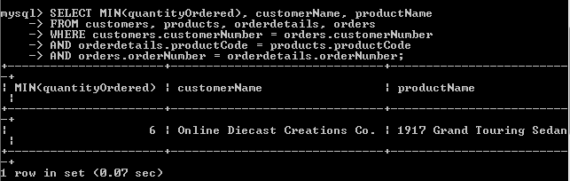

Grouping

The above summary queries are similar to the totals at the bottom of a report. They condense all the detail of a column of data into a single row of summary data. However, we often also want subtotals. The GROUP BY clause allows us to do this.

This clause is used after the WHERE statement, and groups the data from the SELECT producing a single summary row for each group. The GROUP BY clause list the column to group on.

Example : List the office codes, cities and number of employees in each.
SELECT employees.officecode AS Code, City, COUNT(employeenumber)
FROM employees, offices
WHERE employees.officecode = offices.officecode
GROUP BY employee.officecode;

Question 8

List the number of products in each product line.

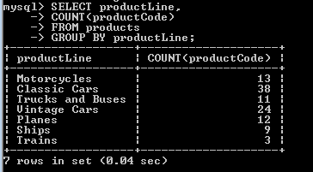

Question 9

What is the average quantity of model ordered for each product line?

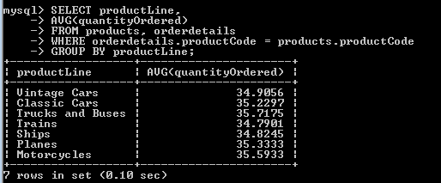

The HAVING clause

The HAVING clause is used in conjunction with the GROUP BY clause to restrict which groups are shown. Do not mistake it for the WHERE clause. The WHERE clause filters the individual rows appearing in the final result table. The HAVING clause filters the groups going into the final result table. (Note : Any query expressed using a HAVING clause can always be rewritten without the HAVING clause).

Example : List the office codes, cities and number of employees in each and who employ more than 2 employees.
SELECT employees.officecode AS Code, City, COUNT(employeenumber)
FROM employees, offices
WHERE employees.officecode = offices.officecode
GROUP BY employee.officecode
HAVING COUNT(employeenumber) > 2;

Question 10

List those product lines, and the number of products they have, who have more than ten products in the line.
