**INDIVIDUAL EVALUATION AND COMENTS**

**Meeting 1**

Date: 05/11/2018 (from 11am to 1pm)

Participants: Aline Fernandes, Amandio Pinto, Darwin Stefano, Paula Oehme and Sarah Narayamy.

Activities: The main topics to be discussed and the architecture of the project were decided.

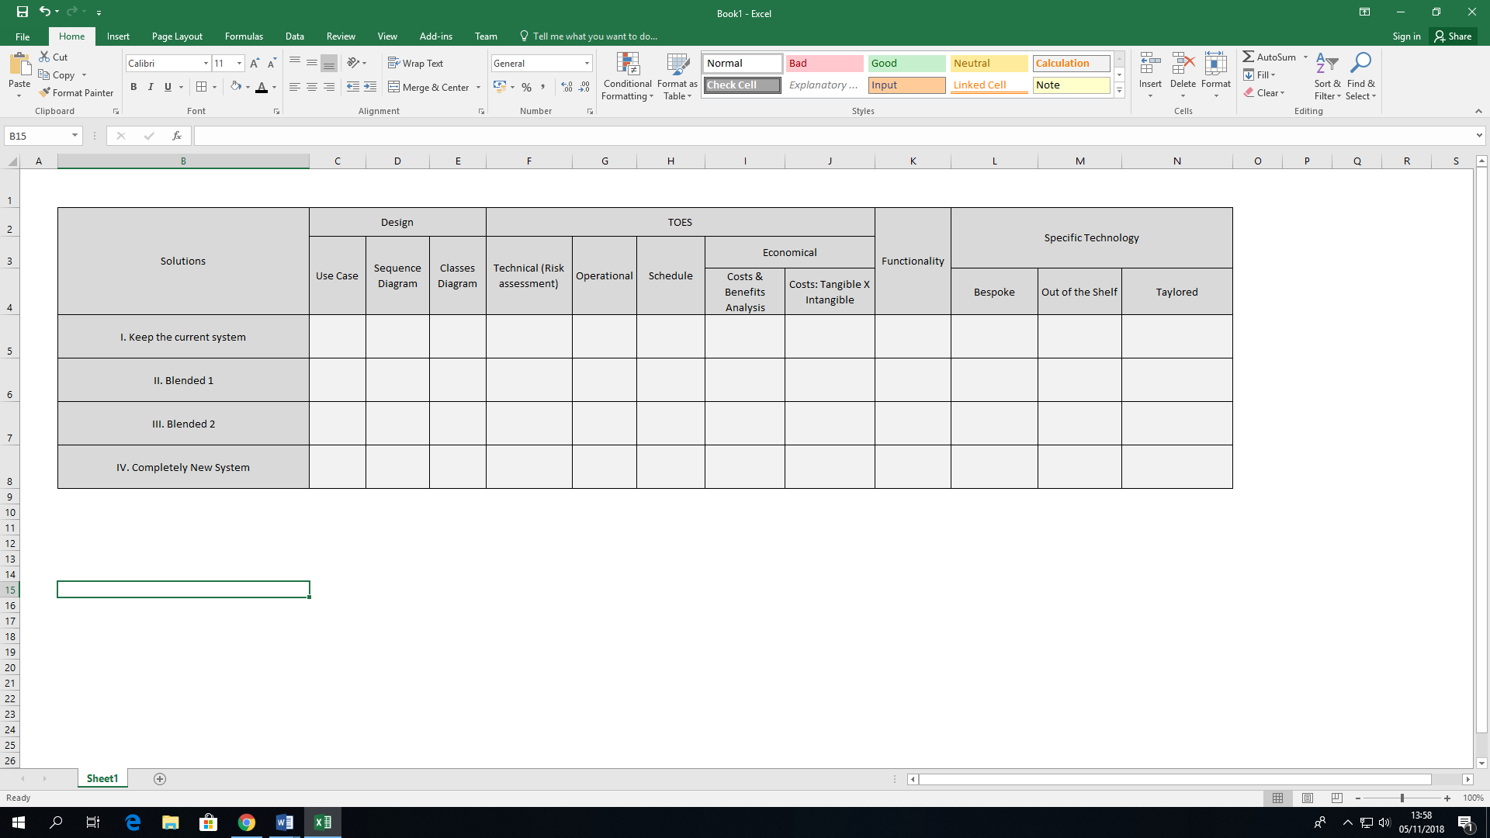

**Meeting 2**

Date: 05/11/2018 (from 2pm to 5pm)

Participants: Aline Fernandes, Darwin Stefano, Paula Oehme and Sarah Narayamy.

Activities: Definition and description of the Summary of the project and template of the presentation.

**Meeting 3**

Date: 06/11/2018 (from 10am to 2pm)

Participants: Aline Fernandes, Darwin Stefano, Paula Oehme and Sarah Narayamy.

Activities:

**Meeting 4**

Date: 06/11/2018 (from 2pm to 5pm)

Participants: Aline Fernandes, Darwin Stefano, Paula Oehme and Sarah Narayamy.

Activities:

**Meeting 5**

Date: 07/11/2018 (from 10am to 2pm)

Participants: Aline Fernandes, Darwin Stefano, Paula Oehme and Sarah Narayamy.

Activities:

**Meeting 6**

Date: 07/11/2018 (from 2pm to 5pm)

Participants: Aline Fernandes, Darwin Stefano, Paula Oehme and Sarah Narayamy.

Activities: