**SUMMARY**

**1. INTRODUCTION 2**

**2. CURRENT FUNCTIONAL PROCEDURES 4**

**3. PROJECT OBJECTIVES 5**

**4. ALTERNATIVE SYSTEMS 6**

4.1 PROPOSED SOFTWARE I 6

4.1.1 Assumptions and Constraints 6

4.1.2 Design and Methodology 6

4.1.3 Feasibility Study 6

4.1.3.1 Technical Feasibility 6

4.1.3.2 Operational Feasibility 6

4.1.3.3 Economic Feasibility 6

4.1.3.4 Schedule Feasibility 6

4.2 PROPOSED SOFTWARE II 6

4.2.1 Assumptions and Constraints 6

4.2.2 Design and Methodology 6

4.2.3 Feasibility Study 6

4.2.3.1 Technical Feasibility 6

4.2.3.2 Operational Feasibility 6

4.2.3.3 Economic Feasibility 6

4.2.3.4 Schedule Feasibility 6

4.3 PROPOSED SOFTWARE III 6

4.3.1 Assumptions and Constraints 6

4.3.2 Design and Methodology 6

4.3.3 Feasibility Study 6

4.3.3.1 Technical Feasibility 6

4.3.3.2 Operational Feasibility 6

4.3.3.3 Economic Feasibility 6

4.3.3.4 Schedule Feasibility 6

**5. RECOMMENDATION 7**

**6. FINAL CONSIDERATIONS 8**

**APPENDICES 10**

# 1. INTRODUCTION

Living in a digital/ globalized world affects everybody’s life in many different ways. Technology is needed nowadays for even simple tasks like calling, starting your car and buying food at the supermarket includes. But technology not only affected people’s life, it also affected organizations in ways that changed completely how they deal with consumers and other businesses. The use of internet is the most necessary item to live in such digitalized world.

Globalization has being interconnecting people and businesses since 1990s, when it emerged. To be global in a company’s perspective means that anybody can reach its products from anywhere and anytime. But on the other hand its advent also brought a new way of doing business and a new way of competing with other businesses.

With the advent of the internet, new forms of goods, services and delivery channels have raised bringing the E-Business, which is a different way of doing business. Nowadays, a firm does not exactly need to have a physical presence on the market; it can deliver its products online. Janita and Chong (2013) define E-Business as the process of exchanging, buying and selling through computer networks involving internet. E-Business is considered to be an innovation that thoroughly changed the traditional way of doing business (Bordonaba-Juste, Lucia Palacios and Polo Redondo, 2012).

These two different ways of doing business are simultaneously in use nowadays and each one of them has its features and its issues. However, the transition from physical shop to digital shop has not yet reached some traditional shops. Having said that, it is important to mention the importance of doing a detailed feasibility study analyzing whether is worth the changing.

According to Maracas and O’Brien (2013), feasibility study is a preliminary study where important aspects of the project such as resource requirements, costs, benefits, viability, etc are determined and taken into consideration before a decision is made for whether adapting the current system or changing completely to a new system. This study is presented in a written format which includes preliminary specifications and a developmental plan for a proposed business application. If the recommendations are approved by the management, the development process can continue.

Conducting a feasibility study has the advantage of giving advance warning about where the project could fail or whether proposed methods or instruments are inappropriate or too complicated. They may also try to identify potential practical problems in following the project implementation (Van Teijlingen and Hundley, 2001).

Evaluate alternative system solutions and propose the most viable and desirable business application for development is the main goal of the feasibility study which can be evaluated in five major categories (Maracas and O’Brien, 2013). Technical feasibility determines what technologies exists or can be developed to solve the problem, risks of building new technologies versus purchasing existing ones. It also assesses whether the organization has the experience required to work effectively with the technologies. Operational feasibility assesses the human element of the proposed system which means, how willing and able its employees are to change. Economic feasibility determines if an organization can afford the system and if the system will provide an adequate return on the investments (cost-benefits). Schedule feasibility determines if the proposed development timeline is realistic. Also, if the company has the resources it needs (Malaga, 2005). Legal and Political feasibility includes a thorough analysis of legal perspectives as a result of the implementation of the new system such as copyright, patent infringements, violation of existing antitrust laws, etc and on the political side, analyses who the stakeholders are within the organization and the degree to which the proposed system may positively or negatively affect the distribution of power (Maracas and O’Brien, 2013).

# 2. CURRENT FUNCTIONAL PROCEDURES

The Vintage Shop is a small business specialized in selling second-hand entertainment items such as: movie DVDs, music CDs and Vinyl Records. All the transactions of the shop are completed over the counter and all the documentation related to those transactions and customers are archived manually.

In order to make a purchase, the customer presents cash to the shop assistant and the transaction is carried out based on a two-part voucher. The customer signs the voucher and keeps one copy, while the assistant retains the other copy of the voucher in the till.

At the end of each day the collected vouchers are sent to the Bookkeeper, responsible for filing them. All the records concerned to the transactions are kept for, at least, three years.

As previously stated, everything in the Vintage Shop is done manually: from the stock supply to the processes and also management of transactions and information, which generates a high demand of paper work requiring an urgent update in the current system.

There are a few constraints associated to the current functional procedures performed in the shop. Among them, it is possible to list the demand of numerous hours of paperwork and that the security related to the costumer’s information in not highly secured or easily accessed. The archives don’t have a backup which is also something relevant in this context.

In order to increase the performance of the shop, Alex Davis (owner of the Vintage Shop) is looking for ways to optimize the business by implementing a computerized system.

# 3. PROJECT OBJECTIVES

This feasibility study has as mainly objective assess three distinctly computerized systems to be implemented in a small business in town to support all the routine transactions, besides an online presence of the company is required, which also allows customer and suppliers to perform transactions.

The study will indicate which system fits the needs of the business covering all the requirements established. Considering the physical store the system will be able to perform daily transactions, such as payments, printing receipts, vouchers, record control and stock supply. In addition, the system allows the clerk using specific technology to automate procedures to increase productivity and reduce human error.

The online store, available 24 hours, will also be implemented to meet of the store goals, which permits the client to register online, check all the catalog available and perform purchases through the website, and also allow them to make payments via debit or credit cards. However, the delivery is still be kept strictly physical. Moreover, the online presence will permit suppliers to perform payment transactions.

**4. ALTERNATIVE SYSTEMS**

Feasibility study is, as the name suggests, an analysis and evaluation of the ability to complete successfully a project taking into consideration the most relevant factors. It is a study of an specific project with the purpose to determine the viability of an alteration in the system or general improvement.

In other words, the referred study seeks to identify the scheduling feasibility of the project and if it is technically, economically, legally and operationally feasible, determining positive and negative outcomes and, consequently, preventing the investment of a considerable amount of money into a project that won’t be financially viable.

As previously mentioned, there are five main areas to be evaluated while developing a Feasibility Project and they will be described in detail below.

Technical Feasibility - this assessment focuses on the available technical resources, like: engineering and architectural requirements, infrastructure, specific technology and equipments. It is also convenient in order to determine if the staff are capable of working with the new implemented system.

Operational Feasibility - this assessment is mandatory in order to identify how well the project will be applied after the most suitable solution is chosen. It analyses the requirements for the system maintenance and personnel (for operation, support, maintenance and ongoing training).

Economic Feasibility - this assessment analyses the required financial resources demanded for the project and financial benefits of the project implementation. It also considers the return of investment and and time of payback.

Scheduling Feasibility - this assessment is considered the most important in relation to the success of the project, and it is due to the fact that it is in this study that the time demanded for the implementation of the project is estimated. It basically traces the deadline for the strategies, plans and processes to be implemented in an achievable perspective.

Legal Feasibility - this assessment consists on the research of legal issues and policies that may conflict with the interests of the project. This study requires the knowledge of certain laws, data protection acts, social media legal aspects and considers the specific location where the business is taking place, once the legal aspects might change depending on that.

Taking into consideration the aspects previously described that are studied in a Feasibility Project, allows us to say that it also helps the companies to identify logistical problems and develop marketing strategies and negotiate with investors.

A feasibility study report also offer multiple possibilities of solutions such as maintain the actual scenario, amend the current system or the use of a new technology. The advantages and disadvantages of the possible solutions must be carefully studied as also the alternative of not changing the current system. Different processes and levels/types of computerisation are are mandatory aspects to be evaluated when proposing new possible solutions. According to these parameters, this project aims to come up with three different as solutions: the first one would be not making changes on the current processes of the Vintage Shop (even though they are considered old fashioned); the second solution presents some important modernization aspects that would help the owner dealing with the paperwork and offering other payment mechanisms; the third solution demands more investment but it is also more comprehensive once it would open the possibility of online presence for the shop. The three studied solutions will be properly addressed as follows.

## **4.1 PROPOSED SOFTWARE I**

As first assess the feasibility study will analyse the current business model and none alteration on the scope of the store will be made due the fact that will be compared to the other two assessment models, in order to establish which one fits to the store needs.

The current system is strictly manually and all interaction with customers are face-to-face transactions. This sort of store still shows many advantages. Indeed, customers still prefer visiting physical stores, dealing directly with the vendor, holding, trying on or touching vinyls , CDs, before buying them, and also deal with issues or doubts regarding the products directly with the vendor. In addition promoting security of knowing that the product really exists.

### **4.1.1 Assumptions and Constraints**

The current model of the Vintage Shop is old fashioned, it doesn’t require any type of technology such as hardware, software or network connection, and all the daily transactions are made manually. Assessing the first alternative, it will not have any alteration in the system model, financial constraints and operating environment.

### **4.1.2 Design and Methodology**

### **4.1.3 Feasibility Study**

#### **4.1.3.1 Technical Feasibility**

This technical assessment will not address any changes to the current system, and all the daily routine will sticky to the existing model of business, no technology will be attached.

Considering daily transactions, they will still be completed over the counter shop dealing directly with customers and the purchases is carried out using two-part voucher. All the records are archived and stored in the store and kept up to three years. Regarding to staff employed is not required any specific qualification or skill , and financially no extras expenses will be added.

#### **4.1.3.2 Operational Feasibility**

As mentioned on topic 4.1, we are taking into consideration keep the system that already exists. Thus when we analyse the performance whether the current system provides adequate throughput and response time, we can realise that the capability/speed/time dealt with during each transaction in store is low and slow, due to all the paperwork to be handled by either the customer and the salesperson.

Analysing the information developed within the current system and the services that it provides, we can visualize the failure regarding the accuracy and reliability of the information as well as its relevance, timely, usability and flexibility once the Vintage Shop is subjected to human failures such as wrong input, difficulty of reading due to bad/wrong handwriting, delay in updating information within the store. Also, when examining its control against fraud and security of data and information it is possible to conclude that the current system it is not appropriate once the receipts are kept in store which facilitates the access of the information by anyone who should or should not have access to it.

An efficiency analysis whether the current system make maximum use of available resources, proves how inefficient the system is by contributing to lower levels of staff productivity. In addition, having boxes to store manually data and files is not environmentally-friendly and this could lead company documentation at risk in the case of a fire as there would be no back up.

Economically speaking, the current is feasible due to the absence of extra investment. Although, it is not exactly cost-effective because it offers no reduction in costs and/or an increase in benefits once the costs on paper for example could easily decrease with the use of a computerized system.

#### **4.1.3.3 Economic Feasibility**

As mentioned on the previous topic, keeping the current system is viable as it will not result in extra investments.

| **BENEFITS** | |
| --- | --- |
| **TANGIBLE** | **INTANGIBLE** |
| No alteration on the expenses | Direct contact between staff/customers |
| No need of training | Broader and deeper network of contacts |
|  | Increased staff experience |

| **COSTS** | |
| --- | --- |
| **Expenses** | **Monthly expenses (€)** |
| Bills | 800 |
| Rent | 700 |
| Staff wages* | 1833.6 |
| Stationary items** | 50 |
| * | |
| Minimum salary (€) | 9.55 |
| Shift (h) | 8 |
| Open days (week) | 6 |
| Weeks (month) | 4 |
| Number of employees | 1 |
| ** | |
| Paper | |
| Carbon paper | |
| Pen | |
| Stapler/staples | |
| Clips | |

#### 

#### **4.1.3.4 Schedule Feasibility**

As previously stated on the topic 4 of this project, the scheduling feasibility estimates how much time will be demanded in order to complete the project. However, considering that this proposed solution offers no changes, there is no time to be estimated.

## **4.2 PROPOSED SOFTWARE II**

### **4.2.1 Assumptions and Constraints**

### **4.2.2 Design and Methodology**

### **4.2.3 Feasibility Study**

#### **4.2.3.1 Technical Feasibility**

#### **4.2.3.2 Operational Feasibility**

#### **4.2.3.3 Economic Feasibility**

#### **4.2.3.4 Schedule Feasibility**

## **4.3 PROPOSED SOFTWARE III**

Brick and Mortar is a jargon used to refer that physical presence of an organization, such a store, like the Vinyl Store that deals with face-to-face transactions with customers. In the recent past this jargon turned into a new one to exemplify the new model of business, due to the rise of electronic commerce. From the Brick to the Clicks, which Clicks consists mainly in transactions made over the internet, and where companies develop electronically mechanism that allow customer make purchases online. Another term merge both models, Click and Mortar, that enable consumers buy things either in the store or online. Companies are recognizing that success will go to those who can execute clicks-and-mortar strategies that bridge the physical and virtual world. Different companies will need to follow different paths in deciding how closely-or loosely- to integrate their internet initiatives with their traditional operations (Bylinsky 2001). Indeed, it modified the scenario of business transactions, making use of electronic communications and digital information to interact electronically rather than by physical presence. To support every step of these process, the electronic commerce rely on the resources of information technologies, and also the internet. This third assess study will implement an ecommerce and automate the system business model in the physical store. This mechanism allows customer and suppliers to register online and make orderings, payments through the website, and the presence store using specific technologies, such barcode scanner, card machine and computerized system to control daily transactions, track customers records and so on.

### **4.3.1 Assumptions and Constraints**

**Provides information about assumptions and constraints such as operational life of the proposed software, financial constraints, changing hardware, software and operating environment, and availability of information and sources.#**

At the beggining

### **4.3.2 Design and Methodology**

This third assess will be based on a tailored system fully developed to support all the requirements established by the Vinyl store. The system physical system will be integrated with the online system using a object-oriented design. The Software design provides a (traceability) link between requirements and an implementable specification. It is a pervasive activity for which often there is no definitive solution. Keys design techniques and issues involve the identification of a overall structure or architecture, the identification of the main elements of software that need to be managed. In order to illustrate the business concept a use case is used to demonstrate the actors and the actions in the physical and online system.

**4.3.2.1 Use case diagram**

| **Use case** |  |
| --- | --- |
| **Primary Actor** |  |
| **Level** |  |
| **Stakeholders** |  |
| **Precondition** |  |
| **Minimal Guarantee** |  |
| **Success Guarantee** |  |
| **Trigger** |  |
|  |  |
|  |  |
| **Trigger** |  |
| **Normal flow** |  |
| **Sub-flows** |  |
|  |  |
|  |  |
|  |  |

### **4.3.3 Feasibility Study**

#### **4.3.3.1 Technical Feasibility**

#### **4.3.3.2 Operational Feasibility**

#### **4.3.3.3 Economic Feasibility**

#### **4.3.3.4 Schedule Feasibility**

# 5. RECOMMENDATION

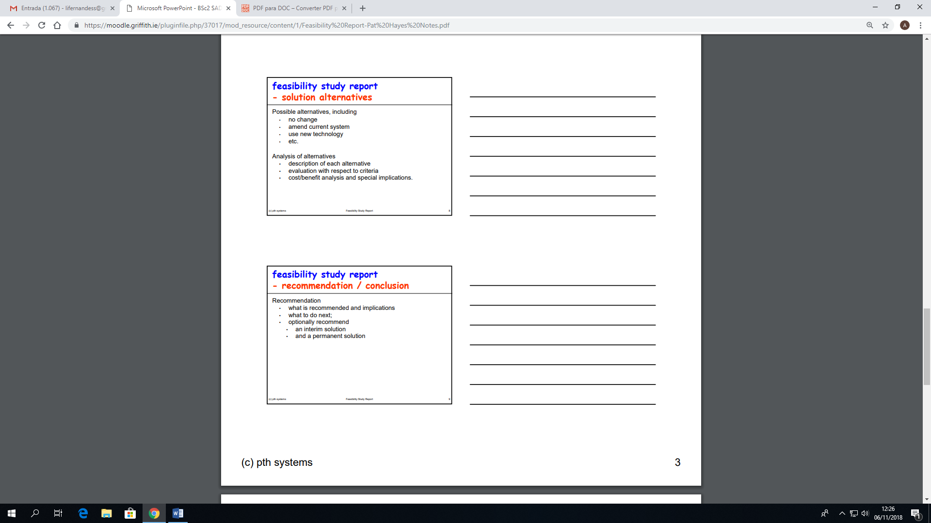

Obs: O tempo que era usado para o paperwork vai passer a ser usado pelo staff administrando o website.

# 6. FINAL CONSIDERATIONS

**7. BIBLIOGRAPHY**

Bordonaba‐Juste, V., Lucia‐Palacios, L. and Polo‐Redondo, Y. (2012). **Antecedents and consequences of e‐business adoption for European retailers**. *Internet Research*, 22(**5**), pp.532-550.

Janita, I. and Chong, W. (2013). **Barriers of B2B e-Business Adoption in Indonesian SMEs: A Literature Analysis**. *Procedia Computer Science*, 17, pp.571-578.

Malaga, R. A. (2005). ***Information systems technology***. Upper Saddle River, NJ: Pearson Prentice Hall.

Marakas, G.M. and O'Brien, J.A., (2013). ***Introduction to information systems***. 16th edn. McGraw-Hill, Inc., New York.

Van Teijlingen, E. and Hundley, V. (2001). **The** **importance of pilot studies**. *Social research Update*, 16(35), pp.33-36.

Bylinsky, G. 2001 “The e-Factory Catch On”. Fortune.

# APPENDICES

