**SUMMARY**

# 1. INTRODUCTION (Sarah & Paula)

Living in a digital/ globalized world affects everybody’s life in many different ways. Technology is needed nowadays for even simple tasks like calling, starting your car and buying food at the supermarket includes. But technology not only affected people’s life, it also affected organizations in ways that changed completely how they deal with consumers and other businesses. The use of internet is the most necessary item to live in such digitalized world.

Globalization has being interconnecting people and businesses since 1990s, when it emerged. To be global in a company’s perspective means that anybody can reach its products from anywhere and anytime. But on the other hand its advent also brought a new way of doing business and a new way of competing with other businesses.

With the advent of the internet, new forms of goods, services and delivery channels have raised bringing the E-Business, which is a different way of doing business. Nowadays, a firm does not exactly need to have a physical presence on the market; it can deliver its products online. Janita and Chong (2013) define E-Business as the process of exchanging, buying and selling through computer networks involving internet. E-Business is considered to be an innovation that thoroughly changed the traditional way of doing business (Bordonaba-Juste, Lucia Palacios and Polo Redondo, 2012).

These two different ways of doing business are simultaneously in use nowadays and each one of them has its features and its issues. However, the transition from physical shop to digital shop has not yet reached some traditional shops. Having said that, it is important to mention the importance of doing a detailed feasibility study analysing whether is worth the changing.

According to Maracas and O’Brien (2013), feasibility study is a preliminary study where important aspects of the project such as resource requirements, costs, benefits, viability, etc are determined and taken into consideration before a decision is made for whether adapting the current system or changing completely to a new system. This study is presented in a written format which includes preliminary specifications and a developmental plan for a proposed business application. If the recommendations are approved by the management, the development process can continue.

Conducting a feasibility study has the advantage of giving advance warning about where the project could fail or whether proposed methods or instruments are inappropriate or too complicated. They may also try to identify potential practical problems in following the project implementation (Van Teijlingen and Hundley, 2001).

Evaluate alternative system solutions and propose the most viable and desirable business application for development is the main goal of the feasibility study which can be evaluated in five major categories (Maracas and O’Brien, 2013). Technical feasibility determines what technologies exists or can be developed to solve the problem, risks of building new technologies versus purchasing existing ones. It also assesses whether the organization has the experience required to work effectively with the technologies. Operational feasibility assesses the human element of the proposed system which means, how willing and able its employees are to change. Economic feasibility determines if an organization can afford the system and if the system will provide an adequate return on the investments (cost-benefits). Schedule feasibility determines if the proposed development timeline is realistic. Also, if the company has the resources it needs (Malaga, 2005). Legal and Political feasibility includes a thorough analysis of legal perspectives as a result of the implementation of the new system such as copyright, patent infringements, violation of existing antitrust laws, etc and on the political side, analyses who the stakeholders are within the organization and the degree to which the proposed system may positively or negatively affect the distribution of power (Maracas and O’Brien, 2013).

# 2. CURRENT FUNCTIONAL PROCEDURES (Aline & Darwin)

The Vintage Shop is a small business specialized in selling second-hand entertainment items such as: movie DVDs, music CDs and Vinyl Records. All the transactions of the shop are completed over the counter and all the documentation related to those transactions and customers are archived manually.

In order to make a purchase, the customer presents cash to the shop assistant and the transaction is carried out based on a two-part voucher. The customer signs the voucher and keeps one copy, while the assistant retains the other copy of the voucher on the till.

At the end of each day the collected vouchers are sent to the Bookkeeper, responsible for filing them. All the records concerned to the transactions are kept for, at least, three years.

As previously stated, everything in the Vintage Shop is done manually: from the stock supply to the processes and also management of transactions and information, which generates a high demand of paper work requiring an urgent update in the current system.

There are a few constraints associated to the current functional procedures performed in the shop. Among them, it is possible to list the demand of numerous hours of paperwork and that the security related to the costumer’s information in not highly secured or easily accessed. The archives do not have a backup which is also something relevant in this context.

In order to increase the performance of the shop, Alex Davis (owner of the Vintage Shop) is looking for ways to optimize the business by implementing a computerized system.

The current model of the Vintage Shop is old fashioned, it does not require any type of technology such as hardware, software or network connection, and all the daily transactions are made manually. This technical assessment will not address any changes to the current system, and all the daily routine will sticky to the existing model of business, no technology will be attached.

# 3. PROJECT OBJECTIVES (Darwin)

This feasibility study has as mainly objective assess three distinctly computerized systems to be implemented in a small business in town to support all the routine transactions, besides an online presence of the company is required, which also allows customer and suppliers to perform transactions.

The study will indicate which system fits the needs of the business covering all the requirements established. Considering the physical store the system will be able to perform daily transactions, such as payments, printing receipts, vouchers, record control and stock supply. In addition, the system allows the clerk using specific technology to automate procedures to increase productivity and reduce human error.

The online store, available 24 hours, will also be implemented to meet of the store goals, which permits the client to register online, browse through the online catalog available, and perform purchases, and also allow them to make payments via debit or credit cards. However, the delivery will be kept strictly physical. Moreover, the online presence will permit suppliers to perform payment transactions.

The current system is strictly manually and all interaction with customers are face-to-face transactions. This sort of store still shows many advantages. Indeed, customers still prefer visiting physical stores, dealing directly with the vendor, holding, trying on or touching vinyl, CDs, before buying them, and also deal with issues or doubts regarding the products directly with the vendor. In addition promoting security of knowing that the product really exists.

**4. ALTERNATIVE SYSTEMS (Aline)**

**4.1 Feasibility study**

Feasibility study is, as the name suggests, an analysis and evaluation of the ability to complete successfully a project taking into consideration the most relevant factors. It is a study of a specific project with the purpose to determine the viability of an alteration in the system or general improvement.

In other words, the referred study seeks to identify the scheduling feasibility of the project and if it is technically, economically, legally and operationally feasible, determining positive and negative outcomes and, consequently, preventing the investment of a considerable amount of money into a project that will not be financially viable.

As previously mentioned, there are five main areas to be evaluated while developing a Feasibility Project and they will be described in detail below.

* Technical Feasibility - this assessment focuses on the available technical resources, like: engineering and architectural requirements, infrastructure, specific technology and equipment. It is also convenient in order to determine if the staff are capable of working with the new implemented system.
* Operational Feasibility - this assessment is mandatory in order to identify how well the project will be applied after the most suitable solution is chosen. It analyses the requirements for the system maintenance and personnel (for operation, support, maintenance and ongoing training).
* Economic Feasibility - this assessment analyses the required financial resources demanded for the project and financial benefits of the project implementation. It also considers the return of investment and time of payback.
* Scheduling Feasibility - this assessment is considered the most important in relation to the success of the project, and it is due to the fact that it is in this study that the time demanded for the implementation of the project is estimated. It basically traces the deadline for the strategies, plans and processes to be implemented in an achievable perspective.
* Legal Feasibility - this assessment consists on the research of legal issues and policies that may conflict with the interests of the project. This study requires the knowledge of certain laws, data protection acts, social media legal aspects and considers the specific location where the business is taking place, and once the legal aspects might change depending on that.

Taking into consideration the aspects previously described that are studied in a feasibility project, allows us to say that it also helps the companies to identify logistical problems and develop marketing strategies and negotiate with investors.

A feasibility study report also offer multiple possibilities of solutions such as maintain the actual scenario, amend the current system or the use of a new technology. The advantages and disadvantages of the possible solutions must be carefully studied as also the alternative of not changing the current system. Different processes and levels/types of computerisation are mandatory aspects to be evaluated when proposing new possible solutions. According to these parameters, this project aims to come up with three different solutions: the first one would be computerize the current system of the Vintage Shop but keep just the physical store; the second solution presents some important modernization aspects that would help the owner dealing with the paperwork and offering other payment mechanisms and a simple website to improve the Vintage Shop’s visibility with the customers, where the customers can browse through the page and the products catalog; the third solution demands more investment but it is also more comprehensive once it would open the possibility of online presence for the shop where the customers could buy the products. The three studied solutions will be properly addressed as follows.

## **4.1 PROPOSED SOFTWARE I (Darwin)**

Considering the store requirements, this first assessment will provide a shortly study of an electronic point of sale system (EPoS system) that will be installed in the checkout counter allowing the staff to perform daily transactions and support the sales report. EPOS system comprise of a computer hardware, peripherals and software perfectly suited to the business needs, also it offers a wide variety invaluable information on their demographic. Moreover, the computerized system helps the business by tracking everything from the inventory cycle to customer spending’s. The EPoS used in this store must provide certain obligatory peripherals to offer a variety of benefits, such as chip and pin card machines, till system, cash drawers and a barcode reader. Those, peripherals will reduce the human error and provide an accurate price of the goods, beside increase significantly the speeding of work.

### **4.1.1 Assumptions and Constraints (Darwin)**

The current business model does not perform any transaction through computers, or other type of devices, they are exclusively made manually. In order to increase the productivity and the sales the new EPoS system installed in the counter might provide a series of benefits. However, some constraints might interfere in the system performance. The purchased system is not an open source system, thus it might not fit all needs of the company, and some features might be not presented in the system. And in case of flaws, the system supplier must be contacted for any support. Moreover, the supplier must provide fully training to the staff regarding the system usage.

### **4.1.2 Analysis and Methodology (Darwin)**

Primarily, it is important to gather information necessary for the system before buying it. Considering exclusively the off-the-shelf system in this section, the study must establish the pre-requirements for the future system, one which is able to perform daily transactions through the counter. A simple purchase from now on must be complete through the system, customer might choose payment type, cash or credit card, and an inventory system will be attached to the system in order to keep track of products availability. Customer may also choose register himself/herself for future purchases.

System requirements:

* Complete daily activities;
* Scan items using a barcode;
* Register, update, and delete employees;
* Register, update, and delete products;
* Register, update, and delete customers;
* Register, update, and delete suppliers;
* Calculate taxes;
* Generate purchases orders;
* Print receipts;
* Allow manager to go over records;
* Keep track of inventory level;

In order to better represent all the information regarding the system above a use case diagram is precisely designed below following the Object-Oriented Models.

**4.3.2.1 Use case – Physical Store System**

| **Use Case:** Physical Store System (Off-the-shelf) |
| --- |
| **Primary Actor:** Clerk |
| **Level:** High |
| **Stakeholders:** Manager, customers and suppliers. |
| **Precondition:** Computer, scan reader, printer and card machine required and also must have access to internet. |
| **Minimal Guarantee:** |
| **Success Guarantee:** Automate all the daily transactions through the system such as payments, print receipt, and update inventory. |
| **Trigger:**  Physical Store System. |
| **Main success Scenario:** Staffperform transactions;   1. Staff initialise system; 2. Customer purchase open; 3. Customers selected products and bring to check-out counter; 4. Staff require some basic information regarding customer personal information, such as name, address, phone etc..; 5. Staff scan items purchased through the scan reader; 6. System calculates taxes & total and display value purchased; 7. Payment type is required: credit card or cash; 8. Payment is issued; 9. System print out receipt; 10. Inventory is updated; 11. Customer purchased ceased. |
| **Extensions:**   1. Computer cannot be initialised;    1. Technical support is required to repair computer.    2. Repair is performed and computer initialises;    3. Computer does not initialises and is necessary replace the hardware; 2. System cannot be initialised;    1. System support must be contacted to require assistance;    2. System initialises and run smoothly;    3. System does not initialises and requires new implementation; 3. Card payment cannot be issued;    1. Card support assistance must be contacted;    2. Assistance is performed and card payment is active again;    3. Card machine is still not working and must be replaced; 4. Devices ( barcode reader and printer) is not working;    1. Technical support must be contacted to require assistance;    2. Assistance is performed and printer and barcode is active again;    3. Clerk offers customers to collect receipt later and product code is inserted manually;    4. Devices require replacement; 5. No internet connection;    1. Inventory system cannot be updated and online purchases cannot be processed;    2. Technical assistance required;    3. Internet connection is active and system updated, and online purchases are being processed again;    4. Internet connection is not active, online purchases will be delayed. |

**4.3.2.1.1 Use case diagram – Physical Store System**

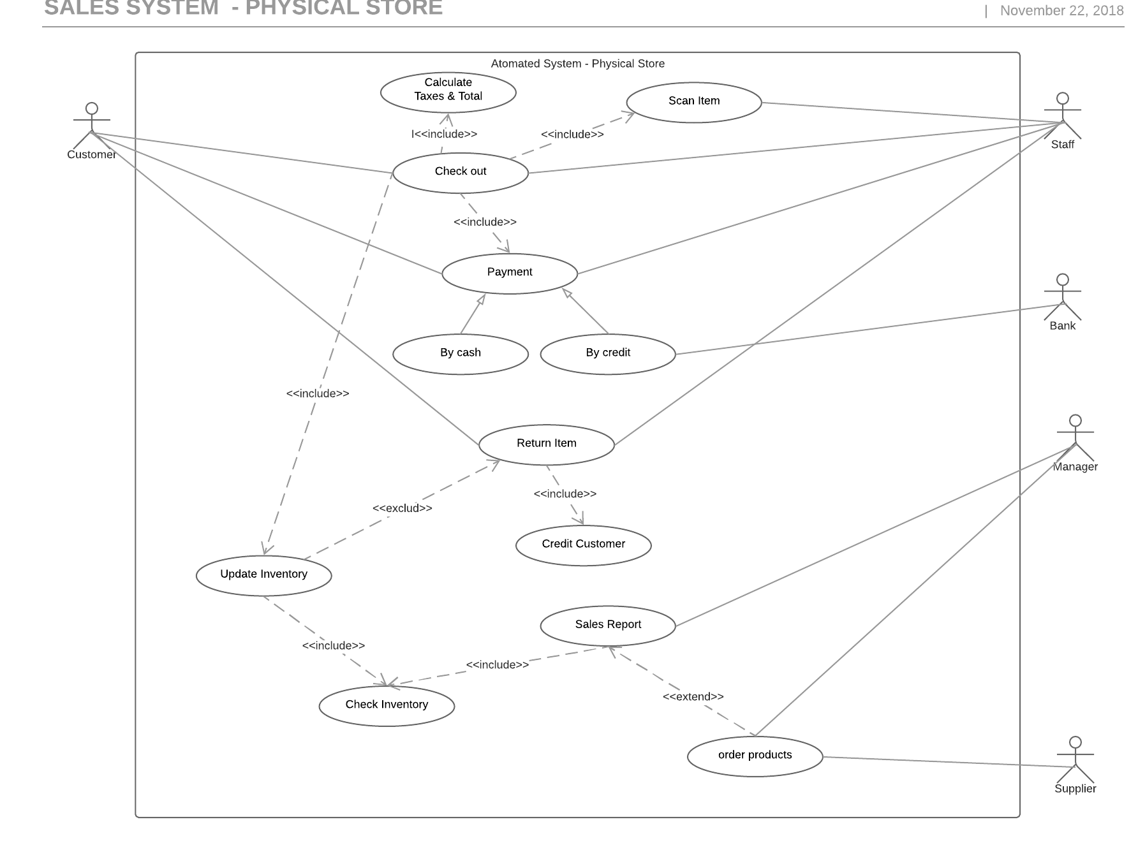

### **4.1.3 Feasibility Study**

#### **4.1.3.1 Technical Feasibility**

#### **4.1.3.2 Operational Feasibility (Sarah)**

As mentioned on topic 4.1, we are improving the current system with the presence of a computerized system within the physical shop. Thus when we analyse the performance whether this proposed system will provide adequate throughput and response time, we can realise that the capability/speed/time dealt with during each transaction in store will considerably be increased, due to the use of a barcode scanner and the EPOS which provides faster information such as Reports.

Analysing the information and the services provided by the new system, we can visualize the improving regarding accuracy and reliability of the information as well as its relevance, timely, usability and flexibility once the EPOS fastly provides up to date inventory control, Invoicing and Receiving, Interfacing with accounting, Accounts payable and receivables, etc. Once more, the barcode scanner acts as a facilitator decreasing the human failures such as wrong input, difficulty of reading due to bad/wrong handwriting, delay in updating information within the store. Also, when examining its control against fraud and security of data and information it is possible to conclude that the current system it is not appropriate once the receipts are kept in store which facilitates the access of the information by anyone who should or should not have access to it. With the new proposed system, we also propose the use of the Cloud as a server in order to keep it safe against fraud.

An efficiency analysis whether the current system make maximum use of available resources, proves how inefficient the system is by contributing to lower levels of staff productivity. As mentioned before, a computerized system will increase the speed of transactions and activities, leaving the staff to do multiple activities consequently increasing it is productivity. In addition, having boxes to store manually data and files is not environmentally-friendly and this could put the company’s documentation at risk in the case of a fire as there would be no back up. Thus, the use of the cloud as a server will extinguish this possibility.

For this proposal there will have the necessity of training the staff and the manager (Owner) with the EPOS in order to guarantee the above positive results. The operation of the system requires the access of internet, support and maintenance can be make by the software seller once it will be obtained off the shelf. Information regarding prices of each product, peripherals, etc will be explored in the next section which is the Economical feasibility study.

#### **4.1.3.3 Economic Feasibility**

#### **4.1.3.4 Schedule Feasibility**

## **4.2 PROPOSED SOFTWARE II (Darwin)**

The second assessment will satisfy the company needs using an off-the-shelf solution in the presence store and a tailored online website. The physical store will still remain with the electronic point of sales system installed, no changes will be made. Thus, this chapter will cover strictly the online web information store developed as mid-range-alternative. The online website will be brought to life with a singularly function, works as a catalog for customers. Customers will be able to browse through the website and check products on sale in the physical store, they also can find out more the store history, check contact information and location.

### **4.2.1 Assumptions and Constraints (Darwin)**

Currently the Vintage store has not acquired any software to the company, and the transactions are performed manually, due this situation the software implementation will affect the routine, and the changeover must be made in phases with the current system, considering that each phase will represent part of the system being implemented. Initially, the system will be implemented only in the physical store, and then when the company inventory is up to date the online website will come on.

### **4.2.2 Analysis and Design. (Darwin)**

### In this section the only proposed system is the website for the physical store, in order to represent the designed system a wireframe and site map will be presented to describe the web page functionalities.

**4.2.2.1 Wireframe**

The wireframe represents the layout used to develop a website, in this case, on the head of page is displayed the logo, home, about us gallery, contact and the box search. Each icons have your particularities to make the user experience easily and friendly.

Home page: displays a full image of the store, the business story, opening hours, contact, directions and social network such as Facebook and Instagram.

About us: this section details the story of business since it was opened.

Gallery: displays all the products on sale in the physical store in catalog format, underneath each image there is a brief description of the product.

Contact: it is a link between the contacts in the home page, it works like an anchor that connect the contact link to the end of the page. In this section, information about location, contact and social networks are available to customer.

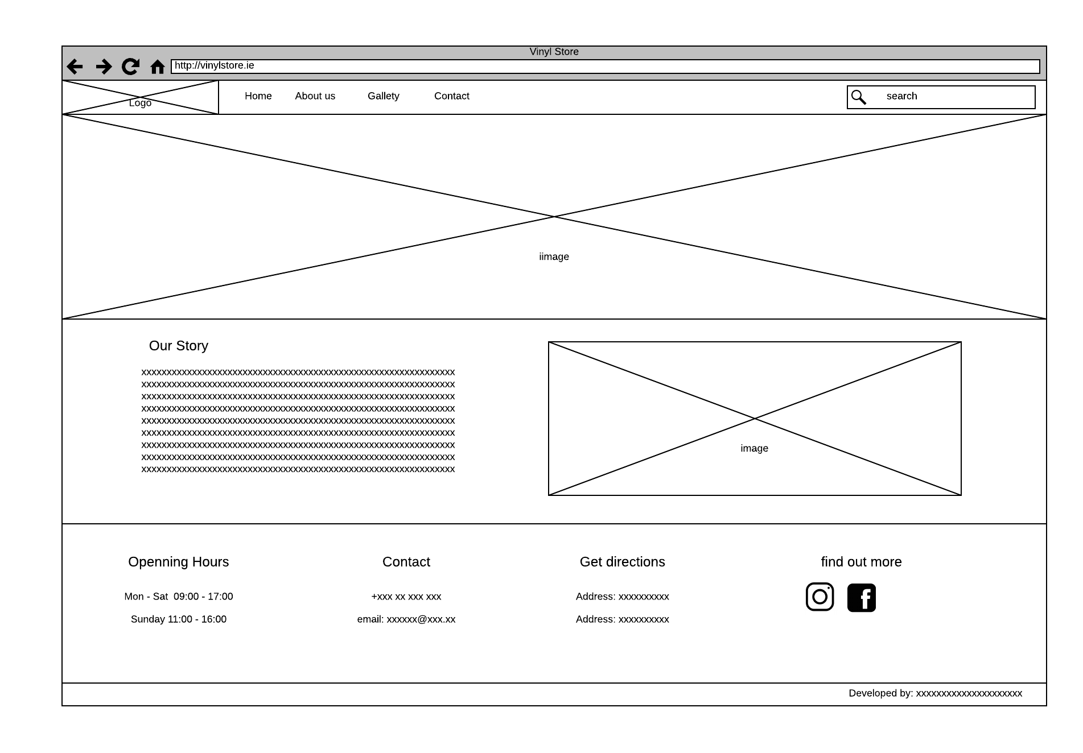

**4.2.2.2 Sitemap**

A sitemap is a list of pages used to present a systematic view, typically hierarchical of the site.



### **4.2.3 Feasibility Study**

#### **4.2.3.1 Technical Feasibility**

#### **4.2.3.2 Operational Feasibility (Sarah)**

Our second proposal does not change in terms of the physical shop, thus the previous Operational Feasibility will remain as it is which is the use of a EPOS system.

There is an increment of it’s operational aspect that should be mentioned though, which is the presence of the website. This new proposal will also increase all the aspects of The Vintage Shop by adding a new visibility of the shop. Once the customer have the opportunity to visualize the availability of products within the online presence, He/She can choose among sales products or not sales products. Also, the website will provide pictures and descriptions of the products once the shop is a second hand shop, different items can have the same features of others, but different description such as damaged packaging, etc.

Another aspect is also about the visibility of the shop; by having an online presence, The Vintage Shop expands its customers to global, once the World Wide Web is accessible by the whole world. Thus, as we are talking about second hand shop, some customers can be collectors searching for a rare product, specially when mentioning the Vinyls which are no longer produced as before.

There is the need of training staff as well as the first proposal. It is recommended to hire a freelance web designer for front end of the webpage in order to keep the website up to date and running properly. As The Vintage shop is a small business there is no need for more than 2 hours a day for a web developer to update the website. Support and maintenance can also be made by the software seller, once it will be off the shelf provided.

#### **4.2.3.3 Economic Feasibility**

#### **4.2.3.4 Schedule Feasibility**

## **4.3 PROPOSED SOFTWARE III (Darwin)**

Brick and Mortar is a jargon used to refer that physical presence of an organization, such a store, like the Vinyl Store that deals with face-to-face transactions with customers. In the recent past this jargon turned into a new one to exemplify the new model of business, due to the rise of electronic commerce. From the Brick to the Clicks, which Clicks consists mainly in transactions made over the internet, and where companies develop electronically mechanism that allow customer making purchases online. Another term merge both models, Click and Mortar, that enable consumers buy things either in the store or online. Companies are recognizing that success will go to those who can execute clicks-and-mortar strategies that bridge the physical and virtual world. Different companies will need to follow different paths in deciding how closely-or loosely- to integrate their internet initiatives with their traditional operations (Bylinsky, 2001). Indeed, it modified the scenario of business transactions, making use of electronic communications and digital information to interact electronically rather than by physical presence. To support every step of these process, the electronic commerce rely on the resources of information technologies, and also the internet. This third assess study will implement an ecommerce and automate the system business model in the physical store. This mechanism allows customer and suppliers to register online and make orderings, payments through the website, and the presence store using specific technologies, such barcode scanner, card machine and computerized system to control daily transactions, track customers records and so on.

### **4.3.1 Assumptions and Constraints (Darwin)**

The new system requires specifics devices, hardware and internet connection to run smoothly. Considering all the changes, initially is necessary to install a base computer with limited configuration, in this case an electronic point of sale, the main purpose of the computer is exclusively perform daily transactions, also the computer must be connected to the internet, and thus it updates the inventory system which is shared between the physical system and online system.

The system will be installed in this computer and used to register products, perform transactions such as update inventory system, process payments and produce sales report. New products should be scanned and registered properly with name, description, product identification, and also an electronic device that can read and output printed barcodes to a computer must be installed, in this case a barcode reader. Besides, a card machine is necessary, once the system offers the possibility to customer pays in cash or by card.

The physical system developed to the company might cover all the desired features pre-established by the owner, otherwise, the system available online might not present uniqueness to all functionalities desired. Considering that the online store will be purchased by a third party. Due to the level of complexity of the application, the website might not be managed by the owner or any staff, then the maintenance and support must be made by the company hired to bring up the website to live. So that implies the system has legal and contractual restrictions, and it cannot be modified legally by the customer.

### **4.3.2 Design and Methodology (Darwin)**

This third assess will be based on a tailored system fully developed to support all the transactions made online, and sustain the requirements established by the Vinyl store. The physical system will be integrated with the online system to keep track of the inventory. The Software designed provides a link between requirements and an implementable specification. In order to illustrate the business concept a use case is used to demonstrate the actors and the transactions performed in the online system. The system designed in object-oriented environment is also included below to demonstrate how the system architecture was planned.

**4.3.2.1.2 Object- Oriented Design**

**4.3.2.2 Use case– Online Store**

| **Use Case:** Online System |
| --- |
| **Primary Actor:** WebCustomers |
| **Level:** High |
| **Stakeholders:** Clerk and customers. |
| **Precondition:** Web site will be loaded |
| **Minimal Guarantee:** |
| **Success Guarantee:** Perform purchases, browse catalog, |
| **Trigger:**  Online system. |
| **Main success Scenario:** Staffperform transactions;   1. Customer initialise website; 2. Website is loaded and display home page; 3. Consumer browse catalog; 4. Website allows customer to manage cart, adding, editing and deleting products; 5. Customer orders and is required to login in the system; 6. If new customer is necessary to create an account, otherwise log in; 7. Products cart are displayed and customer is required to choose shipment options; 8. Order is issued and customer decides payment method (direct debit or Paypal system); 9. Payment is issued; 10. Customer receives receipt and email detailing the purchase; 11. Order status is printed to customer account; 12. Customer purchased is ceased. 13. Administrator receives order; 14. Administrator issue order; 15. Administrator initiates shipment process 16. Order status is changed. 17. Products are sent to deliver. |
| **Extensions:**   1. System cannot be initialised; 2. Computer cannot be initialised; 3. Card payment cannot be issued; 4. Scan reader is not working; 5. Printing cannot be processed; 6. No internet connection; |

**4.3.2.2.1 Use case diagram– Online Store**

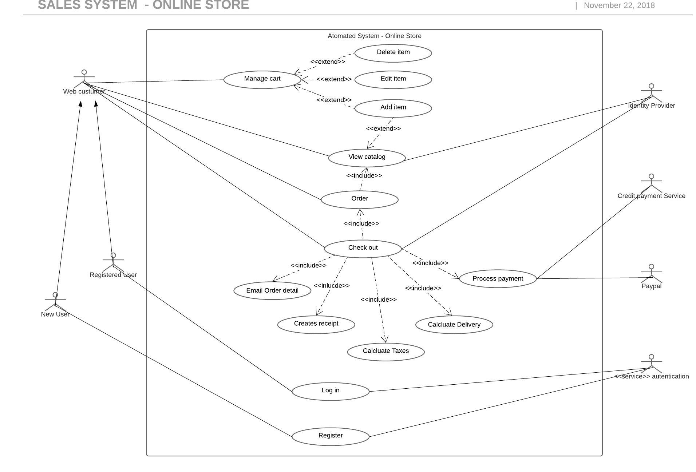

**4.3.2.2.2 Object- Oriented Design**

### **4.3.3 Feasibility Study**

This third assessment will focus on a tailored system for the Vinyl Store.

#### **4.3.3.1 Technical Feasibility**

This third assessment will focus on a tailored system for the Vinyl Store integrating a physical commerce system installed in the store and an ecommerce to deal with transactions made online. The proposed bespoke software requires an order management to deal with those transactions keeping track of the stock rotation, literally it works as a traffic control for all commerce activities, managing order coming in from across both channels and uses automated business logic to match them with the best fulfilment options to meet customers’ expectations and your profitability goals.

The system used to perform all the transactions in presence store will be developed using Java, to support the server side the system counts with PHP integration and MySQL as database. In order to support the daily activities specific technologies will be used such as card machine and barcode reader, outsourced devices that perform payment operations and scanning to register, and input item purchased respectively. Those technologies are available to order as soon as possible and do not require any new specific hardware or technical knowledge to deal with.

The online system is structured using HTML which stands for Hyper Text Markup Language, another language is used to style an lay out the webpage, CSS is stylesheet language used to describe the presentation of a written in HTML. In addition a dynamic language is also used in the development of the e-commerce.

#### **4.3.3.2 Operational Feasibility (Sarah)**

As mentioned previously on the topics 4.1.3.2 and 4.2.3.2 about the first (Low end) and the second (Mid end) alternatives respectively, the benefits of the third proposal are as the same as the others. By implementing a computerized system in The Vintage Shop we increase the speed of information and actions within the store, it also increases the reliability and accuracy of the information to kept about customers and products. Also important to take into consideration the security of data.

The third proposal adds to The Vintage Shop; not only the website with a catalog containing pictures and description of the products; the webshop, where customers can browse through the products and make purchase of any item of their choice and have it sent to their homes. This proposal will increase the visibility of the business and reach customers within long distance from the physical store which makes it hard to obtain the desired product. The importance of a webshop nowadays is necessary once some customers prefer the practicality of having such product drove to them instead of spending some time going to a shop when they can have it delivered at their door. Such time could be more used to do other activities such as work out, cooking, etc. Thus, the customers habits and hobbies will not be affected by their desire to purchase any item.

Once more there will be need to train the staff and the owner of The Vintage Shop in order to maintain the good behavior of the EPOS system. In this case, instead of hiring a freelance web designer, we recommend hiring an IT professional who is able to maintain either the physical system and the webshop by updating its information. Thus the support and maintenance will be more accurate once it will be made by a specialist.

#### **4.3.3.3 Economic Feasibility**

#### **4.3.3.4 Schedule Feasibility**

# 5. RECOMMENDATION

# 6. FINAL CONSIDERATIONS

**7. BIBLIOGRAPHY**

Bordonaba‐Juste, V., Lucia‐Palacios, L. and Polo‐Redondo, Y. (2012). Antecedents and consequences of e‐business adoption for European retailers. *Internet Research*, 22(**5**), pp.532-550.

Janita, I. and Chong, W. (2013). Barriers of B2B e-Business Adoption in Indonesian SMEs: A Literature Analysis. *Procedia Computer Science*, 17, pp.571-578.

Malaga, R. A. (2005). *Information systems technology*. Upper Saddle River, NJ: Pearson Prentice Hall.

Marakas, G.M. and O'Brien, J.A., (2013). *Introduction to information systems*. 16th edn. McGraw-Hill, Inc., New York.

Van Teijlingen, E. and Hundley, V. (2001). The importance of pilot studies. *Social research Update*, 16(**35**), pp.33-36.

Bylinsky, G. 2001 “The e-Factory Catch On”. Fortune.

# APPENDICES