**SUMMARY**

**1. INTRODUCTION 2**

**2. CURRENT FUNCTIONAL PROCEDURES 4**

**3. PROJECT OBJECTIVES 5**

**4. ALTERNATIVE SYSTEMS 6**

4.1 PROPOSED SOFTWARE I 6

4.1.1 Assumptions and Constraints 6

4.1.2 Analysis and Design 6

4.1.3 Feasibility Study 6

4.1.3.1 Technical Feasibility 6

4.1.3.2 Operational Feasibility 6

4.1.3.3 Economic Feasibility 6

4.1.3.4 Schedule Feasibility 6

4.2 PROPOSED SOFTWARE II 6

4.2.1 Assumptions and Constraints 6

4.2.2 Analysis and Design

4.2.3 Feasibility Study 6

4.2.3.1 Technical Feasibility 6

4.2.3.2 Operational Feasibility 6

4.2.3.3 Economic Feasibility 6

4.2.3.4 Schedule Feasibility 6

4.3 PROPOSED SOFTWARE III 6

4.3.1 Assumptions and Constraints 6

4.3.2 Analysis and Design

4.3.3 Feasibility Study 6

4.3.3.1 Technical Feasibility 6

4.3.3.2 Operational Feasibility 6

4.3.3.3 Economic Feasibility 6

4.3.3.4 Schedule Feasibility 6

**5. RECOMMENDATION 7**

**6. FINAL CONSIDERATIONS 8**

**APPENDICES 10**

# 1. INTRODUCTION

Living in a digital/ globalized world affects everybody’s life in many different ways. Technology is needed nowadays for even simple tasks like calling, starting your car and buying food at the supermarket includes. But technology not only affected people’s life, it also affected organizations in ways that changed completely how they deal with consumers and other businesses. The use of internet is the most necessary item to live in such digitalized world.

Globalization has being interconnecting people and businesses since 1990s, when it emerged. To be global in a company’s perspective means that anybody can reach its products from anywhere and anytime. But on the other hand its advent also brought a new way of doing business and a new way of competing with other businesses.

With the advent of the internet, new forms of goods, services and delivery channels have raised bringing the E-Business, which is a different way of doing business. Nowadays, a firm does not exactly need to have a physical presence on the market; it can deliver its products online. Janita and Chong (2013) define E-Business as the process of exchanging, buying and selling through computer networks involving internet. E-Business is considered to be an innovation that thoroughly changed the traditional way of doing business (Bordonaba-Juste, Lucia Palacios and Polo Redondo, 2012).

These two different ways of doing business are simultaneously in use nowadays and each one of them has its features and its issues. However, the transition from physical shop to digital shop has not yet reached some traditional shops. Having said that, it is important to mention the importance of doing a detailed feasibility study analysing whether is worth the changing.

According to Maracas and O’Brien (2013), feasibility study is a preliminary study where important aspects of the project such as resource requirements, costs, benefits, viability, etc are determined and taken into consideration before a decision is made for whether adapting the current system or changing completely to a new system. This study is presented in a written format which includes preliminary specifications and a developmental plan for a proposed business application. If the recommendations are approved by the management, the development process can continue.

Conducting a feasibility study has the advantage of giving advance warning about where the project could fail or whether proposed methods or instruments are inappropriate or too complicated. They may also try to identify potential practical problems in following the project implementation (Van Teijlingen and Hundley, 2001).

Evaluate alternative system solutions and propose the most viable and desirable business application for development is the main goal of the feasibility study which can be evaluated in five major categories (Maracas and O’Brien, 2013). Technical feasibility determines what technologies exists or can be developed to solve the problem, risks of building new technologies versus purchasing existing ones. It also assesses whether the organization has the experience required to work effectively with the technologies. Operational feasibility assesses the human element of the proposed system which means, how willing and able its employees are to change. Economic feasibility determines if an organization can afford the system and if the system will provide an adequate return on the investments (cost-benefits). Schedule feasibility determines if the proposed development timeline is realistic. Also, if the company has the resources it needs (Malaga, 2005). Legal and Political feasibility includes a thorough analysis of legal perspectives as a result of the implementation of the new system such as copyright, patent infringements, violation of existing antitrust laws, etc and on the political side, analyses who the stakeholders are within the organization and the degree to which the proposed system may positively or negatively affect the distribution of power (Maracas and O’Brien, 2013).

# 2. CURRENT FUNCTIONAL PROCEDURES

The Vintage Shop is a small business specialized in selling second-hand entertainment items such as: movie DVDs, music CDs and Vinyl Records. All the transactions of the shop are completed over the counter and all the documentation related to those transactions and customers are archived manually.

In order to make a purchase, the customer presents cash to the shop assistant and the transaction is carried out based on a two-part voucher. The customer signs the voucher and keeps one copy, while the assistant retains the other copy of the voucher on the till.

At the end of each day the collected vouchers are sent to the Bookkeeper, responsible for filing them. All the records concerned to the transactions are kept for, at least, three years.

As previously stated, everything in the Vintage Shop is done manually: from the stock supply to the processes and also management of transactions and information, which generates a high demand of paper work requiring an urgent update in the current system.

There are a few constraints associated to the current functional procedures performed in the shop. Among them, it is possible to list the demand of numerous hours of paperwork and that the security related to the costumer’s information in not highly secured or easily accessed. The archives do not have a backup which is also something relevant in this context.

In order to increase the performance of the shop, Alex Davis (owner of the Vintage Shop) is looking for ways to optimize the business by implementing a computerized system.

The current model of the Vintage Shop is old fashioned, it does not require any type of technology such as hardware, software or network connection, and all the daily transactions are made manually. This technical assessment will not address any changes to the current system, and all the daily routine will sticky to the existing model of business, no technology will be attached.

# 3. PROJECT OBJECTIVES

This feasibility study has as mainly objective assess three distinctly computerized systems to be implemented in a small business in town to support all the routine transactions, besides an online presence of the company is required, which also allows customer and suppliers to perform transactions.

The study will indicate which system fits the needs of the business covering all the requirements established. Considering the physical store the system will be able to perform daily transactions, such as payments, printing receipts, vouchers, record control and stock supply. In addition, the system allows the clerk using specific technology to automate procedures to increase productivity and reduce human error.

The online store, available 24 hours, will also be implemented to meet of the store goals, which permits the client to register online, browse through the online catalog available, and perform purchases, and also allow them to make payments via debit or credit cards. However, the delivery will be kept strictly physical. Moreover, the online presence will permit suppliers to perform payment transactions.

The current system is strictly manually and all interaction with customers are face-to-face transactions. This sort of store still shows many advantages. Indeed, customers still prefer visiting physical stores, dealing directly with the vendor, holding, trying on or touching vinyl, CDs, before buying them, and also deal with issues or doubts regarding the products directly with the vendor. In addition promoting security of knowing that the product really exists.

**4. ALTERNATIVE SYSTEMS**

Feasibility study is, as the name suggests, an analysis and evaluation of the ability to complete successfully a project taking into consideration the most relevant factors. It is a study of a specific project with the purpose to determine the viability of an alteration in the system or general improvement.

In other words, the referred study seeks to identify the scheduling feasibility of the project and if it is technically, economically, legally and operationally feasible, determining positive and negative outcomes and, consequently, preventing the investment of a considerable amount of money into a project that will not be financially viable.

As previously mentioned, there are five main areas to be evaluated while developing a Feasibility Project and they will be described in detail below.

Technical Feasibility - this assessment focuses on the available technical resources, like: engineering and architectural requirements, infrastructure, specific technology and equipment. It is also convenient in order to determine if the staff are capable of working with the new implemented system.

Operational Feasibility - this assessment is mandatory in order to identify how well the project will be applied after the most suitable solution is chosen. It analyses the requirements for the system maintenance and personnel (for operation, support, maintenance and ongoing training).

Economic Feasibility - this assessment analyses the required financial resources demanded for the project and financial benefits of the project implementation. It also considers the return of investment and time of payback.

Scheduling Feasibility - this assessment is considered the most important in relation to the success of the project, and it is due to the fact that it is in this study that the time demanded for the implementation of the project is estimated. It basically traces the deadline for the strategies, plans and processes to be implemented in an achievable perspective.

Legal Feasibility - this assessment consists on the research of legal issues and policies that may conflict with the interests of the project. This study requires the knowledge of certain laws, data protection acts, social media legal aspects and considers the specific location where the business is taking place, and once the legal aspects might change depending on that.

Taking into consideration the aspects previously described that are studied in a Feasibility Project, allows us to say that it also helps the companies to identify logistical problems and develop marketing strategies and negotiate with investors.

A feasibility study report also offer multiple possibilities of solutions such as maintain the actual scenario, amend the current system or the use of a new technology. The advantages and disadvantages of the possible solutions must be carefully studied as also the alternative of not changing the current system. Different processes and levels/types of computerisation are mandatory aspects to be evaluated when proposing new possible solutions. According to these parameters, this project aims to come up with three different solutions: the first one would be not making changes on the current processes of the Vintage Shop (even though they are considered old fashioned); the second solution presents some important modernization aspects that would help the owner dealing with the paperwork and offering other payment mechanisms; the third solution demands more investment but it is also more comprehensive once it would open the possibility of online presence for the shop. The three studied solutions will be properly addressed as follows.

## **4.1 PROPOSED SOFTWARE I**

-→full – off the shelf

### **4.1.1 Assumptions and Constraints**

### **4.1.2 Design and Methodology**

### **4.1.3 Feasibility Study**

#### **4.1.3.1 Technical Feasibility**

#### **4.1.3.2 Operational Feasibility**

As mentioned on topic 4.1, we are taking into consideration keep the system that already exists. Thus when we analyse the performance whether the current system provides adequate throughput and response time, we can realise that the capability/speed/time dealt with during each transaction in store is low and slow, due to all the paperwork to be handled by both the customer and the salesperson.

Analysing the information developed within the current system and the services that it provides, we can visualize the failure regarding the accuracy and reliability of the information as well as its relevance, timely, usability and flexibility once the Vintage Shop is subjected to human failures such as wrong input, difficulty of reading due to bad/wrong handwriting, delay in updating information within the store. Also, when examining its control against fraud and security of data and information it is possible to conclude that the current system it is not appropriate once the receipts are kept in store which facilitates the access of the information by anyone who should or should not have access to it.

An efficiency analysis whether the current system make maximum use of available resources, proves how inefficient the system is by contributing to lower levels of staff productivity. In addition, having boxes to store manually data and files is not environmentally-friendly and this could lead company documentation at risk in the case of a fire as there would be no back up.

Economically speaking, the current is feasible due to the absence of extra investment. Although, it is not exactly cost-effective because it offers no reduction in costs and/or an increase in benefits once the costs on paper for example could easily decrease with the use of a computerized system.

#### **4.1.3.3 Economic Feasibility**

As mentioned on the previous topic, keeping the current system is viable as it will not result in extra investments.

| **BENEFITS** | |
| --- | --- |
| **TANGIBLE** | **INTANGIBLE** |
| No alteration on the expenses | Direct contact between staff/customers |
| No need of training | Broader and deeper network of contacts |
|  | Increased staff experience |

| **COSTS** | |
| --- | --- |
| **Expenses** | **Monthly expenses (€)** |
| Bills | 800 |
| Rent | 700 |
| Staff wages* | 1833.6 |
| Stationary items** | 50 |
| * | |
| Minimum salary (€) | 9.55 |
| Shift (h) | 8 |
| Open days (week) | 6 |
| Weeks (month) | 4 |
| Number of employees | 1 |
| ** | |
| Paper | |
| Carbon paper | |
| Pen | |
| Stapler/staples | |
| Clips | |

#### 

#### **4.1.3.4 Schedule Feasibility**

As previously stated on the topic 4 of this project, the scheduling feasibility estimates how much time will be demanded in order to complete the project. However, considering that this proposed solution offers no changes, there is no time to be estimated.

## **4.2 PROPOSED SOFTWARE II**

The second assessment will satisfy the company needs using a tailored system in the presence store and a off-the-shelf system outsourced to integrate the physical system and also the e-commerce, as a mid-range alternative.

### **4.2.1 Assumptions and Constraints**

Currently the Vinyl store has not acquired any software to the company, and the transactions are performed manually, due this situation the software implementation will affect the routine, and the changeover must be made in phases with the current system, considering that each phase will represent part of the system being implemented. Initially, the system will be implemented only in the physical store, and then when the company inventory is up to date the online store will come on.

The physical system developed to the company might cover all the desired features pre-established by the owner, otherwise, the system available online might not present uniqueness to all functionalities desired by the customer, considering that the online store will be purchased by a third party. Due to the level of complexity of the application, the website might not be managed by the owner or any staff, then the maintenance and support must be made by the company hired to bring up the website to live. So that implies the system has legal and contractual restrictions, and it cannot be modified legally by the customer.

### **4.2.2 Analysis and Design**

The physical system designed in this section will be also used to the fully tailored system in the third proposed software solution alternative. Primarily, is necessary gather information before design it. Considering exclusively the tailored system in this section is required a system that is able to perform daily transactions made over the counter. A simple purchase from now on must be complete through the system, customer might choose payment type, cash or credit card, and an inventory system will be attached to the system in order to keep track of products availability. Customer may also choose register itself for future purchases.

System requirements:

* Complete daily activities;
* Scan items using a barcode;
* Register, update, and delete employees;
* Register, update, and delete products;
* Register, update, and delete customers;
* Register, update, and delete suppliers;
* Calculate taxes;
* Generate purchases orders;
* Print receipts;
* Allow manager to go over records;
* Keep track of inventory level;

In order to better represent all the information regarding the system above a use case diagram is precisely designed below following the Object-Oriented Models.

**4.3.2.1 Use case – Physical Store System**

| **Use Case:** Physical Store System |
| --- |
| **Primary Actor:** Clerk |
| **Level:** High |
| **Stakeholders:** Manager, customers and suppliers. |
| **Precondition:** Computer, scan reader, printer and card machine required and also must have access to internet. |
| **Minimal Guarantee:** |
| **Success Guarantee:** Automate all the daily transactions through the system such as payments, print receipt, and update inventory. |
| **Trigger:**  Physical Store System. |
| **Main success Scenario:** Staffperform transactions;   1. Staff initialise system; 2. Customer purchase open; 3. Customers selected products and bring to check-out counter; 4. Staff require some basic information regarding customer personal information, such as name, address, phone etc..; 5. Staff scan items purchased through the scan reader; 6. System calculates taxes & total and display value purchased; 7. Payment type is required: credit card or cash; 8. Payment is issued; 9. System print out receipt; 10. Inventory is updated; 11. Customer purchased ceased. |
| **Extensions:**   1. Computer cannot be initialised;    1. Technical support is required to repair computer.    2. Repair is performed and computer initialises;    3. Computer does not initialises and is necessary replace the hardware; 2. System cannot be initialised;    1. System support must be contacted to require assistance;    2. System initialises and run smoothly;    3. System does not initialises and requires new implementation; 3. Card payment cannot be issued;    1. Card support assistance must be contacted;    2. Assistance is performed and card payment is active again;    3. Card machine is still not working and must be replaced; 4. Devices ( barcode reader and printer) is not working;    1. Technical support must be contacted to require assistance;    2. Assistance is performed and printer and barcode is active again;    3. Clerk offers customers to collect receipt later and product code is inserted manually;    4. Devices require replacement; 5. No internet connection;    1. Inventory system cannot be updated and online purchases cannot be processed;    2. Technical assistance required;    3. Internet connection is active and system updated, and online purchases are being processed again;    4. Internet connection is not active, online purchases will be delayed. |

**4.3.2.1.1 Use case diagram – Physical Store System**

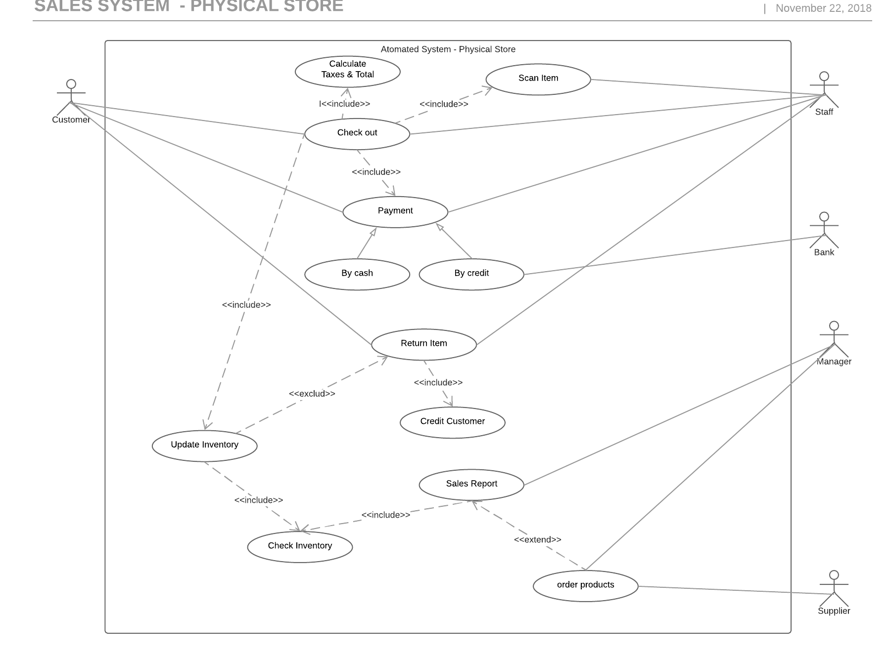

### **4.2.3 Feasibility Study**

#### **4.2.3.1 Technical Feasibility**

#### **4.2.3.2 Operational Feasibility**

#### **4.2.3.3 Economic Feasibility**

#### **4.2.3.4 Schedule Feasibility**

## **4.3 PROPOSED SOFTWARE III**

Brick and Mortar is a jargon used to refer that physical presence of an organization, such a store, like the Vinyl Store that deals with face-to-face transactions with customers. In the recent past this jargon turned into a new one to exemplify the new model of business, due to the rise of electronic commerce. From the Brick to the Clicks, which Clicks consists mainly in transactions made over the internet, and where companies develop electronically mechanism that allow customer making purchases online. Another term merge both models, Click and Mortar, that enable consumers buy things either in the store or online. Companies are recognizing that success will go to those who can execute clicks-and-mortar strategies that bridge the physical and virtual world. Different companies will need to follow different paths in deciding how closely-or loosely- to integrate their internet initiatives with their traditional operations (Bylinsky, 2001). Indeed, it modified the scenario of business transactions, making use of electronic communications and digital information to interact electronically rather than by physical presence. To support every step of these process, the electronic commerce rely on the resources of information technologies, and also the internet. This third assess study will implement an ecommerce and automate the system business model in the physical store. This mechanism allows customer and suppliers to register online and make orderings, payments through the website, and the presence store using specific technologies, such barcode scanner, card machine and computerized system to control daily transactions, track customers records and so on.

### **4.3.1 Assumptions and Constraints**

The new tailored system requires specifics devices, hardware and internet connection to run smoothly. Considering all the changes, initially is necessary to install a base computer with limited configuration, the main purpose of the computer is exclusively perform daily transactions, also the computer must be connected to the internet, and thus it updates the inventory system which is shared between the physical system and online system.

The system will be installed in this computer and used to register products, perform transactions such as update inventory system, process payments and produce sales report. New products should be scanned and registered properly with name, description, product identification, and also an electronic device that can read and output printed barcodes to a computer must be installed, in this case a barcode reader. Besides, a card machine is necessary, once the system offers the possibility to customer pays in cash or by card.

### **4.3.2 Design and Methodology**

This third assess will be based on a tailored system fully developed to support all the requirements established by the Vinyl store. The physical system will be integrated with the online system using an object-oriented design. The Software designed provides a link between requirements and an implementable specification. It is a pervasive activity for which often there is no definitive solution. Keys design techniques and issues involve the identification of an overall structure or architecture, the identification of the main elements of software that need to be managed. In order to illustrate the business concept a use case is used to demonstrate the actors and the transactions performed in the physical and online system. The system designed in object-oriented environment is also included below to demonstrate how the system architecture was planned.

**4.3.2.1.2 Object- Oriented Design**

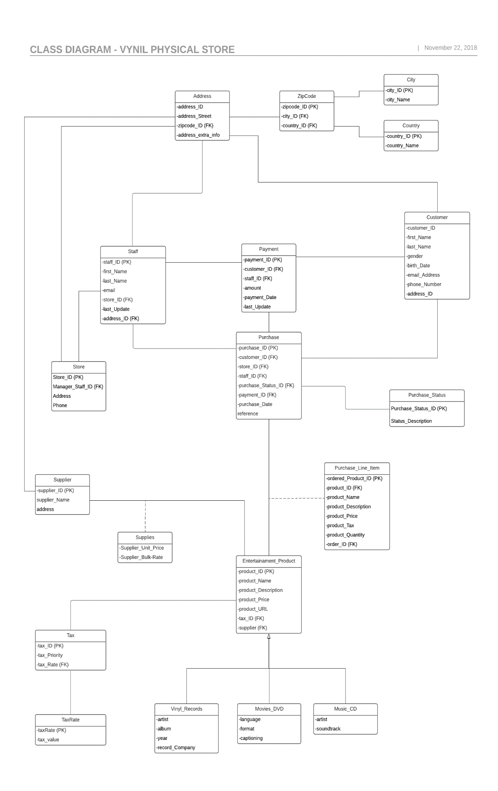

**4.3.2.2 Use case– Online Store**

| **Use Case:** Online System |
| --- |
| **Primary Actor:** WebCustomers |
| **Level:** High |
| **Stakeholders:** Clerk and customers. |
| **Precondition:** Web site will be loaded |
| **Minimal Guarantee:** |
| **Success Guarantee:** Perform purchases, browse catalog, |
| **Trigger:**  Online system. |
| **Main success Scenario:** Staffperform transactions;   1. Customer initialise website; 2. Website is loaded and display home page; 3. Consumer browse catalog; 4. Website allows customer to manage cart, adding, editing and deleting products; 5. Customer orders and is required to login in the system; 6. If new customer is necessary to create an account, otherwise log in; 7. Products cart are displayed and customer is required to choose shipment options; 8. Order is issued and customer decides payment method (direct debit or Paypal system); 9. Payment is issued; 10. Customer receives receipt and email detailing the purchase; 11. Order status is printed to customer account; 12. Customer purchased is ceased. 13. Administrator receives order; 14. Administrator issue order; 15. Administrator initiates shipment process 16. Order status is changed. 17. Products are sent to deliver. |
| **Extensions:**   1. System cannot be initialised; 2. Computer cannot be initialised; 3. Card payment cannot be issued; 4. Scan reader is not working; 5. Printing cannot be processed; 6. No internet connection; |

**4.3.2.2.1 Use case diagram– Online Store**

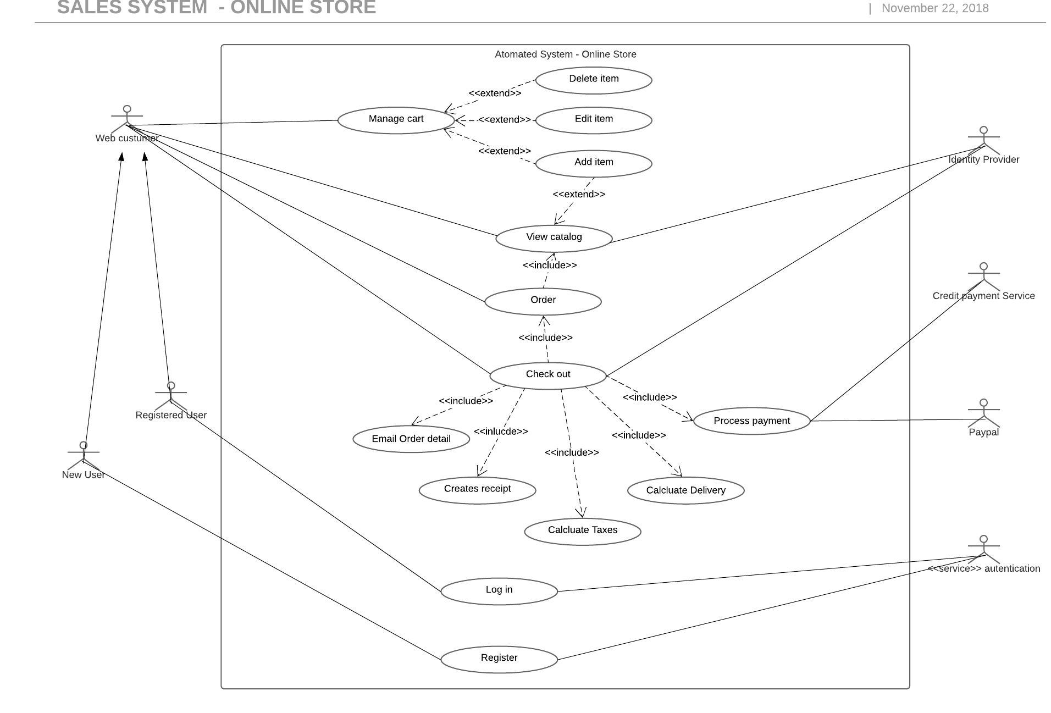

**4.3.2.2.2 Object- Oriented Design**

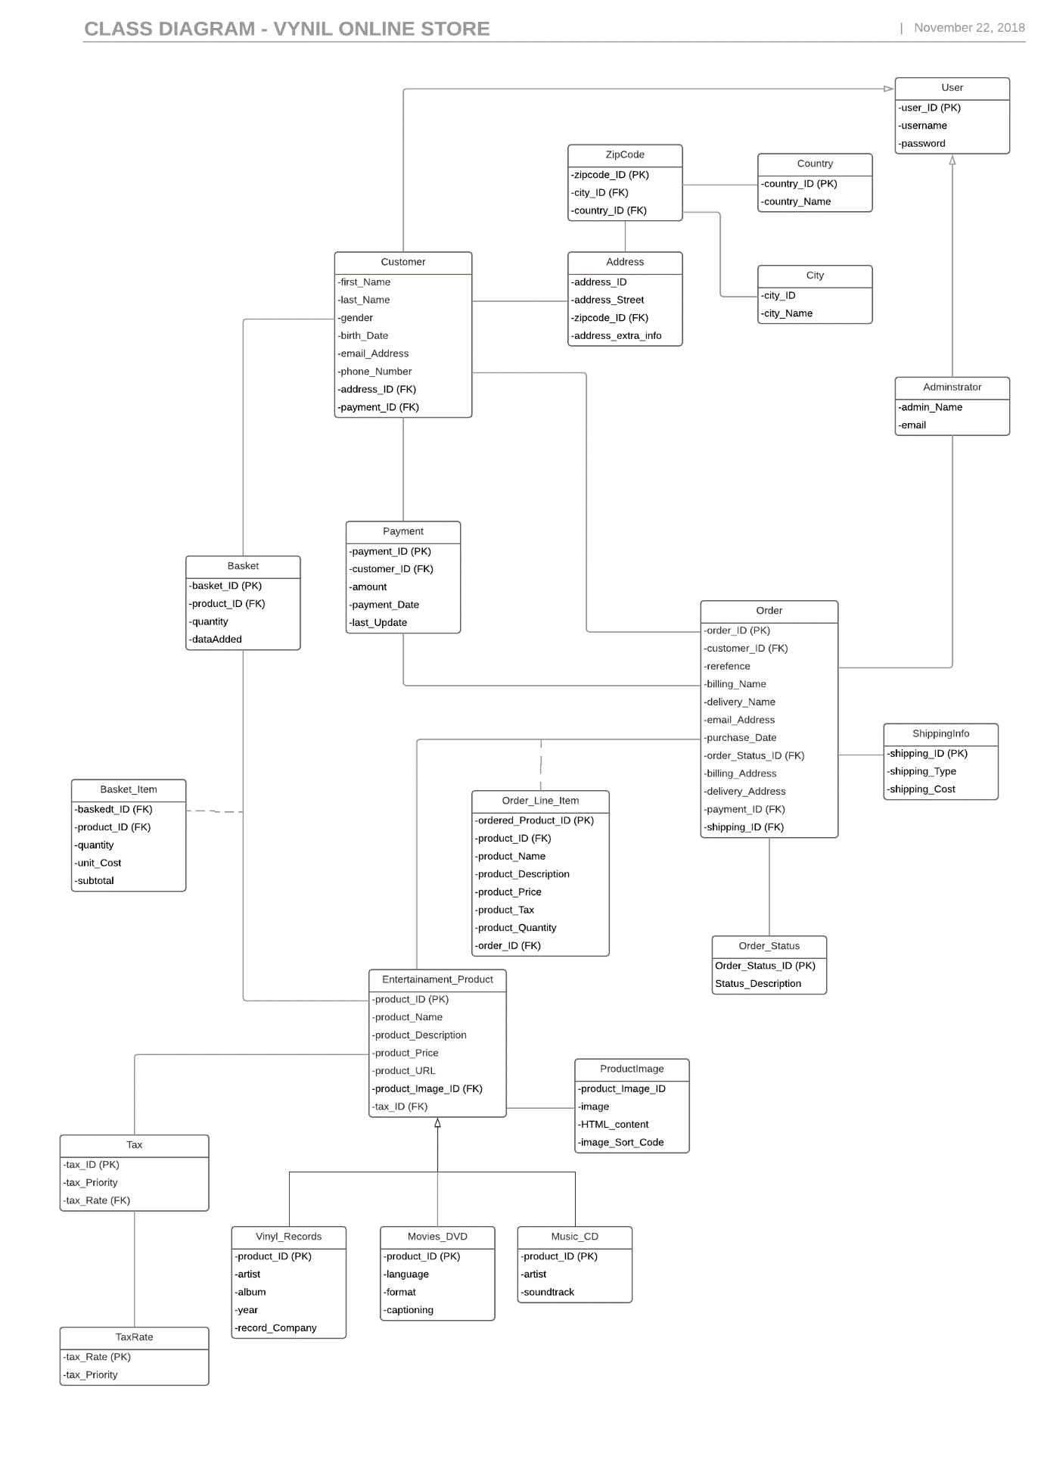

### **4.3.3 Feasibility Study**

This third assessment will focus on a tailored system for the Vinyl Store.

#### **4.3.3.1 Technical Feasibility**

This third assessment will focus on a tailored system for the Vinyl Store integrating a physical commerce system installed in the store and an ecommerce to deal with transactions made online. The proposed bespoke software requires an order management to deal with those transactions keeping track of the stock rotation, literally it works as a traffic control for all commerce activities, managing order coming in from across both channels and uses automated business logic to match them with the best fulfilment options to meet customers expectations and your profitability goals.

The system used to perform all the transactions in presence store will be developed using Java, to support the server side the system counts with PHP integration and MySQL as database. In order to support the daily activities specific technologies will be used such as card machine and barcode reader, outsourced devices that perform payment operations and scanning to register, and input item purchased respectively. Those technologies are available to order as soon as possible and do not require any new specific hardware or technical knowledge to deal with.

The online system is structured using HTML which stands for Hyper Text Markup Language, another language is used to style an lay out the webpage, CSS is stylesheet language used to describe the presentation of a written in HTML. In addition a dynamic language is also used in the development of the e-commerce.

#### **4.3.3.2 Operational Feasibility**

#### **4.3.3.3 Economic Feasibility**

#### **4.3.3.4 Schedule Feasibility**

# 5. RECOMMENDATION

# 6. FINAL CONSIDERATIONS

**7. BIBLIOGRAPHY**

Bordonaba‐Juste, V., Lucia‐Palacios, L. and Polo‐Redondo, Y. (2012). **Antecedents and consequences of e‐business adoption for European retailers**. *Internet Research*, 22(**5**), pp.532-550.

Janita, I. and Chong, W. (2013). **Barriers of B2B e-Business Adoption in Indonesian SMEs: A Literature Analysis**. *Procedia Computer Science*, 17, pp.571-578.

Malaga, R. A. (2005). ***Information systems technology***. Upper Saddle River, NJ: Pearson Prentice Hall.

Marakas, G.M. and O'Brien, J.A., (2013). ***Introduction to information systems***. 16th edn. McGraw-Hill, Inc., New York.

Van Teijlingen, E. and Hundley, V. (2001). **The** **importance of pilot studies**. *Social research Update*, 16(35), pp.33-36.

Bylinsky, G. 2001 “The e-Factory Catch On”. Fortune.

# APPENDICES

