

**Griffith College Limerick**

|  |  |  |  |  |  |  |
| --- | --- | --- | --- | --- | --- | --- |
| **Student name:** | **ASSIGNMENT COVER SHEET**  **Sarah Narayamy Tavares Silva** | | | | | |
| **Student number:** | **2960992** | | |  | | |
| **Faculty:** | Computing Science | | | | | |
| **Course:** | BScO in Computing Science | | | Stage/Year: | 1 | |
| **Module:** | Web Technologies | | | | | |
| **Study Mode:** | Full time | **🗸** |  | Part-time |  |  |
| **Lecturer Name:** | David Byrne | | | | | |
| **Assignment Title:** | Assignment 1 | | | | | |
| **URL (IF Applicable)** |  | | | | | |
|
|
| **Date due:** 22/03/2020 |  | | | **Date submitted: 22/03/2020** | | |
| **Academic Misconduct:**  *I understand that I will be subject to the penalties imposed for breaches of academic conduct as defined in the College’s Academic Misconduct Procedure (QA J6).*  **Signature: Sarah Narayamy Tavares Silva Date: 22/03/2020** | | | | | | |

Please note: Students MUST retain a hard / soft copy of all assignments and must SIGN the Assignment Submission Sheet provided by the lecturer / member of Faculty as proof of submission.

**INTRODUCTION**

A Website is the backbone of any business since it supports all the digital marketing efforts. Any consumer nowadays looks for information online in order to help them make a decision. Most of websites were built using HTML when the web started, which means that there was one file for each page in a website and all these files had to be edited by hand. Even though, HTML still stands in modern days, the idea of facilitating the maintenance of a website brought us to back-end databases to hold content and there is where Content Management System (CMS) came in.

CMS is nothing but a software that helps users create, manage and edit the content on a website, but it has a major importance in businesses. Without the use of CMS, the website would rely only on the developer in order to make any adjustments to it. On the other hand, by using CMS, the website owner can have more control over the content of the page by making the changes as they are needed and when they are needed (Johnston, 2019).

The choice of the Content Management System will depend of several factors, but mainly depends on its needs and the budget given to it. Firstly, it is important to find out who are the stakeholders involved in the decision of choosing a CMS. Normally, the departments involved in this are the IT since they might be involved in the maintenance and modification of the CMS; the second department is the Marketing, since they are responsible for the marketing-focused content within the organization; and the third most common department involved in the decision making is the sales department since they are responsible for guaranteeing improvement in sales efficiency and effectiveness (Saltis, 2020).

Still according to Saltis (2020), the stakeholders requirements must be prioritized once every and each department has different requirements. The MoSCoW method; which is based on “Must-have”, “Should-have”, “Could-have” and “Would-have”; allows us to achieve this goal. The following matrix gives us a better idea on how it works.

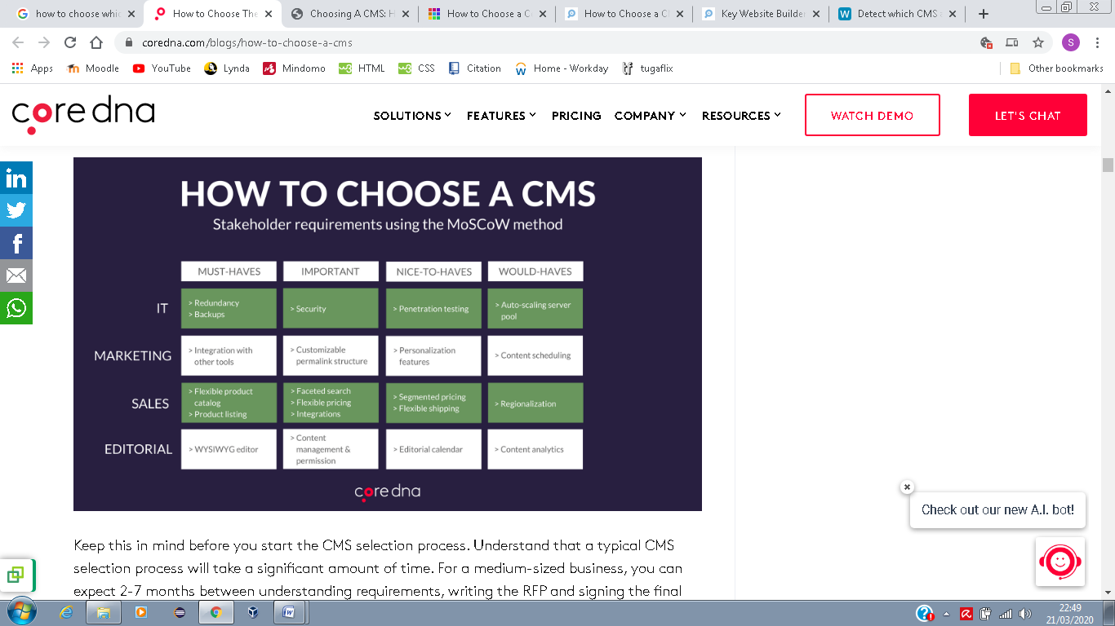

Image 1: MoSCoW method (Saltis, 2020)

Another aspect to take into consideration is the type of CMS to be used. There are 3 types of CMS on the market: On-premise CMS, Cloud Hosted CMS and SaaS CMS. In the On-premise CMS, a license is bought from the vendor and the software is installed on the organization’s own server. The CMS provider is responsible only for the maintenance and updating the software. A Cloud Hosted CMS works similarly to the On-premise CMS but the software is installed on a third-party server not directly owned by the organization. Lastly, the SaaS CMS or Software as a Service is an emerging category in which the provider handles all the technical issues in order for the organization to focus on creating and managing the content. With the SaaS solution, there is no installation or updating or maintenance (Saltis, 2020).

The benefits of using a CMS solution instead of the old fashion way with HTML, CSS, JavaScript among other is huge. For starters is faster to edit it; it provides a safe interaction with the database; it has a user-friendly composition; it also gives accessible content management once you do not need knowledge of HTML to edit the website; the bills for web designing are less; it provides a familiar site management once the knowledge and skills used for one website can be transferred to another site using the same platform; automation is also a benefit of using CMS once posts can be scheduled, etc; the flexibility is another characteristic of using CMS (Broadley, 2020).

Summarizing, when choosing a CMS to use on a website, it is important to consider firstly the available technological capabilities within the organization, which means it needs to be taken into consideration if the organization has the technology and the knowledge to manage the application and if it possesses the resources to keep the software safe from being hacked and of course if the organization can manage by itself any problem the software may come to have; secondly, the organization must determine its flexibility and support requirements, since some software applications like closed source CMS’s might not give users flexibility in managing the application once they are governed by a third party developer, or an Open source CMS in which the organization must rely on a professional team since they will not have support from the developer themselves because these software are managed by the users themselves. Thirdly, the organization must evaluate their budget since the cost can very high initially if it is decided to use an up-to-date and fully-loaded CMS or it can be very low if it is decided to use a basic CMS. Fourthly, it is important that the organization evaluates its plans for the future as well as its expectations once it may start as a simple blog but it can evolve to something bigger than that (Opensource CMS, 2019).

**Case 1: A group of Irish and European Software SME’s forming a Virtual Enterprise to produce a new prototype wheelchair. They do intend to share highly sensitive data and use the proposed CMS system as the primary means of communication, in order to distinguish the project from other work.**

This case requires a very good CMS in terms of security since it is dealing with highly sensitive data. Taking that into consideration I recommend the Magnolia CMS.

Magnolia CMS is an open source software based on Java which is a user-friendly, easy to set up and to use. Magnolia is recommended to enterprises that may not have the technical know-how to build it themselves which means that the company can manage and update on their own. It is a robust, flexible, user-friendly and most importantly it has a high level of security (Wheeler, 2020).

Magnolia is also a cloud hosted CMS which means that it works similarly to an on-premise CMS but it is installed on a third-party server not owned by the company, which means less investment on hardware, it also provides more control over the CMS (Saltis, 2020).

Since it seems to be a very important and complex project, financially, Magnolia offers a quote-based plan which focus on site size, purposes, functionalities, etc. Thus, the company will be paying exactly what it is they will be using on their website, especially, if we consider that Magnolia support a lot of functionalities.

Magnolia provides a very well organized content capability since it has a intuitive content organization. The following image shows how the content can be automatically be broken into chunks.

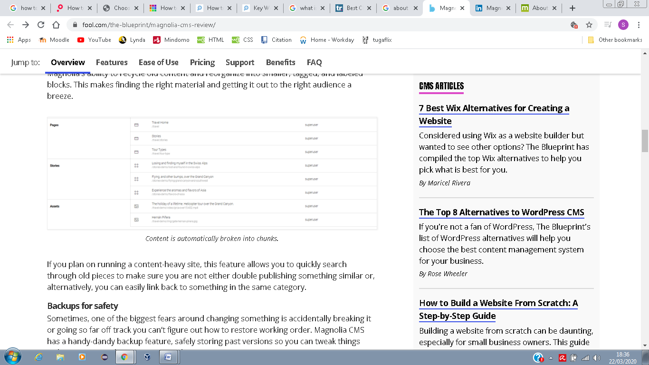

Image 2: Content being broken into chunks. (Wheeler, 2020)

In terms of backups for safety, Magnolia offers a handy-dandy backup feature which means that it stores past versions, thus, if accidentally content is broken, or if it is going far off track, it is easy to improve it. Also, the software provides customized alerts to help users in relation to customer chats, software upgrades, content interaction, etc, which is very important since the organization may not have a professional resource straight away. Bellow there is a representation on how this works.

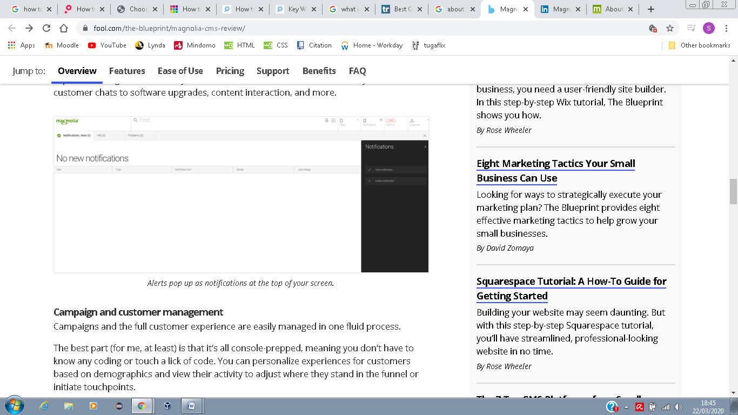

Image 3: Notification feature. (Wheeler, 2020)

Once more, the organization does not have a high level developer but Magnolia offers a great support in case there is struggle, the support is either for developers and maintenance support options and the response time is usually fast and helpful (Wheeler, 2020).

Saltis (2020) says that Security is a double-edged sword once very popular CMSs are more prompt to attacks but on the other hand, the more popular the more developers they will have and the response to an attack is faster. The graph bellow shows how WordPress deals with attacks.

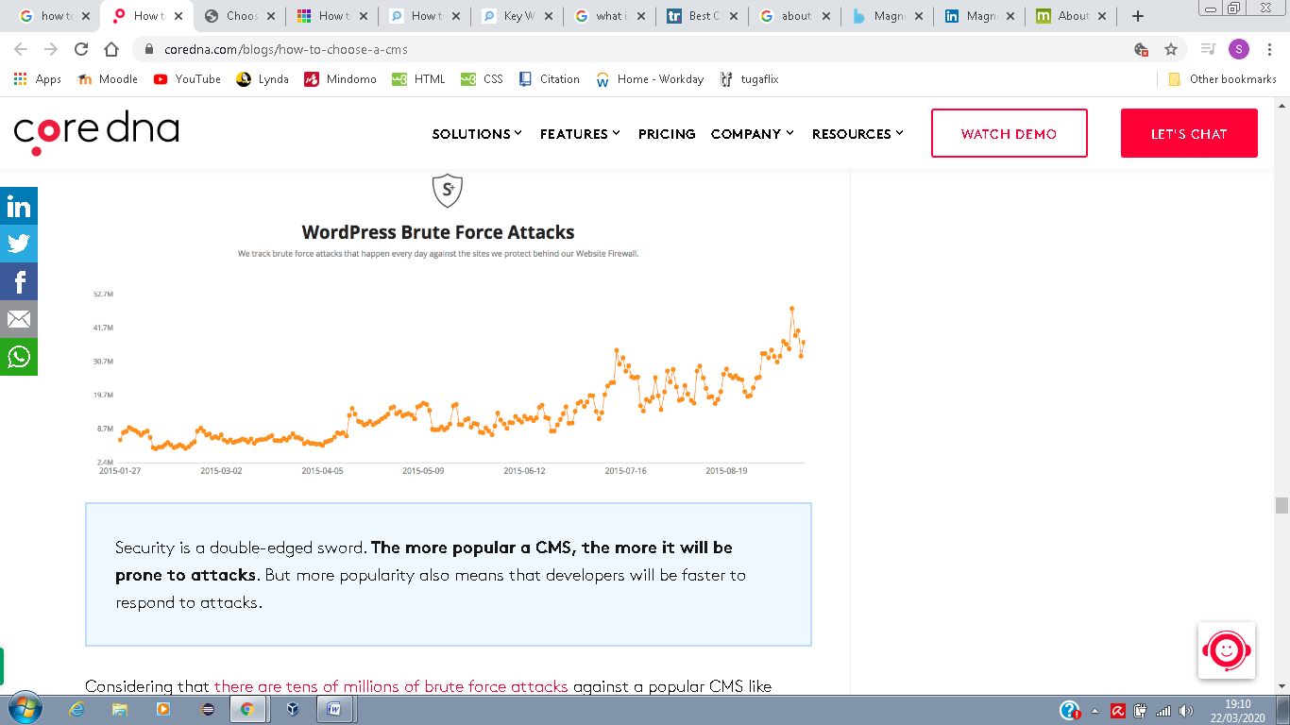

Image 4: WordPress brute force attacks. (Saltis, 2020)

However, in terms of security, Magnolia uses an architecture that separates the public and private elements of a website to help prevent attacks, even though it is not the most popular CMS on the market. This architecture, allows the developer to define activities of the users and the administrative (Fearn, 2020).

**Case 2: A small assembly of Cork based musical artists collaborating on joint projects for a yearly festival showcasing their work (primarily short compositions). While the aim of the CMS is informational primarily, it will contain links and contact details for ticket bookings on external provider sites.**

In this case security is not the main feature once it is an informative website about the musical artists. Taking that into consideration and that the group of musicians have just a lower level skilled developer on their team, I recommend the use of Wordpress.

Wordpress is the most popular open source on-premise CMS. It is free unless for the software, but considering the artists may want to keep record of posts and their work into a database, there is an investment of €8 for the premium cloud hosting option which I believe is enough for this organization. Bellow there are the options for payment for Wordpress (Wordpress, 2020). Even though it is possible to install the software on the organization’s own servers, I believe it is not appropriate since it needs investment on hardware, etc. Thus, the cloud investment is more recommended.

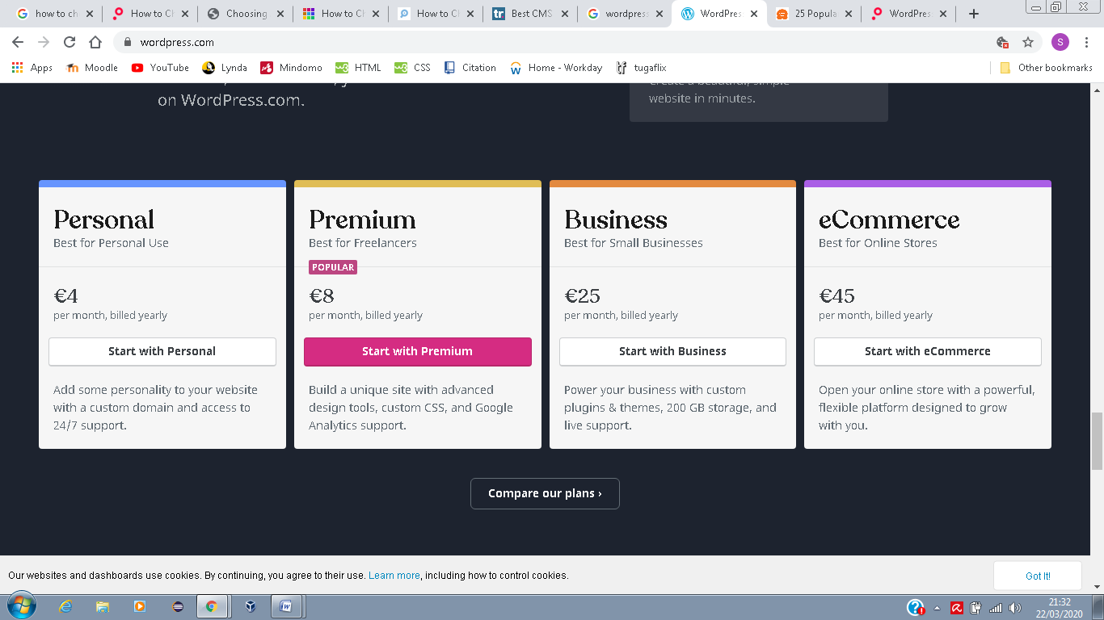

Image 5: Wordpress prices. (Wordpress, 2020)

This CMS option is popular due to its flexibility, also, because it has an easy-to-use admin panel and numerous themes/ templates. With that in mind building the musicians’ website does not require any coding even though it was built based on PHP and MySQL. The software provides tools to create a bog using written, videos, images and more content types just like the musicians want (Fearn, 2020).

**Case 3: A group / organisation that you are familiar with and think would benefit from a web-based means of sharing information. In this option, you are given free reign as to the extent of collaboration and subsequent choice of CMS, as long as you can justify this based on a set of criteria. Specify the aims and main characteristics of the group.**

**A global healthcare company wants to create a website with information about their products as well as information about where to find a store and how to buy it. The company does not want to rely on IT and needs a strong vertical compliance.**

In this case I would recommend the Crownpeak CMS which is an enterprise Digital Experience Platform (DXM) that grows as company grows. It is a cloud based platform easy to create, deploy and optimize customer experience. It offers a personalised tool for searching, hosting and includes Digital Quality Management (DQM) which ensures brand integrity, best practices, and web accessibility compliance (Linkedin, 2020).

The price of the software is tailored to the organization’s needs, thus the healthcare organization needs to contact the provider first to get a price. However, with the price comes the included installation of the platform, training in person, live online, webinars and documentation, it also provides support on business hours and online. Also, since the platform is on the cloud, the provider is responsible for all the maintenance, update, etc; thus, as the company launches new products, customers can see them very fast since these updates are done automatically. Also, it means that the organization only needs to take care of the content within the website.

It provides several features such as Customizable templates, E-forms, full text search, Image editor, SEO management, text editor, version control and website management (Capterra, 2019).

Using a SaaS solution such as Crownpeak adds benefits to the website such as feature rich, since they are developed once and used by everyone within a community; there is no maintenance/upkeep, since all the fixing bugs and maintaining the infrastructure is done by the provider; the updates are done regularly; there is no installation from the organization’s part, since it is done by the provider; it offers pay-as-you-go payment, once the payments are monthly instead of pay a big chunk upfront; the security is another benefit of this platform since it is installed away from the premises and it also have strong backups and recovery process in case of security concerns; since this solution is hosted in the cloud, it provides high scalability, which means that it can grown as it demands and it would not take the website down if there is a huge traffic of information (Saltis, 2020).

**REFERENCES**

Broadley, C., 2020. *Who is hosting this?.* [Online]   
Available at: https://www.whoishostingthis.com/resources/choose-cms/  
[Accessed 21 March 2020].

Capterra, 2019. *Capterra.* [Online]   
Available at: https://www.capterra.com/p/846/CrownPeak/#pricing  
[Accessed 22 March 2020].

Fearn, N., 2020. *Techradar pro.* [Online]   
Available at: https://www.techradar.com/best/cms  
[Accessed 22 March 2020].

Johnston, M., 2019. *CMS Critic.* [Online]   
Available at: https://www.cmscritic.com/how-to-choose-a-cms-in-7-easy-steps/  
[Accessed 20 March 2020].

Linkedin, 2020. *Linkedin.* [Online]   
Available at: https://www.linkedin.com/company/crownpeak-technology/about/  
[Accessed 22 March 2020].

Opensource CMS, 2019. *Opensource CMS cms demos & information.* [Online]   
Available at: https://www.opensourcecms.com/how-to-choose-a-cms/  
[Accessed 22 March 2020].

Saltis, S., 2020. *Coredna.* [Online]   
Available at: https://www.coredna.com/blogs/how-to-choose-a-cms  
[Accessed 19 03 2020].

Wheeler, R., 2020. *The blueprint.* [Online]   
Available at: https://www.fool.com/the-blueprint/magnolia-cms-review/  
[Accessed 20 March 2020].

Wordpress, 2020. *Wordpress.* [Online]   
Available at: https://wordpress.com/  
[Accessed 22 March 2020].