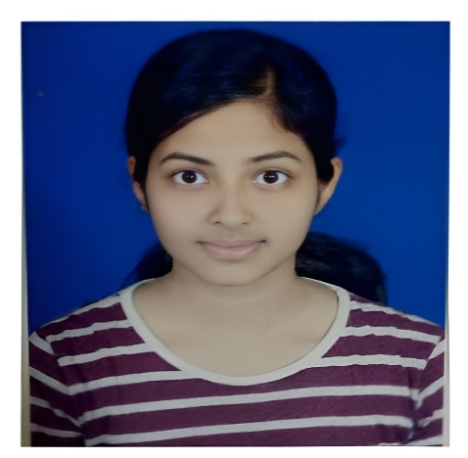

**Post Graduation**

Course: MCA(Computers)

College/University: FAKIR MOHAN UNIVERSITY

***EDUCATION***

**Software Testing Intern (Manual and Automation)**

(Wavelabs Technologies India Pvt Ltd (A Unit of Westagile IT Labs India Pvt Ltd.),

Bangalore, India / June 2023 – September 2023

* Conducted manual test execution for multiple applications, ensuring quality standards.
* Assisted in creating and implementing automated test scripts using Selenium and Hybrid framework.
* Collaborated with teams to identify and track software defects for timely resolution.
* Knowledge on ABot, Spirent and Wire shark tool and 4G and 5G Core domain.
* Developed an automation script, reducing testing time by 30%.
* Contributed to test planning and comprehensive test case creation.
* Proactively collaborated with developers and testers for project success.

***EXPERIENCE***

Experienced and dedicated Software Tester with a passion for ensuring the delivery of high-quality software products. Through an enriching internship, I have honed my testing skills, cultivating a deep understanding of testing methodologies and industry best practices. My strong attention to detail, analytical mindset, and collaborative nature have proven instrumental in detecting and resolving complex software issues.

***SUMMARY***

**SUBHADARSHINI ACHARYA**

***SUMMARY***

***SUMMARY***

**SUBHADARSHINI ACHARYA**

**SUBHADARSHINI ACHARYA**

***SOCIAL LINKS***

* Odia
* Hindi
* English

***LANGUAGES KNOWN***

* Java
* Selenium Web driver
* SQL
* Spirent
* Git Hub repository
* SDLC, STLC
* Automation Testing Hybrid Framework
* Wire shark, ABot
* API Testing Postman

***TECHNICAL SKILLS***

* Manual Testing
* Automation Testing
* Knowledge Automation Tools
* Database Testing
* Bug Reporting
* Writing Test Cases
* Defect Tracking
* Functional Testing
* Retesting
* Regression Testing
* Problem Solving

***SKILL HIGHLIGHTS***

+91 8144246803

guddyacharya98@gmail.com

Brookfield, Bangalore, Karnataka, 560066

**Manual Testing**

Application Name: ADACTIN- A Hotel Booking Application

Description: Using this system user can view and check for various rooms available and simultaneously book them by making online payment. The system calculates the total

cost on booking the services. Once the user makes the payment, system will provide online receipt to the user

Role: Test Case writing, Bug reporting, Various testing (Like Regression Testing, Re-Testing, Functional Testing)

**Automation Testing (SELENIUM Using JAVA)**

Application Name: HRMS

Description: HR management portal (HRMS) is the comprehensive solution for the efficient management and development of Human Resources. It will assist you in the complex and strategic process of managing this crucial resource of your enterprise. Based on modular architecture, it facilitates a vast range of HR activities, with features that reflect the main HR management activities.

Role: Building Hybrid framework, writing automation test scripts, generating logs and generating test reports, reading test data build configurable project

***HOBBIES***

* Playing Chess
* Dance
* Designing Craft
* Willing to learn new things

<https://www.linkedin.com/in/subhadarshini-acharya-210b0a210>

***PROJECT***

Software Testing Manual and Automation

(Naresh IT, Hyderabad)

***CERTIFICATION* Certification**

***SOCIAL LINKS***