|  |  |
| --- | --- |
| **Ex. No: 1** | LA-1: Personal CV - HTML |
| **24.07.2023** |

Aim: To create a personal single-page CV using HTML.

Algorithm: The basic template of any html page is as follows-

<!DOCTYPE html>

<head>

<meta charset="UTF-8">

<title>Your Page Title</title>

<!-- Additional meta tags, links, and stylesheets can go here -->

</head>

<body>

<!-- Page content goes here using html tags to structure & format data -->

</body>

</html>

<!DOCTYPE html>

<html>

<head style:"bg-color:">

<meta charset="utf-8" fit-to-window:"true " >

<title>cv</title>

<h1> NARAYAN KRISHNA R</h1>

</head>

<body>

<table cellspacing:"40">

<tr>

<td><img src="IMG_1.jpg" alt="RNK" width="200px" height="200px"></td>

<td><p><e</strong></em></p>

<p> </p>

</td></tr>

</table>

<hr size="2">

<h2> ABOUT ME</h2>

<p> I am a under graduate in a B.Tech(Iot) in SNU-Chennai with a strong motivation to understand about the Iot industries </p>

<p>

<hr>

<h2> EDUCATION</h2>

<ol>

<li> <strong>Graduated 12 </strong> from P.S.SENIOR SECONDARY School ,Chennai on the year 2021

</li>

<li> Studying <strong> B.Tech CSE(iot) <strong> from Shiv Nadar University

</li>

</ol>

<hr>

<table>

<tr>

<td></td>

</tr>

</table>

</p>

<p>

<h2> HOBBIES</h2>

<ol start="i">

<li> favourite :playing chess</li>

<li> favourite pass-time: reading books</li>

<li> favourite insturment: keyboard </li>

</ol>

</p>

<hr>

<p>

<h3> SKILLS </h3>

<table>

<tr>

<td>

<table>

<tr>

<td>iot</td>

<td>⭐⭐⭐</td>

</tr>

<tr>

<td>python programing </td>

<td>⭐⭐⭐</td>

</tr>

</table>

</td>

<td>

<table>

<tr>

<td>flutter</td>

<td>⭐⭐⭐</td>

</tr>

<tr>

<td>c programming</td>

<td>⭐⭐⭐</td>

</tr>

</table>

</td>

</tr>

</table>

</p>

<hr >

<h3>CONTACT </h3>

<table style="padding:15px">

<tr>

<td>phone number :</td>

<td>1234567890</td>

</tr>

<tr>

<td>email address : </td>

<td>narayankrishna.tvr@gmail.com</td>

</tr>

</table>

</body>

</html>

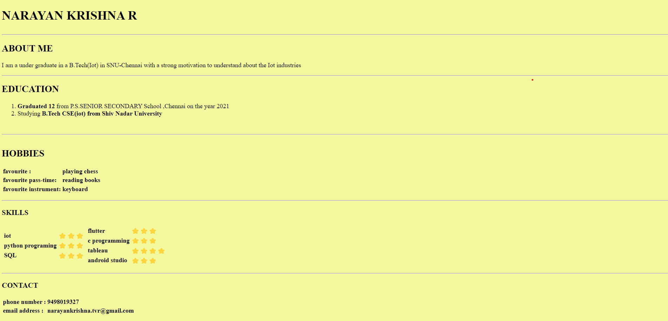

Result: Therefore, we've successfully created a personal CV using HTML