|  |  |
| --- | --- |
| **Ex. No: 2** | LA-2:- LA-2: CSS enabled CV |
| **24.07.2023** |

Aim: To create a personal CV using HTML and CSS.

Algorithm: The basic template of any html page is as follows-

<!DOCTYPE html>

<head>

<meta charset="UTF-8">

<title>Your Page Title</title>

<!-- Additional meta tags, links, and stylesheets can go here -->

</head>

<body>

 <!-- Page content goes here using html tags to structure & format data -->

</body>

</html>

There are 3 ways of CSS implementation in HTML1. Inline Styles: Inline styles involve defining CSS directly within the HTML elements

using the style attribute.

Ex-

<p style="color: blue; font-size: 16px;">This is a blue text with a font size

of 16px.</p>

2. Internal Styles: Internal styles are defined within the <style> element in the HTML

<head>. These styles apply to all elements on the current web page.

Ex-<!DOCTYPE html>

<html>

<head>

<style>

p {

color: blue;

font-size: 16px;

}

</style>

</head>

<body>

<p>This is a blue text with a font size of 16px.</p>

</body>

</html>

3. External Styles: External styles involve creating a separate CSS file with the .css

extension and linking it to multiple HTML pages. This method is widely used for

consistent styling across an entire website and is used here

## HTML CODE

<html lang="en">

<head>

    <script src="https://use.fontawesome.com/59a8f26532.js"></script>

    <meta charset="UTF-8">

    <meta name="viewport" content="width=device-width, initial-scale=1.0">

    <title>Narayan Krishna | Resume</title>

    <link href="https://fonts.googleapis.com/css?family=Artifika|Open+Sans" rel="stylesheet">

    <link rel="stylesheet" href="styles.css">

</head>

<body>

    <header id="about">

      <a class="btn download" href="#" download>Download PDF</a>

      <nav>

        <a href="#about" title="">About</a>

        <a href="#skills" title="">SKILLS</a>

        <a href="#education" title="">Education</a>

        <a href="#contact" title="">Contact</a>

      </nav>

      <div class="content-wrap">

        <img class="profile-img col-narrow" src="IMG_2.jpeg">

        <div class="col-wide">

        <h1>Narayan Krishna R</h1>

          <h2> HOBBIES</h2>

<ol start="i">

<li> playing chess</li>

<li>   reading books</li>

<li>  playing keyboard </li>

</ol>

        </div>

      </div>

    </header>

    <main>

        <section id="skills" class="skills">

          <div class="content-wrap">

            <h3 class="skills"> SKILLS </h3>

        <table >

      <tr>

       <td>

        <table>

          <tr>

            <td>iot</td>

            <td>⭐⭐⭐</td>

          </tr>

          <tr>

            <td>python programing </td>

          <td>⭐⭐⭐</td>

          </tr>

          <tr>

            <td>SQL </td>

          <td>⭐⭐⭐</td>

          </tr>

        </table>

        </td>

        <td>

        <table >

          <tr>

            <td>flutter</td>

            <td>⭐⭐⭐</td>

          </tr>

          <tr>

            <td>c programming</td>

          <td>⭐⭐⭐</td>

          </tr>

          <tr>

            <td> tableau </td>

          <td>⭐⭐⭐⭐</td>

          </tr>

          <tr>

            <td> android studio </td>

          <td>⭐⭐⭐</td>

          </tr>

        </table>

        </td>

      </tr>

    </table>

        </p>

        </section>

        <section id="education" class="education">

          <div class="content-wrap">

            <h2>Education</h2>

            <ol>

<li> <strong>Graduated 12 </strong> from P.S.SENIOR SECONDARY School ,Chennai on the year 2021

</li>

<li> Studying <strong> B.Tech CSE(iot) <strong> from Shiv Nadar University

</li>

</ol>

            </div>

        </section>

    </main>

    <footer id="contact">

      <div class="content-wrap">

        <h2>Let's Keep in Touch!</h2>

        <div class="contact-info">

            <a href="mailto:narayankrishna.tvr@gmail.com"><i class="fa fa-envelope fa-lg" aria-hidden="true"></i>

<span class="sr-only">Email</span></a>

            <a href="https://www.linkedin.com/in/narayan-krishna-tvr-0784b1253/" target="_blank"><i class="fa fa-linkedin fa-lg" aria-hidden="true"></i>

<span class="sr-only">LinkedIn</span></a>

            <a href="https://github.com/nkstriker007" target="_blank"><i class="fa fa-github fa-lg" aria-hidden="true"></i>

<span class="sr-only">Github</span></a>

    </footer>

</body>

</html>

## CSS

html {

  box-sizing: border-box;

}

body {

  font-family: 'Open Sans', sans-serif;

  margin: 0;

}

a {

  color: #EF233c;

}

a:hover {

  text-decoration: none;

}

h1, h2 {

  font-family: 'Artifika', serif;

  font-weight: 400;

}

h1 {

  font-size: 50px;

}

h2 {

  font-size: 25px;

  margin-top: 0;

}

h3 {

  margin: 0;

}

.content-wrap {

  max-width: 950px;

  margin: 0 auto;

  padding: 60px 50px;

  overflow: hidden;;

}

.uppercase {

  text-transform: uppercase;

}

.justified {

  text-align: justify;

}

.btn {

  text-decoration: none;

  background: #EF2336;

  color: #fff;

  padding: 10px;

  display: inline-block;

}

.download {

  position: absolute;

  bottom: 0;

  right: 0;

}

header, footer {

  background-color: #2B2D42;

  color: #8D99AE;

}

header {

  padding-top: 50px;

  position: relative;

}

nav {

  text-align: center;

  background-color: #fff;

  position: fixed;

  top: 0;

  width: 100%;

}

nav a {

  display: inline-block;

  padding: 15px 20px;

  text-decoration: none;

  text-transform: uppercase;

  font-weight: 700;

}

header h1, header h2 {

  color: #EDF2F4;

  margin: 0;

}

.profile-img {

  border-radius: 50%;

}

footer {

  text-align: center;

}

.contact-info a {

  padding: 10px;

  display: inline-block;

}

.education {

  background: linear-gradient(rgba(141, 153, 174, 0.8), rgba(141, 153, 174, 0.5)),

                              url(http:*//freelinkedinbackgrounds.com/wp-content/uploads/2015/01/Technology-008.jpg) no-repeat;*

  background-size: cover;

  background-attachment: fixed;

}

p + h3 {

  margin-top: 30px;

}

.skills {

  background-color: #EDF2F4

}

h3 ~ p {

  margin: 0;

}

.job-description p:first-of-type {

  margin-top: 0;

}

.job-decription {

  margin-bottom: 25px;

}

@media (min-width: 900px) {

  .col-narrow {

    width: 35%;

    float: left;

  }

  .col-wide {

    width: 62%;

    float: right;

    padding-left: 20px;

  }

}

@media (max-width:899px) {

  header {

    text-align: center;

  }

  .profile-img {

    width: 200px;

  }

}

table,td{

  border-right:20px  solid #EDF2F4 ;

}

.skills{

  margin:auto;

}

h3{

  margin:auto;

}

OUTPUT

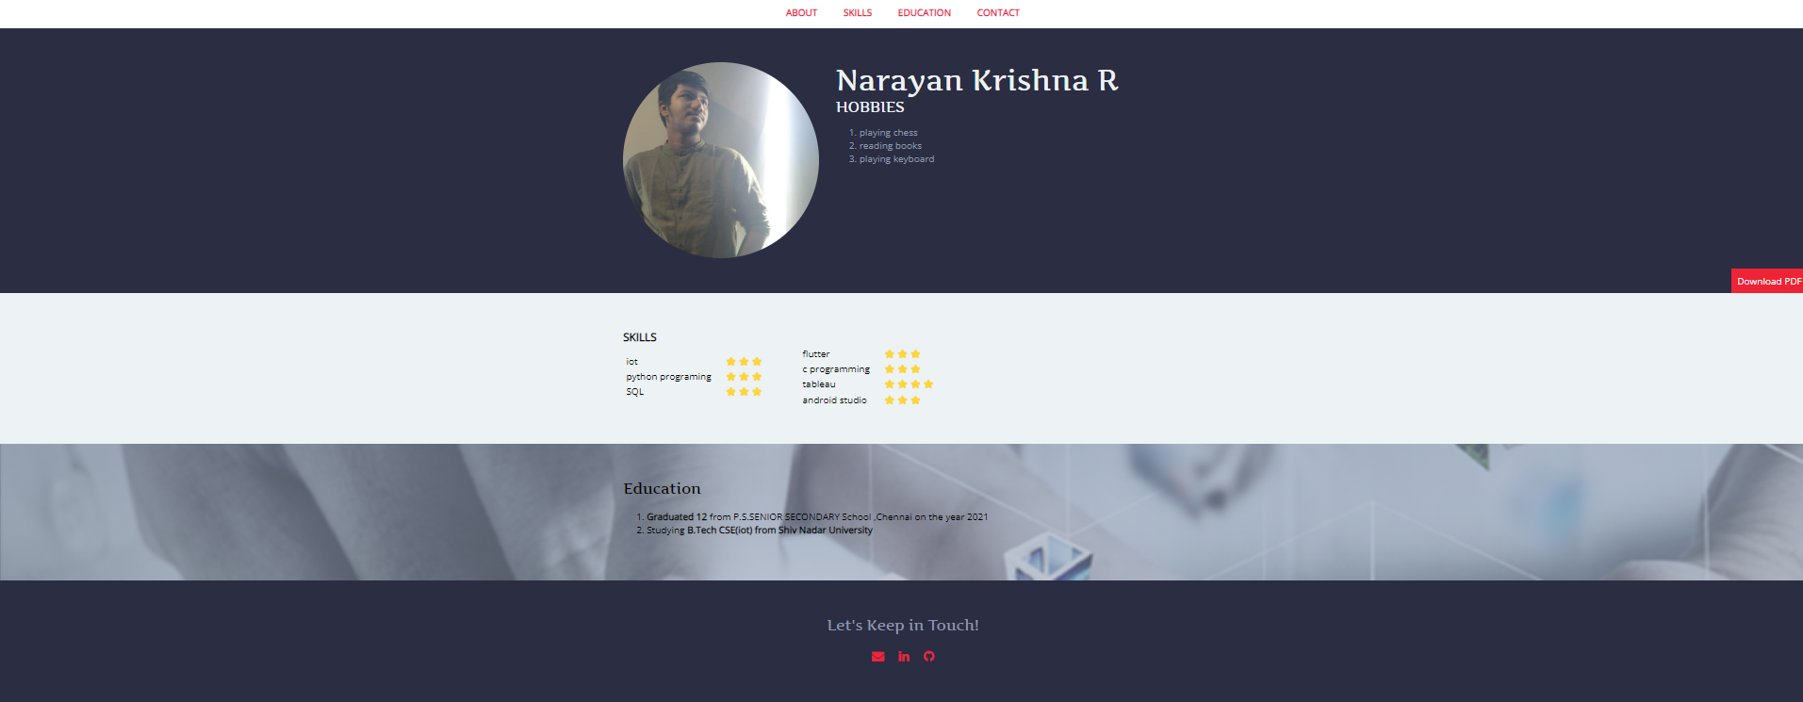

**Result**:

Therefore, we've successfully created a personal CV using HTML and external CSS