|  |  |
| --- | --- |
| **Ex. No: 5** | **React App Development** |
| **22.08.2023** |

**Aim:**

To create an app using React with Components, Rendering, and Data Sharing.

**Program:**

**EditTodoForm.js**

import React, {useState} from 'react'

export const EditTodoForm = ({editTodo, task}) => {

    const [value, setValue] = useState(task.task);

    const handleSubmit = (e) => {

*// prevent default action*

        e.preventDefault();

*// edit todo*

        editTodo(value, task.id);

      };

  return (

    <form onSubmit={handleSubmit} className="TodoForm">

    <input type="text" value={value} onChange={(e) => setValue(e.target.value)} className="todo-input" placeholder='Update task' />

    <button type="submit" className='todo-btn'>Add Task</button>

  </form>

  )

}

**Todo.js**

import React from 'react'

import { FontAwesomeIcon } from '@fortawesome/react-fontawesome'

import { faPenToSquare } from '@fortawesome/free-solid-svg-icons'

import { faTrash } from '@fortawesome/free-solid-svg-icons'

export const Todo = ({task, deleteTodo, editTodo, toggleComplete}) => {

  return (

    <div className="Todo">

        <p className={`${task.completed ? 'completed' : ""}`} onClick={() => toggleComplete(task.id)}>{task.task}</p>

        <div>

        <FontAwesomeIcon icon={faPenToSquare} onClick={() => editTodo(task.id)} />

        <FontAwesomeIcon icon={faTrash} onClick={() => deleteTodo(task.id)} />

        </div>

    </div>

)

}

**TodoForm.js**

**Todo.js**

import React, {useState} from 'react'

export const TodoForm = ({addTodo}) => {

    const [value, setValue] = useState('');

    const handleSubmit = (e) => {

*// prevent default action*

        e.preventDefault();

        if (value) {

*// add todo*

          addTodo(value);

*// clear form after submission*

          setValue('');

        }

      };

  return (

    <form onSubmit={handleSubmit} className="TodoForm">

    <input type="text" value={value} onChange={(e) => setValue(e.target.value)} className="todo-input" placeholder='What is the task today?' />

    <button type="submit" className='todo-btn'>Add Task</button>

  </form>

  )

}

**EditTodoForm.js**

import React, {useState} from 'react'

export const EditTodoForm = ({editTodo, task}) => {

    const [value, setValue] = useState(task.task);

    const handleSubmit = (e) => {

*// prevent default action*

        e.preventDefault();

*// edit todo*

        editTodo(value, task.id);

      };

  return (

    <form onSubmit={handleSubmit} className="TodoForm">

    <input type="text" value={value} onChange={(e) => setValue(e.target.value)} className="todo-input" placeholder='Update task' />

    <button type="submit" className='todo-btn'>Add Task</button>

  </form>

  )

}

**App.css**

@import url('https://fonts.googleapis.com/css2?family=Poppins&display=swap');

* {

  font-family: 'Poppins', sans-serif;

  margin: 0;

  padding: 0;

  box-sizing: border-box;

}

body {

  background: #8758ff;

  display: flex;

  justify-content: center;

  align-items: center;

}

.App {

  text-align: center;

}

h1 {

  color: #fff;

  margin-bottom: 0.5rem;

  font-size: 1.75rem;

}

.TodoWrapper {

  background: #1A1A40;

  margin-top: 5rem;

  padding: 2rem;

  border-radius: 5px;

}

.TodoForm {

  width: 100%;

  margin-bottom: 1rem;

}

.todo-input {

  outline: none;

  background: none;

  border: 1px solid #8758ff;

  padding: 0.5rem 1rem;

  margin-top: 1rem;

  margin-bottom: 2rem;

  width: 300px;

  color: #fff;

}

.todo-input::placeholder {

  color: #ffffff4d;

}

.todo-btn {

  background: #8758ff;

  color: #fff;

  border: none;

  padding: 0.55rem;

  cursor: pointer;

}

.Todo {

  display: flex;

  justify-content: space-between;

  align-items: center;

  background: #8758ff;

  color: #fff;

  padding: 0.75rem 1rem;

  border-radius: 5px;

  margin-bottom: 1rem;

  cursor: pointer;

}

.fa-trash {

  margin-left: 0.75rem;

}

.completed {

  color: #c5aeff;

  text-decoration: line-through;

}

**App.js**

import './App.css';

import { TodoWrapper } from './components/TodoWrapper';

function App() {

  return (

    <div className="App">

      <TodoWrapper  />

    </div>

  );

}

export default App;

**index.js**

import React from "react";

import ReactDOM from "react-dom/client";

import App from "./App";

const root = ReactDOM.createRoot(document.getElementById("root"));

root.render(

  <React.StrictMode>

    <App />

  </React.StrictMode>

);

**Output:**

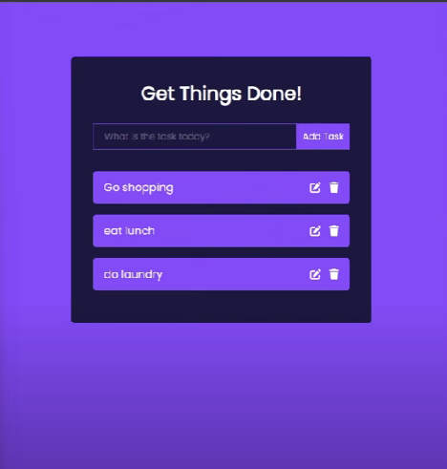

**Result:**

Therefore, we've successfully an app using React with Components, Rendering, and Data Sharing.