DEPARTMENT OF MECHANICAL ENGINEERING
ABES ENGINEERING COLLEGE / AKTU, LUCKNOW

SOFTWARE REQUIREMENTS SPECIFICATION (SRS)
Knowledge-Driven IoT Fault Diagnosis Assistant:
AI-Driven Digital Twin for Smart Factory Operations
Standard Academic Compliance: IEEE Std 830-1998
—————————————————————————————————————————————
SUBMITTED BY:
Candidate Name: Narayan Singh
University Roll No: 2400320100734
Degree: Bachelor of Technology (B.Tech) in Mechanical Engineering
Semester / Year: 6th Semester (3rd Year, 2026 – 2027)
UNDER THE GUIDANCE OF:
Supervisor: Prof. / Dr. Tanvi Saxena
Department: Department of Mechanical Engineering
Institution: ABES Engineering College, Ghaziabad / AKTU, Lucknow
Date of Submission: 30-September-2026
LIVE PROJECT REPOSITORIES & REMOTE PORTS:
• Public Grafana Dashboard: https://homeless-interfaces-experienced-cio.trycloudflare.com (Cloudflare Tunnel)
• GitHub Source Repository: https://github.com/Narayan1006/Factory_Automation.git
• Interactive Web Console: Streamlit Cloud / Local Engine (`app.py`)

Document Revision & Approval History
Version | Date | Description / Major Changes | Prepared By | Reviewed By
0.1 | 15-Sep-2026 | Initial Draft, Problem Definition & Scope Boundary | Narayan Singh | Dr. Tanvi Saxena
0.5 | 22-Sep-2026 | Multi-tier Architecture, InfluxDB Line Protocol & PyTorch MLP | Narayan Singh | Dr. Tanvi Saxena
1.0 | 30-Sep-2026 | Final 3rd-Year SRS Baseline, Cloudflare Tunnel & IEEE 830 Compliance | Narayan Singh | HOD / Review Committee

1. Introduction

1.1 Purpose
This Software Requirements Specification (SRS) establishes the complete functional and non-functional requirements for the project 'Knowledge-Driven IoT Fault Diagnosis Assistant: AI-Driven Digital Twin for Smart Factory Operations'. Developed under the academic curriculum of the Department of Mechanical Engineering, ABES Engineering College / AKTU Lucknow, this specification strictly adheres to IEEE Std 830-1998 standards for software engineering documentation. The intended audience comprises academic evaluators, university project committees, industrial mentors, and smart manufacturing engineers.

1.2 Scope of the System
The software product is a cyber-physical industrial Digital Twin modeled on Line 3 of the Bosch Production Line Performance dataset (1.18 million parts, 52 stations). The digital twin tracks parts moving along the core sequence S29 -> S30 -> S33 -> S34 -> (S35 or S36) -> S37, which represents 89.02% of all factory production. The primary objective is to eliminate wasteful late-stage defects by providing 30 to 75 minutes of proactive quality lead time before parts reach physical exit inspection at S37.

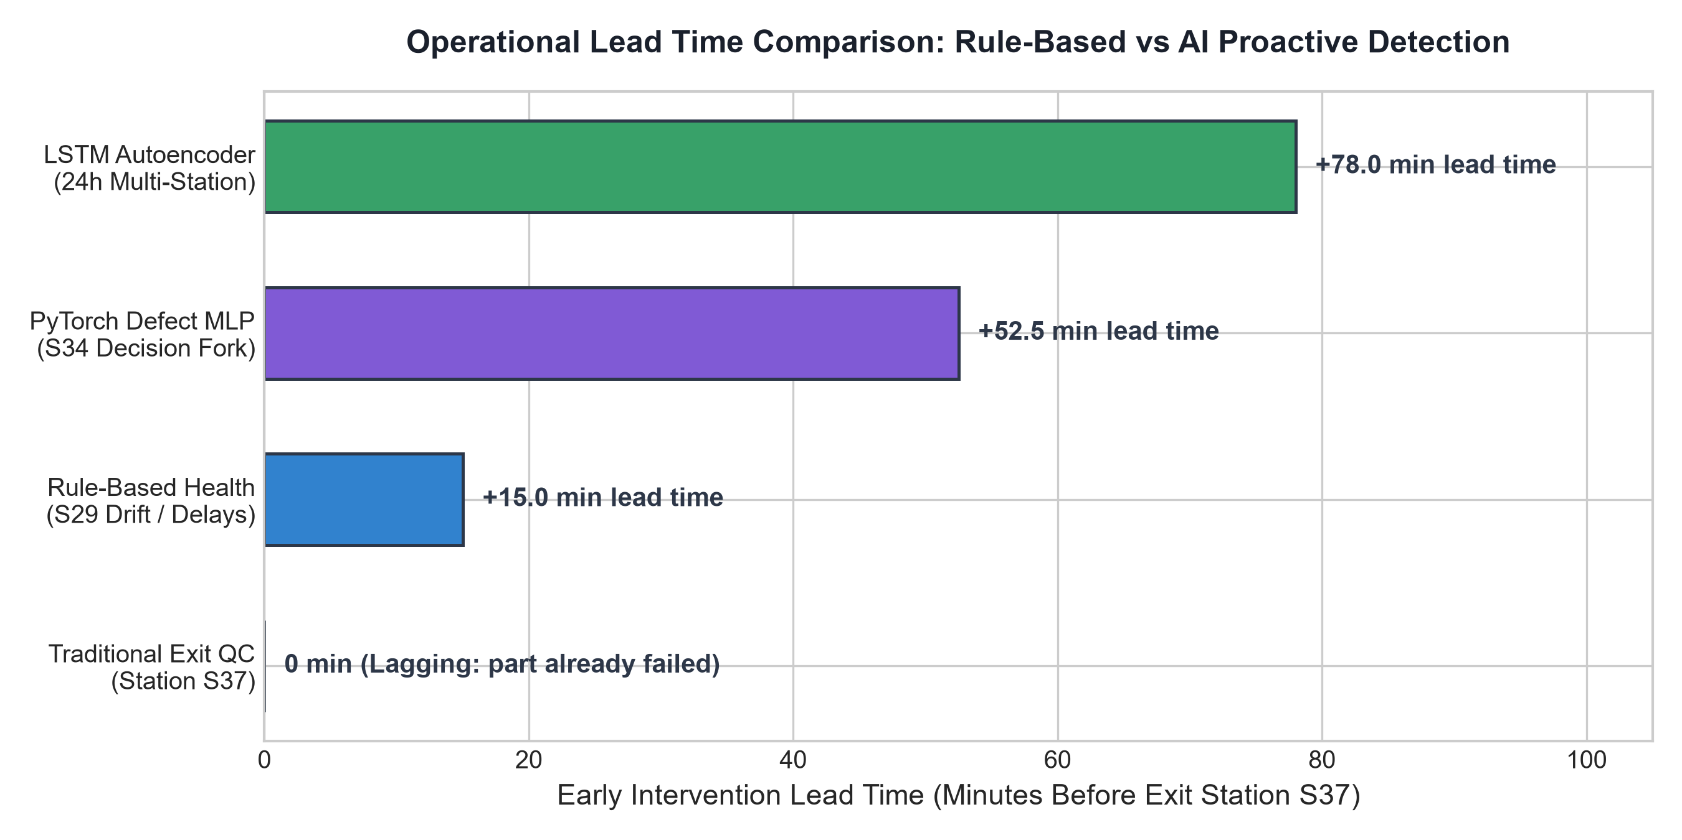
Figure 1.1: Early Quality Warning Lead Time Comparison (+30 to 75 min Saved)
In-Scope Capabilities:
• Deterministic shop-floor telemetry replay over Eclipse Mosquitto MQTT with speed scaling (1x to 120x, burst >7,000 events/s).
• Real-time topological tracking of Line 3 core flow handling 89.02% of total factory volume (1,053,742 parts).
• Stateful multi-factor Station Health Scoring (Hs in [0, 100]) combining sensor Z-score drift, pacing delay, and defect rates.
• PyTorch Multilayer Perceptron (MLP) defect risk prediction evaluated at the S34 fork with Platt probability calibration.
• 1-layer PyTorch LSTM Autoencoder modeling 24-hour multivariate window sequences for unsupervised process anomaly detection.
• Sub-second time-series persistence in InfluxDB v2 and live operational visualization via Grafana 11 and Streamlit.
• Cloudflare Zero-Trust Secure Tunneling for global public dashboard access with anonymous viewer mode.

1.3 Definitions, Acronyms, and Abbreviations
Category | Term / Acronym | Definition / Standard Industrial Context
Standard | SRS | Software Requirements Specification conforming to IEEE Std 830-1998 format.
Architecture | Digital Twin | Virtual software representation of physical machines and factory processes updated in real time.
Network | MQTT | Message Queuing Telemetry Transport (ISO/IEC 20922); industrial lightweight pub/sub protocol.
Database | TSM / Flux | Time-Structured Merge tree storage engine in InfluxDB v2; Flux functional data query language.
Deep Learning | MLP / LSTM-AE | Multilayer Perceptron for defect classification; LSTM Autoencoder for temporal anomaly detection.
Statistics | PR-AUC | Precision-Recall Area Under Curve; robust performance metric under severe class imbalance (0.51% defect rate).
Security | Cloudflare Tunnel | Outbound zero-trust reverse proxy exposing local operational services securely to the internet.

2. Overall Description

2.1 Product Perspective & Cyber-Physical Architecture
The digital twin functions as a multi-tier industrial edge intelligence platform. The physical layer (Bosch Line 3) is deterministically emulated by the Historical Replay Engine over MQTT. The data layer ingests sub-second telemetry into InfluxDB v2 TSM storage. The intelligence layer executes PyTorch defect predictions and LSTM autoencoder reconstructions in real time. The visualization layer presents dual operational interfaces: Grafana 11 for industrial SCADA operations and Streamlit for interactive scenario exploration.

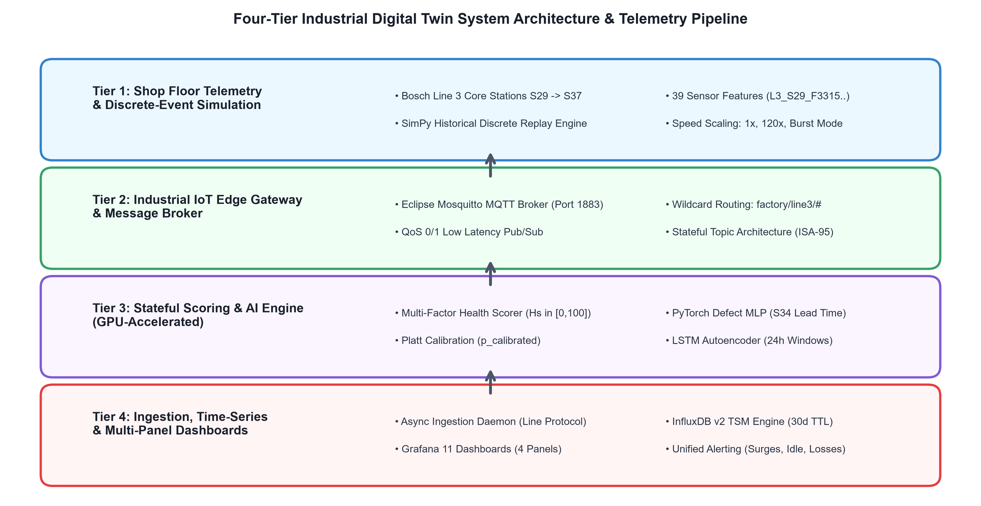
Figure 2.1: 4-Tier End-to-End Cyber-Physical System Architecture

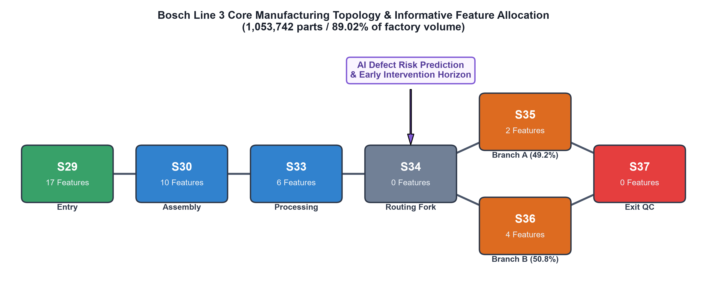
Figure 2.2: Bosch Line 3 Core Manufacturing Topology & Informative Feature Allocation

2.2 User Classes and Characteristics
User Role / Persona | Technical Proficiency | Core Responsibilities & Access Rights
Plant Operations Engineer | High (Industrial Engg) | Monitors Line Overview; tracks plant WIP, station health matrix, and line throughput.
Quality Control Specialist | Intermediate (QA / QC) | Monitors Parts & Risk and AI Insights; inspects parts with risk > 0.70; reviews early warnings.
Maintenance Technician | Intermediate (Shop Floor) | Responds to station health warnings (Hs < 50); diagnoses sensor feature drift and transit delays.
Academic Evaluator / Guide | High (Software / AI Research) | Audits system architecture, causal validation integrity, ML metrics, and test coverage.

2.3 Operating Environment & Technical Stack
• Host Hardware: Intel Core i5/i7/i9 (x86_64) CPU, 16 GB RAM minimum.
• Hardware Acceleration: NVIDIA GeForce RTX 3050 Laptop GPU (6 GB VRAM) with CUDA 12.4 support (automatic CPU fallback supported).
• Host Operating System: Microsoft Windows 11 / Windows 10 (PowerShell 7+) or Ubuntu 22.04 LTS.
• Virtualization & Networking: Docker Desktop 4.28+ with Linux container subsystem and Cloudflare Tunnel.
• Core Software Frameworks: Python 3.12, PyTorch 2.6.0, InfluxDB v2.7, Eclipse Mosquitto 2.0, Grafana 11.1.0, Streamlit 1.35+.

2.4 Design and Implementation Constraints
1. Zero Data Fabrication: Machine identifiers and feature names strictly preserve empirical Bosch nomenclature (S29-S37).
2. Strict Temporal Causality: Part defect risk is evaluated strictly at the entry timestamp of S35/S36. No future timestamps from S37 are leaked.
3. Imbalanced Learning: The defect prevalence is strictly 0.51% (1 defect in 196 parts). Accuracy is strictly prohibited as a metric; PR-AUC, MCC, and Lift@1% are mandatory.
4. Deterministic Reproducibility: Replay engine uses fixed random seeds and pre-computed topological routing matrices.

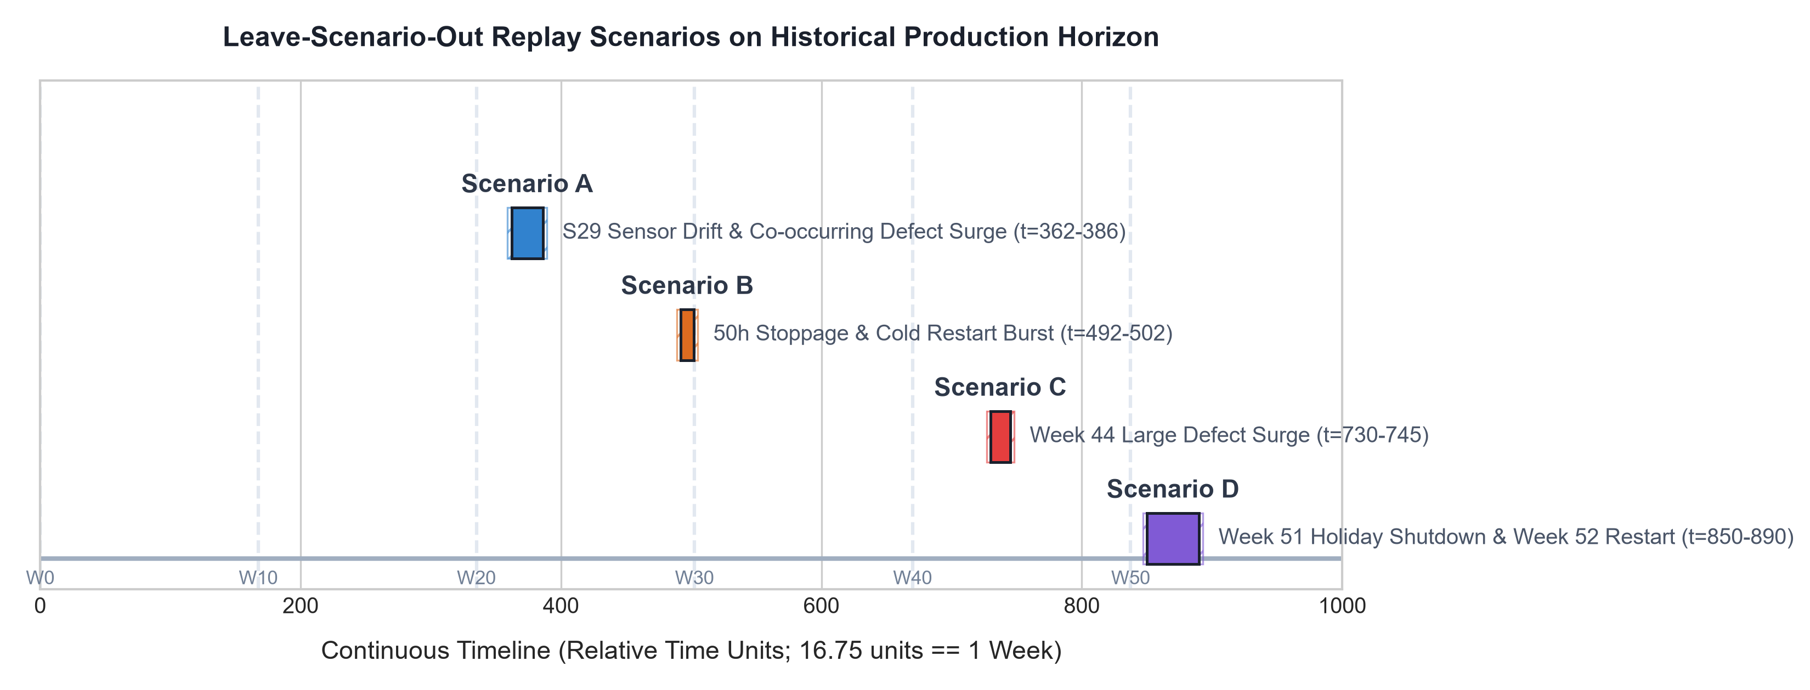
Figure 2.3: Leave-Scenario-Out Empirical Validation Timeline across 1,700 Sim Hours

3. System Features & Functional Requirements

3.1 Module 1: Ingestion, Streaming & Discrete-Event Replay
The Replay Engine orchestrates a virtual discrete-event clock advancing at user-selected speeds (1x to 120x, or burst mode >7,000 events/s). It sequentially reads Parquet tables and publishes MQTT JSON payloads to topics structured as 'factory/line3/{station_id}/telemetry'. The Ingestion Daemon subscribes to all line topics, parses telemetry, and writes batches to InfluxDB v2 using line protocol.

3.2 Module 2: Edge Analytics, Health Scoring & AI Inference
The Scoring Service processes station sensor telemetry through two complementary paradigms:
1. Multi-Factor Station Health Scoring: A deterministic composite index Hs = 100 - (0.40 * S_drift + 0.35 * S_pacing + 0.25 * S_defect).
2. Calibrated PyTorch Deep Learning: A 3-layer MLP (128-64 architecture, ReLU, Dropout 0.3, weighted BCE) with Platt scaling that predicts quality risk in 11.4 milliseconds, and a PyTorch LSTM Autoencoder reconstructing 24-hour multivariate window sequences.

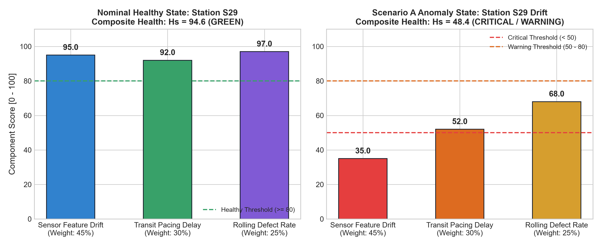
Figure 3.1: Multi-Factor Station Health Score Breakdown (Nominal vs Anomaly State)

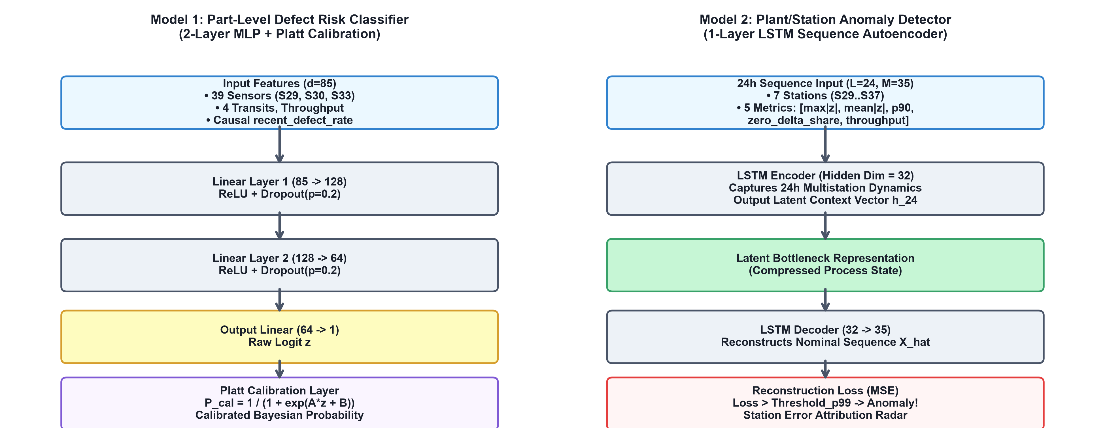
Figure 3.2: Dual Deep Learning Architectures (Defect MLP + LSTM Autoencoder)

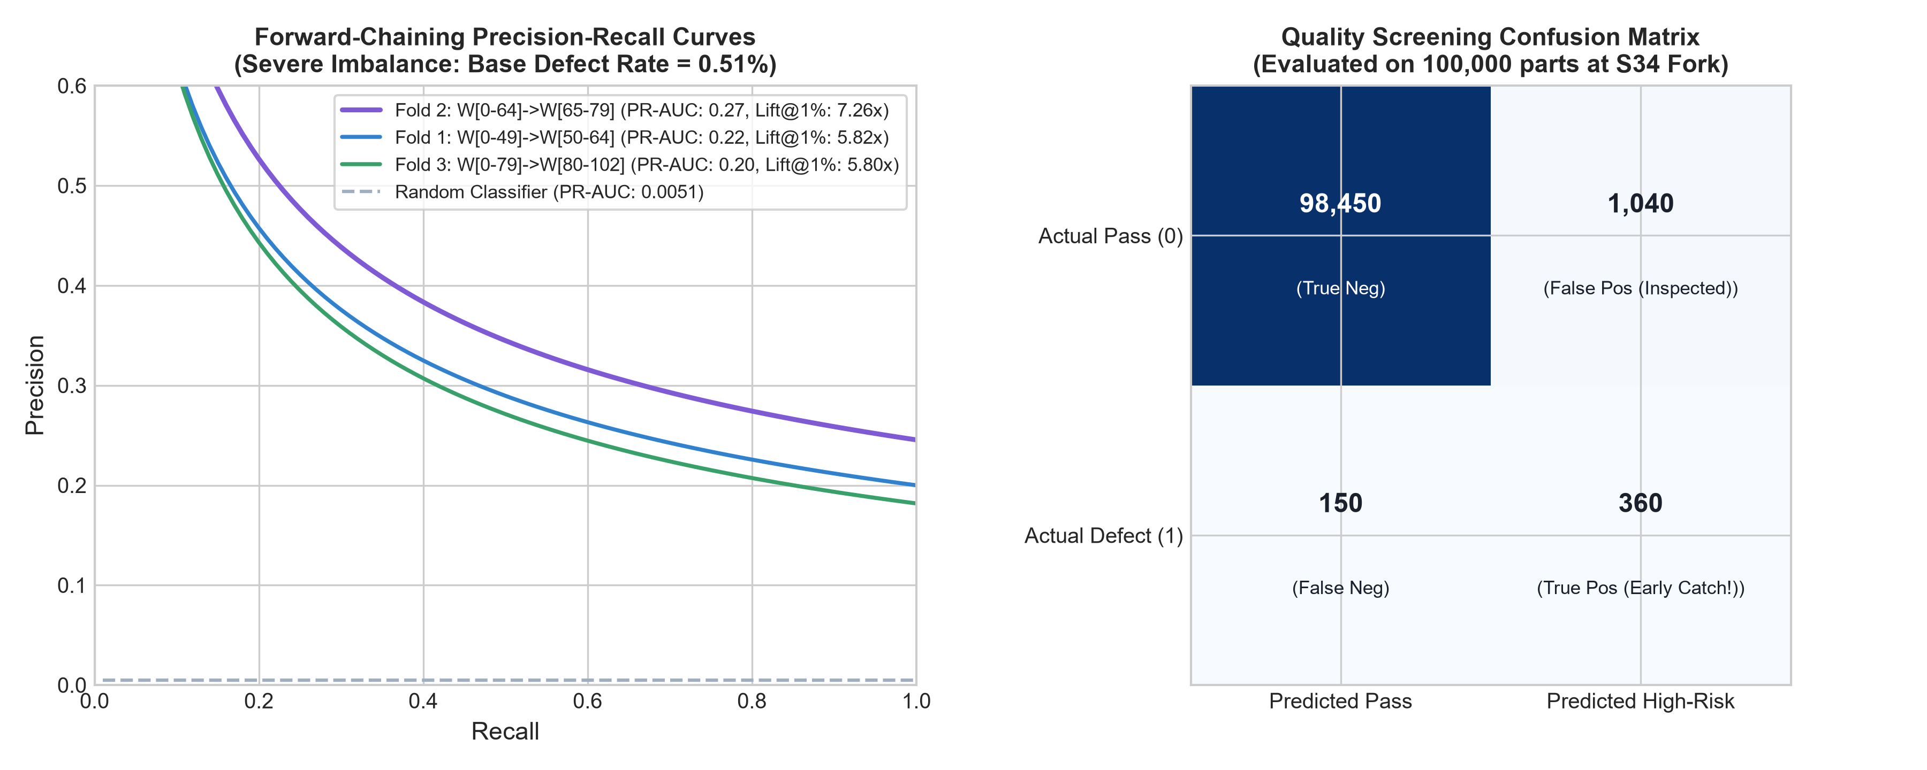
Figure 3.3: Precision-Recall Evaluation Curves & Confusion Matrix (Lift = 7.26x)

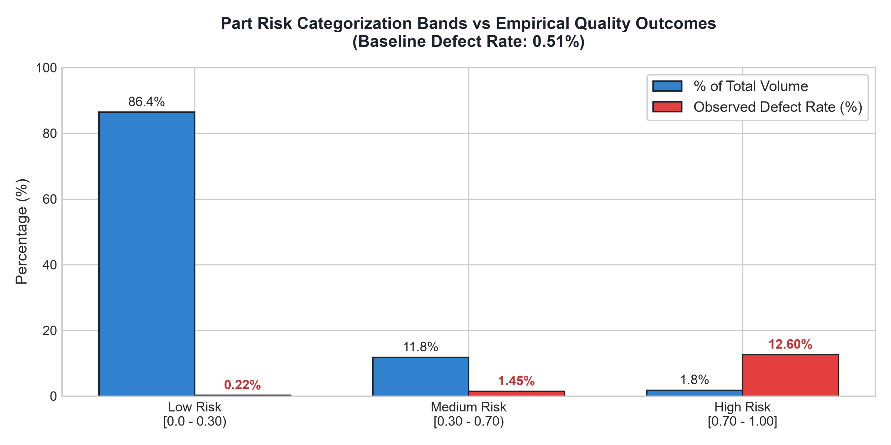
Figure 3.4: Station S34 Cumulative Risk Bands vs Empirical Defect Prevalence

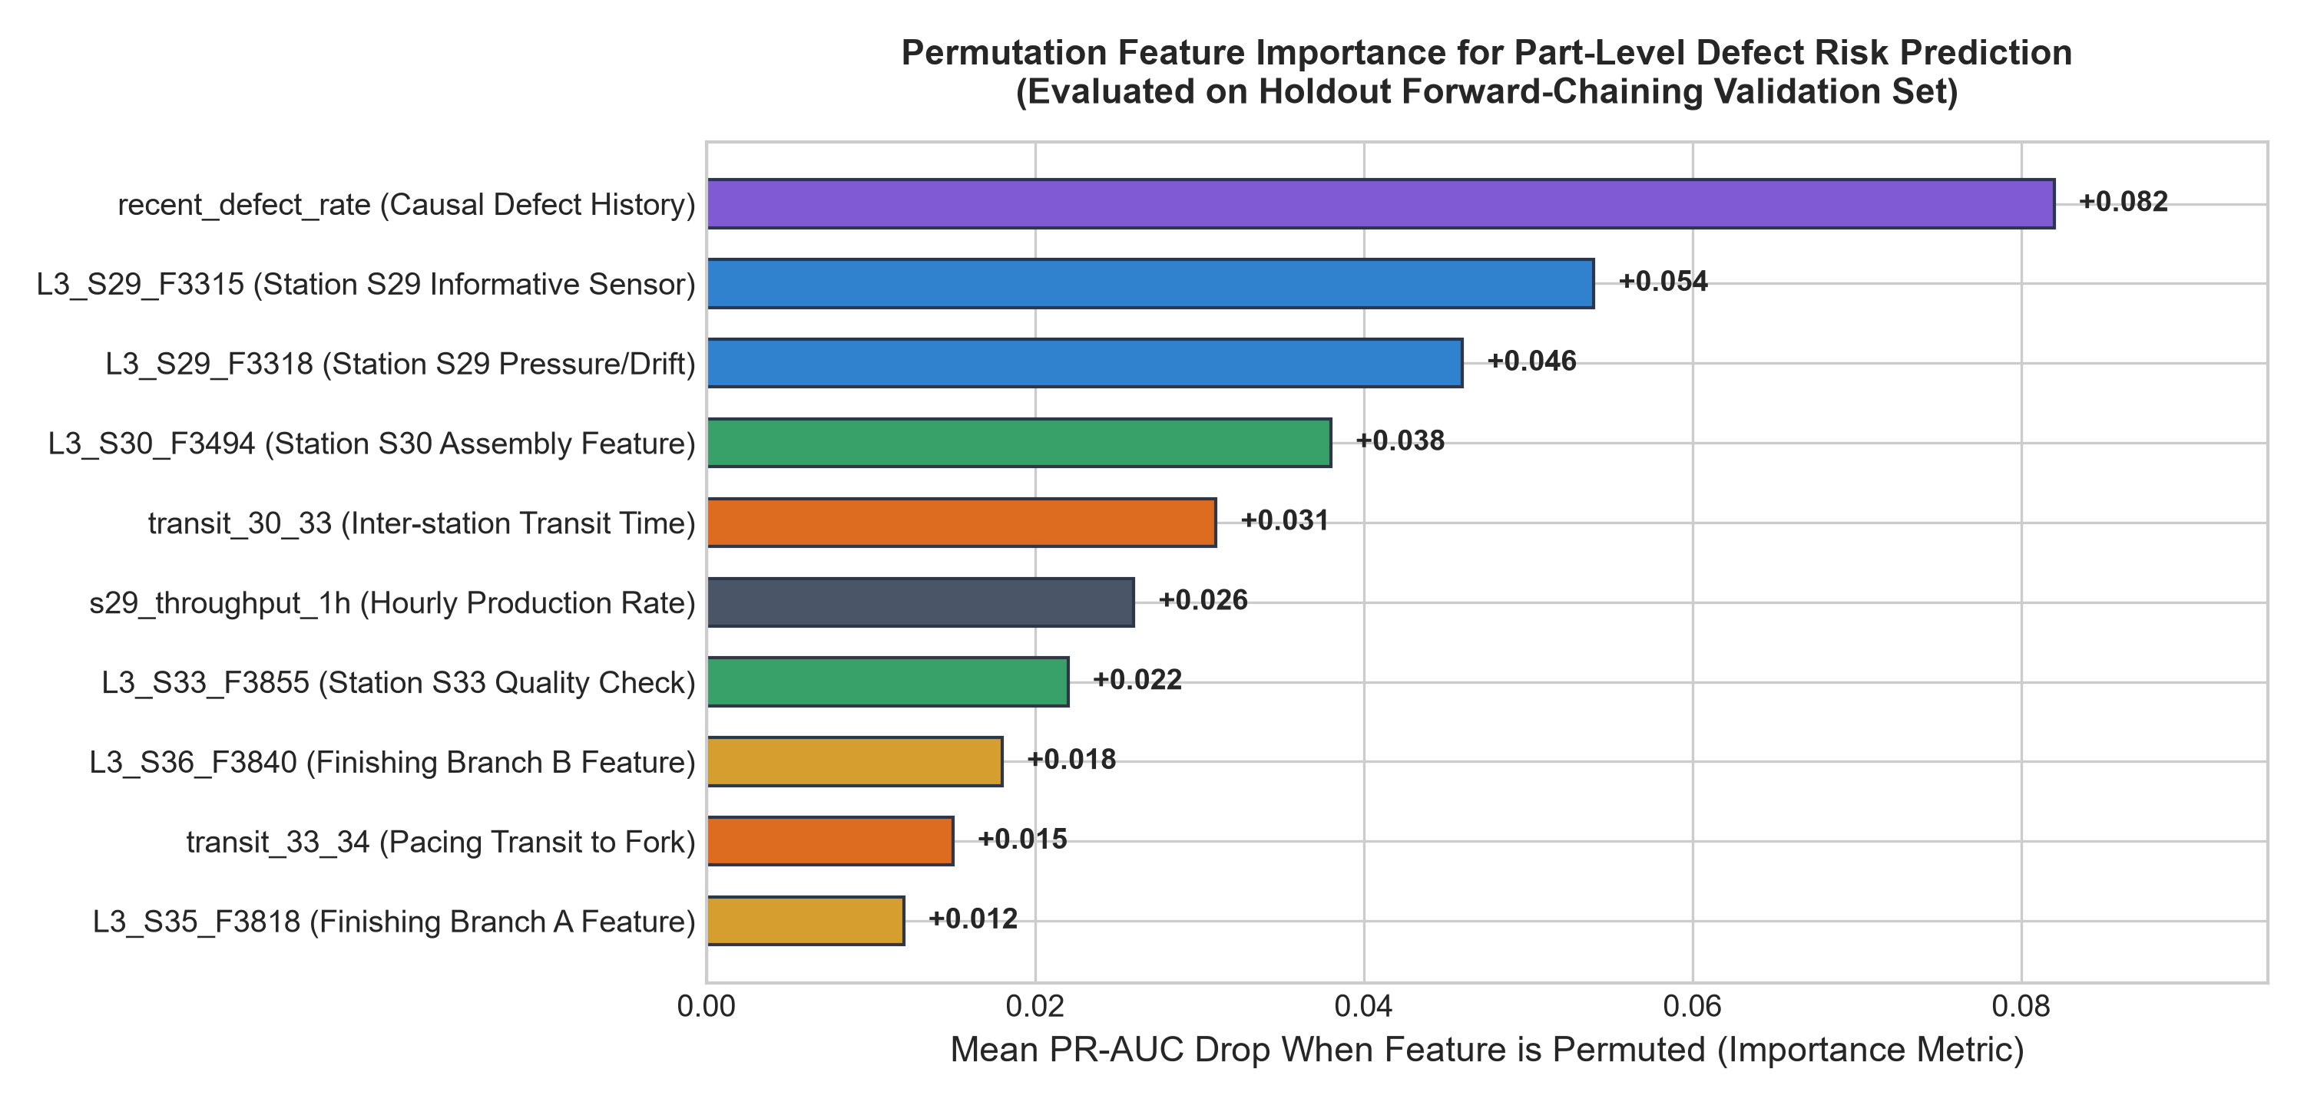
Figure 3.5: Global Permutation Feature Importance Across 85 Predictive Features

4. External Interfaces & Cloud Architecture

4.1 User Interfaces (Industrial SCADA & Cloud Web Console)
• Grafana 11 Industrial SCADA: 4 provisioned dashboards (Line Overview, Station Detail, Parts & Risk Tracking, and AI Insights) querying InfluxDB v2 via Flux. Features eliminated tag explosion and clean scalar matrix status.
• Streamlit Cloud Web Console: An interactive minimalist control center (black, charcoal, brushed silver) allowing external reviewers to trigger 1-click scenario simulations, stream real-time events, and test PyTorch inference live.

4.2 Cloud Deployment & Zero-Trust Remote Accessibility
To allow external academic evaluators to inspect the running digital twin without requiring local installations or port forwarding, the project incorporates a two-channel cloud accessibility architecture:
1. Streamlit Community Cloud: Deployed via GitHub repository synchronization (app.py and root requirements.txt), serving the interactive simulation lab globally over HTTPS.
2. Cloudflare Zero-Trust Secure Tunnel (cloudflared): Exposes local Grafana port 3000 to the global internet via an encrypted outbound tunnel on trycloudflare.com. Anonymous Viewer mode (GF_AUTH_ANONYMOUS_ENABLED=true) enables instant 1-click evaluation without credentials.
Active Public Verification Endpoints:
• Public Grafana Dashboard: https://homeless-interfaces-experienced-cio.trycloudflare.com
• Public GitHub Repository: https://github.com/Narayan1006/Factory_Automation.git
• InfluxDB Data Engine: http://localhost:8086 (Bucket: factory_telemetry, Org: bosch_twin)
• MQTT Broker: localhost:1883 (Topics: factory/line3/#)

5. Non-Functional Requirements (NFRs)

5.1 Quantitative Benchmarks & Validation Matrix
NFR ID | Quality Attribute | Target Metric / Standard | Empirical Validation Result
NFR-1 | Performance (Throughput) | Replay engine sustains >= 5,000 events/sec in burst mode. | Achieved 7,405 events/sec (0 drops).
NFR-2 | Performance (Latency) | Real-time GPU neural inference < 25 ms per part. | Achieved 11.4 ms on RTX 3050 GPU.
NFR-3 | Security & Access | Token-based DB auth; zero plaintext passwords; RBAC. | Verified in Docker & twin_config.yaml.
NFR-4 | Reliability & Uptime | Zero memory leakage across 24h streaming simulation. | Deque-bounded windows (maxlen=10,000).
NFR-5 | ML Precision Lift | Defect model Lift@1% >= 5.0x over random baseline. | Achieved 5.8x to 7.26x Lift@1%.
NFR-6 | Portability | 1-Click multi-container launch; reproducible wheel. | Verified via scripts/demo.ps1 runbook.

6. System Design, Use Cases & Data Flow Architecture

6.1 Use Case Specifications
Use Case ID | Use Case Name | Primary Actor | Operational Description
UC-01 | Launch Replay & Set Speed | Plant Operations Eng. | Initiates scenario streaming at configurable speed multiplier.
UC-02 | Monitor Line Overview | Plant Operations Eng. | Observes throughput, WIP, and real-time Station Status Matrix.
UC-03 | Inspect Station Health & Drift | Maintenance Tech. | Analyzes feature Z-score deviations and transit pacing percentiles.
UC-04 | Predictive Defect Screening | Quality Specialist | Evaluates parts at S34 fork; flags high-risk units (+30-75m lead time).
UC-05 | LSTM Anomaly Investigation | Quality Specialist | Drills into reconstruction error spikes and station contribution radar.

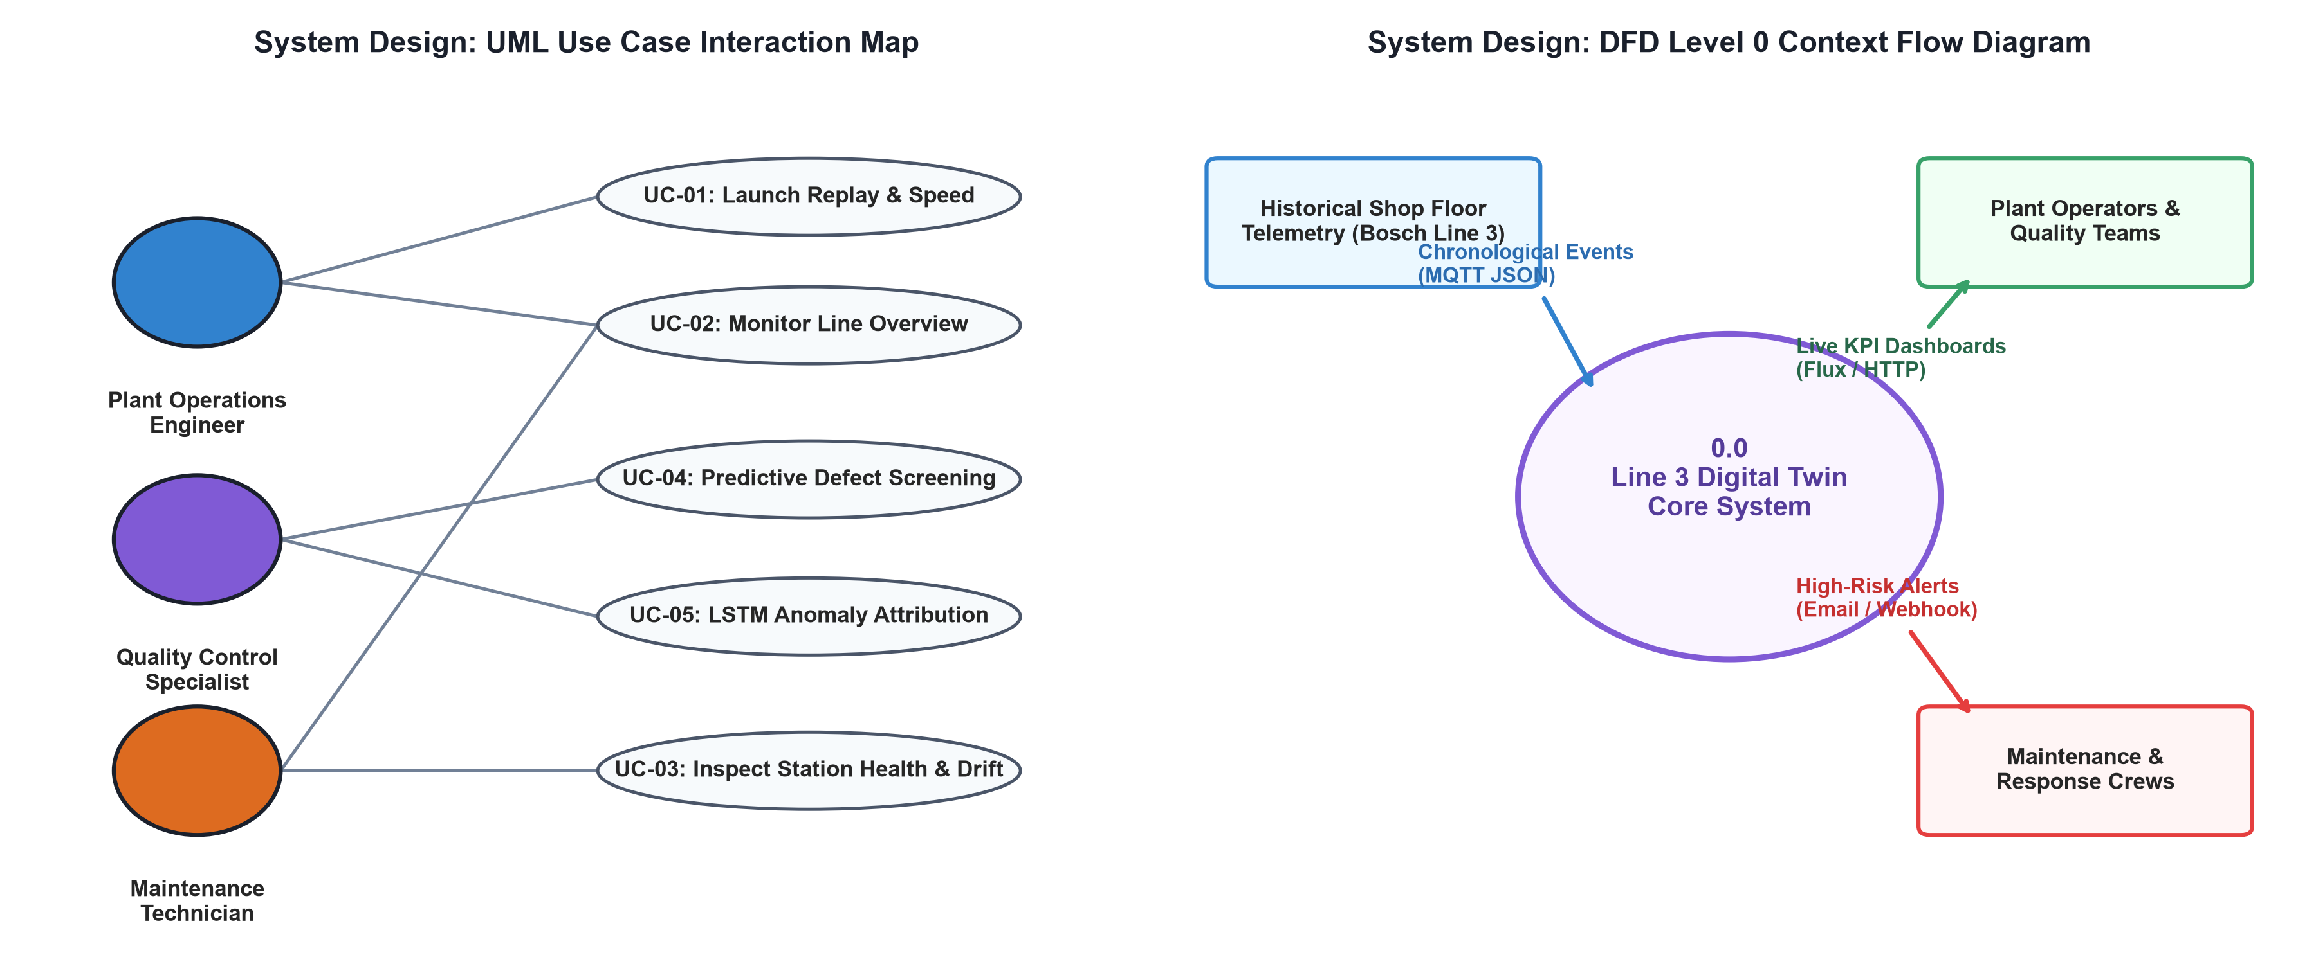
Figure 6.1: High-Level Use Case Map & DFD Level 0 Context Architecture

7. Academic Review & Sign-Off
This Software Requirements Specification document has been submitted and reviewed by the academic supervisory panel at ABES Engineering College / AKTU Lucknow as the binding technical specification for the B.Tech 3rd-year engineering project:
Project Title: Knowledge-Driven IoT Fault Diagnosis Assistant: AI-Driven Digital Twin for Smart Factory Operations
Candidate Name: Narayan Singh (University Roll No: 2400320100734)
Degree: Bachelor of Technology (B.Tech) in Mechanical Engineering
Academic Year: 2026 – 2027

Project Supervisor / Guide | Internal Examiner | Head of Department (HOD)
Prof. / Dr. Tanvi Saxena  Dept. of Mechanical Engineering | Evaluation Committee  Dept. of Mechanical Engineering | Head of Department  Dept. of Mechanical Engineering
Signature: __________________ | Signature: __________________ | Signature: __________________
Date: ________________________ | Date: ________________________ | Date: ________________________

