(006CP2744): Day 23 - 17th Aug 2026

🏗 Brownfield vs. Greenfield

1. What distinguishes a Brownfield application from a Greenfield one in terms of constraints and opportunities?

Answer:
A Brownfield application is an existing system that must be modified while preserving current functionality, integrations, data, and business processes. It has constraints such as legacy technology, technical debt, and existing dependencies. A Greenfield application is built from scratch with no legacy constraints, allowing teams to use modern architectures, technologies, and development practices freely.

2. Why might modernization of a Brownfield system be more complex than building a Greenfield solution?

Answer:
Brownfield modernization is more complex because existing code, data, integrations, business rules, and dependencies must continue working during the transition. Organizations must minimize downtime and disruption, making planning and execution more challenging than creating a new application from scratch.

💼 Business Drivers

3. How do business drivers such as cost reduction, agility, and compliance influence migration decisions?

Answer:
Business drivers provide the justification for migration. Cost reduction encourages moving to more efficient platforms, agility enables faster delivery of new features, and compliance ensures adherence to regulatory requirements. These factors help determine migration priorities, scope, and investment decisions.

4. Can modernization be justified purely on technical grounds without business drivers? Why or why not?

Answer:
No. Modernization should align with business objectives. While technical improvements are important, organizations invest in modernization primarily to achieve business outcomes such as improved efficiency, customer experience, revenue growth, risk reduction, or regulatory compliance.

📊 Application Portfolio Assessment

5. What is the purpose of conducting an application portfolio assessment before migration?

Answer:
The purpose is to understand the current application landscape, identify dependencies, evaluate business value, assess technical health, and determine the best modernization strategy for each application.

6. How does inventorying applications and dependencies reduce risk during modernization?

Answer:
Creating a complete inventory helps identify interconnections, data flows, and dependencies. This prevents unexpected failures, service disruptions, and compatibility issues during migration.

🔍 Discovery & Mapping

7. Why is mapping integration points critical when planning migration?

Answer:
Integration points connect applications, databases, and external systems. Mapping them ensures these interactions continue functioning after migration and helps avoid service interruptions.

8. How can overlooked dependencies derail a migration project?

Answer:
Missed dependencies can cause application failures, data loss, broken integrations, performance issues, delays, and increased costs, potentially impacting business operations.

⚖️ Technical Debt & Stack Evaluation

9. How does technical debt impact modernization strategy selection?

Answer:
High technical debt may require refactoring or rearchitecting instead of simple migration. The greater the technical debt, the more extensive modernization efforts may be needed to improve maintainability and scalability.

10. What role does evaluating runtime dependencies play in migration planning?

Answer:
Evaluating runtime dependencies helps identify required libraries, middleware, services, and system components. This ensures the target environment supports all application functions after migration.

🗄 Database & Infrastructure

11. What are the main risks in database migration, and how can they be mitigated?

Answer:
Main risks include data loss, corruption, downtime, performance degradation, and compatibility issues. These risks can be mitigated through thorough testing, backups, validation procedures, phased migration, and rollback plans.

12. How does hosting infrastructure assessment influence cloud-readiness decisions?

Answer:
Infrastructure assessment identifies hardware requirements, resource utilization, network dependencies, and compatibility issues. This helps determine whether an application can move directly to the cloud or requires modification first.

🔐 Security & Compliance

13. Why must security and compliance be reassessed during migration, even if the application was previously compliant?

Answer:
The new environment may introduce different risks, controls, regulations, and security requirements. Reassessment ensures continued compliance and protection of sensitive data in the target environment.

14. How does modernization affect risk posture?

Answer:
Modernization can reduce risks by improving security, reliability, and supportability. However, it may also introduce temporary migration risks that must be managed through proper planning and governance.

🔄 Migration Strategies (6 R’s)

15. How do the 6 R's of migration provide a framework for decision-making?

Answer:
The 6 R's (Rehost, Replatform, Refactor, Repurchase, Retire, Retain) provide structured options for evaluating each application and selecting the most suitable migration approach based on business and technical requirements.

16. In what scenario would refactoring be preferable to rehosting?

Answer:
Refactoring is preferable when significant code changes are needed to improve scalability, performance, maintainability, or cloud-native capabilities that cannot be achieved through simple lift-and-shift migration.

📈 Cost & Effort Analysis

17. How does TCO (Total Cost of Ownership) differ from upfront migration cost?

Answer:
Upfront migration cost includes expenses directly associated with the migration project. TCO includes all long-term costs such as infrastructure, licensing, operations, maintenance, support, training, and future upgrades.

18. Why is effort, complexity, and risk scoring essential for prioritization?

Answer:
These scores help organizations identify quick wins, allocate resources effectively, manage risks, and prioritize applications that deliver the highest value with acceptable effort and risk levels.

🗂 Prioritization & Planning

19. What factors determine wave planning for application migration?

Answer:
Wave planning is determined by business priority, application complexity, dependency relationships, resource availability, risk levels, and migration readiness.

20. How does prioritization balance business urgency with technical feasibility?

Answer:
Prioritization ensures critical business needs are addressed first while considering technical readiness, available resources, complexity, and risk to maximize migration success.

🏛 Target-State Architecture & Patterns

21. How does defining a target-state architecture guide modernization choices?

Answer:
Target-state architecture defines the future vision for applications, infrastructure, security, and integrations. It guides decisions about technologies, platforms, and migration strategies that support long-term business goals.

22. Compare the Strangler Fig pattern with the Anti-Corruption Layer in terms of risk mitigation.

Answer:
The Strangler Fig pattern gradually replaces legacy functionality with new services, reducing migration risk through incremental change. The Anti-Corruption Layer protects new systems from legacy system complexities by translating communication between old and new components, minimizing integration risk.

📦 Containerization & Cloud-Readiness

23. What are the key indicators that an application is cloud-ready?

Answer:
Key indicators include stateless design, scalable architecture, minimal hardware dependencies, automated deployment capability, externalized configuration, API-based integration, and support for cloud-native services.

24. How does containerization support modernization goals?

Answer:
Containerization packages applications and dependencies into portable units, enabling consistency across environments, improved scalability, faster deployments, easier management, and better use of cloud resources.

📏 Success Metrics & Roadmap

25. Why are KPIs critical in measuring migration success?

Answer:
KPIs provide measurable indicators of performance, cost savings, availability, security, user satisfaction, and business outcomes. They help determine whether migration objectives have been achieved.

26. How does a migration roadmap align technical execution with business case justification?

Answer:
A migration roadmap defines timelines, milestones, resources, and expected outcomes. It ensures technical activities directly support business objectives, budget expectations, and strategic goals.

🛠 Tools & Documentation

27. What role do assessment tools play in reducing subjectivity during planning?

Answer:
Assessment tools provide standardized data collection, automated analysis, dependency mapping, cost estimation, and objective scoring. This reduces personal bias and improves decision accuracy during migration planning.

28. Why is documenting findings essential for stakeholder buy-in?

Answer:
Documentation provides transparency, supports informed decision-making, communicates risks and benefits, establishes accountability, and helps stakeholders understand and approve modernization plans with confidence.

REDIS - TASK 1
What is Redis used for? Why?

What is Redis?
Redis (Remote Dictionary Server) is an in-memory data store used as a:
1. Cache
2. Database
3. Message Broker
4. Session Store

Why is Redis used?
Redis stores data in RAM (memory) instead of disk, which makes data access extremely fast (sub-millisecond response time). 【1-85ce04】【2-3f3e3e】

Common Uses of Redis:
1. Caching
- Store frequently accessed data.
- Reduces database load.
- Improves application speed.

2. Session Management
- Stores user login sessions.
- Fast authentication and user tracking.

3. Real-Time Analytics
- Page views
- Click tracking
- Counters

4. Message Queues
- Supports Pub/Sub messaging.
- Enables communication between applications.

Why Companies Use Redis?
- Extremely fast
- High performance
- Reduces database workload
- Handles millions of operations per second
- Supports multiple data structures (Strings, Lists, Sets, Hashes, etc.) 【1-85ce04】【2-3f3e3e】

REDIS - TASK 2
Explain Redis Architecture with Diagram

Basic Redis Architecture

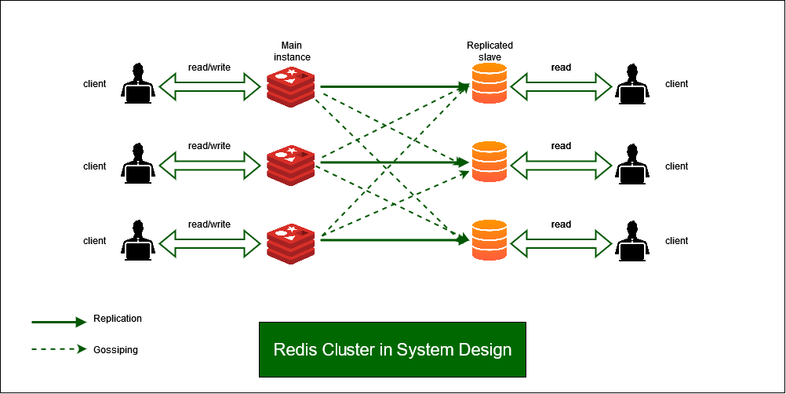

Store Data
in Redis

Working:
1. Client sends request.
2. Application checks Redis.
3. If data exists (Cache Hit):
-> Redis returns data immediately.
4. If data does not exist (Cache Miss):
-> Database is queried.
-> Data is returned.
-> Redis stores the data for future requests. 【2-3f3e3e】

Master:
- Handles read/write operations.

Replicas:
- Receive copied data from Master.
- Used for read scaling and failover.

If Master fails:
- Redis Sentinel can promote a replica as the new Master. 【1-85ce04】

REDIS - TASK 3
Advantages and Disadvantages of Redis

Advantages of Redis

1. Very Fast
- Data stored in memory (RAM).
- Response time is usually less than a millisecond.

2. High Performance
- Can handle millions of requests per second.

3. Supports Multiple Data Types
- Strings
- Hashes
- Lists
- Sets
- Sorted Sets
- Streams

4. Reduces Database Load
- Frequently used data is served from cache.

5. High Availability
- Supports Replication and Sentinel.

6. Persistence Support
- Data can be saved to disk using RDB and AOF.

7. Easy Scalability
- Redis Cluster supports horizontal scaling.

Disadvantages of Redis

1. Memory Cost
- RAM is more expensive than disk storage.

2. Limited by Memory Size
- Very large datasets may require large RAM.

3. Not Ideal for Complex Relational Data
- No foreign keys or table relationships.

4. Limited SQL Support
- Does not use traditional SQL queries.

Task 4:
Install docker in your system
Steps
- Download from https://www.docker.com/products/docker-desktop
- Run installer
- Enable hyper-v
- Restart the system
- Check docker version in cmd
      - docker –version
- Done installed docker ..

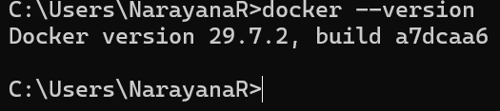

Task 5:
Open docker from the start menu
Now check
Docker version
It should show
Client and server version information like the below ss

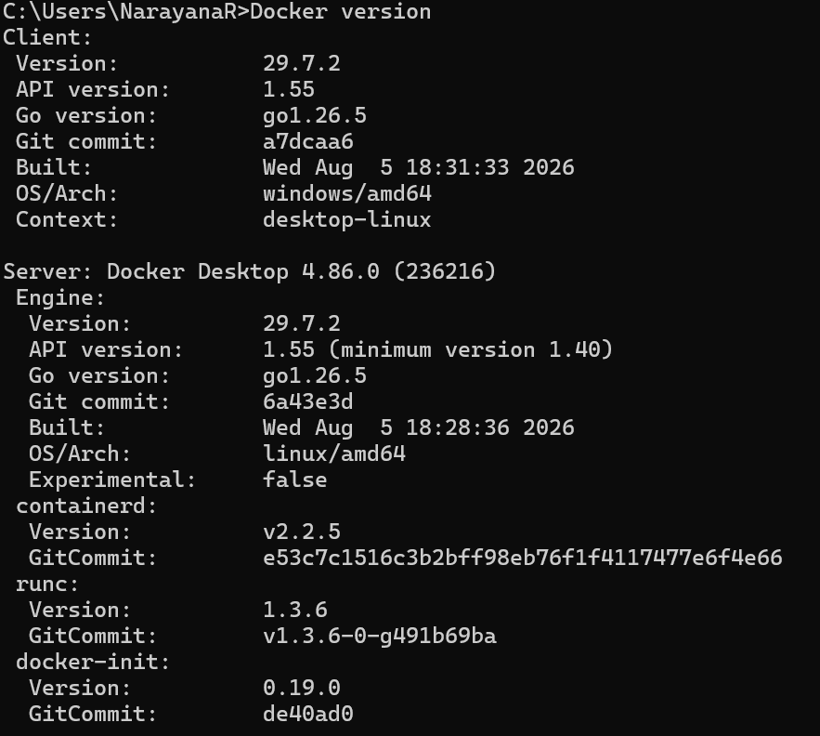

Use command to pull image
docker pull redis
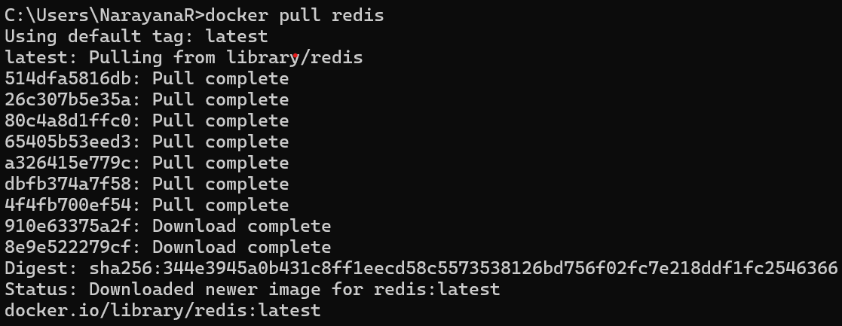

Task 6:
Now run redis container

docker run --name myredis -p 6379:6379 -d redis
Myredis is the name of the container i m creating you can give ur own
-p 6379:6379 this will map the port no to th local host.
-d redis means we RE RUNNING IN detached mode..

Task 7:
Now will test the connection
docker exec -it myredis redis-cli

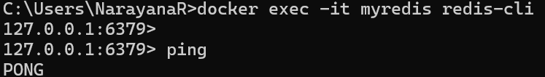

Task 8:
Type Ping
The output should be pong
Pong



Task 9:
127.0.0.1:6379> set mykey1 "hello Prasunamba from redis"
OK
127.0.0.1:6379> get mykey1
"hello Prasunamba from redis"
127.0.0.1:6379>
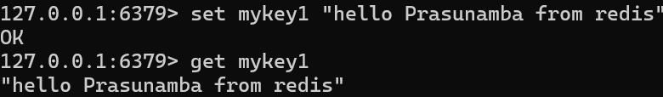

Task 10:
127.0.0.1:6379> incr counter
(integer) 1
127.0.0.1:6379> get counter
"1"

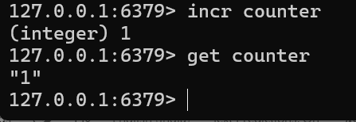

Task 11:
To run hashset you need to open redis - cli
How to do that
- Use command you will see redis if its working or else it will show exit status
  - docker ps -a

Now open another command promt
And use
HSET user:101 name "Prasunamba" email "Prasunamba.mk@gmail.com"
And get using
hgetall user:101

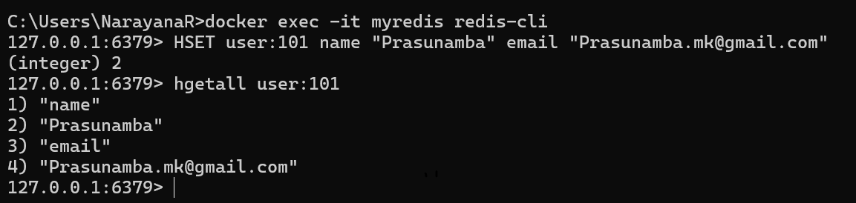

Task 12:
List of ordered collections
LPUSH tasks "Task1"
LPUSH tasks "Task2"
LRANGE tasks 0 -1

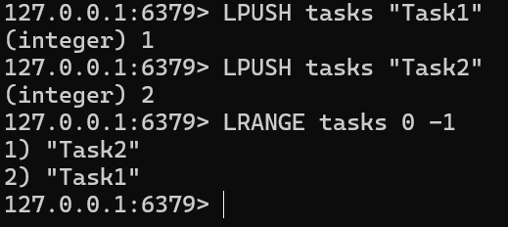

Task 13:
Sets (unique value)
SADD customrs1 "Prasunamba" "Meher" "K"
SMEMBERS customrs1
SISMEMBER customrs1 "K" (sismember is checking if the value exists or not.

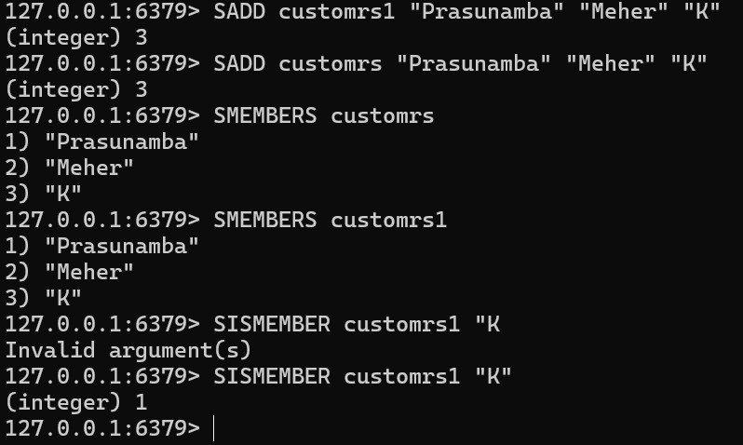

Task 14:
In the same way can you check sorted set … zsets .. what are they ?why they are used ? how to use ? cn you try ?
Like zadd leaderboard 100 “Prasunamba”

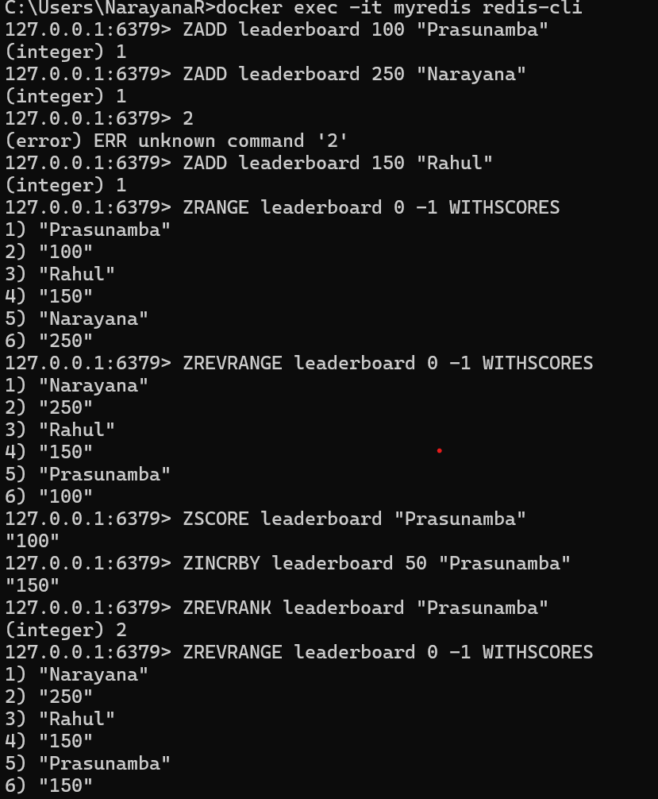
Task 15:
127.0.0.1:6379> set user:1 "Prasunamba"
OK
127.0.0.1:6379> exists user:1
(integer) 1
127.0.0.1:6379> del user:1
(integer) 1
127.0.0.1:6379> keys *
1) "user:101"
2) "customrs"
3) "user"
4) "tasks"
5) "customrs1"
127.0.0.1:6379> rename user:1 user:100
(error) ERR no such key
127.0.0.1:6379> rename user:2 user:100
(error) ERR no such key
127.0.0.1:6379> set user:1 "Prasunamba"
OK
127.0.0.1:6379> rename user:1 user:100
OK
127.0.0.1:6379> keys *
1) "user:100"
2) "user:101"
3) "customrs"
4) "user"
5) "tasks"
6) "customrs1"
127.0.0.1:6379> expire session:123 10
(integer) 0
127.0.0.1:6379> expire session:123 10 ttl session:123
(error) ERR Unsupported option ttl
127.0.0.1:6379> SET session:123 "active"
OK
127.0.0.1:6379> expire session:123 10
(integer) 1
127.0.0.1:6379> ttl session:123
(integer) -2
127.0.0.1:6379> expire session:123 1000
(integer) 0
127.0.0.1:6379> ttl session:123
(integer) -2
127.0.0.1:6379> expire session:123 1000000
(integer) 0
127.0.0.1:6379> ttl session:123
(integer) -2
127.0.0.1:6379>
(nil)
127.0.0.1:6379>

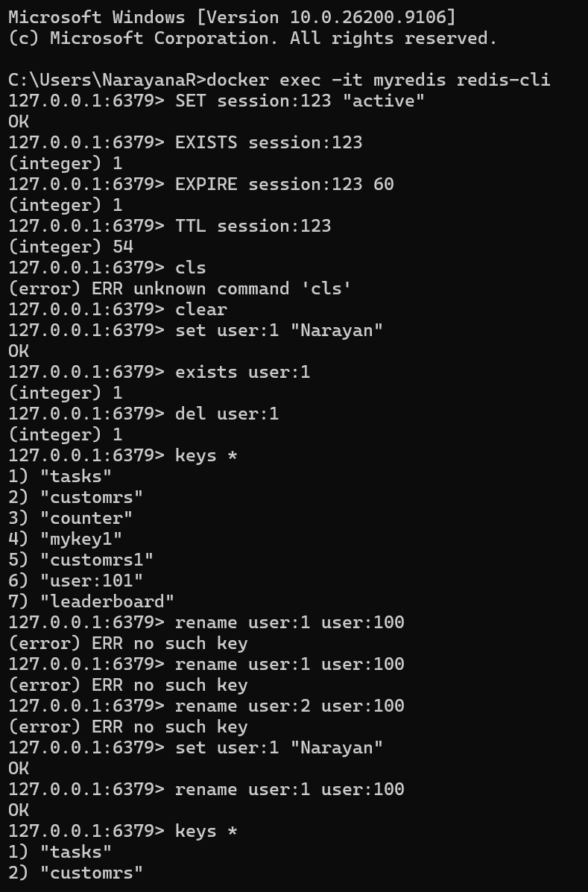

Task 16:
expire session:123 10000 // setting expiry to 10000
(integer) 1
127.0.0.1:6379> ttl session:123
(integer) 9993 // plz observe every time you check ttl it will decrease.
127.0.0.1:6379> ttl session:123
(integer) 9989 // still time to live is 9989 sec
127.0.0.1:6379> ttl session:123
(integer) 9987
127.0.0.1:6379> ttl session:123
(integer) 9985
127.0.0.1:6379> ttl session:123
(integer) 9984
127.0.0.1:6379> ttl session:123
(integer) 9983
127.0.0.1:6379> ttl session:123
(integer) 9977
127.0.0.1:6379> PERSIST session:123 // checking if still persists or not 1 says yes 0 says expired.
(integer) 1

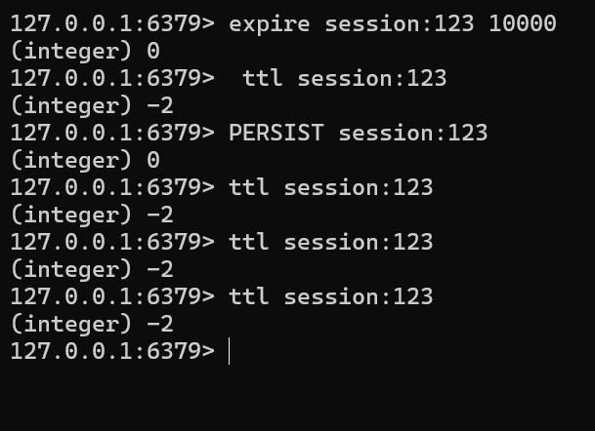

Task 17: How does Cache-Aside balance freshness and performance, and what risks arise if the database is updated frequently?

Answer:
Cache-Aside balances freshness and performance by using the cache only when needed while keeping the database as the primary source of truth. When an application requests data, it first checks the cache. If the data is available, it is returned quickly from the cache. If not, the application retrieves the data from the database and stores it in the cache for future requests. This approach improves performance by reducing database load and speeding up read operations while still allowing relatively fresh data.

However, if the database is updated frequently, the cache may contain outdated (stale) data until it is refreshed, invalidated, or expires. Frequent updates can increase cache invalidation operations and lead to temporary inconsistencies between the cache and the database, which may result in users seeing old information.

Task 18: In what type of workload would Write-Behind caching introduce consistency challenges compared to Write-Through?

Answer:
Write-Behind caching introduces consistency challenges in workloads that require immediate and accurate data updates, such as banking systems, financial transactions, inventory management, reservation systems, and other real-time applications. In this pattern, data is first written to the cache and then asynchronously written to the database later. Although this improves write performance, it creates a delay before the database is updated.

Compared to Write-Through caching, where data is written to both the cache and the database simultaneously, Write-Behind can result in temporary inconsistencies. If a failure occurs before the cached data is written to the database, some updates may be lost. Therefore, Write-Behind is best suited for high-write workloads where performance is more important than immediate consistency, while Write-Through is preferred when strong consistency is required

Task 19: Why might LFU eviction be more suitable than LRU eviction in recommendation systems?

Answer:
LFU (Least Frequently Used) eviction may be more suitable than LRU (Least Recently Used) eviction in recommendation systems because recommendation data often contains items that are consistently popular over long periods. LFU keeps frequently accessed items in the cache by tracking how often they are used, ensuring that popular recommendations remain available.

In contrast, LRU removes items that have not been accessed recently, even if they are generally popular. As a result, valuable recommendation data may be evicted simply because it was not requested in the most recent time window. Therefore, LFU is often better for workloads where long-term popularity is more important than recent access patterns.

Task 20: What are the trade-offs between time-based invalidation and event-based invalidation?

Answer:
Time-based invalidation removes or refreshes cached data after a fixed period, such as every 5 minutes. It is simple to implement and requires less coordination with the underlying data source. However, it may serve stale data until the expiration time is reached, or it may refresh data unnecessarily if no changes have occurred.

Event-based invalidation updates or removes cached data whenever a specific event occurs, such as a database update. This provides fresher and more accurate data because the cache is synchronized with changes in the source system. However, it is more complex to implement, requires reliable event handling, and may increase system complexity and maintenance effort.

In summary:
- Time-based invalidation: Simpler to implement but may serve stale data.
- Event-based invalidation: More accurate and timely but more complex to manage.

Task 21: How would you design cache invalidation for a real-time stock trading system?

Answer:
For a real-time stock trading system, I would use event-based cache invalidation combined with a very short cache lifetime. Whenever stock prices, order books, or trading data are updated, the system would immediately trigger an event to invalidate or refresh the related cached entries. This ensures that traders receive the most current market information.

Additionally, a short time-to-live (TTL) can serve as a backup mechanism in case an invalidation event is missed. Distributed caches can be synchronized through messaging systems or event streams so that all application servers receive updates consistently.

This design minimizes the risk of stale stock data, supports high-speed access, and maintains the accuracy required for real-time trading decisions.

Home Tasks

Task 22: How does sharding in Redis clusters improve scalability, and what complexity does it add to key management?

Answer:
Sharding in Redis clusters improves scalability by distributing data across multiple Redis nodes. Each node stores a portion of the total dataset, allowing the cluster to handle larger amounts of data and higher numbers of requests than a single Redis server. As more nodes are added, storage capacity and processing power increase, making the system more scalable and capable of supporting growing workloads.

However, sharding adds complexity to key management because related keys may be stored on different nodes. Applications must determine which shard contains a specific key, and operations involving multiple keys can become more difficult when those keys reside on different shards. Developers may need to use techniques such as hash tags to ensure related keys are stored together. Additionally, data rebalancing and shard management become more complex as nodes are added or removed from the cluster.

In summary:
- Sharding improves scalability by distributing data and workload across multiple nodes.
- It increases storage capacity, throughput, and fault tolerance.
- It adds complexity to key placement, multi-key operations, and cluster management.

