(006CP2744): Day 27 - 21st Aug 2026

Task 1: Codebase Practices
Q: How do consistent codebase practices (such as naming conventions, modularization, and version control discipline) influence the scalability and maintainability of large enterprise applications?

Answer:
Consistent codebase practices play a crucial role in maintaining and scaling large enterprise applications. Naming conventions improve code readability and help developers quickly understand the purpose of variables, methods, and classes. Modularization breaks applications into smaller, reusable, and independent components, making it easier to enhance, test, and maintain the system. Version control discipline ensures proper tracking of changes, supports team collaboration, prevents conflicts, and allows easy rollback when issues occur. Together, these practices reduce technical debt, improve development efficiency, support onboarding of new developers, and make the application more scalable and maintainable over time.

------------------------------------------------------------------

Task 2: Communication
Q: In a distributed microservices architecture, why is asynchronous communication often preferred over synchronous communication, and what trade-offs does this introduce?

Answer:
Asynchronous communication is often preferred because it allows services to operate independently without waiting for immediate responses from other services. This improves system responsiveness, scalability, and fault tolerance. Message queues and event-driven architectures enable services to continue processing even when dependent services are temporarily unavailable. However, this approach introduces trade-offs such as increased system complexity, eventual consistency instead of immediate consistency, difficulty in tracing transactions across services, and challenges in debugging and monitoring distributed workflows. Proper message handling and monitoring mechanisms are required to manage these complexities effectively.

------------------------------------------------------------------

Task 3: Data
Q: What are the key differences between managing stateful versus stateless data in modern applications, and how do these differences affect system design and performance?

Answer:
Stateful applications store session or user-related information between requests, while stateless applications treat each request independently without retaining client-specific data. Stateful systems often require session storage, synchronization, and data persistence mechanisms, making scaling more complex. Stateless systems are easier to scale horizontally because any server instance can process incoming requests. From a performance perspective, stateless architectures generally provide better scalability and resilience, whereas stateful architectures may offer faster access to user-specific data but require additional resources to maintain consistency and availability. The choice depends on business requirements, performance needs, and system complexity.

------------------------------------------------------------------

Task 4: Fault Tolerance & Monitoring
Q: How does proactive monitoring combined with fault-tolerant design (e.g., retries, circuit breakers, failover strategies) reduce the risk of cascading failures in microservices ecosystems?

Answer:
Proactive monitoring continuously tracks application health, performance metrics, resource utilization, and error rates, allowing teams to identify issues before they become critical. Fault-tolerant mechanisms such as retries help recover from temporary failures, circuit breakers prevent repeated requests to unhealthy services, and failover strategies automatically redirect traffic to backup resources when failures occur. Together, these techniques isolate failures, prevent excessive resource consumption, and maintain system availability. By detecting and responding to problems early, organizations can reduce downtime, improve reliability, and prevent cascading failures from spreading across interconnected microservices.

Task 5:

Once done with the above tasks
Step 1:

Lets Set up your project using spring initializer
start.spring.io

Choose Maven Project, Java, Spring Boot version (latest stable)
Add dependencies: Spring Web, Spring Data JPA, H2 Database
Set Group: com.Microservices, Artifact: userservice
Click Generate to download the project

Step 2:

now will import into our IDE
Open the generated project in your IDE.
Extract the ZIP file
Open in IntelliJ... or any..
Ensure Maven dependencies are downloaded

Step 3:
Create User Entity
Define a simple User model for persistence.
Add fields: id, name, email
Annotate with @Entity
Use @Id and @GeneratedValue for primary key
Like …given below… you can use ur own

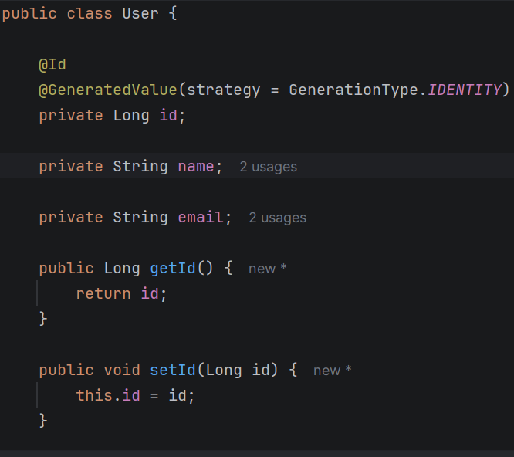

Step 4:
Create Repository
Provide database access using Spring Data JPA.
Extend JpaRepository<User, Long>
No need to write SQL manually

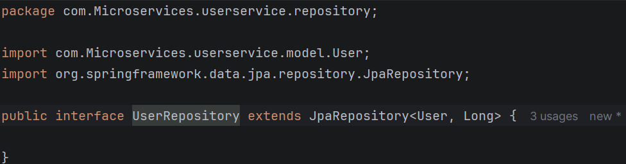

Step 5:

Create Service Layer
Add business logic for user operations.
Methods: createUser, getAllUsers, getUserById
Autowire UserRepository

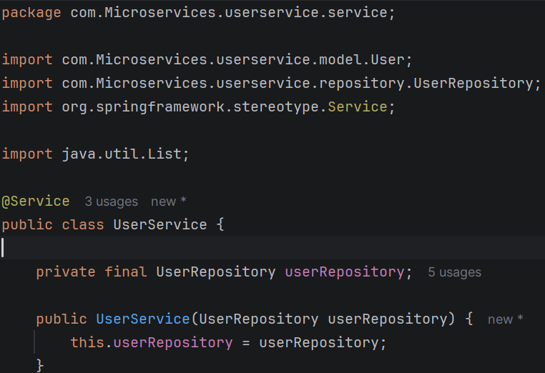

Step 6:

Create REST Controller
Expose REST endpoints for CRUD operations.
Annotate with @RestController
Map endpoints: /users (GET, POST), /users/{id} (GET)
Return JSON responses

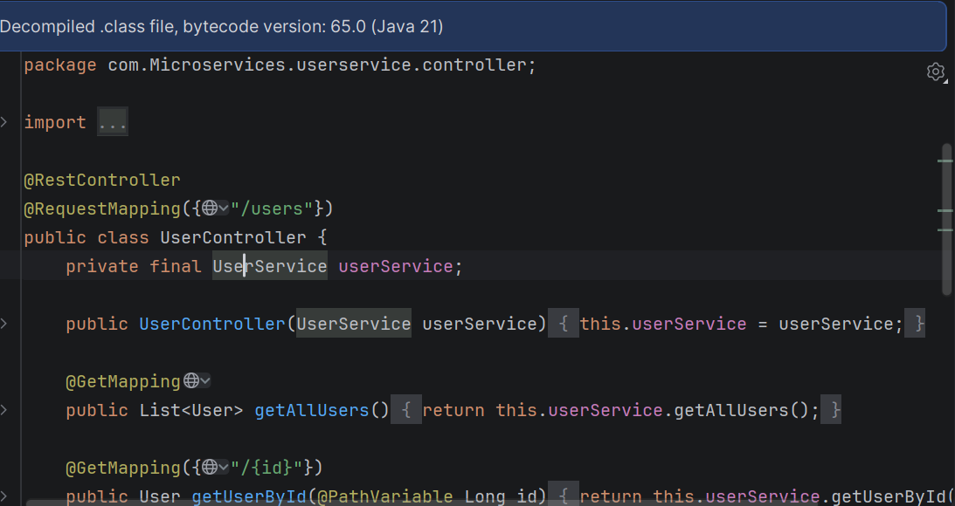

step 07:

Configure H2 Database
Use in-memory H2 database for simplicity.
src/main/resources/application.properties
Add: spring.datasource.url=jdbc:h2:mem:testdb
Add: spring.h2.console.enabled=true
Add: spring.jpa.hibernate.ddl-auto=update

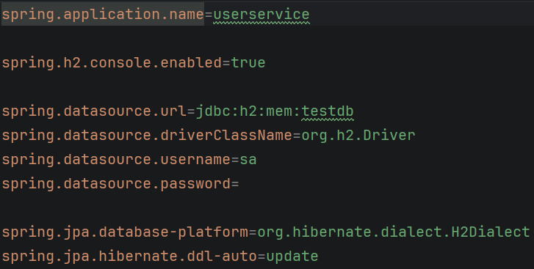

Step 08:

now run Application
Start the Spring Boot app.
Run UserserviceApplication.java
Console shows Tomcat started on port 8080

Step 09:
Test Endpoints
Verify APIs using Postman or browser.
POST http://localhost:8080/users with JSON body
GET http://localhost:8080/users
GET http://localhost:8080/users/{id}
Check H2 console at /h2-console

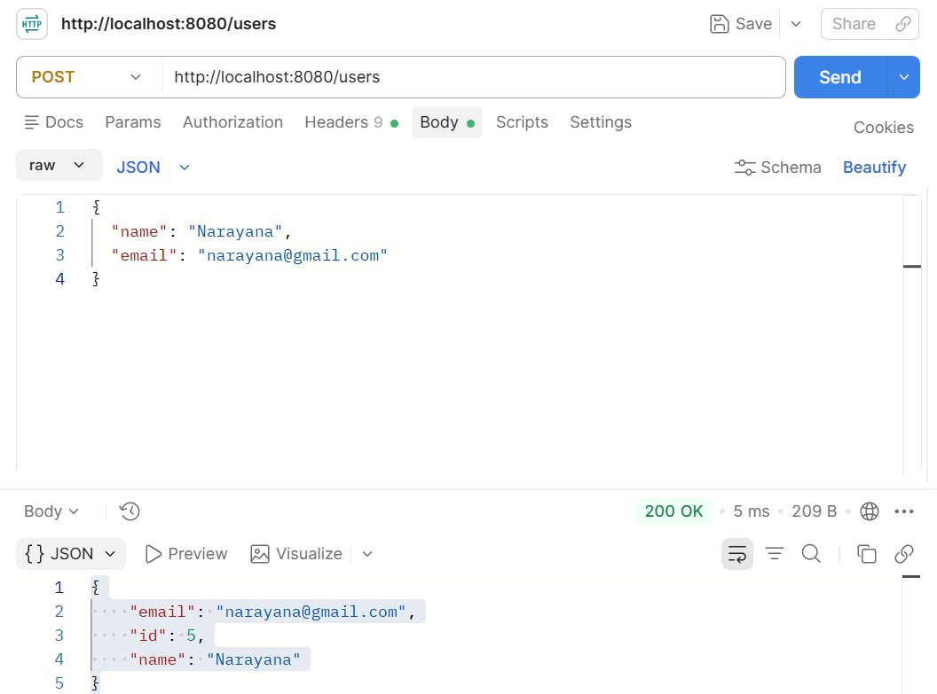

<dependency>
<groupId>jakarta.persistence</groupId>
<artifactId>jakarta.persistence-api</artifactId>
<version>3.2.0</version>
</dependency>

