(006CP2744): Day 30 - 26th Aug 2026 – Virtual

Task 1

Q1. Producers and Consumers
How does the decoupling of producers and consumers in a messaging system improve scalability and fault tolerance compared to direct point-to-point communication?

Answer:
In a messaging system, producers send messages to a broker without knowing who will consume them, while consumers receive messages independently. This decoupling improves scalability because producers and consumers can be scaled separately based on workload. It also improves fault tolerance because messages are stored in the broker until consumers are available. If a consumer fails, messages are not lost and can be processed later. In direct point-to-point communication, both systems must be available at the same time, making the system more tightly coupled and less resilient.

--------------------------------------------------

Q2. Consumer Groups and Scaling
Why do consumer groups enable horizontal scaling in Kafka, and what trade-offs arise when multiple consumers in a group share partitions?

Answer:
Consumer groups enable horizontal scaling in Kafka by allowing multiple consumers to share the workload of reading messages from a topic. Kafka assigns partitions among consumers so that each partition is processed by only one consumer within the group. This increases throughput and allows parallel processing. However, the number of active consumers cannot exceed the number of partitions. Additional consumers remain idle. Rebalancing can also occur when consumers join or leave the group, which may temporarily interrupt message processing.

--------------------------------------------------

Q3. Spring for Apache Kafka
How does Spring Kafka simplify the development of event-driven applications, and what role do message listeners play in abstracting Kafka's native APIs?

Answer:
Spring Kafka simplifies Kafka application development by providing high-level abstractions, configuration support, serialization utilities, and integration with the Spring ecosystem. Developers can use annotations and templates instead of interacting directly with Kafka's low-level APIs. Message listeners, such as those created with the @KafkaListener annotation, automatically consume and process messages. They abstract polling, deserialization, and consumer management, allowing developers to focus on business logic rather than Kafka infrastructure details.

--------------------------------------------------

Q4. RabbitMQ Concepts (Exchanges, Queues, Bindings)
In RabbitMQ, how do exchanges, queues, and bindings work together to implement flexible routing patterns, and why is this separation of concerns important?

Answer:
In RabbitMQ, producers send messages to exchanges rather than directly to queues. Exchanges determine how messages should be routed based on routing rules. Bindings connect exchanges to queues and define the conditions under which messages are delivered to specific queues. This separation of concerns is important because it allows flexible routing patterns such as direct, topic, fanout, and header-based routing. Producers remain independent of queue details, making the system easier to maintain, modify, and scale.

--------------------------------------------------

Q5. Spring AMQP / RabbitMQ Integration
What advantages does Spring AMQP provide when integrating with RabbitMQ, particularly in terms of template-based messaging and listener container management?

Answer:
Spring AMQP simplifies RabbitMQ integration by providing components such as RabbitTemplate for sending and receiving messages and listener containers for managing message consumption. RabbitTemplate reduces boilerplate code and simplifies message conversion and routing. Listener containers automatically handle connections, thread management, acknowledgments, retries, and error handling. These features improve productivity, reduce development complexity, and ensure reliable message processing.

--------------------------------------------------

Q6. Event-Driven Patterns (Notification, Event-Carried State Transfer)
How do event-driven patterns like Notification and Event-Carried State Transfer differ in terms of data payload and system coupling, and when would each be more appropriate?

Answer:
Notification events contain only minimal information, usually indicating that something has happened. Consumers must query the source service to retrieve additional data. This results in smaller messages but creates tighter runtime coupling between services.

Event-Carried State Transfer includes all relevant data in the event payload. Consumers can process the event without calling the source service. This reduces coupling and improves performance but increases message size and may result in data duplication.

Notification is appropriate when consumers need only limited details or when data changes frequently. Event-Carried State Transfer is more suitable when independence, scalability, and reduced inter-service communication are important.

Task 02:

- Install RabbitMQ
  - Erlang installation done by 5 out of 20. https://www.erlang.org/downloads
  - Click the above link to download erlang and then install it..
  - After set path like C:\Program Files\Erlang OTP\erts-17.0.5\bin
  - C:\Users\PRASUNA>erl -version
Erlang (SMP,ASYNC_THREADS) (BEAM) emulator version 17.0.5

Done by 20 out of 20

- Download from rabbitmq.com (rabbitmq.com in Bing)
- Start server: rabbitmq-server
C:\Windows\System32>net start rabbitmq
The requested service has already been started.
More help is available by typing NET HELPMSG 2182.
C:\Windows\System32>erl -version
Erlang (SMP,ASYNC_THREADS) (BEAM) emulator version 17.0.5
14 done out of 20
- Management UI: http://localhost:15672 (default user: guest/guest)
- Create Spring Boot Project
  - Use Spring Initializr → add Spring Web, Spring AMQP.
- Add Config, Producer, Consumer (as shown below).
- Plz add
Step 1: Add Dependency
xml
<dependency>
<groupId>org.springframework.boot</groupId>
<artifactId>spring-boot-starter-amqp</artifactId>
</dependency>

Step 2: Configure RabbitMQ (application.properties)
properties
spring.rabbitmq.host=localhost
spring.rabbitmq.port=5672
spring.rabbitmq.username=guest
spring.rabbitmq.password=guest

Step 3: Define Exchange, Queue, Binding
java
@Configuration
public class RabbitConfig {
@Bean
public DirectExchange orderExchange() {
return new DirectExchange("orderExchange");
}

@Bean
public Queue orderQueue() {
return new Queue("orderQueue", true);
}

@Bean
public Binding binding(Queue orderQueue, DirectExchange orderExchange) {
return BindingBuilder.bind(orderQueue).to(orderExchange).with("newOrder");
}
}

Step 4: Producer (Sender)
java
@Service
public class OrderProducer {
@Autowired
private AmqpTemplate amqpTemplate;

public void sendOrder(String order) {
amqpTemplate.convertAndSend("orderExchange", "newOrder", order);
System.out.println("Sent: " + order);
}
}

Step 5: Consumer (Listener)
java
@Component
public class OrderConsumer {
@RabbitListener(queues = "orderQueue")
public void receiveOrder(String order) {
System.out.println("Received: " + order);
}
}
- Run Application
  - Start RabbitMQ server.
  - Run Spring Boot app.
  - Call producer method (e.g., via REST endpoint).
  - Observe consumer logs receiving the message.

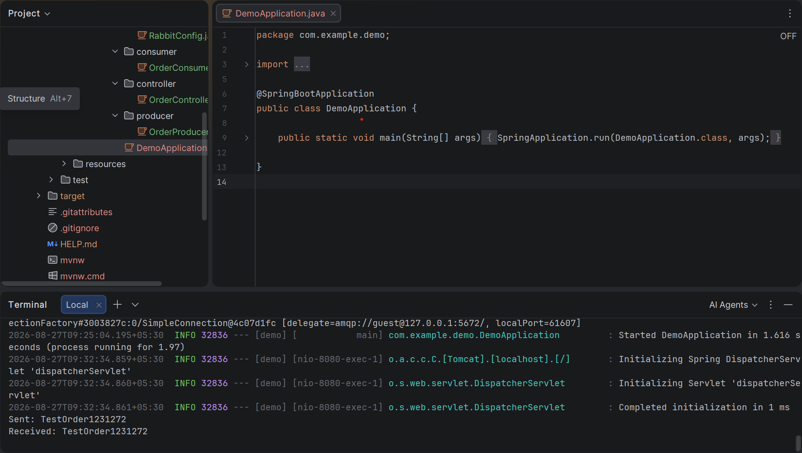

Task 3:
Messaging & Event-Driven Demo

in your earlier Banking Transaction Demo Proj we hav 2 services right :
Transaction Service here we will implement → Publishes events (Kafka or RabbitMQ).
Account Service we will implemnet → Consumes events, updates balances.
we will use
Sychronous vs. Asynchronous calls
Kafka (topics, partitions, consumer groups)
RabbitMQ (exchanges, queues, bindings)
Event-driven patterns (notification, event-carried state transfer)
Idempotency & Saga pattern basics

Step 1:

Proj structure:

event-driven-demo/
├── transaction-service/ (Spring Boot + Kafka/RabbitMQ Producer)
├── account-service/ (Spring Boot + Kafka/RabbitMQ Consumer)
├── docker-compose.yml (Kafka + RabbitMQ setup)
└── README.md (Steps to run)

In docker-compose.yml

version: '3.8'
services:
kafka:
image: bitnami/kafka:latest
ports:
- "9092:9092"
environment:
- KAFKA_CFG_ZOOKEEPER_CONNECT=zookeeper:2181
- ALLOW_PLAINTEXT_LISTENER=yes
depends_on:
- zookeeper

zookeeper:
image: bitnami/zookeeper:latest
ports:
- "2181:2181"

rabbitmq:
image: rabbitmq:3-management
ports:
- "5672:5672"
- "15672:15672" # management UI

Step 2:
Run:
bash
docker-compose up -d

Step 3:
Now lets creat Transaction service (Producer ) it s a kafka producer.
@RestController
@RequestMapping("/transaction")
public class TransactionController {

private final KafkaTemplate<String, String> kafkaTemplate;

public TransactionController(KafkaTemplate<String, String> kafkaTemplate) {
this.kafkaTemplate = kafkaTemplate;
}

@PostMapping
public String createTransaction(@RequestBody Transaction tx) {
// Publish event to Kafka topic
kafkaTemplate.send("transactions", tx.getUserId(), tx.toString());
return "Transaction submitted: " + tx.getId();
}
}

Now let create Rabbit mq producer..
@Autowired
private AmqpTemplate amqpTemplate;

@PostMapping("/rabbit")
public String createTransactionRabbit(@RequestBody Transaction tx) {
amqpTemplate.convertAndSend("transaction-exchange", "transaction.key", tx);
return "Transaction submitted via RabbitMQ: " + tx.getId();
}

Step 4:
Now consumers

Account Service (Consumer)
Kafka Consumer
java
@Component
public class TransactionConsumer {

@KafkaListener(topics = "transactions", groupId = "account-service")
public void consume(String message) {
System.out.println("Received Kafka event: " + message);
// Update account balance here
}
}

Rabbit mq consumer

RabbitMQ Consumer
java
@RabbitListener(queues = "transaction-queue")
public void receive(Transaction tx) {
System.out.println("Received RabbitMQ event: " + tx);
// Update account balance here
}

in event-Driven Patterns
Notification → Consumer just logs event.
Event-Carried State Transfer → Consumer updates DB with transaction details.
Saga Pattern → Chain multiple services (e.g., Transaction → Payment → Notification) with compensating actions.

Step 5 👍

now lets implement Idempotency & Exactly-Once
Add a unique transactionId and check before updating DB:
java
if (!processedTransactions.contains(tx.getId())) {
account.setBalance(account.getBalance() - tx.getAmount());
processedTransactions.add(tx.getId());
}

Step 6:
---->Step-by-Step Execution
Start Infrastructure
bash
docker-compose up -d

Kafka → localhost:9092
RabbitMQ → localhost:5672 (UI at http://localhost:15672)
Run Transaction Service
bash
cd transaction-service
mvn spring-boot:run

Run Account Service
bash
cd account-service
mvn spring-boot:run

Trigger Transaction
bash
curl -X POST http://localhost:8080/transaction \
-H "Content-Type: application/json" \
-d '{"id":1,"userId":101,"amount":500}'

Observe Consumer Logs
Kafka consumer prints: Received Kafka event: Transaction{id=1, userId=101, amount=500}
RabbitMQ consumer prints similar message.
Check RabbitMQ UI
Navigate to http://localhost:15672
Login: guest/guest
See messages flowing through exchange → queue → consumer.

