(006CP2744): Day 31 - 27th Aug 2026

TOP 5 HIGH-VALUE APPLICATION SECURITY QUESTIONS & ANSWERS

1. Application Security Fundamentals & OWASP Top 10

Q: How do least privilege and defense in depth help mitigate OWASP Top 10 vulnerabilities?

A:
- Least Privilege gives users/applications only the permissions they need.
- Defense in Depth uses multiple security layers to protect systems.
- Example: In SQL Injection, even if an attacker bypasses input validation, restricted database permissions limit the damage.
- Together, they reduce both the chance and impact of attacks.

----------------------------------------------------------------

2. Authentication vs. Authorization

Q: Why is it dangerous to confuse authentication with authorization, and how can it lead to privilege escalation?

A:
- Authentication = Verifying who the user is.
- Authorization = Determining what the user can access.
- If only authentication is checked, normal users may access admin resources.
- In Spring Boot, use role-based checks such as @PreAuthorize("hasRole('ADMIN')") to prevent privilege escalation.

----------------------------------------------------------------

3. Spring Security Filter Chain & JWT

Q: Explain how Spring Security processes a JWT request and how it differs from form-based login.

A:
- Client sends JWT in the Authorization header.
- JWT filter extracts and validates the token.
- User details are stored in SecurityContext.
- Authorization checks are applied before accessing resources.

Difference:
- Form Login: Uses sessions and cookies.
- JWT Authentication: Stateless; token is validated on every request.

----------------------------------------------------------------

4. Secure Coding Practices & Input Validation

Q: What is the difference between input validation and output encoding, and why are both needed?

A:
- Input Validation checks whether user input is valid and expected.
- Output Encoding converts dangerous characters into safe formats before displaying data.
- Input validation helps prevent injection attacks.
- Output encoding helps prevent XSS attacks.
- Both are required for complete protection.

----------------------------------------------------------------

5. Secrets Management & Dependency Scanning

Q: How do hardcoded secrets and vulnerable dependencies increase security risk, and how can they be mitigated?

A:
- Hardcoded API keys or passwords can be exposed if the application is compromised.
- Vulnerable dependencies may allow attackers to access source code or secrets.
- Use Vaults (Azure Key Vault, HashiCorp Vault, AWS Secrets Manager) instead of hardcoding secrets.
- Perform regular dependency scanning using tools like Snyk, OWASP Dependency Check, or Dependabot.
- Rotate secrets regularly and keep dependencies updated.

Task 2:

.Application Security
📂 Project Structure
Code
spring-security-demo/
├── pom.xml
└── src/main/java/com/security/demo/
├── DemoApplication.java
├── config/
│ └── SecurityConfig.java
├── controller/
│ └── UserController.java
├── model/
│ └── User.java
├── service/
│ └── UserService.java
└── util/
└── JwtUtil.java

🔹 Step 1: Create Spring Boot Project
Use Spring Initializr (https://start.spring.io).
add dependencies: Spring Web, Spring Security, Spring Data JPA, H2 Database, Spring Boot Starter Validation, jjwt (for JWT).

🔹 Step 2: create Main Application

🔹 Step 3: for Security Configuration

Like ..the given below.. Plz implement your own ..

@Configuration
@EnableWebSecurity
public class SecurityConfig {

@Bean
public SecurityFilterChain filterChain(HttpSecurity http) throws Exception {
http
// 🔹 CSRF disabled for APIs, enabled for forms
.csrf(csrf -> csrf.disable())
// 🔹 CORS enabled for cross-origin requests
.cors(Customizer.withDefaults())
.authorizeHttpRequests(auth -> auth
.requestMatchers("/public/**").permitAll() // No login needed
.requestMatchers("/admin/**").hasRole("ADMIN") // Role-based
.anyRequest().authenticated()
)
.formLogin(Customizer.withDefaults()) // Form-based login
.httpBasic(Customizer.withDefaults()); // Basic auth for APIs
return http.build();
}
}

🔹 Step 4: User Model

Use your existing model.. That we have created earlier

@Entity
public class User {
@Id
@GeneratedValue
private Long id;

@NotBlank
private String username;

@NotBlank
private String password; // 🔹 Will be stored as BCrypt hash

private String role; // USER / ADMIN
}

🔹 Step 5: Password Hashing

Use bcryptpasswordencoder()

Like

@Bean
public PasswordEncoder passwordEncoder() {
return new BCryptPasswordEncoder(); }

🔹 Step 6: JWT Utility

@Component
public class JwtUtil {
private final String SECRET = "mysecretkey";

public String generateToken(String username) {
return Jwts.builder()
.setSubject(username)
.setIssuedAt(new Date())
.setExpiration(new Date(System.currentTimeMillis() + 1000 * 60 * 30)) // 30 min
.signWith(SignatureAlgorithm.HS256, SECRET)
.compact();
}

public String extractUsername(String token) {
return Jwts.parser().setSigningKey(SECRET)
.parseClaimsJws(token).getBody().getSubject();
}
}

🔹 Step 7: Controller

Use ur usercontroller here

@RestController
@RequestMapping("/api")
public class UserController {

@Autowired private JwtUtil jwtUtil;

@GetMapping("/public/hello")
public String publicHello() {
return "Hello World - Public!";
}

@GetMapping("/user/hello")
public String userHello() {
return "Hello User - Authenticated!";
}

@GetMapping("/admin/hello")
public String adminHello() {
return "Hello Admin - Restricted!";
}

@PostMapping("/login")
public String login(@RequestParam String username, @RequestParam String password) {
// 🔹 Normally validate against DB
if(username.equals("demo") && password.equals("password")) {
return jwtUtil.generateToken(username);
}
throw new RuntimeException("Invalid credentials");
}
}

🔹 Step 8: Secure Coding Practices
Input Validation → @NotBlank, @Valid annotations.
Output Encoding → Use Thymeleaf or Spring’s HtmlUtils to escape HTML.
Secrets Management → Store secrets in application.properties or environment variables, not in code.
Dependency Scanning → Use OWASP Dependency Check plugin in Maven.

🔹 Step 9: Execution Process
Clone/Download project.
Run mvn spring-boot:run.
Access endpoints:
http://localhost:8080/api/public/hello → No login required.
http://localhost:8080/api/user/hello → Requires login.
http://localhost:8080/api/admin/hello → Requires ADMIN role.
POST http://localhost:8080/api/login → Returns JWT token.
Use JWT token in Authorization: Bearer <token> header for secured APIs.

🔹 How This Covers all our Topics
OWASP Top 10 → Input validation, CSRF, CORS, password hashing, dependency scanning.
Authentication vs Authorization → Form login, Basic auth, JWT, role-based.
Spring Security Filter Chain → Configured in SecurityConfig.
OAuth2 / OIDC → Extend with spring-boot-starter-oauth2-client.
Secrets Management → Environment variables.
Session Management → Default Spring Security session handling.

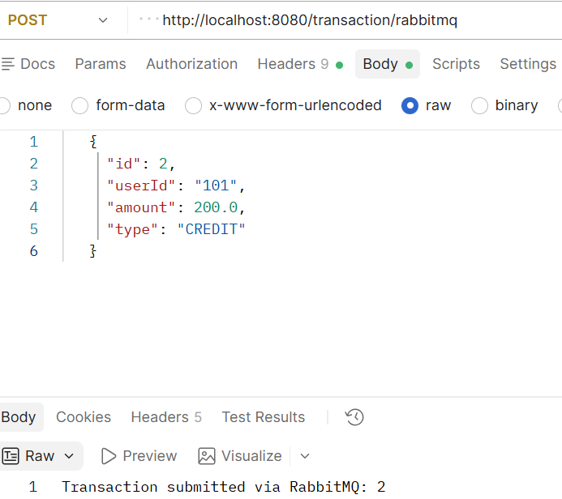

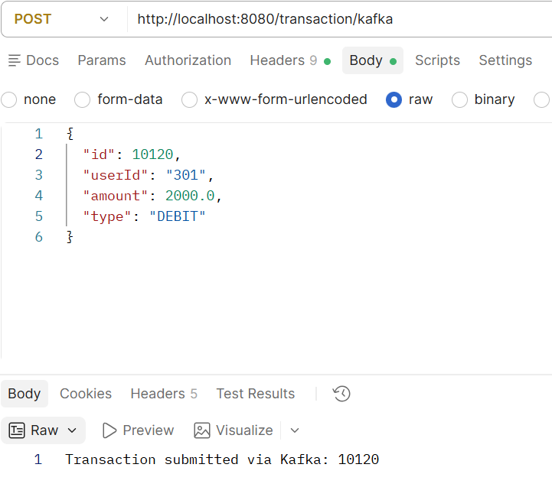

Q1: How does cloud computing differ from traditional on-premises IT infrastructure in terms of scalability and cost management?

Answer:
Cloud computing provides on-demand resources that can be scaled up or down quickly based on business needs, whereas traditional on-premises infrastructure requires organizations to purchase and maintain physical hardware in advance. Cloud computing follows a pay-as-you-go model, reducing upfront capital expenses and improving cost efficiency. In contrast, on-premises infrastructure involves high initial investments and ongoing maintenance costs.

Q2: Why is it important to deploy applications across multiple Availability Zones within a region?

Answer:
Deploying applications across multiple Availability Zones (AZs) increases high availability and fault tolerance. If one AZ experiences a failure, the application can continue running in another AZ, minimizing downtime and ensuring business continuity. This architecture improves reliability and resilience.

Q3: What is the difference between IAM roles and IAM users, and when would you use each?

Answer:
IAM users represent individual people or applications that require long-term credentials to access AWS resources. IAM roles do not have permanent credentials and are assumed temporarily by users, applications, or AWS services. Use IAM users for specific individuals requiring access, and use IAM roles when granting temporary permissions or allowing AWS services to interact securely with other resources.

Q4: How does Amazon EC2 enable elasticity in application deployment, and what role does Auto Scaling play?

Answer:
Amazon EC2 enables elasticity by allowing organizations to quickly launch or terminate virtual servers based on demand. Auto Scaling automatically adjusts the number of EC2 instances according to predefined metrics such as CPU utilization or traffic levels. This ensures optimal performance, availability, and cost efficiency.

Q5: What makes Amazon S3 an object storage service, and how does it ensure durability of stored data?

Answer:
Amazon S3 is an object storage service because it stores data as objects containing the file, metadata, and a unique identifier. S3 ensures durability by automatically replicating data across multiple devices and facilities within an AWS Region. This design provides extremely high durability and protects data from hardware failures.

Q6: Why would you place a database in a private subnet within a VPC instead of a public subnet?

Answer:
A database is typically placed in a private subnet to prevent direct access from the internet. This improves security by allowing only authorized application servers or users within the VPC to connect to the database. It reduces the risk of unauthorized access, attacks, and data breaches.

Q7: How does Amazon RDS simplify database management compared to running a database on EC2?

Answer:
Amazon RDS is a managed database service that automates administrative tasks such as backups, software patching, database updates, monitoring, and high availability configuration. When running a database on EC2, these tasks must be manually handled by the user. RDS reduces operational overhead and allows teams to focus on application development.

Q8: How do security groups function as virtual firewalls, and what is the principle of “least privilege” in configuring them?

Answer:
Security groups act as virtual firewalls that control inbound and outbound traffic for AWS resources such as EC2 instances. The principle of least privilege means granting only the minimum permissions necessary for users, applications, or services to perform their tasks. This reduces security risks and limits the potential impact of unauthorized access.

Q9: What are the advantages of using the AWS CLI over the AWS Management Console for managing cloud resources?

Answer:
The AWS CLI allows users to manage AWS resources through command-line commands, enabling automation, scripting, and faster execution of repetitive tasks. It is ideal for large-scale resource management and DevOps workflows. In contrast, the AWS Management Console provides a graphical interface that is easier for beginners but less efficient for automation and bulk operations.

