(006CP2744); Day 33 - 31st Aug 2026

Task 1:

Amazon RDS (Relational Database Service) – a managed database instance (like MySQL) on AWS, connect to it, and test it.
Step 01:
Open RDS Service
RDS is AWS’s managed database service for MySQL, PostgreSQL, Oracle, SQL Server, and MariaDB.
AWS Console → Services → RDS
- Log in to AWS Console
- In the search bar, type RDS
- Click RDS to open the dashboard
Step 02:
Create Database Instance
Beginner Setup
You’ll launch a new managed database with free-tier options.
RDS Dashboard → Create database
- Choose Standard create
- Select MySQL (or PostgreSQL)
- Pick Free tier template
- Enter DB instance identifier (e.g., mydb-demo)

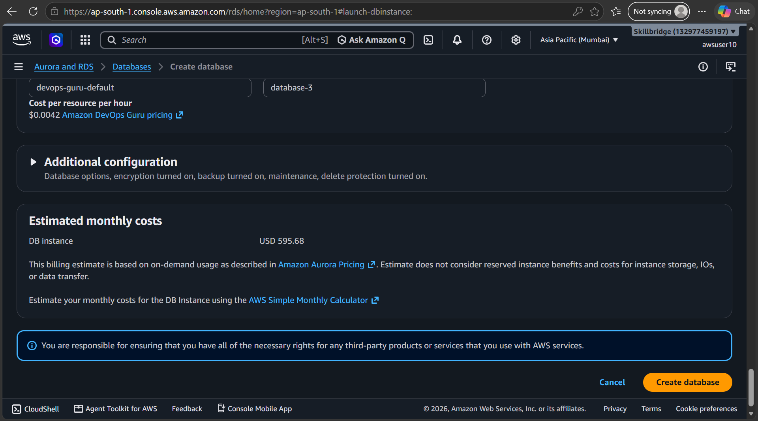

03
Configure Credentials
Set up the master username and password for database access.
- Enter Master username (e.g., admin)
- Enter a strong password
- Note these credentials — you’ll need them later
04
Choose Instance Size
Pick a small instance type suitable for beginners.
- Select db.t3.micro (free tier eligible)
- Keep storage defaults (20 GB)
- Disable autoscaling for demo
05
Set Connectivity
Configure how your database can be accessed.
- Select Default VPC
- Choose Public access → Yes (for demo)
- Pick or create a Security Group
- Add inbound rule: MySQL/Aurora (Port 3306) from your IP
06
Launch Database
AWS will now provision your managed DB instance.
- Click Create database
- Wait 5–10 minutes until status shows Available

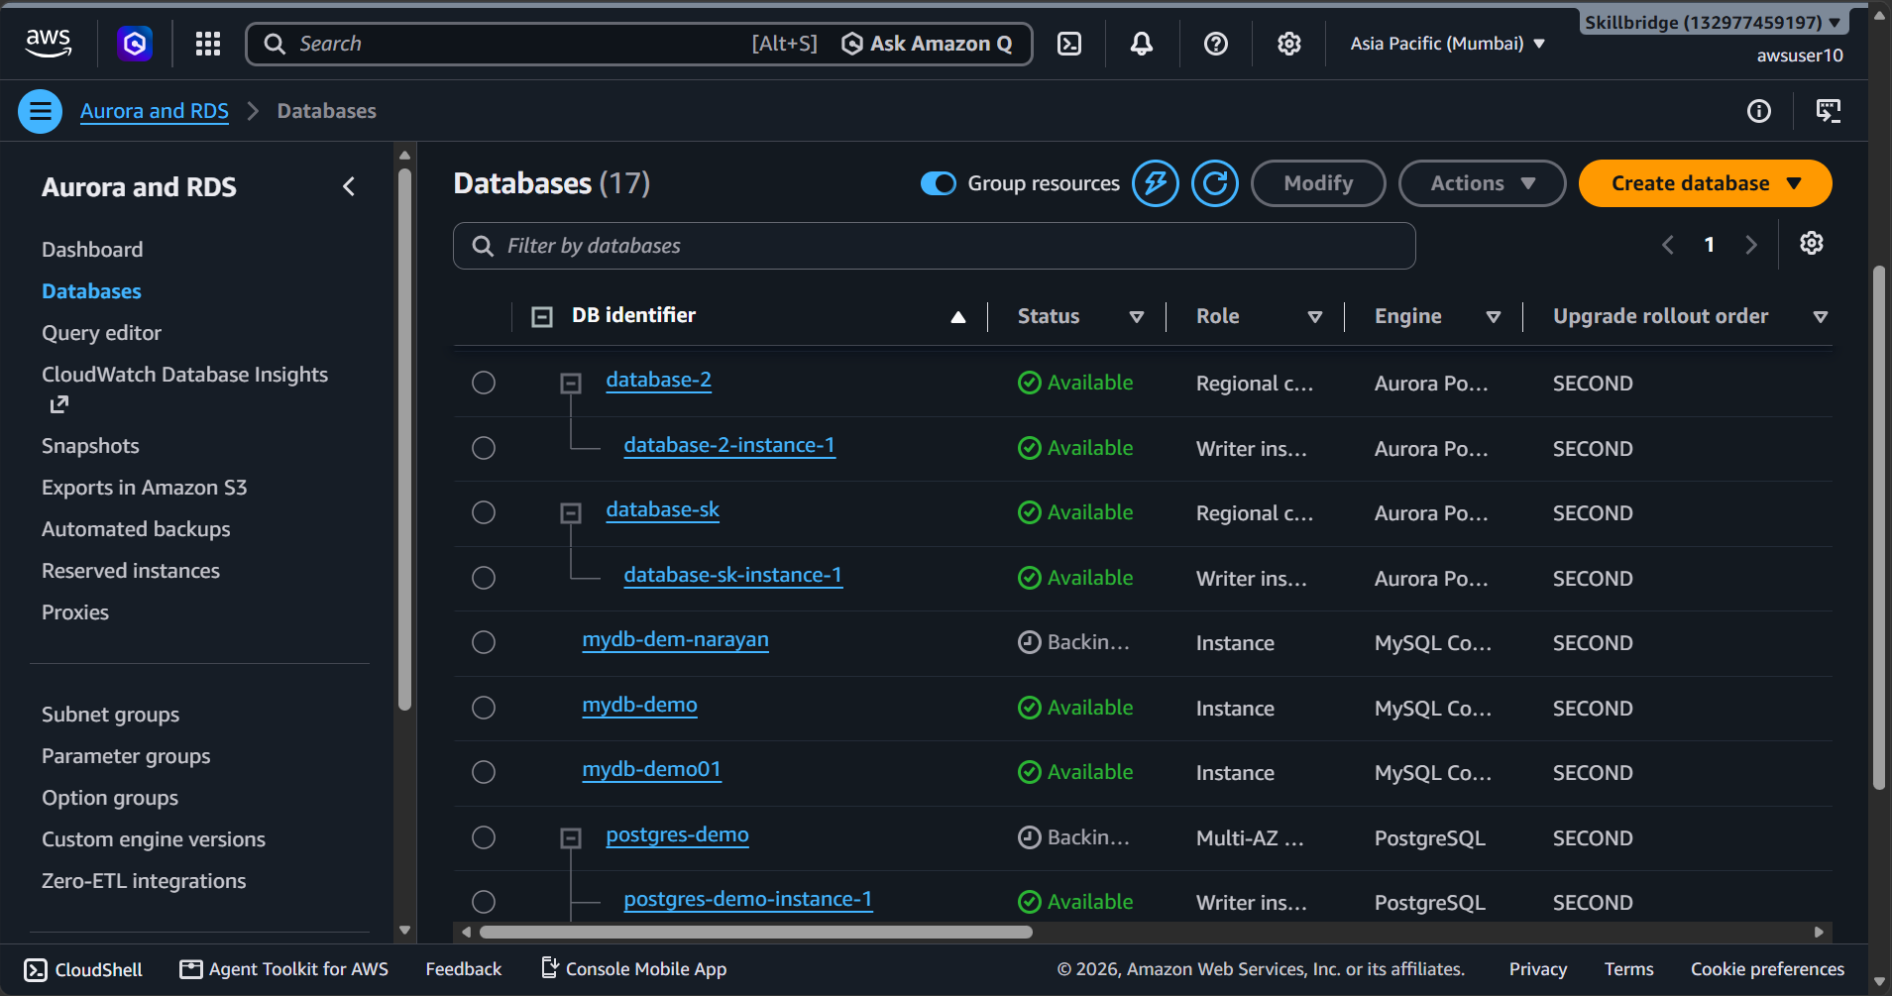

07
Connect via EC2 or Local Client
Use the endpoint provided by RDS to connect.
- Copy the Endpoint from RDS instance details
- From EC2 or local MySQL client, run:
bash
mysql -h <endpoint> -u admin -p

- Enter password → you’re inside the DB
08
Test Database
Verify that your database is working.
- Run SHOW DATABASES;
- Create a sample DB: CREATE DATABASE demo;
- Confirm with SHOW DATABASES;
Now we created a managed MySQL database on AWS RDS, connected to it, and tested it with basic SQL commands. The beauty of RDS is that AWS handles backups, patching, and scaling for you — so you focus on using the database, not maintaining servers.

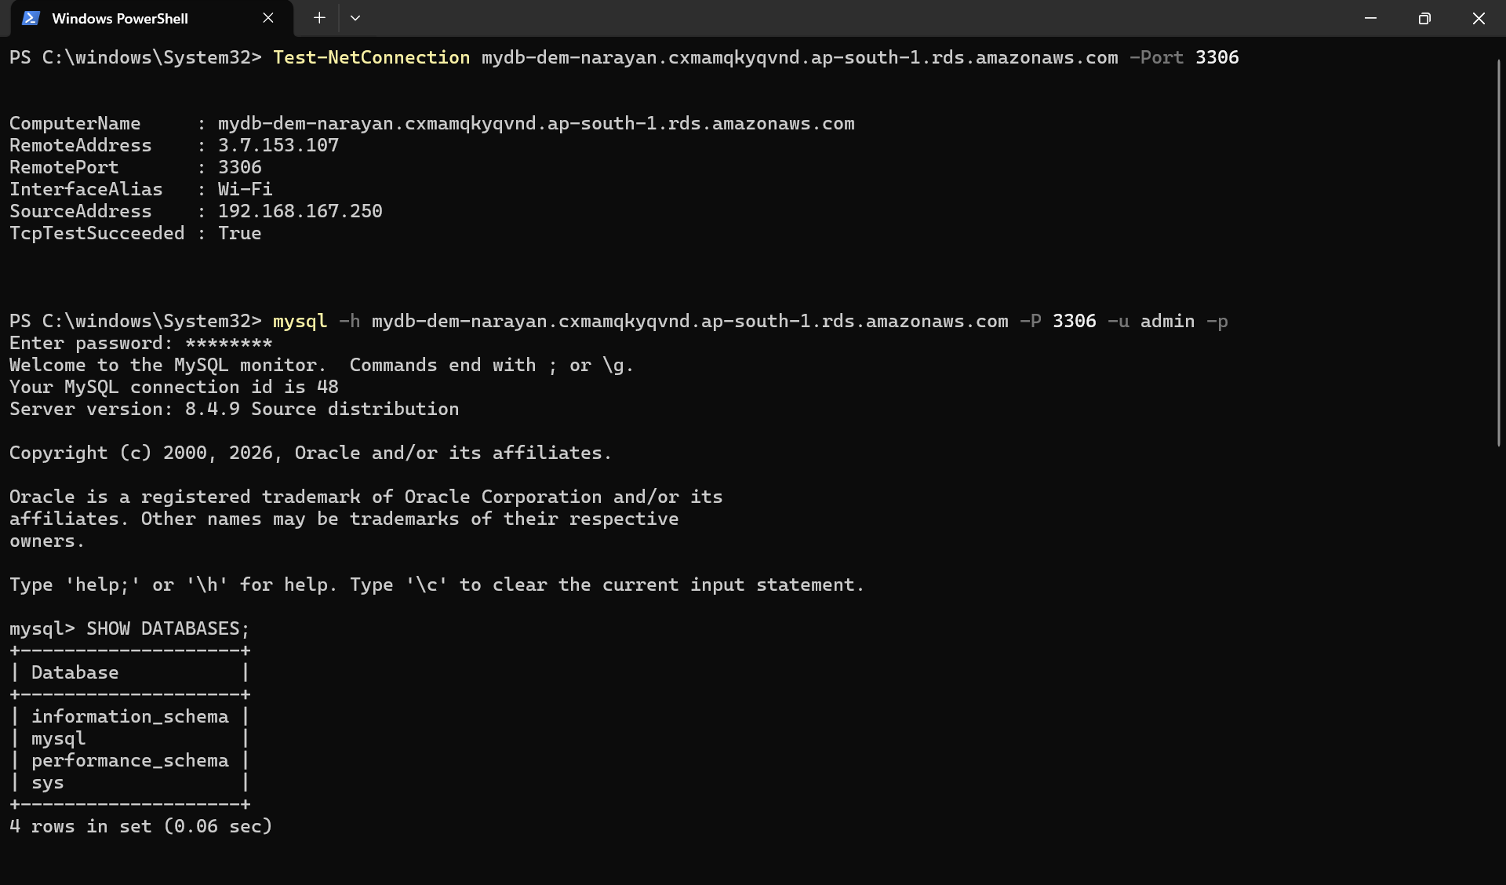

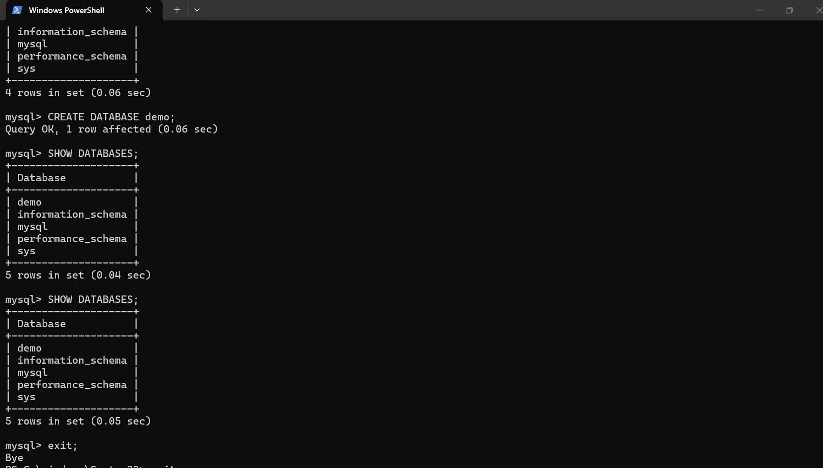

Task 02:
Once done with RDS above Tsk 1.. Connect spring boot application that you have created with the DB .. using cloud
Steps for your reference are give at the end..of this doc

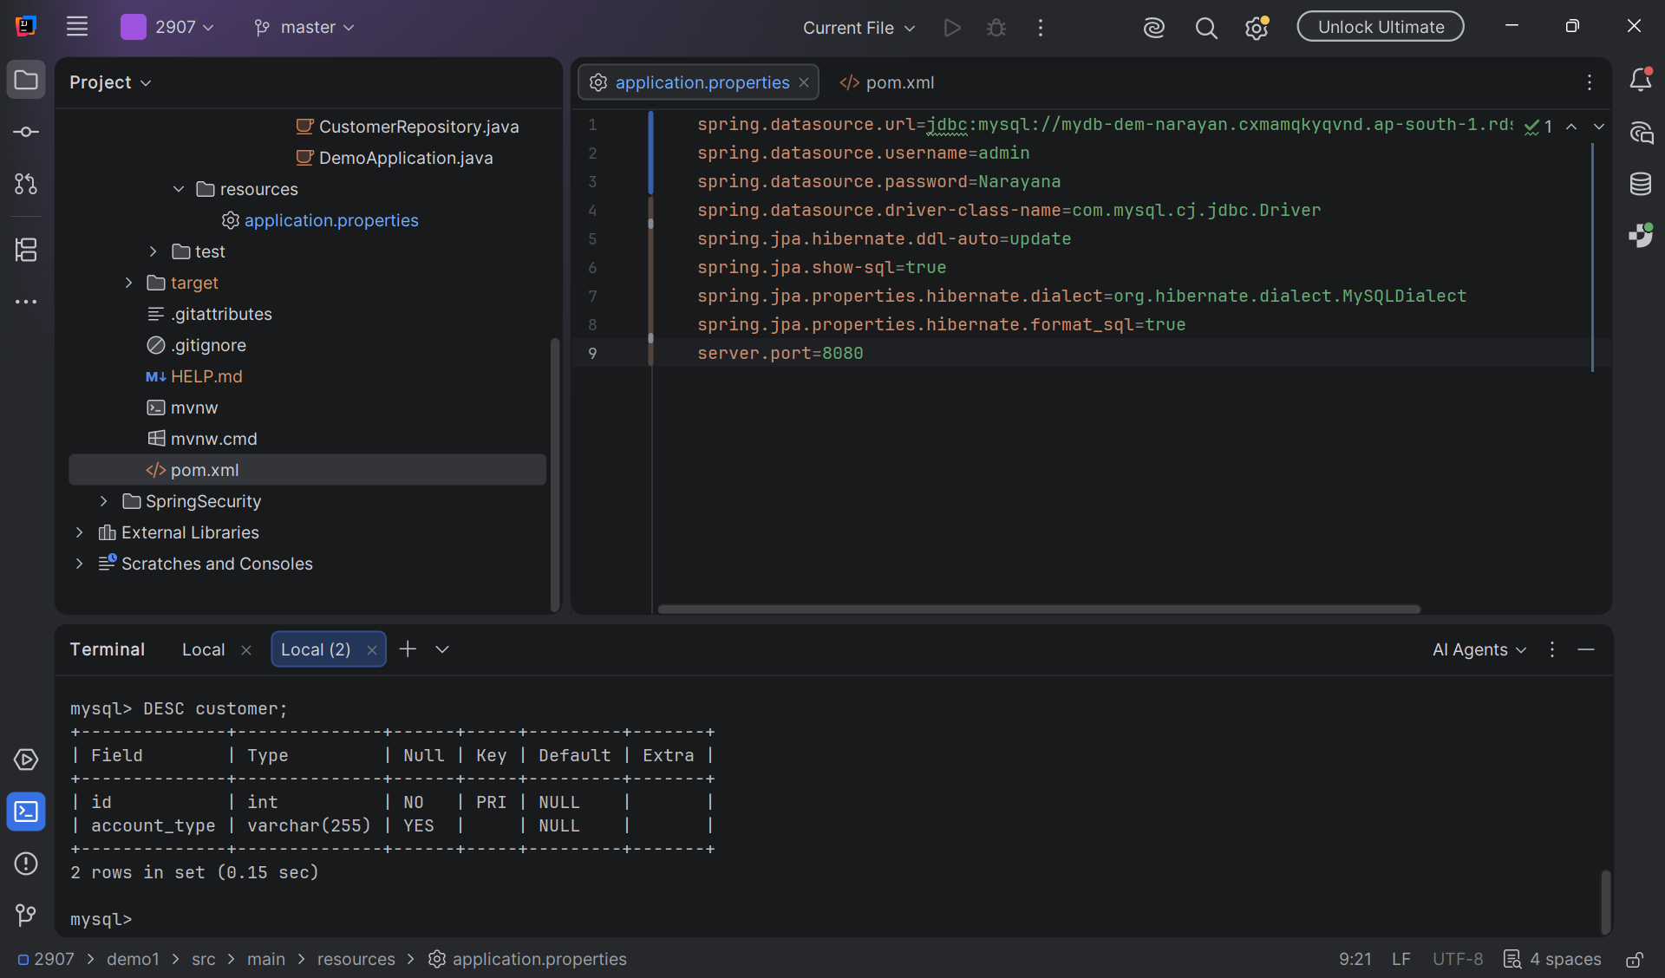

Task 03:
AWS Security Groups and Basic Cloud Security . Security Groups act like virtual firewalls for your EC2 instances and RDS databases, controlling inbound and outbound traffic.
01
Open Security Groups in AWS Console
Security Groups are managed under the EC2 service.
AWS Console → EC2 → Network & Security → Security Groups
- Log in to the AWS Management Console
- Navigate to EC2 service
- On the left menu, click Security Groups
02
Create a New Security Group
Setup
Define a firewall set for your instance or database.
- Click Create Security Group
- Enter a name and description
- Select the VPC where your resources are running
03
Add Inbound Rules
Control what traffic can reach your instance.
- Choose Add Rule
- Select Type (e.g., SSH, HTTP, MySQL)
- Set Source (e.g., My IP for SSH, Anywhere for HTTP)
- Example: Allow MySQL/Aurora (3306) from your application server’s IP
04
Add Outbound Rules
Define what traffic your instance can send out.
- By default, all outbound traffic is allowed
- You can restrict it to specific destinations if needed
05
Attach Security Group to Resource
Apply the firewall rules to your EC2 or RDS instance.
- Go to your EC2 instance or RDS database
- Under Networking → Security Groups, click Edit
- Select the new security group and save changes
06
Test Connectivity
Best Practice
Verify that rules are working as expected.
- Try connecting via SSH or database client
- If blocked, check inbound rules
- Always restrict sensitive ports (e.g., SSH) to your IP only
You’ve now created and applied a Security Group to control access. This is the foundation of AWS cloud security — always follow the principle of least privilege (only open the ports and IPs you truly need).

real-world AWS security demo where you secure an RDS database so that only your application server (EC2) can connect. that shows how Security Groups enforce isolation and controlled access.
Securing RDS with Security Groups
1. Launch Two Resources
- EC2 Instance (your application server).
- RDS Instance (e.g., MySQL).
Both must be in the same VPC for easy communication.
2. Create Security Groups
- AppServerSG → for EC2.
  - Inbound: Allow SSH (port 22) from your IP.
  - Outbound: Allow all (default).
- DBSG → for RDS.
  - Inbound: Allow MySQL (port 3306) only from AppServerSG.
  - Outbound: Allow all (default).
👉 Key point: Instead of opening RDS to the world (0.0.0.0/0), you restrict it to traffic coming from the EC2’s Security Group.
3. Attach Security Groups
- Assign AppServerSG to your EC2 instance.
- Assign DBSG to your RDS instance.
4. Test Connectivity
SSH into EC2:
bash
ssh -i mykey.pem ec2-user@<EC2-Public-IP>

Install MySQL client:
bash
sudo yum install mysql -y

Connect to RDS:
bash
mysql -h <RDS-ENDPOINT> -u admin -p
- ✅ Connection succeeds because EC2 is in the allowed SG.
5. Verify Security
Try connecting from your laptop directly:
bash
mysql -h <RDS-ENDPOINT> -u admin -p
- ❌ It fails — because your laptop’s IP is not allowed in DBSG.
- This proves only EC2 can talk to RDS.
6. Best Practices
- Always use least privilege: open only required ports.
- Use SG references (AppServerSG → DBSG) instead of IPs for dynamic scaling.
- Enable RDS encryption and automated backups for extra security.
- Consider IAM roles for EC2 → RDS authentication in advanced setups.
✨ Result: You’ve secured your RDS so that only your application server can connect. This is the foundation of network-level security in

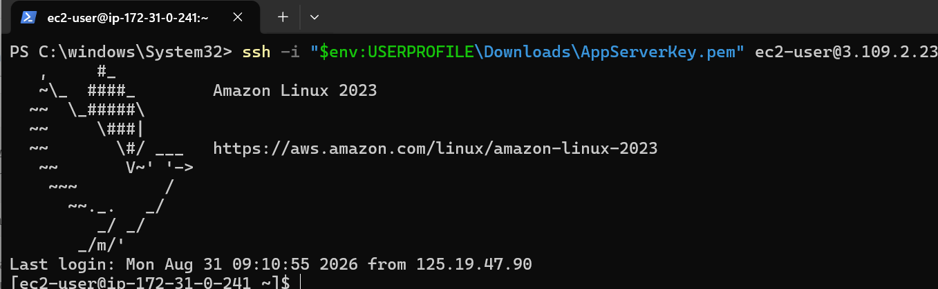

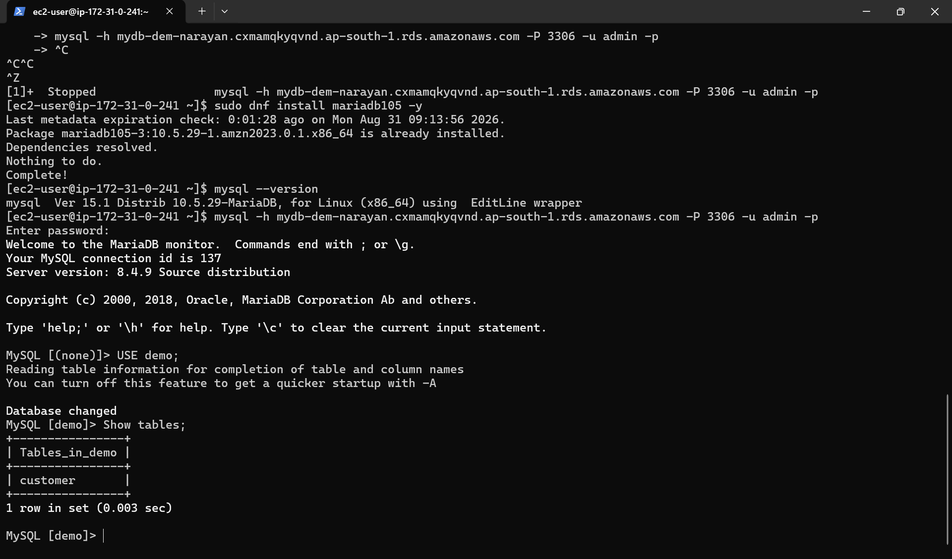

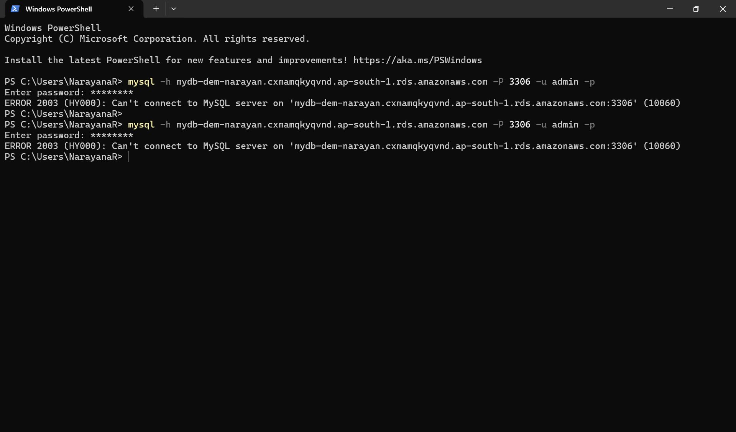

Task 04:

Now lets create a project Terraform

Terraform-aws-demo
Project structure

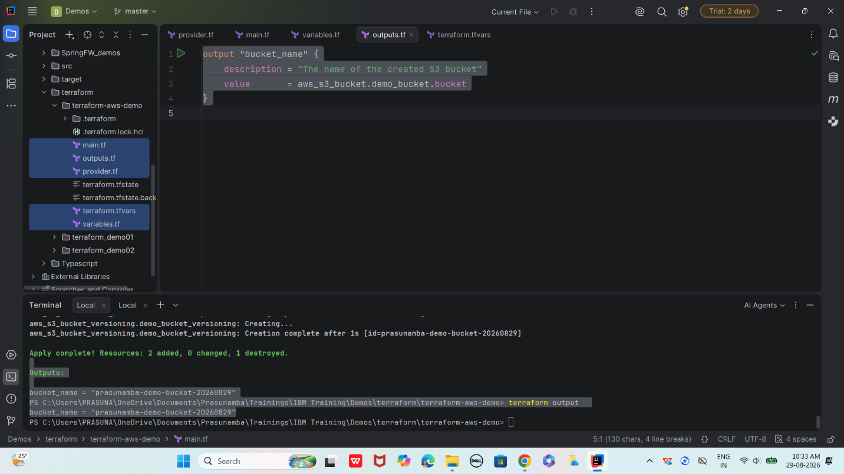

Step 1:

Create provider.tf

provider "aws" {
region = "ap-south-2"
}

variables.tf

variable "bucket_name" {
description = "Name of the Prasunamba's S3 bucket"
type = string
default = "prasunamba-demo-bucket-20260829"
}

main.tf

resource "aws_s3_bucket" "demo_bucket" {
bucket = var.bucket_name

tags = {
Name = var.bucket_name
Environment = "Demo"
Owner = "Prasunamba"
}
}

# Enable versioning (optional, production-style)
resource "aws_s3_bucket_versioning" "demo_bucket_versioning" {
bucket = aws_s3_bucket.demo_bucket.id
versioning_configuration {
status = "Enabled"
}
}

Terraform.tfvars

bucket_name = "prasunamba-demo-bucket-20260829"

outputs.tf
output "bucket_name" {
description = "The name of the created S3 bucket"
value = aws_s3_bucket.demo_bucket.bucket
}

Step 2:
1️⃣ Initialize Terraform
This sets up the working directory and downloads the AWS provider plugin.
cmd
terraform init

2️⃣ Validate Configuration
Check if your .tf files are syntactically correct.
cmd
terraform validate
3️⃣ Plan Infrastructure
Preview what Terraform will create before applying.
cmd
terraform plan
4️⃣ Apply Infrastructure
Actually create the S3 bucket in AWS.
cmd
terraform apply
Terraform will ask for confirmation:
Code
Do you want to perform these actions?
Terraform will perform the actions described above.
Only 'yes' will be accepted to approve.

Enter a value: yes
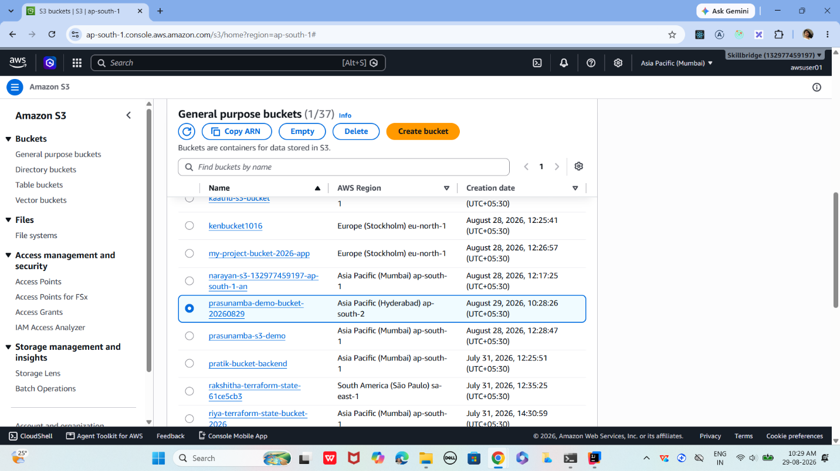
5️⃣ Output Values (Optional)
If you define outputs in outputs.tf, you can view them:
cmd
terraform output
Example outputs.tf:
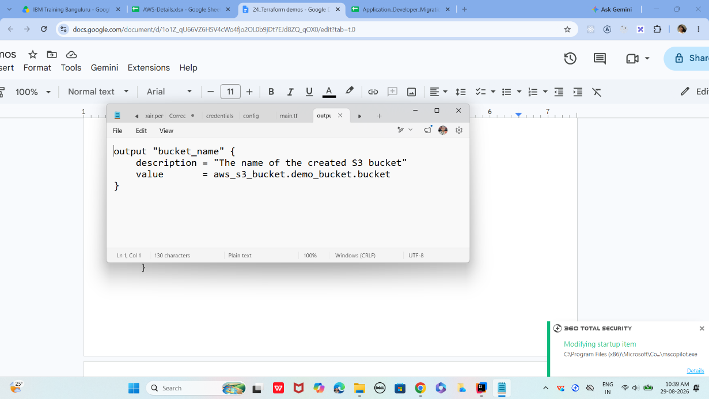

Plz dont destroy..
Task 05 is in continuation with task 4
6️⃣ Destroy Infrastructure (Cleanup)
When you’re done, remove everthing:
cmd
terraform destroy
Confirmation prompt:
Code
Do you really want to destroy all resources?
Only 'yes' will be accepted to confirm.

Enter a value: yes
So far covered
- Providers (connect to cloud APIs)
- Resources (define infrastructure objects)
- Workflow (init → plan → apply → destroy)
full lifecycle demo: init → validate → plan → apply → output → destroy

