(006CP2744): Day 35 - 02nd Sept 2026

Task 1:

Docker Swarm is Docker’s native clustering and orchestration tool, letting you manage multiple Docker nodes as a single virtual system. lets start with a single-node swarm and scale to multi-node clusters for production.
Step 1:
Docker version – check
Swarm mode requires Docker Engine installed on all participating nodes.
C:\Users\PRASUNA>docker --version
Docker version 29.7.2, build a7dcaa6

Step 2:
Now lets Initialize Swarm Mode // ensure docker engine in running..
Enable swarm mode on your first node, which becomes the manager.
docker swarm init

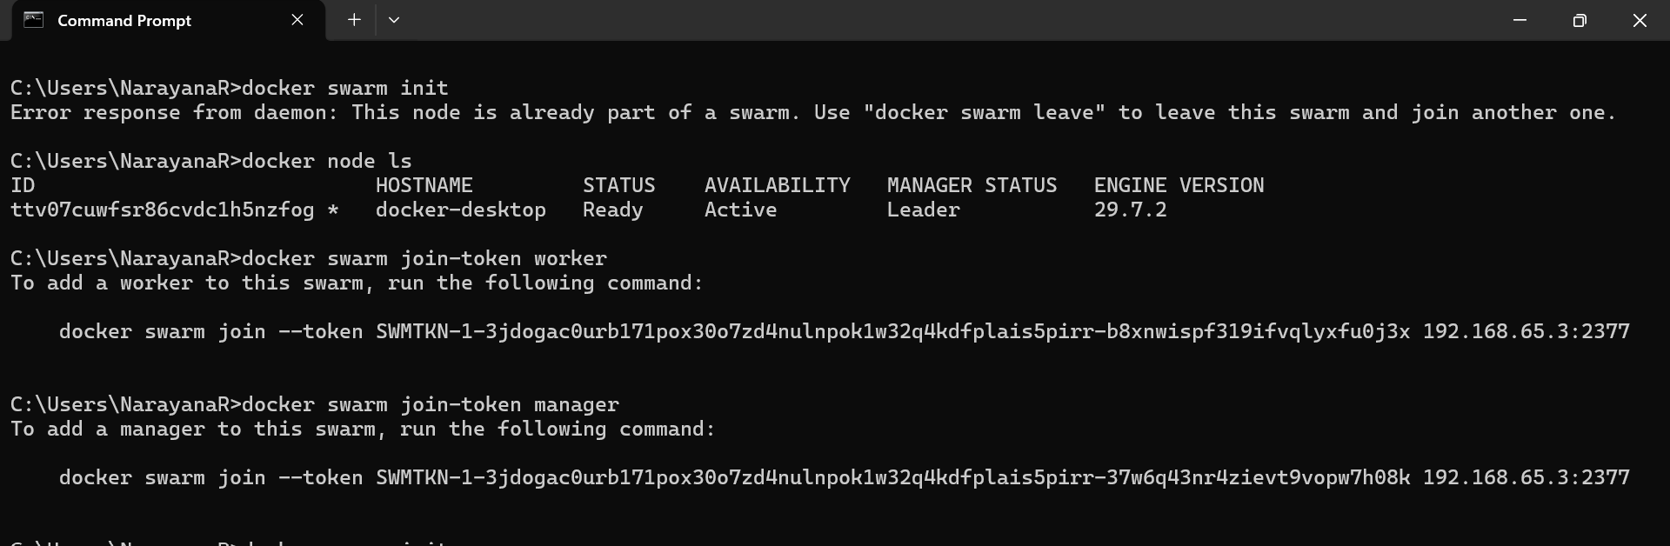

- This sets the current node as manager
For me (ttv07cuwfsr86cvdc1h5nzfog) is the manager

To add a worker to this swarm, run the following command:

docker swarm join --token SWMTKN-1-3jdogac0urb171pox30o7zd4nulnpok1w32q4kdfplais5pirr-b8xnwispf319ifvqlyxfu0j3x 192.168.65.3:2377

To add a manager to this swarm, run the following command:

docker swarm join --token SWMTKN-1-3jdogac0urb171pox30o7zd4nulnpok1w32q4kdfplais5pirr-37w6q43nr4zievt9vopw7h08k 192.168.65.3:2377

- Creates default overlay network ingress

Step 03:
Add Worker Nodes
Join additional nodes to expand the swarm cluster.
Run docker swarm join --token <token> <manager-ip>:2377
Like
docker swarm join --token SWMTKN-1-2cjadejmuhkx5ulb5qe885x1ysz5zvq4aj3p8w9b0a01mz56r3-dzpy756d8j8ks8ommwnb9ybk9 192.168.65.3:2377
Incase of error : Error response from daemon: This node is already part of a swarm. Use "docker swarm leave" to leave this swarm and join another one.

Use docker swarm leave --force command to forcely leave
Again initialize docker swarm init
Then run join command
Now again use above join command..
- Use the token provided by docker swarm init
- Replace <manager-ip> with manager’s IP
- Workers will now accept tasks from manager

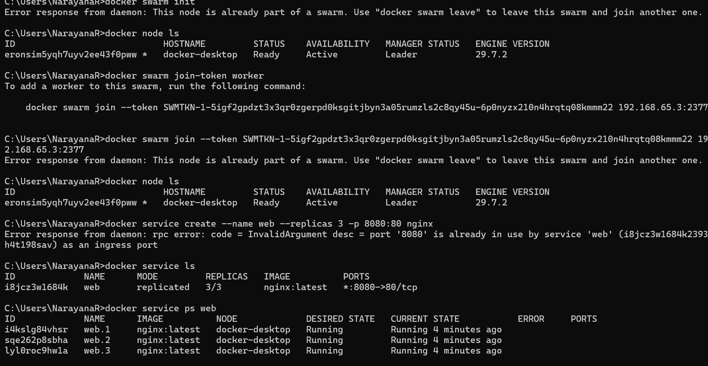

C:\Users\NarayanaR>docker service create --name web --replicas 3 -p 8080:80 nginx
Error response from daemon: rpc error: code = InvalidArgument desc = port '8080' is already in use by service 'web' (i8jcz3w1684k2393h4t198sav) as an ingress port

C:\Users\NarayanaR>docker service ls
ID NAME MODE REPLICAS IMAGE PORTS
i8jcz3w1684k web replicated 3/3 nginx:latest *:8080->80/tcp

C:\Users\NarayanaR>docker service ps web
ID NAME IMAGE NODE DESIRED STATE CURRENT STATE ERROR PORTS
i4kslg84vhsr web.1 nginx:latest docker-desktop Running Running 4 minutes ago
sqe262p8sbha web.2 nginx:latest docker-desktop Running Running 4 minutes ago
lyl0roc9hw1a web.3 nginx:latest docker-desktop Running Running 4 minutes ago

C:\Users\NarayanaR>docker service create --name web nginx
Error response from daemon: rpc error: code = AlreadyExists desc = name conflicts with an existing object: service web already exists

C:\Users\NarayanaR>docker service create --name web --replicas 3 nginx
Error response from daemon: rpc error: code = AlreadyExists desc = name conflicts with an existing object: service web already exists

C:\Users\NarayanaR>docker service ls
ID NAME MODE REPLICAS IMAGE PORTS
i8jcz3w1684k web replicated 3/3 nginx:latest *:8080->80/tcp

C:\Users\NarayanaR>docker service scale web=3
web scaled to 3
overall progress: 3 out of 3 tasks
1/3: running [==================================================>]
2/3: running [==================================================>]
3/3: running [==================================================>]
verify: Service web converged

C:\Users\NarayanaR>docker service ps web
ID NAME IMAGE NODE DESIRED STATE CURRENT STATE ERROR PORTS
i4kslg84vhsr web.1 nginx:latest docker-desktop Running Running 18 minutes ago
sqe262p8sbha web.2 nginx:latest docker-desktop Running Running 18 minutes ago
lyl0roc9hw1a web.3 nginx:latest docker-desktop Running Running 18 minutes ago

C:\Users\NarayanaR>

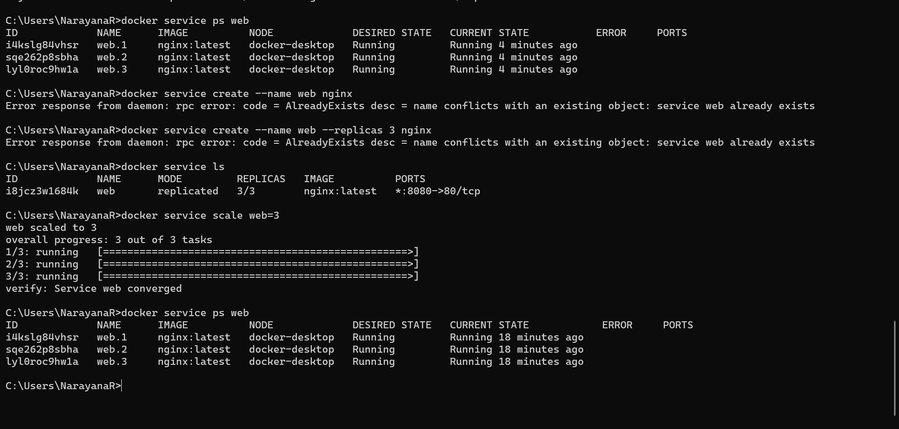

05
Manage and Monitor
Check swarm health and manage services.
Run docker node ls and docker service ps <service>
- docker node ls shows all nodes
- docker service ps shows running tasks
- Use docker service rm <service> to remove services
Sources:
# List all nodes in the swarm
docker node ls

# Show tasks running for a specific service
docker service ps <service-name>

# Remove a service from the swarm
docker service rm <service-name>

# Inspect details of a service
docker service inspect <service-name>

# Scale a service to a desired number of replicas
docker service scale <service-name>=<replica-count>

# List all services running in the swarm
docker service ls

Key Concepts to note
- Manager Node: Controls the swarm, schedules tasks.
- Worker Node: Executes tasks assigned by the manager.
- Service: Defines how containers run across the swarm.
- Overlay Network: Enables communication between containers on different nodes.
Common Commands
- docker swarm init → Start swarm mode.
- docker swarm join → Add nodes.
- docker service create → Deploy services.
- docker service scale → Scale replicas.
- docker node ls → List nodes.
Advertise
bash
docker swarm init --advertise-addr <manager-ip>

is used to initialize a swarm and explicitly tell Docker which IP address the manager should advertise to other nodes.

Why Swarm is Useful
- Cluster management → Combine multiple machines into one swarm cluster.
- Service deployment → Run containers as services that can be scaled and updated easily.
- Load balancing → Traffic is automatically distributed across replicas.
- High availability → If one node fails, tasks are rescheduled on healthy nodes.
- Rolling updates → Update services without downtime.
- Networking → Overlay networks allow containers on different nodes to communicate securely.

