(006CP2744): Day 36 - 03rd Sept 2026

KUBERNETES TASK 1

==========================
1. Cluster Architecture
==========================

Q1 (In Session):
Explain the difference between the control plane and worker nodes in a Kubernetes cluster.

Answer:
The Control Plane is responsible for managing the Kubernetes cluster. It makes decisions about scheduling, maintaining desired state, and handling cluster operations. Key components include the API Server, Scheduler, Controller Manager, and etcd.

Worker Nodes are the machines where application workloads run. They contain components such as kubelet, kube-proxy, and container runtime, which execute and manage pods.

In short:
- Control Plane = Manages and controls the cluster.
- Worker Nodes = Run the actual applications.

Q2 (Home Task):
Why is this separation important?

Answer:
Separating the Control Plane from Worker Nodes improves scalability, security, reliability, and performance. The Control Plane can focus on cluster management while Worker Nodes focus on running applications. This design prevents application workloads from affecting cluster management functions and enables independent scaling of infrastructure components.

==========================
2. Pods & Containers
==========================

Q1 (In Session):
What role do pods play in Kubernetes, and how are they different from containers?

Answer:
A Pod is the smallest deployable unit in Kubernetes. It can contain one or more containers that share the same network, storage, and execution environment.

Difference:
- Container = Runs a specific application process.
- Pod = Wrapper around one or more containers, providing shared networking and storage.

Q2 (Home Task):
Why are pods considered ephemeral?

Answer:
Pods are considered ephemeral because they are temporary and can be created, terminated, or replaced at any time. If a pod fails, Kubernetes typically creates a new pod instead of repairing the existing one. Therefore, applications should not rely on pod-specific local storage for persistent data.

==========================
3. Networking & Services
==========================

Q1 (In Session):
How does a Kubernetes Service enable communication between pods?

Answer:
A Kubernetes Service provides a stable IP address and DNS name for a group of pods. Since pod IP addresses can change when pods are recreated, the Service acts as a permanent access point and automatically routes traffic to healthy pods using label selectors.

Q2 (Home Task):
Compare the use cases for ClusterIP, NodePort, and LoadBalancer services.

Answer:

1. ClusterIP
- Default service type.
- Accessible only within the cluster.
- Used for internal communication between services.

2. NodePort
- Exposes the service on a specific port on every node.
- Accessible from outside the cluster using NodeIP:Port.
- Useful for development and testing environments.

3. LoadBalancer
- Uses a cloud provider's external load balancer.
- Provides a public IP address for external access.
- Commonly used for production applications.

==========================
4. Deployments & Scaling
==========================

Q1 (In Session):
What problem does a Deployment solve in Kubernetes?

Answer:
A Deployment manages application updates and ensures the desired number of pod replicas are running. It supports rolling updates, rollbacks, self-healing, and automatic replacement of failed pods.

Q2 (Home Task):
How does Kubernetes handle scaling applications up and down?

Answer:
Kubernetes scales applications by adjusting the number of pod replicas.

- Scaling Up: Increases replicas to handle higher traffic.
- Scaling Down: Reduces replicas when demand decreases.

This can be done manually using Deployment settings or automatically through the Horizontal Pod Autoscaler (HPA), which monitors CPU or memory usage.

==========================
5. Storage & Persistence
==========================

Q1 (In Session):
Describe how Persistent Volumes (PV) and Persistent Volume Claims (PVC) work together.

Answer:
A Persistent Volume (PV) is a storage resource provided by the cluster administrator.

A Persistent Volume Claim (PVC) is a request for storage made by a user or application.

Workflow:
1. Administrator creates a PV.
2. Application creates a PVC requesting storage.
3. Kubernetes binds the PVC to a matching PV.
4. The pod uses the storage through the PVC.

Q2 (Home Task):
Why is this abstraction necessary for stateful applications?

Answer:
The PV-PVC abstraction separates storage management from application requirements. Stateful applications such as databases need persistent data even when pods restart or move to different nodes. This abstraction allows applications to use storage without needing to know the underlying storage implementation.

==========================
6. Configuration Management
==========================

Q1 (In Session):
How do ConfigMaps and Secrets differ in purpose and usage?

Answer:

ConfigMaps:
- Store non-sensitive configuration data.
- Examples: application settings, URLs, environment variables.

Secrets:
- Store sensitive information.
- Examples: passwords, API keys, tokens, certificates.
- Data is encoded and handled more securely than ConfigMaps.

Q2 (Home Task):
What are best practices for managing sensitive data in Kubernetes?

Answer:
- Use Secrets instead of ConfigMaps for sensitive information.
- Enable encryption at rest for Secrets.
- Restrict access using RBAC.
- Avoid storing secrets directly in source code.
- Rotate credentials regularly.
- Use external secret management tools such as Azure Key Vault, HashiCorp Vault, or AWS Secrets Manager when possible.

==========================
7. Scheduling & Resource Management
==========================

Q1 (In Session):
How does the Kubernetes scheduler decide which node a pod should run on?

Answer:
The Kubernetes Scheduler evaluates available nodes and selects the most suitable node for the pod based on resource availability and scheduling requirements.

The scheduler checks:
- CPU and memory requirements.
- Node conditions.
- Affinity and anti-affinity rules.
- Taints and tolerations.
- Resource policies.

Q2 (Home Task):
What factors influence scheduling decisions?

Answer:
Factors include:
- Available CPU and memory.
- Resource requests and limits.
- Node labels and selectors.
- Pod affinity and anti-affinity.
- Taints and tolerations.
- Storage requirements.
- Network constraints.
- Overall cluster workload balance.

==========================
8. Self-Healing & Automation
==========================

Q1 (In Session):
What mechanisms does Kubernetes use to ensure workloads remain available when pods or nodes fail?

Answer:
Kubernetes uses several self-healing mechanisms:
- Automatically restarts failed containers.
- Recreates failed pods.
- Reschedules pods to healthy nodes.
- Uses ReplicaSets to maintain the desired number of replicas.
- Performs readiness and liveness health checks.
- Replaces unhealthy instances automatically.

Q2 (Home Task):
How does this contribute to high availability?

Answer:
These self-healing capabilities minimize downtime by automatically recovering from failures without manual intervention. Multiple replicas can run across different nodes, ensuring that if one pod or node fails, users continue accessing the application through remaining healthy instances, thereby maintaining high availability.

Task 2:

Step 1:

Enable Virtualization & WSL2
Kubernetes requires virtualization and a Linux kernel environment.
Control Panel → Programs → Turn Windows features on/off
- Ensure Virtualization is enabled in BIOS
- Turn on Windows Subsystem for Linux and Virtual Machine Platform

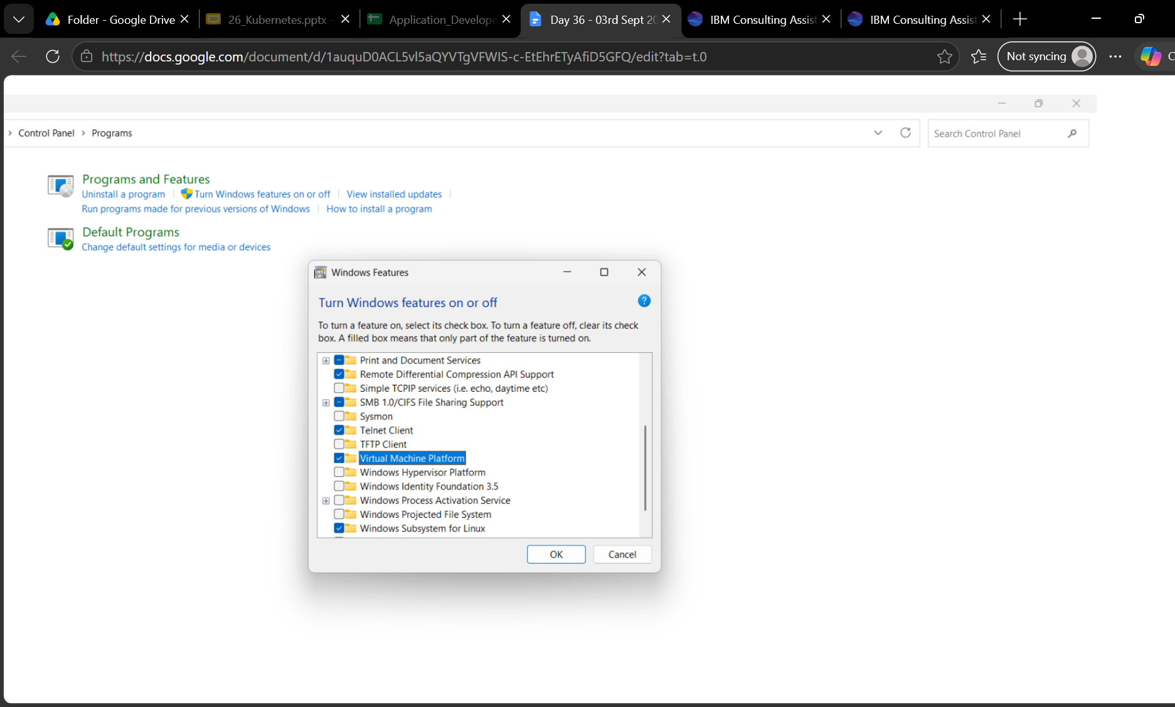

- Install WSL2 kernel update from Microsoft
wsl --install
- Set default version: PRASUNA>wsl --set-default-version 2
wsl --version → chek for version

Step 2:
Check for docker install

Step 3:
Enable Kubernetes in Docker Desktop
Most Common Setup
Docker Desktop can run a single-node Kubernetes cluster.
Docker Desktop → Settings → Kubernetes
- Check Enable Kubernetes
- Apply & restart Docker Desktop
- Wait until Kubernetes shows as Running

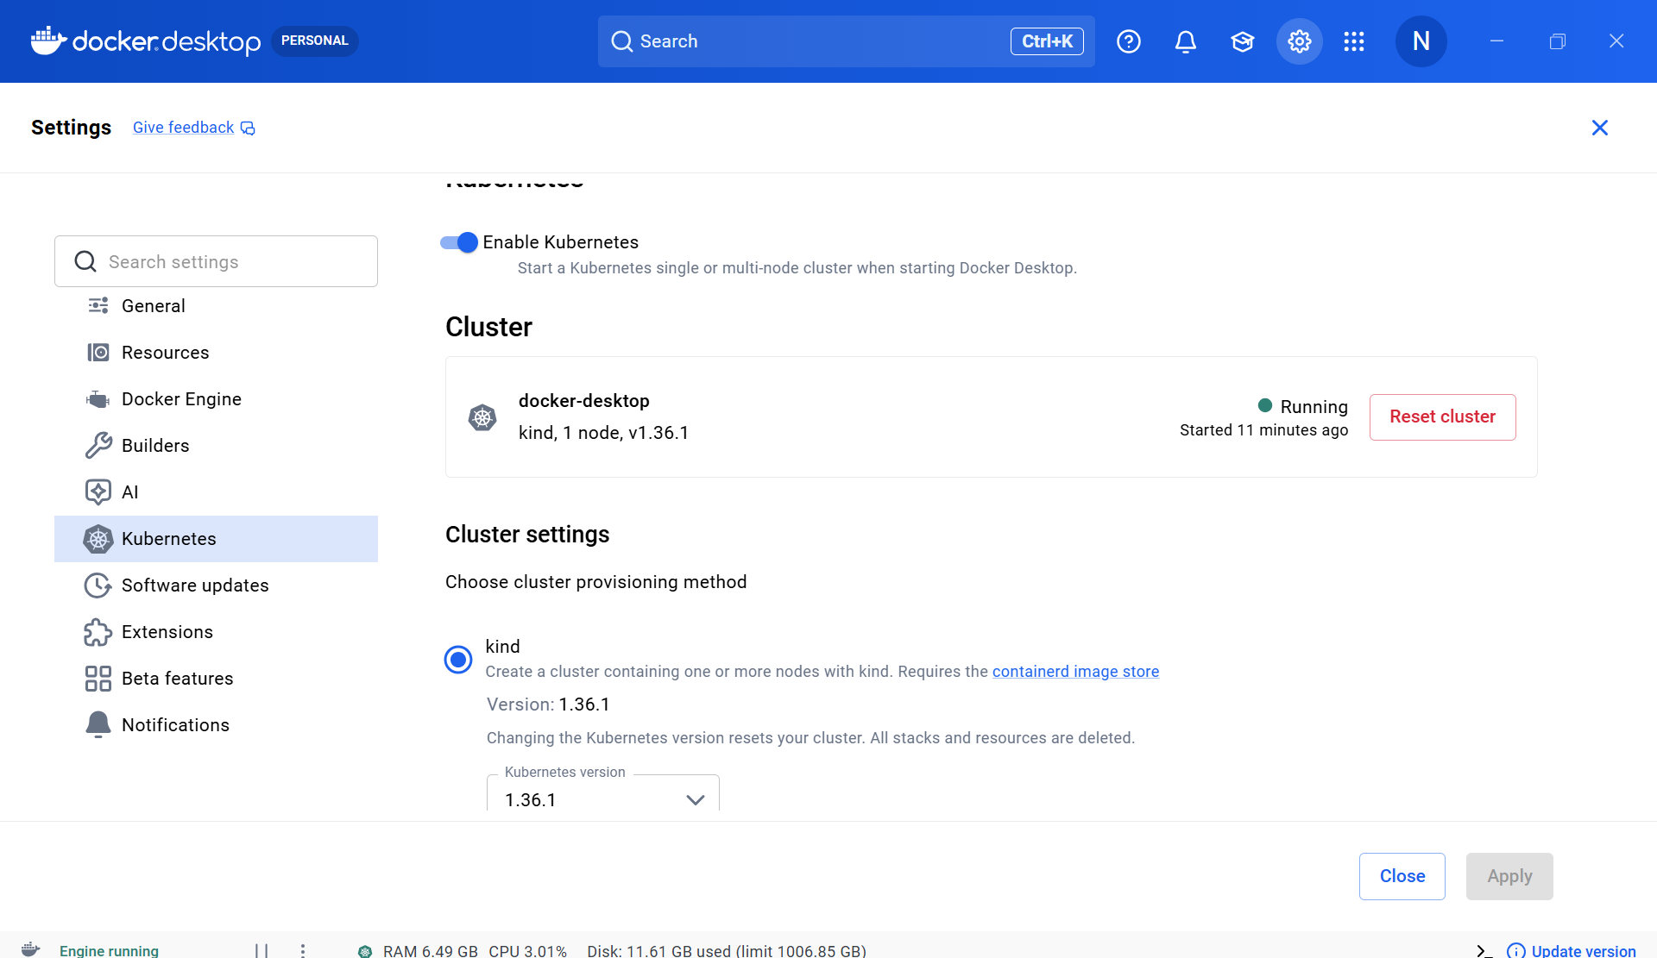

Check
kubectl version --client
kubectl get nodes
You should see your local node listed as Ready.
This confirms Kubernetes is active inside Docker Desktop.

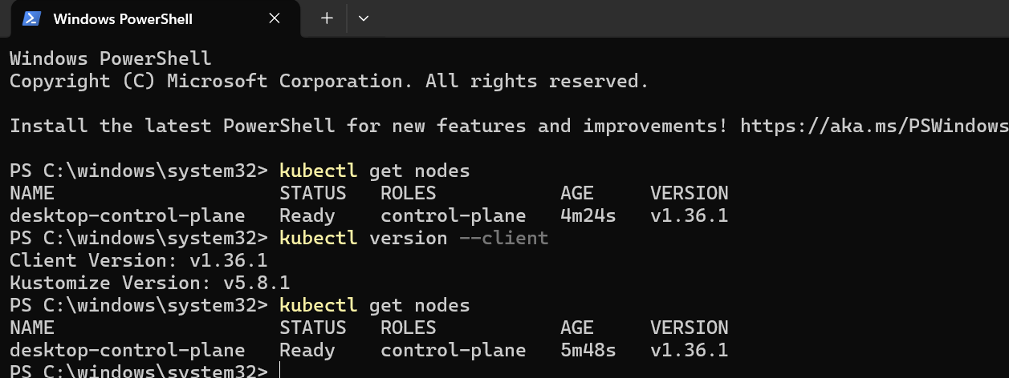

Step 4L:
Install kubectl CLI
kubectl is the command-line tool to interact with Kubernetes.
Windows Terminal / PowerShell
- Install via Chocolatey: >choco install kubernetes-cli

- Verify : kubectl version --client

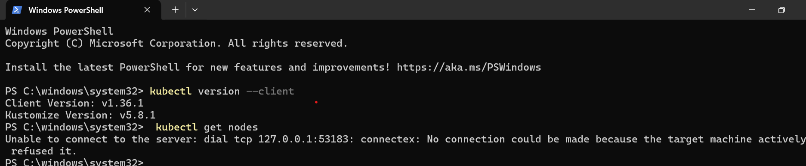

Step 5:
Verify Cluster Setup
Confirm Kubernetes is running correctly.
Windows Terminal / PowerShell
- Run kubectl cluster-info
- Run kubectl get nodes → should show docker-desktop node as Ready

PS C:\windows\system32> kubectl cluster-info
>> kubectl get nodes
Kubernetes control plane is running at https://127.0.0.1:53183
CoreDNS is running at https://127.0.0.1:53183/api/v1/namespaces/kube-system/services/kube-dns:dns/proxy

To further debug and diagnose cluster problems, use 'kubectl cluster-info dump'.
NAME STATUS ROLES AGE VERSION
desktop-control-plane Ready control-plane 19m v1.36.1
PS C:\windows\system32>
STep 6:

Optional: Use Minikube
Alternative Method
Minikube provides a flexible local Kubernetes cluster.
Windows Terminal / PowerShell
- Install Minikube: choco install minikube
- Start cluster: minikube start --driver=docker
- Verify: kubectl get nodes
- Launch dashboard: minikube dashboard

Task 3:
Using minikube

01
Install Minikube
Minikube lets you run a local Kubernetes cluster for practice.

Download from https://minikube.sigs.k8s.io/docs/start/

Install VirtualBox or Hyper-V (needed for VM backend)

Run choco install minikube (Windows with Chocolatey)

Verify with minikube version

C:\Windows\System32>minikube version
minikube version: v1.38.1
commit: c93a4cb9311efc66b90d33ea03f75f2c4120e9b0

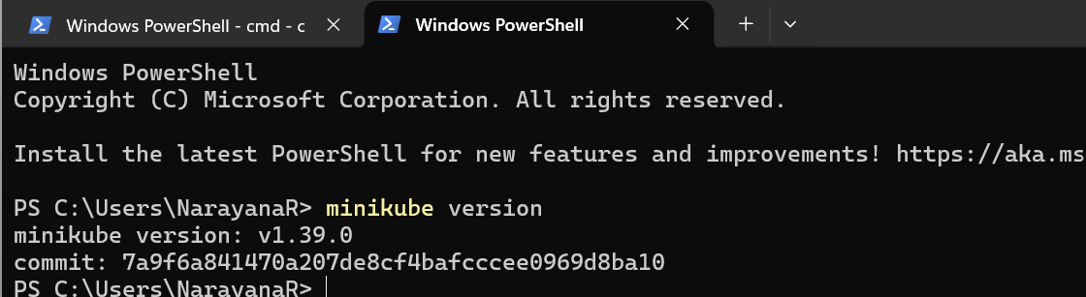

02
Start Minikube Cluster
This launches a single-node Kubernetes cluster locally.

Run in PowerShell or CMD

minikube start --driver=hyperv (or virtualbox)

Wait until it shows Kubernetes cluster is running

PS C:\WINDOWS\system32> minikube start --driver=docker
>>
* minikube v1.38.1 on Microsoft Windows 11 Home Single Language 25H2
* Using the docker driver based on user configuration
! Starting v1.39.0, minikube will default to "containerd" container runtime. See #21973 for more info.
* Using Docker Desktop driver with root privileges
* Starting "minikube" primary control-plane node in "minikube" cluster
* Pulling base image v0.0.50 ...
* Downloading Kubernetes v1.35.1 preload ...
> preloaded-images-k8s-v18-v1...: 272.45 MiB / 272.45 MiB 100.00% 530.11
> gcr.io/k8s-minikube/kicbase...: 519.58 MiB / 519.58 MiB 100.00% 709.25
* Creating docker container (CPUs=2, Memory=4000MB) ...
* Preparing Kubernetes v1.35.1 on Docker 29.2.1 ...
* Configuring bridge CNI (Container Networking Interface) ...
* Verifying Kubernetes components...
- Using image gcr.io/k8s-minikube/storage-provisioner:v5
* Enabled addons: storage-provisioner, default-storageclass

! C:\ProgramData\chocolatey\bin\kubectl.exe is version 1.37.0, which may have incompatibilities with Kubernetes 1.35.1.
- Want kubectl v1.35.1? Try 'minikube kubectl -- get pods -A'
* Done! kubectl is now configured to use "minikube" cluster and "default" namespace by default
PS C:\WINDOWS\system32>

Verify with kubectl cluster-info

m32> kubectl cluster-info
>>
Kubernetes control plane is running at https://127.0.0.1:57672
CoreDNS is running at https://127.0.0.1:57672/api/v1/namespaces/kube-system/services/kube-dns:dns/proxy

To further debug and diagnose cluster problems, use 'kubectl cluster-info dump'.

Check
kubectl get nodes

2> kubectl get nodes
>>
NAME STATUS ROLES AGE VERSION
minikube Ready control-plane 55m v1.35.1
PS C:\WINDOWS\system32>

Check system pods..

kubectl get pods -n kube-system

S\system32> kubectl get pods -n kube-system
>>
NAME READY STATUS RESTARTS AGE
coredns-7d764666f9-2cslp 1/1 Running 0 55m
etcd-minikube 1/1 Running 0 55m
kube-apiserver-minikube 1/1 Running 0 55m
kube-controller-manager-minikube 1/1 Running 0 55m
kube-proxy-v95cf 1/1 Running 0 55m
kube-scheduler-minikube 1/1 Running 0 55m
storage-provisioner 1/1 Running 1 (55m ago) 55m

kubectl create deployment hello-world --image=nginx
kubectl get pods

This ensures workloads can be scheduled and started.

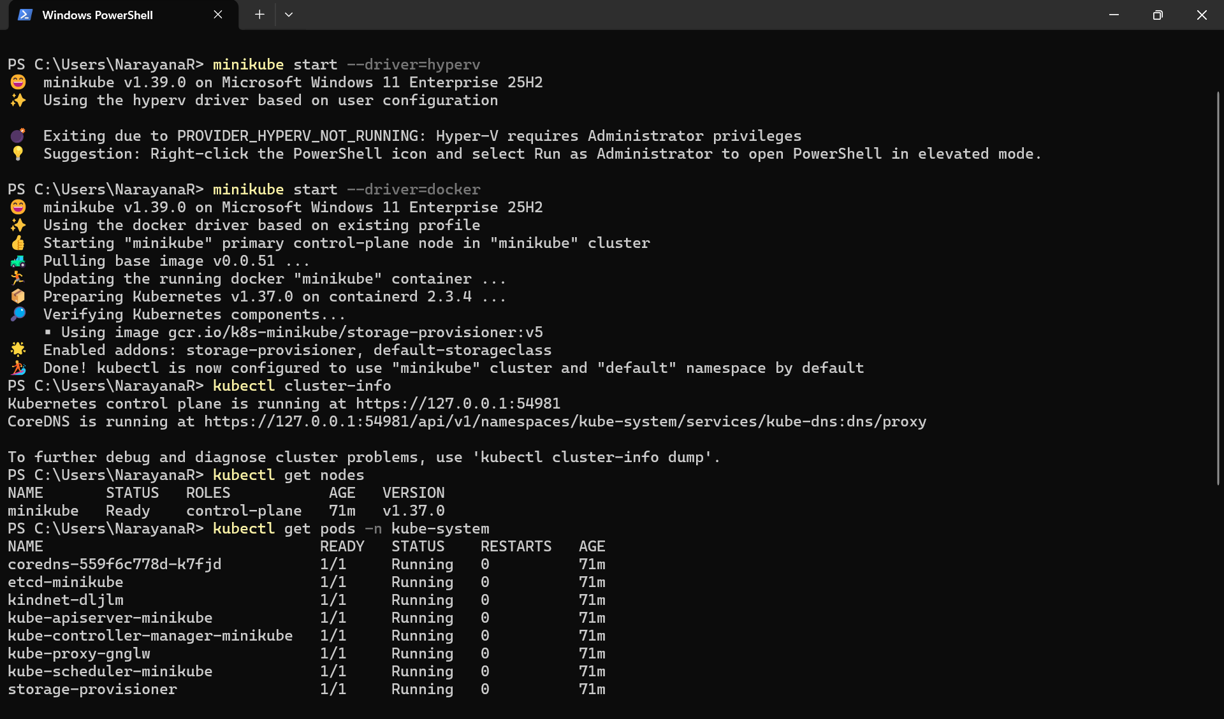

03
Create a Pod
Pods are the smallest deployable unit in Kubernetes.

Run in PowerShell or CMD

kubectl run nginx-pod --image=nginx --restart=Never
em32> kubectl run nginx-pod --image=nginx --restart=Never
pod/nginx-pod created

Check with kubectl get pods

m32> kubectl get pods
>>
NAME READY STATUS RESTARTS AGE
hello-world-86df7f6cdb-zb8t7 1/1 Running 0 91s
nginx-pod 1/1 Running 0 30s

Describe with kubectl describe pod nginx-pod
C:\WINDOWS\system32> kubectl describe pod nginx-pod
Name: nginx-pod
Namespace: default
Priority: 0
Service Account: default
Node: minikube/192.168.49.2
Start Time: Thu, 03 Sep 2026 13:59:03 +0530
Labels: run=nginx-pod
Annotations: <none>
Status: Running
IP: 10.244.0.4
IPs:
IP: 10.244.0.4
Containers:
nginx-pod:
Container ID: docker://a6fb5296a0c5aa876972efb27b28ef8bbc2f4676405694d71ad6c3c4e0c0c85b
Image: nginx
Image ID: docker-pullable://nginx@sha256:dd0e2565131859c7fefc0cc0cb90fd31e9cc3bfa39e4516e82c183ec1916d332
Port: <none>
Host Port: <none>
State: Running
Started: Thu, 03 Sep 2026 13:59:06 +0530
Ready: True
Restart Count: 0
Environment: <none>
Mounts:
/var/run/secrets/kubernetes.io/serviceaccount from kube-api-access-xqjxp (ro)
Conditions:
Type Status
PodReadyToStartContainers True
Initialized True
Ready True
ContainersReady True
PodScheduled True
Volumes:
kube-api-access-xqjxp:
Type: Projected (a volume that contains injected data from multiple sources)
TokenExpirationSeconds: 3607
ConfigMapName: kube-root-ca.crt
Optional: false
DownwardAPI: true
QoS Class: BestEffort
Node-Selectors: <none>
Tolerations: node.kubernetes.io/not-ready:NoExecute op=Exists for 300s
node.kubernetes.io/unreachable:NoExecute op=Exists for 300s
Events:
Type Reason Age From Message
---- ------ ---- ---- -------
Normal Scheduled 58s default-scheduler Successfully assigned default/nginx-pod to minikube
Normal Pulling 57s kubelet spec.containers{nginx-pod}: Pulling image "nginx"
Normal Pulled 55s kubelet spec.containers{nginx-pod}: Successfully pulled image "nginx" in 2.194s (2.194s including waiting). Image size: 170059427 bytes.
Normal Created 55s kubelet spec.containers{nginx-pod}: Container created
Normal Started 55s kubelet spec.containers{nginx-pod}: Container started
PS C:\WINDOWS\system32>

