(006CP2744): Day 37 - 04th Sept 2026

Task 1:

1. Install Python
- Download Python (3.10 or later) from python.org.
- During installation, check “Add Python to PATH”.
Verify:
cmd
python --version

2. Install Ansible via Pip
Ansible is not officially packaged for Windows, but you can install it using pip:
cmd
pip install ansible

Check installation:
cmd
ansible --version

3. Prepare Inventory File
Create a file inventory.ini in your working directory:
ini
- [web]
- 192.168.1.101
- [db]
- 192.168.1.102

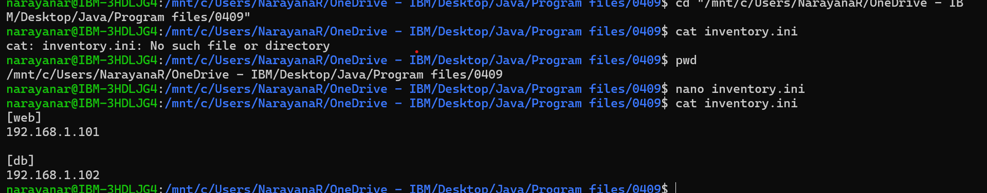

4. Write a Playbook
Create site.yml:
yaml
- - name: Install IIS on Windows
- hosts: web
- tasks:
- - name: Ensure IIS is installed
- win_feature:
- name: Web-Server
- state: present

👉 Notice: On Windows targets, you use WinRM instead of SSH, and modules like win_feature, win_service, etc.

5. Configure WinRM on Target Windows Machines
Run this on each managed node (PowerShell as Admin):
powershell
- winrm quickconfig
- winrm set winrm/config/service/Auth @{Basic="true"}
- winrm set winrm/config/service @{AllowUnencrypted="true"}

6. Run the Playbook
From CMD/Powershell on your control node:
cmd
- ansible-playbook -i inventory.ini site.yml

7. Verify Results
Check IIS service on target:
powershell
- Get-Service W3SVC

Task 2:
📂 Project Structure (Windows Automation)
Code
ansible-windows-project/
├── inventory.ini
├── site.yml
├── roles/
│ └── windows_iis/
│ ├── tasks/
│ │ └── main.yml
│ ├── vars/
│ │ └── main.yml
│ ├── handlers/
│ │ └── main.yml
│ ├── templates/
│ │ └── index.html.j2
│ └── files/
│ └── custom-config.xml

🗂 Inventory File (inventory.ini)
ini
[windows]
192.168.1.101 ansible_user=Administrator ansible_password=YourPassword ansible_connection=winrm ansible_winrm_transport=basic

📜 Master Playbook (site.yml)
yaml
- name: Configure Windows IIS Server
hosts: windows
roles:
- windows_iis

🧩 Role: windows_iis
🔹 Tasks (roles/windows_iis/tasks/main.yml)
yaml
- name: Install IIS Web Server
win_feature:
name: Web-Server
state: present

- name: Deploy custom homepage
template:
src: index.html.j2
dest: C:\inetpub\wwwroot\index.html
notify: Restart IIS

🔹 Variables (roles/windows_iis/vars/main.yml)
yaml
homepage_title: "Welcome to Ansible Automated IIS"
homepage_message: "This IIS server was configured using Ansible on Windows."

🔹 Handlers (roles/windows_iis/handlers/main.yml)
yaml
- name: Restart IIS
win_service:
name: W3SVC
state: restarted

🔹 Template (roles/windows_iis/templates/index.html.j2)
html
<html>
<head>
<title>{{ homepage_title }}</title>
</head>
<body>
<h1>{{ homepage_message }}</h1>
</body>
</html>

🚀 Execution Flow Recap (Windows)
- Install Python + Ansible on control node.
- Configure WinRM on managed Windows servers.
- Define inventory with credentials.
- Write playbook calling roles.
Run playbook:
cmd
ansible-playbook -i inventory.ini site.yml
- Verify IIS service and homepage deployment.

—-----------------------------------------------
Task 3:
Install jdk 21 or 25
Install jenkins using this link
https://www.oracle.com/in/java/technologies/downloads/#jdk25-windows
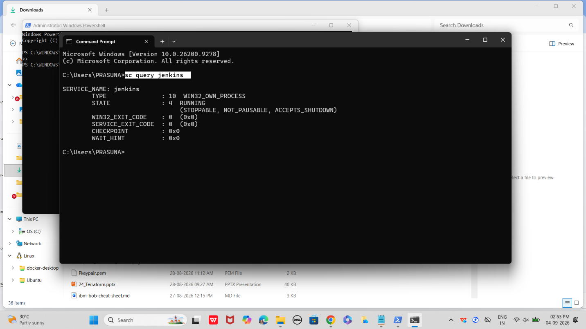

2
Configure Jenkins
Unlock Jenkins and install required plugins.
- Use initial admin password from /var/lib/jenkins/secrets/initialAdminPassword
- Install suggested plugins (Git, Pipeline, Docker, Kubernetes)
- Create admin user for Jenkins dashboard
3
Connect Source Code
Integrate Jenkins with GitHub or GitLab repository.
- Install Git plugin
- Create a new Jenkins job (Pipeline)
- Provide repository URL and credentials
- Enable webhooks for automatic build triggers
4
Write Jenkinsfile
Core
Define pipeline stages in a Jenkinsfile stored in your repo.
Example Jenkinsfile:
Code
pipeline {
agent any
stages {
stage('Build') {
steps { sh 'mvn clean package' }
}
stage('Dockerize') {
steps { sh 'docker build -t myapp .' }
}
stage('Push Image') {
steps { sh 'docker push myrepo/myapp' }
}
stage('Deploy') {
steps { sh 'kubectl apply -f k8s/deployment.yaml' }
}
}
}

- Stage 1: Build with Maven
- Stage 2: Create Docker image
- Stage 3: Push image to registry
- Stage 4: Deploy to Kubernetes
5
Add Credentials
Securely store DockerHub and Kubernetes credentials.
- Go to Jenkins → Manage Credentials
- Add DockerHub username/password
- Add Kubernetes cluster config
- Reference credentials in Jenkinsfile
6
Run Pipeline
Trigger the pipeline and observe execution.
- Commit Jenkinsfile to repo
- Push code to GitHub → webhook triggers Jenkins
- Jenkins executes stages sequentially
- Verify build logs and deployment status
7
Verify Deployment
Final
Confirm application is running in Kubernetes cluster.
- Run kubectl get pods to check status
- Access service via NodePort/Ingress
- Validate application functionality
📝 Key Notes for Beginners
- Jenkinsfile is the heart of CI/CD — it defines the flow.
- Always test locally first (Maven build, Docker image run) before automating.
- Use credentials binding instead of hardcoding secrets.
- Start small: build → dockerize → deploy. Later add tests, monitoring, rollback.
—-----------------------

Great — let’s extend our Jenkins CI/CD pipeline demo with Ansible + Kubernetes integration so you see the full flow from code → build → container → deploy.
🔹 Step 1: Jenkinsfile (Pipeline Definition)
Here’s a complete Jenkinsfile with comments:
groovy
pipeline {
agent any

environment {
DOCKER_IMAGE = "myapp:latest"
DOCKER_REGISTRY = "dockerhub_username/myapp"
KUBE_CONFIG = credentials('kubeconfig-cred') // stored in Jenkins
}

stages {
stage('Checkout') {
steps {
// Pull latest code from GitHub
git branch: 'main', url: 'https://github.com/your-repo/myapp.git'
}
}

stage('Build') {
steps {
// Compile & package (example: Maven project)
sh 'mvn clean package'
}
}

stage('Docker Build & Push') {
steps {
// Build Docker image
sh "docker build -t $DOCKER_REGISTRY:$BUILD_NUMBER ."
// Push to DockerHub
sh "docker push $DOCKER_REGISTRY:$BUILD_NUMBER"
}
}

stage('Deploy to Kubernetes') {
steps {
// Use Ansible to apply Kubernetes manifests
sh """
ansible-playbook -i inventory/hosts k8s-deploy.yml \
--extra-vars "image=$DOCKER_REGISTRY:$BUILD_NUMBER"
"""
}
}
}
}

🔹 Step 2: Ansible Playbook (k8s-deploy.yml)
This playbook applies Kubernetes manifests using kubectl.
yaml
- name: Deploy app to Kubernetes
hosts: localhost
tasks:
- name: Apply Deployment
kubernetes.core.k8s:
kubeconfig: "{{ lookup('env','KUBE_CONFIG') }}"
state: present
definition: "{{ lookup('file','deployment.yml') }}"

- name: Apply Service
kubernetes.core.k8s:
kubeconfig: "{{ lookup('env','KUBE_CONFIG') }}"
state: present
definition: "{{ lookup('file','service.yml') }}"

🔹 Step 3: Kubernetes Deployment (deployment.yml)
yaml
apiVersion: apps/v1
kind: Deployment
metadata:
name: myapp-deployment
spec:
replicas: 2
selector:
matchLabels:
app: myapp
template:
metadata:
labels:
app: myapp
spec:
containers:
- name: myapp
image: dockerhub_username/myapp:latest
ports:
- containerPort: 8080

🔹 Step 4: Kubernetes Service (service.yml)
yaml
apiVersion: v1
kind: Service
metadata:
name: myapp-service
spec:
type: NodePort
selector:
app: myapp
ports:
- port: 8080
targetPort: 8080
nodePort: 30080

🚀 End-to-End Flow
- Developer pushes code → GitHub.
- Jenkins pipeline triggers → builds JAR → Docker image → pushes to registry.
- Jenkins calls Ansible → applies Kubernetes manifests.
- Kubernetes runs pods → exposes service at NodePort 30080.
👉 This gives you a realistic beginner-friendly CI/CD pipeline: Jenkins orchestrates, Docker packages, Ansible automates, Kubernetes deploys.
—---------------------

🔹 Step 1: Build the Application
Assume you have a simple Java Spring Boot app.
bash
# Clone your repo
git clone https://github.com/your-repo/myapp.git
cd myapp

# Build with Maven
mvn clean package

👉 Output: target/myapp.jar
🔹 Step 2: Dockerize the App
Create a Dockerfile:
dockerfile
FROM openjdk:17-jdk-slim
WORKDIR /app
COPY target/myapp.jar app.jar
EXPOSE 8080
ENTRYPOINT ["java","-jar","app.jar"]

Build and run locally:
bash
docker build -t myapp:local .
docker run -p 8080:8080 myapp:local

👉 Test at: http://localhost:8080
🔹 Step 3: Push Image to DockerHub
bash
docker login
docker tag myapp:local dockerhub_username/myapp:v1
docker push dockerhub_username/myapp:v1

🔹 Step 4: Kubernetes Manifests
deployment.yml and service.yml (as shown earlier). Apply them manually first:
bash
kubectl apply -f deployment.yml
kubectl apply -f service.yml
kubectl get pods
kubectl get svc

👉 Access app via NodePort → http://<minikube-ip>:30080
🔹 Step 5: Automate with Ansible
Inventory file (inventory/hosts):
ini
[local]
localhost ansible_connection=local

Playbook (k8s-deploy.yml):
yaml
- name: Deploy app to Kubernetes
hosts: local
tasks:
- name: Apply Deployment
command: kubectl apply -f deployment.yml

- name: Apply Service
command: kubectl apply -f service.yml

Run manually:
bash
ansible-playbook -i inventory/hosts k8s-deploy.yml

🔹 Step 6: Connect to Jenkins
Now wire these steps into your Jenkins pipeline (the Jenkinsfile we wrote earlier).
- Jenkins pulls code → builds JAR → builds Docker image → pushes → runs Ansible → deploys to Kubernetes.
- Each stage mirrors the manual commands you just practiced.

