(006CP2744): Day 13 - 03th July 2026

Task 1:
What is an ER diagram? Draw an entity relationship diagram with attributes.

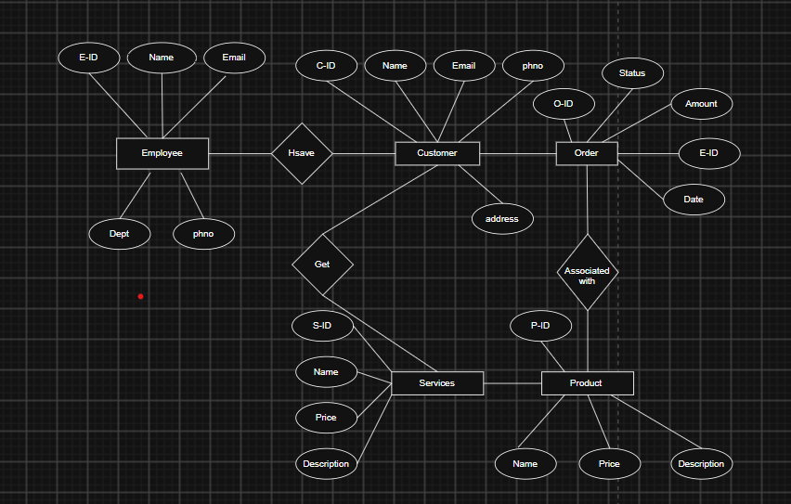

Task 2:
What do you understand by indexing in DBMS? How does it work?

Indexing is a technique used in a Database Management System (DBMS) to speed up the retrieval of records from a database table. An index is a separate data structure that stores the values of one or more columns along with pointers to the corresponding rows in the table.

Task 3:
Do you think Indexing strategy improves the query performance ? explain .

Yes, indexing strategy significantly improves query performance in a DBMS. An effective indexing strategy helps the database locate and retrieve data quickly without scanning the entire table.

When a table contains a large number of records, searching for specific data without an index requires a full table scan, which can be time-consuming.
Without an index, the DBMS checks each row until it finds the required record. With an index on EmployeeID, the database can directly locate the record, greatly reducing search time.
1. Faster Data Retrieval
2. Improved Search Operations
3. Efficient Sorting and Grouping

Task 4:
What are the ACID properties in RDBMS? Explain.

ACID is a set of properties that ensure database transactions are processed reliably and maintain data integrity in a Relational Database Management System (RDBMS).

ACID stands for:
- A – Atomicity: Atomicity ensures that a transaction is completed entirely or not executed at all.
- C – Consistency: Consistency ensures that a transaction takes the database from one valid state to another valid state while following all rules, constraints, and relationships.
- I – Isolation: Isolation ensures that multiple transactions executing simultaneously do not affect each other.
- D – Durability: Durability ensures that once a transaction is committed, its changes are permanently stored in the database.

Download postgresql

https://www.enterprisedb.com/downloads/postgres-postgresql-downloads

or

https://www.postgresql.org/download/windows/

Type postgres -V or postgres --version to check version

Pgadmin GUI - ensure u have it in your systems

Create a database;

Create database BankDB;

Create table

Create table Account {
Id Serial,
custName varchar(10)
};

Insert values to your table

insert into Accounts values (101, 'Prasunamba');
insert into Accounts values (102, 'Mehr');
insert into Accounts values (103, 'K');

Query the details of your table

select * from Accounts;

Drop the table

Drop table Accounts;

Delete all records in a table

Truncate table Accounts;

-- table with a primary key
create table Customer(
id int primary key,
name varchar(20),
age int
);

insert into Customer values (101,'Rama',50);
insert into Customer values (102,'Sita',45);
insert into Customer values (103,'Lakshman',48);

insert into customer values (101, 'Ravan', 55);
Gives an error

ERROR: duplicate key value violates unique constraint "customer_pkey"
Key (id)=(101) already exists.

SQL state: 23505
Detail: Key (id)=(101) already exists.

-- in this begin will begin the transaction.. if there is no error it will commit all the trans ..
-- if error -- rollsback all the trans
begin;
insert into Customer values (104,'Urmila',20);
insert into Customer values (105,'Raghava',45);
insert into Customer values (101,'Lakshman',48); // error..
commit;
rollback;
insert into customer values (101, 'Ravan', 55);

select * from Customer;

101 "Rama" 50
102 "Sita" 45
103 "Lakshman" 48

Only 3 records due to error.

Task 5:
Alter a table to add a column with unique key

ALTER TABLE Accounts
ADD COLUMN email varchar(100) UNIQUE;

Task 6:
Add a check constraint to your column (eg: balance > 0)

ALTER TABLE Accounts
ADD COLUMN balance NUMERIC(10,2);

ALTER TABLE Accounts
ADD CONSTRAINT balance_check
CHECK (balance > 0);

Task 7:
use where clause and check if it works

SELECT *
FROM Accounts
WHERE id = 4;

Task 8:
Use order by

SELECT * FROM Accounts
ORDER BY balance;

Task 9:
use limit

SELECT * FROM Accounts
LIMIT 2;

Task 10:
Create queries for left outer join
Right outer join
Inner join
Cross join

LEFT OUTER JOIN
SELECT
c.id,
c.name,
c.age,
a.id AS account_id,
a.balance
FROM Customer c
LEFT OUTER JOIN Accounts a
ON c.id = a.customer_id;

RIGHT OUTER JOIN
SELECT
c.id,
c.name,
c.age,
a.id AS account_id,
a.balance
FROM Customer c
RIGHT OUTER JOIN Accounts a
ON c.id = a.customer_id;

FULL OUTER JOIN
SELECT
c.id,
c.name,
c.age,
a.id AS account_id,
a.balance
FROM Customer c
FULL OUTER JOIN Accounts a
ON c.id = a.customer_id;

SELECT
c.id,
c.name,
c.age,
a.id AS account_id,
a.balance
FROM Customer c
LEFT JOIN Accounts a
ON c.id = a.customer_id

UNION

SELECT
c.id,
c.name,
c.age,
a.id AS account_id,
a.balance
FROM Customer c
RIGHT JOIN Accounts a
ON c.id = a.customer_id;

CROSS JOIN

SELECT *
FROM Customer
CROSS JOIN Accounts;

INNER JOIN
SELECT
c.id,
c.name,
c.age,
a.id AS account_id,
a.balance
FROM Customer c
INNER JOIN Accounts a
ON c.id = a.customer_id;

Task 11:
Try playing with indexes on your table.. And see the performance it should increase the query performance.

select * from accounts;
select * from Customer;

CREATE INDEX idx_accounts_custname
ON Accounts (custName);

CREATE UNIQUE INDEX idx_accounts_email_unique
ON Accounts (email);

CREATE INDEX idx_accounts_positive_balance
ON Accounts (balance)
WHERE balance > 0;

SELECT *
FROM Accounts
WHERE balance > 0;

Task 12:
Schemas
Trying creating a schema .. and inside create a table ..

SELECT * FROM Accounts;
SELECT * FROM public.Accounts;
SELECT * FROM public.Customer;

CREATE SCHEMA banking;

CREATE TABLE banking.Transactions (
id SERIAL PRIMARY KEY,
customer_id INT,
amount NUMERIC(10,2)
);

INSERT INTO banking.Transactions (customer_id, amount)
VALUES
(101, 5000),
(102, 2500),
(103, 1000);

SELECT * FROM banking.Transactions;

CREATE TABLE banking.Customer (
id INT,
name VARCHAR(20)
);

SELECT * FROM public.Customer;
SELECT * FROM banking.Customer;

Task 13:
Can you create a java code and connect with the postgresql

In pom.xml

<dependency>
<groupId>org.postgresql</groupId>
<artifactId>postgresql</artifactId>
<version>42.7.3</version>
</dependency>

Java

App.java
package org.example;
import java.sql.Connection;
import java.sql.DriverManager;
import java.sql.ResultSet;
import java.sql.Statement;
public class App {
public static void main(String[] args) {
String url = "jdbc:postgresql://localhost:5432/BankDB";
String username = "postgres";
String password = "root";
try {
Connection connection =
DriverManager.getConnection(url, username, password);
System.out.println("Connected successfully!");
Statement statement = connection.createStatement();
String sql = "SELECT * FROM Accounts";
ResultSet resultSet = statement.executeQuery(sql);
while (resultSet.next()) {
int id = resultSet.getInt("id");
String name = resultSet.getString("custName");
System.out.println(id + " " + name);
}
resultSet.close();
statement.close();
connection.close();
} catch (Exception e) {
e.printStackTrace();
}
}
}

Spring

