(006CP2744) – day4 04th Aug 2026

Task 1:
What do you understand by Git collaboration?

Using Git Collaboration we can work with multiple people with same project in same time, This will helps us to reduce the time consumption and increase the effeiciency.

Task 2:
Why is collaboration necessary while working on git?

If we work on same project in different repository it will be difficult to access, share and identify the mistakes of the project in each save points, so if we use Git Collaboration we can do development, testing and reviewing everything at same time which will increase working speed and reduce the cost of the project.

Task 3:
What are the commands that we use while collaborating?

git clone <repository-url>
git pull
git branch
git checkout <branch-name>
git add .
git commit -m "message"
git push origin <branch-name>
git fetch
git merge <branch-name>
git status

Task 4:
Can you show the typical work flow while working on Git ?

1. Clone Repository
↓
2. Create/Switch to a Branch
↓
3. Make Changes
↓
4. Check Status
↓
5. Stage Changes
↓
6. Commit Changes
↓
7. Pull Latest Changes
↓
8. Resolve Conflicts (if any)
↓
9. Push Changes
↓
10. Create Pull Request / Merge Request
↓
11. Review and Merge

Task 5:
Give some to do practices that we need to follow while working on Git Repo on a daily basis.

1. Pull the Latest Changes Before Starting Work
Always sync your local repository with the remote repository.
git pull origin main

2. Work on a Separate Branch
Never make changes directly on the main or master branch.
git checkout -b feature/user-login

3. Commit Frequently
Make small, logical commits instead of one large commit.
git commit -m "Added login form validation"
git commit -m "Updated error messages"

4. Write Meaningful Commit Messages
A commit message should clearly describe what was changed.
git commit -m "Added password reset functionality"

5. Push Your Changes Regularly
git push origin feature/user-login

Task 6:
Create a demo typescript file and execute it

demo.ts
function sum(a: number, b: number){

return a+b;

}

console.log(sum(10, 20));

>>>tsc index.ts

Task 7:
Create an interface and try it out?

interface User {
name: string;
age: number;
greet(): void;
}

const user: User = {
name: "John",
age: 25,
greet() {
console.log("Hello");
}
};

console.log(user);

console.log(user.greet());
console.log(user.greet());

Task 8:
In the above code use optional variable ?

interface User {
name: string;
age?: number;
greet(): void;
}

const user: User = {
name: "John",
age: 25,
greet() {
console.log("Hello");
}
};

console.log(user);

console.log(user.greet());
console.log(user.greet());

Task 9:
Create a demo with constructor, default and with parameterised..

Constructor
class Student{
name: String = "Narayana";
constructor(){
console.log("constructor");
}
}
const s1 = new Student();
console.log(s1.name);
Paramterized Constructor
class Student {
name: string;
age: number;

constructor(name: string, age: number){
this.name = name;
this.age = age;
}
}
const s1 = new Student("narayan", 26);
console.log(s1);
Default Constructor
class Student {
constructor(
public name: string = "Unknown",
public age: number = 18
) {}
}

const s1 = new Student();
console.log(s1.name);
console.log(s1.age);

Task 10;
What are primitive and special data types in typescript?

Primitive data types: number, string, boolean, bigint, and symbol. They represent basic values.
Special data types: any, unknown, void, null, undefined, and never. They are used for special situations such as unknown values, functions with no return value, or values that never occur.

Task 11:
Create a class with access modifiers.

console.log("Program Started");

class Employee {
public name: string;
private salary: number;
protected department: string;

constructor(name: string, salary: number, department: string) {
this.name = name;
this.salary = salary;
this.department = department;
}

public display(): void {
console.log(this.name);
console.log(this.salary);
console.log(this.department);
}
}

const e1 = new Employee("Narayan", 1000000, "CSE");
e1.display();

Task 12: Steps to Create and Run a TypeScript File

1. Install Node.js

2. Install TypeScript
npm install -g typescript

3. Create a folder
mkdir TS_Demo

4. Open the folder
cd TS_Demo

5. Create TypeScript configuration file
tsc --init

6. Create a file named index.ts

7. Write TypeScript code in index.ts

8. Compile the TypeScript file
tsc

9. Run the generated JavaScript file
node index.js

Output:
Hello TypeScript

Task 13:
Create a demo and see how generics work in ts.

Generics allow us to write reusable code that can work with different data types.
Example:
function display<T>(value: T): T {
return value;
}

console.log(display<string>("Narayan"));
console.log(display<number>(100));
console.log(display<boolean>(true));
Output:
Narayan
100
true
Steps to Run:
- Create a file named generics.ts
- Copy the above code into the file
- Compile:
tsc
- Run:
node generics.js
Result:
The same function works for string, number, boolean, etc. using Generics.

Task 14:
What are type annotations in typescript?

Type Annotations in TypeScript
Type Annotations specify the data type of variables, function parameters, and return values. They help catch type errors during compilation.
let name: string = "Narayan";
let age: number = 26;
let isActive: boolean = true;

function add(a: number, b: number): number {
return a + b;
}

console.log(add(10, 20));
Output:
30

Task 15:
What is the Purpose of the 'any' Keyword in TypeScript?

The 'any' keyword is used when a variable can hold values of any data type.

When a variable is declared with 'any', TypeScript skips type checking for that variable.

Syntax:

let value: any;

value = "Narayan";
value = 100;
value = true;

console.log(value);

Output:
true

Example:

let data: any = "Hello";
data = 25;
data = false;

console.log(data);

Output:
false

Purpose of 'any':
1. Allows storing any type of value.
2. Useful when the data type is unknown.
3. Helps when working with dynamic data from APIs.
4. Disables TypeScript type checking for that variable.

Task 16:
Can you give an example to show the difference between any and unknown.

any allows you to use a value without type checking, while unknown requires you to check the type before using it.
let a: any = "Hello";
console.log(a.length); // Allowed

let b: unknown = "Hello";
// console.log(b.length); // Error

if (typeof b === "string") {
console.log(b.length); // Allowed
}
Task 17:
What is the tsconfig.json file used for ?

The tsconfig.json file is a configuration file used by TypeScript.
It tells the TypeScript compiler how to compile and process TypeScript files in a project.

Uses of tsconfig.json:
1. Defines compiler options.
2. Specifies which files to compile.
3. Enables or disables strict type checking.
4. Sets the target JavaScript version.
5. Helps manage large TypeScript projects.

Example:

{
"compilerOptions": {
"target": "ES2020",
"module": "commonjs",
"strict": true,
"outDir": "./dist"
}
}

Common Options:

target - Specifies the JavaScript version.
module - Specifies the module system.
strict - Enables strict type checking.
outDir - Specifies the output folder for compiled files.

Create tsconfig.json:
tsc --init

Benefit:
The tsconfig.json file provides a centralized way to configure TypeScript compilation for an entire project.

Task 18:
Code
banking-app/
├── backend/
│ ├── src/
│ │ ├── index.ts
│ │ ├── routes/
│ │ │ └── accountRoutes.ts
│ │ ├── controllers/
│ │ │ └── accountController.ts
│ │ ├── models/
│ │ │ └── account.ts
│ │ └── services/
│ │ └── accountService.ts
└── frontend/
└── Angular project (ng new banking-ui)

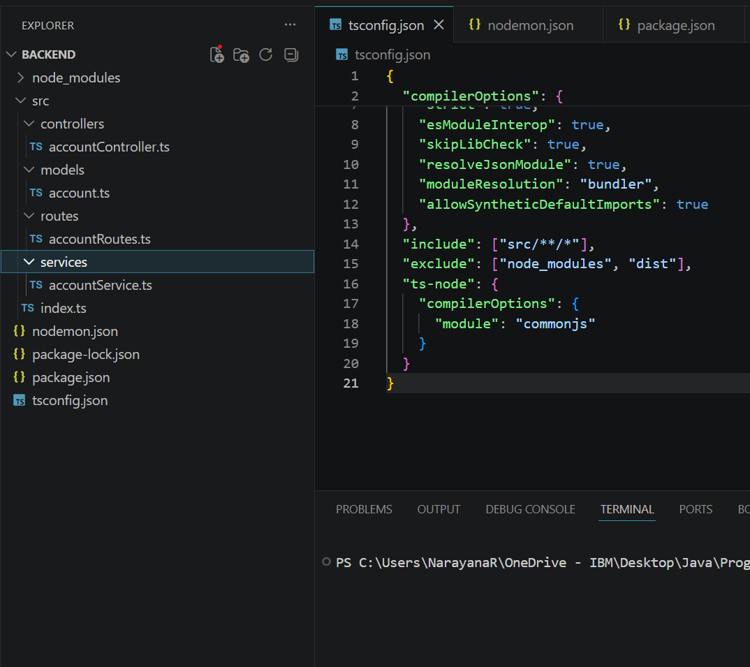

models/account.ts
ts
export interface Account {
id: number;
name: string;
balance: number;
}

services/accountService.ts
ts
import { Account } from "../models/account";

let accounts: Account[] = [
{ id: 1, name: "Prasunamba", balance: 5000 },
{ id: 2, name: "Meher", balance: 3000 }
];

export const getAccounts = (): Account[] => accounts;

export const getAccountById = (id: number): Account | undefined =>
accounts.find(acc => acc.id === id);

export const deposit = (id: number, amount: number): Account | undefined => {
const account = getAccountById(id);
if (account) account.balance += amount;
return account;
};

export const withdraw = (id: number, amount: number): Account | undefined => {
const account = getAccountById(id);
if (account && account.balance >= amount) account.balance -= amount;
return account;
};

routes/accountRoutes.ts
ts
import { Router } from "express";
import { getAllAccounts, depositAmount, withdrawAmount } from "../controllers/accountController";

const router = Router();

router.get("/", getAllAccounts);
router.post("/deposit", depositAmount);
router.post("/withdraw", withdrawAmount);

export default router;

controllers/accountController.ts
ts
import { Request, Response } from "express";
import * as accountService from "../services/accountService";

export const getAllAccounts = (req: Request, res: Response) => {
res.json(accountService.getAccounts());
};

export const depositAmount = (req: Request, res: Response) => {
const { id, amount } = req.body;
const account = accountService.deposit(id, amount);
account ? res.json(account) : res.status(404).send("Account not found");
};

export const withdrawAmount = (req: Request, res: Response) => {
const { id, amount } = req.body;
const account = accountService.withdraw(id, amount);
account ? res.json(account) : res.status(400).send("Insufficient funds");
};

index.ts
ts
import express from "express";
import bodyParser from "body-parser";
import cors from "cors";
import accountRoutes from "./routes/accountRoutes";

const app = express();
app.use(cors());
app.use(bodyParser.json());

app.use("/api/accounts", accountRoutes);

const PORT = 5000;
app.listen(PORT, () => {
console.log(`Server running on http://localhost:${PORT}`);
});

tsconfig.js

{
// Visit https://aka.ms/tsconfig to read more about this file
"compilerOptions": {
// File Layout
// "rootDir": "./src",
// "outDir": "./dist",

// Environment Settings
// See also https://aka.ms/tsconfig/module
"module": "nodenext",
"target": "esnext",
"types": [],
// For nodejs:
// "lib": ["esnext"],
// "types": ["node"],
// and npm install -D @types/node

// Other Outputs
"sourceMap": true,
"declaration": true,
"declarationMap": true,

// Stricter Typechecking Options
"noUncheckedIndexedAccess": true,
"exactOptionalPropertyTypes": true,

// Style Options
// "noImplicitReturns": true,
// "noImplicitOverride": true,
// "noUnusedLocals": true,
// "noUnusedParameters": true,
// "noFallthroughCasesInSwitch": true,
// "noPropertyAccessFromIndexSignature": true,

// Recommended Options
"strict": true,
"jsx": "react-jsx",
"verbatimModuleSyntax": true,
"isolatedModules": true,
"noUncheckedSideEffectImports": true,
"moduleDetection": "force",
"skipLibCheck": true,
}
}

Run backend ..

