(006CP2744): Day 16 - 06th Aug 2026

Task 1:
In yesterday's project can you implement a custom pipe to mask the account number..

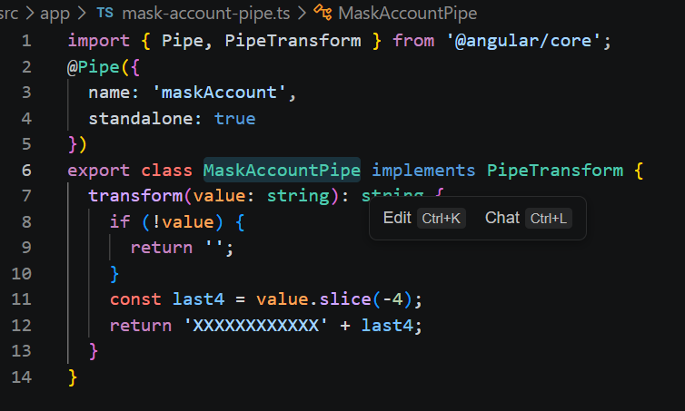

Task 2:
Also use currency pipe for the amount.
For eg In you dashboard.component.ts a sample code for your ref.

Dashboard.component.ts
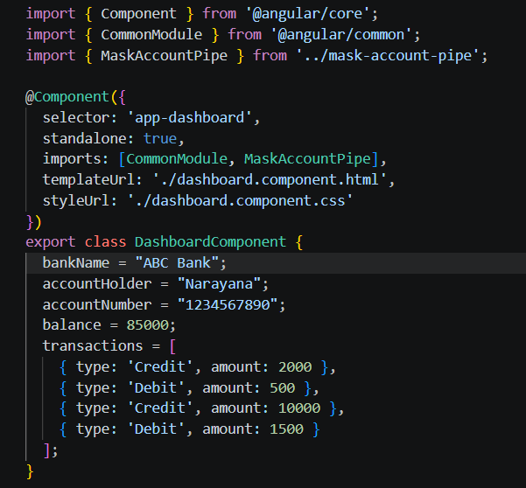
Dashboard.component.css
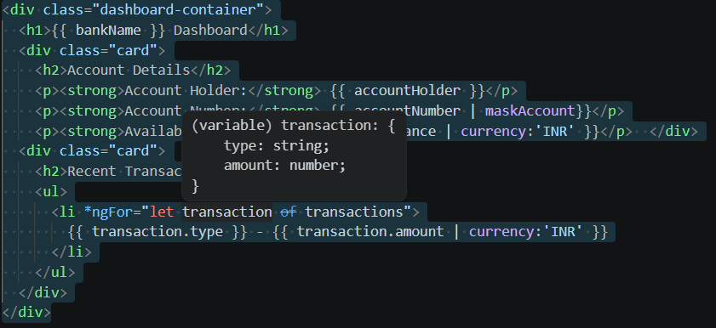

Task 3:
Create a service banking.service.ts
Http requests.. Use the Crud operations fro – post , get, delete, patch ….

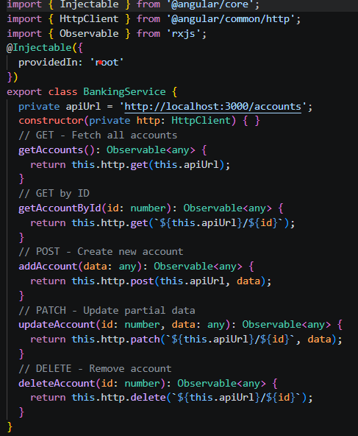

Task 4:
Create authentication for your account’s id and password..
For eg : auth.service.ts

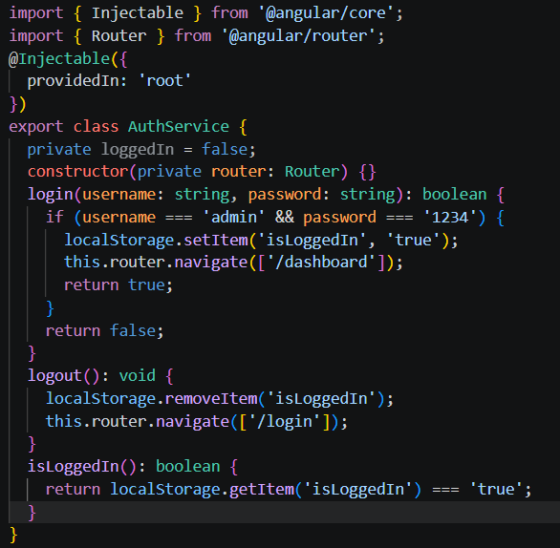

Task 5:
Create a shared module fro all your pipes to be bundles ..
For eg: shared.module.ts

shared.module.ts

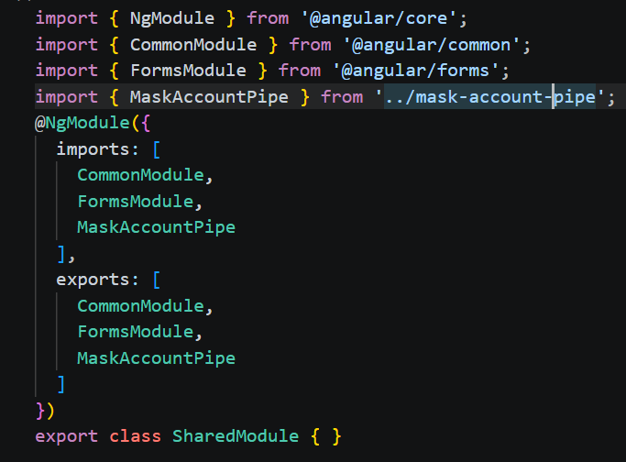
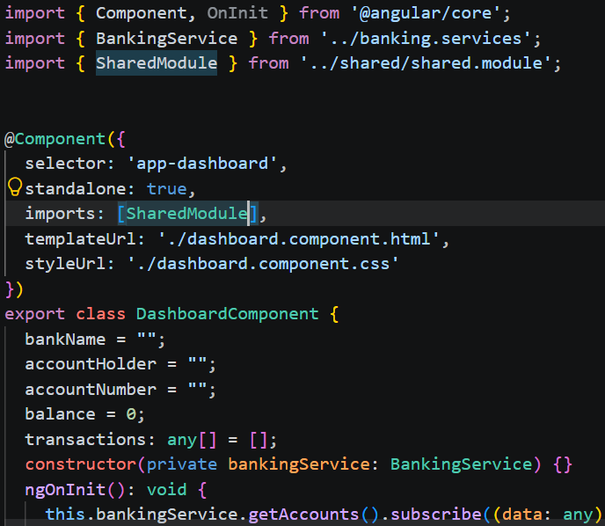

Task 6:
Create auth.module.ts for your login and register components.ts

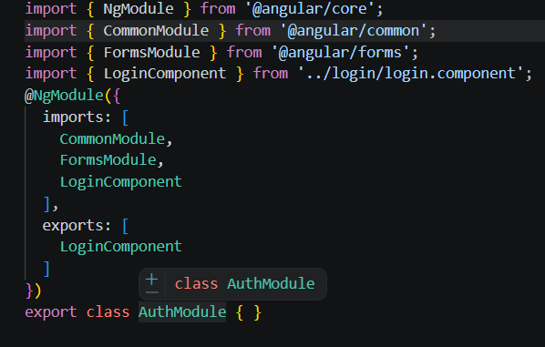

Task 7:
Write unit test cases for banking service and login components.
For eg for my

