(006CP2744): Day 17 - 07th Aug 2026

Task 1:
What is data binding?

Data Binding is the process of connecting data from a data source (such as a database, object, or variable) to a user interface element so that changes in the data are automatically reflected in the UI, and vice versa.

Task 2:
What do you understand by one way data binding and two way data binding?

One-way data binding means data flows in only one direction, from the data source (model) to the user interface (UI).
- Changes in the data source automatically update the UI.
- Changes made in the UI do not update the data source.

Task 3:
When do you use one way data binding and when to use two way data binding?give examples.

1. One-Way Data Binding
Use one-way data binding when data only needs to be displayed to the user and the user is not expected to change it.
Suitable Scenarios
- Reports and dashboards
- Product listings
- Displaying user profile details

2. Two-Way Data Binding
Use two-way data binding when users need to view and edit data.
Suitable Scenarios
- Registration forms
- Login forms
- Employee information forms

Task 4:
What is the state in react?

State is a built-in React object used to store and manage data that can change over time within a component. When the state changes, React automatically re-renders the component to display the updated data.

Task 5:
Can you explain SPA?

A Single Page Application (SPA) is a web application that loads a single HTML page initially and then dynamically updates the content without reloading the entire page.

Task 6:
What is DOM?

DOM (Document Object Model) is a programming interface for HTML and XML documents. It represents a web page as a tree-like structure of objects, allowing JavaScript to access, modify, add, or delete elements and content dynamically.
Task 7:
What is virtual DOM?

Virtual DOM (VDOM) is a lightweight, in-memory copy of the actual DOM (Real DOM) used by React to improve application performance.
Instead of updating the Real DOM directly whenever data changes, React first updates the Virtual DOM, compares it with the previous version, and then updates only the changed parts of the Real DOM.

Task 8:
What are props in react ? can you explain about prop drilling?

Props (Properties) are used to pass data from a parent component to a child component in React.
Prop Drilling is the process of passing props through multiple intermediate components to reach a deeply nested child component.
Sometimes intermediate components don't need the data but still have to pass it down.

Task 9:
Why do we use react?give importance and describe in detail.

React is a popular JavaScript library used for building fast, interactive, and reusable user interfaces (UIs), especially for Single Page Applications (SPAs).

Importance of React
Modern web applications require:
- Fast performance
- Dynamic UI updates
- Reusable code

1. Component-Based Architecture
React applications are built using components.
A component is a reusable piece of UI.

2. Virtual DOM Improves Performance
React uses a Virtual DOM instead of directly updating the Real DOM.

Task 10:
What do you understand by component based architecture?

Component-Based Architecture is a design approach in React where the user interface (UI) is divided into small, independent, reusable pieces called components.
Each component is responsible for a specific part of the UI and contains its own structure, logic, and behavior.

Component-Based Architecture is an approach where the UI is divided into small, reusable, and independent components. Each component handles a specific part of the application and can be combined with other components to build complex user interfaces. This architecture makes React applications more reusable, maintainable, scalable, and easier to develop.

Task 11:
Explain lifecycle of react component with diagram.. Describe mounting , unmounting etc ..

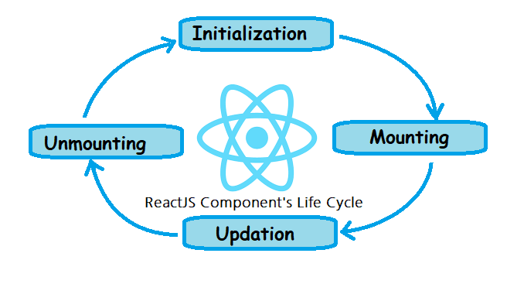
1. Mounting Phase
Mounting is the phase when a component is created and inserted into the DOM for the first time.
Lifecycle Methods in Mounting
a) constructor()
The constructor is called first when the component is created.
Used for:
- Initializing state
- Binding event handlers

2. Updating Phase
The updating phase occurs whenever:
- State changes
- Props change
- Force update is called

3. Unmounting Phase
Unmounting occurs when a component is removed from the DOM.

Task 12:
What are Hooks in react?why use hooks- importance ? What are different types of hooks?

Hooks are special functions introduced in React 16.8 that allow developers to use state, lifecycle features, and other React capabilities inside functional components without writing class components.

Task 13:
What is react redux architecture ?explain in detail.

Redux is a predictable state management library commonly used with React applications to manage and share data across multiple components.
When applications grow large, managing state using only React's useState and props becomes difficult. Redux provides a centralized store to manage the application's state efficiently.

React Redux is a state management architecture that stores application data in a centralized Store. It follows a one-way data flow: Component → Dispatch Action → Reducer → Store → UI Update. The main parts of Redux are Store, Action, Reducer, and Dispatch. Redux helps avoid prop drilling, provides predictable state management, improves debugging, and is widely used in large React applications.

npm create vite@latest banking-app --template react

Demo1:

10.52 to 11.07 break..

Step 1:

Create the root app —> app.jsx – with h1 tag in the function app
And export it..

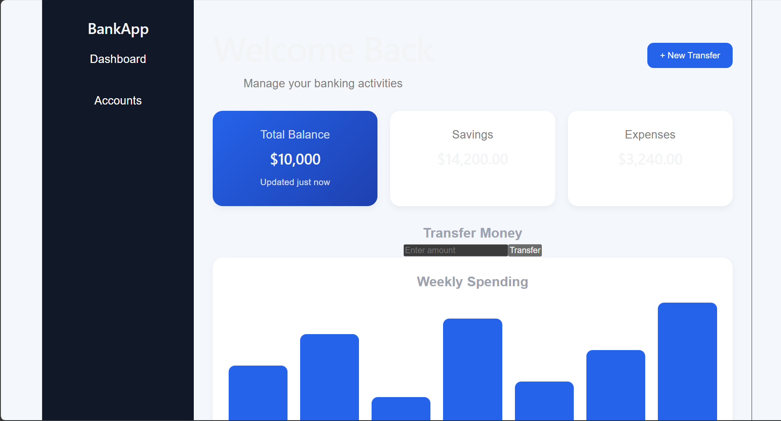

Step 2:
In src..
Create a components folder and add a function component.

Like dashboard.jsx

Step 3:
In components/ create Accounts.jsx

Step 4:

Create a usestate … initialize and use it to display the current balance

Import useState hook

import React, { useState } from "react";// react hook - usestate

Initialize the useState

const [balance, setBalance] = useState(1000);

// Handle new transaction
const handleTransaction = (type, amount) => {
let newBalance = balance;
if (type === "Deposit") newBalance += amount;
if (type === "Withdraw") newBalance -= amount;
setBalance(newBalance);

Step 4:

Conditional rendering like
Balance <0 —>

{balance < 0 && <p style={{ color: "red" }}>⚠️ Overdraft Alert!</p>}

Step 5:

In components / create TransactionForm.jsx

Now
Step 6:
Can you implement use state hook in TransactionForm.jsx
For setAmmount
Set Type → deposit.. Or so

Step 7:
Use the concept of prop drilling

Ex: prop drilling… from APP →parent → child → grand child.. Any connection break will lead to disturb prop drilling..
Note: If you add more nested layers, the chain grows longer.
Refactoring becomes painful because every layer is tied to the prop.

function App() {
const user = "Prasunamba";
return <Parent user={user} />;
}

function Parent({ user }) {
return <Child user={user} />;
}

function Child({ user }) {
return <GrandChild user={user} />;
}

function GrandChild({ user }) {
return <p>Hello {user}</p>;
}

Finally the output

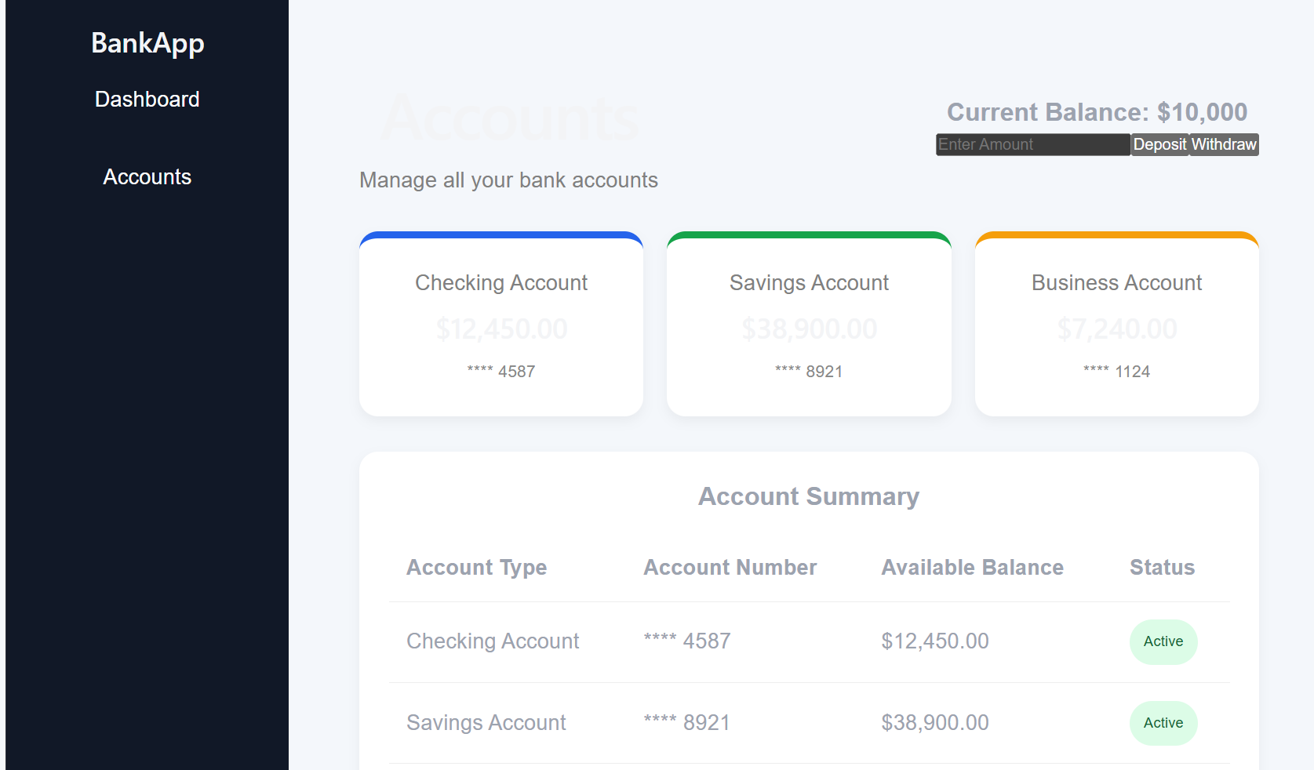

Step 8:

As you have already implemented state hooks..

Eg :useState - -> Declares a state variable and updater function.

const [count, setCount] = useState(0);

Can you try to implement one more state hook .. useReducer?

Like eg:
useReducer -> → Manages complex state logic with a reducer function.

const [state, dispatch] = useReducer(reducer, initialState);

Step 9:

Effect Hooks:

useEffect → Handles side effects (API calls, subscriptions, DOM updates).
Like example
useEffect(() => {
document.title = `Count: ${count}`;
}, [count]);

Step 10:
useLayoutEffect → Runs before the browser repaints (for layout measurements).

useInsertionEffect → Used mainly by libraries to inject styles before DOM updates.

Step 11:
Use contextHooks:

useContext → Accesses values from React Context without prop drilling.

Like eg

const theme = useContext(ThemeContext);

Step 12:
Ref Hooks:

useRef → Stores mutable values (like DOM nodes or timers) without causing re-renders.

const inputRef = useRef(null);

Step 13:
Performance Hooks
useMemo → Memoizes expensive calculations.

useCallback → Memoizes functions to avoid unnecessary re-renders.

useTransition → Manages concurrent rendering for smoother UI.

useDeferredValue → Defers updating non-critical UI parts.

Step 14:
useId → Generates unique IDs for accessibility.

useDebugValue → Labels custom hooks for debugging.

=================================================
Juz fyi only:

App.jsx

import React from "react";
import Dashboard from "./components/Dashboard";
function App() {
return (
<div>
<title>Prasunamba </title>
<h1>🏦 My Banking Application</h1>
<Dashboard />
</div>
);
}
export default App

Account.jsx

import React from "react";
function Account({ balance }) {
return (
<div>
<h2>💰 Current Balance: ₹{balance}</h2>
{balance < 0 && <p style={{ color: "red" }}>⚠️ Overdraft Alert!</p>}
</div>
);
}
export default Account;
Dash board.jsx

import React, { useState } from "react";// react hook - usestate
import Account from "./Account";
import TransactionForm from "./TransactionForm";
import TransactionHistory from "./TransactionHistory";
function Dashboard() {
// State hooks
const [balance, setBalance] = useState(1000);
const [transactions, setTransactions] = useState([]);
// Handle new transaction
const handleTransaction = (type, amount) => {
let newBalance = balance;
if (type === "Deposit") newBalance += amount;
if (type === "Withdraw") newBalance -= amount;
setBalance(newBalance);
// Add to transaction history
const newTransaction = {
id: transactions.length + 1,
type,
amount,
date: new Date().toLocaleString(),
};
setTransactions([...transactions, newTransaction]);
};
return (
<div>
<Account balance={balance} />
<TransactionForm onTransaction={handleTransaction} />
<TransactionHistory transactions={transactions} />
</div>
);
}
export default Dashboard;

TransactionForm.jsx

import React, { useState } from "react";
function TransactionForm({ onTransaction }) {
const [amount, setAmount] = useState("");
const [type, setType] = useState("Deposit");
const handleSubmit = (e) => {
e.preventDefault();
if (!amount || amount <= 0) return alert("Enter valid amount");
onTransaction(type, parseFloat(amount));
setAmount("");
};
return (
<form onSubmit={handleSubmit}>
<h3>Make a Transaction</h3>
<select value={type} onChange={(e) => setType(e.target.value)}>
<option value="Deposit">Deposit</option>
<option value="Withdraw">Withdraw</option>
</select>
<input
type="number"
placeholder="Enter amount"
value={amount}
onChange={(e) => setAmount(e.target.value)}
/>
<button type="submit">Submit</button>
</form>
);
}
export default TransactionForm;

TransactionHistory.jsx

import React from "react";
function TransactionHistory({ transactions }) {
return (
<div>
<h3>📜 Transaction History</h3>
{transactions.length === 0 ? (
<p>No transactions yet.</p>
) : (
<table border="1" cellPadding="5">
<thead>
<tr>
<th>ID</th>
<th>Type</th>
<th>Amount</th>
<th>Date</th>
</tr>
</thead>
<tbody>
{transactions.map((txn) => (
<tr key={txn.id}>
<td>{txn.id}</td>
<td>{txn.type}</td>
<td>₹{txn.amount}</td>
<td>{txn.date}</td>
</tr>
))}
</tbody>
</table>
)}
</div>
);
}
export default TransactionHistory;

