(006CP2744): Day 18 - 10th Aug 2026

Redirecting Output (> and >>)

ls > files.txt

cat files.txt

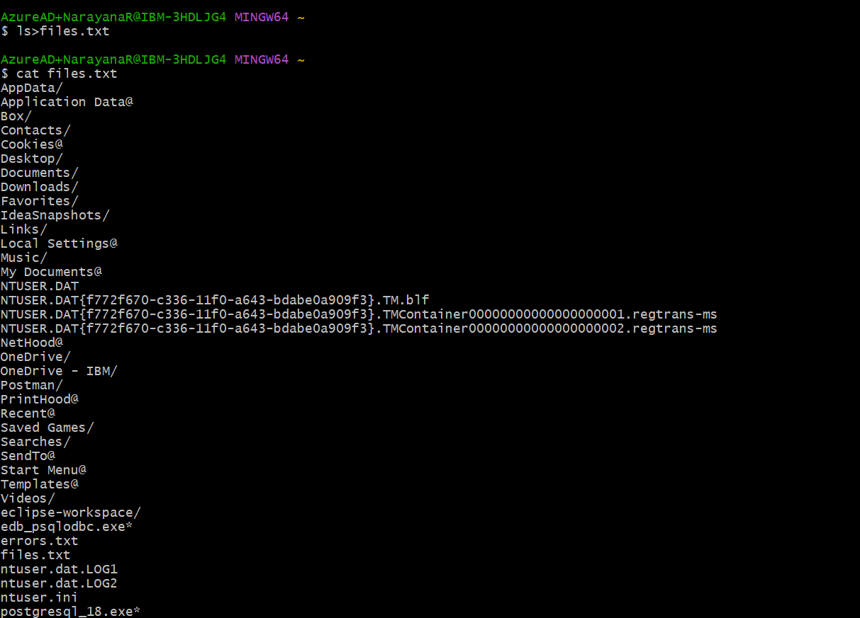

Append instead of overwrite

echo "New entry" >> files.txt

Redirecting Input (<)

echo -e "banana\napple\ncherry" > fruits.txt
-e interprets escape characters..

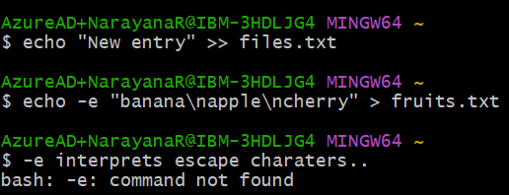

Redirecting Errors (2>)
ls /not_a_real_folder 2> errors.txt

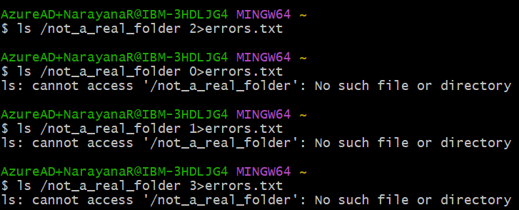

Pipes (|)
ls | wc -l

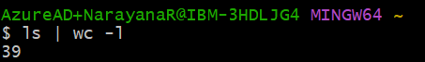

Filter processes

ps aux | grep bash

Check with
Ps a
Ps au
Ps aux

Ps aux | grep bash

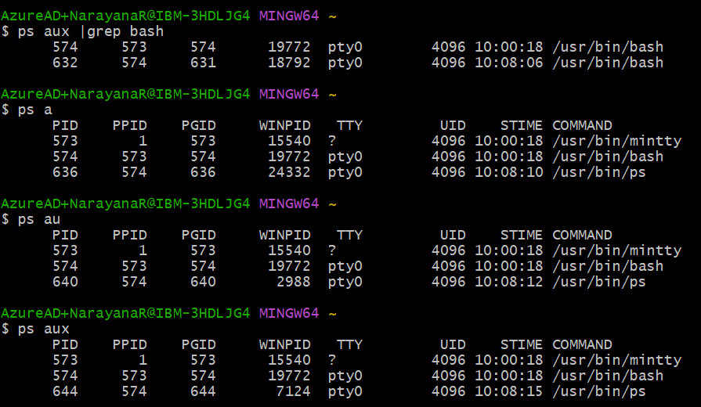

Multi-stage Pipeline

Du -sh * | sort -rh | head -5

Silent Execution will Suppress output

./script.sh > /dev/null 2>&1

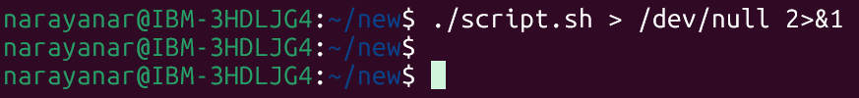

Task 1:

Sed

Go to https://www.lipsum.com/

Pick some dummy data .. and keep it in a file filename.txt

1.What will this command do
Sed filename.txt
This command is incorrect because `sed` requires an editing expression or command before the filename. Running it usually gives an error.

- Can you replace a word with another
S → search for 1st occurrence of any old keyword and change it with new in your file..
sed 's/old/new/' filename
- s stands for substitute.
- Replaces only the first occurrence of Linux with Unix in each line of the file.

3.G flag → for all occurrences of the word and change it to new word.
sed 's/old/new/g' filename
- g stands for global.
- Replaces all occurrences of Linux with Unix in each line of the file.

4.Try with delete flag
sed '/word/d' filename
- d stands for delete.
- Removes all lines that contain the word Linux from the output.

- Print specific line numbers line line 3 of your file
sed -n '3p' filename
- -n suppresses automatic printing of all lines.
- 3p prints only line number 3 from the file.
6.Print range of lines
Like from line 2 to 5
sed -n '2,5p' filename
- `-n` suppresses automatic output.
- `2,5p` prints lines starting from line 2 up to line 5 from the file.

Task 2:

Awk (used for pattern scanning and processing)
1.Now try same with awk
awk '{print}' filename
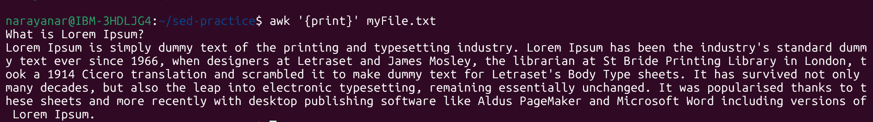

2.Print specific column
awk '{print $2}' filename

3.Print multiple columns
awk '{print $1, $3}' filename

4.Filter rows by giving condition
Like print 1st nd 3rd column only if 3rd column value is > 50 fo example..
awk '$3 > 50 {print $1, $3}' filename

5.Use custom delimiter (comma , is a delimiter operator) and print first 2 fields..
awk -F, '{print $1, $2}' filename (here f is filed separator (demiliter))
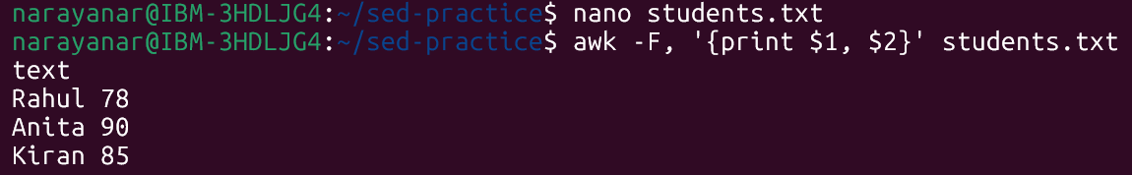

6.Now count lines
awk 'END {print NR}' filename (nr is no of records..)

Task 3:

Ping google.com
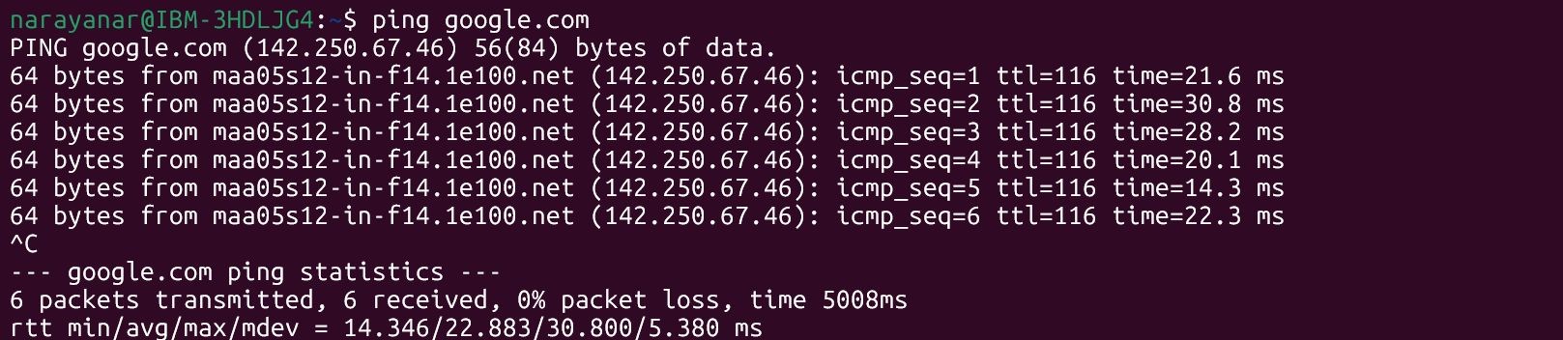

Curl https://google.com
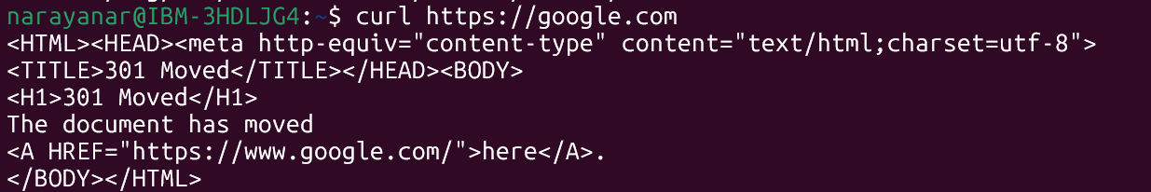

Netstat -an
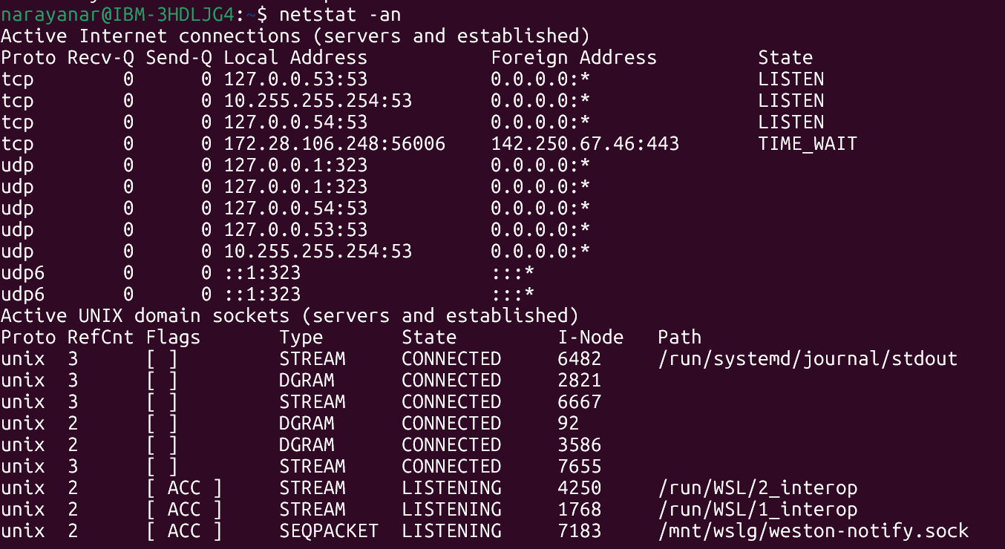

Task 4:

Install open ssl in your system

https://www.xolphin.com/support/OpenSSL/OpenSSL_-_Installation_under_Windows#:~:text=Download%20the%20OpenSSL%20for%20Windows,file%20can%20be%20downloaded%20here.

Or

https://slproweb.com/products/Win32OpenSSL.html
Step 2 Generate a certificate signing request (CSR)

openssl genrsa -out localhost.key 2048

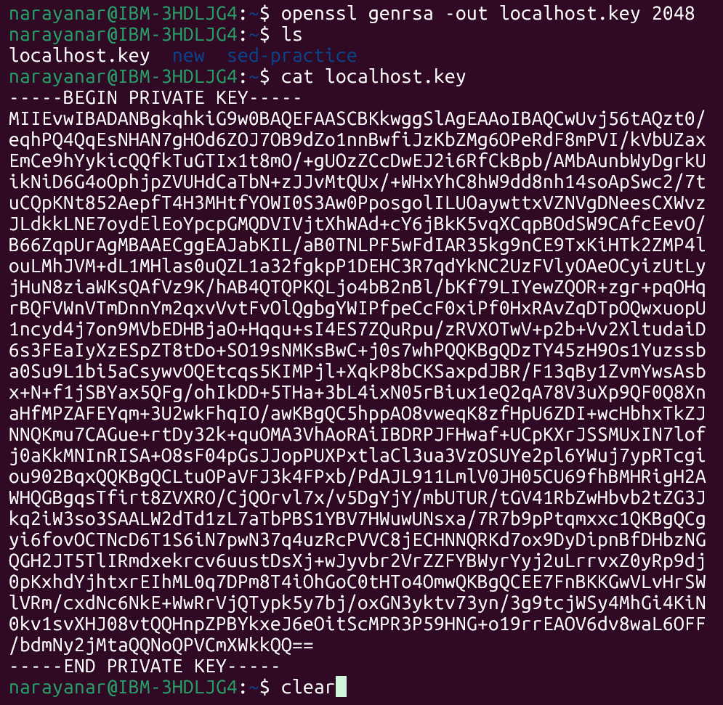

Step 3:

Generate a self-signed certificate
In bash
openssl x509 -req -days 365 -in localhost.csr -signkey localhost.key -out localhost.crt

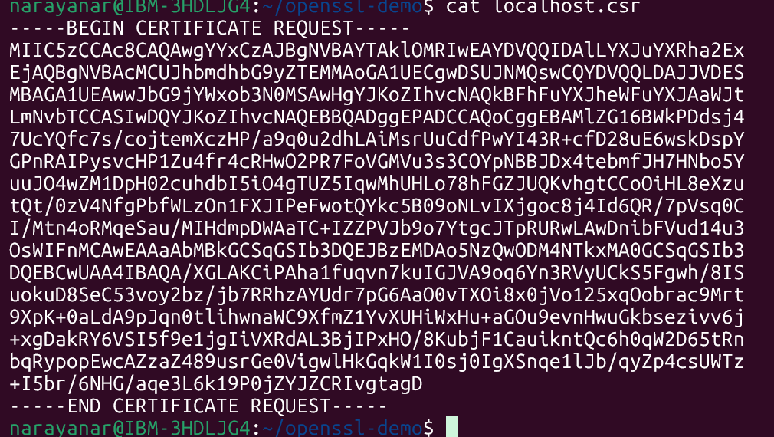

Step 4:
Now Start a Simple HTTPS Server
Use Python: `python -m http.server 4443 --bind 127.0.0.1 --ssl-certfile cert.pem --ssl-keyfile key.pem`.

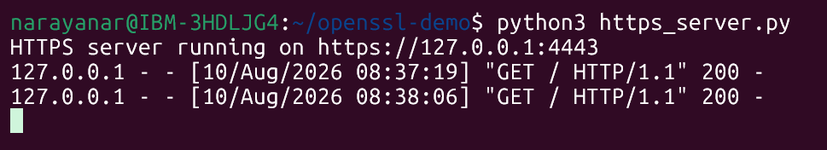

Step 5:
Now Test with Browser or Curl
Visit https://localhost:4443 or run `curl -k https://localhost:4443` to see encrypted communication.

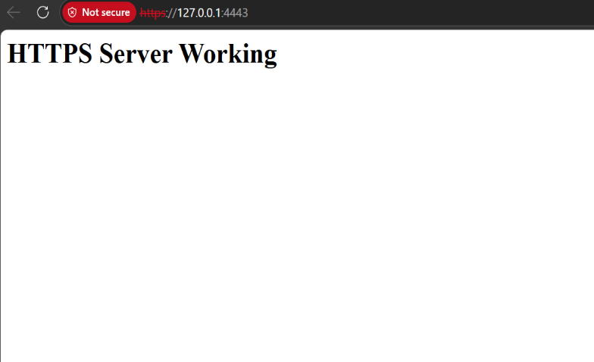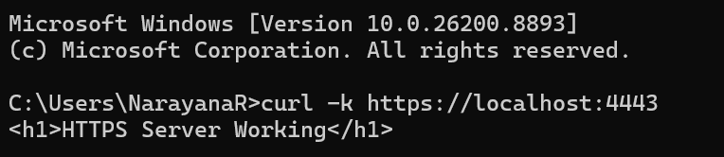

Step 6:
Did u Observe TLS Handshake
Use Wireshark or `openssl s_client -connect localhost:4443` to watch how TLS negotiates keys and ciphers.

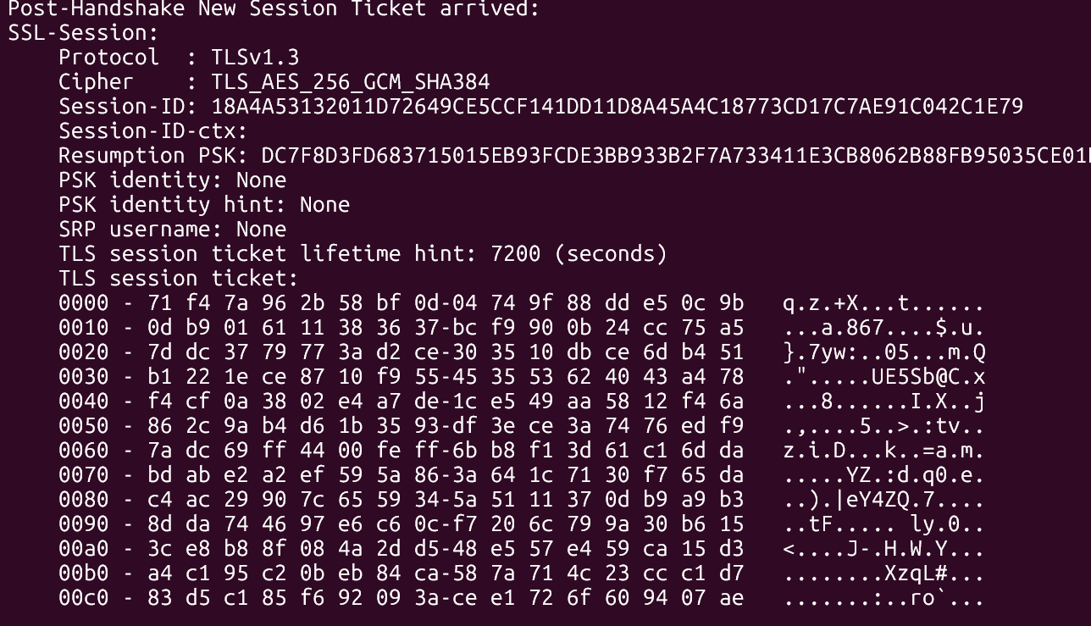

Step 7:
Verify Certificate Trust
Browsers will warn about self-signed certs; in real deployments, use CA-issued certificates for trust.

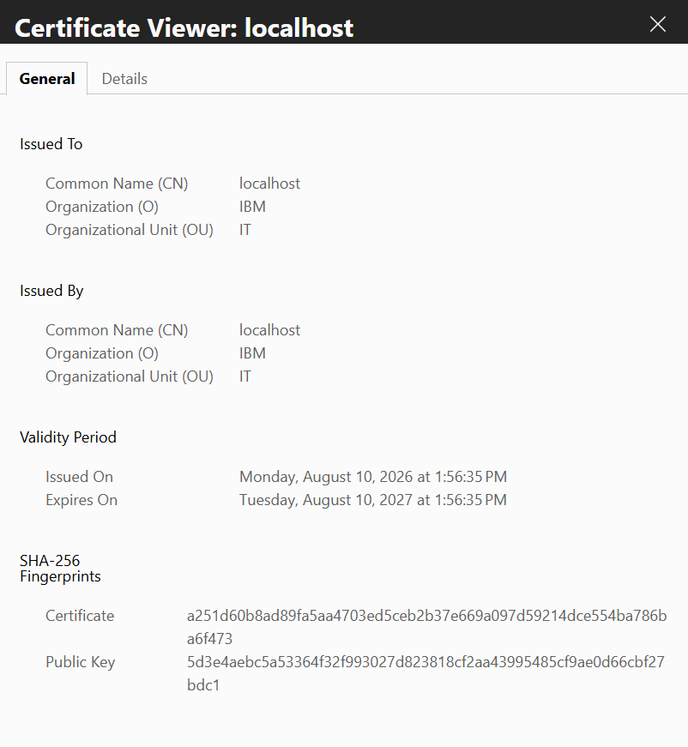
Task 5:
What are trees ? where do you implement them?

Trees are hierarchical data structures made up of nodes connected by edges. They represent parent-child relationships and are used to store and organize data efficiently.

1.Trees are hierarchical data structures made up of nodes connected by edges. They represent parent-child relationships and are used to store and organize data efficiently.
2.Databases
B-Trees and B+ Trees are used indexing for fast searching and retrieval.
3.Compilers
Syntax trees (Parse Trees) are used to analyze programming language expressions.

Task 6:
Can you give types of trees?

1.Binary Tree
A tree where each node has at most two children:
- Left child
- Right child
2.Binary Search Tree (BST)
A binary tree where:
- Left subtree contains smaller values
- Right subtree contains larger values
Used for fast searching and sorting.
3.AVL Tree
A self-balancing Binary Search Tree where the height difference between left and right subtrees is at most 1.
Provides efficient search, insertion, and deletion operations.
4.Red-Black Tree
A self-balancing BST that uses coloring rules (Red/Black nodes) to maintain balance.
Used in:
- Java TreeMap
- Linux kernel
- C++ STL map/set

Task 7:
What is binary search tree?

A Binary Search Tree (BST) is a type of binary tree where each node follows a specific ordering rule:
- Values smaller than the node are stored in the left subtree.
- Values greater than the node are stored in the right subtree.
1.Search
Compare the target value with the current node and move left or right accordingly.
2.Insertion
Insert the new value at the correct position while maintaining BST property.
3.Deletion
Remove a node and rearrange the tree to maintain BST rules.

Task 8:
Can you create a simple binary tree using a node and insert values in it?
Like in java

class Node {
int val;
Node left, right;
Node(int val) { this.val = val; }
}

Insert values in left side and right side of the nodes and display the tree values

class Node {
int val;
Node left, right;
Node(int val) {
this.val = val;
}
}
public class BinaryTreeDemo {
// Inorder Traversal
static void display(Node root) {
if (root != null) {
display(root.left);
System.out.print(root.val + " ");
display(root.right);
}
}
public static void main(String[] args) {
// Create root node
Node root = new Node(10);
// Insert left and right children
root.left = new Node(20);
root.right = new Node(30);
// Insert more nodes
root.left.left = new Node(40);
root.left.right = new Node(50);
root.right.left = new Node(60);
root.right.right = new Node(70);
System.out.println("Binary Tree Values:");
// Display tree values
display(root);
}
}

Task 9
Now extend the above code to search a no in your list.

class Node {
int val;
Node left, right;
Node(int val) {
this.val = val;
}
}
public class BinaryTreeSearch {
// Inorder Traversal
static void display(Node root) {
if (root != null) {
display(root.left);
System.out.print(root.val + " ");
display(root.right);
}
}
// Search a value in the Binary Tree
static boolean search(Node root, int target) {
if (root == null) {
return false;
}
if (root.val == target) {
return false;
}
if (root.val == target) {
return true;
}
return search(root.left, target) ||
search(root.right, target);
}
public static void main(String[] args) {
// Create tree
Node root = new Node(10);
root.left = new Node(20);
root.right = new Node(10);
root.left = new Node(20);
root.right = new Node(30);
root.left.left = new Node(40);
root.left.right = new Node(50);
root.right.left = new Node(60);
root.right.right = new Node(70);
System.out.println("Tree Values:");
display(root);
int target = 50;
// Search value
if (search(root, target)) {
System.out.println("\nValue " + target + " found in the tree.");
} else {
System.out.println("\nValue " + target + " not found in the tree.");
}
}
}

Task 10:
Now can you do inorder traversal in your bst?

class Node {
int val;
Node left, right;
Node(int val) {
this.val = val;
}
}
public class BSTInorderTraversal {
// Inorder Traversal
static void inorder(Node root) {
if (root != null) {
// Visit left subtree
inorder(root.left);
// Print current node
System.out.print(root.val + " ");
// Visit right subtree
inorder(root.right);
}
}
public static void main(String[] args) {
// Create BST
Node root = new Node root = new Node(50);
root.left = new Node(30);
root.right = new Node(70);
root.left.left = new Node(20);
root.left.right = new Node(20);
root.left.right = new Node(40);
root.right.left = new Node(60);
root.right.right = new Node(80);
System.out.println("Inorder Traversal of BST:");
inorder(root);
}
}

Task 11:
What is the fundamental difference between BFS and DFS?

BFS (Breadth-First Search) and DFS (Depth-First Search) are graph/tree traversal algorithms, but they differ in the way they explore nodes.
BFS (Breadth-First Search):
- Traverses nodes level by level.
- Visits all neighboring nodes before moving deeper.
- Uses a Queue (FIFO).

DFS (Depth-First Search):
- Traverses deep into one branch before backtracking.
- Explores child nodes first.
- Uses Stack (LIFO) or Recursion.

task 12:
Which underlying data structures are used to implement BFS and DFS?

BFS (Breadth-First Search) and DFS (Depth-First Search) use different underlying data structures for traversal.
BFS (Breadth-First Search):
- Uses a Queue data structure.
- Queue follows FIFO (First In First Out).
- Nodes are visited level by level.

DFS (Depth-First Search):
- Uses a Stack data structure or Recursion.
- Stack follows LIFO (Last In First Out).
- Traverses deep into one branch before backtracking.

Task 13:
How do you find the shortest path in an unweighted graph?

The shortest path in an unweighted graph is found using Breadth-First Search (BFS).
Reason:
- BFS explores the graph level by level.
-level.
- In an unweighted graph, the first time a node is reached represents the shortest path to that node.
Steps:
- Start from the source node.
- Mark it as visited.
- Insert it into a queue.
- Visit all adjacent nodes.
- Store the distance of each node from the source.

task 14:
How do you detect a cycle in a graph?

- Cycle detection in a graph is used to check whether a path starts and ends at the same node.
- The most common method is Depth-First Search (DFS).
- In DFS, nodes are marked as visited while traversing the graph.
- If a visited node is encountered again during traversal, nodes are marked as visited while traversing the graph.
- If a visited node is encountered again during traversal, a cycle exists.
- Time Complexity for cycle detection is O(V + E).

task 15:
Explain the internal working of a HashMap.

- HashMap stores data in key-value pairs using a hash table internally.
- When a key is inserted, HashMap computes a hash code to determine the storage index.
- If multiple keys map to the same index, collision handling is done using a linked list or balanced tree.
- If multiple keys map to the same index, collision handling is done using a linked list or balanced tree.

Task 16:
Which property of a hashmap is used to find the intersection of two arrays?

- HashMap uses the property of fast key lookup to find the intersection of two arrays.
- Elements of one array are stored as keys in the HashMap.
- The second array is traversed and each element is checked in the HashMap.
- If the element exists in both arrays, it is part of the intersection.
- HashMap provides average O(1) lookup time, making intersection efficient.

Task 17:
What is collision in HashMap?

- Collision in HashMap occurs when two different keys generate the same hash index.
- Both keys get stored in the same bucket of the hash table.
- HashMap handles collisions using linked lists or balanced trees internally.
- During retrieval, HashMap searches within the bucket to find the correct key.
- Collisions can affect performance if too many keys map to the same index.

Task 18:
How Does Java's Capacity And Size Of Hashmap Differ?

- In HashMap, size refers to the number of key-value pairs currently stored in the map.
- Capacity refers to the number of key-value pairs currently stored in the map.
- Capacity refers to the total number of buckets available internally in the hash table.
- Size increases when new elements are added to the HashMap.

Task 19:
Does hashmap allow you to store null values?
Yes, We can store as many null values in a hashmap as we want but only one null key can be stored not more than that.

Let’s see a program that depicts how we can store null values in a hashmap.

import java.util.*;
import java.io.*;
public class interviewBit {
public static void main(String[] args)
{
HashMap hmap=new HashMap();
hmap.put(1,"Program to store null value");
hmap.put(null,"InterviewBit");
System.out.println(hmap);
}
}

Can you predict the output and also explain.. I or 2 lines

- Java HashMap allows multiple null values but only one null key.
- When null is used again as a key, the previous value is replaced because keys in HashWhen null is used again as a key, the previous value is replaced because keys in HashMap must be unique.

Task 20:
hashmaps in Java are not thread-safe.can you juztify?

- Java HashMap is not thread-safe because multiple threads can access and modify it simultaneously without synchronization.
- Concurrent modifications may cause data inconsistency, race conditions, or loss of data.
- During resizing, HashMap can enter an inconsistent state if accessed by multiple threads.
- Therefore, HashMap should not be used directly in multi-threaded environments without synchronization.

Task 21:
Can you store multiple keys with the same value in a hashmap?

- Yes, HashMap allows multiple keys to have the same value.
- Keys in a HashMap must be unique, but values can be duplicated.
- Keys in a HashMap must be unique, but values can be duplicated.
- If duplicate keys are inserted, the previous value gets replaced.
- Different keys can point to the same value without any issue.

Task 22:
can you tell the differences between a Hashmap and a Hashtable in Java.

- HashMap is not thread-safe, while Hashtable is thread-safe because its methods are synchronized.
- HashMap allows one null key and multiple null values, whereas Hashtable does not allow null keys or values.
- HashMap is generally faster because it does not use synchronization.
- Hashtable is slower due to synchronized operations for thread safety.

Sorting Algorithms
Can you create a java code for bubble sort …
The snippet for your ref is given below

1. Bubble Sort
- Concept: Repeatedly swaps adjacent elements if they are in the wrong order.
- Complexity: O(n2)
- Best for: Small datasets or teaching algorithm basics.
java
for (int i = 0; i < n-1; i++)
for (int j = 0; j < n-i-1; j++)
if (arr[j] > arr[j+1])
swap(arr[j], arr[j+1]);

Visualization: Each pass “bubbles” the largest element to the end.

public class BubbleSort {
public static void main(String[] args) {
int[] arr = {64, 34, 25, 12, 22, 11, 90};
int n = arr.length;
// Bubble Sort
for (int i = 0; i < n - 1; i++) {
for (int j = 0; j < n - i - 1; j++) {
if (arr[j] > arr[j + 1]) {
// Swap elements
int temp = arr[j];
arr[j] = arr[j + 1];
arr[j + 1] = temp;
}
}
}
}
System.out.println("Sorted Array:");
for (int num : arr) {
System.out.print(num + " ");
}
}
}

Task 24:
Can you create a java code for selection sort …
The snippet for your ref is given below
2. Selection Sort
- Concept: Selects the smallest element and places it at the beginning.
- Complexity: O(n2)
- Best for: Simple, predictable sorting.
java
for (int i = 0; i < n-1; i++) {
int min = i;
for (int j = i+1; j < n; j++)
if (arr[j] < arr[min]) min = j;
swap(arr[i], arr[min]);
}
public class SelectionSort {
public static void main(String[] args) {
int[] arr = {64, 25, 12, 22, 11};
int n = arr.length;
// Selection Sort
for (int i = 0; i < n - 1; i++) {
int min = i;
for (int j = i + 1; j < n; j++) {
if (arr[j] < arr[min]) {
min = j;
}
}
// Swap elements
int temp = arr[i];
arr[i] = arr[min];
arr[min] = temp;
}
System.out.println("Sorted Array:");
for (int num : arr) {
System.out.print(num + " ");
}
}
}

Searching Algorithms
Can you create a java code for linear search …

The snippet for your ref is given below

1. Linear Search
- Concept: Sequentially checks each element.
- Complexity: O(n)
- Best for: Unsorted or small datasets.
java
for (int i = 0; i < n; i++)
if (arr[i] == key) return i;

public class LinearSearch {
public static void main(String[] args) {
int[] arr = {10, 20, 30, 40, 50};
int key = 30;
int position = -1;
// Linear Search
for (int i = 0; i < arr.length; i++) {
if (arr[i] == key) {
position = i;
break;
}
}
if (position != -1) {
System.out.println("Element found at index: " + position);
} else {
System.out.println("Element not found");
}
}
}
—----------------------------------------------------------------------------------------------------------------------------------------------------------------------------------------------------------------------------------------------------------
Home tasks:
Can you create a java code for earch of the below sort and search …

The snippet for your ref is given below
3. Insertion Sort
- Concept: Builds the sorted array one element at a time.
- Complexity: O(n2)
- Best for: Nearly sorted data.
java
for (int i = 1; i < n; i++) {
int key = arr[i];
int j = i - 1;
while (j >= 0 && arr[j] > key)
arr[j+1] = arr[j--];
arr[j+1] = key;
}

public class InsertionSort {
public static void main(String[] args) {
int[] arr = {5, 2, 9, 1, 5, 6};
for (int i = 1; i < arr.length; i++) {
int key = arr[i];
int j = i - 1;
< arr.length; i++) {
int key = arr[i];
int j = i - 1;
while (j >= 0 && arr[j] > key) {
arr[j + 1] = arr[j];
j--;
}
arr[j + 1] = key;
}
System.out.println("Sorted Array:");
for (int num : arr) {
System.out.print(num + " ");
for (int num : arr) {
System.out.print(num + " ");
}
}
}

4. Merge Sort
- Concept: Divide and conquer — splits array, sorts halves, merges results.
- Complexity: O(nlog⁡n)
- Best for: Large datasets.
java
void mergeSort(int[] arr, int l, int r) {
if (l < r) {
int m = (l + r) / 2;
mergeSort(arr, l, m);
mergeSort(arr, m+1, r);
merge(arr, l, m, r);
}
}

class MergeSort {
void merge(int arr[], int l, int m, int r) {
int n1 = m - l + 1;
int n2 = r - m;
int L[] = new int[n1];
int R[] = new int[n2];
for (int i = 0; i int R[] = new int[n2];
for (int i = 0; i < n1; i++)
L[i] = arr[l + i];
for (int j = 0; j < n2; j++)
R[j] = arr[m + 1 + j];
int i = 0, j = 0, k = l;
while (i < n1 && j < n2) {
if (L[i] <= R[j]) {
arr[k++] = L[i++];
} else {
arr[k++] = R[j++];
}
}
while (i < n1)
arr[k++] = L[i++];
while (j < n2)
arr[k++] = R[j++];
}
void mergeSort(int arr[], int l, int r) {
if (l < r) {
int m = (l + r) / 2;
mergeSort(arr, l, m);
mergeSort(arr, m + 1, r);
merge(arr, l, m, r);
}
}
public static void main(String[] args) {
int[] arr = {38, 27, 43, 3, 9, 82, 10};
MergeSort ob = new MergeSort();
ob.mergeSort(arr, 0, arr.length - 1);
System.out.println("Sorted Array:");
for (int num : arr)
System.out.print(num + " ");
}
}

5. Quick Sort
- Concept: Selects a pivot, partitions array around it.
- Complexity: Average O(nlog⁡n), Worst O(n2)
- Best for: Fast in practice, widely used.
java
int partition(int[] arr, int low, int high) {
int pivot = arr[high];
int i = low - 1;
for (int j = low; j < high; j++)
if (arr[j] < pivot) swap(arr[++i], arr[j]);
swap(arr[i+1], arr[high]);
return i+1;
}
public class QuickSort {
int partition(int[] arr, int low, int high) {
int pivot = arr[high];
int i = low - 1;
for (int j = low; j < high; j++) {
if (arr[j] < pivot) {
i++;
int temp = arr[i];
arr[i] = arr[j];
arr[j] = temp;
}
}
int temp = arr[i + 1];
arr[j] = temp;
}
}
int temp = arr[i + 1];
arr[i + 1] = arr[high];
arr[j] = temp;
}
}
int temp = arr[i + 1];
arr[i + 1] = arr[high];
arr[high] = temp;
return i + 1;
}
void quickSort(int[] arr, int low void quickSort(int[] arr, int low, int high) {
if (low < high) {
int pi = partition(arr, low high) {
int pi = partition(arr, low, high);
quickSort(arr, low, pi - 1);
quickSort(arr, pi + 1, high);
}
}
public static void main(String[] args) {
int[] arr = {10, 7, 8, 9, 1, 5};
QuickSort obj = new QuickSort();
obj.quickSort(arr, 0, arr.length - 1);
QuickSort obj = new QuickSort();
obj.quickSort(arr, 0, arr.length - 1);
System.out.println("Sorted Array:");
for (int num : arr)
System.out.print(num + " ");
}
}

2. Binary Search
- Concept: Repeatedly divides sorted array in half.
- Complexity: O(log⁡n)
- Best for: Sorted data.
java
int binarySearch(int[] arr, int key) {
int low = 0, high = arr.length - 1;
while (low <= high) {
int mid = (low + high) / 2;
if (arr[mid] == key) return mid;
if (arr[mid] < key) low = mid + 1;
else high = mid - 1;
}
return -1;
}

public class BinarySearch {
static int binarySearch(int[] arr, int key) {
int low = 0;
int high = arr.length - 1;
while (low <= high) {
int mid = (low + high) / 2;
if (arr[mid] == key) {
return mid;
}
if (arr[mid] < key) {
low = mid + 1;
} else {
high = mid - 1;
}
}
return -1;
}
public static void main(String[] args) {
int[] arr = {10, 20, 30, 40, 50};
int key = 20, 30, 40, 50};
int key = 30;
int result = binarySearch(arr, key);
if (result != -1) {
System.out.println("Element found at index: " + result);
} else {
System.out.println("Element not found");
}
}
}

Algorithm | Type | Time Complexity | Space Complexity | Stability
Bubble Sort | Sorting | O(n2) | O(1) | ✅
Selection Sort | Sorting | O(n2) | O(1) | ❌
Insertion Sort | Sorting | O(n2) | O(1) | ✅
Merge Sort | Sorting | O(nlog⁡n) | O(n) | ✅
Quick Sort | Sorting | O(nlog⁡n) | O(log⁡n) | ❌

