(006CP2744): Day 20 - 12th Aug 2026

Recap/ revise of linux and git ..

Task 1:
What do you understand about integration testing?

Integration Testing is a software testing technique in which two or more modules, components, services, or systems are combined and tested together to verify that they interact correctly.
Purpose
The main goal of integration testing is to identify defects in the interfaces and interactions between integrated components that may not be detected during unit testing.

Task 2:
Where do you use it and when ?

Integration testing is used wherever multiple components, modules, APIs, databases, or external systems need to work together.
Common use cases include:
- Web Applications
  - Frontend interacting with backend APIs
  - Backend interacting with databases
- Microservices Architecture
  - Communication between services using REST APIs, gRPC, or messaging queues

Task 3:
Can you write an integration test for your existing code ?

@SpringBootTest
@AutoConfigureMockMvc
class OrderIntegrationTest {

@Autowired
private MockMvc mockMvc;

@Autowired
private OrderRepository orderRepository;

@Test
void shouldCreateOrderAfterSuccessfulPayment() throws Exception {

String requestBody = """
{
"userId": 101,
"productId": 2001,
"quantity": 1,
"paymentMethod": "CARD"
}
""";

mockMvc.perform(post("/orders")
.contentType(MediaType.APPLICATION_JSON)
.content(requestBody))
.andExpect(status().isCreated())
.andExpect(jsonPath("$.status").value("CONFIRMED"));

Order order = orderRepository.findByUserId(101);

assertNotNull(order);
assertEquals("CONFIRMED", order.getStatus());
}
}

Task 4:
What are test containers?

Testcontainers is an open-source Java library that allows you to run real Docker containers during automated tests. Instead of mocking services like databases, message brokers, or caches, Testcontainers starts actual instances of them in Docker and connects your application to these instances for testing.

Task 5:
When do we use ? and what is the need for test containers?

We use Testcontainers primarily in integration testing when our application depends on external services such as:
- Databases (PostgreSQL, MySQL, MongoDB)
- Message brokers (Kafka, RabbitMQ)
- Cache servers (Redis)

Task 6:
Can you write a piece of code for your existing application to see how test container works?

@SpringBootTest
@Testcontainers
class UserRepositoryIT {

@Container
static PostgreSQLContainer<?> postgres =
new PostgreSQLContainer<>("postgres:15")
.withDatabaseName("testdb")
.withUsername("test")
.withPassword("test");

@DynamicPropertySource
static void configureProperties(DynamicPropertyRegistry registry) {
registry.add("spring.datasource.url", postgres::getJdbcUrl);
registry.add("spring.datasource.username", postgres::getUsername);
registry.add("spring.datasource.password", postgres::getPassword);
}

@Autowired
private UserRepository userRepository;

@Test
void testSaveUser() {

// Arrange
User user = new User("Alice");

// Act
userRepository.save(user);

// Assert
User savedUser = userRepository.findById(user.getId())
.orElseThrow();

assertEquals("Alice", savedUser.getName());
}
}

Task 7:
What is code coverage ?

Code Coverage is a software testing metric that measures how much of your application's source code is executed when running automated tests.

Task 8:
What’s the need for code coverage?

1. Identifies Untested Code
Code coverage highlights areas of the application that are never executed during testing.
2. Improves Software Quality
Higher coverage generally means more code paths are verified, helping detect defects earlier in the development cycle.

React 👍

📂 Project Structure
Code
banking-app/
│── public/
│ └── index.html
│── src/
│ ├── components/
│ │ ├── AccountDetails.js
│ │ ├── Transactions.js
│ │ └── TransferFunds.js
│ ├── pages/
│ │ ├── Home.js
│ │ ├── Accounts.js
│ │ └── About.js
│ ├── App.js
│ ├── index.js
│ └── api.js
└── package.json

Task 9:

Plz ensure your project is similar to the above structure .. need not have to be exactly same.

Now 1. We will reach out to the Web (Http / Ajax)

lets simulate a backend API call using fetch. In accountDetails.java class in useEffect..

we will use fetch
// we are Simulate backend API call (replace with real endpoint)
fetch("https://api.examplebank.com/accounts/12345")

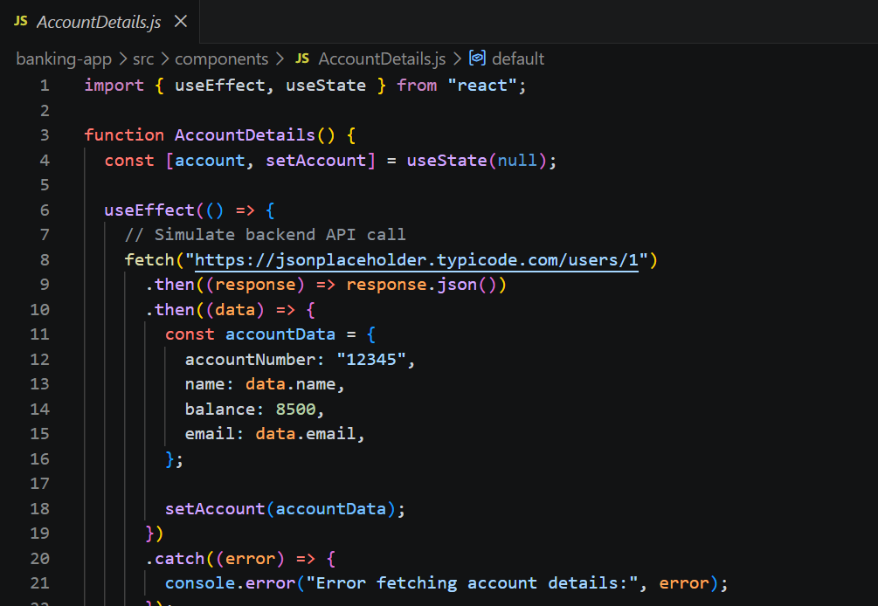

Step 2:
Access the server from your application
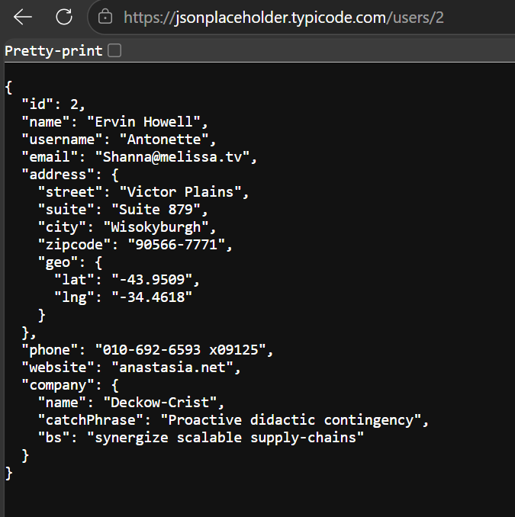

Step 3:
Use routing to implement SPA.

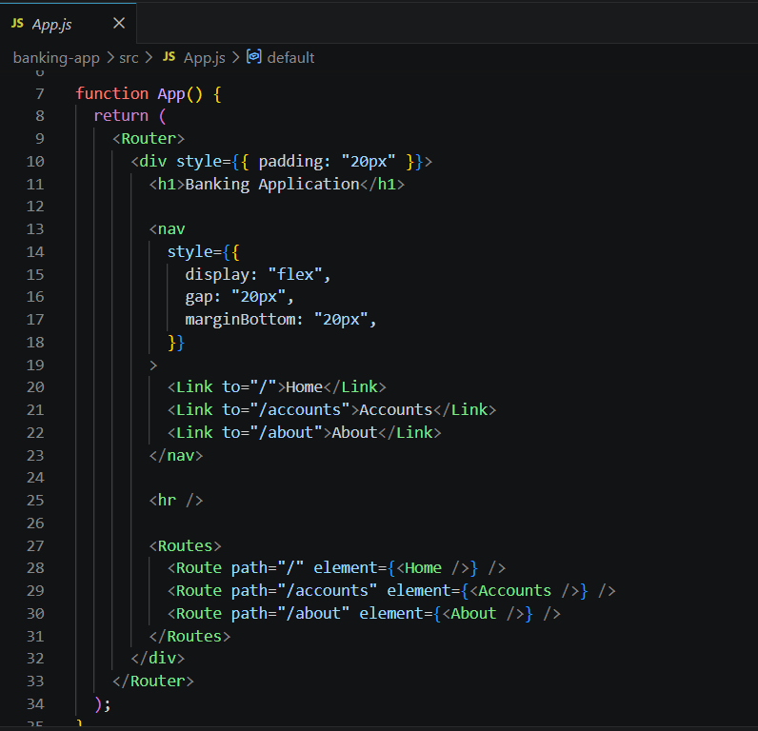

Task 10:
Redux: What is REdux used for?

Redux is used for state management in JavaScript applications, especially React applications.
It helps manage and share data across components in a predictable and centralized way.

Task 11:
Why do we need to maintain the state throughout the app..?

We maintain state throughout the app so the application can remember, update, and share data consistently across different components and pages.

Task 12:
What is useSelector used for ?

useSelector is a React-Redux hook used to read data from the Redux store inside a React component.

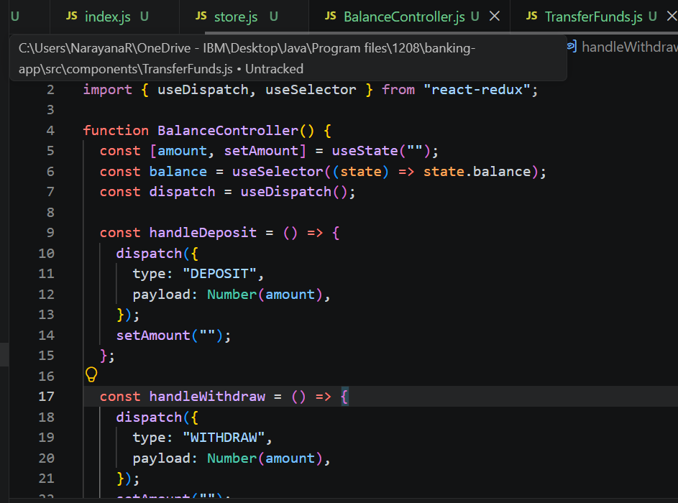

Task 13:
After the break we would be working with the Redux ..
In this can you create a store

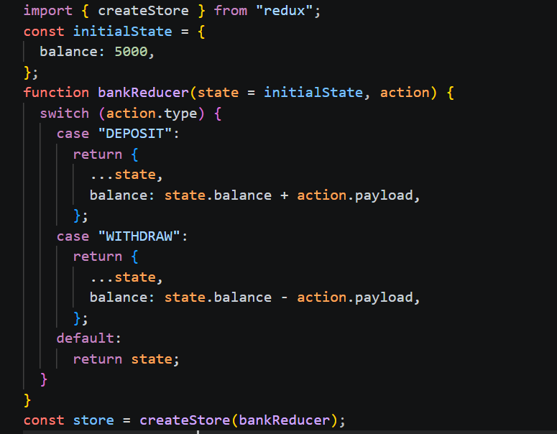

Task 14:
What is Node JS for?

Node.js is a JavaScript runtime environment that allows developers to run JavaScript code outside of a web browser, mainly on the server side.

Task 15:
Why use Node Js?

Node.js is used because it enables developers to build fast, scalable, and efficient server-side applications using JavaScript.

Task 16:
What are Common and modern modulus in Nodejs ?

1. CommonJS (CJS)
This is the traditional module system used in Node.js.

2. ES Modules (ESM) - Modern Modules
ES Modules are the modern JavaScript standard and are supported by Node.js.

Home Tasks

Node.js Home Task - Questions and Answers

1.What is the difference between Node.js and a traditional web server like Apache or Nginx?
Node.js is a JavaScript runtime environment used to build server-side applications. It uses an event-driven, non-blocking architecture. Apache and Nginx are traditional web servers mainly designed to handle HTTP requests and serve web content. Node.js is especially useful for real-time and I/O-heavy applications, while Apache and Nginx are commonly used for serving static files, reverse proxying, and handling web traffic.

2.Explain the event-driven architecture of Node.js.
Node.js uses an event-driven architecture where actions are triggered by events. Instead of waiting for an operation to finish, Node.js registers a callback or handler and continues executing other tasks. When the operation is completed, the corresponding event is handled by the event loop. This makes Node.js efficient for applications with many concurrent requests.

3.How does the single-threaded model in Node.js handle concurrency?
Node.js runs JavaScript code on a single main thread. It handles concurrency using the event loop and asynchronous, non-blocking operations. Time-consuming I/O operations such as file access, database queries, and network requests are handled asynchronously. When they finish, their callbacks are placed in the appropriate queue and executed by the event loop.

4.What is the role of the V8 engine in Node.js?
V8 is the JavaScript engine developed by Google and used by Node.js. It converts JavaScript code into machine code and executes it. V8 is responsible for running JavaScript efficiently, while Node.js provides additional APIs such as file system, networking, and operating system functionality.

5.Why is Node.js considered non-blocking?

Node.js is considered non-blocking because it does not wait for I/O operations to complete before continuing execution. For example, when Node.js starts reading a file, it can continue executing other code. Once the file operation is completed, a callback, promise, or async/await mechanism handles the result.

6.What is the difference between callbacks, promises, and async/await in Node.js?
Callbacks are functions passed to another function and executed after an asynchronous operation completes.
Promises represent the eventual result of an asynchronous operation and can be handled using .then() and .catch().
Async/await is a cleaner way of working with promises. It allows asynchronous code to be written in a style similar to synchronous code.
Example:
Callback: readFile(file, callback)
Promise: readFile(file).then(result => {})
Async/await: const result = await readFile(file)

7.How does the event loop work, and what are its phases?
The event loop allows Node.js to perform asynchronous operations while using a single JavaScript thread. It continuously checks for completed asynchronous operations and executes their callbacks.
The main phases of the Node.js event loop are:
- Timers - Executes callbacks scheduled by setTimeout() and setInterval().
- Pending Callbacks - Executes certain pending system-related callbacks.
- Idle, Prepare - Internal Node.js operations.
- Poll - Retrieves new I/O events and executes their callbacks.
- Check - Executes setImmediate() callbacks.
- Close Callbacks - Executes close-related callbacks such as socket close handlers.

8.What is the difference between process.nextTick() and setImmediate()?
process.nextTick() executes its callback immediately after the current operation finishes, before the event loop continues to its next phase.
setImmediate() executes its callback during the Check phase of the event loop.
Therefore, process.nextTick() generally executes before setImmediate().

9.How does Node.js handle I/O operations asynchronously?
Node.js uses asynchronous APIs and the event loop to handle I/O operations. When an I/O operation such as reading a file or making a network request starts, Node.js does not wait for it to finish. The operation is handled by the operating system or Node.js's underlying mechanisms. When it completes, its callback or promise is processed by the event loop.

10.How does the require() function work internally?
The require() function is used in CommonJS modules to import JavaScript files or packages.
When require() is called, Node.js:
- Resolves the module path.
- Loads the module.
- Wraps the module code in a function.
- Executes the module.
- Stores the result in a cache.
- Returns the value exported using module.exports.
Because of caching, requiring the same module again normally does not execute the module code again.

11.What is the purpose of package.json and package-lock.json?
package.json contains information about a Node.js project, such as the project name, version, scripts, and dependencies.
package-lock.json records the exact versions of installed packages and their dependency tree. It helps ensure that the same dependency versions are installed across different environments.
In short:
package.json = Project information and dependency requirements.
package-lock.json = Exact dependency versions and dependency tree.

12.Explain the difference between dependencies and devDependencies in npm.
dependencies are packages required for the application to run in production.
devDependencies are packages required only during development, testing, or building the application.
Example:
npm install express
This normally adds Express to dependencies.
npm install jest --save-dev
This adds Jest to devDependencies.
In short:
dependencies = Required to run the application.
devDependencies = Required only for development and testing.

