Development of pro-drug type peptides for the intervention of Amylin aggregation.

Altaf Hussain Kawa and Bhubaneswar Mandal*

*Department of Chemistry, Indian Institute of Technology Guwahati, Guwahati, India-781039*

[*bmandal@iitg.ac.in*](mailto:bmandal@iitg.ac.in)

**ABSTRACT**

The contemporary peptide based amyloid inhibitors have a pre-installed breaker element. These breaker elements are designed to develop a kink in the back bone of the inhibitor peptide which, inhibits amyloid formation. The kink in itself significantly reduces the target site recognition efficiency of the amyloid inhibitor. We have developed a new strategy for amyloid disruption. The designed peptide efficiently binds to the target site as a normal peptide. The peptide undergoes cascade of chemical reactions and transforms into the actual breaker peptide and thereby enhances the amyloid inhibition efficiency of the peptide. The designed peptidomimetics have demonstrated significant efficiency in the inhibition of Amylin aggregates.

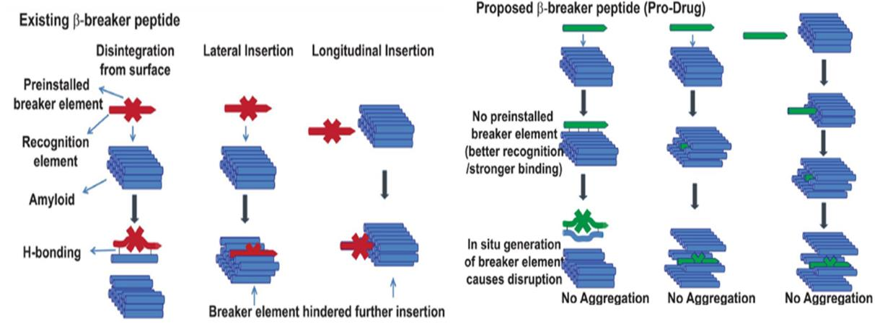

**Figure 1:** Pictorial representation of the proposed action of the amyloid inhibitor with pre-installed breaker element and the inhibitor based on pro-drug mechanism. [1]

**Keywords:** Amyloid, Aggregates, Inhibitor, T2D

**References:**

[1] Paul, A., Kumar, S., Kalita, S., Gosh, A. K., Mandal, A. C., and Mandal, B, *Int. J. of Pep. Res. And therapeutics*. 2018, 24(1), 201.