Simultaneous Sensing and Photocatalytic Degradation to Free Water from Toxic Dye Pollutants for Possible Agricultural and Household Applications: Role of Generated Holes and Hydroxyl Radicals

***Subhendu Sekhar Baga,b\*****,* ***Aniket Banerjeeb****, Sayantan Sinhab and Animes Golderb,c*

*a Chemical Biology/Genomics Laboratory, Department of Chemistry, Indian Institute of Technology Guwahati,*

*Guwahati-781039, India*

*b Center for the Environment, Indian Institute of Technology Guwahati, Guwahati-781039, India*

*c Department of Chemical Engineering, Indian Institute of Technology Guwahati, Guwahati-781039, India*

**Abstract:**

Careless discharge of textile/industry effluents containing carcinogenic organic dyes into local water bodies like lakes, rivers, and ponds has become the major source of wastewater pollution, threatening public health in India. Therefore, herein for the first time, we have developed I5+/TiO2 as a smart catalyst serving a dual role. Thus, the catalyst is efficient in (a) colourimetric visual sensing/discrimination of methyl orange (MeO) and Methylene blue (MeB) in water through colour change and (b) degradation of such dyes upon irradiation of light (λ>400 nm). The I5+/TiO2 has been synthesized through a simple thermal-assisted chemical synthesis route which has shown the specific interaction with MeO resulting in colour change through various photophysical experiments. We have established our synthesized nanomaterial as an excellent photocatalyst with excellent ability in photo-assisted catalytic degradation of MeO and MeB dyes within 60 min. The role of various active species in the photocatalytic reaction as well as the degradation pathway of the targeted dyes have also been thoroughly studied. To establish the effectiveness of our photocatalyst, we have further extended our study to find the effect of the treated water on the germination of *Vigna radiata* (green gram seeds) and monitored the plants' growth until the 16th day. Additionally, we also tested the treated water on HEK293 mammalian cell lines for cytotoxicity analysis. The results obtained suggested that the treated water is completely safe and devoid of any toxicity toward plants and human health. Therefore, the I5+/TiO2-assisted photocatalytic treated dye water can be utilized for agricultural and other household activities like washing, cleaning and gardening.

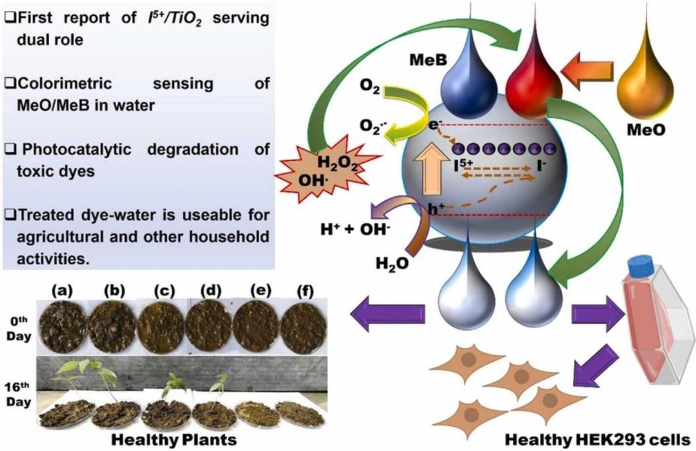

**Figure 1.** Graphical Abstract Demonstrating the Simultaneous Sensing and Photocatalytic Degradation to Free Water from Toxic Dye Pollutants for Possible Agricultural and Household Applications