**Sono-assisted pretreatment of lignocellulosic biomass for extraction of lignin**

Anindita Das, Kaustubha Mohanty*

Department of Chemical Engineering, IIT Guwahati, Assam-781039, India

*Corresponding author: Tel: +91 361 258 2267, E-mail: kmohanty@iitg.ac.in

**Abstract**

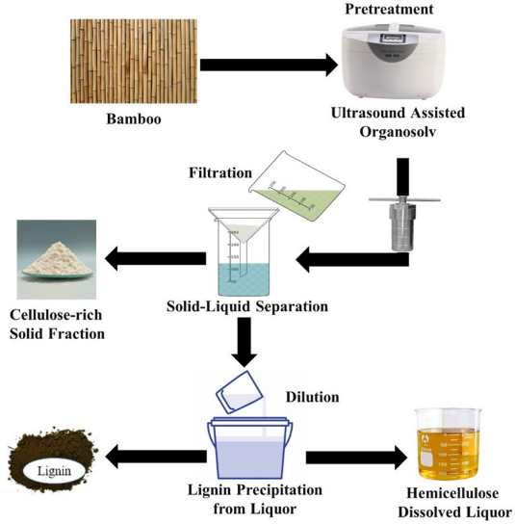The highly recalcitrance structure of lignocellulosic biomass demands pretreatment for its efficient utilization. The valorization strategies for cellulose and hemicellulose are already well-adopted. But for a sustainable biorefinery, utilization of each biomass fraction is of utmost necessity. This work focused on the extraction of lignin from lignocellulosic biomass which can be utilized for the production of bulk, fine chemicals, etc. The synergistic effects of ultrasound and organosolv pretreatment were investigated in this study. *Bambusa tulda* (bamboo) containing 21.22±2.13% lignin was considered for ultrasound-assisted organosolv pretreatment. The effect of sonication time (15-45 min), pretreatment temperature (140-180 °C), and pretreatment time (30-90 min) were investigated using response surface methodology (RSM) coupled with central composite design (CCD) for maximizing the lignin recovery. TGA-DTG, FTIR, XRD, FESEM analysis of untreated and pretreated biomass confirmed the extraction of lignin during the pretreatment. The changes in the morphological structure of biomass after pretreatment demonstrated by SEM were in favor of delignification. Moreover, an increase in the crystallinity index, an increase in the specific surface area, and pore size also confirmed the beneficial role of ultrasound-assisted organosolv pre-treatment. The optimal condition (180 °C, 55 min, and 30 min sonication) resulted in 65.81±2.40% of lignin yield with 95.37± 1.17% purity. A reduction in 7.85% yield and 1.54% purity of lignin with organosolv pretreatment highlighted the efficacy of sonication in lignin extraction. Ultrasound resulted in homolytic cleavage of the lignin-carbohydrate bond that enhanced delignification and increase the cellulose crystallinity. NMR, FTIR, GPC, and TGA of lignin suggested the superiority of sonication in maintaining lignin quality. A significant amount of β-O-4 linkages in extracted lignin is favorable for its subsequent valorization.

Figure : Flow Diagram

**Keywords:** biomass pretreatment, organosolv pretreatment, ultrasound-assisted organosolv pretreatment, lignin extraction